Environmental drivers of algal metacommunity structure in in river-connected lakes

Min Sung Kim^{1,2}, Seok Hyun Ahn¹, In Jae Jung¹, Tae Kwon Lee^{1*}
¹Department of Environmental Engineering, College of Health Science, Yonsei University, Gangwon 26493, South Korea

*Corresponding authors:
Tae Kwon Lee: tklee@yonsei.ac.kr

Supplementary Material

Supplementary tables

Supplementary Table S1. Season and annual variation of six lakes metacommunity structure
 |  | PD | CP | UM | CC | SY | HC | ALL
Season | Spring | C | C | C | QC | C | C | QC
Season | Summer | QC | C | C | C | C | QC | C
Season | Fall | QC | C | C | QC | C | QC | C
* C, Clementsian; QC, Quasi-Clementsian

Supplementary Table S2. Distribution of water qualities between six lakes. The values indicated mean ± standard deviation of water qualities.
 | PD | CP | UM | CC | SY | HC
Temperature  (℃) | 17.5 ± 5.5ª | 17.1 ± 5.5ª | 12.4 ± 4.5ª | 17.2 ± 5.4ª | 10.2 ± 4.1^{c} | 16.1 ± 4.9^{b}
Conductivity | 94.9 ± 18.3ª | 99 ± 27.0^{c} | 105.2 ± 28.3^{c} | 161.9 ± 33.5^{c} | 75 ± 10.0^{d} | 92.3 ± 15.1^{b}
pH | 8.1 ± 0.6^{b} | 7.9 ± 0.5^{b} | 7.8 ± 0.5ª | 7.9 ± 0.4ª | 7.5 ± 0.7^{c} | 8.2 ± 0.5^{b}
BOD | 0.9 ± 0.4ª | 1.0 ± 0.4^{b} | 0.7 ± 0.4ª | 1.3 ± 0.4^{b} | 1.1 ± 0.3ª | 1.2 ± 0.4^{c}
COD | 2.7 ± 0.9ª | 3.3 ± 0.5^{b} | 2.2 ± 0.7^{c} | 3.9 ± 0.4^{d} | 2.1 ± 0.4e | 3.1 ± 0.6e
TN | 1.7 ± 0.6ª | 1.7 ± 0.4^{b} | 1.5 ± 0.4ª | 2.0 ± 0.4^{b} | 1.6 ± 0.3^{bc} | 2.0 ± 0.6^{c}
NH₄⁺ | 0.08 ± 0.08^{bc} | 0.05 ± 0.07^{cd} | 0.07 ± 0.12ª | 0.05 ± 0.03^{b} | 0.04 ± 0.05e | 0.09 ± 0.06^{d}
TP | 0.02 ± 0.03ª | 0.02 ± 0.02^{b} | 0.01 ± 0.01^{b} | 0.04 ± 0.02^{c} | 0.01 ± 0.01^{b} | 0.03 ± 0.04^{d}
PO₄⁻ | 0.003 ± 0.004ª | 0.008 ± 0.009ª | 0.003 ± 0.003^{b} | 0.01 ± 0.01^{bc} | 0.002 ± 0.002^{c} | 0.004 ± 0.004^{c}
* Different small letters indicate significant differences between values of water qualities in sampling sites.
** BOD, Biochemical oxygen demand; COD, Chemical oxygen demand; TN, Total nitrogen; NH₄⁺, Ammonium; TP, Total phosphorus; PO₄⁻, Phosphate (unit: mg/L)

Supplementary Table S3. Distribution of seasonal precipitation of six lakes in sampling periods
Average  precipitation  per season  (mm) | Year | Season | PD | CP | UM | CC | SY | HC
Average  precipitation  per season  (mm) | 2008 | Spring | 36.7±25.6 | 43.7±37.8 | 59.0±27.9 | 55.7±23.7 | 42.3±41.1 | 51.0±21.1
Average  precipitation  per season  (mm) | 2008 | Summer | 380.0±157.1 | 373.3±178.8 | 330.7±166.5 | 331.7±266.6 | 349.0±161.3 | 318.0±158.1
Average  precipitation  per season  (mm) | 2008 | Fall | 52.7±40.0 | 40.7±26.6 | 33.3±21.5 | 23.7±9.4 | 37.7±25.0 | 40.0±25.9
Average  precipitation  per season  (mm) | 2009 | Spring | 65.7±27.0 | 55.7±36.1 | 67.7±16.5 | 79.7±12.8 | 58.3±31.8 | 56.3±18.6
Average  precipitation  per season  (mm) | 2009 | Summer | 139.0±94.1 | 404.3±257.1 | 337.7±200.2 | 335.3±177.8 | 344.7±207.1 | 301.3±75.3
Average  precipitation  per season  (mm) | 2009 | Fall | 42.3±2.6 | 51.3±8.8 | 29.0±12.0 | 33.3±13.7 | 37.3±9.0 | 28.3±11.1
Average  precipitation  per season  (mm) | 2010 | Spring | 85.0±25.0 | 119.0±32.0 | 72.0±19.0 | 89.0±23.0 | 81.5±22.5 | 62.0±13.0
Average  precipitation  per season  (mm) | 2010 | Summer | 257.0±101.1 | 318.3±133.3 | 227.0±156.7 | 291.0±147.3 | 240.3±171.8 | 229.7±123.2
Average  precipitation  per season  (mm) | 2010 | Fall | 198.7±250.9 | 217.3±280.0 | 158.0±197.4 | 149.3±178.1 | 163.3±202.1 | 128.0±155.8
Average  precipitation  per season  (mm) | 2011 | Spring | 82.5±31.5 | 91.5±19.5 | 100.5±3.5 | 101.5±3.5 | 129.5±14.5 | 90.5±2.5
Average  precipitation  per season  (mm) | 2011 | Summer | 587.3±373.6 | 534.0±328.0 | 510.3±320.4 | 500.3±341.7 | 520.0±323.0 | 391.0±248.5
Average  precipitation  per season  (mm) | 2011 | Fall | 46.7±2.5 | 54.3±19.1 | 46.3±18.2 | 56.3±31.5 | 50.7±20.3 | 46.3±21.4
Average  precipitation  per season  (mm) | 2012 | Spring | 65.7±50.3 | 87.3±70.2 | 70.3±39.8 | 76.7±57.7 | 73.0±48.1 | 45.0±34.0
Average  precipitation  per season  (mm) | 2012 | Summer | 374.0±186.1 | 335.0±152.1 | 221.3±87.8 | 257.0±103.5 | 243.7±90.4 | 179.3±83.2
Average  precipitation  per season  (mm) | 2012 | Fall | 130.5±55.5 | 138.5±36.5 | 89.0±19.0 | 115.5±28.5 | 103.5±29.5 | 88.0±28.0
Average  precipitation  per season  (mm) | 2013 | Spring | 102.5±29.5 | 112.5±26.5 | 101.5±45.5 | 101.0±17.0 | 77.0±18.0 | 56.5±11.5
Average  precipitation  per season  (mm) | 2013 | Summer | 396.7±358.5 | 115.0±54.0 | 349.3±313.1 | 362.0±358.6 | 395.3±384.7 | 327.3±317.6
Average  precipitation  per season  (mm) | 2013 | Fall | 94.0±90.0 | 53.3±32.5 | 71.3±63.8 | 72.3±57.2 | 72.7±58.7 | 70.0±54.4
Average  precipitation  per season  (mm) | 2015 | Spring | 40.7±30.6 | 52.7±40.0 | 43.7±35.8 | 46.7±34.6 | 44.3±34.8 | 36.3±25.8
Average  precipitation  per season  (mm) | 2015 | Summer | 139.7±58.9 | 147.0±125.2 | 99.3±86.8 | 153.3±134.9 | 129.0±93.4 | 111.0±98.3
Average  precipitation  per season  (mm) | 2015 | Fall | 57.3±38.2 | 56.3±38.2 | 55.7±43.3 | 76.0±64.9 | 65.0±49.3 | 57.0±42.9
Average  precipitation  per season  (mm) | 2016 | Spring | 84.7±38.1 | 89.7±40.7 | 78.7±23.0 | 1181.0±22.0 | 77.3±23.3 | 70.0±25.8
Average  precipitation  per season  (mm) | 2016 | Summer | 166.0±140.1 | 200.3±212.0 | 232.0±238.6 | 199.0±222.1 | 222.7±238.6 | 147.7±150.9
Average  precipitation  per season  (mm) | 2016 | Fall | 44.3±24.2 | 41.0±24.2 | 58.7±36.1 | 72.5±29.5 | 59.7±39.7 | 44.3±33.4

Supplementary Table S4. Climate information of six lakes within sampling periods
Temperature  (℃) | Year | Season | PD | CP | UM | CC | SY | HC
Temperature  (℃) | 2008 | Spring | 11.6±4.6 | 11.6±4.6 | 11.6±4.7 | 11.6±4.7 | 11.6±4.7 | 10.8±4.8
Temperature  (℃) | 2008 | Summer | 23.8±1.9 | 23.8±1.9 | 23.2±2.0 | 23.2±2.0 | 23.2±2.0 | 22.6±1.8
Temperature  (℃) | 2008 | Fall | 13.5±6.1 | 13.5±6.1 | 12.8±6.0 | 12.8±6.0 | 12.8±6.0 | 12.2±6.1
Temperature  (℃) | 2009 | Spring | 12.2±5.1 | 12.2±5.1 | 11.8±5.2 | 11.8±5.2 | 11.8±5.2 | 10.6±5.4
Temperature  (℃) | 2009 | Summer | 23.6±1.0 | 23.6±1.0 | 23.1±1.2 | 23.1±1.2 | 23.1±1.2 | 22.3±1.3
Temperature  (℃) | 2009 | Fall | 13.2±5.8 | 13.2±5.8 | 12.8±5.8 | 12.8±5.8 | 12.8±5.8 | 11.8±5.9
Temperature  (℃) | 2010 | Spring | 13.5±3.9 | 13.5±3.9 | 13.2±4.0 | 13.2±4.0 | 13.2±4.0 | 12.0±4.2
Temperature  (℃) | 2010 | Summer | 24.9±1.5 | 24.9±1.5 | 24.8±1.4 | 24.8±1.4 | 24.8±1.4 | 24.1±1.4
Temperature  (℃) | 2010 | Fall | 13.0±6.6 | 13.0±6.6 | 12.4±6.6 | 12.4±6.6 | 12.4±6.6 | 11.7±6.7
Temperature  (℃) | 2011 | Spring | 9.0±1.6 | 9.0±1.6 | 13.6±3.5 | 13.6±3.5 | 13.6±3.5 | 12.9±3.8
Temperature  (℃) | 2011 | Summer | 24.1±1.4 | 24.1±1.4 | 23.8±1.4 | 23.8±1.4 | 23.8±1.4 | 23.2±1.4
Temperature  (℃) | 2011 | Fall | 14.0±4.6 | 14.0±4.6 | 13.2±4.8 | 13.2±4.8 | 13.2±4.8 | 12.5±4.7
Temperature  (℃) | 2012 | Spring | 12.0±5.5 | 12.0±5.5 | 11.3±5.8 | 11.3±5.8 | 11.3±5.8 | 10.3±6.0
Temperature  (℃) | 2012 | Summer | 25.2±1.1 | 25.2±1.1 | 24.7±1.2 | 24.7±1.2 | 24.7±1.2 | 23.6±1.1
Temperature  (℃) | 2012 | Fall | 16.2±3.3 | 16.2±3.3 | 15.9±3.3 | 15.9±3.3 | 15.9±3.3 | 15.2±3.1
Temperature  (℃) | 2013 | Spring | 13.9±4.0 | 13.9±4.0 | 13.5±4.4 | 13.5±4.4 | 13.5±4.4 | 12.5±4.4
Temperature  (℃) | 2013 | Summer | 25.2±1.1 | 25.2±1.1 | 25.3±1.2 | 25.3±1.2 | 25.3±1.2 | 24.4±1.2
Temperature  (℃) | 2013 | Fall | 13.2±6.4 | 13.2±6.4 | 12.9±6.5 | 12.9±6.5 | 12.9±6.5 | 11.5±6.6
Temperature  (℃) | 2015 | Spring | 12.6±5.3 | 12.6±5.3 | 12.3±5.6 | 12.3±5.6 | 12.3±5.6 | 11.0±5.6
Temperature  (℃) | 2015 | Summer | 24.7±1.1 | 24.7±1.1 | 24.7±0.9 | 24.7±0.9 | 24.7±0.9 | 23.2±1.1
Temperature  (℃) | 2015 | Fall | 14.2±4.9 | 14.2±4.9 | 14.0±5.1 | 14.0±5.1 | 14.0±5.1 | 12.6±5.0
Temperature  (℃) | 2016 | Spring | 13.2±5.1 | 13.2±5.1 | 12.9±5.4 | 12.9±5.4 | 12.9±5.4 | 11.7±5.3
Temperature  (℃) | 2016 | Summer | 25.3±1.4 | 25.3±1.4 | 25.0±1.3 | 25.0±1.3 | 25.0±1.3 | 23.8±1.3
Temperature  (℃) | 2016 | Fall | 14.3±6.4 | 14.3±6.4 | 13.7±6.5 | 13.7±6.5 | 13.7±6.5 | 12.6±6.5

Supplementary Table S5. The loading of first axis canonical correspondence analysis (CCA) The value of table means loading value from CCA 1.
 | ALL | PD | CP | UM | CC | SY | HC
Temperature | -0.061 | -0.844 | 0.703 | 0.732 | 0.734 | -0.781 | 0.205
Conductivity | 0.743 | 0.274 | -0.259 | -0.3 | -0.217 | -0.326 | 0.885
pH | 0.354 | 0.741 | -0.623 | 0.199 | 0.176 | -0.279 | -0.229
BOD | 0.57 | 0.823 | -0.816 | -0.592 | 0.187 | 0.297 | -0.29
COD | 0.711 | 0.311 | -0.388 | 0.238 | 0.129 | -0.524 | 0.046
TN | 0.355 | 0.269 | -0.079 | -0.321 | 0.091 | 0.52 | -0.26
NH₄⁺ | 0.072 | 0.095 | -0.056 | -0.305 | -0.155 | -0.367 | -0.066
TP | 0.189 | -0.293 | 0.19 | 0.057 | 0.298 | -0.452 | 0.061
PO₄⁻ | 0.012 | -0.369 | 0.085 | -0.269 | 0.332 | -0.208 | 0.133
*The bold text was indicated that loading value was higher than 0.5
**BOD, Biochemical oxygen demand; COD, Chemical oxygen demand; TN, Total nitrogen; NH₄⁺, Ammonium; TP, Total phosphorus; PO₄⁻, Phosphate

Supplementary figures
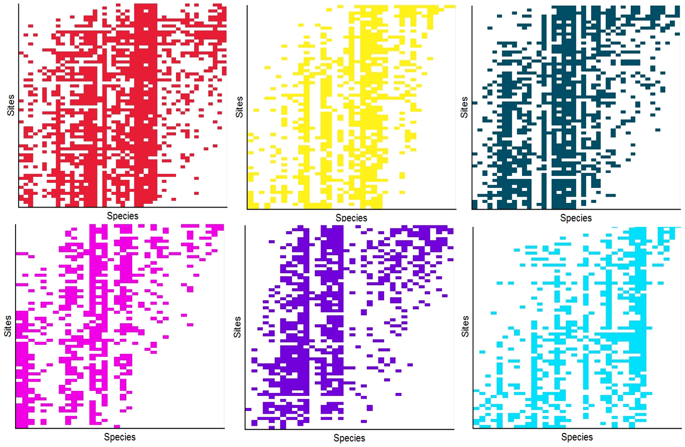
Figure S1. Metacommunity structures of sampling sites (a) Paldang (PD), (b) Cheongpyeong (CP), (c) Uiam (UM), (d) Chuncheon (CC), (e) Soyang (SY) and (f) Hwacheon (HC). All metacommunity structures classified as Clemensian metacommunity. Only Paldang was defined as quasi-Clemensian.
Figure S2. Visualization of metacommunity structures by (a) upstream, (b) midstream and (c) downstream. For the upstream and midstream represents Clementsian structure that algal community gradually shifted by sites but downstream showed qausi-Clementsian.

