Supplementary materials for “The role of a 3D printed model in the teaching of human anatomy”

Zhen Ye, Hanming Jiang, Cuifang Nie, Shulian Zhao, Tao Wang, Aishe Dun, Jing Zhai

Table S1 Literature quality assessment included in the analysis.
Quality assessment |  |  |  |  |  |  | No of patients |  | Quality | Importance
No of studies | Design | Risk of bias | Inconsistency | Indirectness | Imprecision | Other considerations | Conventional group | 3D printing group | Quality | Importance
Post-training tests_ Nervous system model_3D vs control
6 | Randomised trials | Serious¹ | No serious inconsistency | No serious indirectness | No serious imprecision | Undetected³  Strong association² | 152 | 153 | HIGH | CRITICAL
Post-training tests_ Heart model _3D vs control
5 | Randomised trials | Serious¹ | Serious | No serious indirectness | No serious imprecision | NA  Strong association² | 83 | 83 | LOW | Not IMPORTANT
Post-training tests_ Abdominal anatomy_3D vs control
3 | Randomised trials | Serious¹ | No serious inconsistency | No serious indirectness | No serious imprecision | NA | 72 | 72 | MODERATE | IMPORTANT
Post-training tests_3D vs Cadaver
4 | Randomised trials | Serious¹ | No serious inconsistency | No serious indirectness | No serious imprecision | NA | 153 | 149 | MODERATE | IMPORTANT
Post-training tests_3D vs 2D
10 | Randomised trials | Serious¹ | No serious inconsistency | No serious indirectness | No serious imprecision | Reporting bias³  Strong association² | 379 | 378 | MODERATE | IMPORTANT
Answering time_3D vs control
3 | Randomised trials | Serious¹ | Serious | No serious indirectness | No serious imprecision | NA | 237 | 237 | LOW | Not IMPORTANT
Usefulness_3D vs control
3 | Randomised trials | Serious¹ | Serious | No serious indirectness | No serious imprecision | NA | 95 | 107 | LOW | Not IMPORTANT
Satisfaction_3D vs control
6 | Randomised trials | Serious¹ | Serious | No serious indirectness | No serious imprecision | NA  Strong association² | 157 | 157 | HIGH | CRITICAL
Accuracy_3D vs control
2 | Randomised trials | Serious¹ | No serious inconsistency | No serious indirectness | No serious imprecision | NA | 64 | 65 | MODERATE | IMPORTANT
¹ The papers did not specifically describe the procedures of randomization.
² The number of included studies is no less than 5.
³ Publication bias was evaluated if a sufficient number of studies (n >= 5) were included.

Figure S1 Comparison of test results of the experimental and control groups for heart models.

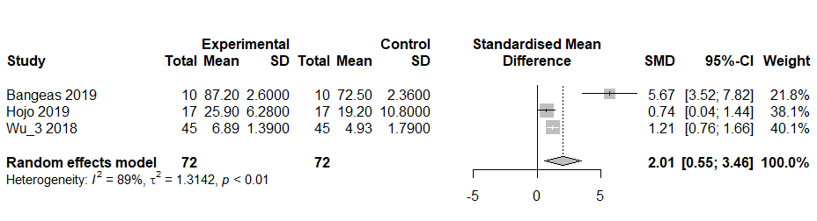
Figure S2 Comparison of test results of the experimental and the control groups for abdominal anatomy models.

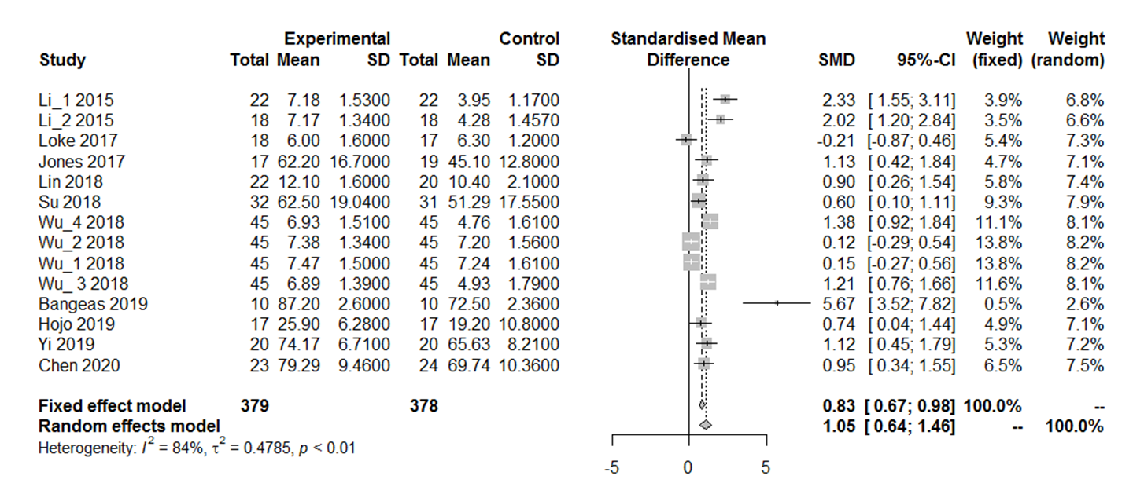
Figure S3 Comparison of the test results in answering questions between the 3D and 2D groups.

Figure S4 Comparison of the time spent in answering questions between the experimental and the control groups.

Table S2 The four documents describing the satisfaction of 3D vs. traditional groups.
Study | Description
Bangeas, 2017 | Both groups were satisfied with the study about the use of 3D printing technology for educational purposes.
Loke, 2017 | The residents reported better satisfaction when using the 3D group as compared to the 2D group with an improvement in composite learner satisfaction score from 21 to 24.
Wang, 2017 | Compared with the Traditional Model Group, more students in the 3D Printing Group marked 9−10 points for satisfaction with teaching, although the difference was not significant.
Wu, 2018 | The mean score in the visual analog scale for satisfaction was 7.49 ± 1.38 in the 3D group and 5.80 ± 1.30 in the traditional group (P < 0.05).
Chen, 2020 | For general satisfaction, 21  interns who in the 3D group feel satisfied, which higher than those in the control  group (p = 0.032).
Jordan, 2020 | The 3D group had significantly higher Likert scores as compared to the control group (P < 0.05 for all questions).

Table S3 The two documents described the answering accuracy of 3D vs. traditional groups.
Study |  | Description
Cai, 2018 |  | The students in the simulation learning group achieved a far better understanding than those in the traditional learning group with mean values of 85.03 ± 10.13% and 70.71 ± 15.13%, respectively (P < 0.05).
Huang, 2018 |  | While testing major fracture lines and classification, the 3D group showed a clear advantage over the PM and VR groups. The rates of ‘all correct’ classifications were 27.7%, 27.7%, and 51.1% in the PM, VR, and 3D groups, respectively.

