Supplementary figures:
Figure S1: ULF-STDP protocol applied to either the ACC or GPi electrode alone does not alter alcohol consumption in a two-bottle choice model. In mice displaying high alcohol preference, ULF-STDP(+) was applied to a single electrode in either the ACC (magenta) or GPi (gold) (A). Alcohol consumption in g/kg/24h period before ULF-STDP (PRE) and 24 hours after ULF-STDP (POST) for groups in which ULF-STDP(+) was delivered to only the ACC (B) and ULF-STDP(+) GPi (C). Statistical significance of comparison of alcohol consumption immediately before and after ULF-STDP was determined using a paired Student’s t-test, p<0.05 (n=8). Error bars represent standard error. Box and whisker plots in B-C represent median, 95% CI, and max/minimum where black dots and gray lines represent individual animals.

Figure S2: Microwire array impedances are stable across weeks as measured via a TDT PZ5 neurodigitizer amplifier. Squares, circles, and triangles represent mean impedance values of all electrodes for unique animals. Error bars of longitudinal recordings of standard error of impedance.

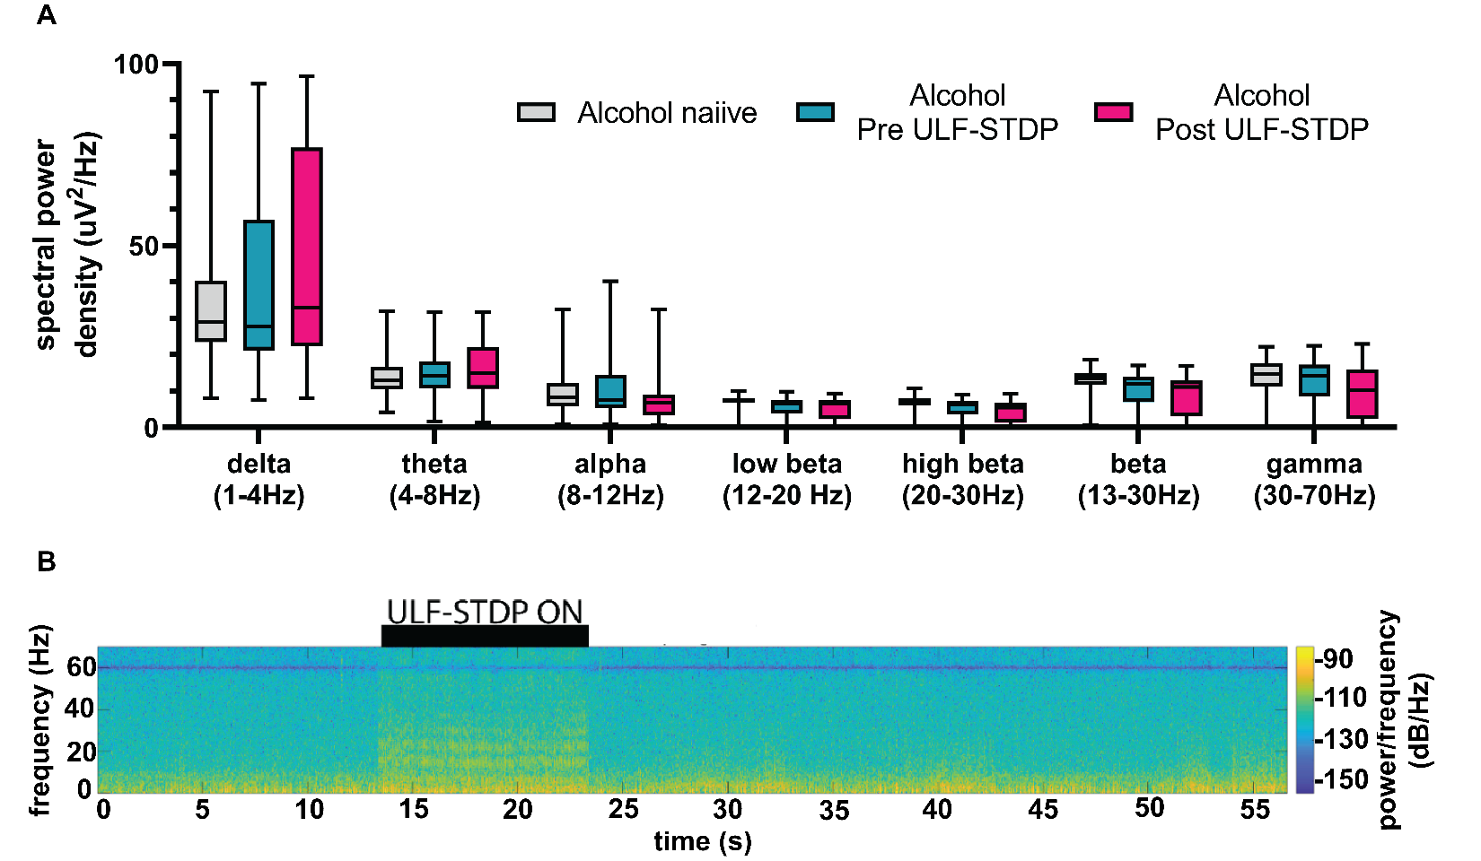
Figure S3: ULF-STDP(+) does not alter DMS local field potential spectra (A) band power analysis showing representative power spectral density and (B) spectrogram before and after ULF-STDP (+). Error bars represent standard error. Box and whisker plots in B-C represent median, 95% CI, and max/minimum. (n=32 channels, 1 mouse).

Figure S4: Real Time Place Preference Behavior test to demonstrate hedonic or aversive properties of ULF-STDP(+). (A) A custom real time place preference chamber (60cm x 30cm) was fabricated with “Dot” and “Stripe” visual cues on the left and right halves of the chamber, respectively. Mice used in in Figure S1 were allowed 10 days in their home cage prior to performing a real time place preference test. Briefly, lightweight cables were connected to the ACC and GPi stimulating electrodes immediately before placing the mice in the real time place preference chamber. (B) Spontaneous locomotor activity was recorded for 10 minutes without stimulation in a “Pretest” session. Twenty-four hours later, mice stimulating electrodes were re-connected to lightweight cables and received ULF-STDP(+) (1Hz, 90us, 250uA, balanced, cathodic leading, GPi 18ms prior to ACC) only when on the “Stripe” side of the chamber. Spontaneous locomotor activity was recorded again for 10 minutes while animals were stimulated with ULF-STDP(+) only on the “Stripe” half of the chamber . We report (C) time in zone, (D) average speed, and (E) distance traveled (F) for all treatment conditions. Statistical significance was determined using one-way ANOVA, p<0.05 (n=13). Box and whisker plots in C-F represent median, 95% CI, and max/minimum where black dots represent individual animals.

