Tunnel Engineering for Modulating the Substrate Preference in Decarbonylase P450_{Bsβ}HI

Shuaiqi Meng^{a, b, #}, Ruipeng An^{a, #}, Zhongyu Liª, Ulrich Schwaneberg^{b, c}, Yu Ji^{b}, Mehdi D. Davari^{b}, Fang, Wangª, Meng Wangª, Meng Qinª, Kaili Nieª, Luo Liu^{a,} *

¹ Beijing Bioprocess Key Laboratory, Beijing University of Chemical Technology, Beijing, 100029, PR China
² Lehrstuhl für Biotechnologie, RWTH Aachen University, Worringerweg 3, 52074 Aachen, Germany
³ DWI-Leibniz Institut für Interaktive Materialien, Forckenbeckstraße 50, 52056 Aachen, Germany
# same contribution
Tel: 0086 10 64421335
Fax: 0086 10 64416428

* To whom correspondence should be addressed. E-mail: liuluo@mail.buct.edu.cn (Luo Liu). Beijing Bioprocess Key Laboratory, Beijing University of Chemical Technology, Beijing, 100029, PR China.

Table S1 The residues lining identified tunnels in P450_{Bsβ}HI.

Tunnel number | Residues lining in the identified tunnels
Tunnel 1 | H85, F79, G86, R66, L70, Q75, L293, A69, A83, G294, N82, Q352, C363, K72, Q67, N68, G290, P243, R242, G80, I170, P291, F289, N239, L78, V81, A295, A246
Tunnel 2 | F173, V74, L78, L293, F292, R73, L70, H180, L42, F79, L17, G174, S77, K76, L18, C363, P243, L315, H85, G294, R242, R184, A175, P71, V176, P291, I170, L15, S14, G290, F289, N239, W181, A246

Table S2 The sequence of primers for P450_{Bsβ}HI mutagenesis. Mutated codon is formatted in bold red text.

Name | 5’→3’ sequence
BsβHI-F79G-F | TCTCTGGGTGGTGTTAACGCGATTCATGGTATGGATGGTTC
BsβHI-F79G-R | CGCGTTAACACCACCCAGAGATTTCTGAACGCGTTTCGGC
BsβHI-F79V-F | TCTCTGGTTGGTGTTAACGCGATTCATGGTATGGATGGTTC
BsβHI-F79V-R | CGCGTTAACACCAACCAGAGATTTCTGAACGCGTTTCGGC
BsβHI-F79A-F | TCTCTGGCAGGTGTTAACGCGATTCATGGTATGGATGGTTC
BsβHI-F79A-R | CGCGTTAACACCTGCCAGAGATTTCTGAACGCGTTTCGGC
BsβHI-F79S-F | TCTCTGTCAGGTGTTAACGCGATTCATGGTATGGATGGTTC
BsβHI-F79S-R | CGCGTTAACACCTGACAGAGATTTCTGAACGCGTTTCGGC
BsβHI-F79I-F | TCTCTGATTGGTGTTAACGCGATTCATGGTATGGATGGTTC
BsβHI-F79I-R | CGCGTTAACACCAATCAGAGATTTCTGAACGCGTTTCGGC
BsβHI-F79T-F | TCTCTGACCGGTGTTAACGCGATTCATGGTATGGATGGTTC
BsβHI-F79T-R | CGCGTTAACACCGGTCAGAGATTTCTGAACGCGTTTCGGC
BsβHI-F79C-F | TCTCTGTGTGGTGTTAACGCGATTCATGGTATGGATGGTTC
BsβHI-F79C-R | CGCGTTAACACCACACAGAGATTTCTGAACGCGTTTCGGC
BsβHI-F79L-F | TCTCTGTTAGGTGTTAACGCGATTCATGGTATGGATGGTTC
BsβHI-F79L-R | CGCGTTAACACCTAACAGAGATTTCTGAACGCGTTTCGGC
BsβHI-F79P-F | TCTCTGCCGGGTGTTAACGCGATTCATGGTATGGATGGTTC
BsβHI-F79P-R | CGCGTTAACACCCGGCAGAGATTTCTGAACGCGTTTCGGC
BsβHI-F173G-F | GATTGATGCAGGTGGTGCGGTGGGTCCGCGCCATTGGA
BsβHI-F173G-R | ACCGCACCACCTGCATCAATCATATCAATGAAATCGTCAGCA
BsβHI-F173V-F | GATTGATGCAGTTGGTGCGGTGGGTCCGCGCCATTGGA
BsβHI-F173V-R | ACCGCACCAACTGCATCAATCATATCAATGAAATCGTCAGCA
BsβHI-F173A-F | GATTGATGCAGCAGGTGCGGTGGGTCCGCGCCATTGGA
BsβHI-F173A-R | ACCGCACCTGCTGCATCAATCATATCAATGAAATCGTCAGCA
BsβHI-F173S-F | GATTGATGCATCAGGTGCGGTGGGTCCGCGCCATTGGA
BsβHI-F173S-R | ACCGCACCTGATGCATCAATCATATCAATGAAATCGTCAGCA
BsβHI-F173I-F | GATTGATGCAATTGGTGCGGTGGGTCCGCGCCATTGGA
BsβHI-F173I-R | ACCGCACCAATTGCATCAATCATATCAATGAAATCGTCAGCA
BsβHI-F173T-F | GATTGATGCAACCGGTGCGGTGGGTCCGCGCCATTGGA
BsβHI-F173T-R | ACCGCACCGGTTGCATCAATCATATCAATGAAATCGTCAGCA
BsβHI-F173C-F | GATTGATGCATGTGGTGCGGTGGGTCCGCGCCATTGGA
BsβHI-F173C-R | ACCGCACCACATGCATCAATCATATCAATGAAATCGTCAGCA
BsβHI-F173L-F | GATTGATGCATTAGGTGCGGTGGGTCCGCGCCATTGGA
BsβHI-F173L-R | ACCGCACCTAATGCATCAATCATATCAATGAAATCGTCAGCA
BsβHI-F173P-F | GATTGATGCACCGGGTGCGGTGGGTCCGCGCCATTGGA
BsβHI-F173P-R | ACCGCACCCGGTGCATCAATCATATCAATGAAATCGTCAGCA

Table S3 The properties of identified access tunnels in P450_{Bsβ}HI and its beneficial variants. The access tunnel analysis was carried out with MOLEonline serve (Pravda, L, 2018). The number suffixed by the variant name is the tunnel number.

Variants | Tunnels | Length(Å) | Radius in bottleneck (Å) | Polarity
BsbHI | 1 | 29 | 1.4 | 4.06
BsbHI | 2 | 37 | 1.2 | 8.48
F79A | 1 | 26.2 | 1.8 | 4.37
F79A | 2 | 33.8 | 1 | 12.42
F79V | 1 | 27.4 | 1.6 | 5.03
F79V | 2 | 34.5 | 1.3 | 11.57
F79S | 1 | 27.3 | 1.6 | 4.09
F79S | 2 | 33.8 | 1.1 | 13.04
F79T | 1 | 26.7 | 1.7 | 4.62
F79T | 2 | 33 | 1.1 | 11.3
F173V | 1 | 28.8 | 1.7 | 6.3
F173V | 2 | 34.5 | 1.3 | 12.81

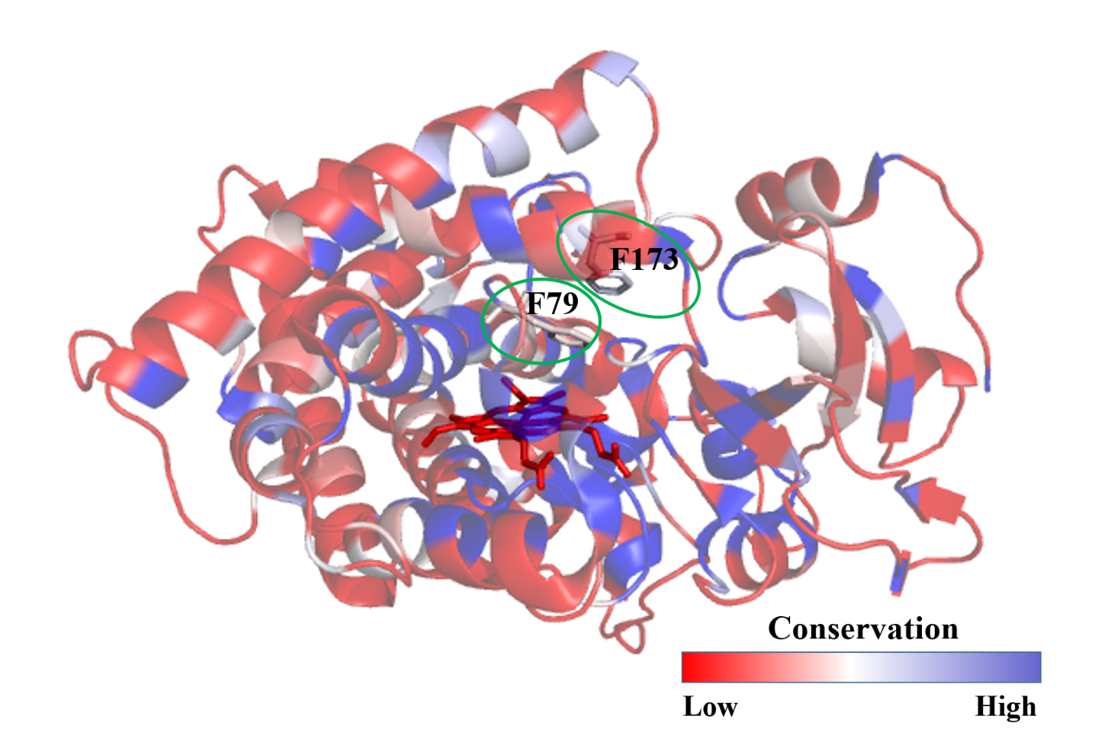
Figure S1: Conservation analysis of P450_{Bsβ}HI. The residues of phenylalanine 79 and phenylalanine 179 were marked by green circle. The conservation analysis was performed using Consurf online serve (Ashkenazy et al., 2016). Multiple sequence alignment was built using MAFFT; The homologues were collected from UNIREF90; The homolog search algorithm is HMMER; HMMER E-value is 0.0001. The calculation is performed on P450_{Bsβ}HI of 150 sequences that represent the list of homologues to the query.

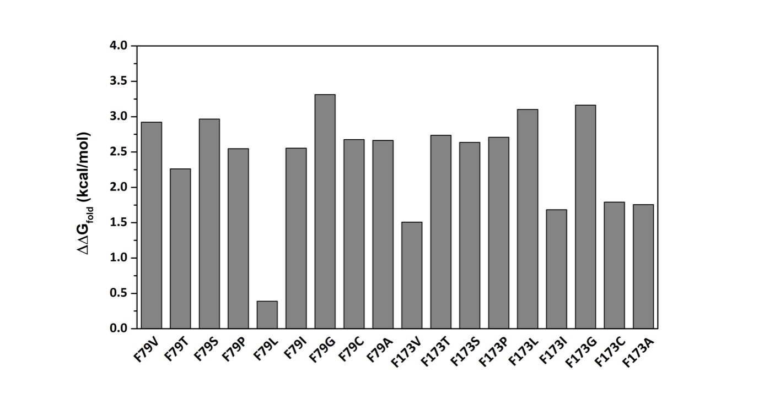
Figure S2 The relative folding free energies (ΔΔG_{fold}=ΔG_{fold},variants−ΔG_{fold},wild-type) values of 18 substitutions at two amino acid positions of the P450_{Bsβ}HI.

The ΔΔG_{fold} values were calculated using FoldX employing the YASARA plugin (version 19.12.4). The initial structure of P450_{Bsβ}HI was constructed by the Automated Modeling Tool of Swiss Model Web Service (http://swissmodel.expasy.org/) using the crystal structure of P450_{Bsβ} from Bacillus subtilis (PDB code: 1IZO with the resolution in 2.10 Å) as template. FoldX parameters was temperature 298 K, pH 7, and 0.05 M ionic strength.

Based CompassR rule developed by Cui et.al., the substitutions were divided three categories: Active (ΔΔG_{fold}≤+0.36 kcal mol⁻¹), Unpredictable (+0.36 kcal mol⁻¹≤ΔΔG_{fold}≤+7.52 kcal mol⁻¹), and Inactivated (ΔΔG_{fold}≥+7.52 kcal mol⁻¹) [1]. There is no unstable substitution was found among all of the variants.

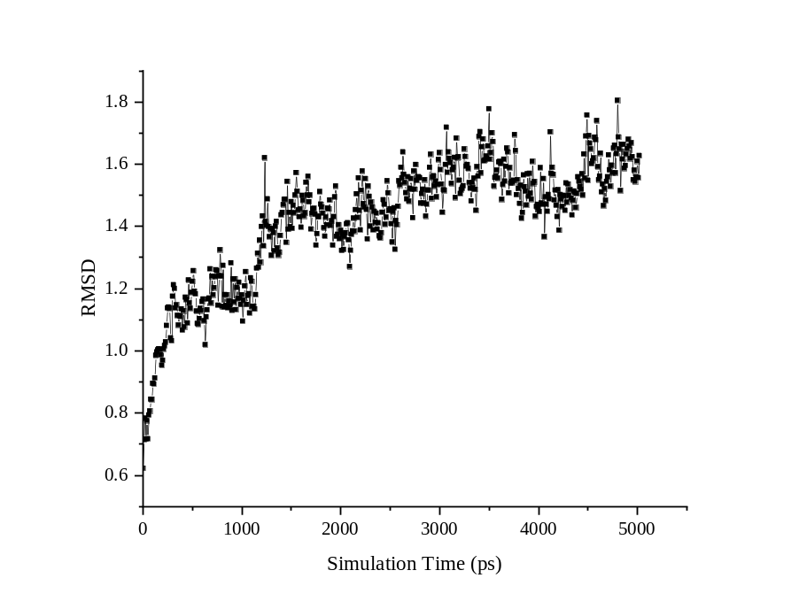
Figure S3 The Root-mean-square deviation (RMSD) of CA atoms of P450_{Bsβ}HI versus the starting structure.

Reference:
Pravda, L., Sehnal, D., Tousek, D., Navratilova, V., Bazgier, V., Berka, K., et al. (2018). MOLEonline: a web-based tool for analyzing channels, tunnels and pores (2018 update). Nucleic Acids Res, 46(W1), W368-W373.
Ashkenazy, H., Abadi, S., Martz, E., Chay, O., Mayrose, I., Pupko, T., & Ben-Tal, N. (2016). ConSurf 2016: an improved methodology to estimate and visualize evolutionary conservation in macromolecules. Nucleic Acids Res, 44(W1), W344-W350.

