Appendix A. Main export products to the United States

Table 11
Colombia's bilateral trade with the United States. Main export products to the United States
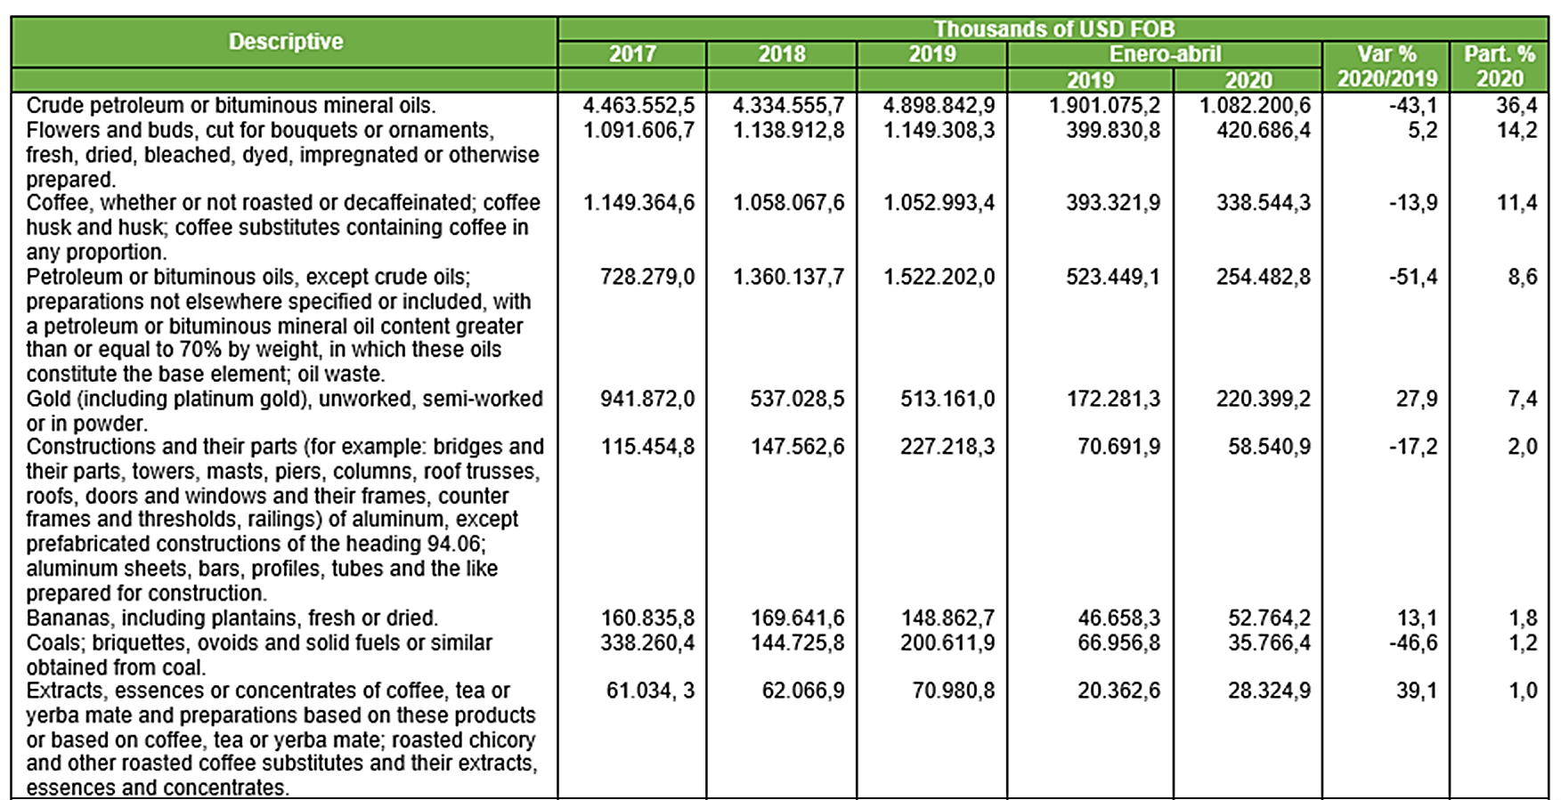

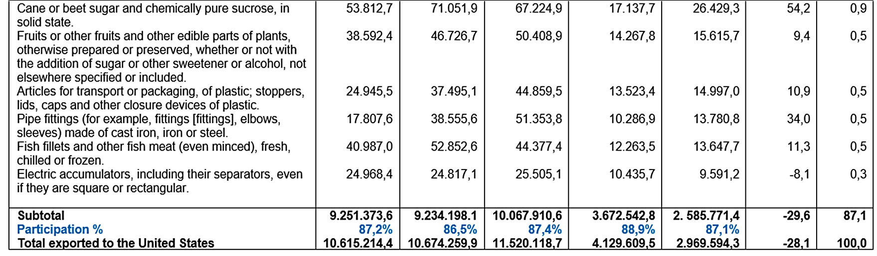

Source: Ministry of Commerce, Industry and Tourism -Mincit (2020).

APPENDIX B. Revealed Comparative Advantage Method
The method of the Center for Prospective Studies and International Information (CEPII) called Revealed Comparative Advantages (RCA) carried out by (De-Saint-Vaulry, 2008) was used. The CEPII indicator measures comparative advantages in a standard way, revealing them through an analysis of exchanges, as the index initially proposed by Balassa (1965) and has its antecedents in David Ricardo's theory of “comparative advantage”. Below is the calculation formulated:
$${RCA}_{kit}≔\frac{1000}{Y_{it}}\left[\begin{matrix}\begin{matrix}{X^{'}}_{kit}-{M^{'}}_{kit}-v_{kt}\end{matrix} \sum_{k=1}^{K}{{ (X'}_{kit}-{M^{'}}_{kit})}\end{matrix}\right]∈ R$$
where:$Y_{it}$ is the GDP of country i in time t
$v_{kt}$:= $W_{kt}/W_{t}$
$$W_{kt}≔\sum_{i=1}^{n}{{ (X}_{kit}+M_{kit});W_{t}}≔\sum_{k=1}^{k}{W_{kt}}$$
${X^{'}}_{kit}≔$ $X_{kit}˙e_{kt};{M^{'}}_{kit}≔M_{kit}˙e_{kt}$
$$e_{kt}≔1si W_{kt}/W_{t}=0; otherwise e_{kt}: =\frac{W_{kr}/W_{r}}{W_{kt}/W_{t}}$$
The evaluated zone may be the world, the members of the World Trade Organization (WTO), or a group of at least two countries, however the index and the variables that enable its calculation refers only to the selected zone. The identification of a country that belongs to a zone is identified by the letter i, a group of products by the letter k and a time period by the letter t. “The variable denotes the ${RCA}_{kit}$ index of country i with respect to the product (or group of products) k in period t (and within the zone)”. (Stellian & Danna p. 133)
The starting point is $W_{kt}$, which represents trade in k by all the countries in the zone in period t, $X_{kit}$ denotes total exports by country i in time t, for the K product groups considered in the nomenclature, otherwise $X_{kit}$ $∈$ $R_{+}$ represents exports of k (in monetary units) made by country i in time-period t.
Once $W_{kt}$ has been calculated for each k, it is possible to sum $W_{1t}$+ $W_{2t}$+…$W_{kt}$ and calculate $W_{t}$, which represents “global” trade defined as the trade in all K product groups in t by all countries in the zone. The coeffcient $e_{kt}$ is determined by selecting a “reference period” denoted by the letter r. Thus, $W_{kt}/ W_{r}$ is the share of k in global trade in the reference period r. It is assumed that $W_{kt}/ W_{r}$ reflects the structural factors of k trade irrespective of short-term fluctuations.
Continuing with Stellian & Buitrago, i denotes Colombia, to identify Colombia’s comparative (dis)advantages in the bilateral trade zone with the United States (then n = 2). Data for exports and imports are taken from UNCTADstat (unctadstat.unctad.org), supplied according to the three-digit SITC Rev.3 nomenclature.
The evaluation period was from the implementation of the treaty and the joint bias was 2014.

