The subduction influence on ocean ridge basalts and its significance

A. Y. Yang^{1,2,3}, C. H. Langmuir^{4,1}, Y. Cai⁵, S. L. Goldstein⁵, P. Michael⁶, Z. Chen⁴
¹State Key Laboratory of Isotope Geochemistry, Guangzhou Institute of Geochemistry, Chinese Academy of Sciences, Guangdong, China. ²Key Laboratory of Ocean and Marginal Sea Geology, Guangzhou Institute of Geochemistry, Chinese Academy of Sciences, Guangdong, China. ³Southern Marine Science and Engineering Guangdong Laboratory, Guangdong, China, ⁴Harvard University, MA, USA. ⁵Lamont-Doherty Earth Observatory, Columbia University, NY, USA. ⁶University of Tulsa, OK, USA
Supplementary information
Table S1 Chemical and isotopic compositions for MORB from Dredge 274 and 55
Table S2 Major and trace element compositions for the in-house quality control standard VE32 and BHVO-2G for standardization
Table S3 Ba, Nb, Rb, Ce, Pb, Th, and U for MORB from Gakkel by LA-ICP-MS
Table S4 Ce/Pb and Nb/U ratios for Gakkel samples averaged per dredging station
Table S5 Parameters used for subduction flux calculation
Table S6 Global MORB and BABB compilation

Supplementary discussion
1. Analytical problems with U and Pb and the compilation of an updated global MORB dataset
The advent of Inductively Coupled Plasma Mass Spectrometry (ICP-MS) analyses has led to large numbers of samples with measurements of Pb and U in ocean ridge basalts. Although MORB have been known to have the “canonical ratios” of Nb/U =47, and Ce/Pb = 25^{1,2}, yet a download of ICP-MS data on supposedly pristine glasses from any region will show large variations in these ratios. Figure S1 a-c shows ICP-MS data from three regions, not chosen for particularly large variability- the Pacific-Antarctic Ridge (PAR, all glasses) (Fig. S1a), Mid-Atlantic 33-41°N with glass and whole rock with separate symbols (Fig S1b), Central Indian Ridge (all glasses, Fig S1c), and the Gakkel Ridge (all glasses, Fig. S1d). The few Central Indian Ridge samples with low Nb/U and Ce/Pb appear to be “arc-like”, but they do not show negative anomalies in Nb and Ta in trace element diagrams. The prominent with strong positive anomalies in Pb (and U) suggest that the apparent trend is caused by some combination of alteration increase of U, contamination of Pb and analytical error.
Using solution ICP-MS, Pb analyses have the difficulty Pb contamination of samples at all stages of the analytical process, as well as analytical uncertainties for samples with low Pb concentrations, or when special care is not taken with the analyses and the standards used. U analyses are problematic because even small amounts of alteration can increase the U contents of MORB, and depleted MORB have U concentrations near the detection limits of many laboratories, so that results less than 0.1 ppm are sometimes reported with only one significant figure. These problems lead to very scattered data and large ranges in these ratios. In many regional datasets, the relative variations in Ce/Pb or Nb/U are similar to La/Sm, even though variations in La/Sm are used as a general index of source enrichment and depletion.
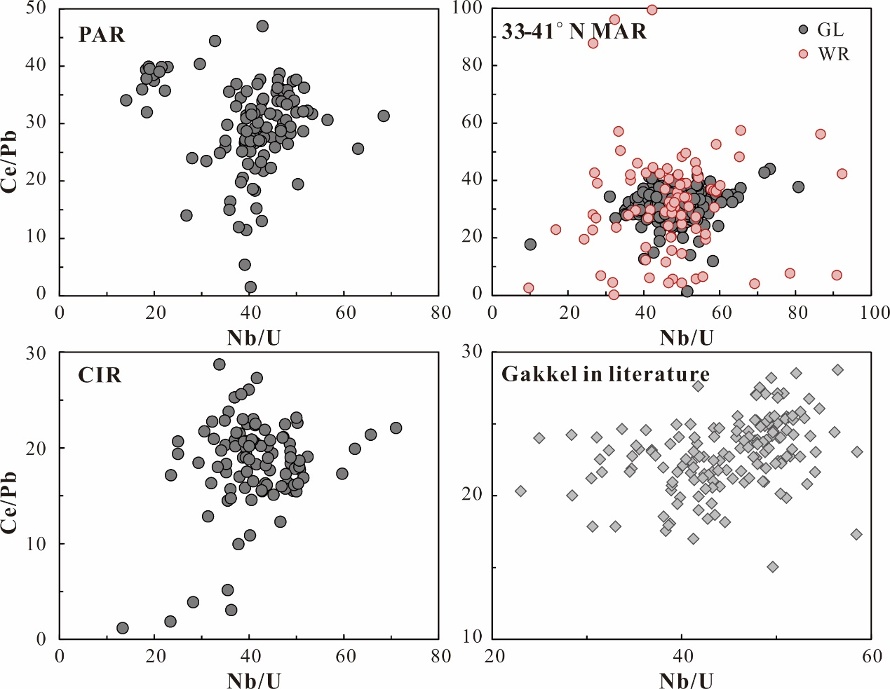
Fig. S1 Nb/U versus Ce/Pb correlations of ICP-MS data for MORB from Pacific-Antarctic Ridge (PAR), 33-41°N Mid-Atlantic Ridge (MAR), Central Indian Ridge (CIR), and Gakkel MORB. Grey symbols are all glasses. All data were downloaded from PetDB.
Use of a laser ablation (LA)-ICP-MS to collect data avoids Pb contamination and U alteration, and the data quality of samples with low Pb and U concentrations can be largely improved by multiple analyses on the same batch of samples. Therefore, more consistent data can be acquired, as evidenced by new LA-ICP-MS data set of Gakkel MORB in this study, which lacks the extreme outliers, and begins to show a positive correlation between Nb/U and Ce/Pb (Fig. 1b). Fig. S2 shows the U and Pb contents of the same batch of Gakkel samples using both solution ICP-MS and LA-ICP-MS method. Many samples fall above the 1:1 line, indicating the solution ICP-MS U and Pb data show much larger uncertainty than laser data.
The consistency of data from multiple samples of the same dredge (Fig. 1c) also increases confidence that the new LA-ICP-MS analyses have solved the problems of alteration and contamination, and that the ratios we measured are an accurate reflection of the magma. The consistency of the elemental ratios for restricted parts of the MOR, and their distinctiveness within regions increases our confidence that the ratios to construct the BABB filter reflect a mantle source signal, and are not related to shallower processes such as assimilation or interaction with the lower crust. The laser data presented in Fig. 1 of the main text shows a good correlation between Ce/Pb and Nb/U that is absent in the older solution ICP-MS data presented in Fig. S1d.
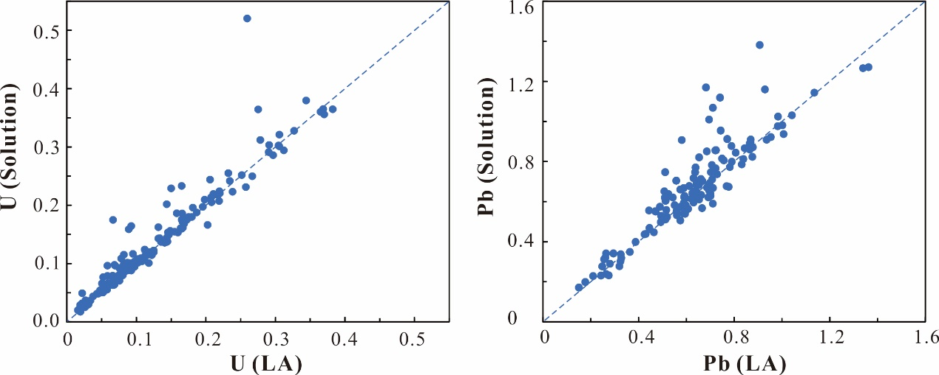
Fig. S2 Comparison of U and Pb for solution ICP-MS data with in situ LA-ICP-MS data for Gakkel MORB. The diagonal lines are 1:1 correlation lines.
To circumvent these problems with most literature data, we identified some papers with clearly problematic Pb or U analyses, and eliminated those analyses from the data set. We also eliminated all values of Ce/Pb greater than 50.
In addition to the global data set of Gale et al³, we added new papers which were included in PetDB, and did our own literature search to find additional papers not yet included in PetDB. After screening for papers without problematic Pb and U, the new data include data from Jenner and O'Neill⁴ that were not included in the Gale et al.³ compilation, Reekie et al.⁵, Kelley et al.⁶, Nielsen et al.⁷, Jones et al.⁸; Clog⁹, Standish¹⁰, Gill, et al.¹¹, Janin et al.¹², Möller¹³, Yang et al.¹⁴, Hoernle et al.¹⁵, Paquet, et al.¹⁶, Mallick, et al.¹⁷, Zong, et al.¹⁸, Shimizu, et al.¹⁹, Shimizu, et al.²⁰, and Escrig, Langmuir (unpublished), leading to 3000 more analyses than were included in Gale, et al.³. The new data compilation used for the global analysis that includes the original Gale et al.³ file is given in its entirety in Table S6.
2. Presentation of more detail on Gakkel Ridge
The Gakkel ridge in the Arctic Ocean is the slowest spreading ridge on Earth, with a full spreading rate of ~15 mm/yr in the west near Lena Trough and as slow as ~7 mm/yr near the Siberian margin^{21,22}. The 2001 Arctic Mid-Ocean Ridge Expedition (AMORE) sampled ~1000 km of the Gakkel Ridge between longitudes 7°W to 86°E.
We use a small number of elements to define the subduction influence because of the limitations of global data. This can be problematic because low Nb/U and Ce/Pb ratios are often observed in continental basalts, as basaltic magma erupted in continents may react with surrounding continental crust during its transportation through the continental lithosphere²³. However, it is not the case for MORB. As the Gakkel Ridge is where new oceanic crust is produced, MORB magma would not be subject to continental crustal contamination. Therefore, the likely way to produce Nb depletion and Pb enrichment relative to U and Ce in fresh MORB glass is through subduction-derived contributions, where U and Pb are more mobile compared to Nb and Ce during slab dehydration, respectively²⁴. Therefore, it appears that the BABB-like MORB from the Gakkel Ridge, and the overall trend to lower Ce/Pb and Nb/U than the canonical values of these ratios are likely caused by contribution to the MORB source by materials affected by subduction processes.
This can be tested with other elements that are also sensitive to subduction processes. For example, Th/Nb and K₂O/TiO₂ ratios are also elevated by subduction. Plots of La/Sm vs. Th/Nb and K₂O/TiO₂ also shows many of the Gakkel samples offset in the direction of a subduction influence, as evident in the Pacific/BABB comparison for these ratios.
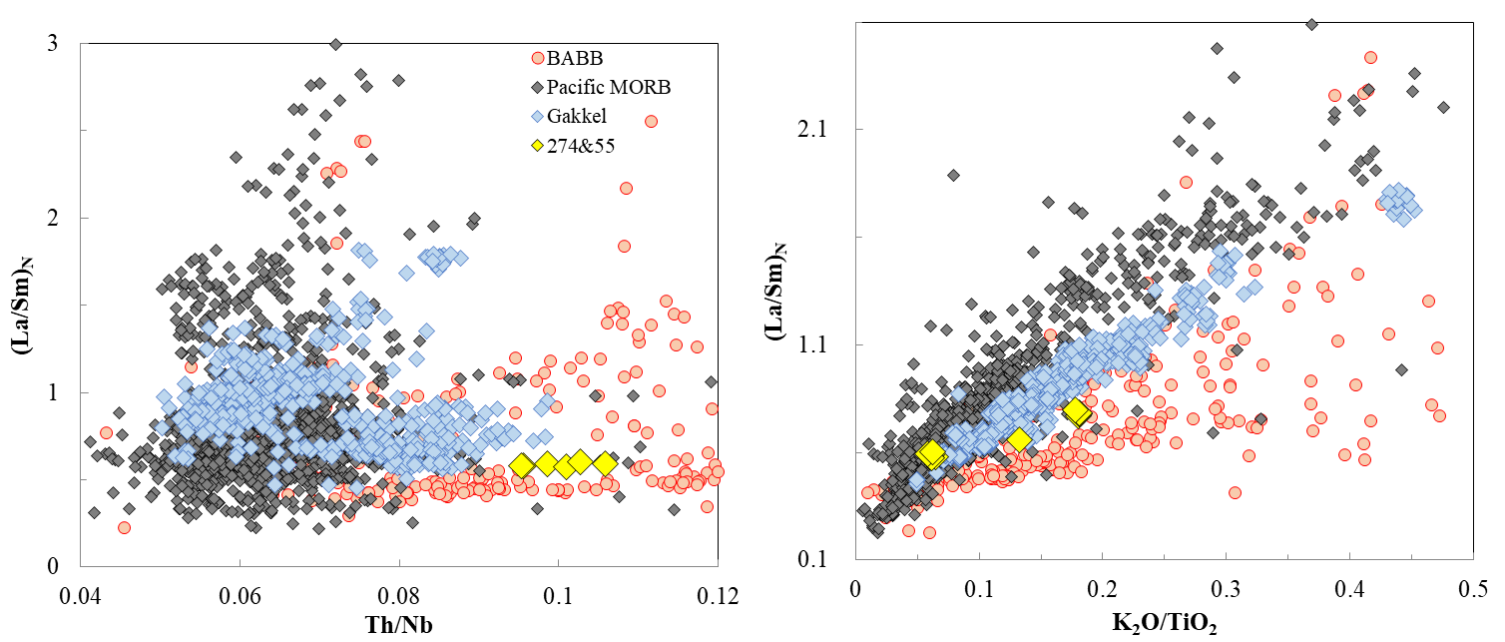
Fig. S3 Th/Nb and K₂O/TiO₂ vs. (La/Sm)_{N} for Pacific and Gakkel MORB as well as global BABB. Pacific MORB show clear separations with BABB with Th/Nb mostly lower than 0.08, independent of trace element enrichments indicated by (La/Sm)_{N}. MORB from Dredge 274 have high Th/Nb ratios up to 0.49, plotted way off the scale of diagram a). Significant amount of Gakkel MORB including Dredge 274 and 55 shift towards higher Th/Nb than 0.08, and higher K₂O/TiO₂ relative to (La/Sm)_{N}, similar to BABB, indicating a subduction influence.
These particular ratios are important because Goldstein et al²⁵ argued for the importance of a history involving phlogopite for some of the Gakkel samples with high Ba/Nb and Rb/Nb. But Th is not influenced by phlogopite²⁶, and therefore the offset in Th requires an additional explanation associated with subduction. The same reasoning applies to Ce/Pb and Nb/U ratios, which are also independent of phlogopite²⁶.
The tectonic history of the Arctic shows hundreds of millions of years of subduction from multiple directions towards this basin (Fig. S4). The Gakkel Ridge is surrounded by continental lithosphere, and therefore spreading does not have open access to the surrounding mantle. This is a likely explanation for the strong subduction influence observed in this region.
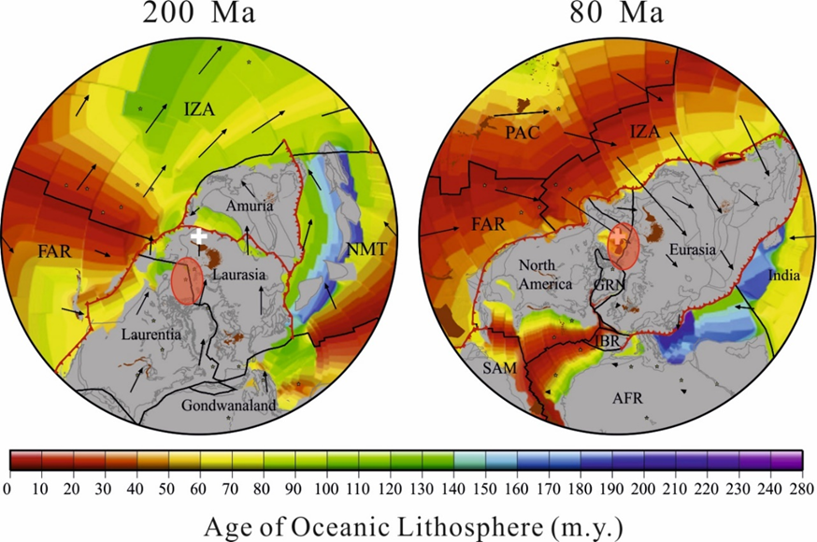
Fig. S4 Continuous subduction events beneath Arctic Ocean shown by global plate reconstructions from North Pole (white crosses) projection at 200 Ma and 80 Ma, modified from Seton, et al.²⁷. Red shaded fields represent the future location of Gakkel Ridge. Basemap shows the age–area distribution of oceanic lithosphere at the time of formation. Red lines denote subduction zones, black lines denote mid-ocean ridges and transform faults. Absolute plate velocity vectors are denoted as black arrows. Abbreviations for the plates are the same as in previous figures. Abbreviations include: AFR = African plate, FAR = Farallon plate, IBR = Iberian plate, IZA = Izanagi plate, NMT = North Meso-Tethys, PAC = Pacific plate, SAM = South American plate.
3. Distribution of BABB-like MORB vs. DUPAL anomaly
The distribution of BABB-like MORB also shows similarities with the DUPAL anomaly, in that it is mostly outside the Pacific subduction zones (Figure S6). The two are not equivalent, however. While many (59%) of BABB-like MORB with Pb isotopic data have DUPAL anomaly (defined by △8/4 over 30²⁵), most (75%) of global MORB with DUPAL anomaly do not pass the BABB filter (Fig. S5 and S7). That is, MORB with DUPAL anomaly do not necessarily have BABB-like trace element signatures, even though the majority of BABB-like MORB have isotopes characteristic of DUPAL (Fig. S5). Furthermore, BABB-like MORB have comparable ranges of △8/4 as MORB that do not pass BABB filter (Fig. S5). These observations indicate that recent subduction is not the cause of the global distribution of the DUPAL anomaly, but instead superimposes a subduction influence on the pre-existing large-scale mantle heterogeneity, of whatever flavor it may be.
The independence of DUPAL and BABB-like MORB becomes clearer when looking in detail at the DUPAL MORB that pass the BABB filter. Those samples that both pass the filter and have extreme DUPAL isotope signatures have Pacific-like H₂O/Ce ratios (Fig. S5). In contrast, those with lower △8/4 tend to have higher H₂O/Ce ratios (Fig. S5). Such a negative correlation between DUPAL and subduction input for global BABB-like MORB suggests a dilution effect on the DUPAL signature by subduction flux. Pb isotopic compositions of slab-derived fluids would depend on the relatively proportion of Pb in the sediments and igneous crust in the slab. Average global subducted sediment (GLOSS) has △8/4 ratios of 60²⁸, whereas Pacific igneous crust have △8/4 ratios of 2 (averaged using our data collection). Thus, Pb from slab would have △8/4 less than 60, ~30 if considering half Pb from sediment as indicated by Straub et al.^{29,30}. The extreme DUPAL MORB have △8/4 ratios of over 100 (Fig. S5), thus are not likely to be accounted for by recent subduction contributions. Alternatively, with continuous subduction of Pacific plate, the subduction flux would contribute isotopically less DUPAL-like Pb to the convecting mantle, diluting the DUPAL signature in preexisting mantle. It is of course significant that both DUPAL and subduction influence are rare in Pacific MORB, indicating that the isolation of Pacific MORB caused by subduction shields may be much longer than the past 180 Myr, and that both signals are associated with continental break-up, lithosphere delamination, and subduction over hundreds of millions of years.
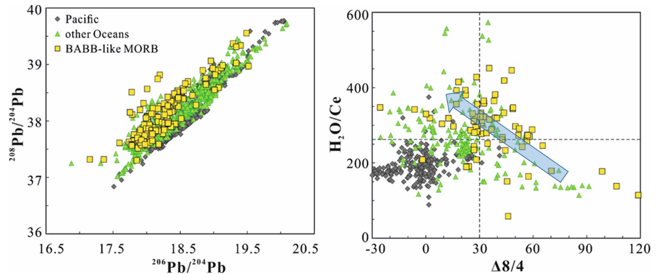

Fig. S5 ²⁰⁸Pb/²⁰⁴Pb vs. ²⁰⁶Pb/²⁰⁴Pb and H₂O/Ce vs. △8/4 for BABB-like MORB and MORB from Pacific and other oceans. It is clearly shown that Pacific MORB are mostly plotted in the quadrant of low H₂O/Ce and low △8/4, whereas BABB-like MORB show the same distribution with MORB from other oceans without subduction contributions. The blue arrow shows that BABB-like MORB with more subduction input (higher H₂O/Ce) became less DUPAL-like.

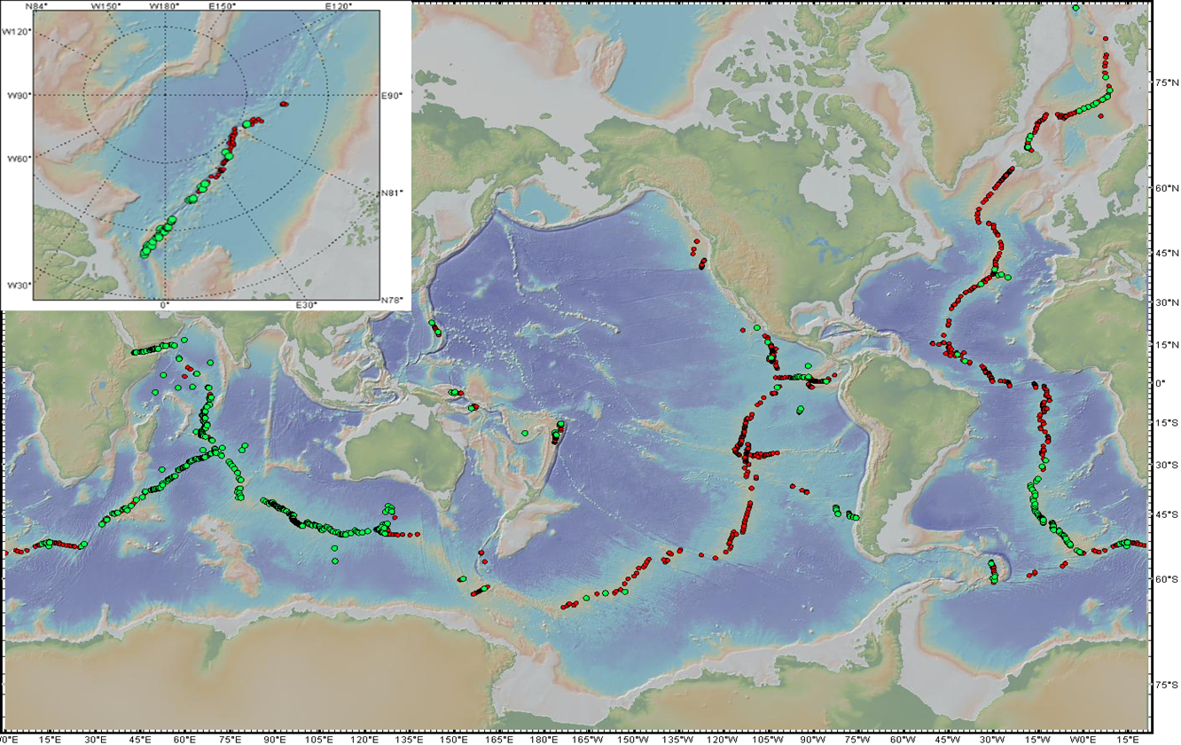
Fig. S6 Distribution of MORB with DUPAL anomaly. Green dots are for global MORB samples with △8/4 > 30, and red dots are for all the samples with Pb isotopic data.
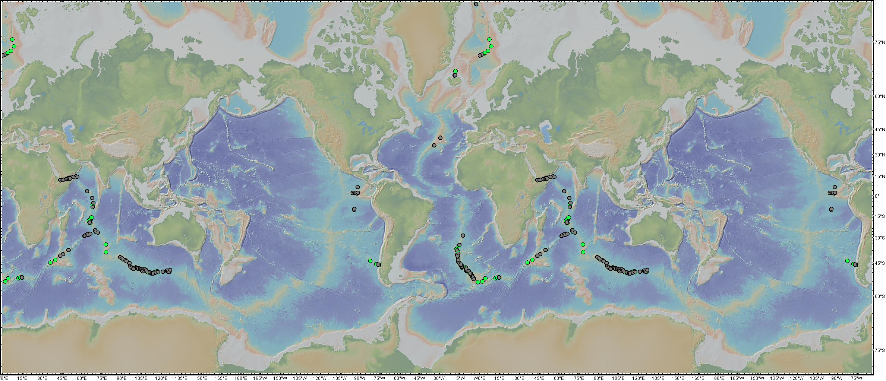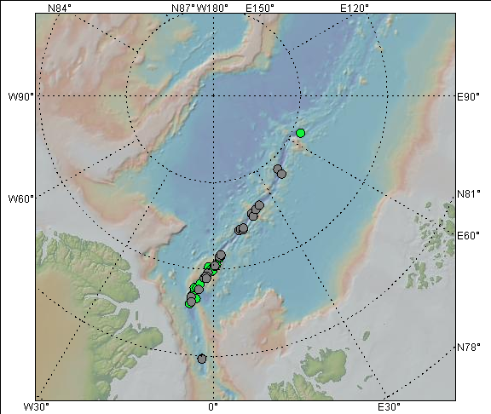
Fig. S7 Distribution of MORB with DUPAL anomaly which do not pass BABB filter (grey dots). Green dots are all the DUPAL-MORB with trace element data to apply the BABB filter on, shown as a reference.

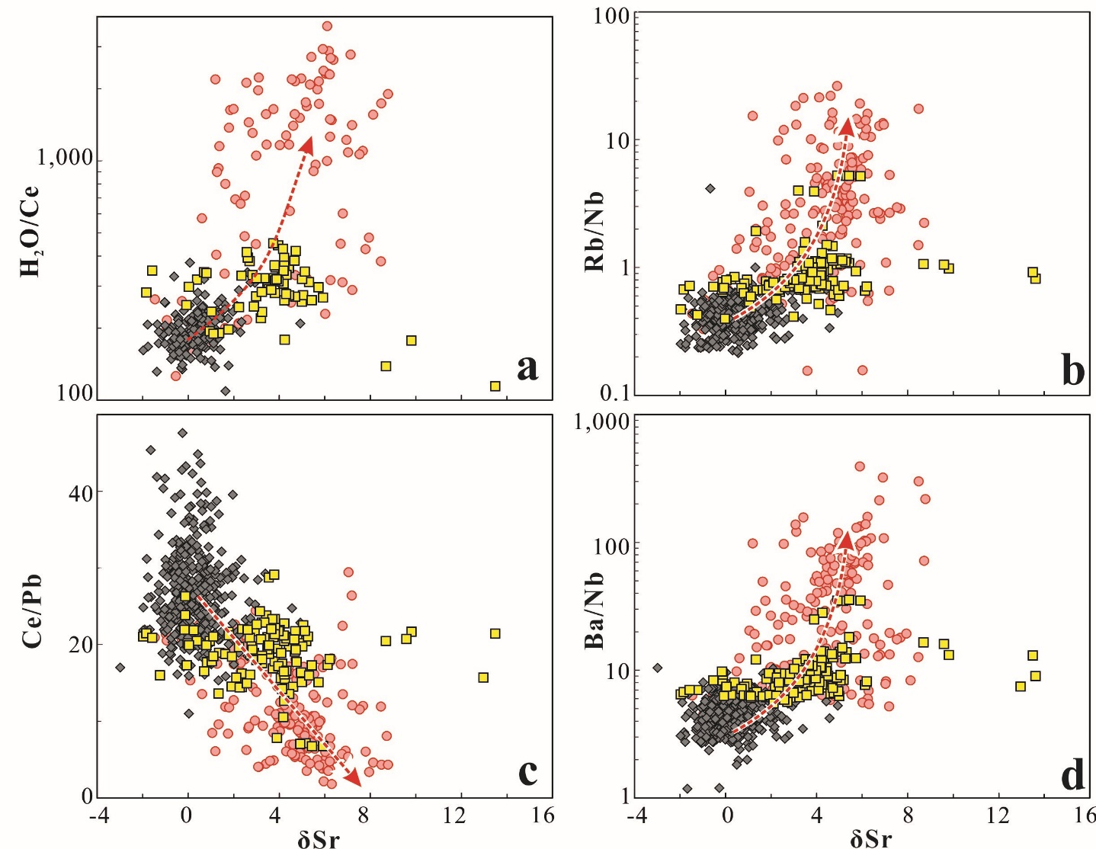
Fig. S8. H₂O/Ce, Rb/Nb, Ce/Pb, and Ba/Nb ratios vs. δSr (Deviation of ⁸⁷Sr/⁸⁶Sr relative to the Pacific MORB reference line (PMRL) as defined in the Methods) for Pacific MORB, BABB and BABB-like MORB. The higher δSr values of BABB-like MORB correlate systematically with higher H₂O/Ce and fluid-mobile element enrichments (Rb, Ba, and Pb), indicating the dominant role of subduction input in the elemental and isotopic characteristics of BABB-like MORB relative to Pacific MORB, as shown by the red arrows.

References
1 Hofmann, A. W., Class, C. & Goldstein, S. L. Size and composition of the residual and depleted mantle reservoir. Preprint at https://www.essoar.org/doi/pdf/10.1002/essoar.10501102.1, 43, doi:doi:10.1002/essoar.10501102.1 (2020).
2 Hofmann, A. W., Jochum, K., Seufert, M. & White, W. M. Nb and Pb in oceanic basalts: new constraints on mantle evolution. Earth Planet. Sci. Lett. 79, 33-45 (1986).
3 Gale, A., Dalton, C. A., Langmuir, C. H., Su, Y. & Schilling, J.-G. The mean composition of ocean ridge basalts. Geochem. Geophys. Geosyst. 14, 489-518, doi:10.1029/2012GC004334 (2013).
4 Jenner, F. E. & O'Neill, H. S. Analysis of 60 elements in 616 ocean floor basaltic glasses. Geochemistry Geophysics Geosystems 13, doi:Q0200510.1029/2011gc004009 (2012).
5 Reekie, C. et al. Sulfide resorption during crustal ascent and degassing of oceanic plateau basalts. Nature communications 10, 1-11 (2019).
6 Kelley, K. A., Kingsley, R. & Schilling, J.-G. Composition of plume-influenced mid-ocean ridge lavas and glasses from the Mid-Atlantic Ridge, East Pacific Rise, Galapagos Spreading Center, and Gulf of Aden. Geochemistry Geophysics Geosystems 14, 223-242, doi:10.1029/2012gc004415 (2013).
7 Nielsen, S. G., Shimizu, N., Lee, C. T. A. & Behn, M. D. Chalcophile behavior of thallium during MORB melting and implications for the sulfur content of the mantle. Geochem. Geophys. Geosyst. 15, 4905-4919 (2014).
8 Jones, M. et al. New constraints on mantle carbon from Mid-Atlantic Ridge popping rocks. Earth Planet. Sci. Lett. 511, 67-75 (2019).
9 Clog, M. Concentration et composition isotopique en hydrogène du manteau terrestre, Paris 7, (2010).
10 Standish, J. J. The influence of ridge geometry at the ultraslow-spreading Southwest Indian Ridge (9°--25° E): Basalt composition sensitivity to variations in source and process. (2006).
11 Gill, J. et al. Spatial and Temporal Scale of Mantle Enrichment at the Endeavour Segment, Juan de Fuca Ridge. J. Petrol. 57, 863-895, doi:10.1093/petrology/egw024 (2016).
12 Janin, M. et al. The Amsterdam-St. Paul Plateau: A complex hot spot/DUPAL-flavored MORB interaction. Geochemistry Geophysics Geosystems 13, doi:10.1029/2012gc004165 (2012).
13 Möller, H. Magma genesis and mantle sources at the Mid-Atlantic Ridge east of Ascension Island, Christian-Albrechts Universität Kiel, (2002).
14 Yang, S., Humayun, M. & Salters, V. J. M. Elemental Systematics in MORB Glasses From the Mid-Atlantic Ridge. Geochemistry Geophysics Geosystems 19, 4236-4259, doi:10.1029/2018gc007593 (2018).
15 Hoernle, K. et al. On- and off-axis chemical heterogeneities along the South Atlantic Mid-Ocean-Ridge (5-11 degrees S): Shallow or deep recycling of ocean crust and/or intraplate volcanism? Earth Planet. Sci. Lett. 306, 86-97, doi:10.1016/j.epsl.2011.03.032 (2011).
16 Paquet, M., Cannat, M., Brunelli, D., Hamelin, C. & Humler, E. Effect of melt/mantle interactions on MORB chemistry at the easternmost Southwest Indian Ridge (61 degrees-67 degrees E). Geochemistry Geophysics Geosystems 17, 4605-4640, doi:10.1002/2016gc006385 (2016).
17 Mallick, S., Salters, V. J. M. & Langmuir, C. H. Geochemical Variability Along the Northern East Pacific Rise: Coincident Source Composition and Ridge Segmentation. Geochemistry Geophysics Geosystems 20, 1889-1911, doi:10.1029/2019gc008287 (2019).
18 Zong, T. et al. H2O in basaltic glasses from the slow-spreading Carlsberg Ridge: Implications for mantle source and magmatic processes. Lithos 332, 274-286, doi:10.1016/j.lithos.2019.01.022 (2019).
19 Shimizu, K. et al. Two-component mantle melting-mixing model for the generation of mid-ocean ridge basalts: Implications for the volatile content of the Pacific upper mantle. Geochim. Cosmochim. Acta 176, 44-80, doi:10.1016/j.gca.2015.10.033 (2016).
20 Shimizu, K. et al. Identifying volatile mantle trend with the water-fluorine-cerium systematics of basaltic glass. Chem. Geol. 522, 283-294, doi:10.1016/j.chemgeo.2019.06.014 (2019).
21 Coakley, B. J. & Cochran, J. R. Gravity evidence of very thin crust at the Gakkel Ridge (Arctic Ocean). Earth Planet. Sci. Lett. 162, 81-95, doi:10.1016/s0012-821x(98)00158-7 (1998).
22 Michael, P. et al. Magmatic and amagmatic seafloor generation at the ultraslow-spreading Gakkel ridge, Arctic Ocean. Nature 423, 956-961 (2003).
23 DePaolo, D. & Wasserburg, G. Petrogenetic mixing models and Nd-Sr isotopic patterns. Geochim. Cosmochim. Acta 43, 615-627 (1979).
24 Kessel, R., Schmidt, M. W., Ulmer, P. & Pettke, T. Trace element signature of subduction-zone fluids, melts and supercritical liquids at 120-180 km depth. Nature 437, 724-727, doi:10.1038/nature03971 (2005).
25 Goldstein, S. L. et al. Origin of a ‘Southern Hemisphere’geochemical signature in the Arctic upper mantle. Nature 453, 89-93 (2008).
26 Schmidt, K. H., Bottazzi, P., Vannucci, R. & Mengel, K. Trace element partitioning between phlogopite, clinopyroxene and leucite lamproite melt. Earth Planet. Sci. Lett. 168, 287-299, doi:10.1016/s0012-821x(99)00056-4 (1999).
27 Seton, M. et al. Global continental and ocean basin reconstructions since 200Ma. Earth-Science Reviews 113, 212-270, doi:10.1016/j.earscirev.2012.03.002 (2012).
28 Plank, T. (Elsevier, 2014).
29 Straub, S. M., Goldstein, S. L., Class, C. & Schmidt, A. Mid-ocean-ridge basalt of Indian type in the northwest Pacific Ocean basin. Nat. Geosci. 2, 286-289, doi:10.1038/ngeo471 (2009).
30 Straub, S. M., Layne, G. D., Schmidt, A. & Langmuir, C. H. Volcanic glasses at the Izu arc volcanic front: New perspectives on fluid and sediment melt recycling in subduction zones. Geochem. Geophys. Geosyst. 5 (2004).

