Coding of Images in Long Term Memory:
The Fate of Visual Memories across Weeks in Adults and Children

Annabelle Goujon
University of Franche-Comté

Simon Thorpe
CerCo-CNRS & University of Toulouse 3

Supplementary materials

 | Condition | Exposure duration | Exposures number | Immediate delay | Three-weeks delay | Six-weeks delay
Hits | Meaningful-Old | 120  120  1920  1920 | 1  2  1  2 | 0,650 (0,056)  0,775 (0,043)  0,879 (0,035)  0,971 (0,018) | 0,392 (0,041)  0,617 (0,047)  0,674 (0,037)  0,888 (0,029) | 0,485 (0,053)  0,629 (0,042)  0,608 (0,037)  0,804 (0,038)
Hits | Meaningless-Old | 120  120  1920  1920 | 1  2  1  2 | 0,392 (0,051)  0,521 (0,054)  0,733 (0,042)  0,908 (0,024) | 0,317 (0,022)  0,350 (0,046)  0,492 (0,030)  0,792 (0,044) | 0,221 (0,045)  0,259 (0,056)  0,350 (0,059)  0,725 (0,061)
False alarms | New/Old Gist | 120  120  1920  1920 | 1  2  1  2 | 0,267 (0,036)  0,225 (0,048)  0,142 (0,029)  0,175 (0,039) | 0,308 (0,063)  0,333 (0,035)  0,308 (0,043)  0,342 (0,061) | 0,292 (0,060)  0,317 (0,037)  0,417 (0,055)  0,258 (0,061)
False alarms | Meaningful-New |  |  | 0,135 (0,032) | 0,306 (0,035) | 0,358 (0,039)
False alarms | Meaningless-New |  |  | 0,181 (0,034) | 0,234 (0,026) | 0,232 (0,045)

Table S1: Hits and false alarms in adults in the recognition task depending of the type of images, the exposure duration, the number of exposures and the delay. In parentheses are represented the standard errors.

 | Condition | Exposure duration | Exposures number | Immediate delay | Three-weeks delay | Six-weeks delay
Hits | Meaningful-Old | 120  120  1920  1920 | 1  2  1  2 | 0,571 (0,070)  0,688 (0,059)  0,879 (0,037)  0,963 (0,016) | 0,318 (0,056)  0,375 (0,042)  0,460 (0,042)  0,648 (0,044) | 0,336 (0,055)  0,424 (0,050)  0,509 (0,058)  0,695 (0,060)
Hits | Meaningless-Old | 120  120  1920  1920 | 1  2  1  2 | 0,229 (0,041)  0,333 (0,070)  0,550 (0,070)  0,788 (0,056) | 0,156 (0,049)  0,200 (0,066)  0,211 (0,050)  0,423 (0,073) | 0,155 (0,038)  0,258 (0,056)  0,235 (0,041)  0,550 (0,056)
False alarms | New/Old Gist | 120  120  1920  1920 | 1  2  1  2 | 0,192 (0,034)  0,267 (0,062)  0,183 (0,037)  0,233 (0,058) | 0,272 (0,077)  0,279 (0,066)  0,272 (0,075)  0,289 (0,085) | 0,300 (0,049)  0,354 (0,037)  0,292 (0,060)  0,337 (0,052)
False alarms | Meaningful-New |  |  | 0,154 (0,024) | 0,225 (0,057) | 0,306 (0,046)
False alarms | Meaningless-New |  |  | 0,187 (0,041) | 0,157 (0,055) | 0,214 (0,042)

Table S2: Hits and false alarms in 9-year-old children in the recognition task depending of the type of images, the exposure duration, the number of exposures and the delay. In parentheses are represented the standard errors.

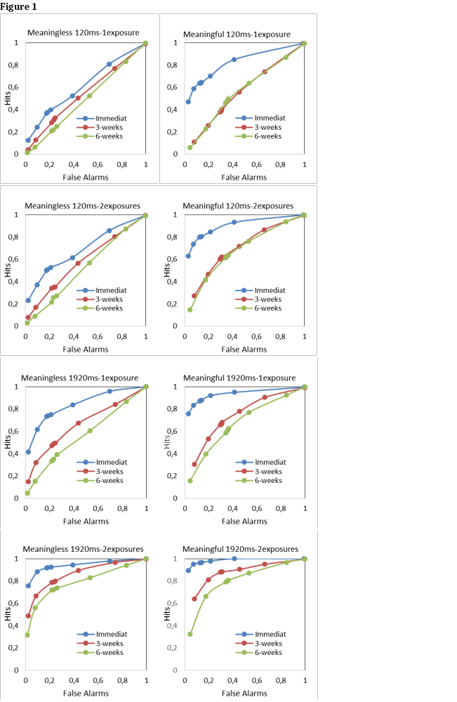Figure S1: Receiver-operating curves in adults for both types of images (meaningless: panels on the left and meaningful: panels on the right) and each condition (120ms-1exposure, 120ms-2exposures, 1920ms-1exposure, 1920ms-2exposures). Each point on the curve represents a different level of confidence (from 1 to 4: the images were classified as old (1= very sure; 4= just guessing); from 5 to 8: the images were classified as new (5=just guessing; 8=very sure). The point were calculated by cumulating response proportions of hits and false alarms, depending of the degree of response bias (1 to 8).

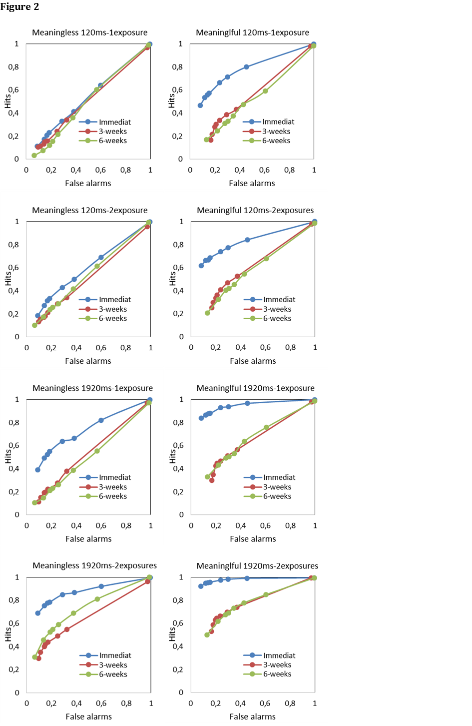Figure S2: Receiver-operating curves in children for both types of images (meaningless: panels on the left and meaningful: panels on the right and each condition (120ms-1exposure, 120ms-2exposures, 1920ms-1exposure, 1920ms-2exposures).

