Supplementary material
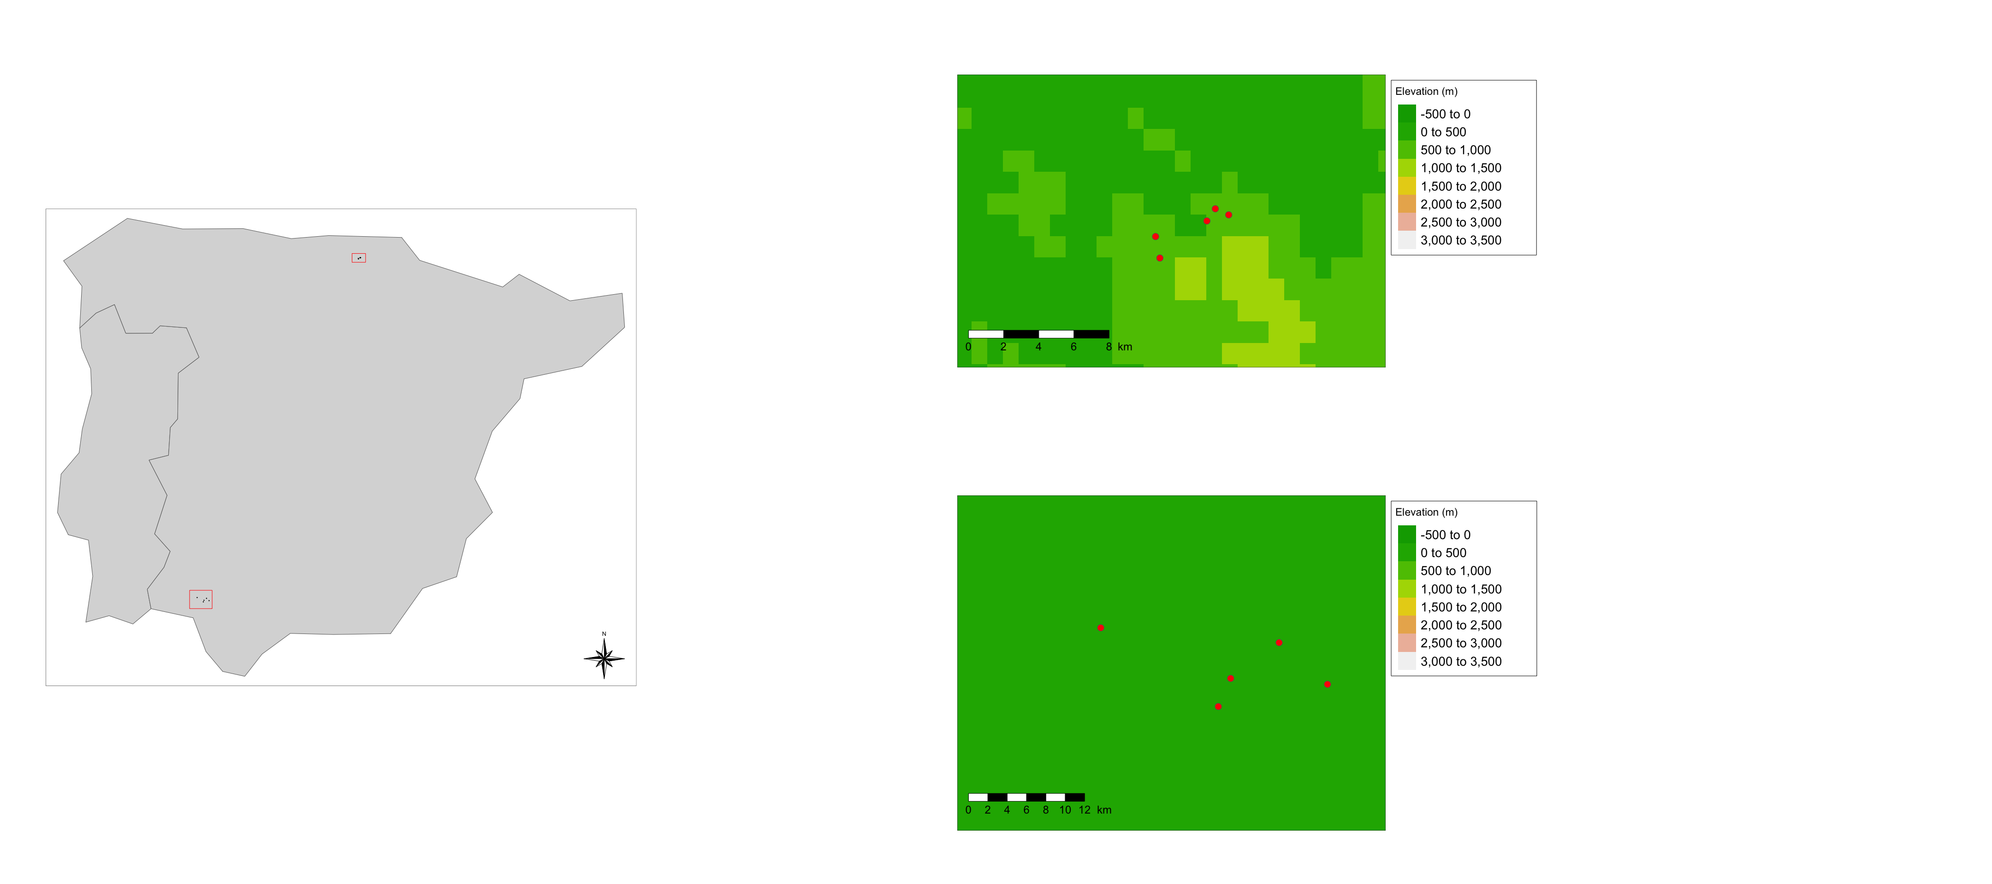
Figure S1. Location of our study areas and distribution of sites within them.
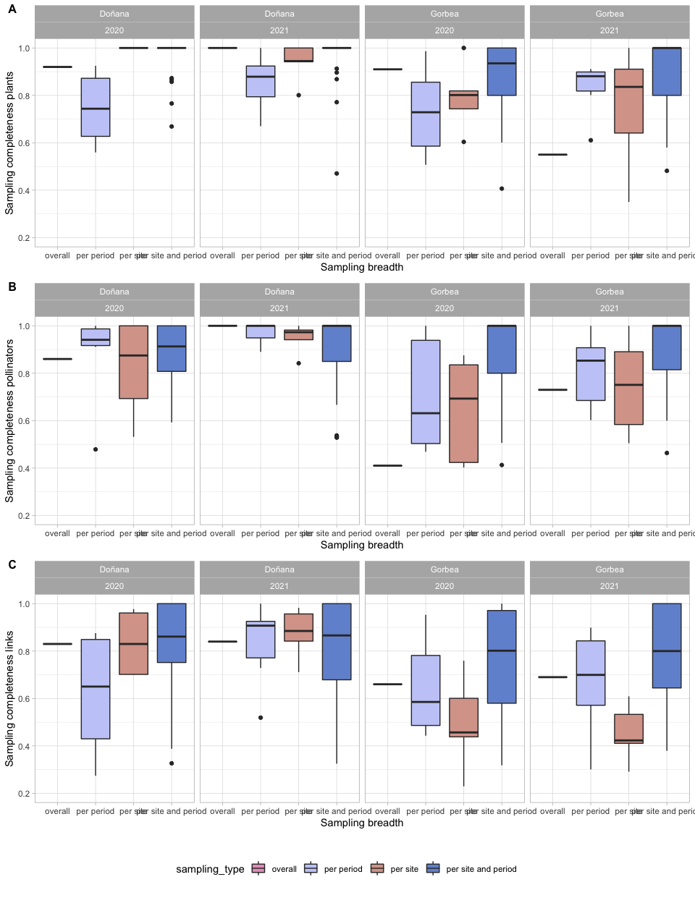
Figure S2. Boxplots showing sampling completeness for a) plant species, b) pollinator species and c) plant-pollinator links. Data used is subset of data that only includes interactions present across both study years. Different colors represent different ways in which data can be analyzed, pink shows overall sampling completeness calculated using all data collected, purple completeness for each of the time periods grouping all sites together, orange shows completeness for each of the different sites separately grouping data for the different periods of time in which each site is sampled and blue shows completeness for each individual sampling event, i.e., for each site at each period.

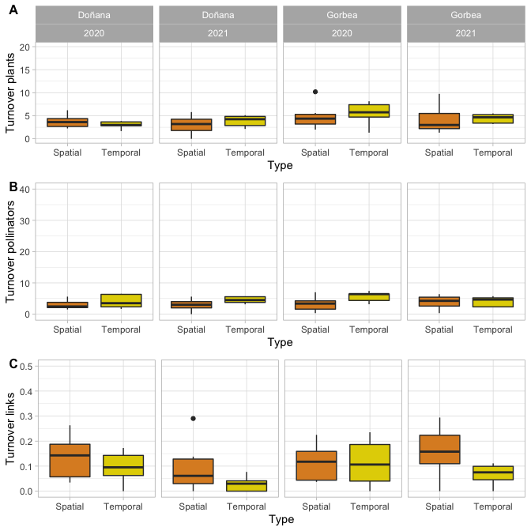
Figure S3. Boxplots showing spatial and temporal turnover for a) plant species, b) pollinator species and c) plant-pollinator links including plant and pollinator species that are common across periods or sites. Data used is subset of data that only includes interactions present across both study years.

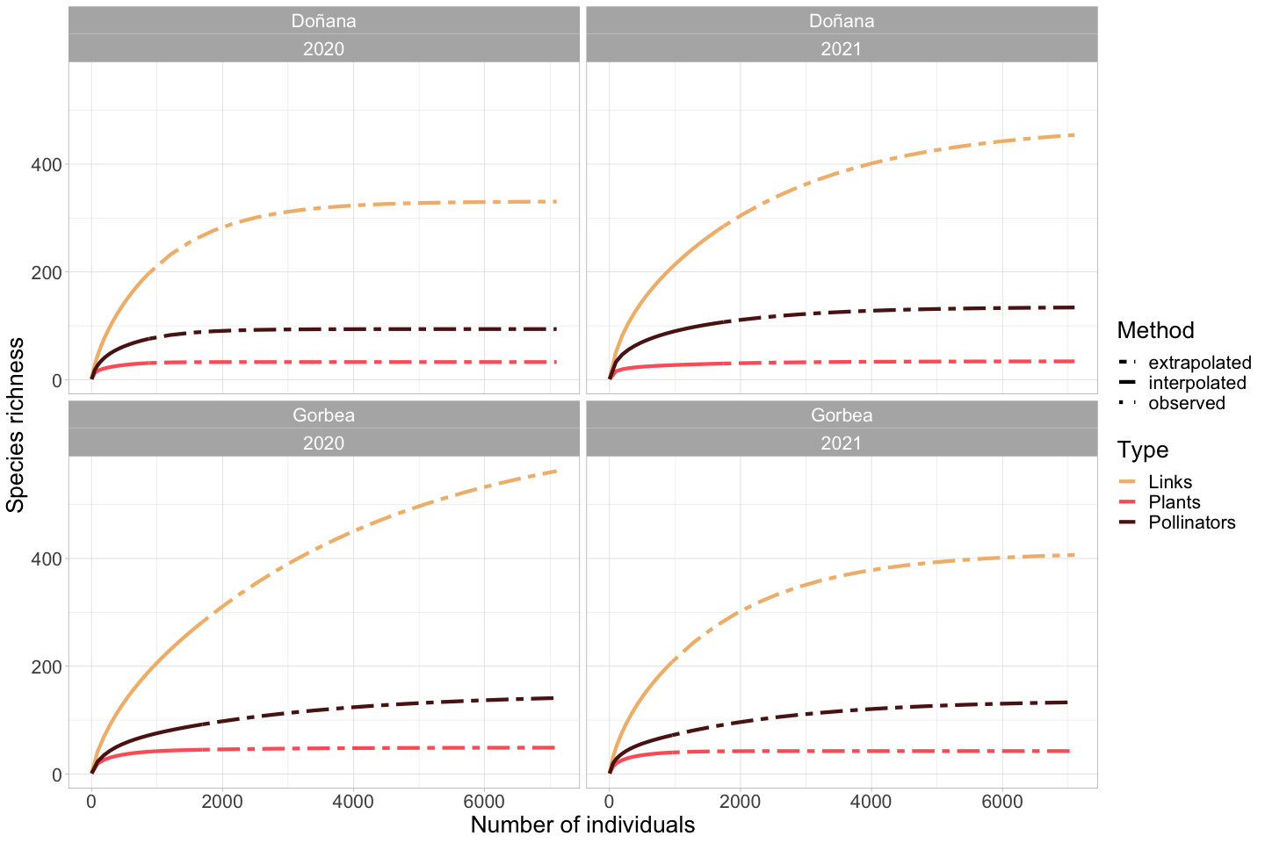
Fig. S4. Sampling completeness for links, plant and pollinator species for both study areas and years.
Table S1. Results of LMM analyzing spatial differences in A) complementary specialization (H2’) at the community level and B) species-level specialization (d’). Table shows Type II Wald chisquare tests. Data used is suubset of data including only interactions that are present across the two study years. Bold letters indicate variables whose confidence intervals do not overlap 0.
A) | Chisq | Df | Pr(>Chisq)
Site | 8.83 | 9 | 0.45
Plant sps | 0.01 | 1 | 0.91
Pollinator sps | 0.01 | 1 | 0.94

B) | Chisq | Df | Pr(>Chisq)
Site | 25.06 | 9 | 0.00
Plant sps | 0.57 | 1 | 0.45
Pollinator sps | 3.78 | 1 | 0.05

