Supplementary Information
Optospintronic Tunnel Junctions for Non-volatile Photonic Memories

Authors:
Luding Wang,^{1,2} Houyi Cheng,¹ Pingzhi Li,² Yang Liu,¹ Youri L. W. van Hees,² Reinoud Lavrijsen², Xiaoyang Lin,¹ Kaihua Cao,¹ Bert Koopmans,² and Weisheng Zhao¹

Affiliations:
¹Fert Beijing Institute, School of Integrated Circuit Science and Engineering, Beijing Advanced Innovation Center for Big Data and Brain Computing, Beihang University, 100191 Beijing, China
²Department of Applied Physics, Institute for Photonic Integration, Eindhoven University of Technology, P.O. Box 513, 5600 MB Eindhoven, The Netherland

* Author to whom correspondence should be addressed: weisheng.zhao@buaa.edu.cn

SUPPLEMENTARY NOTE 1:
Temperature dependence of magnetic characteristics of the OMTJ stack
To investigate the temperature dependence of the magnetic properties of the OMTJ stack, the magnetic moment versus external magnetic field (M-H) loops are measured at different temperature using the full-sheet sample, with the stack structure as shown in the main text. To compare the magnetic properties at different temperature, we use only one sample with a square shape for all the measurements. The diamagnetic background has been subtracted from the data at each temperature.
Supplementary Figure 1 shows the out-of-plane hysteresis loops measured by a VSM-SQUID (vibrating sample magnetometer - superconducting quantum interference device), at 250 K, 300 K, and 350 K, respectively. This temperature range is chosen because of the operation temperature (~ -20℃ - 80℃) for practical electronic device applications.
We observe that the strong RKKY coupling between the Gd/Co bilayer and the top CoFeB layer is withstood in such temperature range, which is evidenced by the sharp reversal process of the free layer (FL). The strong RKKY coupling in the free layer is crucial for our OMTJ performance. In addition, perpendicular magnetic anisotropy (PMA) exhibits in both of the FL and the reference layer (RL), as indicated by the squareness and high remanence of the hysteresis loops. These results indicate the feasibility of the OMTJ stack in a practical environment, highly promising towards future chip applications.
Supplementary Figure 2 shows the temperature dependence of the magnetic properties, which are extracted from the M-H hysteresis loops. The left axis in the bottom panel shows the saturation magnetization ($M_{s}$) of the full stack (black dots), whereas the left axis in the top panel shows the $M_{s}$ of the FL (red diamonds). A clear temperature dependence of $M_{s}$ is observed, enhancing upon lower temperature, as expected from the Bloch law. Note that although the Curie temperature of the bulk Gd is slightly lower than room temperature, it is enhanced at the Co interface due to the proximity induced effect, as showed in previous work¹⁻³.
The right axis of the bottom panel shows the temperature dependence of the antiferromagnetic coupling field ($μ_{0}H_{AFC}$) of the SAF layer (purple squares). Specifically, compared with $μ_{0}H_{AFC}$ = 175 mT at 350 K, it is enhanced to 230 mT at 250 K. The right axis of the top panel shows the coercive field ($μ_{0}H_{c}$) of the FL (blue triangles), which is also enhanced from 1.7 mT to 4.3 mT, corresponding to a 153% increase.
These results are in reasonable agreement with previous studies on CoFeB/MgO-based MTJ stacks⁴, demonstrating the feasible temperature range for our proof-of-concept OMTJ is at least ranging from -20℃ - 80℃.
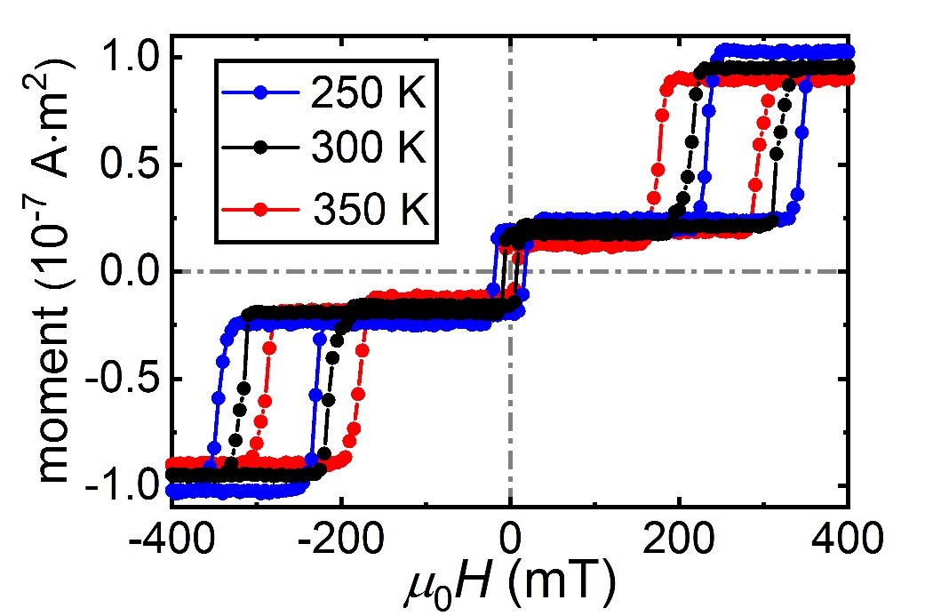
Supplementary Figure 1. Out-of-plane hysteresis loops of the OMTJ stack at different temperature. Magnetic moment versus an external perpendicular magnetic field (M-H) loops, measured at 250 K, 300 K, 350 K, respectively.
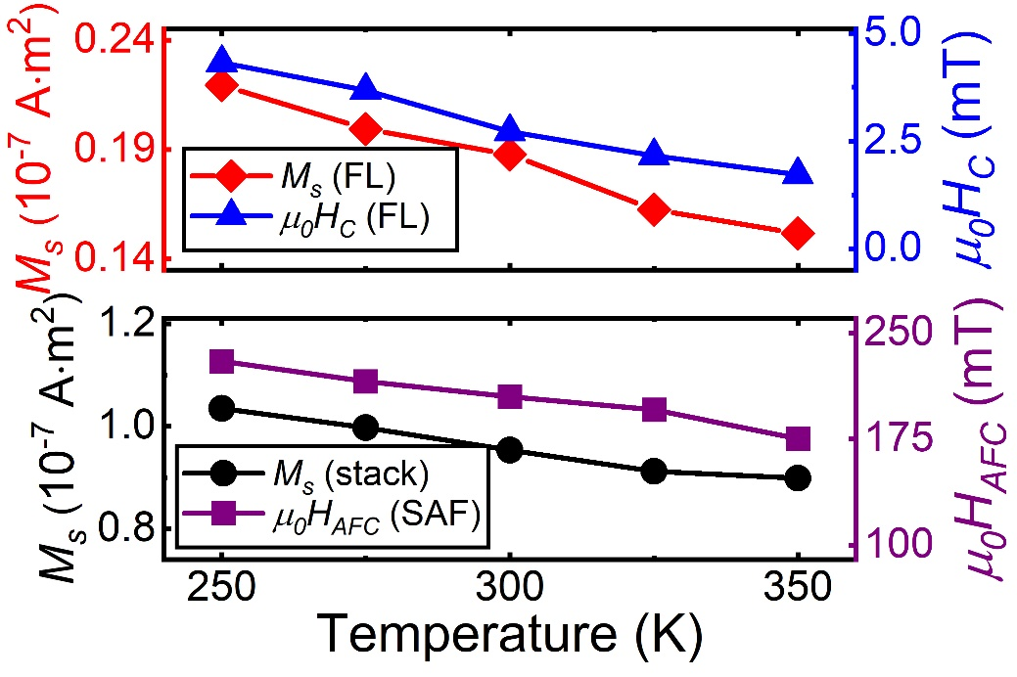
Supplementary Figure 2. Temperature dependence of the magnetic properties of the OMTJ stack. Bottom: Temperature dependence of the saturation magnetization ($M_{s}$) of the complete stack (left, black dots) and antiferromagnetic coupling field ($μ_{0}H_{AFC}$) (right, purple squares) ranging from 250 K to 350 K. Top: Temperature dependence of $M_{s}$ of the free layer (left, red diamond) and their coercive field ($μ_{0}H_{c}$) (right, blue triangles).

SUPPLEMENTARY NOTE 2:
Layer depth dependence of optical absorption
To investigate the optical absorption in the RKKY-coupled FL, we calculate the optical absorption in the OMTJ stack, using a transfer matrix calculation.
In the calculation, the configuration of the OMTJ is, from the laser incidence side downwards, Pt(2)/Gd(3)/Co(1)/Ta(0.3)/CoFeB(1)/MgO(1)/CoFeB(1.2)/Ta(0.3)/[Co/Pt]_{n}/Ru(0.8)/[Co/Pt]_{m}/Ta(0.7)/Ru(20)/Ta(3)/sub. (numbers in parentheses denote the layer nominal thicknesses in nanometer), in accordance with the stack we deposited by magnetron sputtering. Note that the full OMTJ stack including the thermally oxidized Si:SiO_{x} substrate are considered in the calculation.
The optical profile of the complete stack is shown in Supplementary Fig. 2. Results are calculated using the transfer matrix calculation⁵, by inputting the layer-specific refractive index values at 700 nm. These values are determined either from our measurements or from the literature⁶. The left axis indicates the absorption per depth (%/nm), as a function of layer depth. The absorption in the layer in then calculated by integrating over the thickness, as plotted in the Right axis.
One might expect that the relatively thick stack, with a Pt layer on top, would lead to a strong loss of optical energy, thus negligible laser-induced phenomena in the OMTJ. However, in our calculation, we observe that nearly 12% of the laser energy is absorbed by the complete FL. We found that this value is significantly enhanced due to the Si:SiO_{x} substrate, which acts as a reflective layer. The total absorption in the FL is consistent with previous studies using Gd/Co bilayers^{1,5}. Moreover, it has been proven that the AOS threshold fluence ($F_{0}$) is partially attributed to the effective optical absorption in the Gd/FM (FM: ferromagnetic) layer⁵. The increased optical absorption partially explains the enhanced $F_{0}$ of the OMTJ stack, which is only slightly lower than more conventional AOS systems^{1,7}.

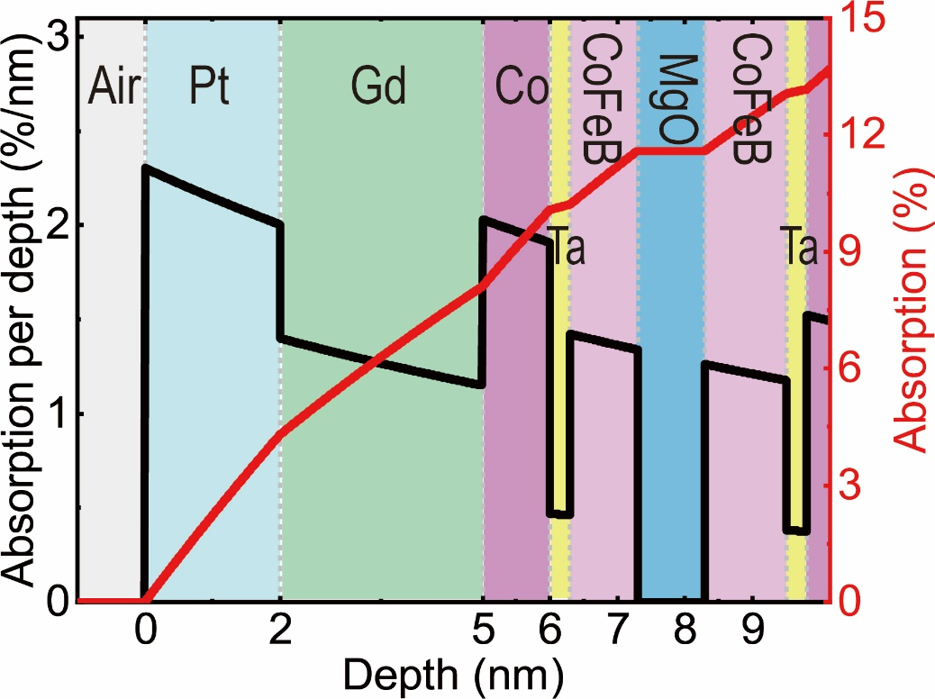
Supplementary Figure 2. Calculation of optical absorption profile of the OMTJ stack used in this work, from the laser incidence side downwards, Pt(2)/Gd(3)/Co(1)/Ta(0.3)/CoFeB (1)/MgO(1)/CoFeB (1.2)/Ta(0.3)/[Co/Pt]_{n}/Ru(0.8)/[Co/Pt]_{m}/Ta(0.7)/Ru(20)/Ta(3)/sub. (numbers in parentheses denote the layer nominal thicknesses in nanometer). The full stack structure as well as the thermally oxidized Si:SiO₂ substrate are included in the calculation. Left: Optical absorption per depth (%/nm) vs. Layer Depth;

SUPPLEMENTARY REFERENCES
¹Lalieu, M. L., Peeters, M. J., Haenen, S. R., Lavrijsen, R. & Koopmans, B. Deterministic all-optical switching of synthetic ferrimagnets using single femtosecond laser pulses. Phys. Rev. B 96, 220411 (2017).
²Beens, M., Lalieu, M. L., Deenen, A. J., Duine, R. A. & Koopmans, B. Comparing all-optical switching in synthetic ferrimagnetic multilayers and alloys. Phys. Rev. B 100, 220409 (2019).
³Gerlach, S. et al. Modeling ultrafast all-optical switching in synthetic ferrimagnets. Phys. Rev. B 95, 224435 (2017).
⁴Cao, K. et al. Low-Temperature Performance of Nanoscale Perpendicular Magnetic Tunnel Junctions with Double MgO-Interface Free Layer. IEEE Trans. Magn. 55, 3400304 (2019).
⁵van Hees, Y. L., van de Meugheuvel, P., Koopmans, B. & Lavrijsen, R. Deterministic all-optical magnetization writing facilitated by nonlocal transfer of spin angular momentum. Nat. Commun. 11, 3835 (2020).
⁶Filmetrics refractive index database, [Online, accessed January 9th 2020].
⁷Radu, I. et al. Transient ferromagnetic-like state mediating ultrafast reversal of antiferromagnetically coupled spins. Nature 472, 205 (2011).

