RESULTS
This prospective study was conducted to study the effects of food habits on pregnancy outcome . This prospective study was conducted in the Department of Obstetrics and Gynecology, Voluntary Health services, Multi-specialty Hospital and Research Institute, Chennai. The study was carried out between January 2013- July2014. From the antenatal clinic, 350 women who satisfied the inclusion and exclusion criteria were admitted to the study.

Characteristics of the women in the study

Age distribution
Age distribution of women who participated in this study is shown in the table 1.
AGE (YRS) | TOTAL NOS ( % )
15-20 | 30 (8 )
21-25 | 165 (47 )
26-30 | 140 (40)
31-35 | 15 (5)
TOTAL | 350

From the above table it is seen that the maximum number of pregnant women belonged to the age group of 21-25 yrs (47%) followed by the 26-30 yrs age group (40%).The number of teenage pregnancies was 30 (8%) whereas 5% of pregnant women belong the age group of 31-35 yrs.
Parity
Half of the pregnant women (50%) in the study group were primigravidas and (43.5%) were second gravidas . In this study, 6 % and 0.5 % of pregnant women were third and fourth gravidas respectively.

Socio economic status

The socio economic status of the respondents as per Kuppuswamy’s classification Table: 2 Socio economic statuses of the pregnant women

INCOME GROUP | TOTAL NOS (%)
LOWER | 290 (83)
UPPER LOWER | 50 (14)
MIDDLE LOWER | 10 (3)
TOTAL NOS | 350

It is seen from the above table that 83% of the study population belonged to the low socioeconomic class .14 % and 3 % of the study population belonged to the upper lower and middle lower socioeconomic class respectively . Majority of women in this study belong to low socioeconomic class this institute provides medical care especially to the patients belonging to the lower socioeconomic class on par with the upper socioeconomic class patients .

Prepregnancy B.M.I
Figure 1 : Prepregnancy B.M.I (kg/m²) OF PREGNANT WOMEN
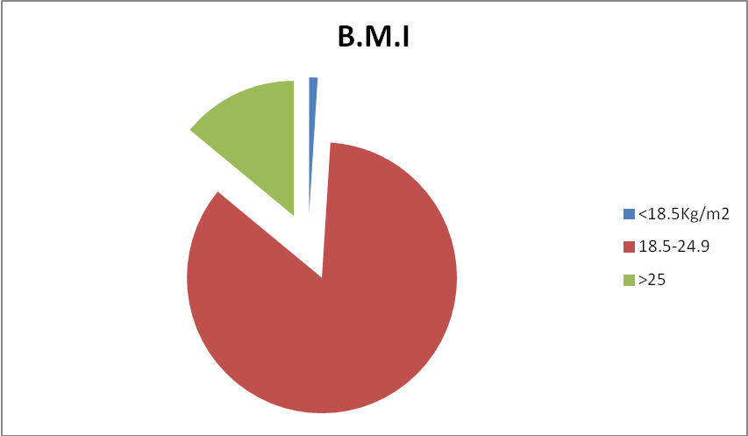

Food habits of pregnant mothers
Depending upon the B.M.I, the mothers in this study were divided into three major groups .The food items specifically consumed by the pregnant women who participated in this study is shown in the tables below.
Table 3 : Food items specifically consumed by the mothers belonging to different B.M.I groups
FOOD ITEMS | B.M.I  <18.5 kg/m²  % of mothers | 18.5-24.9 | >25
Rice | 85 | 95 | 90
Milk | 75 | 68 | 54
Idly | 80 | 85 | 70
Rassam | 25 | 17 | 40
Apple | 50 | 47 | 56
Papaya | 00 | 00 | 00
Banana | 75 | 44 | 40
Eggs | 50 | 51 | 60
Dates | 50 | 50 | 60
Mutton soups | 00 | 17 | 40

The above table shows the food habits of participant mothers belonging to different B.M.I groups. In all the three groups the mothers have added the nutritious food items in their diet.
In the mothers with low B.M.I , milk and banana was added by 75% of mothers followed by apple and dates by 50% of mothers.
In the mothers with B.M.I within normal range, milk was added by 68% of mothers followed by apples ( 47 %), dates( 50%) and bananas(44%). Eggs were added by 51% mothers in their diet.
In the mothers with B.M.I >25 kg/m², 54 % of mothers added milk followed by eggs (60%),dates (60%) and apples by 56% of mothers

Association between the socioeconomic status and calorie intake
The association between the socioeconomic status and calorie intake of the mothers is shown in the table 4

TABLE 4 : SOCIOECONOMIC SATUS AND CALORIE INTAKE
SES | Visit1  Calories (kcal/kg) | Visit2 | VIsit3 | Visit4
LIG | 1991.2 | 2063.1 | 2134.4 | 2139.1
MIG | 2036.0 | 2132.2 | 2171.0 | 2179.4
P - Value | 0.136 | 0.023 | 0.144 | 0.006

The above table 4, shows the association between the calorie intake and socioeconomic status . As shown in the above table, there is a significant association between the socio-economic status of the mother and the calorie intake .

CALORIE INTAKE

The average calorie intake of the mothers belonging to different groups during each visit is shown in table 5

B.M.I (kg/m²⁾ | CALORIES (kcal/day)
B.M.I (kg/m²⁾ | 14-16 wks | 24-26 wks | 28-30 wks | 32-36 wks
<18.5 | 1640 | 1750 | 2125 | 1950
18.5-24.9 | 1800 | 2000 | 2150 | 2100
>25 | 1900 | 1950 | 2050 | 2000

The above table shows us the average calorie intake of the mothers belonging to different B.M.I groups. The highest calorie intake during the first visit (1900 kcal/day) was seen in the mothers belonging to the >25 kg/m² B.M.I group, whereas the least calorie intake during the first visit (1640 kcal/day) was seen in the mothers with B.M.I <18.5 kg/m² .In the mothers belonging to B.M.I within normal range (18.5-24.9 kg/m²) the calorie intake during the first visit was 1800 kcal/day.
In all the three groups there has been a fall in calorie intake during the last visit as compared to the calorie intake in the third visit. The maximum fall in calorie intake was seen in the mothers with B.M.I <18.5 kg/m² (1950kcal/day). The calorie intake in the mothers with B.M.I within normal range and mothers with B.M.I >25 kg/m² was reduced to 2100 kcal/day and 2000 kcal/day respectively.
Mode of delivery of participant mothers
Maximum number of women (65%) had a normal delivery. About 30% of women underwent a cesarean section. Only 5% of the pregnant women underwent an instrumental delivery .
Birth weight

The above tables shows the birth weight of the babies in the present study . Majority of the babies (66%) had the birth weight in the range of 2.5-2.9 kgs .29 % of babies had birth weight in the range of 3-3.5 kgs .5% of babies had birth weight in the range of 2-2.49 kgs.
Association between the parity and calorie intake
TABLE 6: PARITY AND CALORIE INTAKE

Parity code | Visit1  calories | Visit2 | VIsit3 | Visit4
P1 | 1990.3 | 2060.3 | 2127.0 | 2139.1
P2 | 2002.6 | 2084.6 | 2146.2 | 2145.0
P3 | 2050.0 | 2113.2 | 2200.0 | 2206.3
P4 | 1900.0 | 2010.0 | 2140.0 | 2110.0
P - Value | 0.050 | 0.297 | 0.035 | 0.335

Above table shows the association between parity and the calorie intake of the pregnant women. As per the statistical analysis, there is a significant association between parity and calorie intake during the pregnancy. There is a declining trend in the calorie intake especially in multiparous mothers .

CALORIE INTAKE AND BIRTH WEIGHT

The association between the calorie intake and birth weight of the baby is shown in the table 7
Table 7: calorie intake and birth weight
Wt (kg) | Visit1 | Visit2 | VIsit3 | Visit4
2-2.49 | 1663.6 | 1795.5 | 1913.6 | 1900.0
2.5-2.99 | 1968.2 | 2025.6 | 2117.9 | 2115.8
3-3.49 | 2051.4 | 2140.2 | 2183.1 | 2197.6
≥3.5 | 2018.8 | 2106.3 | 2122.9 | 2129.2
P - Value | 0.000 | 0.000 | 0.000 | 0.000

Above table shows the association between the calorie intake of pregnant mother and weight of the baby at birth. As shown in the above table, there is a very significant association between the calorie intake of the mother and birth weight of the baby. Proper calorie intake of the mother has a positive impact on the baby weight.

CALORIE INTAKE AND NICU ADMISSION
In the present study 3 babies had NICU admission for the fetal distress.
The association between the calorie intake of the mother and need for NICU admission for fetal distress is shown in the table 8.
Table 8: Association between the calorie intake and NICU admission at birth
NICU | Visit1 | Visit2 | VIsit3 | Visit4
Yes | 1987.5 | 2100.0 | 2060.0 | 2097.5
No | 1997.9 | 2072.9 | 2140.7 | 2145.6
P - Value | 0.188 | 0.392 | 0.046 | 0.000

Table 8 shows the association between the calorie intake and the (NICU) Neonatal intensive care unit admission at birth for fetal distress.

Condition at discharge
All the mothers who participated in this study were discharged on third day in case of a normal delivery and on eighth day in case of a cesarean section.
All the babies including those admitted in NICU were discharged on day 3 after checking their bilirubin levels.
There was no case of neonatal death, postnatal complications like puerperal sepsis and anemia in this study .

