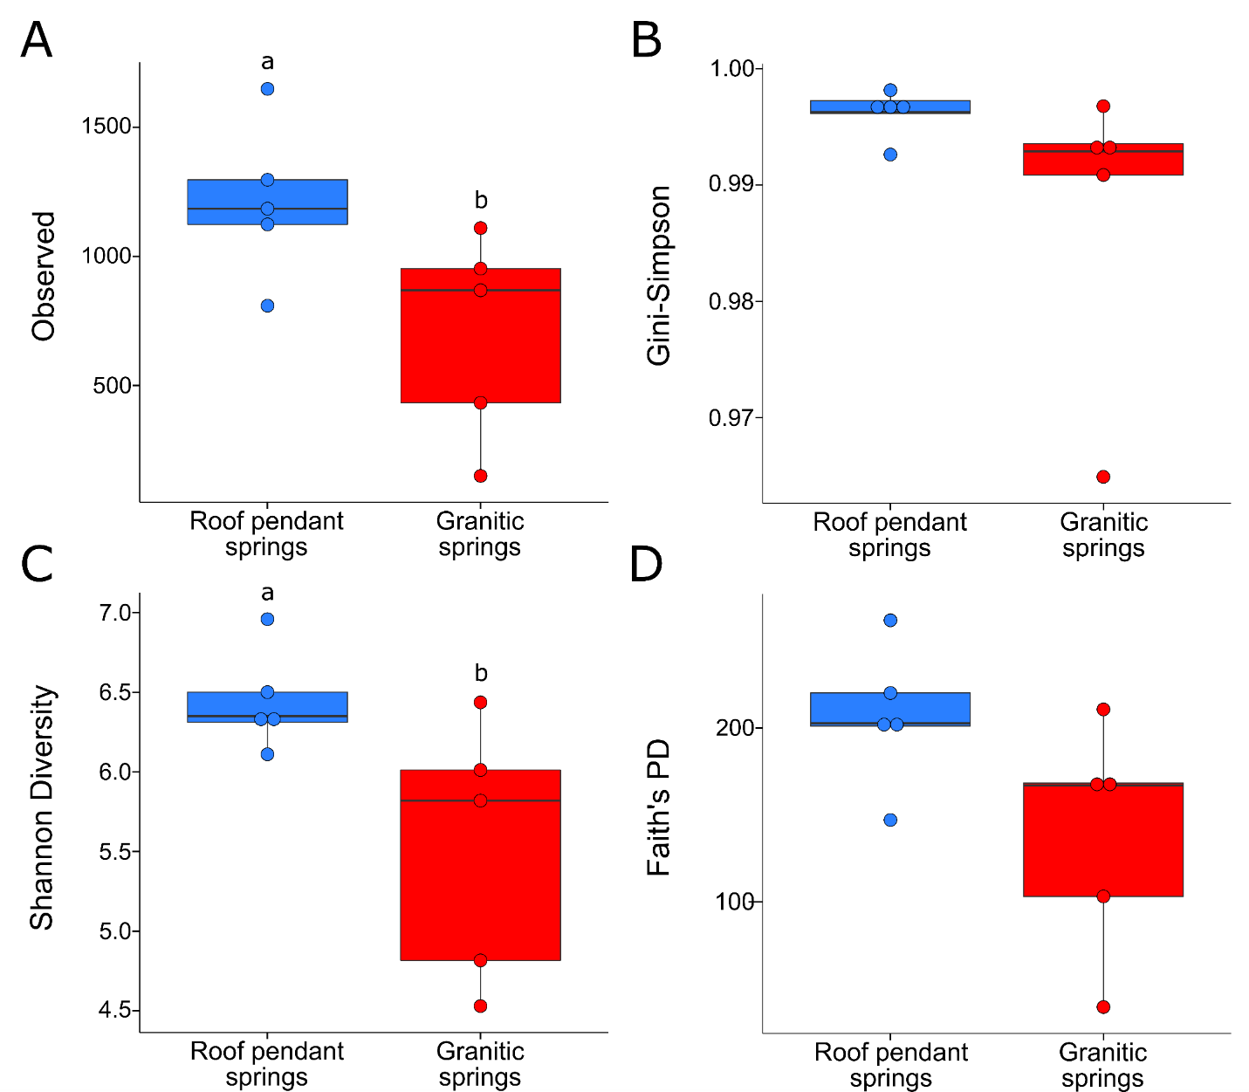
Supplementary Figure 1. Alpha-diversity metrics for water microbial samples. Boxplots of A) Observed sequence variants, B) Gini-Simpson Index, C) Shannon Index and D) Faith’s phylogenetic diversity (Faith’s PD) values for water microbial communities. All boxes are colored according to hydrogeochemical grouping: roof pendant springs (blue) and granitic springs (red). IQRs, medians, and points are represented on the plots as previously described in Figure 3. No significant differences were observed between the hydrogeochemical groups for richness or diversity.

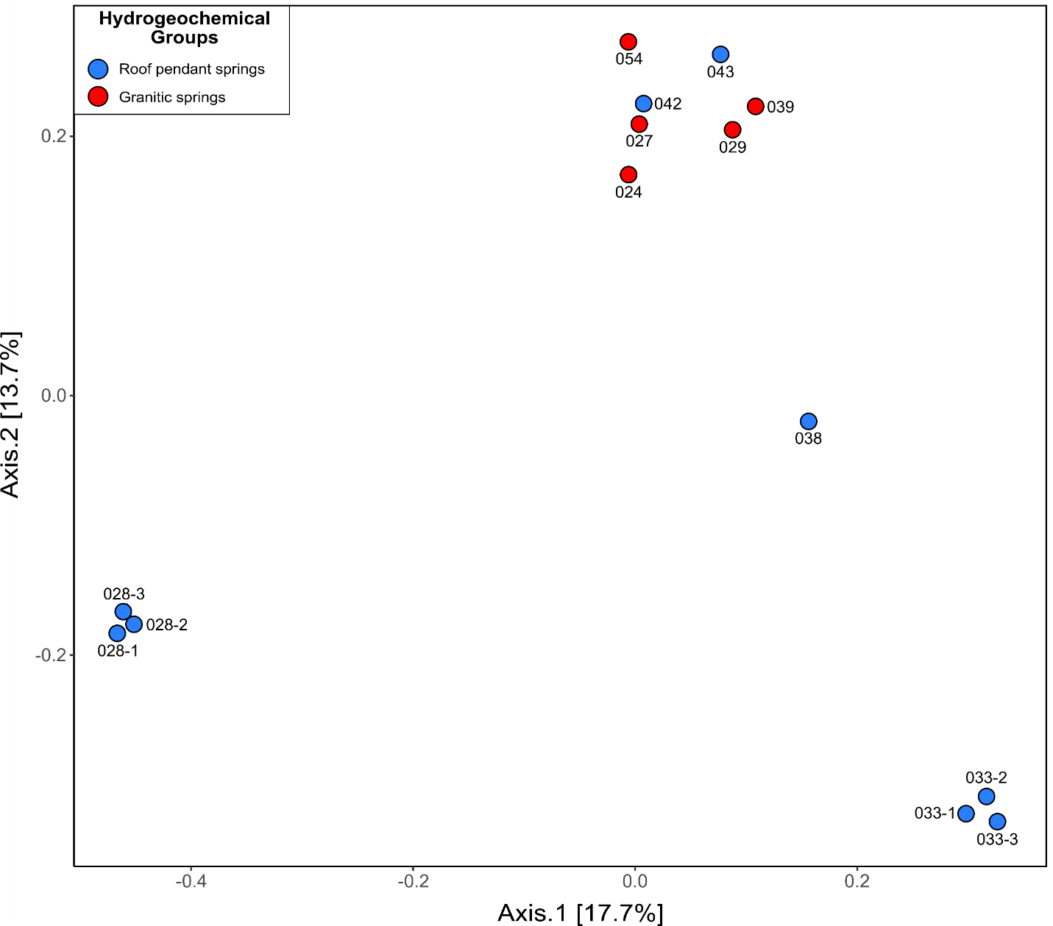
Supplementary Figure 2. Principal coordinates analysis (PCoA) by hydrogeochemical grouping for unaveraged water microbial samples. PCoA ordination of Bray-Curtis dissimilarity between ten springs for water microbial samples. Each point on the plot represents one sample; replicate samples for Grover Anton Spring (028) and Elderberry Canyon Spring (033) were left unmerged on this plot and cluster closely together. Points have been colored by hydrogeochemical grouping: roof pendant springs (blue) and granitic springs (red). The influence of hydrogeochemical grouping on β-diversity was found to be significant via ANOSIM (R = 0.29, p-value = 0.042).

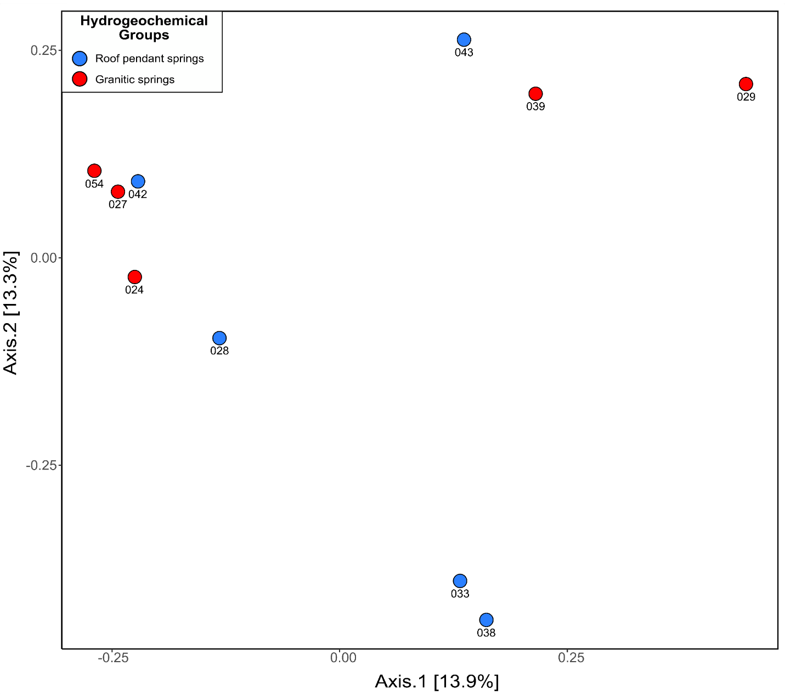
Supplementary Figure 3. Principal coordinates analysis (PCoA) by hydrogeochemical grouping for averaged water microbial samples. PCoA ordination of Bray-Curtis dissimilarity between ten study springs for water microbial samples. Each point on the plot represents one sample; replicate samples for Grover Anton Spring (028) and Elderberry Canyon Spring (033) were averaged together for this plot. Points have been colored by hydrogeochemical grouping: roof pendant springs (blue) and granitic springs (red). The influence of hydrogeochemical grouping on β-diversity was found to be non-significant via ANOSIM (R = 0.16, p-value = 0.08).

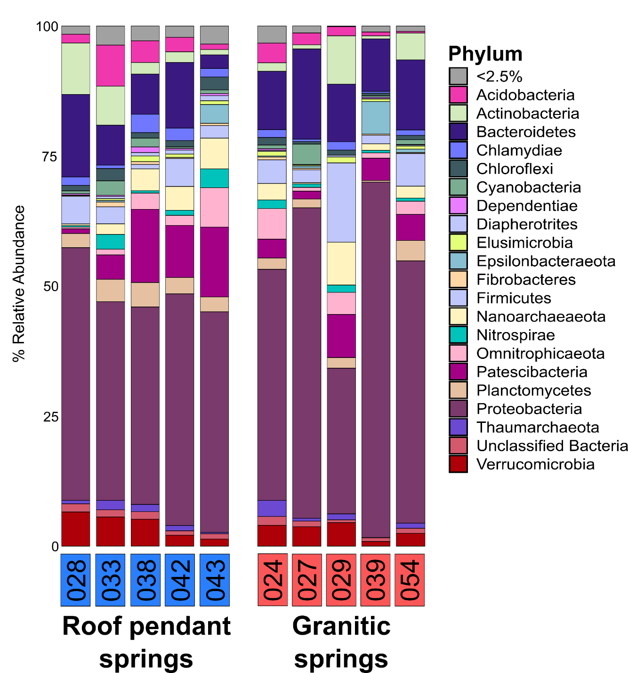
Supplementary Figure 4. Water microbe phylum-level community composition. Phylum-level relative abundance bar plot representing the of taxa in only water samples. Any taxa calculated to be <2.5% across the dataset were agglomerated and plotted as such. Taxonomic classification was determined using the SILVA database (version 132).

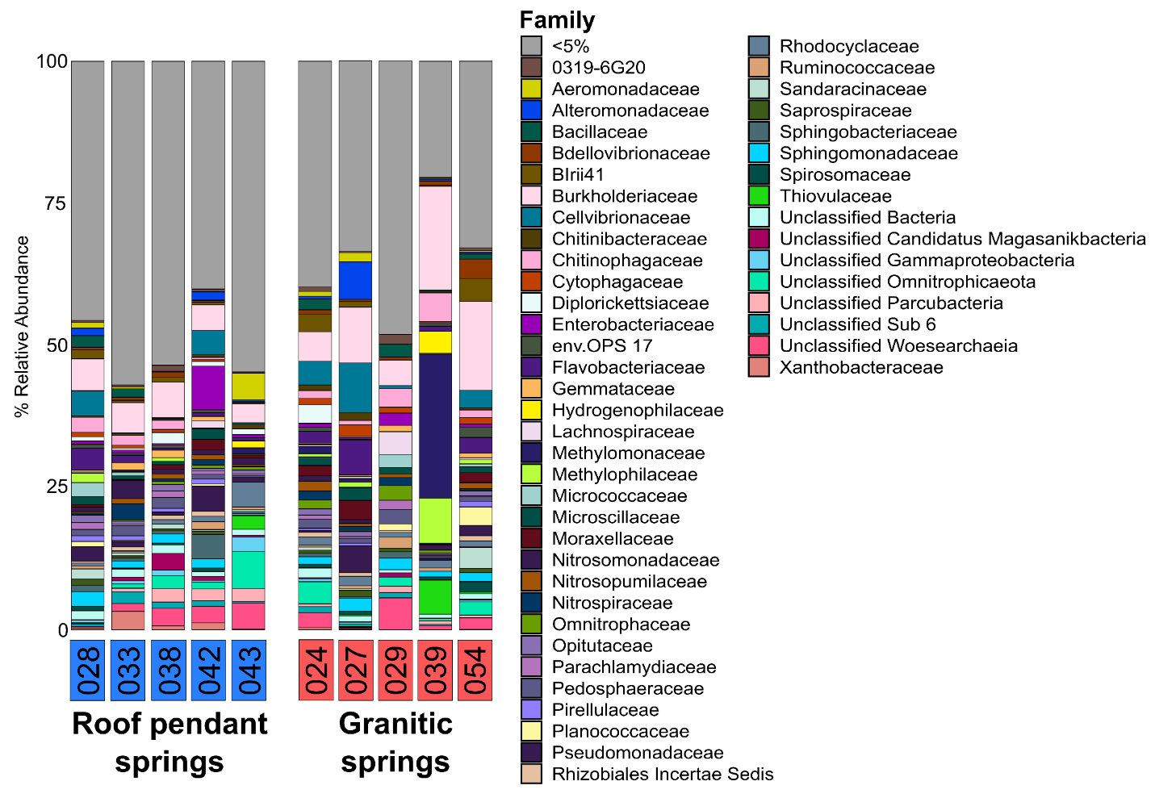
Supplementary Figure 5. Water microbe family-level community composition. Family-level relative abundance bar plot representing the of taxa in only water samples. Any taxa calculated to be <5% across the dataset were agglomerated and plotted as such. Taxonomic classification was determined using the SILVA database (version 132).

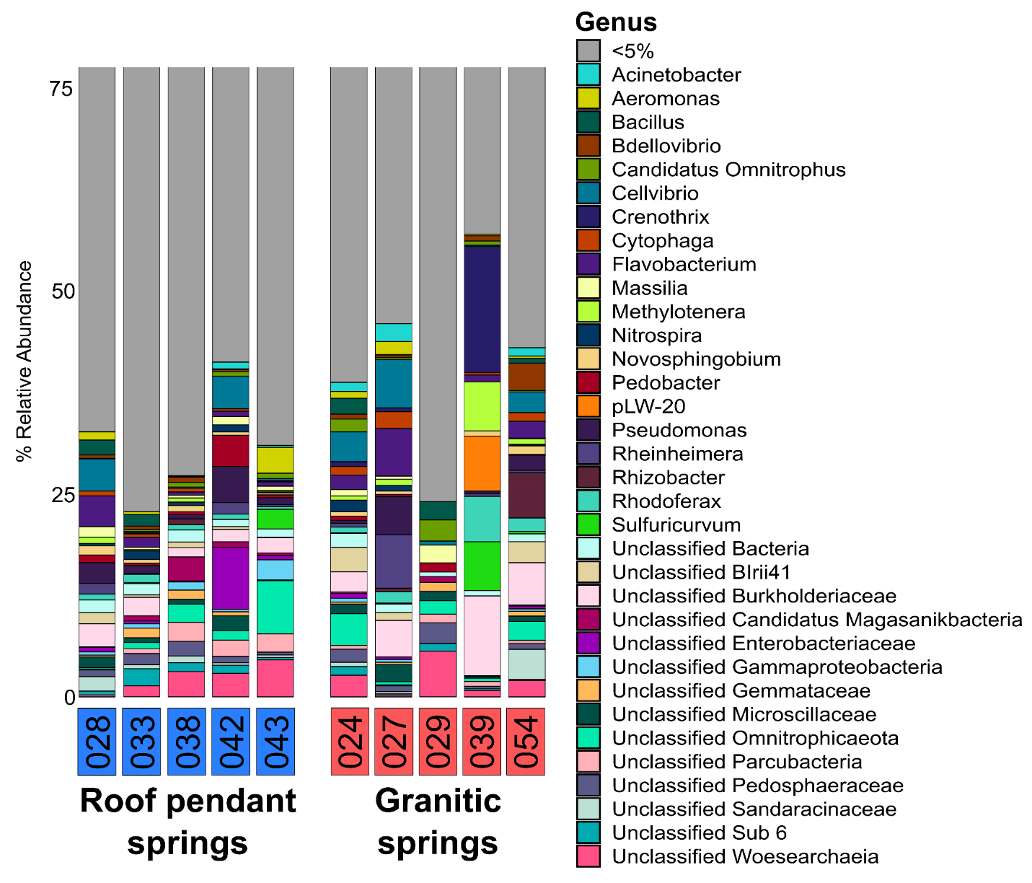
Supplementary Figure 6. Water microbe genus-level community composition. Genus-level relative abundance bar plot (75% cut-off) representing the of taxa in only water samples. Any taxa calculated to be <5% across the dataset were agglomerated and plotted as such. Taxonomic classification was determined using the SILVA database (version 132).

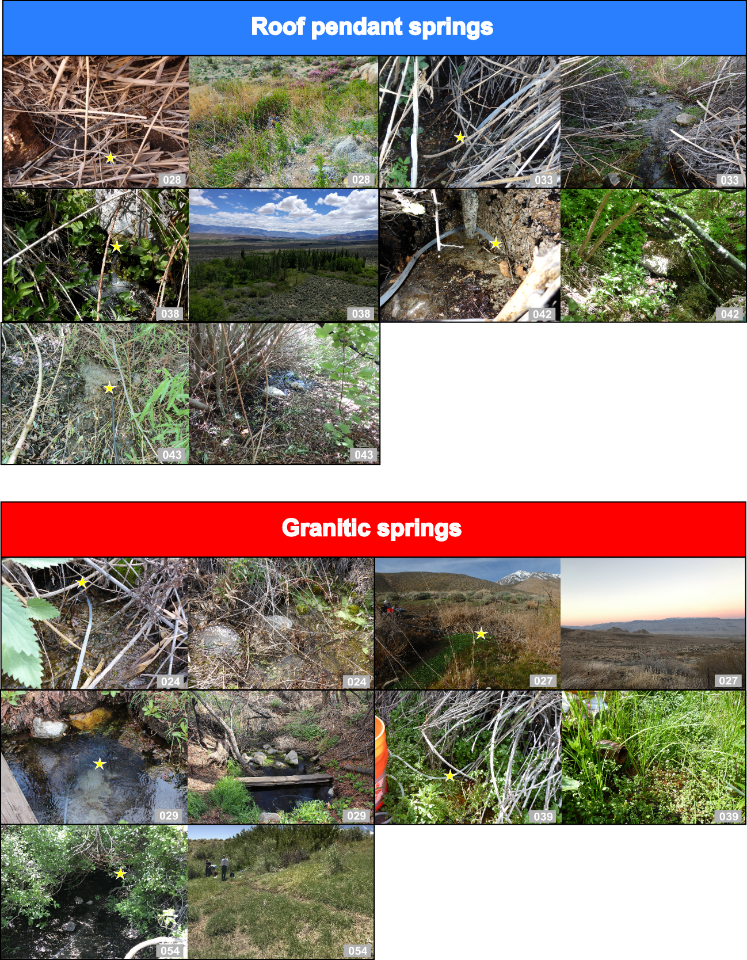
Supplementary Figure 7. Spring photos. Photo compilation of the ten study springs, photos have been arranged according to the hydrogeochemical grouping. Photos of the pumping location (at/as close to the source as possible) for each spring are shown and marked with a yellow star. Additionally, spring setting or landscape setting photos are included to provide further context for the springs. The majority of photos shown in this figure were taken at the time of sampling. The exception being two photos: the source photo for Grover Anton Spring (IES028) and the landscape setting photo for Boron Spring A (IES027), which were instead from a sampling campaign in March 2017.
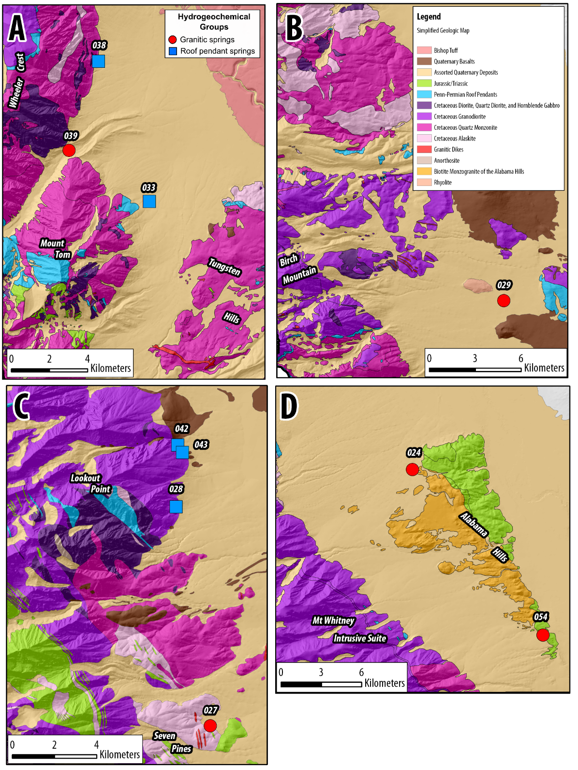
Supplementary Figure 8. Geological setting of springs. A simplified geologic map depicting major geological units modified from Meyers et al., 2022. Each spring has been marked using a colored shape that corresponds to the hydrogeochemical groupings: roof pendant springs (blue square) and granitic springs (red circle). This study area map is sectioned into four quadrants or geological areas of interest (AOI). The four AOIs are as follows: (A) Bishop, CA; (B) Big Pine, CA; (C) Independence, CA; and (D) Alabama Hills, west of Lone Pine, CA.
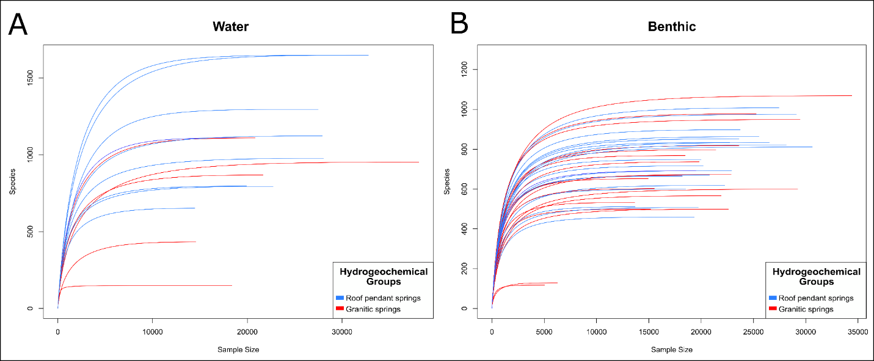
Supplementary Figure 9. Rarefaction curves for water and benthic samples. Rarefaction curve comparing the number of total observed species (Species) to the number of reads in each sample (Sample Size). Samples are colored corresponding to hydrogeochemical grouping: roof pendant springs (blue) and granitic spring (red).

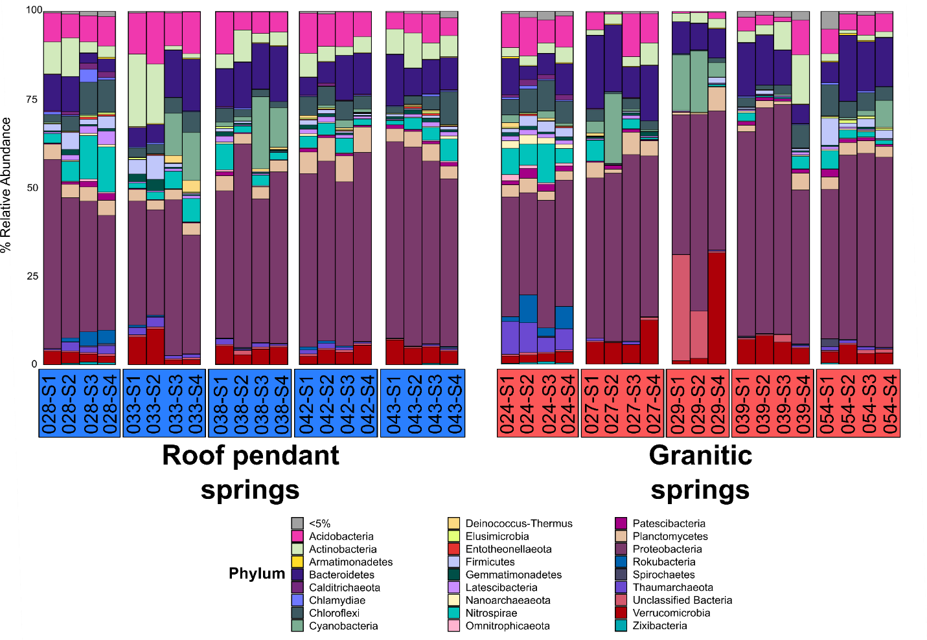
Supplementary Figure 10. Benthic microbe phylum-level community composition. Phylum-level relative abundance bar plot representing the of taxa in only sediment samples. Any taxa calculated to be <5% across the dataset were agglomerated and plotted as such. Taxonomic classification was determined using the SILVA database (version 132).

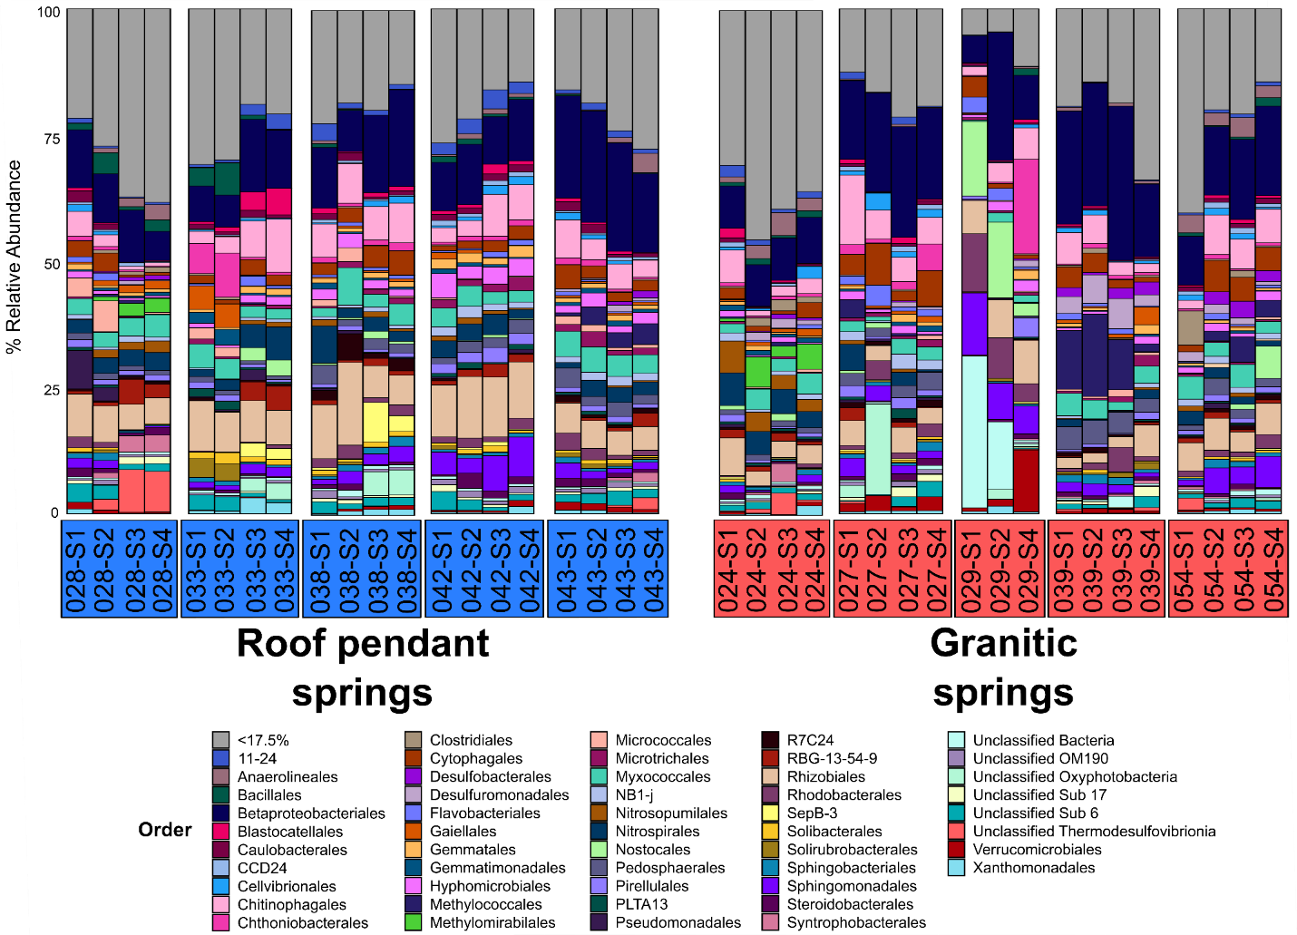
Supplementary Figure 11. Benthic microbe order-level community composition. Order-level relative abundance bar plot representing only benthic samples. Any taxa calculated to be <17.5% across the dataset were agglomerated and plotted as such. Taxonomic classification was determined using the SILVA database (version 132).

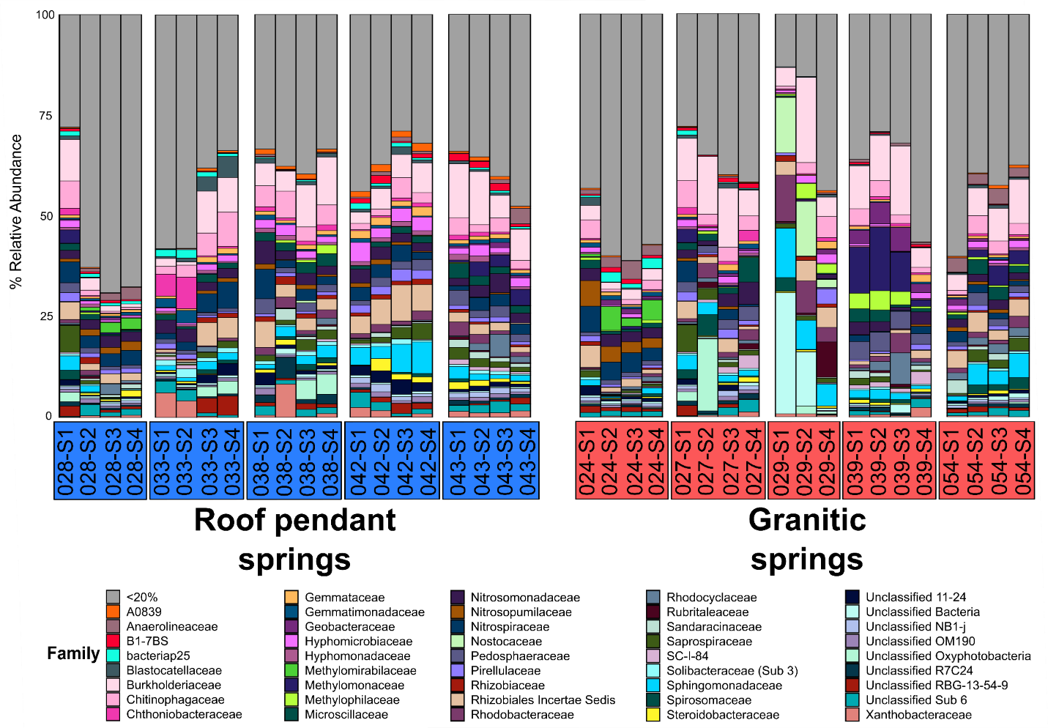
Supplementary Figure 12. Benthic microbe family-level community composition. Family-level relative abundance bar plot representing only benthic samples. Any taxa calculated to be <20% across the dataset were agglomerated and plotted as such. Taxonomic classification was determined using the SILVA database (version 132).

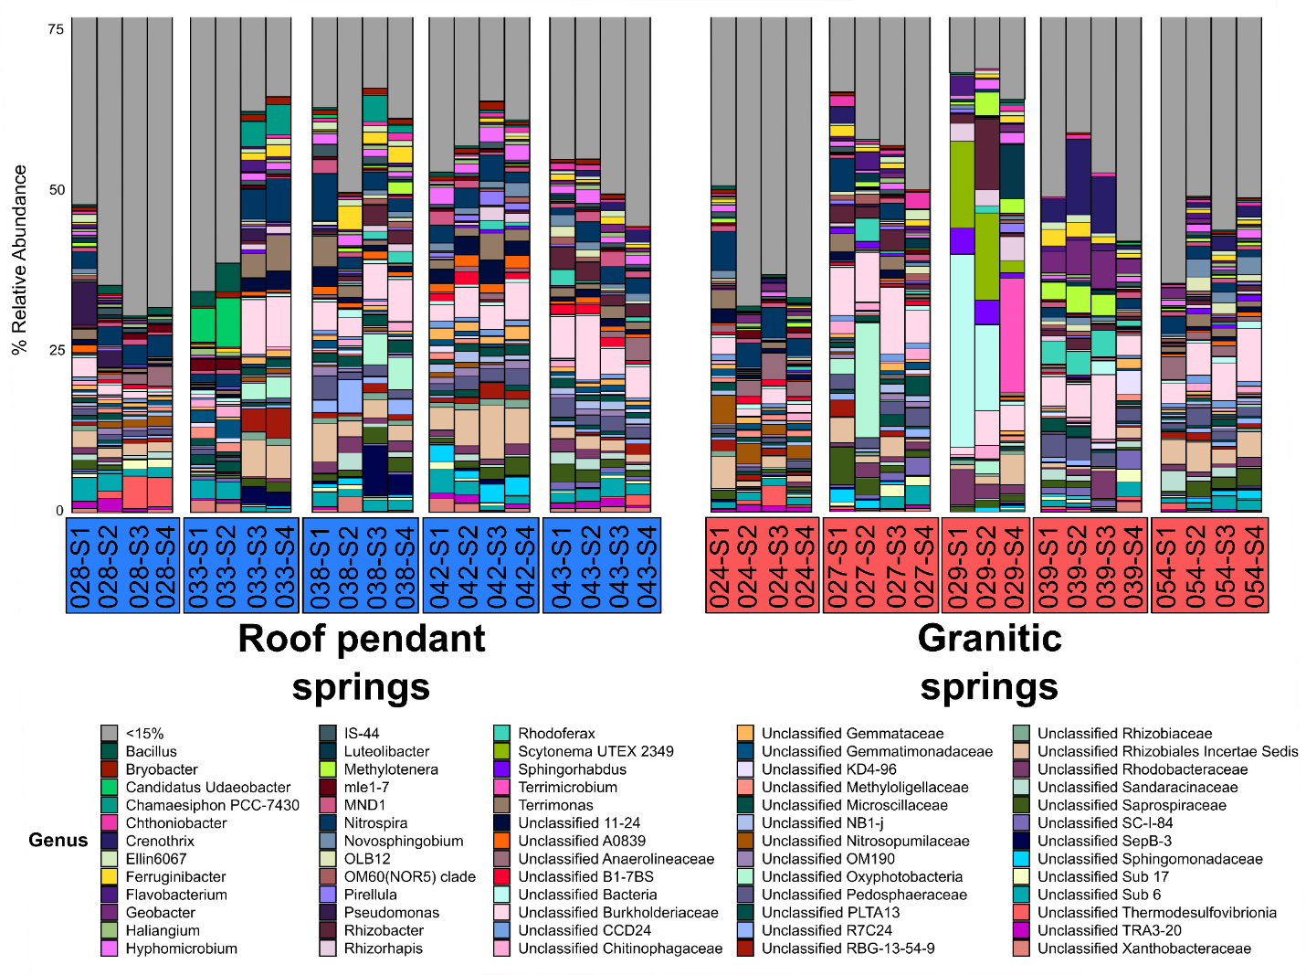
Supplementary Figure 13. Benthic microbe genus-level community composition. Genus-level relative abundance bar plot (75% cut-off) representing only benthic samples. Any taxa calculated to be <15% across the dataset were agglomerated and plotted as such. Taxonomic classification was determined using the SILVA database (version 132).

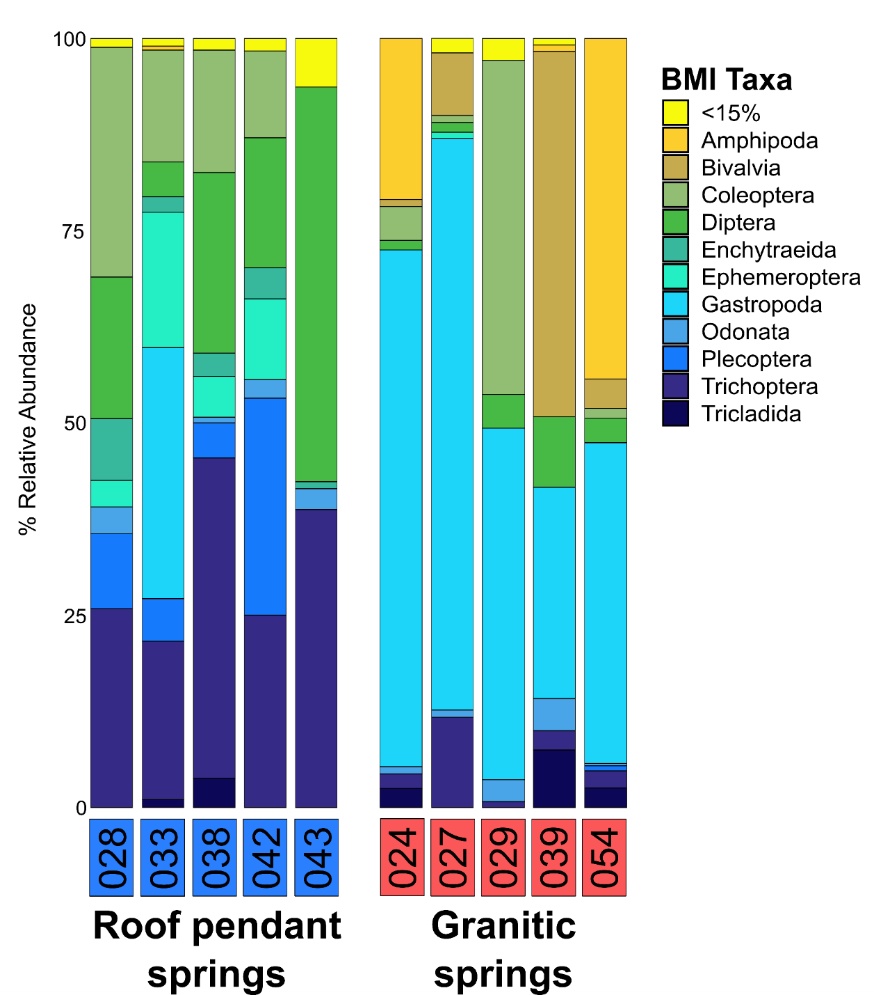Supplementary Figure 14. Benthic macroinvertebrate class- and order-level community composition. Class- and order-level relative abundance bar plot of major BMI taxa. Any taxa calculated to be <15% across the dataset were agglomerated and plotted as such.

