Supplementary figures and legends
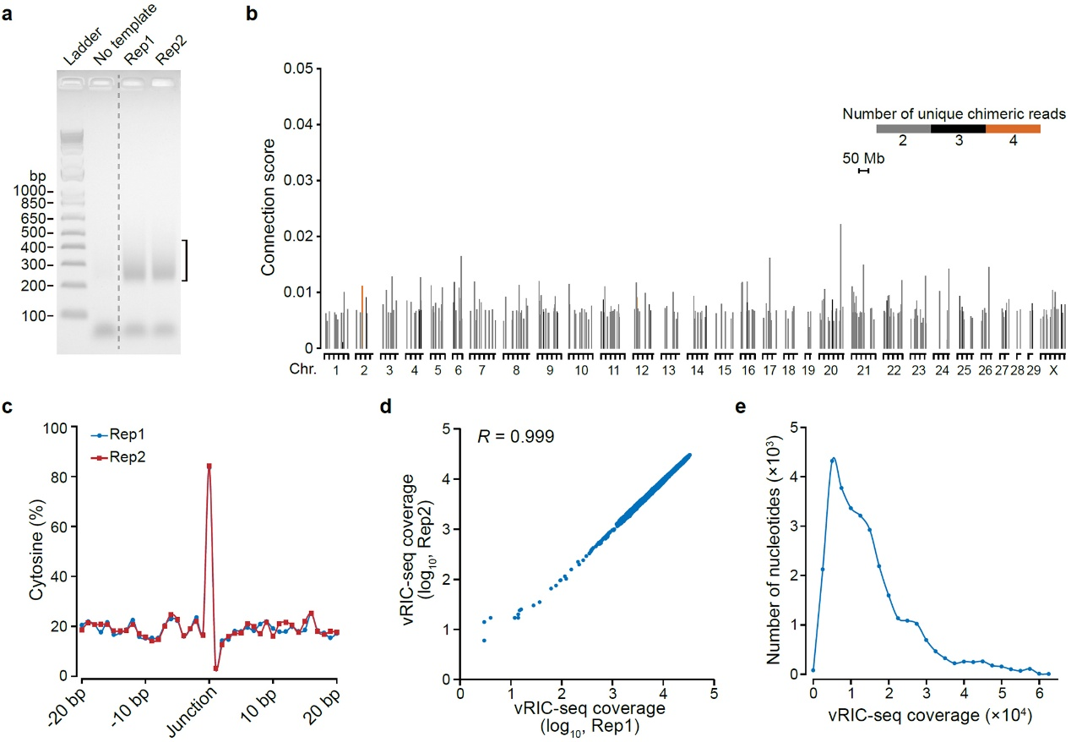
Supplementary Fig. 1 | Characterization of vRIC-seq technology. a, The PCR products were purified from the agarose gel (the bracketed region) for paired-end sequencing. b, The chromosomal location of host RNA fragments ligated to viral RNA. The color scale indicates the number of unique chimeric reads supporting each interaction. Chr represents the chromosome. c, The percentages of cytosine around the junction of chimeric reads. d, Scatter plot showing the correlation for coverage of chimeric reads along the SARS-CoV-2 genome in two biological replicates (Rep1 and Rep2). R, Pearson correlation coefficient. e, The coverage of chimeric reads for each nucleotide of the SARS-CoV-2 genome.

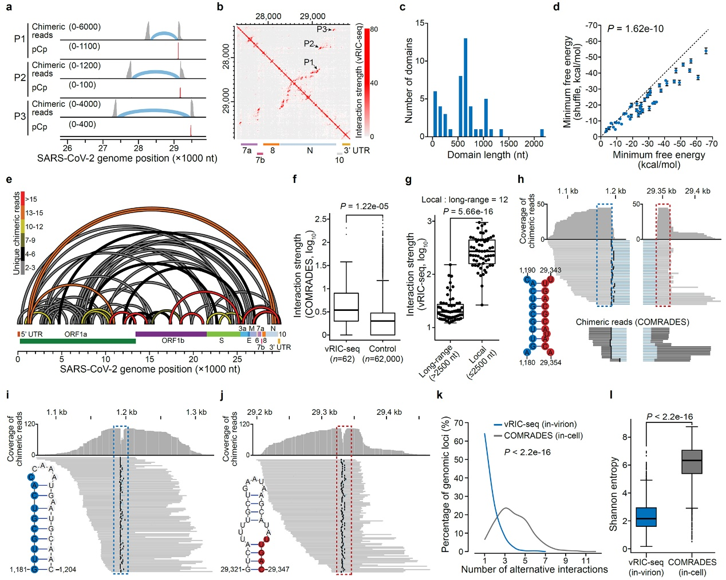
Supplementary Fig. 2 | The features of long-range duplexes. a, Three representative long-rang duplexes contain additional pCp-biotin in the juncture (red lines). b, The RNA interaction map shown P1, P2, and P3 duplexes positions. c, The size distribution of RNA topological domains. d, The minimum free energy of vRIC-seq detected duplexes are significantly lower than the shuffled control. P-value was determined by the two-tailed, paired t-test. Data are mean ± s.e.m. e, Schematic diagram showing RNA-RNA interactions spanning more than 2.5 kb along the SARS-CoV-2 genome. The color scale indicates the number of unique chimeric reads supporting each interaction. f, vRIC-seq captured long-range interactions showed significantly stronger COMRADES signals than randomly selected size-matched controls (1000 times). g, RNA fragments spanning more than 2.5 kb showed stronger interaction with its local partners. The median fold of local to long-range interaction is 12. P-value was determined by the two-tailed, paired t-test. h, One of the pairwise interactions spanning the longest distance. Chimeric reads from vRIC-seq (grey) and COMRADES (dark grey) are shown at the bottom. The blue line between a chimeric read (grey boxes) represents the gap. A black line is placed at the last base of the left arm to facilitate the visualization of gaps. Bottom left: the predicted hybrids formed between pairwise fragments in the dashed boxes. i-j, Chimeric reads support local interactions for 5’ (i, blue box) and 3’ (j, red box) RNA fragments shown in (h). Bottom: the predicted local duplexes using the RNAstructure program. k, COMRADES reveals pervasive alternative RNA-RNA interactions in host cells, while vRIC-seq usually identifies one predominant interaction in the virion. l, COMRADES revealed in-cell pairwise interactions showed a higher value of Shannon entropy than in-virion interactions detected by vRIC-seq. P-values in f, k, and l were determined by the two-tailed, unpaired t-test. For the box plots in f, g, and l, the centre line of the box plot represents the median, the box borders represent the first (Q1) and third (Q3) quartiles, and the whiskers are the most extreme data points within 1.5× the interquartile range (from Q1 to Q3).

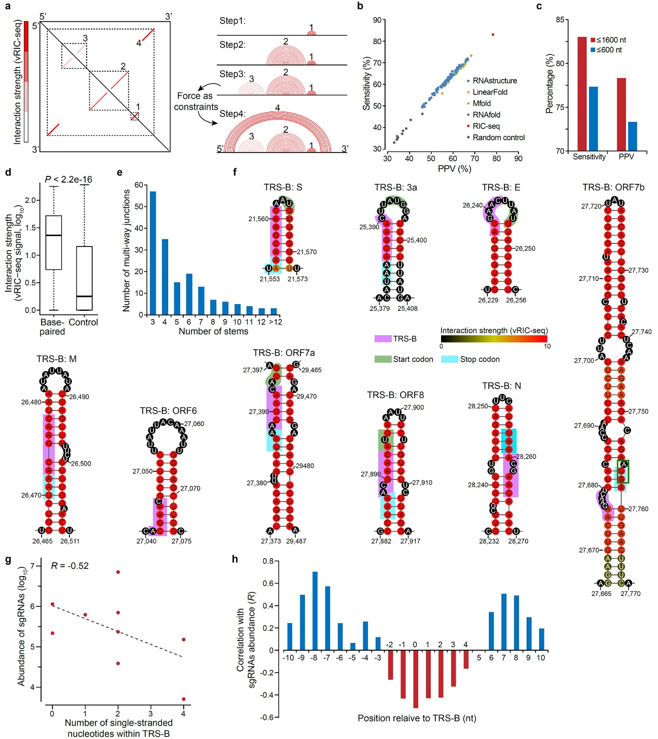
Supplementary Fig. 3 | Performance of the adaptive algorithm. a, The adaptive algorithm was developed to predict RNA secondary structure based on vRIC-seq data. Local duplexes were first predicted and used as a constraint for inferring long-range duplexes. b, Comparing the adaptive algorithm’s performance and several computational software on predicting the secondary structure of 28S rRNA. PPV stands for positive predictive value. Control was chosen by randomly divide the 28S rRNA into size-matched fragments. c, Sensitivity and PPV increased if including the longer duplexes (≤1600 nt, red) for predicting the secondary structure of 28S rRNA by our adaptive strategy. d, Pairwise interacting RNA fragments showed more vRIC-seq signals than the random controls that have the same spanning distance. P-value was determined by the two-tailed, unpaired t-test. The centre line of the box plot represents the median, the box borders represent the first (Q1) and third (Q3) quartiles, and the whiskers are the most extreme data points within 1.5× the interquartile range (from Q1 to Q3). e, Summary of the number of multi-way junctions and the corresponding stems in on our secondary structure model. f, The secondary structure model of nine TRS-B elements. The core sequence (CS) of each TRS-B, the start codons, and the stop codons are marked by purple, green, and cyan boxes, respectively. g, The number of single-stranded nucleotides in the TRS regions showed negative correlations to the sgRNAs abundance. h, The number of single-stranded nucleotides surrounding the TRS regions showed positive correlations to the sgRNAs abundance.

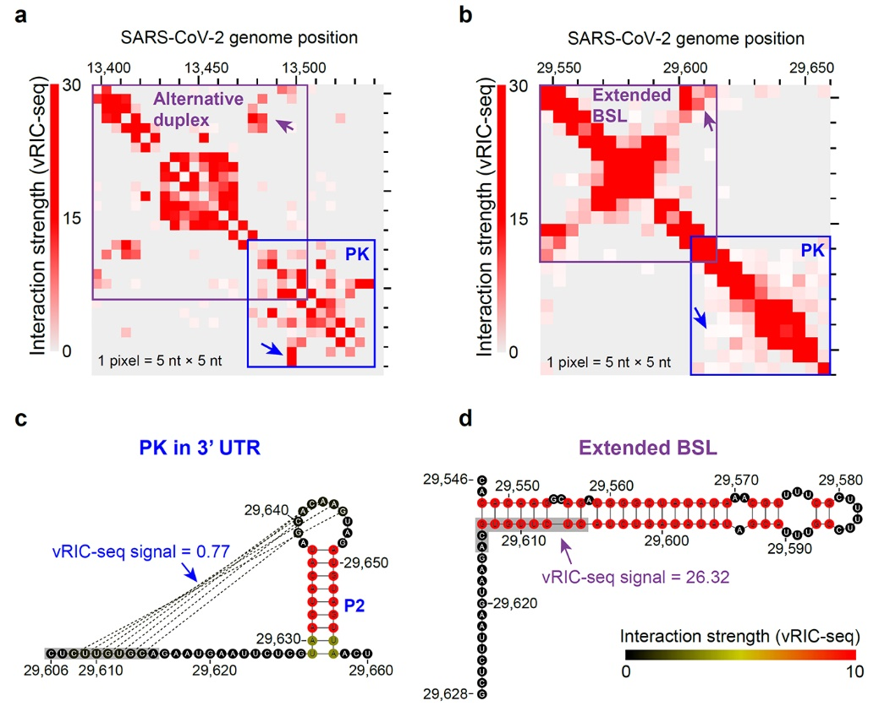
Supplementary Fig. 4 | Alternative conformation for pseudoknots in FSE and 3’ UTR. a, The RNA map view of the frame-shifting element (FSE) surrounded regions. Two alternative conformations may mutually present in the virions. Arrowheads are showing two alternative interactions. b, The RNA map view of the bulged stem-loop (BSL) element and pseudoknot (PK) in the 3’ UTR. The vRIC-seq data preferably supports an extended BSL conformation in the virions (see purple arrowhead). c, The 3’ UTR pseudoknot structure is barely supported by vRIC-seq data. d, An extended BSL duplex is strongly supported by vRIC-seq data.

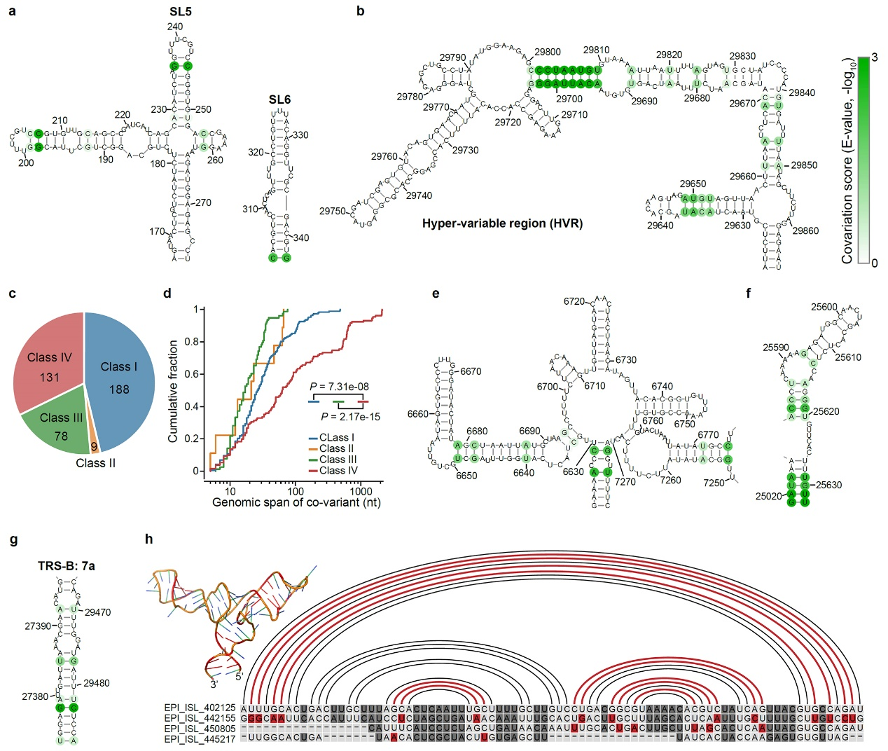
Supplementary Fig. 5 | Co-variant base pairs in SARS-CoV-2. a-b, Base pairs with conserved covariation in the 5’ UTR (a) and 3’ UTR (b) are shown in green. Color intensity indicates the covariation score given by the R-scape program. c, The in-virion structure revealed more co-variants than the in-cell and in silico predicted structures. d, The genomic span distances of two pairwise covariation sites in different categories listed in c. Two-sided Kolmogorov-Smirnov test was used to calculate the P-value. e-g, Co-variant base pairs in three long-range (>600 nt) duplexes. h, Co-variant base pairs in a three-way junction (27,552-27,634 nt) in the SARS-CoV-2 genome. Arc lines and nucleotides colored in red indicate co-variant base pairs. RNAComposer modeled the 3D structure of this three-way junction based on vRIC-seq data.

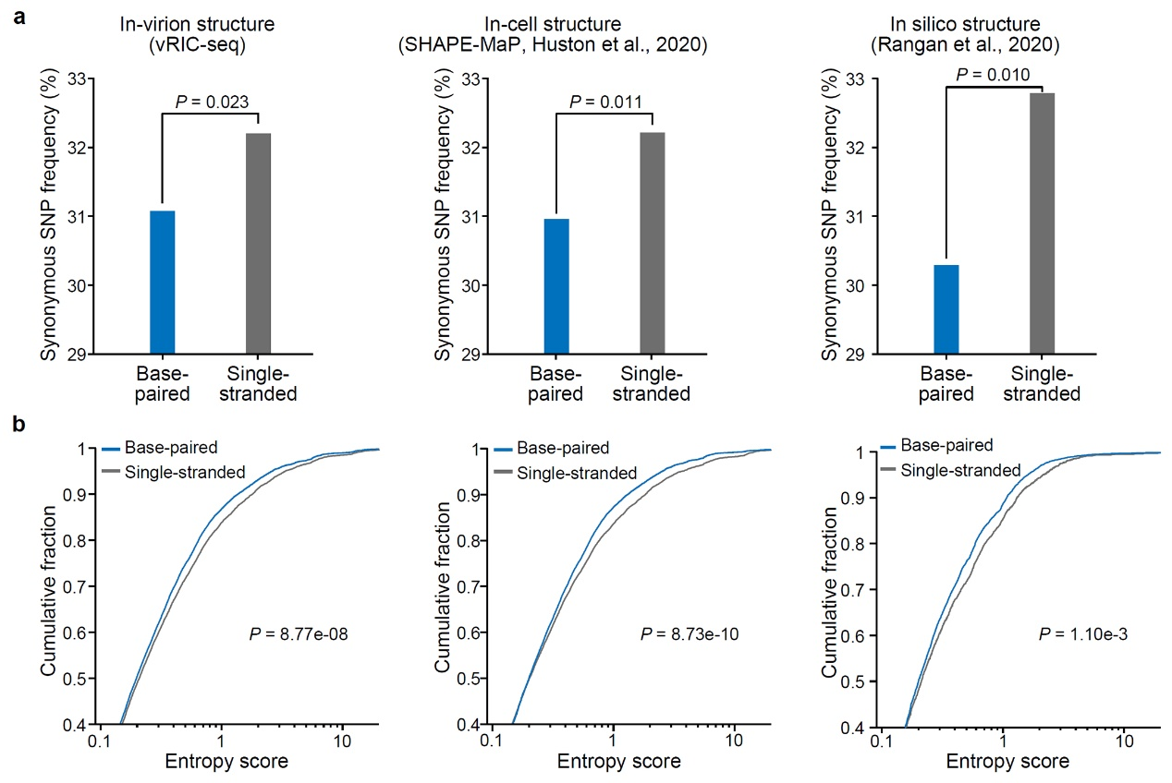
Supplementary Fig. 6 | Base-paired nucleotides are less mutated during evolution. a, Synonymous single nucleotide polymorphisms (SNPs) more frequently happen in single-stranded regions than base-paired regions. P-value was determined by the one-sided Fisher’s exact test. b, The entropy scores are significantly lower in the base-paired regions than single-stranded regions. A two-sided Kolmogorov-Smirnov test was used to calculate the P-value.

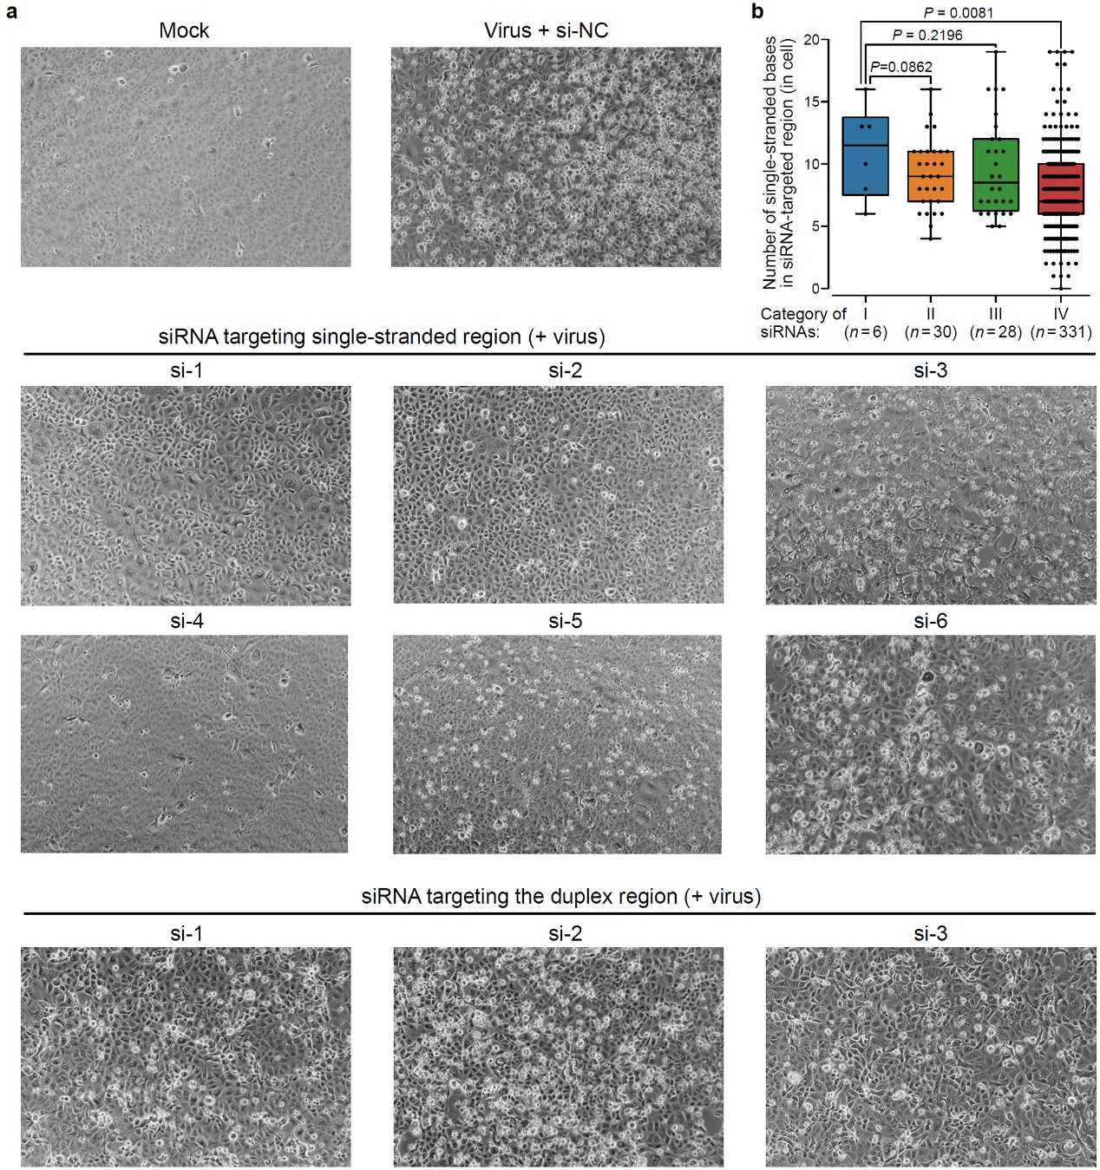
Supplementary Fig. 7 | Cells transfected with single-strand-specific siRNAs are more potent against SARS-CoV-2 infection. a, Vero cells treated by siRNAs targeting single-stranded regions survived better than those with siRNA targeting the duplex regions after the infection of SARS-CoV-2. b, The number of single-stranded nucleotides within the siRNAs’ target region in cells. Category I: six single-strand-specific siRNAs designed from our in-virion structure model. Category II: siRNAs designed by the ViennaRNA Web Services. Category III: siRNA targeting unstructured regions designed from the in silico model of SARS-CoV-2³⁶. Category IV: all possible siRNAs designed from the linear sequence SARS-CoV-2. The centre line of the box plot represents the median, the box borders represent the first (Q1) and third (Q3) quartiles, and the whiskers are the most extreme data points within 1.5× the interquartile range (from Q1 to Q3). P-value was determined by the one-tailed, unpaired t-test.
Supplementary Table 1. RNA topological domains in the SARS-CoV-2 genome.
Domain | Start | End
Domain1 | 1 | 780
Domain2 | 781 | 1840
Domain3 | 1841 | 1920
Domain4 | 1921 | 2500
Domain5 | 2501 | 3250
Domain6 | 3251 | 3480
Domain7 | 3481 | 3760
Domain8 | 3761 | 4330
Domain9 | 4331 | 4940
Domain10 | 4941 | 5970
Domain11 | 5971 | 6650
Domain12 | 6651 | 6740
Domain13 | 6741 | 7260
Domain14 | 7261 | 8320
Domain15 | 8321 | 8950
Domain16 | 8951 | 9600
Domain17 | 9601 | 9910
Domain18 | 9911 | 11220
Domain19 | 11221 | 12180
Domain20 | 12181 | 13370
Domain21 | 13371 | 13560
Domain22 | 13561 | 14630
Domain23 | 14631 | 15270
Domain24 | 15271 | 15330
Domain25 | 15331 | 16410
Domain26 | 16411 | 17000
Domain27 | 17001 | 17550
Domain28 | 17551 | 18220
Domain29 | 18221 | 18910
Domain30 | 18911 | 19600
Domain31 | 19601 | 20120
Domain32 | 20121 | 20910
Domain33 | 20911 | 21730
Domain34 | 21731 | 22400
Domain35 | 22401 | 23040
Domain36 | 23041 | 23100
Domain37 | 23101 | 23670
Domain38 | 23671 | 24360
Domain39 | 24361 | 24990
Domain40 | 24991 | 25670
Domain41 | 25671 | 26370
Domain42 | 26371 | 26520
Domain43 | 26521 | 26670
Domain44 | 26671 | 26730
Domain45 | 26731 | 26870
Domain46 | 26871 | 27380
Domain47 | 27381 | 29540
Domain48 | 29541 | 29620
Domain49 | 29621 | 29903
Supplementary Table 2. List of 62 interactions spanning more than 2.5 kb.
5’ arm |  | 3’ arm |  | Number of supporting COMRADES reads (unique) | Co-variants
Start | End | Strat | End | Number of supporting COMRADES reads (unique) | Co-variants
380 | 410 | 24170 | 24200 | 0
1040 | 1070 | 5570 | 5600 | 4
10110 | 10140 | 25280 | 25310 | 1
10490 | 10520 | 13360 | 13390 | 10
12180 | 12210 | 14700 | 14730 | 13
2930 | 2960 | 21700 | 21730 | 2
25510 | 25540 | 29860 | 29890 | 0 | 25517:29861
7990 | 8020 | 22670 | 22700 | 0
14550 | 14580 | 17420 | 17450 | 3
17350 | 17380 | 25190 | 25220 | 2
1100 | 1130 | 7180 | 7210 | 7
1410 | 1440 | 10920 | 10950 | 6
26860 | 26890 | 29840 | 29870 | 4 | 26873:29868
3130 | 3160 | 6940 | 6970 | 1
12760 | 12790 | 15410 | 15440 | 37
1460 | 1490 | 24450 | 24480 | 0
10500 | 10530 | 13360 | 13390 | 12
3690 | 3720 | 7620 | 7650 | 2
7290 | 7320 | 10310 | 10340 | 17
15310 | 15340 | 18570 | 18600 | 2 | 15324:18589
21600 | 21630 | 24210 | 24240 | 3
1180 | 1210 | 29330 | 29360 | 6
7020 | 7050 | 24970 | 25000 | 3
25660 | 25690 | 29740 | 29770 | 2
7300 | 7330 | 10870 | 10900 | 9
7510 | 7540 | 29590 | 29620 | 1
6740 | 6770 | 26220 | 26250 | 0
19810 | 19840 | 24540 | 24570 | 0
3090 | 3120 | 9630 | 9660 | 0
3130 | 3160 | 22100 | 22130 | 2
50 | 80 | 4000 | 4030 | 9
860 | 890 | 3680 | 3710 | 5
3240 | 3270 | 14820 | 14850 | 2
26860 | 26890 | 29860 | 29890 | 0 | 26873:29868
1410 | 1440 | 10930 | 10960 | 10
18540 | 18570 | 21090 | 21120 | 203
7040 | 7070 | 15410 | 15440 | 1
22980 | 23010 | 25660 | 25690 | 4
6080 | 6110 | 9600 | 9630 | 0
8100 | 8130 | 28610 | 28640 | 4
26850 | 26880 | 29860 | 29890 | 2 | 26873:29868
1440 | 1470 | 4690 | 4720 | 3
9670 | 9700 | 19800 | 19830 | 8
7970 | 8000 | 25070 | 25100 | 2 | 7979:25088
3960 | 3990 | 8340 | 8370 | 1
2780 | 2810 | 7200 | 7230 | 2
1410 | 1440 | 29070 | 29100 | 10
7550 | 7580 | 10580 | 10610 | 4
12070 | 12100 | 25760 | 25790 | 0
25690 | 25720 | 29710 | 29740 | 2
7810 | 7840 | 10950 | 10980 | 14
10420 | 10450 | 14980 | 15010 | 0
1390 | 1420 | 18630 | 18660 | 8 | 1401:18646
26960 | 26990 | 29870 | 29900 | 0
18550 | 18580 | 21090 | 21120 | 147
4690 | 4720 | 26990 | 27020 | 2
3100 | 3130 | 9610 | 9640 | 0
2600 | 2630 | 7520 | 7550 | 6
8480 | 8510 | 13270 | 13300 | 20
26860 | 26890 | 29850 | 29880 | 4 | 26873:29868
6480 | 6510 | 26600 | 26630 | 5
21690 | 21720 | 29500 | 29530 | 1
Supplementary Table 3. List of co-variant base pairs among 429 non-redundant coronavirus genomes.
5' position | 3' position | 5' nucleotide | 3' nucleotide | Frequencey
46 | 58 | A | U | 247
47 | 57 | U | A | 212
88 | 123 | G | C | 214
101 | 111 | G | U | 240
102 | 110 | G | C | 250
151 | 293 | C | G | 244
192 | 214 | G | C | 138
198 | 207 | G | C | 131
199 | 206 | G | C | 142
229 | 251 | A | U | 254
236 | 245 | G | C | 160
254 | 261 | C | G | 216
302 | 343 | C | G | 241
348 | 397 | U | A | 212
355 | 388 | C | G | 189
629 | 640 | C | G | 209
651 | 725 | A | U | 154
654 | 722 | G | C | 137
760 | 819 | U | A | 187
778 | 798 | U | A | 193
784 | 791 | C | G | 194
785 | 790 | A | U | 223
863 | 2400 | U | A | 214
1067 | 1093 | G | C | 194
1072 | 1088 | A | U | 250
1101 | 1289 | C | G | 213
1185 | 1200 | C | G | 228
1208 | 1271 | A | U | 165
1509 | 1551 | G | C | 149
1520 | 1543 | A | U | 193
1526 | 1536 | G | U | 225
1528 | 1534 | C | G | 163
1529 | 1533 | U | G | 156
1599 | 1609 | G | C | 153
1685 | 1698 | G | C | 174
1713 | 1730 | C | G | 199
2285 | 2298 | A | U | 173
2315 | 2379 | A | U | 113
2382 | 2397 | G | C | 130
2469 | 2496 | C | G | 257
2470 | 2495 | C | G | 231
2471 | 2494 | C | G | 185
2477 | 2488 | G | C | 161
2501 | 2519 | A | U | 173
2504 | 2516 | C | G | 226
2524 | 3144 | A | U | 232
2537 | 3133 | U | A | 247
2570 | 2604 | C | G | 196
2583 | 2591 | C | G | 83
2668 | 2809 | C | G | 288
2709 | 2761 | U | A | 184
2715 | 2754 | G | U | 152
2718 | 2751 | G | C | 186
2723 | 2742 | C | G | 201
2775 | 2793 | A | U | 242
2778 | 2790 | G | C | 128
2862 | 2867 | C | G | 210
2931 | 3111 | U | A | 163
3015 | 3077 | C | G | 212
3018 | 3074 | C | G | 213
3043 | 3051 | U | A | 143
3153 | 3411 | G | C | 148
3156 | 3202 | C | G | 164
3158 | 3200 | A | U | 254
3159 | 3197 | C | G | 195
3173 | 3182 | C | G | 149
3328 | 3347 | G | U | 210
3356 | 3363 | U | A | 130
3372 | 3402 | A | U | 233
3376 | 3398 | U | A | 180
3384 | 3390 | U | A | 227
3429 | 3452 | C | G | 248
3432 | 3449 | U | A | 104
3433 | 3448 | G | C | 226
3435 | 3446 | U | G | 54
3438 | 3443 | U | G | 97
3478 | 3506 | U | A | 215
3484 | 3499 | A | U | 169
3485 | 3498 | G | C | 101
3515 | 3596 | C | G | 215
3611 | 3641 | C | G | 193
3743 | 3759 | C | G | 245
3816 | 4281 | A | U | 85
4033 | 4082 | U | G | 182
4094 | 4111 | A | U | 244
4095 | 4109 | C | G | 238
4100 | 4104 | U | A | 271
4115 | 4127 | C | G | 201
4195 | 4217 | U | A | 284
4447 | 4462 | A | U | 132
4449 | 4460 | C | G | 140
4650 | 4688 | C | G | 213
4656 | 4680 | G | C | 250
4848 | 4935 | U | A | 233
4895 | 4912 | U | A | 256
4901 | 4907 | C | G | 254
4973 | 4993 | G | C | 194
5001 | 5019 | U | A | 198
5023 | 5031 | G | C | 213
5102 | 5135 | C | G | 190
5108 | 5130 | G | C | 201
5250 | 5265 | A | U | 188
5253 | 5262 | G | C | 186
5278 | 5289 | U | A | 130
5309 | 5334 | A | U | 228
5311 | 5333 | A | U | 208
5346 | 5375 | C | G | 149
5388 | 5451 | C | G | 124
5403 | 5441 | U | G | 148
5453 | 5474 | G | C | 188
5544 | 5558 | C | G | 137
5631 | 5646 | G | C | 166
5740 | 5769 | U | A | 129
5748 | 5761 | C | G | 203
5781 | 7455 | U | A | 216
5797 | 5845 | U | A | 254
5799 | 5843 | U | A | 193
5931 | 7417 | G | C | 157
5934 | 7414 | C | G | 209
5965 | 5982 | U | A | 198
6008 | 6543 | G | C | 181
6009 | 6542 | U | A | 236
6021 | 6532 | C | G | 210
6039 | 6050 | U | A | 173
6041 | 6048 | G | U | 221
6042 | 6047 | A | U | 197
6147 | 6209 | C | G | 186
6155 | 6201 | A | U | 207
6165 | 6189 | U | A | 120
6174 | 6180 | U | A | 248
6219 | 6251 | U | A | 191
6230 | 6241 | C | G | 148
6270 | 6297 | C | G | 157
6312 | 6404 | C | G | 254
6318 | 6349 | C | G | 206
6332 | 6339 | A | U | 59
6366 | 6386 | A | U | 246
6461 | 6487 | G | C | 231
6470 | 6480 | A | U | 117
6471 | 6479 | C | G | 153
6578 | 6589 | C | G | 169
6626 | 7275 | A | U | 175
6629 | 7272 | C | G | 247
6633 | 6694 | C | G | 155
6634 | 6693 | U | A | 240
6640 | 6687 | U | A | 160
6647 | 6681 | G | C | 168
6649 | 6679 | U | A | 174
6771 | 7255 | U | A | 105
6774 | 7252 | C | G | 213
6798 | 6827 | A | U | 241
6799 | 6826 | A | U | 220
6837 | 7022 | A | U | 272
6840 | 7019 | C | G | 253
6855 | 6879 | C | G | 228
6900 | 6984 | A | U | 132
6986 | 7006 | G | C | 230
6987 | 7005 | G | C | 189
7031 | 7149 | A | U | 157
7032 | 7148 | A | U | 176
7221 | 7246 | C | G | 241
7222 | 7245 | U | G | 190
7225 | 7242 | U | A | 206
7476 | 7504 | G | C | 20
7671 | 7680 | U | A | 90
7827 | 7842 | U | A | 201
7865 | 7875 | G | C | 249
8169 | 8192 | C | G | 218
8170 | 8191 | A | U | 263
8172 | 8189 | C | G | 233
8267 | 8286 | G | U | 111
8270 | 8282 | A | U | 179
8273 | 8279 | U | A | 39
8350 | 8370 | U | A | 44
8380 | 8907 | A | U | 122
8382 | 8905 | G | C | 236
8544 | 8549 | U | G | 176
8567 | 8631 | A | U | 173
8570 | 8628 | U | A | 192
8576 | 8622 | A | U | 171
8672 | 8679 | U | A | 206
8673 | 8678 | C | G | 187
8697 | 8735 | C | G | 253
9330 | 9401 | A | U | 162
9414 | 9447 | G | C | 155
9459 | 9524 | U | A | 56
9486 | 9495 | A | U | 107
9666 | 9729 | C | G | 110
9683 | 9710 | A | U | 168
9851 | 9866 | G | C | 100
9891 | 9923 | C | G | 136
10400 | 10619 | G | C | 59
10881 | 10890 | U | G | 33
10992 | 11011 | U | G | 112
11079 | 11088 | U | A | 166
11241 | 11329 | G | U | 137
11281 | 11291 | U | G | 239
11346 | 11370 | U | A | 114
11351 | 11364 | A | U | 223
11390 | 11411 | U | A | 177
11394 | 11405 | C | G | 169
11439 | 11457 | A | U | 197
11889 | 11899 | U | A | 110
11967 | 12019 | C | G | 109
12206 | 12215 | A | U | 156
12707 | 12729 | G | C | 206
12708 | 12728 | C | G | 240
12735 | 12750 | G | C | 162
12930 | 12965 | G | U | 62
12938 | 12957 | G | U | 154
13167 | 13529 | A | U | 140
13169 | 13527 | A | U | 196
13206 | 13230 | C | G | 23
13561 | 14660 | A | U | 123
15291 | 15298 | G | C | 14
15928 | 15962 | C | G | 9
17045 | 17265 | A | U | 12
17163 | 17170 | C | G | 190
17273 | 17281 | U | A | 14
17323 | 17341 | U | G | 97
17680 | 17695 | C | G | 121
18125 | 18140 | U | A | 34
18887 | 18913 | A | U | 13
19084 | 19088 | A | U | 170
19604 | 19613 | C | G | 78
19670 | 19694 | G | C | 91
19892 | 19909 | A | U | 63
19967 | 20008 | G | C | 218
20103 | 20127 | U | A | 253
20109 | 20118 | U | A | 107
20611 | 20616 | C | G | 154
20962 | 21688 | G | U | 89
21133 | 21238 | C | G | 241
21157 | 21209 | G | U | 201
21164 | 21200 | U | A | 9
21337 | 21348 | A | U | 35
21338 | 21347 | A | U | 34
21359 | 21375 | C | G | 94
21409 | 21425 | C | G | 163
21415 | 21419 | A | U | 55
21451 | 21476 | G | C | 140
21458 | 21469 | U | A | 50
21548 | 21579 | A | U | 109
21591 | 21599 | U | A | 230
21650 | 21664 | A | U | 232
21719 | 21811 | G | C | 180
21720 | 21810 | A | U | 168
21724 | 21805 | G | C | 265
21725 | 21804 | U | A | 80
21726 | 21801 | U | A | 250
21742 | 21785 | C | G | 191
21818 | 21825 | U | A | 217
21819 | 21824 | U | G | 136
21962 | 22017 | C | G | 283
22041 | 22070 | A | U | 285
22050 | 22059 | C | G | 236
22134 | 22209 | A | U | 98
22155 | 22164 | A | U | 210
22230 | 22262 | U | A | 105
22235 | 22257 | C | G | 232
22236 | 22256 | C | G | 158
22341 | 22346 | C | G | 235
22351 | 22367 | A | U | 234
22353 | 22365 | C | G | 147
22356 | 22362 | A | U | 250
22393 | 22399 | A | U | 266
22476 | 23016 | C | G | 270
22485 | 22500 | U | A | 129
22563 | 22611 | A | U | 207
22680 | 22698 | C | G | 149
22719 | 22767 | A | U | 123
22799 | 22806 | G | C | 223
22932 | 22968 | G | C | 219
23031 | 23668 | U | A | 252
23033 | 23666 | C | G | 258
23118 | 23135 | A | U | 239
23272 | 23348 | U | A | 137
23274 | 23346 | A | U | 257
23281 | 23339 | U | G | 250
23355 | 23408 | U | A | 245
23367 | 23390 | C | G | 180
23412 | 23439 | G | C | 149
23413 | 23438 | C | G | 183
23417 | 23424 | G | C | 243
23578 | 23627 | U | A | 222
23583 | 23622 | A | U | 102
23653 | 23664 | G | C | 239
23690 | 24295 | A | U | 237
23868 | 24099 | G | C | 188
24018 | 24030 | A | U | 12
24191 | 24228 | C | G | 161
24257 | 24263 | G | C | 146
24563 | 24570 | C | G | 183
24790 | 25017 | A | U | 259
24917 | 24927 | A | U | 156
24948 | 24959 | U | G | 240
25019 | 25632 | G | U | 90
25020 | 25631 | A | U | 53
25021 | 25630 | U | G | 257
25022 | 25629 | A | U | 191
25070 | 25087 | U | A | 141
25230 | 25262 | G | C | 219
25239 | 25250 | C | G | 169
25295 | 25310 | A | U | 201
25331 | 25418 | G | C | 112
25342 | 25364 | C | G | 197
25471 | 25578 | G | C | 213
25474 | 25575 | U | A | 217
25476 | 25573 | U | A | 183
25489 | 25544 | G | C | 214
25491 | 25542 | A | U | 243
25492 | 25541 | A | U | 218
25494 | 25539 | G | C | 248
25498 | 25538 | C | G | 257
25503 | 25533 | A | U | 241
25582 | 25620 | A | U | 225
25583 | 25619 | C | G | 223
25584 | 25618 | C | G | 193
25586 | 25616 | U | A | 217
25593 | 25613 | G | C | 261
25674 | 26358 | U | A | 235
25781 | 26333 | G | C | 167
25820 | 25839 | C | G | 232
25981 | 26015 | G | C | 231
26140 | 26195 | G | C | 166
26213 | 26316 | C | G | 231
26219 | 26311 | A | U | 202
26278 | 26291 | U | G | 197
26391 | 26423 | G | C | 235
26402 | 26411 | A | U | 144
26637 | 26652 | U | A | 140
26926 | 26987 | A | U | 135
26950 | 26965 | U | A | 216
27012 | 27096 | C | G | 170
27029 | 27087 | U | G | 247
27043 | 27073 | G | C | 94
27048 | 27069 | C | G | 197
27374 | 29486 | U | A | 242
27378 | 29482 | G | C | 251
27379 | 29481 | A | U | 235
27385 | 29477 | U | G | 160
27392 | 29470 | A | U | 194
28341 | 29024 | C | G | 250
28403 | 28411 | G | C | 189
28437 | 28968 | C | G | 182
28451 | 28776 | G | C | 144
28457 | 28462 | G | C | 215
28524 | 28625 | U | G | 191
28532 | 28571 | U | A | 74
28534 | 28569 | C | G | 259
28544 | 28561 | A | U | 257
28545 | 28560 | C | G | 215
28547 | 28558 | A | U | 257
28593 | 28610 | G | C | 133
28668 | 28725 | G | C | 76
28799 | 28829 | A | U | 173
28806 | 28821 | G | C | 232
28808 | 28819 | G | C | 219
28856 | 28962 | A | U | 105
28875 | 28940 | G | C | 241
28879 | 28936 | U | G | 144
28883 | 28932 | G | C | 190
28985 | 29003 | G | C | 217
28986 | 29002 | G | C | 236
28987 | 29001 | C | G | 218
29044 | 29051 | G | C | 152
29213 | 29222 | U | A | 117
29215 | 29220 | C | G | 115
29255 | 29363 | G | C | 238
29321 | 29347 | G | C | 133
29324 | 29344 | A | U | 210
29423 | 29462 | C | G | 154
29425 | 29460 | G | C | 197
29427 | 29459 | G | C | 191
29428 | 29458 | A | U | 235
29434 | 29453 | G | C | 207
29505 | 29538 | U | A | 102
29548 | 29613 | C | G | 233
29564 | 29600 | U | A | 249
29565 | 29599 | A | U | 199
29566 | 29598 | U | A | 210
29634 | 29652 | A | U | 195
29635 | 29651 | C | G | 151
29636 | 29650 | A | U | 128
29637 | 29649 | U | A | 158
29640 | 29645 | C | G | 238
29661 | 29850 | U | A | 129
29664 | 29847 | A | U | 192
29669 | 29842 | A | U | 183
29670 | 29841 | C | G | 260
29671 | 29840 | A | U | 201
29674 | 29831 | G | C | 140
29675 | 29830 | C | G | 152
29676 | 29829 | A | U | 129
29680 | 29824 | U | A | 145
29684 | 29820 | A | U | 196
29689 | 29815 | U | A | 204
29695 | 29809 | A | U | 198
29696 | 29808 | C | G | 234
29697 | 29807 | A | U | 198
29698 | 29806 | U | A | 257
29699 | 29805 | U | A | 148
29700 | 29804 | A | U | 202
29701 | 29803 | G | C | 181
29702 | 29802 | G | C | 164
29703 | 29801 | G | C | 70
Supplementary Table 4. List of co-variant base pairs among different SARS-CoV-2 strains.
5’ position | 3’ position | 5’ nucleotide | 3’ nucleotide | Frequency
7 | 33 | G | C | 2
8 | 32 | G | C | 1
9 | 31 | U | A | 2
11 | 29 | U | A | 1
13 | 26 | U | A | 4
14 | 25 | A | U | 19
15 | 24 | C | G | 2
16 | 23 | C | G | 14
17 | 22 | U | A | 11
45 | 59 | G | C | 1
46 | 58 | A | U | 1
188 | 218 | G | C | 1
189 | 217 | G | C | 3
191 | 215 | U | A | 2
198 | 207 | G | C | 2
236 | 245 | G | C | 1
305 | 340 | G | C | 2
320 | 332 | C | G | 1
324 | 328 | U | A | 1
361 | 380 | A | U | 1
367 | 373 | C | G | 3
512 | 520 | C | G | 1
513 | 519 | A | U | 2
962 | 988 | G | C | 1
1073 | 1087 | U | A | 1
1420 | 1470 | C | G | 1
2689 | 2698 | A | U | 1
2729 | 2738 | A | U | 1
2855 | 2875 | C | G | 1
3945 | 3968 | A | U | 1
7914 | 7919 | A | U | 1
8047 | 8056 | C | G | 1
8048 | 8055 | G | C | 1
8083 | 8092 | G | C | 1
9483 | 9498 | A | U | 1
9485 | 9496 | U | A | 1
9546 | 9579 | U | A | 1
10978 | 11032 | A | U | 1
11093 | 11124 | G | C | 1
14849 | 14856 | U | A | 1
15019 | 15043 | C | G | 1
17328 | 17337 | U | A | 1
18105 | 18167 | G | C | 3
19348 | 19360 | G | C | 1
19455 | 19465 | G | C | 1
19457 | 19463 | G | C | 2
19833 | 19848 | A | U | 2
20160 | 20199 | G | C | 1
20215 | 20228 | A | U | 1
20219 | 20224 | U | G | 1
20268 | 20385 | A | U | 1
20306 | 20312 | G | C | 1
20406 | 20418 | U | A | 1
20915 | 20946 | G | C | 1
20926 | 20933 | C | G | 1
21013 | 21051 | C | G | 1
21014 | 21050 | A | U | 1
21029 | 21036 | G | C | 1
21815 | 21828 | C | G | 1
21882 | 21896 | G | U | 1
22439 | 22462 | C | G | 1
22441 | 22460 | U | A | 1
22447 | 22455 | U | A | 1
25438 | 25451 | A | U | 2
25553 | 25563 | C | G | 23
25854 | 25879 | C | G | 3
27473 | 27478 | C | G | 1
27553 | 27633 | U | A | 1
27554 | 27632 | U | G | 1
27556 | 27630 | G | C | 1
27557 | 27628 | C | G | 1
27572 | 27584 | G | C | 1
27573 | 27583 | C | G | 2
27596 | 27621 | C | G | 3
27597 | 27620 | U | A | 1
27601 | 27615 | G | C | 1
27602 | 27614 | G | U | 1
27604 | 27612 | G | C | 2
27649 | 27659 | C | G | 1
27651 | 27657 | G | C | 1
27675 | 27760 | A | U | 1
27682 | 27758 | U | G | 1
27694 | 27749 | U | A | 1
27704 | 27738 | U | A | 1
27710 | 27731 | C | G | 1
27719 | 27723 | U | A | 1
28806 | 28821 | G | C | 7
28883 | 28932 | G | C | 23
29399 | 29415 | G | C | 1
29503 | 29540 | C | G | 1
29625 | 29864 | C | G | 7
29627 | 29862 | C | G | 1
29728 | 29768 | U | A | 1
29730 | 29766 | C | G | 1
29731 | 29765 | A | U | 1
29732 | 29764 | C | G | 2
29743 | 29755 | C | G | 4
29777 | 29788 | G | C | 2
Supplementary Table 5. List of 130 single-stranded regions in the SARS-CoV-2 genome in virion.
Region | Start | End | Predicted by Manfredonia et al.
Region1 | 128 | 142 | Yes
Region2 | 926 | 939 | Yes
Region3 | 1031 | 1042
Region4 | 1163 | 1172
Region5 | 1304 | 1321
Region6 | 1358 | 1368
Region7 | 1808 | 1819 | Yes
Region8 | 1838 | 1847
Region9 | 2269 | 2280 | Yes
Region10 | 2303 | 2313 | Yes
Region11 | 3671 | 3680
Region12 | 3703 | 3715 | Yes
Region13 | 3933 | 3942
Region14 | 4083 | 4092
Region15 | 4331 | 4344
Region16 | 4475 | 4484 | Yes
Region17 | 4494 | 4503 | Yes
Region18 | 4580 | 4590
Region19 | 4747 | 4756
Region20 | 4790 | 4800
Region21 | 5204 | 5217
Region22 | 6105 | 6115
Region23 | 6256 | 6268 | Yes
Region24 | 6390 | 6403
Region25 | 6509 | 6531
Region26 | 6600 | 6611
Region27 | 6775 | 6793
Region28 | 6887 | 6899 | Yes
Region29 | 6950 | 6959
Region30 | 6990 | 7002
Region31 | 7081 | 7091
Region32 | 7162 | 7171
Region33 | 7691 | 7700
Region34 | 7705 | 7716
Region35 | 7728 | 7743
Region36 | 8254 | 8263
Region37 | 8443 | 8452
Region38 | 8471 | 8480
Region39 | 8815 | 8827
Region40 | 9023 | 9033
Region41 | 9555 | 9569
Region42 | 9588 | 9599
Region43 | 9605 | 9618
Region44 | 10018 | 10030
Region45 | 10277 | 10286
Region46 | 10335 | 10344
Region47 | 10368 | 10378 | Yes
Region48 | 11478 | 11487
Region49 | 11568 | 11577 | Yes
Region50 | 11612 | 11621 | Yes
Region51 | 11728 | 11742
Region52 | 11755 | 11765
Region53 | 12108 | 12119
Region54 | 12193 | 12202
Region55 | 12598 | 12607
Region56 | 12620 | 12630
Region57 | 12738 | 12747
Region58 | 12780 | 12796
Region59 | 12855 | 12865
Region60 | 12880 | 12889
Region61 | 12967 | 12981 | Yes
Region62 | 13454 | 13468 | Yes
Region63 | 13859 | 13869
Region64 | 13990 | 14005
Region65 | 14255 | 14265
Region66 | 14642 | 14652
Region67 | 14693 | 14702
Region68 | 15026 | 15036
Region69 | 15152 | 15163
Region70 | 15201 | 15210
Region71 | 15459 | 15469
Region72 | 15533 | 15542
Region73 | 15890 | 15904
Region74 | 16043 | 16053 | Yes
Region75 | 16197 | 16206
Region76 | 16477 | 16488
Region77 | 17006 | 17015
Region78 | 17200 | 17209
Region79 | 17449 | 17461
Region80 | 17775 | 17789
Region81 | 18924 | 18937
Region82 | 19260 | 19271
Region83 | 19408 | 19417
Region84 | 19638 | 19655
Region85 | 19895 | 19906
Region86 | 20147 | 20157
Region87 | 20476 | 20487
Region88 | 20658 | 20667
Region89 | 20716 | 20730
Region90 | 20818 | 20833
Region91 | 21362 | 21372
Region92 | 21651 | 21663
Region93 | 21670 | 21679
Region94 | 21703 | 21717
Region95 | 21830 | 21844
Region96 | 23226 | 23235
Region97 | 23245 | 23257
Region98 | 23306 | 23317 | Yes
Region99 | 23428 | 23437 | Yes
Region100 | 23704 | 23720
Region101 | 23923 | 23934
Region102 | 23960 | 23974
Region103 | 24450 | 24461
Region104 | 24496 | 24505
Region105 | 24701 | 24711
Region106 | 24808 | 24817
Region107 | 24876 | 24888
Region108 | 25367 | 25379
Region109 | 25439 | 25450
Region110 | 25701 | 25719
Region111 | 25823 | 25836 | Yes
Region112 | 26127 | 26137
Region113 | 26428 | 26438 | Yes
Region114 | 26868 | 26885 | Yes
Region115 | 27053 | 27064
Region116 | 27128 | 27148 | Yes
Region117 | 27289 | 27298 | Yes
Region118 | 27312 | 27326 | Yes
Region119 | 27519 | 27533 | Yes
Region120 | 28143 | 28156
Region121 | 28572 | 28584
Region122 | 28688 | 28711 | Yes
Region123 | 28989 | 28999
Region124 | 29013 | 29022
Region125 | 29034 | 29043
Region126 | 29074 | 29089 | Yes
Region127 | 29307 | 29320 | Yes
Region128 | 29348 | 29359 | Yes
Region129 | 29791 | 29800 | Yes
Region130 | 29868 | 29903
Supplementary Table 6. List of siRNAs, primers, and probe used in this study.
siRNA sequences
siRNA |  | Sequence (5' to 3')
si-NC |  | UUCUCCGAACGUGUCACGUTT
single-stranded region si-1 |  | CACACGUCCAACUCAGUUUTT
single-stranded region si-2 |  | GCCCCUUUUCUCUAUCUUUTT
single-stranded region si-3 |  | CCACCACAAACCUCUAUCATT
single-stranded region si-4 |  | GGAGUCAAAUUACAUUACATT
single-stranded region si-5 |  | CACCUGAAGAACAUUUUAUTT
single-stranded region si-6 |  | GAGCCCUAAUGUGUAAAAUTT
duplex region si-1 |  | GGUUGGUGGUAAUUAUAAUTT
duplex region si-2 |  | CUGCAAGAUCAUAAUGAAATT
duplex region si-3 |  | GACUGUGUUAUGUAUGCAUTT
Primer sequences and TaqMan probe used for qPCR
Primers | Sequence (5' to 3')
pcDNA3.1-dual-1-nCOV delete F | TGTACCGTCTGCGGTATGTGGAAACCCATGCTTCAGTCAGCTGATGCA
pcDNA3.1-dual-1-nCOV delete R | TGCATCAGCTGACTGAAGCATGGGTTTCCACATACCGCAGACGGTACA
GAPDH-qF | GTCTCCTCTGACTTCAACAGCG
GAPDH-qR | ACCACCCTGTTGCTGTAGCCAA
SARS-CoV-2 RdRp-qF | CAAATTCTATGGTGGTTGGCACA
SARS-CoV-2 RdRp-qR | GGCATGGCTCTATCACATTTAGG
SARS-CoV-2 N gene-qF | AACACAAGCTTTCGGCAGAC
SARS-CoV-2 N gene-qR | ACCTGTGTAGGTCAACCACG
SARS-CoV-2 N gene probe | /5’-6-FAM/CAGCGCTTCAGCGTTCTTCGGAATGTCGC/3’-BHQ/

