Long non-coding RNAs act as prognostic biomarkers in breast and gynecologic cancers
Fan Zhao^{1#}, Huiqi Chen^{1#}, Kelie Chen^{1#},Shengchao Wang², Dexin Yang¹, Honghe Zhang³, Weiguo Lu², Dajing Xia^{1*}, Yihua Wu^{1*}
1. Department of Toxicology, School of Public Health, and Department of Gynecologic Oncology of Women’s Hospital, School of Medicine, Zhejiang University, Hangzhou 310058, China.
2. Department of Gynecologic Oncology of Women’s Hospital, School of Medicine, Zhejiang University, Hangzhou 310006, China.
3. Department of Pathology, Key Laboratory of Disease Proteomics of Zhejiang Province, School of Medicine, Zhejiang University, Hangzhou 310058, China.

Contents
Supplementary Table 1
Supplementary Table 2
Supplementary Table 3
Supplementary Table 4
Supplementary Table 5
Supplementary Figure 1
Supplementary Figure 2
Supplementary Figure 3
Supplementary Figure 4
Supplementary Figure 5

Supplementary Table 1. Characteristics of the included studies.
Uploaded as a separate file.

Supplementary Table 2. Quality assessment performed according to the REMARK guideline
Upload as a separate file.

Supplementary Table 3. Meta-analysis of the association between tissue lncRNA expression and survival outcome in breast and gynecologic cancers.
lncRNA | Study number | No. of participants | Pooled HR (95%CI)
lncRNA | Study number | No. of participants | OS | DFS
SPRY4-IT1 | 3 | 2542 | 1.54(1.03-2.28)* | 4.89(1.24-6.53)*
HOXA11-AS | 3 | 2539 | 1.24(1.02-1.50)* | 1.73(1.02-2.95)*
SNHG16 | 3 | 2459 | 1.33(0.96-1.86) | -
MEG3 | 3 | 2597 | 0.78(0.52-1.18) | 0.22(0.11-0.43)*
AFAP1-AS1 | 3 | 2716 | 1.43(0.97-2.10) | 2.92(1.61-5.32)*
BANCR | 3 | 2629 | - | 1.55(1.30-1.85)*
XIST | 3 | 2419 | 0.88(0.66-1.19) | -
LINP1 | 3 | 2568 | 1.50(1.03-2.17)* | 3.65(1.82-7.32)*
SNHG15 | 3 | 2558 | 1.23(1.03-1.47)* | 1.12(1.06-1.19)*
TP73-AS1 | 3 | 2416 | 1.76(1.01-3.06)* | -
DANCR | 3 | 2073 | 1.21(0.76-1.94) | -
H19 | 3 | 2690 | 1.30(0.89-1.91) | 0.80(0.16-3.99)
TUG1 | 3 | 2635 | 1.35(0.86-2.11) | -
-Could not be calculated.
*Significant association was indicated, statistical z test: P＜0.05.
HR, hazard risk; CI, confidence interval.

Supplementary Table 4. Subgroup analyses for the association between tissue lncRNA expression and OS in breast and gynecologic cancers.
Categories | lncRNA | Classification | Study number | No. of participants | HR (95% CI) | Heterogeneity
 |  |  |  |  |  | I² | P
Cancer type | MEG3 | gynecologic cancer | 2 | 1295 | 0.86(0.51-1.45) | 82.20% | 0.001
Cancer type | MEG3 | breast cancer | 2 | 1302 | 0.58(0.17-1.94) | 88.30% | 0.003
Cancer type | SNHG15 | gynecologic cancer | 2 | 1405 | 1.14(1.07-1.22)* | 1.10% | 0.387
Cancer type | SNHG15 | breast cancer | 2 | 1153 | 1.67(0.72-3.86) | 78.70% | 0.030
Cancer type | TP73-AS1 | gynecologic cancer | 2 | 1285 | 1.97(0.96-4.03) | 90.20% | 0.000
Cancer type | TP73-AS1 | breast cancer | 2 | 1131 | 1.47(0.37-5.76) | 79.80% | 0.026
Cancer type | HOTTIP | gynecologic cancer | 3 | 822 | 1.44(0.81-2.56) | 77.10% | 0.004
Cancer type | HOTTIP | breast cancer | 2 | 1165 | 2.08(0.53-8.15) | 91.20% | 0.001
Cancer type | DANCR | gynecologic cancer | 2 | 915 | 1.04(0.50-2.18) | 81.70% | 0.004
Cancer type | DANCR | breast cancer | 2 | 1158 | 1.51(0.77-2.98) | 72.80% | 0.055
*Significant association was indicated, statistical z test: P < 0.05.

Supplementary Table 5. The association between tissue lncRNA expression and clinicopathological features in breast and gynecologic cancers.
Pooled OR  (95%CI)  lncRNAs | Age | FIGO Stage  (I-II vs III-IV) | Histology Grade  (G1+G2 vs G3) | Lymph node metastasis (LNM) | Lymphovascular space invasion  (LVSI) | Tumor size
SPRY4-IT1 | 1.25(0.47-3.33) | 8.23(3.53-19.23)* | 1.05(0.16-7.10) | 4.30(1.75-10.57)* | - | 4.65(1.93-11.22)*
HOXA11-AS | - | 3.81(1.07-13.63)* | 2.97(1.19-7.42)* | 1.27(0.59-2.71) | 1.56(0.68-3.56) | -
SNHG16 | 1.07(0.55-2.09) | 3.15(1.24-8.00)* | 1.25(0.11-14.78) | 4.71(1.18-18.86)* | - | 1.40(0.10-20.47)
MEG3 | 0.74(0.43-1.28) | - | 0.42(0.24-0.75)* | 0.26(0.13-0.52)* | - | 1.29(0.73-2.30)
AFAP1-AS1 | 1.10(0.64-1.90) | 1.18(0.70-1.99) | - | 0.53(0.29-0.97)* | - | -
BANCR | 0.84(0.36-1.94) | 12.25(1.27-118.37)* | 6.00(1.17-30.73)* | 4.09(2.39-7.01)* | - | 2.42(1.46-4.00)*
XIST | 1.25(0.13-12.65) | 2.19(0.67-7.22) | - | - | - | 4.90(0.20-118.71)
LINP1 | 1.06(0.53-2.14) | - | - | 0.37(0.20-0.70)* | - | 1.22(0.51-2.93)
SNHG15 | 0.91(0.54-1.52) | 2.14(0.99-4.61) | - | 4.41(1.22-16.00)* | - | 7.04(1.73-28.60)*
TP73-AS1 | 2.06(1.01-4.20)* | 19.25(5.12-72.33)* | 7.43(2.26-24.40)* | 1.00(0.05-19.37) | - | 2.98(1.44-6.20)*
DANCR | 0.83(0.41-1.68) | 6.25(2.09-18.74)* | 10.20(3.12-33.34)* | 8.84(3.70-21.12)* | - | 1.87(0.35-10.03)
H19 | 0.61(0.17-2.22) | 5.42(1.51-19.42)* | 1.34(0.39-4.61) | 2.06(0.54-7.90) | - | 3.52(1.28-9.67)*
TUG1 | 0.93(0.53-1.61) | 4.43(1.49-13.12)* | 3.27(1.15-9.28)* | 1.14(0.61-2.13) | - | 2.30(0.73-7.24)
⁻Could not be calculated.
*Significant association was indicated, statistical z test: P < 0.05.
The analysis of FIGO stage only included studies focusing on gynecologic cancers.

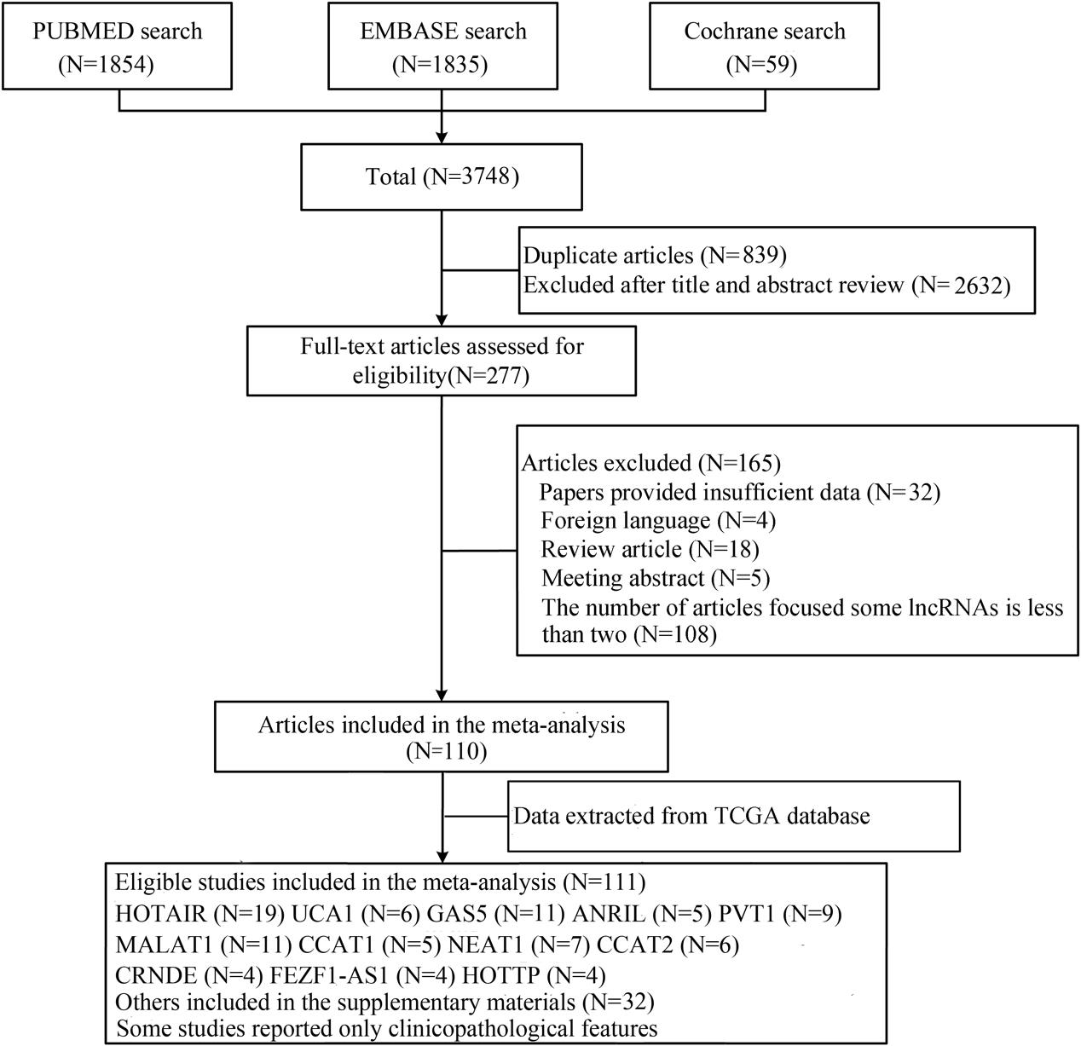
Fig. S1. Flow diagram of study selection process.

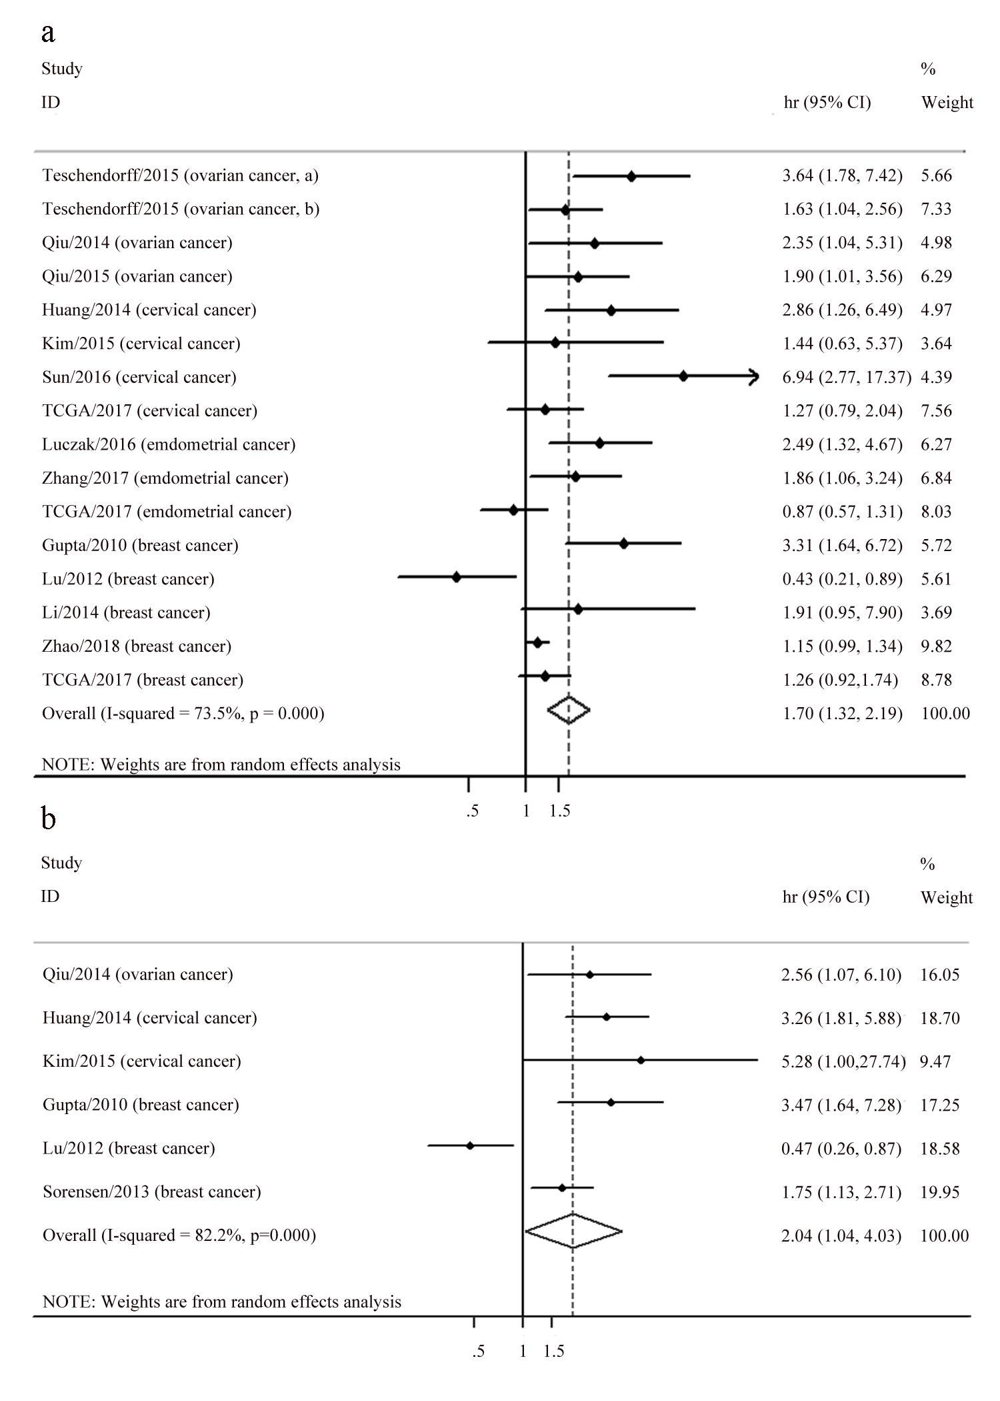
Fig. S2. Association between tissue HOTAIR expression and survival of breast and gynecologic cancers. a Forest plots of the association between tissue HOTAIR expression and OS in breast and gynecologic cancers. b Forest plots of the association between tissue HOTAIR expression and DFS in breast and gynecologic cancers.

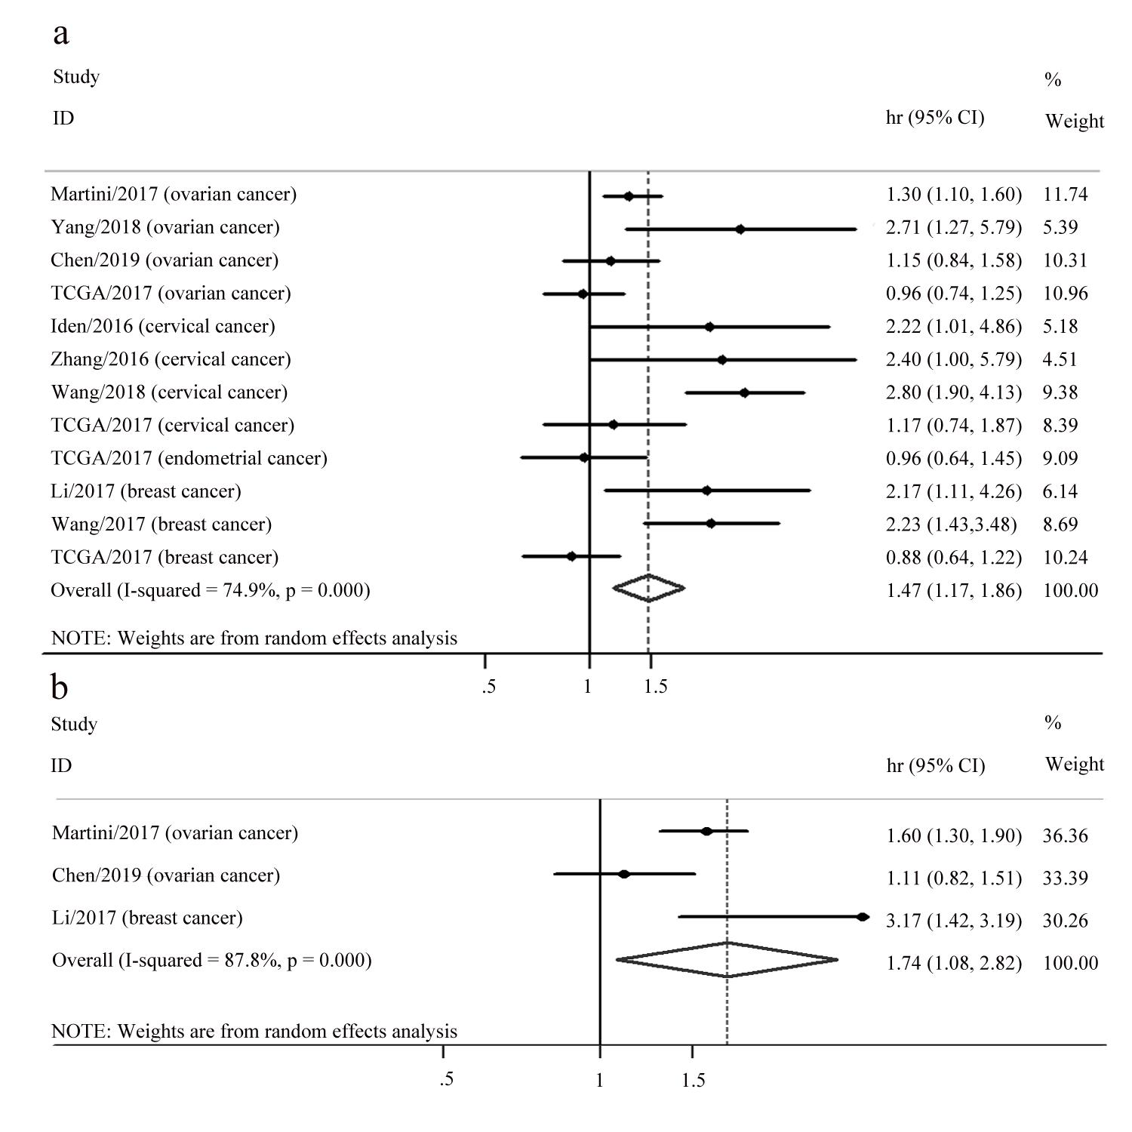
Fig. S3. Association between tissue PVT1 expression and survival of breast and gynecologic cancers. a Forest plots of the association between tissue PVT1 expression and OS in breast and gynecologic cancers. b Forest plots of the association between tissue PVT1 expression and DFS in breast and gynecologic cancers.

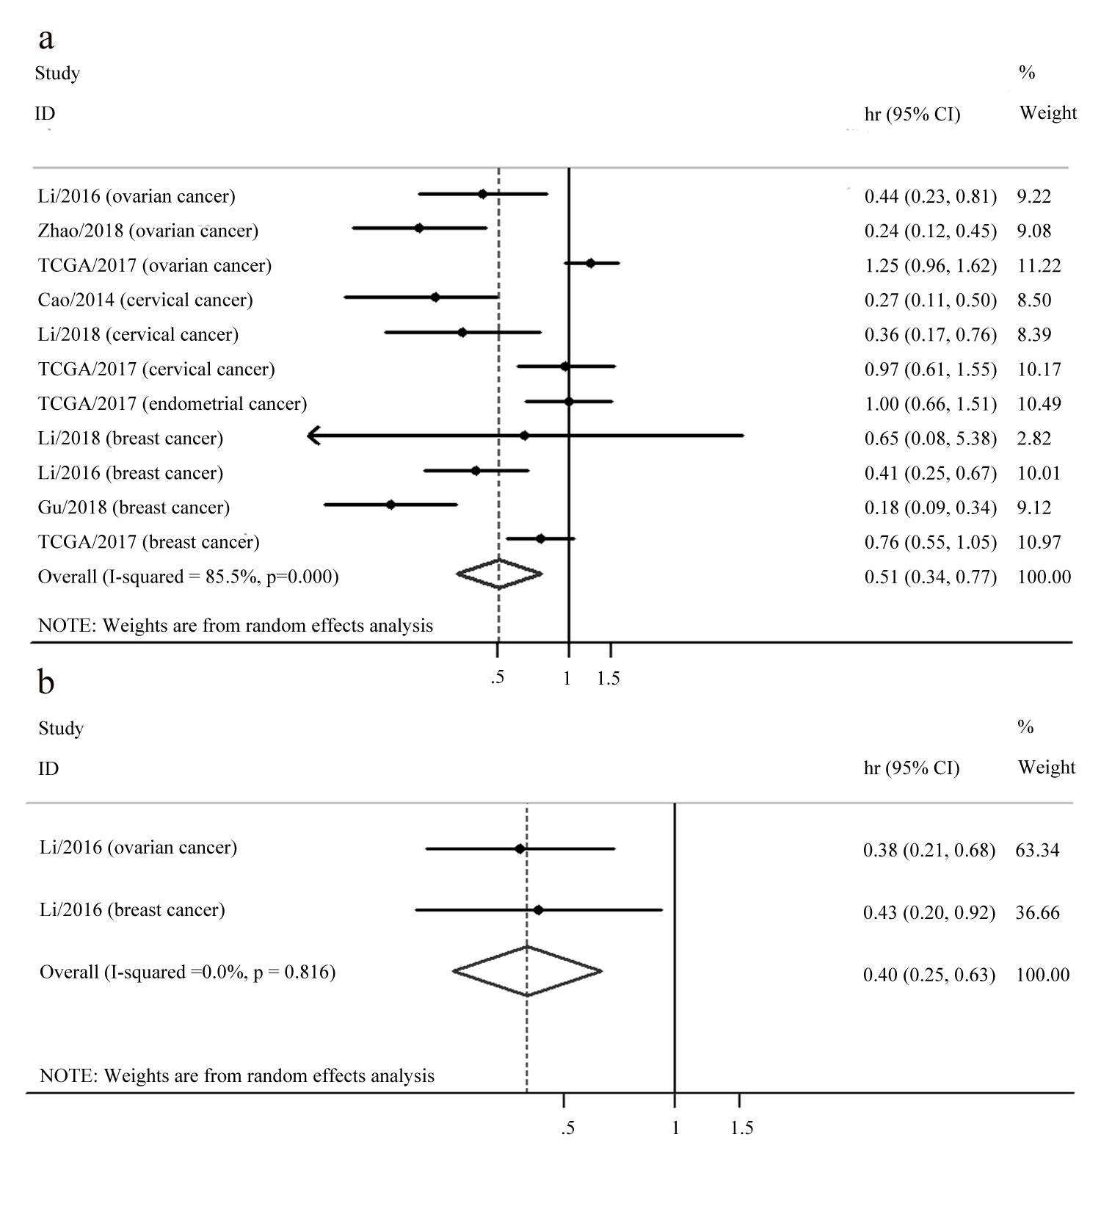
Fig. S4. Association between tissue GAS5 expression and survival of breast and gynecologic cancers. a Forest plots of the association between tissue GAS5 expression and OS in breast and gynecologic cancers. b Forest plots of the association between tissue GAS5 expression and DFS in breast and gynecologic cancers.

Fig. S5. Funnel plots for the association between tissue lncRNA expression and survival outcome of breast and gynecologic patients in the current study.

