SUPPLEMENTARY DATA
Zinc (II) complex of (Z)-4-((4-nitrophenyl) amino) pent-3-en-2-one, a potential antimicrobial agent: Synthesis, characterization, electrochemical, antimicrobial, DFT and docking studies
Waziri I.^{1*}, Wahab O.O.^{2*}, Oselusi S.O.³, Egieyeh S.A.³, Mala G. A.¹, and Nasir H.⁴
¹Department of Pure and Applied Chemistry, University of Maiduguri, P.M.B. 1069, Maiduguri, Maiduguri, Nigeria
²Department of Chemistry, Faculty of Natural and Applied Sciences, Nigerian Army University Biu, P.M.B. 1500, Biu, Nigeria.
³School of Pharmacy, University of the Western Cape, Bellville, Cape Town, 7535, South Africa.
⁴Department of Science Laboratory Technology (SLT), Ramat Polytechnics Maiduguri, Nigeria.
Correspondence Email: triumph2236@gmail.com and olaide.wahab@naub.edu.ng

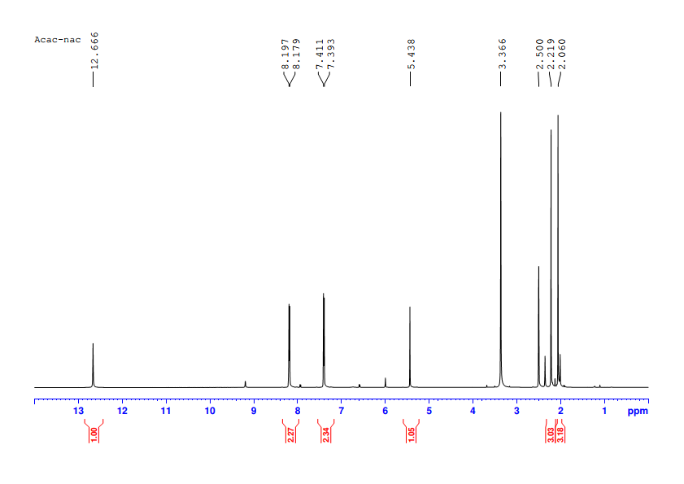
Fig. S1: ¹H NMR spectrum of the ligand (HL) in DMSO-d₆
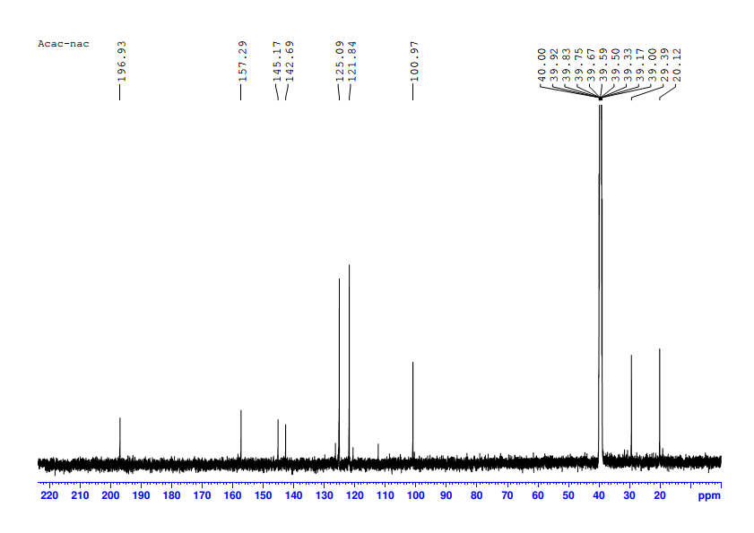
Fig. S2: ¹³C{H} NMR spectrum of the ligand (HL) in DMSO-d₆

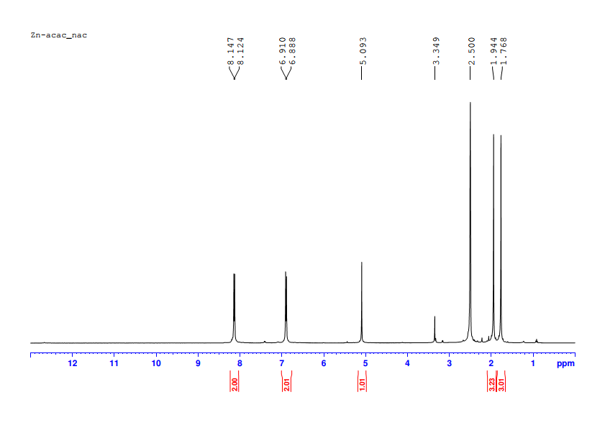
Fig. S3: ¹H NMR spectrum of the complex [ZnL₂] in DMSO-d₆

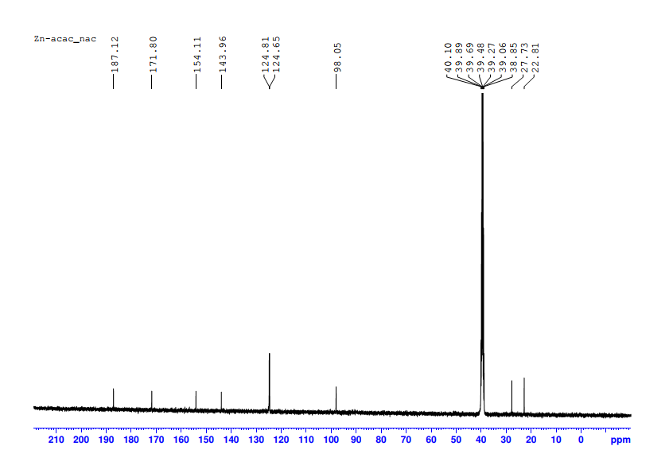Fig. S4: ¹³C{H} NMR spectrum of the complex [ZnL₂] in DMSO-d₆

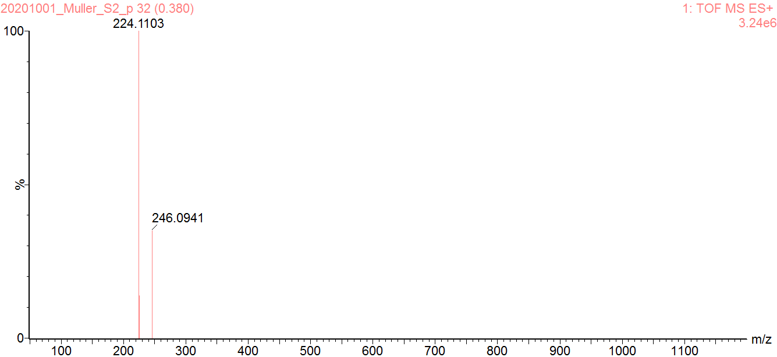
Fig. S5: HRMS of the ligand (HL)

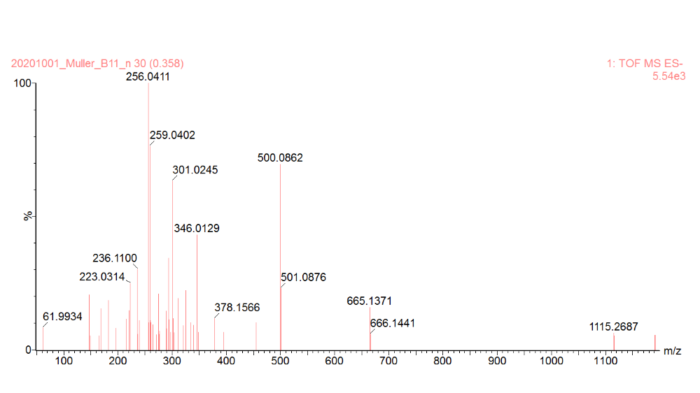
Fig. S6: HRMS of the complex [ZnL₂]

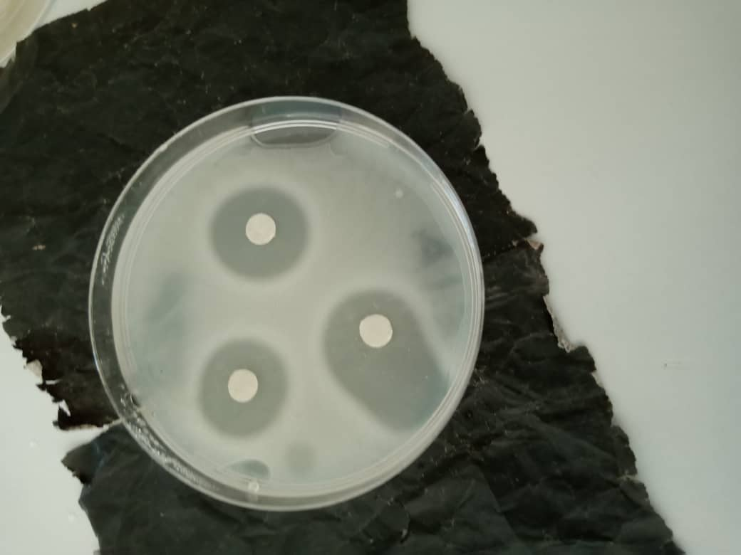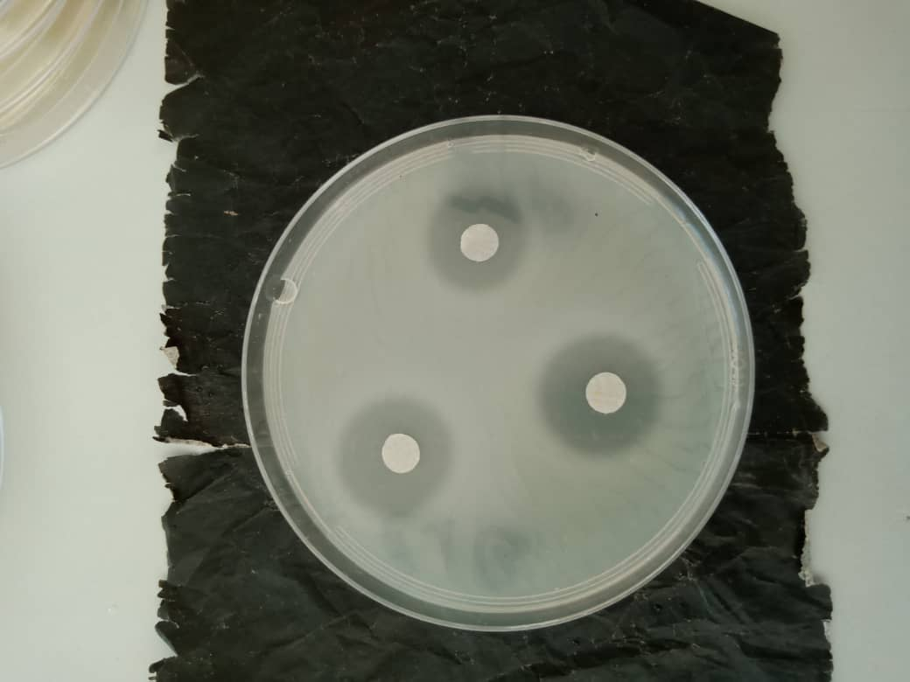
Fig. S7: The photographic image of In vitro study culture plates

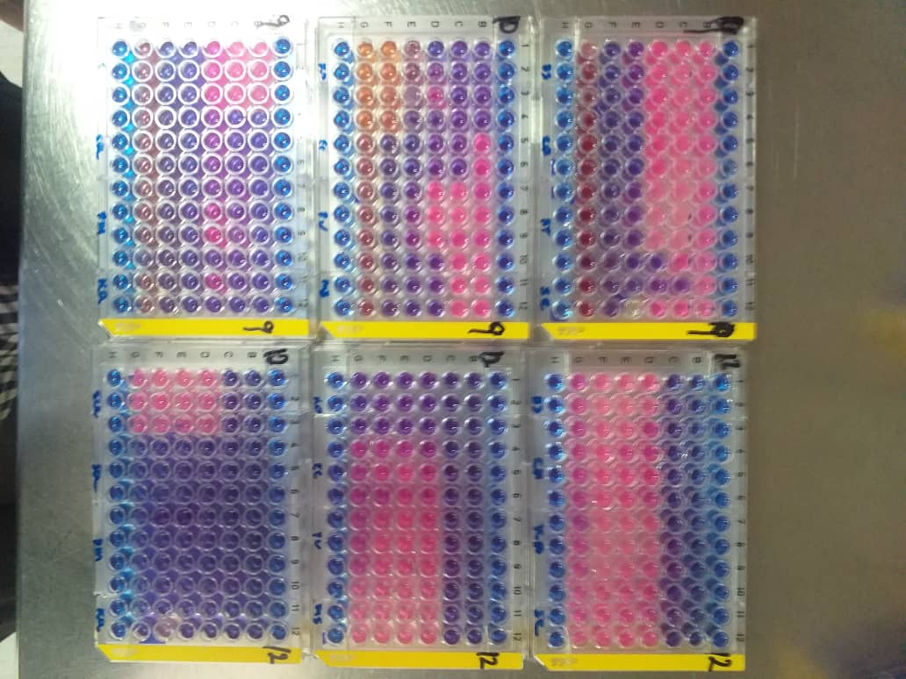
Fig. S8:Photographic image of the MIC study plates

I
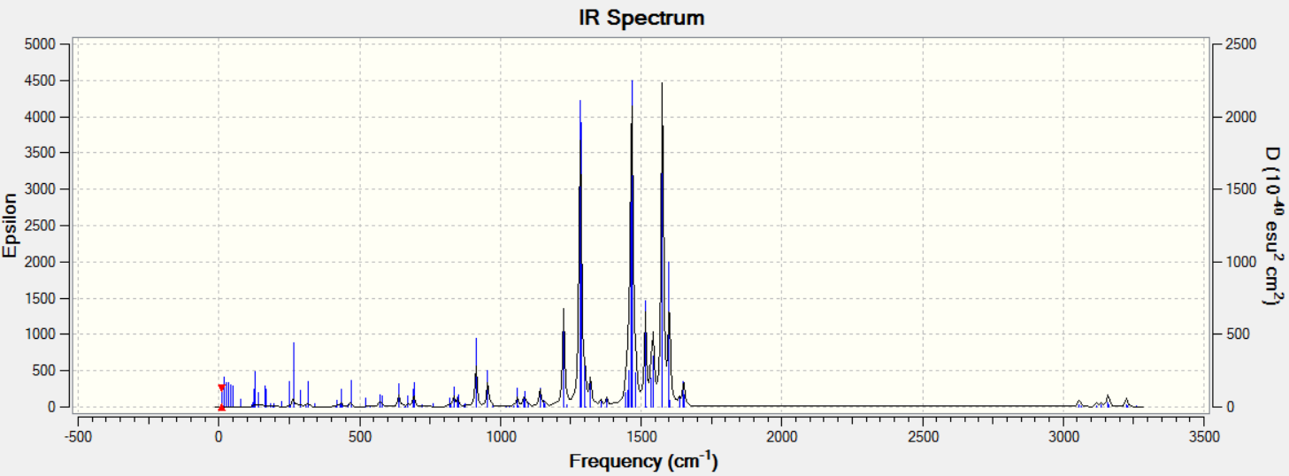
II
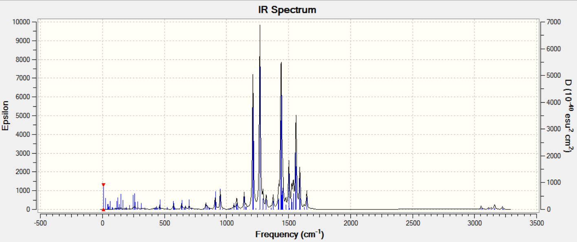
Fig. S9: B3LYP/6-31+G(d,p)predicted IR spectra for HL (I) and ZnL₂ (II) in methanol.
Table S1: Predicted IR frequencies in cm⁻¹unit
Model | N-H | C=O | C-N | Zn-O | Zn-N
HL
B3LYP/6-31+G(d,p) | 3192(3239) | 1666(1632) | 1554(1550) | – | –
wb97xd/6-31+G(d,p) | 3316(3365) | 1722(1642) | 1584(1577) | – | –
M06-2X/6-31+G(d,p) | 3334(3380) | 1747(1714) | 1580(1574) | – | –
Expt. | 3101 | 1620 | 1526 | – | –
ZnL₂
B3LYP/6-31+G(d,p) | – | 1469(1439) | 1320(1321) | 580(581) | 429(430)
wb97xd/6-31+G(d,p) | – | 1491(1452) | 1350(1348) | 595(592) | 440(438)
M06-2X/6-31+G(d,p) | – | 1484(1450) | 1348(1352) | 591(595) | 446(452)
Expt. | – | 1504 | 1334 | 563 | 428

