Supplementary Information
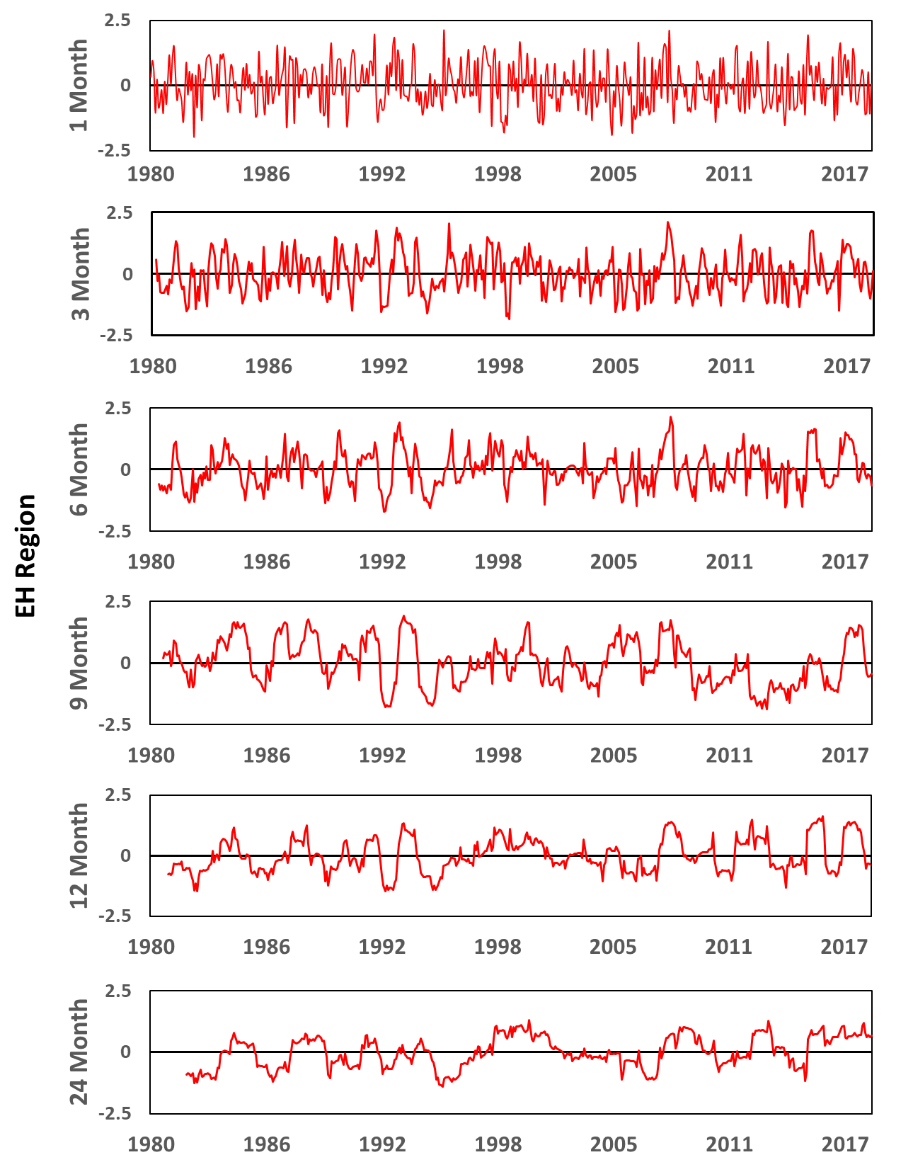 | 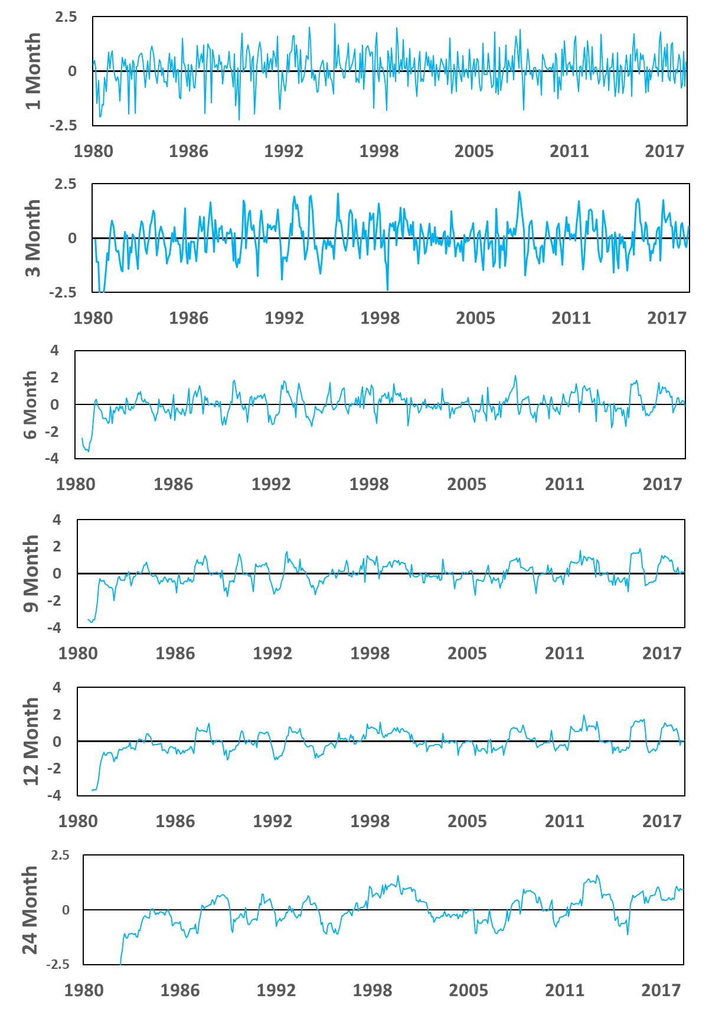
Figure S1 (a) The SPI (left side red colour and SPEI (right side blue colour) values at different timescales for Eastern Hills (EH) region
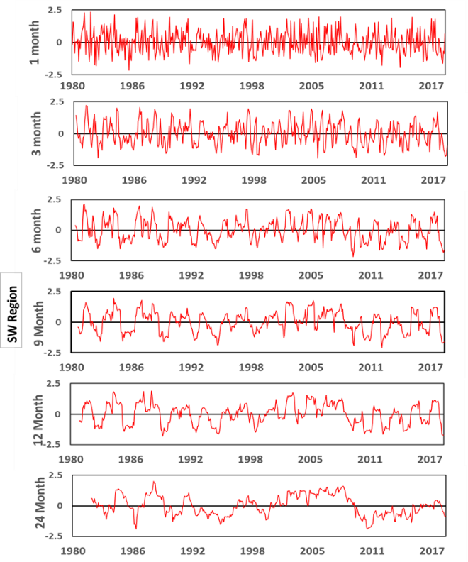 | 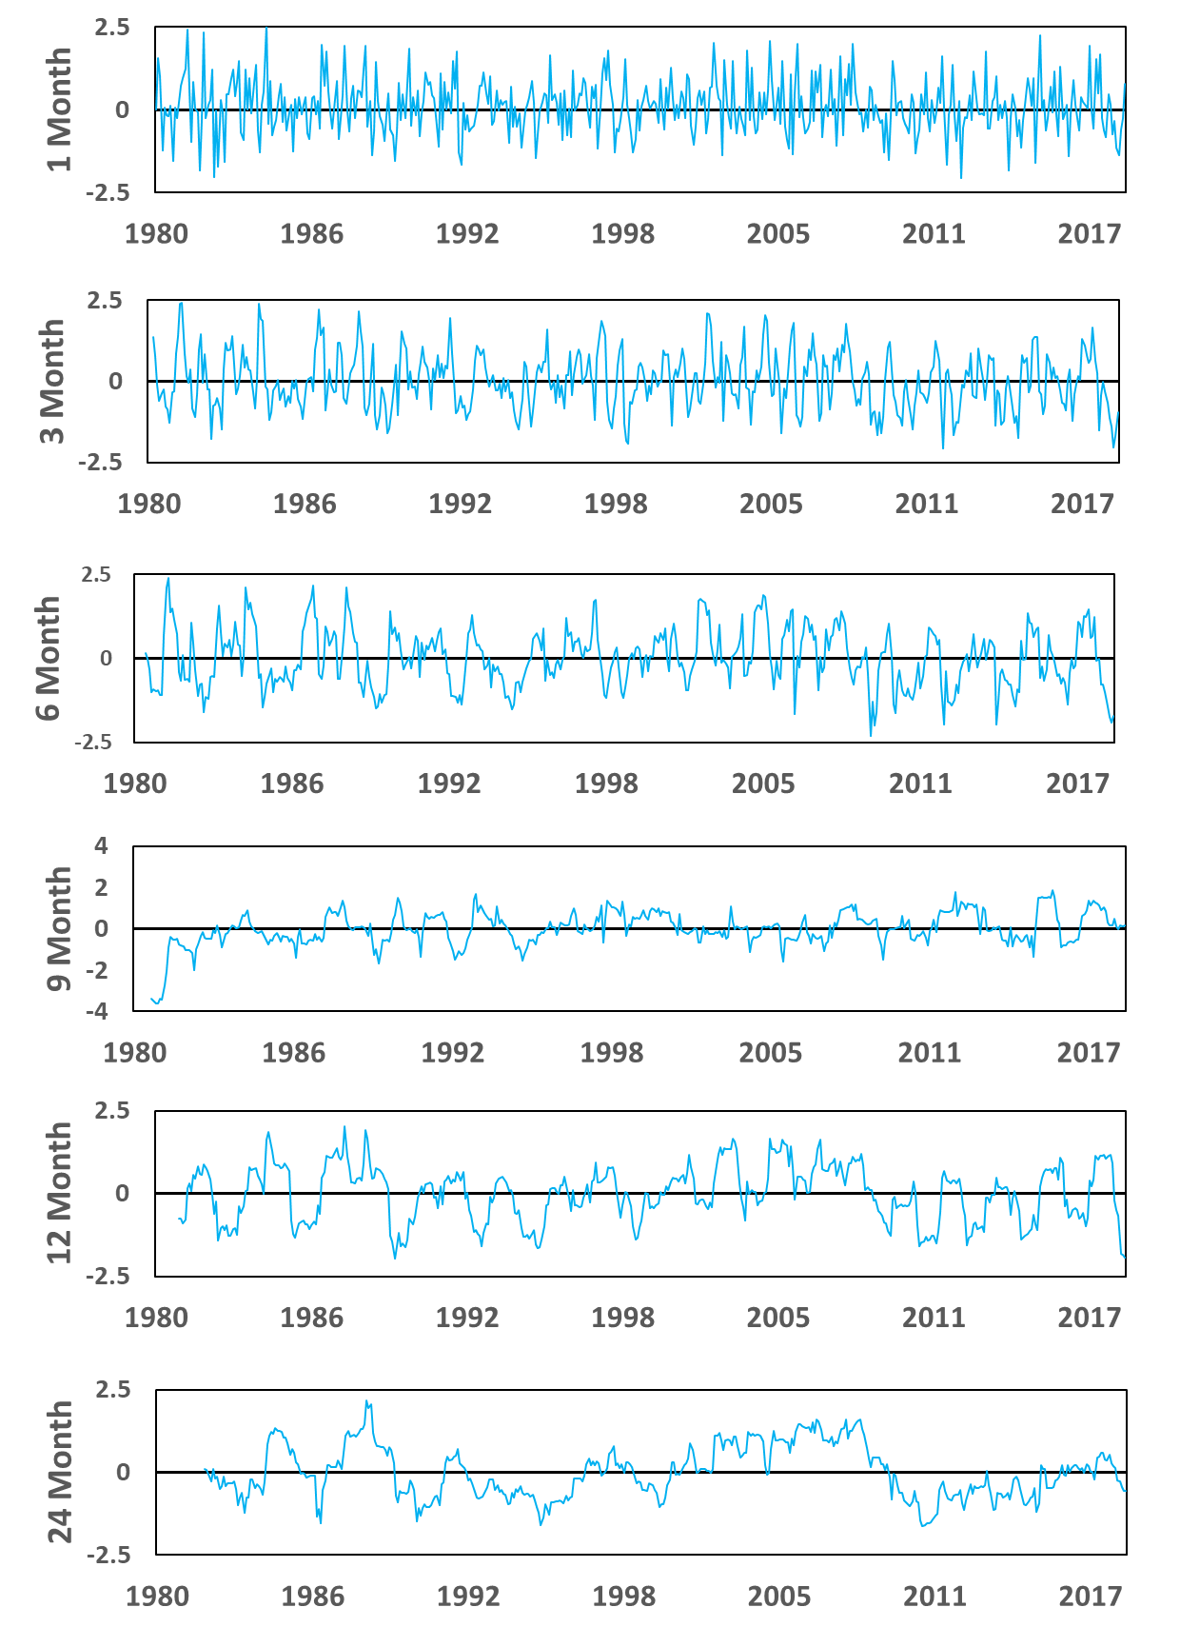
Figure S1 (b) Same as Figure S1 (a), but for Southwest (SW) region
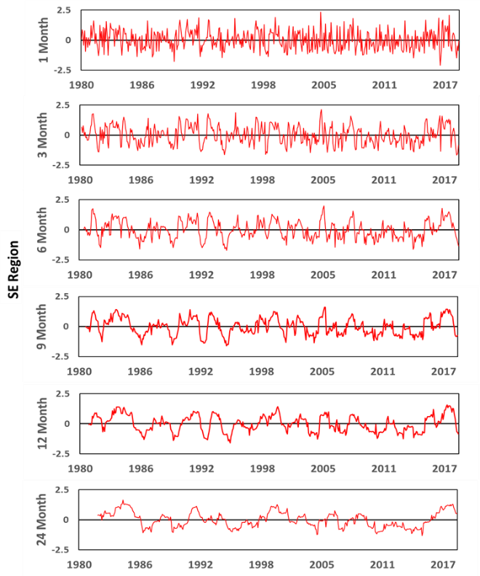 | 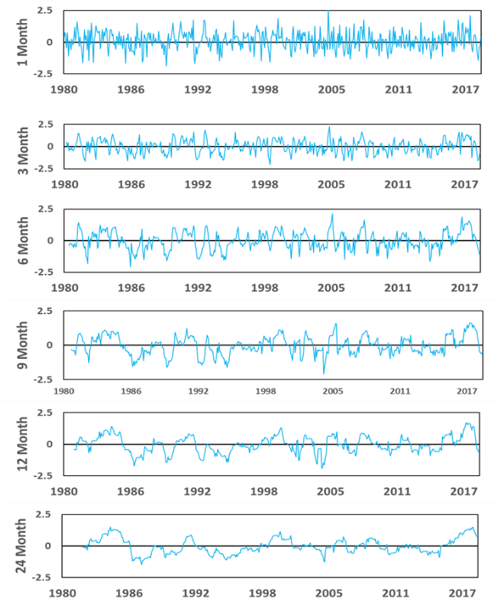
Figure S1 (c) Same as Figure S1 (a), but for Southeast (SE) region
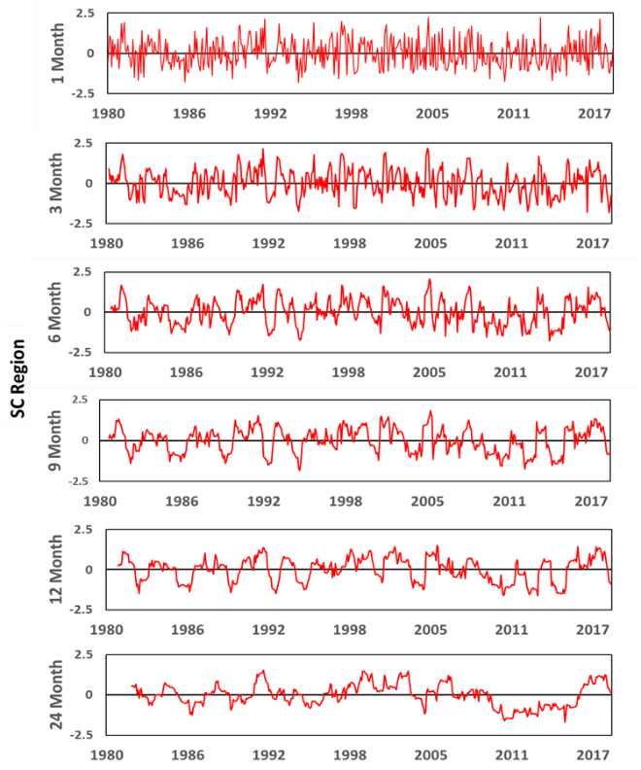 | 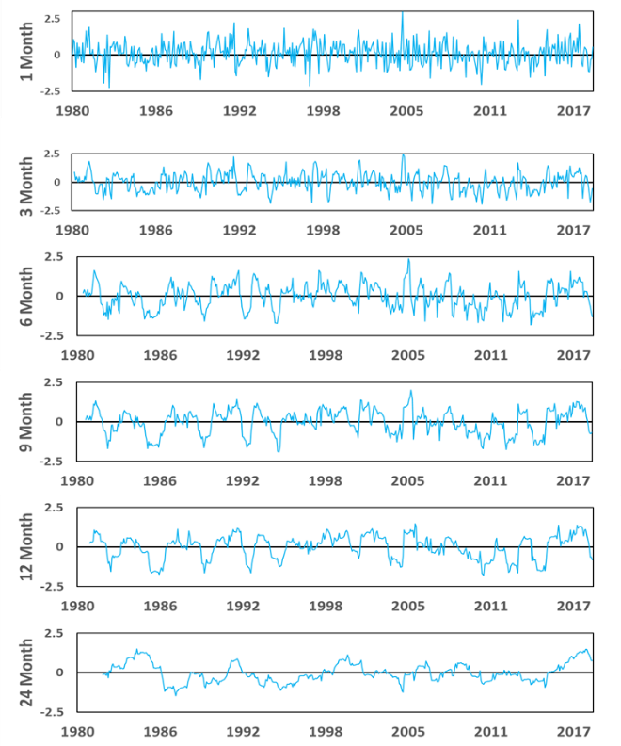
Figure S1 (d) Same as Figure S1 (a), but for South Central (SC) region
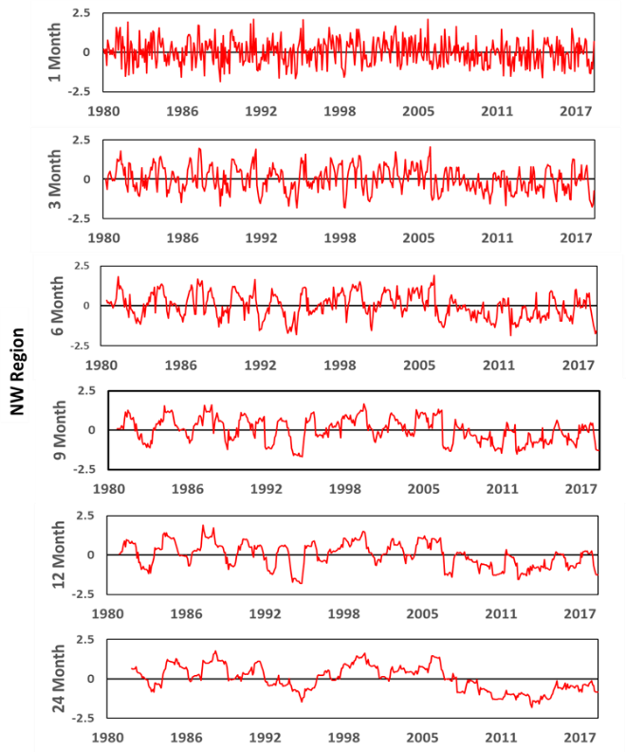 | 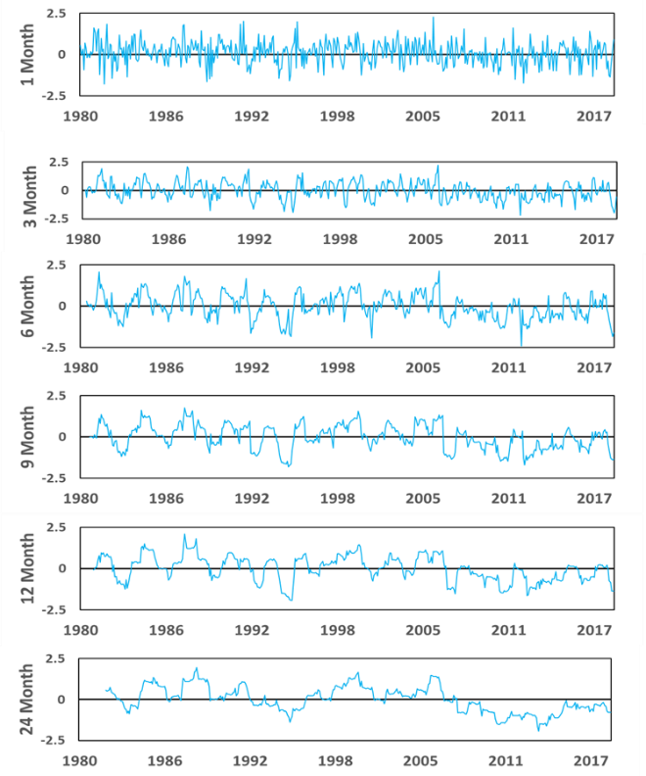
Figure S1 (e) Same as Figure S1 (a), but for Northwest (NW) region
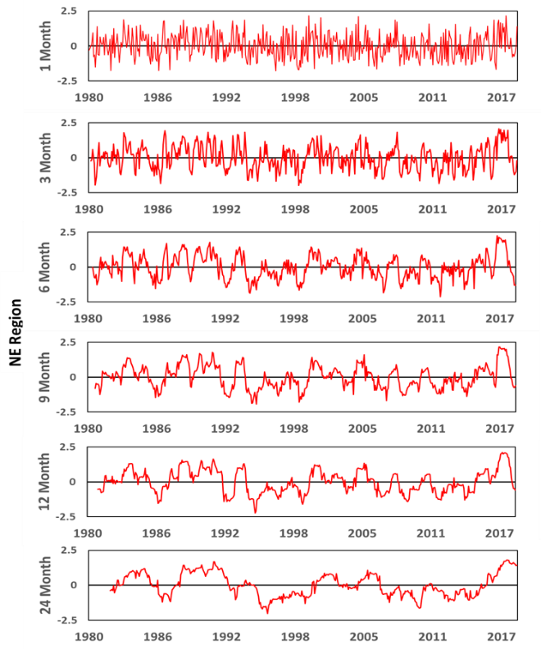 | 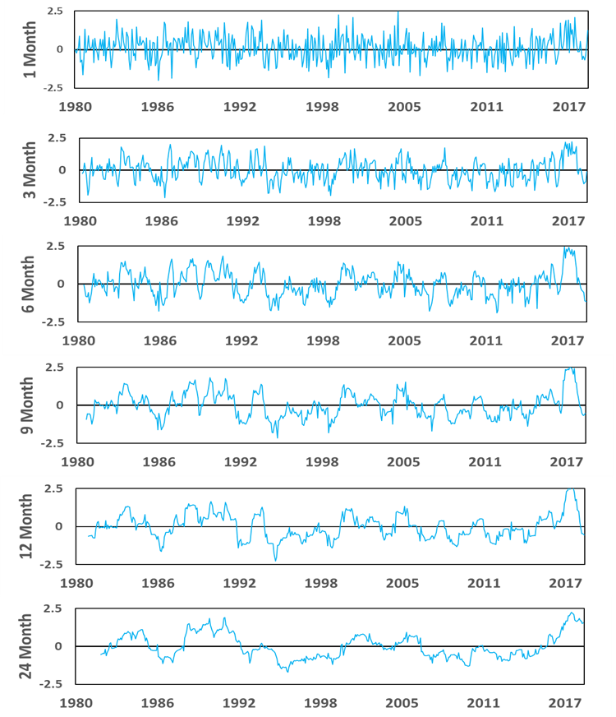
Figure S1 (f) Same as Figure S1 (a), but for Northeast (NE) region
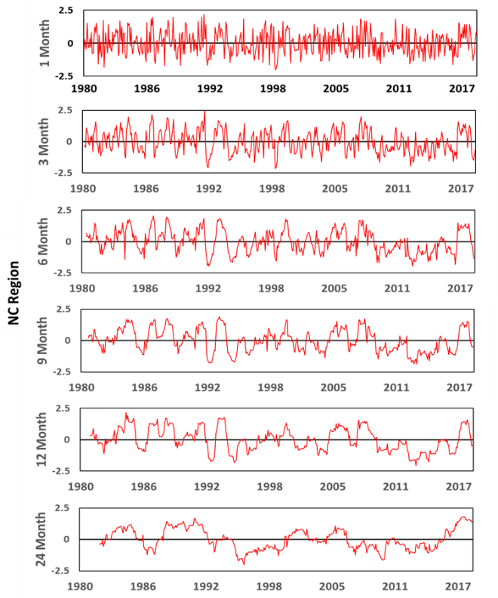 | 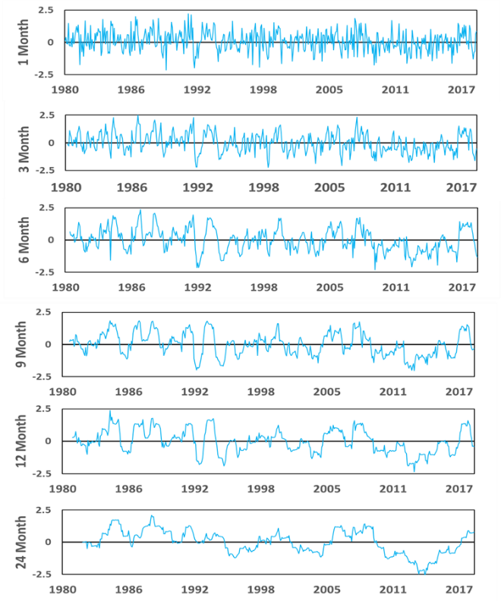
Figure S1 (g) same as Figure S1 (a), but for North Central (NC) region

