Supplementary Information for
Excitatory drive of cortical fast-spiking GABAergic interneurons is set by d-serine acting on NMDA receptors
Pierre Lecouflet^{1†}, Steeve Maldera^{1†}, Brigitte Potier¹, Loredano Pollegioni², Jean-Pierre Mothet^{1*}
¹Université Paris-Saclay, CNRS, ENS Paris-Saclay, CentraleSupélec, Laboratoire Lumière, Matière et Interfaces (LuMin) UMR9024, 91190, Gif-sur-Yvette, France.
²Department of Biotechnology and Life Sciences, University of Insubria, Varese, Italy
†These authors contributed equally to this work
*Corresponding author. jean-pierre.mothet@universite-paris-saclay.fr

The file includes:
Figs. S1 to S7

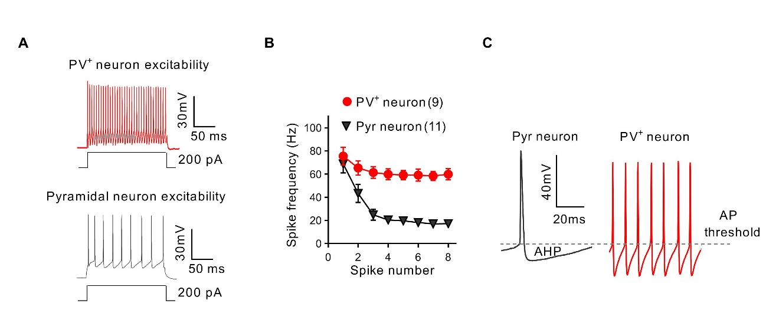
Supplementary figures
Fig. S1. Firing profile of pyramidal cells and FS-PV⁺ interneurons from the layer 5 of mPFC. (A) Representative traces of the firing pattern for a FS-PV⁺ interneurons (red) and regular spiking pyramidal cells (Pyr, black) in response to a 200pA depolarizing current step. (B) Frequency adaptation is limited in FS-PV⁺ interneurons while present in Pyr cells. (C) Comparison of spikes in Pyr neuron (black trace) and FS-PV⁺ interneuron (red trace) highlighting the faster kinetic and bigger after-hyperpolarisation characteristic of spikes from FS-PV⁺ neurons.

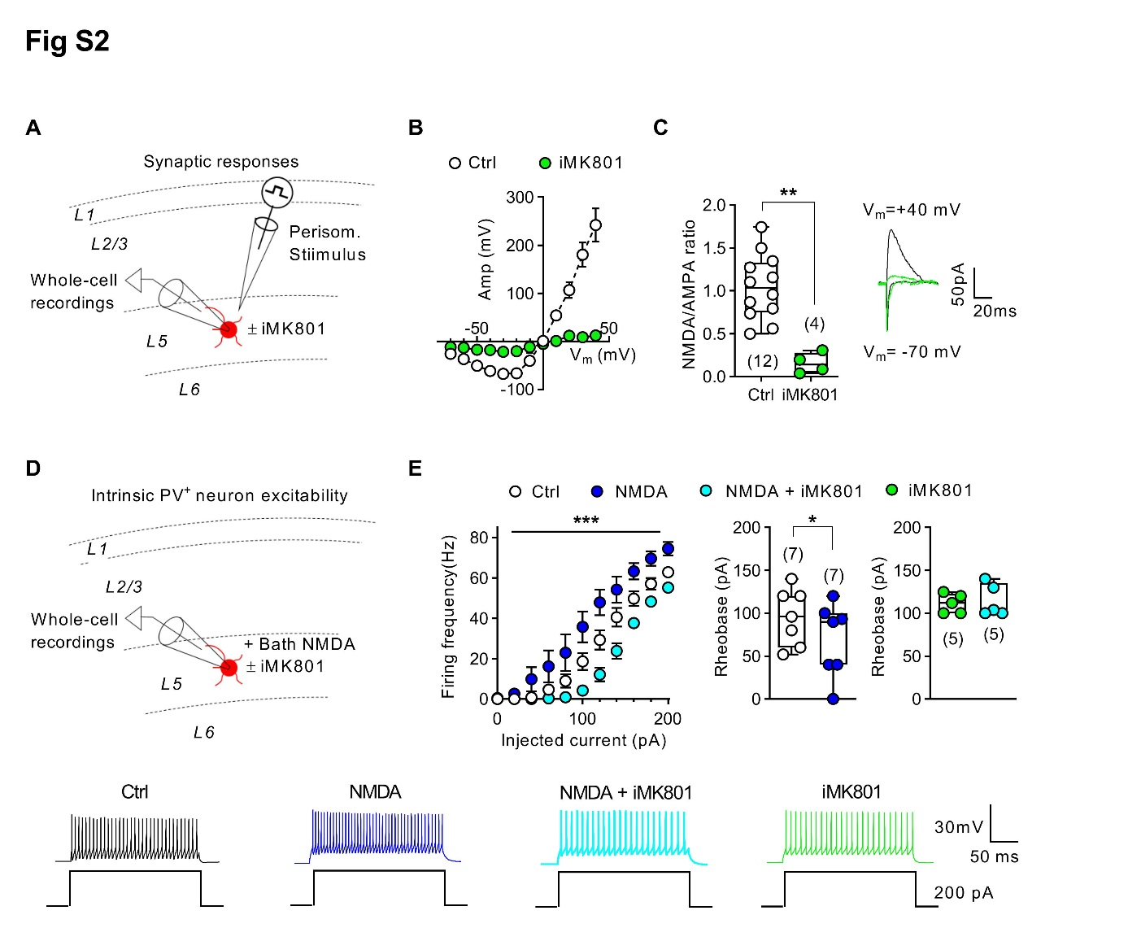
Fig. S2. NMDAR are present on adolescent FS-PV⁺ interneurons and control their excitability. (A), Experimental protocol for EPSCs recording at the excitatory PC onto PV⁺ cell synapse. (B) IV relationship showing almost complete block of NMDA EPSCs’s amplitude by iMK801 (light green) compared to control (Two-way ANOVA: *p=0.0203). (C) iMK801 strongly reduced NMDA/AMPA ratio (Mann-Whitney test: **p=0.0044; Ctrl 1.045 ± 0.11; iMK801 0.1816 ± 0.11) without altering AMPA EPSCs. On the right: representative traces of NMDA EPSCs at +40mV (top) and AMPA EPSCs at -70mV (bottom). (D) Experimental protocol for recording intrinsic excitability of FS-PV⁺ interneurons from PV⁺-tdTomato mice. (E) Top left, Activation of NMDAR by application of NMDA (dark blue) enhanced firing frequency while their blockade by intra-pipette MK801 (iMK801, cyan) had the opposite effect (Two-way ANOVA, ***p=0.0004, F_{(2,27)}=10,72).Top right, NMDA application decreased rheobase (Wilcoxon test, **p=0.0313) while iMK801 increased it (Mann-Whitney test, *p=0.0180). iMK801 suppressed the effect of NMDA on firing frequency (left, Two-way ANOVA, p=0.8093) and on rheobase (right, Wilcoxon test, p=0,7500). Bottom, representative traces of the firing pattern of FS-PV⁺ interneurons for all tested conditions.

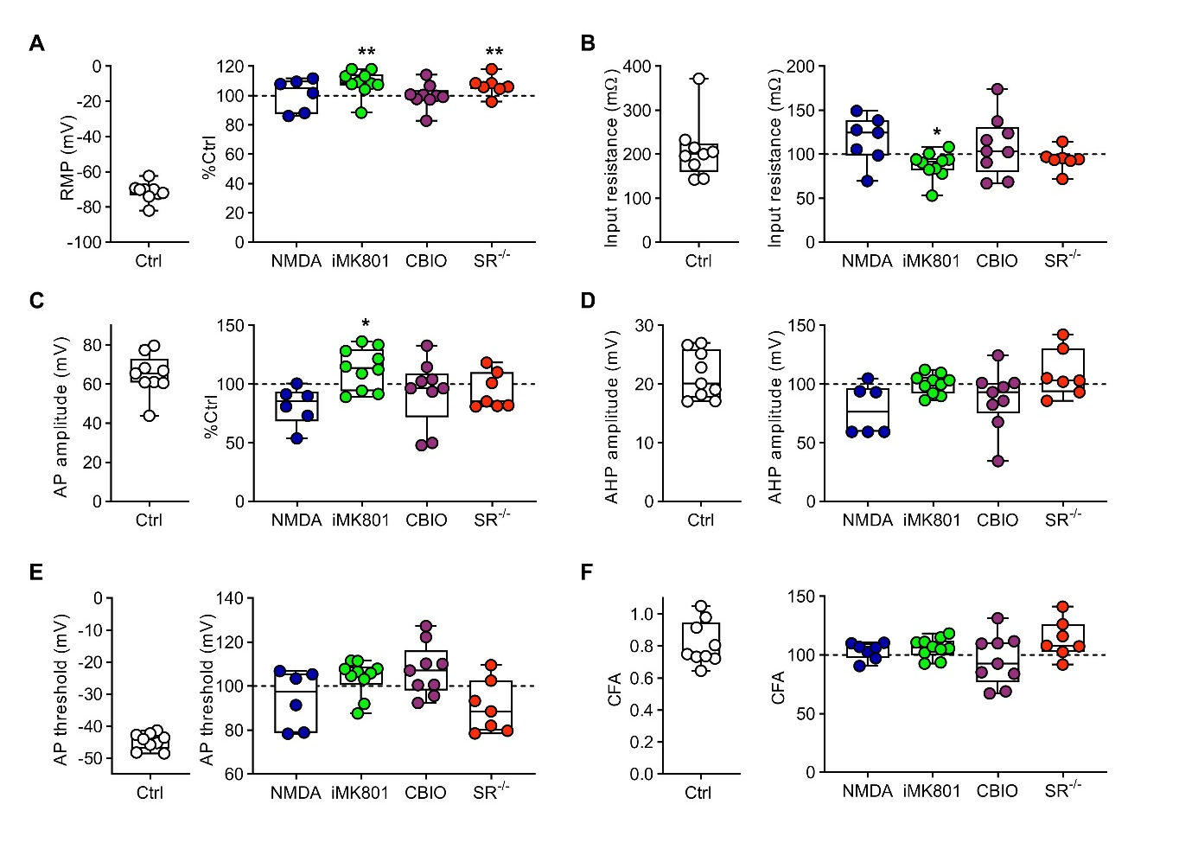
Fig. S3. Gain- and loss-of-function of d-serine does not affect membrane properties of FS-PV⁺ interneurons. (A - F) on the left: boxplot representing control values for resting membrane potential (RMP) (A), input resistance (B), action potential amplitude (AP amplitude) (C), after-hyperpolarization amplitude (AHP amplitude) (D), action potential threshold (AP threshold) (E) and coefficient of frequency adaptation (CFA) (F), respectively. On the right: values of treated group normalized to control mean. iMK801 (110.3 ± 2.72 % of control, n=10) and SR^{-/-} (108.3 ± 2.51 % of control, n=7) groups showed a significant increase in RMP (Wilcoxon test vs 100: *p=0.0275 and *p=0.0313 for MK801 and SR^{-/-} groups respectively). iMK801 treated group also showed a marked decrease in input resistance (87,74 ± 4,75 % of control, Wilcoxon test vs 100 : *p=0.0273) and an increased AP amplitude (113,20 ± 5,44 % of control, Wilcoxon test vs 100 : *p=0.0371).

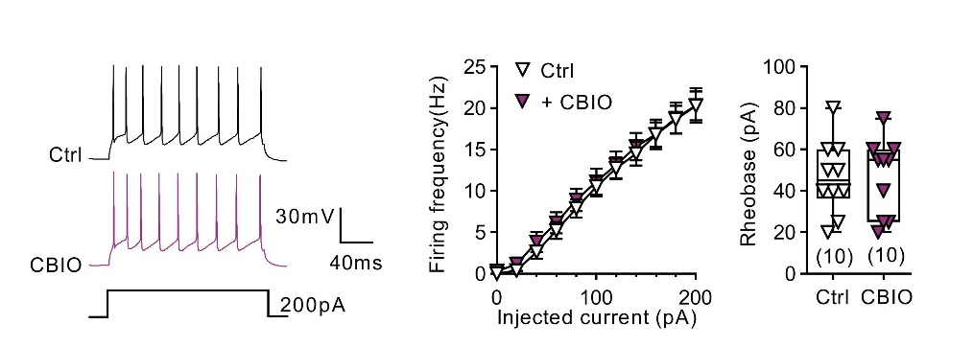

Fig S4. Firing profile of pyramidal cells is not affected by gain of d-serine function. On the left: representative traces of the firing pattern of Pyr cells under control conditions (black trace) and after application of the DAAO inhibitor CBIO (1µM) (purple traces). Elevation of d-serine extracellular levels by CBIO affected neither firing frequency (in the middle, two-way ANOVA, p=0.2565, n=11) nor rheobase (on the right, Wilcoxon test, p>0.9999, n=11).

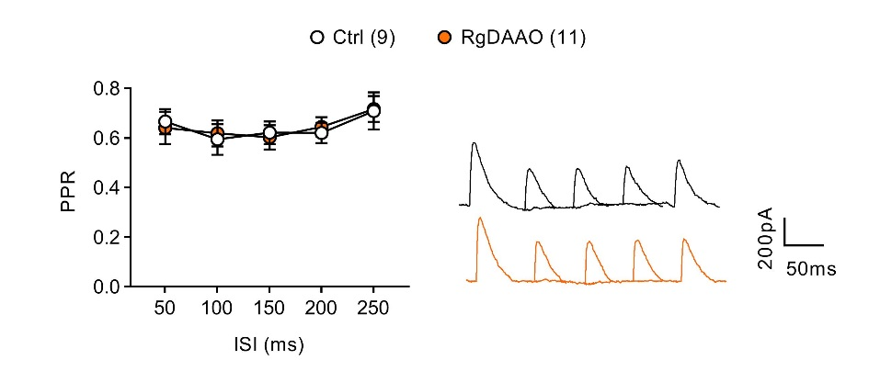

Fig. S5. RgDAAO does not affect paired-pulse ratio. Treatment of PFC slices with RgDAAO to acutely deplete d-serine did not affect PPR (Mixed model REML, p=0.8125 for group effect, F_{(1,18)}=0,05792; n=9 for control and n=11 for RgDAAO). Insets show representative traces at all inter stimulus interval (ISI) tested for control (black traces) and RgDAAO (orange traces) conditions.

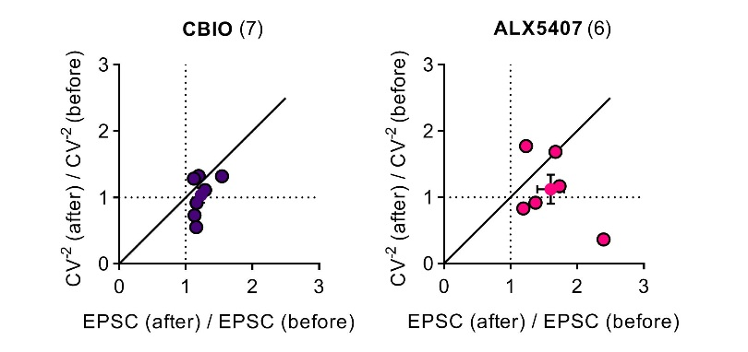

Fig. S6. Postsynaptic modulation of NMDA-EPSCs by d-serine and glycine. Plotting the ratio (after/before CBIO or ALX5407 bath application) of the inverse square of the coefficient of variation (CV⁻²) against the ratio (after/before CBIO or ALX5407 bath application) of the amplitude shows that for both compounds the CV⁻² did not change (One sample Wilcoxon test vs 1: p=0.6875 for both CBIO (1.03 ± 0.11, n=7) and ALX5407 (1.12 ± 0.22, n=6). On the contrary, the amplitude ratio was significantly higher than one (One sample Wilcoxon test vs 1: p=0.0156 for CBIO (1.23 ± 0.06, n=7) and p=0.0313 for ALX5407 (1.60 ± 0.18, n=6).

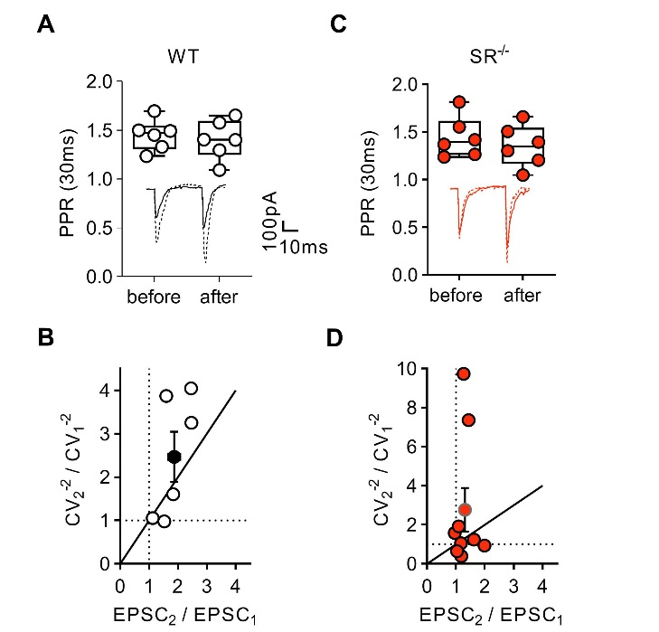

Fig. S7. CV analysis of the theta burst-induced LTP at the PC-to-PV⁺ synapse. (A and C) Paired-pulse ratio in control (1.451 ± 0.065 vs 1.405 ± 0.082, Wilcoxon test p=0.8438, n=6) and SR^{-/-} (1.444 ± 0.088 vs 1.353 ± 0.089, Wilcoxon test p=0.6875, n=6) groups were similar before and after LTP. Insets show representative EPSCs separated by 30 ms for control (before eLTP, continuous black trace and after eLTP black dashed trace) and SR^{-/-} groups (before eLTP, continuous red trace and after eLTP, red dashed trace). (B and D) Plotting the ratio (after/before LTP induction) of the inverse square of the coefficient of variation (CV⁻²) against the ratio (after/before LTP induction) of the amplitude revealed a non-significant increase of CV⁻² for both groups (One sample Wilcoxon test vs 1: p=0.0625 for Ctrl (2.47 ± 0.58, n=6) and p=0.2031 for SR^{-/-} (2.77 ± 1.12, n=9). On the contrary, the amplitude ratio was significantly higher than one (One sample Wilcoxon test vs 1: p=0.0313 for Ctrl (1.83 ± 0.22, n=6) and p=0.0117 for SR^{-/-} (1.31 ± 0.11, n=9).

