Additional Figure 2: Standardized incidence ratio (SIR) of acute lymphoblastic leukaemia (ALL) in the municipalities of residence at birth grouped into rapeseed densityª categories, for children aged 7-14 years (mainland France, RNCE, 1990–2015)
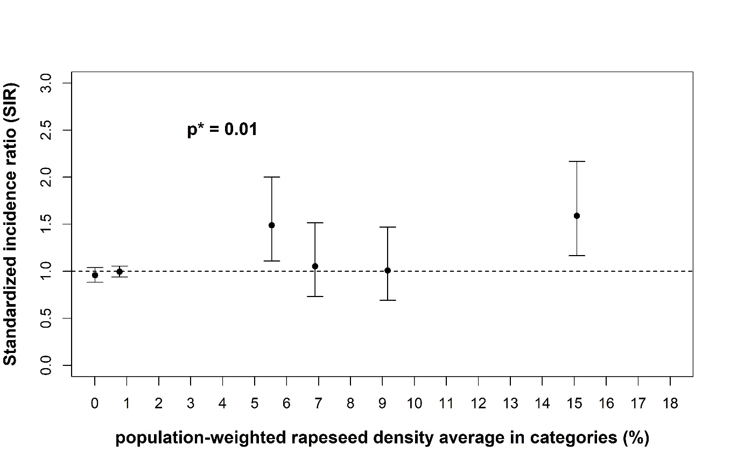
ª The rapeseed density in a municipality is defined as the ratio of the total area used for rapeseed over the total area of the municipality
*p-value of the chi-square test of heterogeneity of SIR of rapeseed density categories

