Supplementary Material 1
This is the isomers of technical 4-NP isomer mixtures. There are hundreds of isomers in the mixtures, and 12 are the main composition.
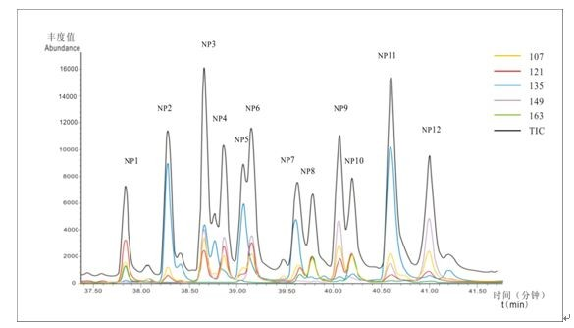

(Wang et al.,2013)
Wang SY., Liu F, Liu YL., Chen L. 2013. Determination of 12 isomers of p-nonylphenol in groundwater by gas chromatography-mass spectrometry. Chinese Journal of Analytical Chemistry,11(41) 1699- 1703.

The structure of 4-NP7 is as below. Although the nomenclature in different publications is different, but the structer is the same(Kim et al., 2005; Saito et al., 2007; Uchiyama et al., 2008; Katase et al., 2008).
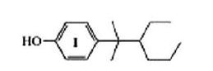

4-(3-ethyl-2-methylhexan-2-yl) phenol

Kim, YS., Katase,T., Horii, Y., Yamashita, N., Makino, M., Uchiyama, T., Fujimoto, Y., Inou. T. 2005. Estrogen equivalent concentration of individual isomer-specific 4-nonylphenol in Ariake sea water, Japan. Marine Pollution Bulletin. 51: 850–856.

Saito H, Uchiyama T, Makino M, Katase T, Fujimoto Y, Hashizume D. Optical resolution and absolute configuration of branched 4-nonylphenol isomers and their estrogenic activities. 2007. J Health Sci;53(2):177–184.

Uchiyama T, Makino M, Saito H, Katase T, Fujimoto Y. 2008. Syntheses and estrogenic
activity of 4-nonylphenol isomers. Chemosphere, 73(1):S60-5.

Katase T, Okuda K, Kim YS, Eun H, Takada H, Uchiyama T, et al. 2008. Estrogen equivalent concentration of 13 branched para-nonylphenols in three technical mixtures by isomer-specific determination using their synthetic standards in SIM mode with GC–MS and two new diasteromeric isomers. Chemosphere, 70(11):1961–1972.

Supplementary Material 2
The extraction of NP and BPA
NP and BPA were extracted by small volume extraction agent after centrifuged. 1 g NaCl was added into the supernatant, and pH was adjusted to 2 with HCL. 4 mL methylene chloride was added, then the solution was shocked for half an hour to mix completely, and then centrifuged, at last the separated methylene chloride solvent was transferred into a new vessel using a bath tube, repeat three times and the extracted solution was combined, then anhydrous Na2SO4 was added to remove residual water. The solution was concentrated to 1 mL and put in a 2mL-Little brown bottle and stored at 4℃.

