Highly improved supercapacitance properties of MnFe₂O₄ nanoparticles by MoS₂ nanosheets

Samira Sharifi, Kourosh Rahimi, and Ahmad Yazdani*
Condensed Matter Physics Group, Department of Basic Sciences, Tarbiat Modares University, Jalal-Ale-Ahmad Avenue, Tehran, Iran.
*Corresponding author: yazdania@modares.ac.ir

Figure S1 presents a graphical abstract of the research highlights.

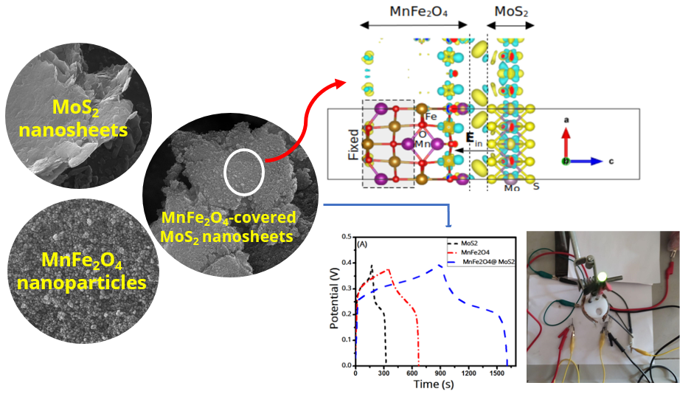
Figure S1. Graphical abstract of the research

