The effectiveness of Non Pharmaceutical Interventions in reducing the outcomes of the COVID-19 epidemic in the UK, an observational and modelling study.

Galanis G. ²*, Di Guilmi C.³, Bennett D.L.¹, Baskozos G.¹*

- Neural Injury Group, Nuffield Department of Clinical Neuroscience, John Radcliffe Hospital, University of Oxford, Oxford, OX39DU,UK

- Institute of Management Studies, Goldsmiths, University of London, New Cross, SE14 6NW, UK.

3. Department of Economics, University of Technology Sydney, Australia
* contributed equally to this work.

Corresponding author: Georgios Baskozos,
email: georgios.baskozos@ndcn.ox.ac.uk
Nuffield Department of Clinical Neuroscience,
John Radcliffe Hospital,
University of Oxford,
Oxford,
UK

Keywords

SEIR model, COVID-19, Bahavioural model, Intervention effectiveness

Supplementary Material
Supplemental Figure 1:
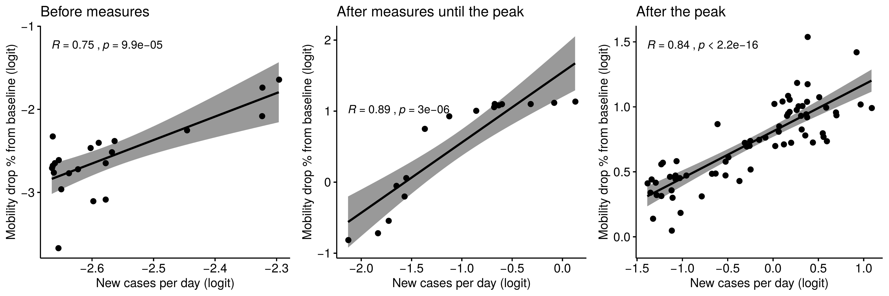Supplemental Figure 1
Plots of the logit transformation (ratio of proportions) of the percentage drop of mobility from baseline against new cases per day. Plots show the relationship between mobility and new cases for three periods. A: Before measures, B: After implementing the Non-Pharmaceutical Interventions and C: After the peak of the epidemic. In all cases we have strong significant correlations between drop in mobility and new cases per day. The correlation is stronger after the measures and up to peak of the epidemic.

