Positive end-expiratory pressure selection by comprehensively considering clinical measurements and patient characteristics may improve ICU outcome in ARDS patients: an observational study

Supplements

Qing Pan, Yuhan Zhou, Yilin Qian, Zhongheng Zhang,
Luping Fang, Gangmin Ning, Leo M. Heunks, Huiqing Ge

eTable 1 Included features listed by category
Feature Category | Features
Demographic information | Age, Gender, Weight, Height, Admission type, Ethnicity
Ventilator Information | Ventilator duration hours, Tidal volume, Respiratory rate set, FiO₂, P_{peak}-PEEP
Vital signs | Heart rate, Systolic blood pressure, Diastolic blood pressure, Mean arterial pressure, Percutaneous oxygen saturation, Respiratory rate, Temperature
Blood Gas | Glucose, Arterial PH, Arterial partial pressure of oxygen (PaO₂), Arterial partial pressure of carbon dioxide (PaCO₂), Base excess, PaO₂/FiO₂ ratio
Clinical Scores | Sequential Organ Failure Assessment (SOFA)

eTable 2 Definition of the discrete action space for the reinforcement learning model. PEEP grades are categorized into eleven levels.
Discretized PEEP grade | PEEP range (cmH₂O)
0 | <5
1 | [5,7)
2 | [7,9)
3 | [9,11)
4 | [11,13)
5 | [13,15)
6 | [15,17)
7 | [17,19)
8 | [19,21)
9 | [21,23)
10 | ≥23

eTable 3 Percentage of the patients where clinicians gave higher, equal, and lower PEEP grade during the first 7 days of MV using assist/control ventilation, and its relationship with the outcome in the eICU database.
 | <0  (clinicians higher PEEP than RL model) |  | =0 | >0  (RL model higher PEEP than clinicians) | p-value
Number of patients
n (%)
mild ARDS | 69 (17.1) |  | 146 (36.1) | 189 (46.8)
moderate ARDS | 315 (31.4) |  | 124 (12.4) | 563 (56.2)
severe ARDS | 340 (47.8) |  | 20 (2.8) | 351 (49.4)
total | 724 (34.2) |  | 290 (13.7) | 1103 (52.1)
PEEP-G_{RL-model}ª
mean (±SD)
mild ARDS | 1.2 (±0.4) |  | 1.0 (±0.0) | 1.7 (±0.8) | <0.0001
moderate ARDS | 1.4 (±0.6) |  | 1.0 (±0.3) | 2.1 (±0.8) | <0.0001
severe ARDS | 2.2 (±0.8) |  | 1.3 (±0.6) | 2.4 (±0.7) | <0.0001
total | 1.7 (±0.8) |  | 1.0 (±0.3) | 2.1 (±0.8) | <0.0001
PEEP-G_{clinician}
mean (±SD)
mild ARDS | 1.8 (±0.7) |  | 1.0 (±0.0) | 1.0 (±0.3) | <0.0001
moderate ARDS | 2.1 (±1.0) |  | 1.0 (±0.3) | 1.3 (±0.5) | <0.0001
severe ARDS | 3.4 (±1.4) |  | 1.3 (±0.6) | 1.6 (±0.6) | <0.0001
total | 2.7 (±1.4) |  | 1.0 (±0.3) | 1.3 (±0.6) | <0.0001
Demographic information
mean (±SD)
Age (year) | 61.8 (±15.7) |  | 68.6 (±14.1) | 58.5 (±16.3) | <0.0001
BMI (kg/m²) | 32.3 (±11.0) |  | 29.4 (±8.6) | 29.5 (±10.3) | <0.0001
ARDS risk
n (%)
direct | 470 (64.9) |  | 119 (41.0) | 611 (55.4)
indirect | 254 (35.1) |  | 171 (59.0) | 492 (44.6)
Ventilatory parameters
mean (±SD)
V_{T} (ml) | 458.4 (±81.5) |  | 476.7 (±90.6) | 468.2 (±86.2) | <0.01
V_{T}/pbw (ml/kg) | 7.2 (±1.3) |  | 7.7 (±1.9) | 7.3 (±2.1) | <0.001
RR_{set} (bpm) | 18.5 (±5.3) |  | 15.0 (±3.5) | 18.6 (±4.7) | <0.0001
FiO₂ (%) | 52.1 (±13.0) |  | 38.6 (±7.0) | 47.4 (±11.1) | <0.0001
P/F (mmHg) | 204.9 (±80.8) |  | 291.6 (±105.8) | 232.2 (±92.7) | <0.0001
P_{plat} (cmH₂O) | 22.9 (±5.3) |  | 17.6 (±4.0) | 20.3 (±4.7) | <0.0001
P_{peak} (cmH₂O) | 25.2 (±6.5) |  | 19.8 (±5.7) | 23.5 (±6.0) | <0.0001
DP (cmH₂O) | 13.8 (±4.1) |  | 12.6 (±4.0) | 14.3 (±4.5) | <0.0001
C_{rs} (ml/cmH₂O) | 39.4 (±15.7) |  | 43.8 (±23.3) | 38.6 (±16.4) | <0.0001
MP (J/minute) | 17.4 (±7.9) |  | 11.8 (±5.6) | 16.0 (±6.7) | <0.0001
norMP ($×$10⁻³J/min/kg) | 275.4 (±126.2) |  | 195.0 (±124.3) | 249.2 (±126.5) | <0.0001
Clinical scores
mean (±SD)
SOFA |  | 8.8 (±3.8) | 7.5 (±3.2) | 9.3 (±4.0) | <0.0001
Outcome
ICU mortality, n (%)
mild ARDS |  | 11 (15.9) | 12 (8.2) | 41 (21.7)
moderate ARDS |  | 68 (21.6) | 12 (9.7) | 133 (23.6)
severe ARDS |  | 116 (34.1) | 1 (5.0) | 130 (37.0)
total |  | 195 (26.9) | 25 (8.6) | 304 (27.6)
28-day ventilation-free days, mean (±SD)
mild ARDS |  | 18.2 (±9.2) | 20.1 (±7.4) | 19.5 (±7.9) | 0.238
moderate ARDS |  | 16.3 (±9.2) | 19.6 (±7.2) | 17.4 (±9.5) | <0.01
severe ARDS |  | 13.4 (±12.0) | 20.7 (±3.7) | 16.5 (±10.1) | <0.0001
total |  | 15.1 (±10.8) | 19.9 (±7.1) | 17.5 (±9.5) | <0.0001
ª: The actual PEEP range is between 5 + (PEEP grade - 1) $×$ 2 and 5 + PEEP grade $×$ 2 cmH₂O

eTable 4 Characteristics of the patients in four groups of in the eICU database
Groups of | -2 | -1 | 0 | 1 | 2 | p-value
Range of | <-1 | [-1, 0) | 0 | (0,1] | >1
No.
Mild | 18 | 51 | 146 | 139 | 50
Moderate | 66 | 249 | 124 | 364 | 199
Severe | 156 | 184 | 20 | 224 | 127
All | 240 | 484 | 290 | 727 | 376
Mortality (%)
Mild | 38.9 | 7.8 | 8.2 | 20.1 | 26.0
Moderate | 25.8 | 20.5 | 9.7 | 20.3 | 29.6
Severe | 39.1 | 29.8 | 5.0 | 36.6 | 37.8
All | 35.4 | 22.7 | 8.6 | 25.3 | 31.9
Free from ventilation (days)
Mild | 21.9 (18.0, 23.2) | 21.2 (16.6, 23.8) | 22.8 (18.6, 24.7) | 22.1 (16.9, 24.2) | 22.9 (14.9, 25.4) | 0.509
Moderate | 19.4 (13.4, 23.7) | 18.7 (12.6, 22.4) | 21.9 (16.3, 24.7) | 19.9 (14.0, 23.3) | 20.8 (14.3, 25.0) | <0.0001
Severe | 15.8 (7.5, 20.2) | 16.2 (8.0, 21.0) | 20.4 (18.6, 23.4) | 19.1 (12.4, 22.7) | 19.8 (13.5, 24.6) | <0.001
All | 17.0 (9.4, 22.2) | 18.2 (11.8, 22.0) | 22.1 (17.9, 24.7) | 20.1 (14.0, 23.6) | 20.6 (14.1, 24.9) | <0.0001
Admission type (No.)
Urgent | 98 (40.8) | 191 (39.5) | 118 (40.7) | 300 (41.3) | 149 (39.6)
Non-urgent | 142 (59.2) | 293 (60.5) | 172 (59.3) | 427 (58.7) | 227 (60.4)
ARDS risk (No.)
direct | 161 (67.1) | 309 (63.8) | 119 (41.0) | 419 (57.6) | 192 (51.1)
indirect | 79 (32.9) | 175 (36.2) | 171 (58.9) | 308 (42.4) | 184 (48.9)
Age (year) | 59.5 (48.0, 71.0) | 65.0 (55.0, 74.2) | 70.0 (60.2, 79.0) | 64.0 (54.0, 73.0) | 52.5 (38.8, 62.0) | <0.0001
BMI (kg/m²) | 33.2 (27.3, 40.6) | 29.2 (24.5, 34.5) | 27.9 (24.2, 32.6) | 28.1 (23.7, 33.6) | 27.7 (23.5, 33.2) | <0.0001
PEEP (cmH₂O) | 11.8 (9.5, 13.2) | 7.2 (6.2, 9.1) | 5.0 (5.0, 5.0) | 5.2 (5.0, 7.5) | 5.3 (5.0, 6.2) | <0.0001
V_{T} (ml) | 450.0 (389.3, 500.0) | 461.7 (400.0, 504.2) | 477.2 (431.0, 500.0) | 475.1 (420.0, 500.4) | 467.8 (400.0, 500.0) | <0.001
V_{T} /pbw (ml/kg) | 7.0 (6.1, 7.8) | 7.2 (6.5, 7.9) | 7.5 (6.8, 8.3) | 7.3 (6.5, 8.1) | 7.0 (6.4, 7.7) | <0.0001
RR_{set} (bpm) | 20.0 (16.0, 24.6) | 16.2 (14.0, 20.0) | 14.1 (12.0, 16.8) | 17.0 (14.5, 20.5) | 19.9 (16.0, 23.0) | <0.0001
FiO₂ (%) | 57.9 (48.8, 67.6) | 46.9 (41.0, 54.5) | 39.7 (33.4, 42.2) | 44.6 (39.8, 51.7) | 46.7 (41.4, 54.0) | <0.0001
P/F (mmHg) | 163.0 (126.1, 225.8) | 202.9 (160.0, 259.9) | 281.3 (229.1, 340.0) | 219.8 (173.6, 280.1) | 207.8 (161.6, 272.4) | <0.0001
P_{plat} (cmH₂O) | 25.5 (22.0, 29.3) | 21.0 (18.0, 24.4) | 17.2 (15.0, 20.0) | 19.7 (16.8, 23.0) | 20.2 (17.6, 23.2) | <0.0001
DP (cmH₂O) | 13.8 (11.2, 17.0) | 13.0 (10.8, 15.9) | 12.1 (9.9, 14.9) | 13.3 (10.8, 16.2) | 14.2 (11.9, 17.3) | <0.0001
C_{rs} (ml/cmH₂O) | 35.6 (27.4, 45.9) | 37.5 (30.3, 47.1) | 39.9 (33.1, 50.0) | 37.3 (29.9, 46.7) | 34.3 (26.4, 42.3) | <0.0001
P_{peak} (cmH₂O) | 27.9 (23.8, 32.4) | 23.6 (19.1, 27.6) | 19.5 (16.1, 23.2) | 22.8 (19.1, 26.8) | 24.4 (20.2, 28.0) | <0.0001
MP (J/minute) | 18.9 (15.0, 24.7) | 14.7 (11.0, 20.1) | 11.1 (8.3, 14.3) | 14.7 (11.0, 19.2) | 16.2 (12.2, 20.7) | <0.0001
norMP ($×$10⁻³J/min/kg) | 303.7 (232.6, 413.8) | 241.8 (169.4, 311.5) | 180.8 (126.9, 238.2) | 230.1 (175.8, 300.6) | 246.9 (186.4, 322.8) | <0.0001
SOFA | 9.0 (7.0, 12.0) | 8.0 (6.0, 11.0) | 7.0 (5.0, 10.0) | 9.0 (6.0, 12.0) | 10.0 (7.0, 13.0) | <0.0001
Data are given in median (IQR)
MP was calculated as described previously [1], using VT, P_{peak}, respiratory rate (RR), and driving pressure (DP) data: $\text{MP }\left({\text{J}}/{\text{min}}\right)\text{=0.098×}{\text{V}}_{\text{T}}\text{×RR×}{\text{(P}}_{\text{peak}}\text{-0.5×DP)}$. norMP[2] was calculated as $\text{norMP (×}{\text{10}}^{\text{-3}}\text{J/min/kg)=MP/PBW}$.
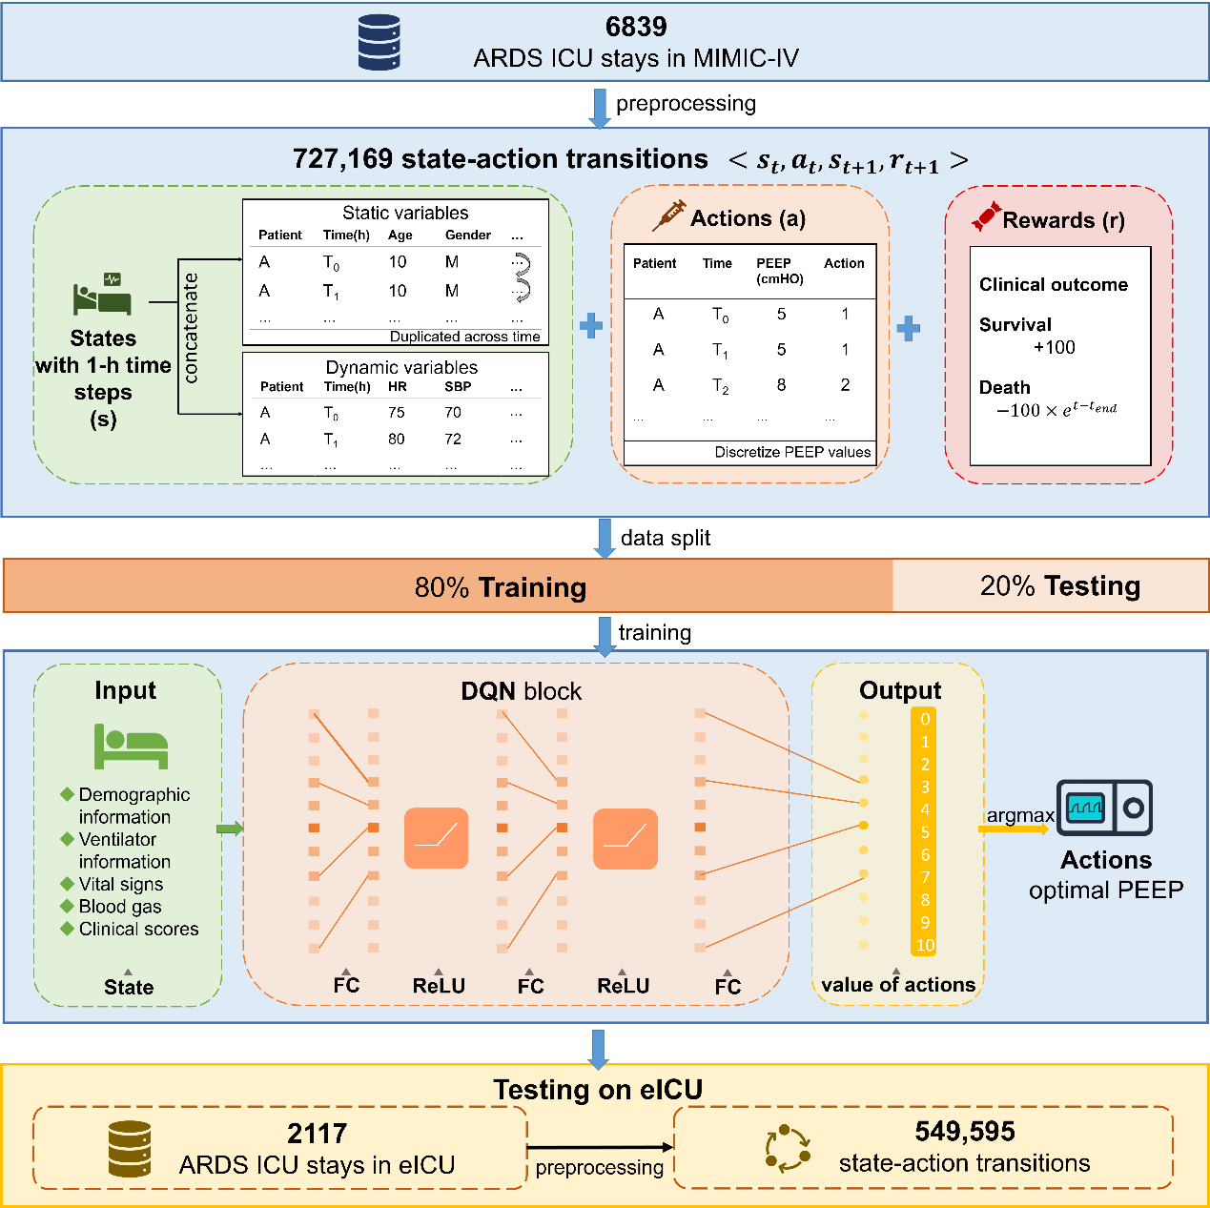
eFigure 1 The block diagram of the deep Q network.

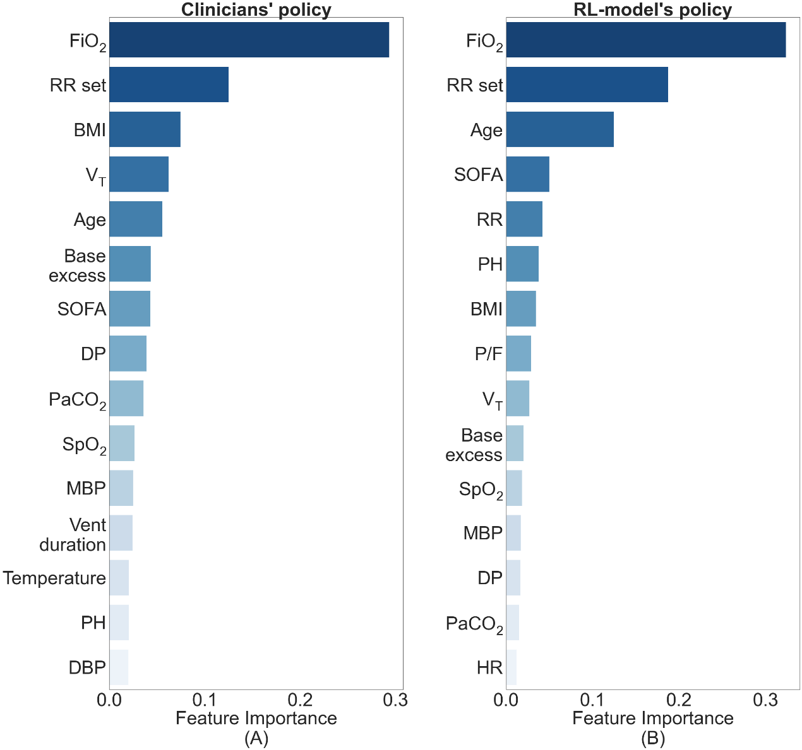
eFigure 2 Ranking of relative feature importance of the (A) clinicians and (B) RL model for high PEEP ($≥$10 cmH₂O) and low PEEP (<10 cmH₂O) in the eICU database

References
1. Gattinoni L, Tonetti T, Cressoni M, Cadringher P, Herrmann P, Moerer O, Protti A, Gotti M, Chiurazzi C, Carlesso EJICM, (2016) Ventilator-related causes of lung injury: the mechanical power42: 1567-1575
2. Zhang Z, Zheng B, Liu N, Ge H, Hong Y, (2019) Mechanical power normalized to predicted body weight as a predictor of mortality in patients with acute respiratory distress syndrome. Intensive Care Med 45: 856-864

