Supplementary data 1

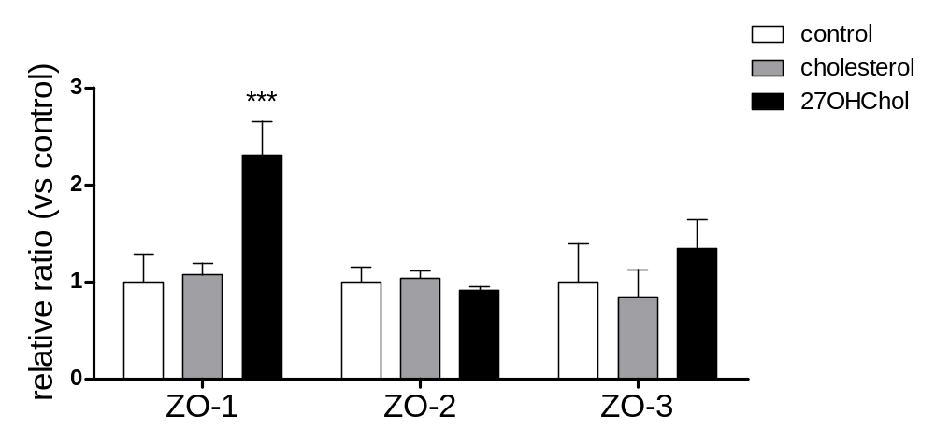

Role of 27OHChol in expression of ZO-family on monocytic cells

THP-1 cells (1×10⁶ cells/60 mm culture dish) were stimulated for 48 h with 5 µg/ml of cholesterol or 2.5 µg/ml of 27OHChol. Total RNAs were extracted and analyzed by quantitative real-time PCR. Results are representative of three independent experiments. ***: P < 0.01 vs. control

Supplementary data 2
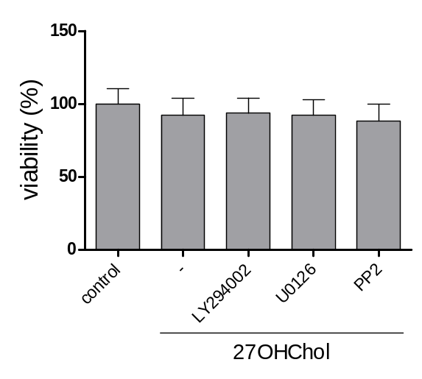
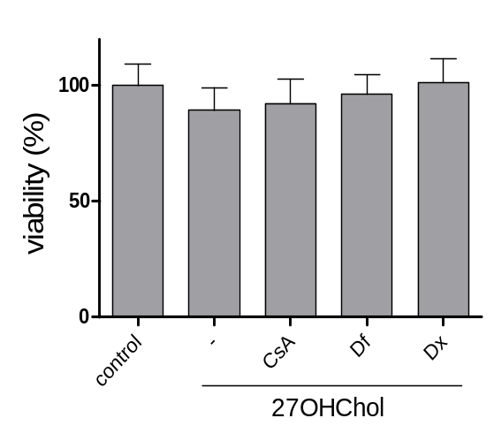
(A)
(B)

Check of viability for toxicity of inhibitors and drugs on monocytic cells

THP-1 cells (1×10⁴ cells/96 well plate; triplicate) were co-cultured for 48 h with 2.5 µg/ml of 27OHChol and the experimented concentration of inhibitors/drugs. Viability of the cells was determined with cell counting kit-8 (CCK-8).

Supplementary data 3
(A)
(B)

(C)
(D)

Role of differentiation-involved drugs in the 27OHChol-induced ZO-1 expression on monocytic cells

THP-1 cells (1×10⁶ cells/60 mm culture dish) were treated with 2.5 µg/ml of 27OHChol and 50 nM of CsA/ 25 μg/ml of Df for 48 h. (A) Transcription of ZO-1 was analyzed by real-time PCR. ***: P < 0.01 vs. control; #: P < 0.1 vs. 27OHChol; ###: P < 0.01 vs. 27OHChol (B) Protein level of the ZO-1 was determined by Western blot. (C) The cells, stimulated with 27OHChol and indicated concentration of drugs, were immunostained with antibody against ZO-1 and were analyzed by flow cytometry. (D) The cells cultured on coated coverslip were immunostained with anti-ZO-1 antibody, and were visualized by confocal microscopy. Results are representative of three independent experiments.

