Supporting Information
Soil vulnerability to acid or alkali spills: Identifying changes in physicochemical properties and pH buffering capacity in response to spills
Inhyeong Jeon¹, Hyeonyong Chung¹, Sang Hyun Kim¹, Kyoungphile Nam^{1,}*

¹Department of Civil and Environmental Engineering, Seoul National University, Gwanak-ro 1, Gwank-gu, Seoul 08826, Republic of Korea

*Corresponding author: Prof. Kyoungphile Nam
Address: Seoul National University, Gwanak-ro 1, Gwanak-gu, Seoul 08826, Republic of Korea
Email address: kpnam@snu.ac.kr
Phone: +82 2 880 1448
Fax: +82 2 873 2684

Number of Pages: 12
Number of Figures: 4
Number of Tables: 7
The Supporting Information contains the following figures and tables:

Fig. S1. Titration curves of twenty soils (untreated, acid-spilled, and alkali-spilled)
Fig. S2. Standardized residual plots and Q-Q plots of SMLR of CEC and pH buffering capacity of three different soils (untreated, acid-spilled, and alkali-spilled)
Fig. S3. Number of clusters against within groups sum of squared errors (SSE) based on organic matter and clay content, CEC, and pH buffering capacity
Fig. S4. Relationship between organic matter and clay content and soil vulnerability the spills

Table S1. Physicochemical properties of twenty field soils used in this study
Table S2. Physicochemical properties of twenty soils after acid or alkali spills
Table S3. pH buffering capacity of twenty soils before and after acid or alkali spills
Table S4. Results of Kolomogorov-Smirnov test to check normality assumption of the differences in physicochemical properties and pH buffering capacity of soils before and after acid or alkali spills
Table S5. Pairwise t-test or Wilcoxon signed rank test results of the differences in the physicochemical properties and pH buffering capacity of soils before and after acid or alkali spills
Table S6. Results of tests to check the normality, autocorrelation, and multicollinearity assumptions for multiple linear regression analysis
Table S7. Summary on statistical tests (i.e., KS, ANOVA, KW, and Levene’s test, and post-hoc analysis) of three clustered groups’ physicochemical properties and pH buffering capacity

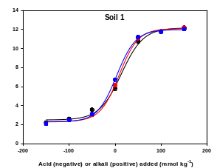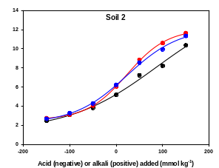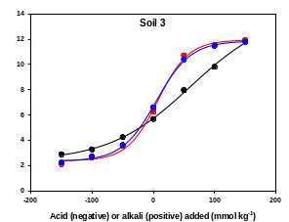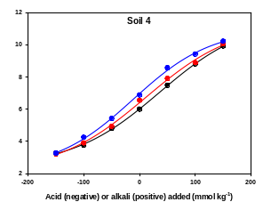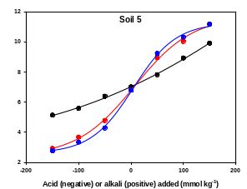
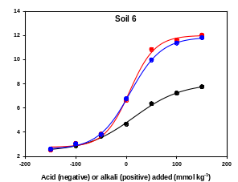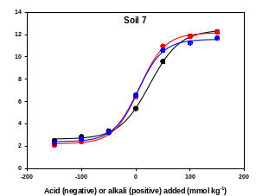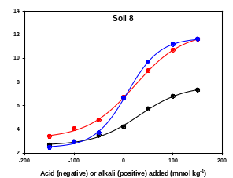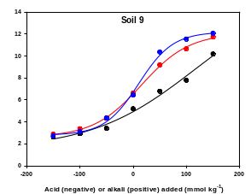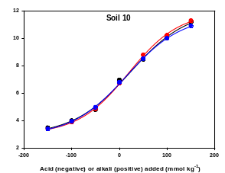
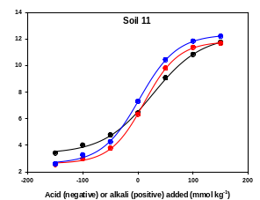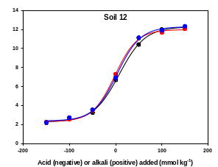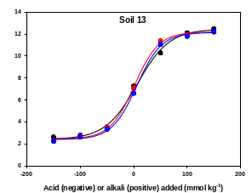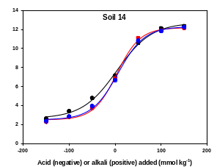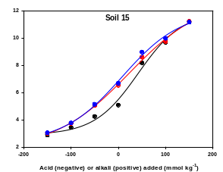
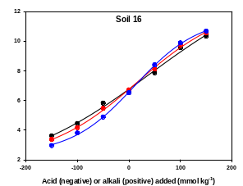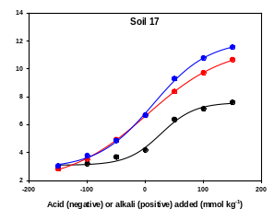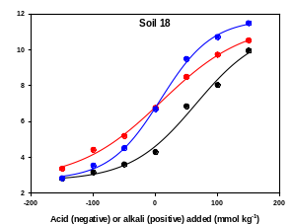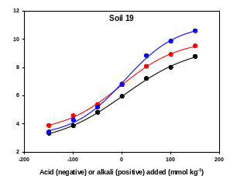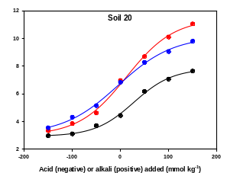
Fig. S1. Titration curves of twenty soils (untreated, acid-spilled, and alkali-spilled). Symbols are experimental data and lines are fitted sigmoidal curve derived from optimized adjustable parameters in Eq. (2). Black, red, and blue symbols or lines represent data of untreated, acid-spilled, and alkali-spilled soils, respectively. All experimental data fitted well within predicted titration curves.

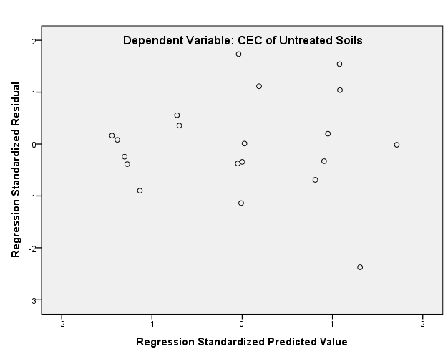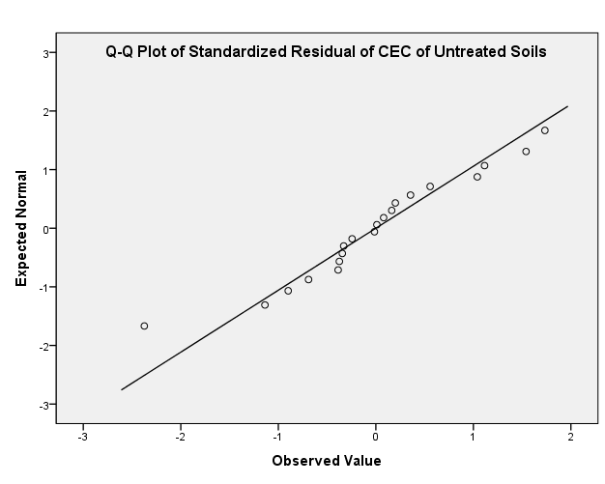
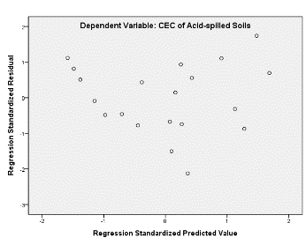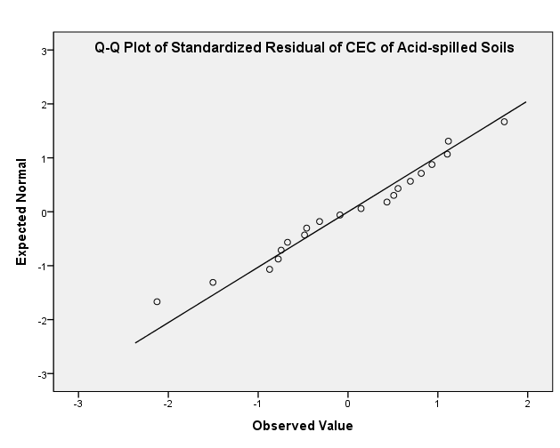
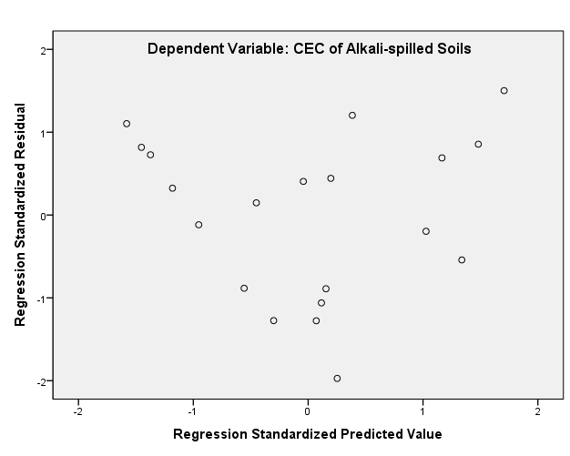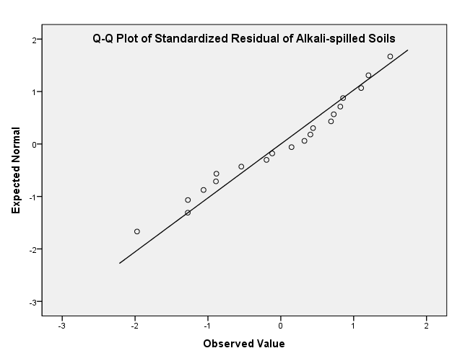
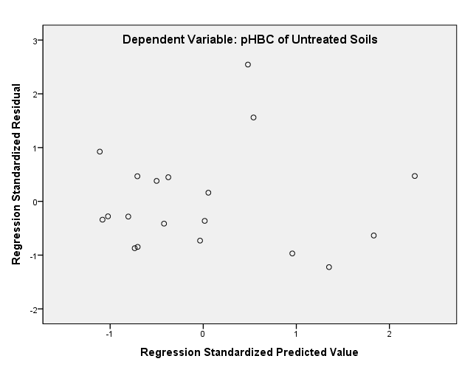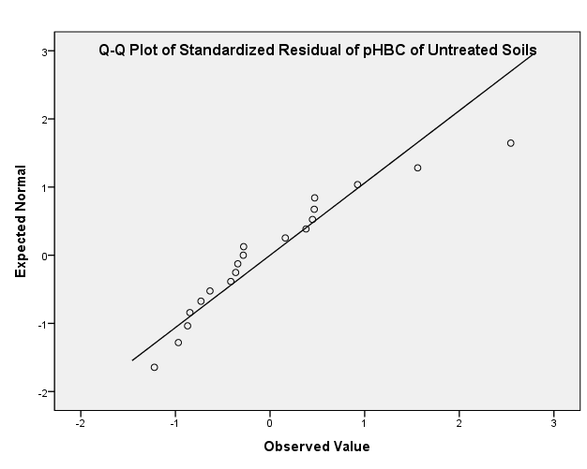
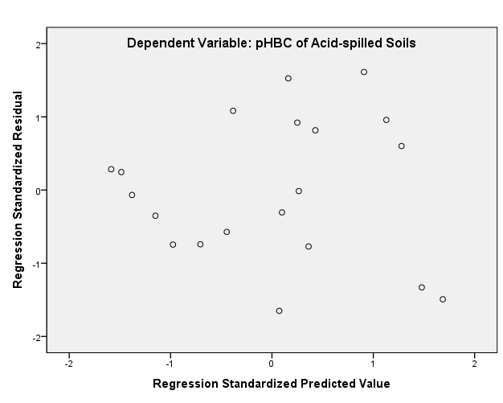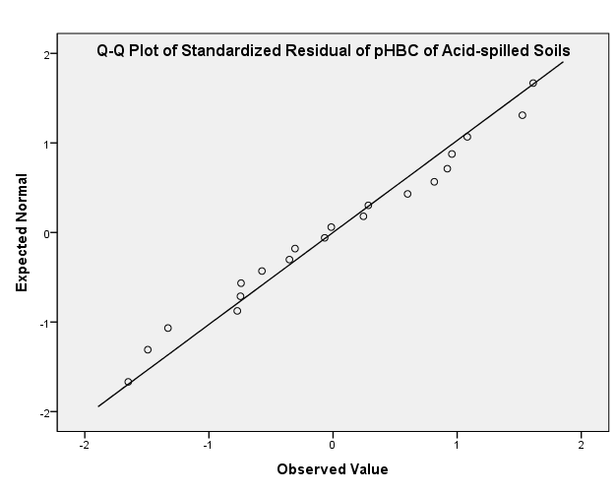
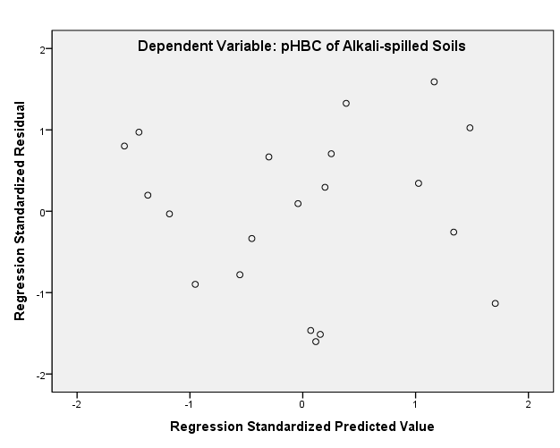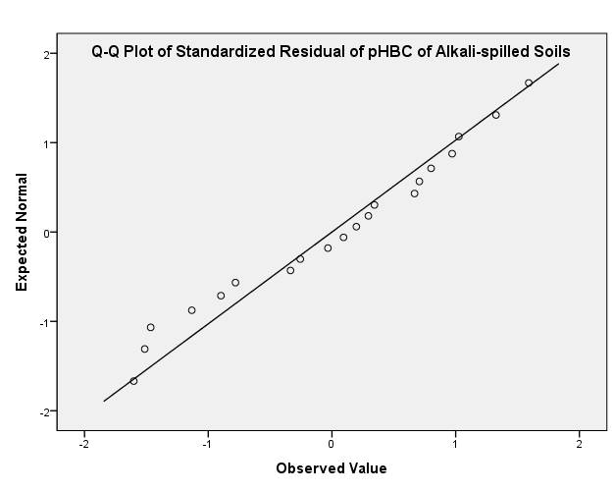
Fig. S2. (Left) standardized residual plots and (right) Q-Q plots of SMLR of CEC and pH buffering capacity of three different soils (untreated, acid-spilled, and alkali-spilled).
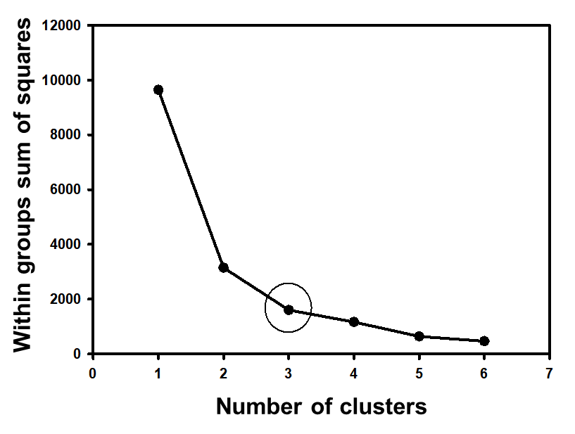
Fig. S3. Number of clusters against within groups sum of squared errors (SSE) based on organic matter and clay content, CEC, and pH buffering capacity. Within groups SSE for a number of clusters ranges from 1 to 6, and the within groups SSE is similar if k is greater than three; Thus, soils are classified into three clusters.

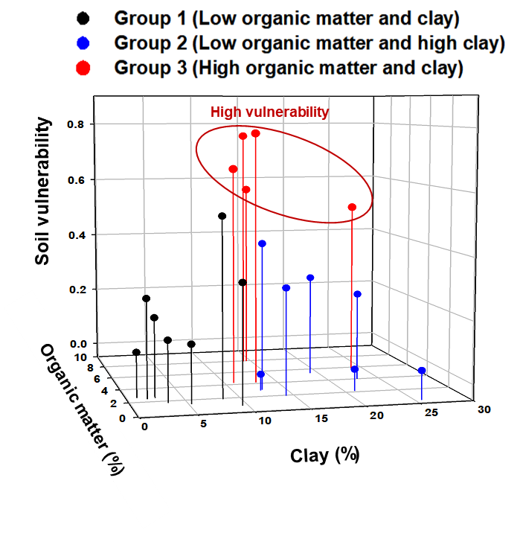
Fig. S4. Relationship between organic matter and clay content and soil vulnerability the spills
Table S1. Physicochemical properties of twenty field soils used in this study
Label | Properties
 | pH | OM | CEC | Clay
 |  | % | cmol kg⁻¹ | %
Soil No. 1 | 5.81 | 1.38 | 5.24 | 2.24
Soil No. 2 | 5.26 | 1.95 | 14.26 | 12.37
Soil No. 3 | 5.71 | 1.87 | 8.36 | 8.94
Soil No. 4 | 6.04 | 2.16 | 20.95 | 17.60
Soil No. 5 | 7.09 | 4.26 | 10.88 | 17.65
Soil No. 6 | 4.8 | 4.16 | 12.96 | 17.71
Soil No. 7 | 5.3 | 1.73 | 3.32 | 2.71
Soil No. 8 | 4.2 | 7.92 | 14.22 | 19.31
Soil No. 9 | 5.08 | 3.00 | 12.77 | 10.14
Soil No. 10 | 7.17 | 0.38 | 25.60 | 25.64
Soil No. 11 | 6.69 | 0.83 | 9.51 | 9.29
Soil No. 12 | 6.9 | 2.65 | 0.91 | 2.74
Soil No. 13 | 7.4 | 2.54 | 2.51 | 2.55
Soil No. 14 | 7.4 | 2.40 | 1.75 | 2.97
Soil No. 15 | 5.3 | 1.80 | 14.67 | 13.51
Soil No. 16 | 6.8 | 3.98 | 22.83 | 16.85
Soil No. 17 | 4.4 | 7.95 | 14.55 | 21.06
Soil No. 18 | 4.6 | 2.91 | 12.57 | 11.91
Soil No. 19 | 6.2 | 5.28 | 19.20 | 24.33
Soil No. 20 | 4.7 | 5.83 | 23.90 | 26.29

Table S2. Physicochemical properties of twenty soils after acid or alkali spills
Label | Properties
 | OM (%) |  | CEC (cmol kg⁻¹) |  | Clay (%)
 | After acid spills | After alkali spills | After acid spills | After alkali spills | After acid spills | After alkali spills
Soil No. 1 | 0.19 | 0.58 | 0.84 | 0.54 | 5.10 | 5.37
Soil No. 2 | 0.54 | 0.56 | 6.64 | 2.49 | 15.00 | 14.24
Soil No. 3 | 0.42 | 0.78 | 2.87 | 0.71 | 7.10 | 8.28
Soil No. 4 | 0.43 | 1.16 | 16.62 | 16.04 | 20.68 | 20.95
Soil No. 5 | 2.20 | 1.04 | 7.39 | 1.14 | 9.49 | 10.17
Soil No. 6 | 2.10 | 1.01 | 8.04 | 4.35 | 12.86 | 13.23
Soil No. 7 | 0.72 | 0.40 | 0.53 | 0.44 | 3.82 | 3.69
Soil No. 8 | 3.21 | 1.38 | 9.28 | 5.10 | 14.29 | 13.52
Soil No. 9 | 2.68 | 1.42 | 6.23 | 3.43 | 13.06 | 12.90
Soil No. 10 | 0.54 | 0.31 | 23.13 | 21.80 | 24.80 | 24.93
Soil No. 11 | 0.80 | 0.83 | 4.01 | 4.43 | 9.03 | 9.06
Soil No. 12 | 0.23 | 0.22 | 0.26 | 0.28 | 0.59 | 0.75
Soil No. 13 | 0.38 | 0.41 | 0.29 | 0.45 | 2.11 | 2.28
Soil No. 14 | 0.30 | 0.25 | 0.26 | 0.23 | 1.33 | 1.70
Soil No. 15 | 0.28 | 0.43 | 13.62 | 12.74 | 15.50 | 15.21
Soil No. 16 | 2.56 | 1.86 | 16.37 | 13.45 | 21.79 | 22.22
Soil No. 17 | 3.73 | 1.29 | 13.23 | 9.32 | 14.18 | 13.83
Soil No. 18 | 1.06 | 0.80 | 10.67 | 7.73 | 13.52 | 12.07
Soil No. 19 | 3.59 | 3.38 | 18.45 | 12.55 | 19.05 | 19.93
Soil No. 20 | 4.94 | 1.96 | 24.15 | 18.49 | 23.27 | 23.28

Table S3. pH buffering capacity of twenty soils before and after acid or alkali spills
Label | pH buffering capacity (mmol kg⁻¹ (pH unit)⁻¹)ª |  |  | Clustered group^{b}
 | Before the spills | After acid spills | After alkali spills
Soil No. 1 | 9.89 | 8.42 | 8.62 | 1
Soil No. 2 | 29.21 | 18.38 | 22.76 | 2
Soil No. 3 | 23.60 | 10.49 | 11.81 | 1
Soil No. 4 | 34.12 | 34.52 | 32.29 | 2
Soil No. 5 | 62.74 | 23.83 | 18.74 | 3
Soil No. 6 | 55.02 | 10.94 | 13.62 | 3
Soil No. 7 | 11.46 | 9.47 | 10.08 | 1
Soil No. 8 | 75.42 | 22.18 | 14.21 | 3
Soil No. 9 | 28.77 | 19.18 | 13.79 | 2
Soil No. 10 | 26.41 | 24.08 | 26.44 | 2
Soil No. 11 | 20.66 | 13.47 | 14.13 | 1
Soil No. 12 | 11.17 | 9.97 | 10.23 | 1
Soil No. 13 | 11.94 | 9.42 | 9.55 | 1
Soil No. 14 | 15.22 | 10.49 | 11.74 | 1
Soil No. 15 | 20.72 | 28.38 | 25.88 | 2
Soil No. 16 | 39.73 | 33.52 | 26.96 | 2
Soil No. 17 | 56.34 | 27.66 | 20.91 | 3
Soil No. 18 | 24.63 | 30.60 | 18.52 | 2
Soil No. 19 | 44.32 | 36.77 | 26.90 | 2
Soil No. 20 | 57.91 | 23.49 | 32.51 | 3
ªAdjustable parameters in Eq. (2) were optimized through a linear least square estimation procedure, and the pH buffering capacities were calculated from Eq. (3).
^{b}It is a result from a clustering analysis, and note that all soils whose pH buffering capacity is higher than 50 mmol kg-1 (pH unit)⁻¹ are classified into group 3.

Table S4. Results of Kolomogorov-Smirnov test to check normality assumption of the differences in physicochemical properties and pH buffering capacity of soils before and after acid or alkali spills
 | Difference | Kolmogorov-Smirnov
 |  | Statistic | Degree of freedom | p value
Acid spills | OM | .200 | 20 | .036
 | Clay | .128 | 20 | .200^{a,b}
 | CEC | .220 | 20 | .012
 | pHBC | .243 | 20 | .003
Alkali spills | OM | .222 | 20 | .011
 | Clay | .140 | 20 | .200^{a,b}
 | CEC | .183 | 20 | .077^{b}
 | pHBC | .221 | 20 | .011
ªThis is a lower bound of the true significance.
^{b}Because the p value was greater than the 0.05, pairwise t-test was conducted. Otherwise, Wilcoxon signed rank test was conducted.

Table S5. Pairwise t-test or Wilcoxon signed rank test results of the differences in the physicochemical properties and pH buffering capacity of soils before and after acid or alkali spills
 | Difference | Method | p value
Acid spills | OM | Wilcoxon singed rank test | .000
 | Clay | Pairwise t-test | .149ª
 | CEC | Wilcoxon singed rank test | .000
 | pHBC | Wilcoxon singed rank test | .002
Alkali spills | OM | Wilcoxon singed rank test | .000
 | Clay | Pairwise t-test | .109ª
 | CEC | Pairwise t-test | .000
 | pHBC | Wilcoxon singed rank test | .000
ªThere was no significant difference before and after acid or alkali spills.

Table S6. Results of tests to check the normality, autocorrelation, and multicollinearity assumptions for multiple linear regression analysis
Dependent variable | Classification | N | Independent variable | SMLR assumption
 |  |  |  | Normality | Autocorrelation | Multicollinearity
 |  |  |  | p value (KS test) | Durbin-Watson statistics | VIF
CEC | Untreated | 20 | Clay, OM | 0.200ª | 2.07  (No autocorrelation) | 1.07
CEC | Acid-spilled | 20 | Clay | 0.200ª | 1.50  (No autocorrelation) | -
CEC | Alkali-spilled | 20 | Clay | 0.200ª | 1.71  (No autocorrelation) | -
pHBC | Untreated | 19^{b} | Clay, OM | 0.054 | 1.09  (Inconclusive) | 1.08
pHBC | Acid-spilled | 20 | Clay | 0.200ª | 1.39  (Inconclusive) | -
pHBC | Alkali-spilled | 20 | Clay | 0.200ª | 1.53  (No autocorrelation) | -
ªThis is a lower bound of the true significance.
^{b}The most outlying data (soil No. 17) was excluded to satisfy the normal distribution.

Table S7. Summary on statistical tests (i.e., KS, ANOVA, KW, and Levene’s test, and post-hoc analysis) of three clustered groups’ physicochemical properties and pH buffering capacity
 | OM | Clay | CEC | pHBC | Soil vulnerability  (acid, alkali)
 | Kolmogorov-Smirnov p value
Group 1 | 0.200ª | 0.200ª | 0.010 | 0.104 | 0.200 ª, 0.200 ª
Group 2 | 0.200ª | 0.199 | 0.200ª | 0.200ª | 0.200 ª, 0.200 ª
Group 3 | 0.200ª | 0.033 | 0.200ª | 0.200ª | 0.200 ª, 0.200 ª
 | ANOVA | KW | KW | ANOVA | ANOVA
p value^{b} | 0.000 | 0.001 | 0.001 | 0.000 | 0.000, 0.001
 | Levene’s test
p value | 0.075 | - | - | 0.570 | 0.162, 0.263
 | Post-hoc analysis
 | Scheffe | Bonferroni | Bonferroni | Scheffe | Scheffe
1-2^{c} | 0.568 | 0.033 | 0.017 | 0.002 | 0.171, 0.933
1-3 | 0.000 | 0.001 | 0.001 | 0.000 | 0.015, 0.004
2-3 | 0.002 | 1.000 | 0.743 | 0.000 | 0.000, 0.002
Rank^{d} | 1<2<3 | 1<3<2 | 1<2<3 | 2<1<3 | 2<1<3, 2<1<3
ªThis is a lower bound of the true significance.
^{b}If a p value is lower than 0.05, reject the null hypothesis that the distribution of physicochemical properties or pH buffering capacity is the same across clustered soil groups.
^{c}1-2: Difference in group 1 and 2.
^{d}A<B: A is significantly less than B, A<B: A is less than B, but there is no statistical significance.

