Tensile force promotes osteogenic differentiation via ephrinB2-EphB4 signaling pathway in orthodontic tooth movement
Hang Yu^{a,b,c#}, Xiaoxi Wei ^{a,b,c#}, Zhina Wu ^{a,b,c}, Huan Jiang ^{a,b,c}, Huichuan Qi ^{a,b,c}, Yi Zhang ^{a,b,c} *, Min Hu ^{a,b,c} *
ªDepartment of Orthodontics, Hospital of Stomatology, Jilin University, Changchun, Jilin, P.R. China.
^{b} Jilin Provincial Key Laboratory of Tooth Development and Bone Remodeling, School and Hospital of Stomatology, Jilin University
^{c} Jilin Provincial Clinical Medicine Research Center of Orthodontics

Supplementary information
Supplementary Figure S1. Full-blots. A molecular weight marker was loaded on each gel.

Supplementary Figure S2. Weight curve of the rats. Record the weight curve of the rats during the 7 days of rearing.

Supplementary Figure S3. H&E staining of hearts, livers, kidneys, lungs and spleens.

Supplementary Figure S1. Full-blots.
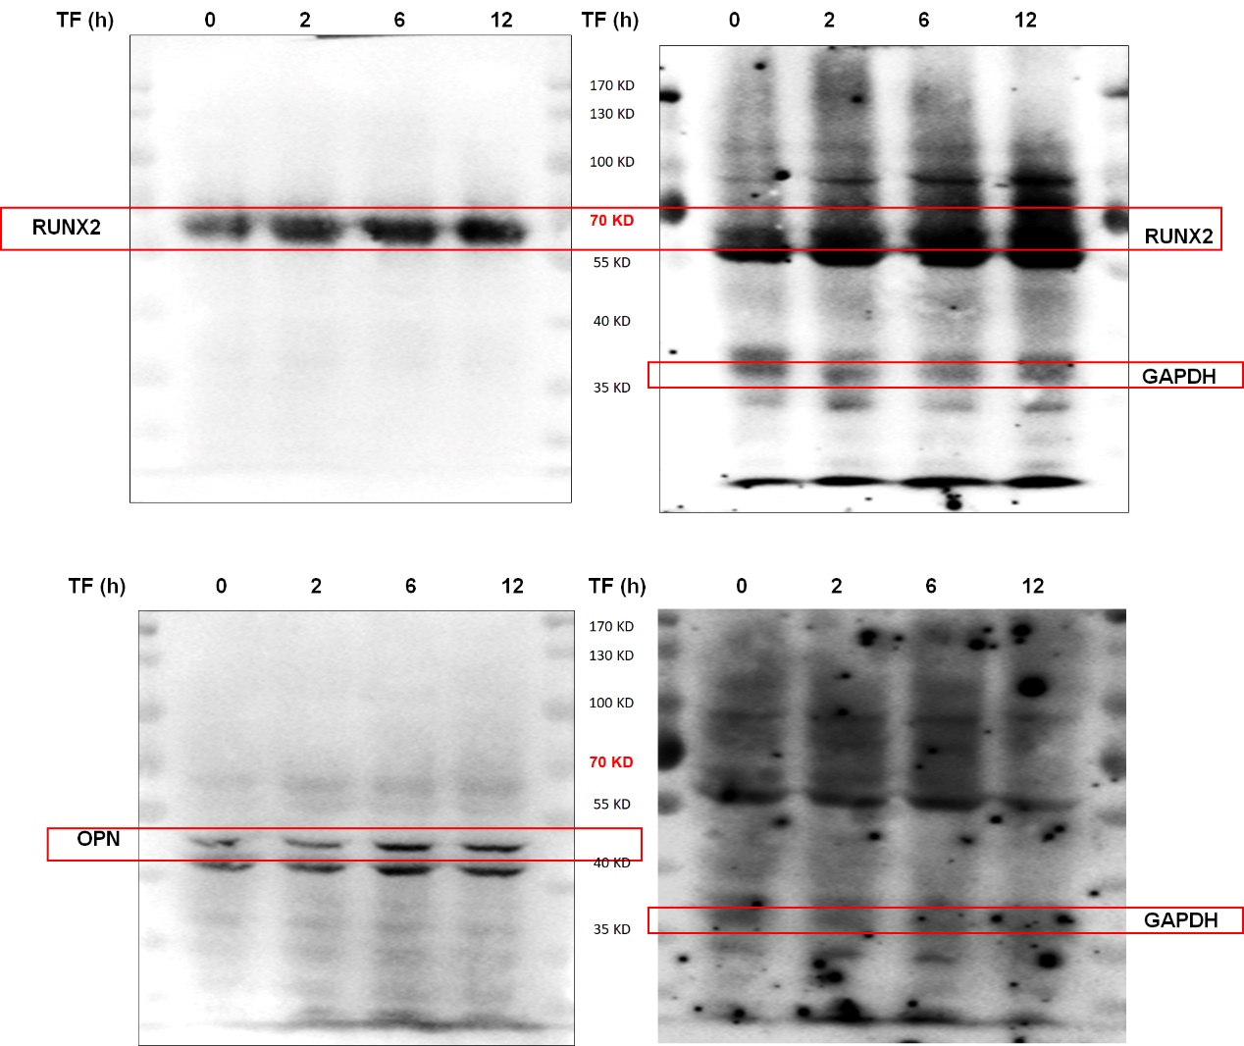

Supplementary Figure S2. Weight curve of the rats. Record the weight curve of the rats during the 7 days of rearing.

Supplementary Figure S3. H&E staining of hearts, livers, kidneys, lungs and spleens.
