SUPPLEMENTAL FIGURES

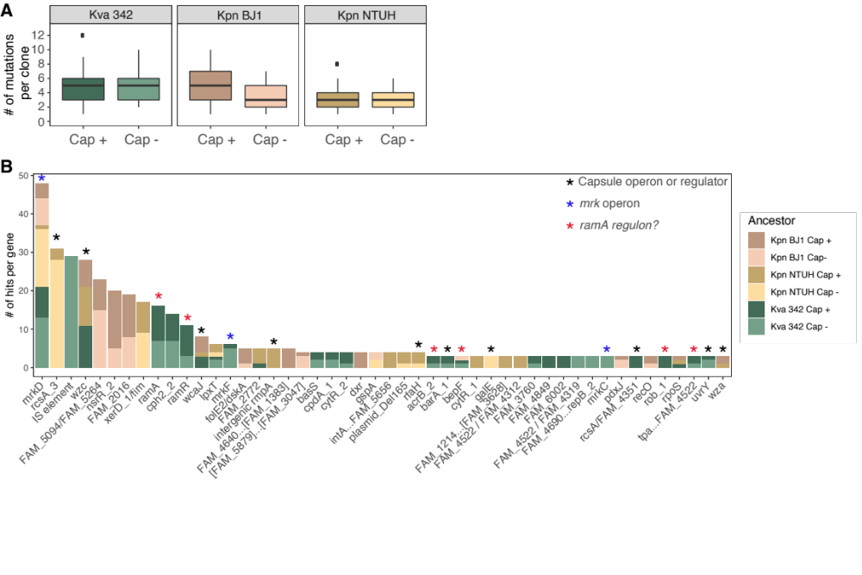

Figure S1. Analysis of mutations in independent clones. A. Number of mutations observed per clone. Data is represented as a boxplot in which the median is highlighted, and dots are outliers. No significant differences across groups (Two-way ANOVA, Tukey HSD post hoc). B. Number of independent clones in which a given gene is mutated. Only genes that are mutated in more than two clones per strain are represented. FAM_XXXX belongs to genes of unknown function, to which a family number was assigned when identifying the pangenome. “IS element” corresponds to an IS missing from its native position. XX…YY corresponds to deletion and XX/YY indicate intergenic mutations between adjacent genes.

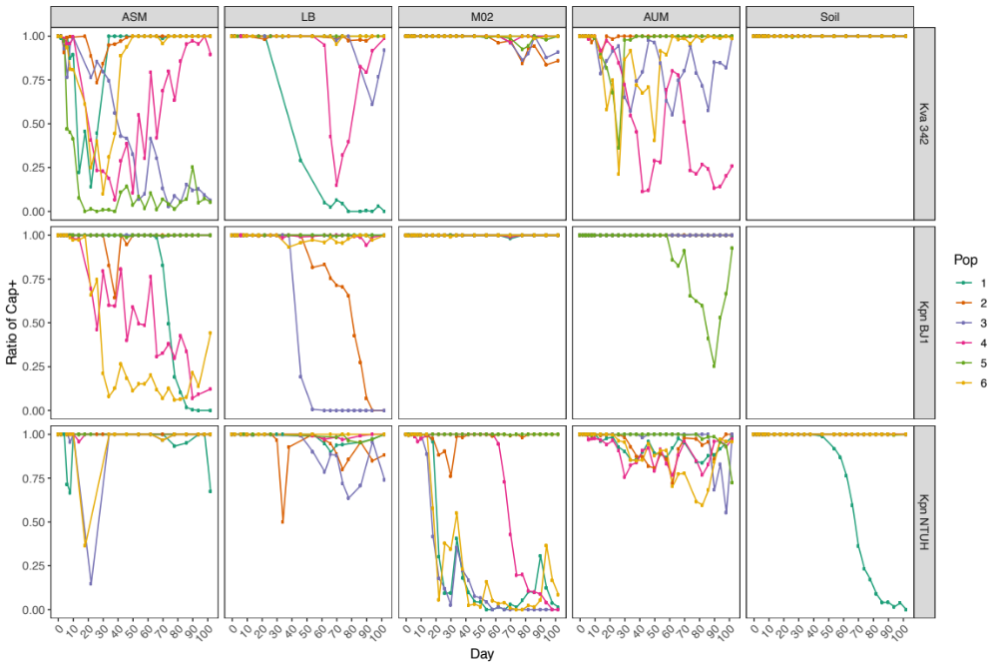

Figure S2. Emergence of non-capsulated clones during the KlebEvoII experiment. Different colours represent independently evolving populations.

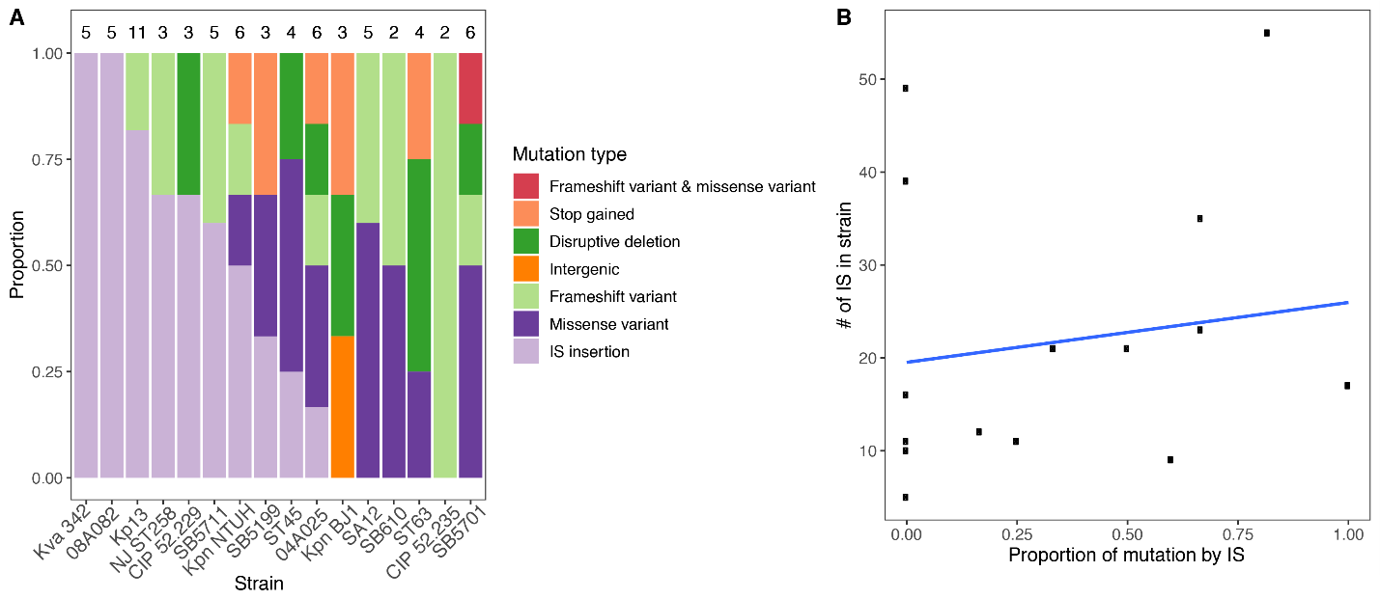

Figure S3. Capsule operon often mutates by IS elements. A. Proportion of each type of mutation leading to a non-capsulated phenotype in each strain of the KlebEvoI experiment. Number on top of bars represent the total number of clones analysed per strain. B. Correlation between the number of IS in a strain and the proportion of mutations in the capsule operon caused by IS insertion. Each dot corresponds to one strain. The blue line represents the trend line of a linear model (GLM, P> 0.05).

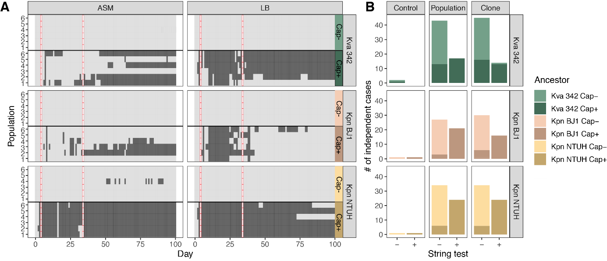

Figure S4. Evolution of HMP during the experiment. A. Day by day observation of HMP in liquid culture. Each line represents and independent population. Black represent HMP, light grey colour represents the ancestral states, and white and red squares represents absence of recording of HMP phenotype. B. Number of clones and populations showing HMP on agar (string-test). Controls correspond to ancestral clones.

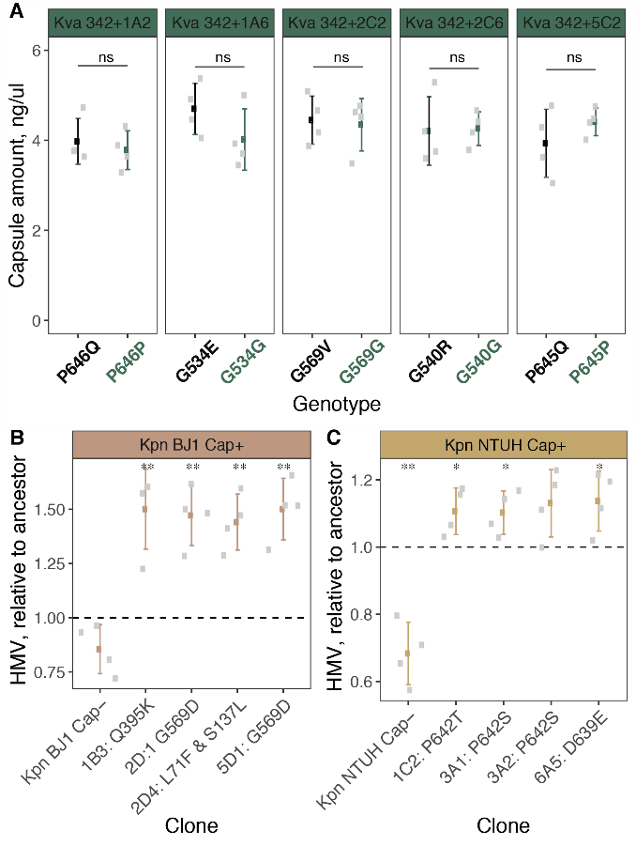

Figure S5. Characteristics of HMP mutations and clones. A. Capsule quantification of wzc evolved alleles in ancestral background. Individual dots represent independent experiments, error bars correspond to the standard deviation of the mean. ns not significant, t-student test. B and C. HMP of several evolved clones bearing mutations in wzc and evolved in different environments (1B3 and 1C2 in ASM; 2D1, 2D4,3A1 and 3A2 in LB; 5D1 and 6A5 in AUM). HMP is expressed as hypermucoviscosity (HMV) index relative to the capsulated. Non-capsulated ancestor was included as a control. One sample T-test, difference from 1. * P <0.05,** P < 0.01.

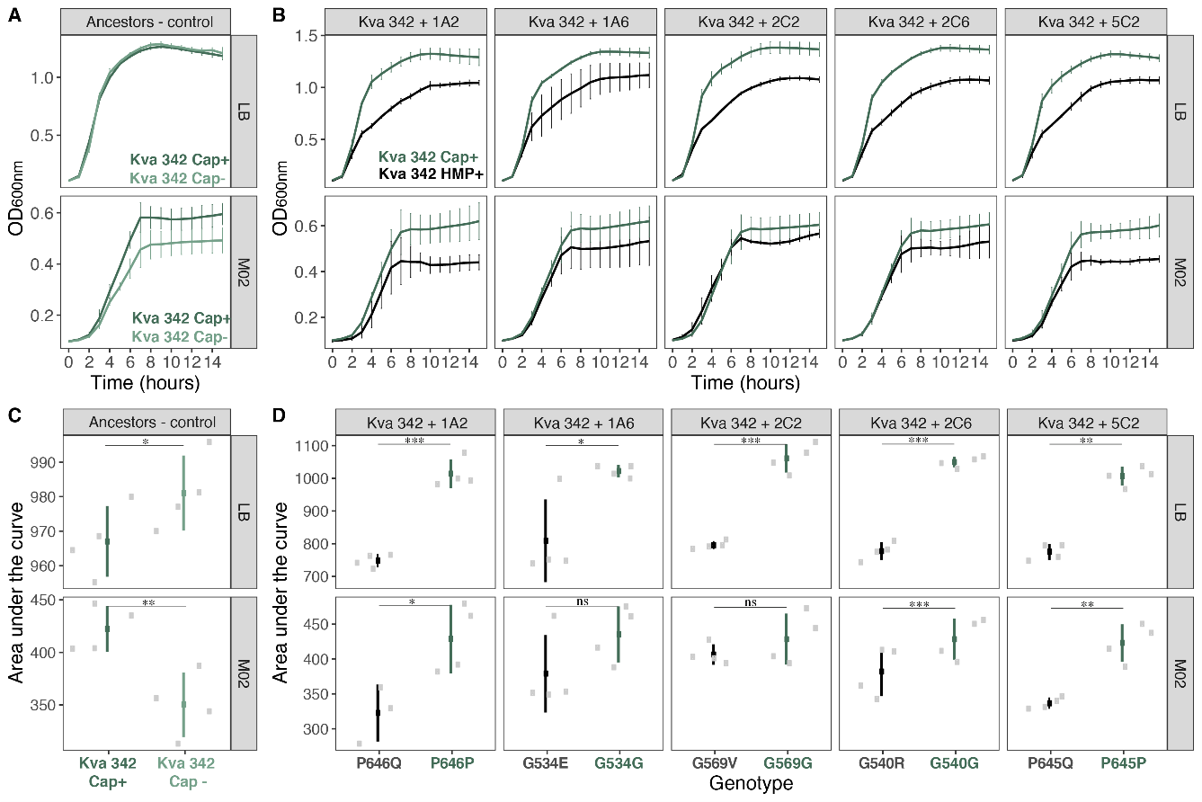

Figure S6. Cost of HMP during fast growth. Growth curves (A and B) and area under the growth curve of capsulated (dark green) and non-capsulated ancestors (light green) (C and D) of ancestral controls and engineered strains in which the evolved wzc allele was reintroduced into the ancestral background (black) and a control clone in which after double recombination event the ancestral allele remained (dark green). Area under the curve was calculated using the trapz formula from the pracma package for R. Statistics were calculated using a paired t-tests. * P <0.05,** P < 0.01, *** P < 0.001.

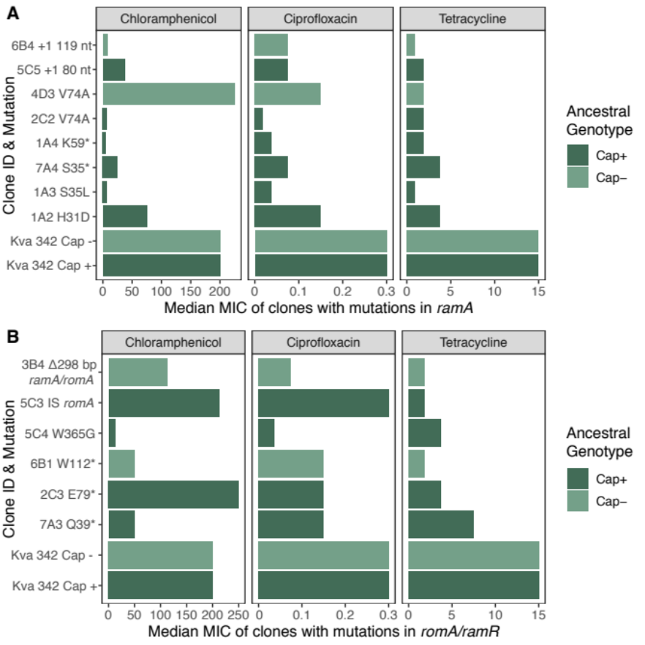

Figure S7. Median MIC of selected evolved clones with mutations in ramA (A) or in romA/ramR (B). The median of three independent experiments is depicted.

