SUPPLEMENTARY INFORMATION

Nonvolatile Memristor-Based Reservoir Computing System with Reservoir Controllability

Supplementary Figures
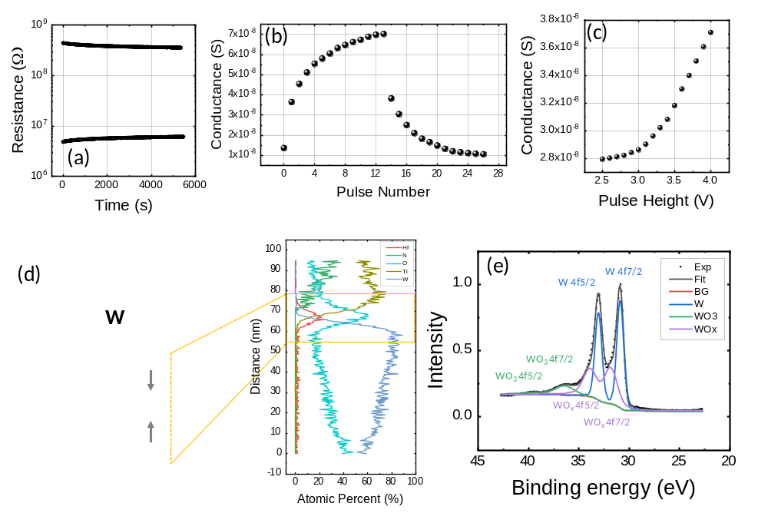
Supplementary Figure S1: Analysis of the retention property, AC characteristics, and device structure of the W/HfO₂/TiN memristor. a) Retention performance of the W/HfO₂/TiN memristor where the read voltage was 0.5 V and the temperature was 25 °C. b) Changes in conductance of memristor according to pulse number. Pulse number 1~13 correspond to SET pulse, 14~26 correspond to RESET pulse, and read voltage was 0.5 V. The SET and RESET pulse heights were 4 V and -4 V, respectively, and the width of both was 200 µs. c) The conductance of the memristor according to the 2.5~4 V SET pulse height. Multilevel switching is possible for both SET and RESET, but the change in conductance according to the pulse number is non-linear (b). Also, the change in conductance according to the pulse height is non-linear as the pulse height decreases (c). Both nonlinearities were used for the non-linear transformation of the input in the reservoir. d) Scanning transmission electron microscopy (STEM) cross-sectional image and energy-dispersive x-ray spectroscopy (EDS) analysis results (right portion) of the fabricated W/HfO₂/TiN memristor with a depth profile. e) XPS spectra of the W 4f region with a depth profile and fitting results for the W/HfO₂/TiN memristor. The sample was measured immediately after the deposition. d, e show that tungsten oxide was generated in the memristor.

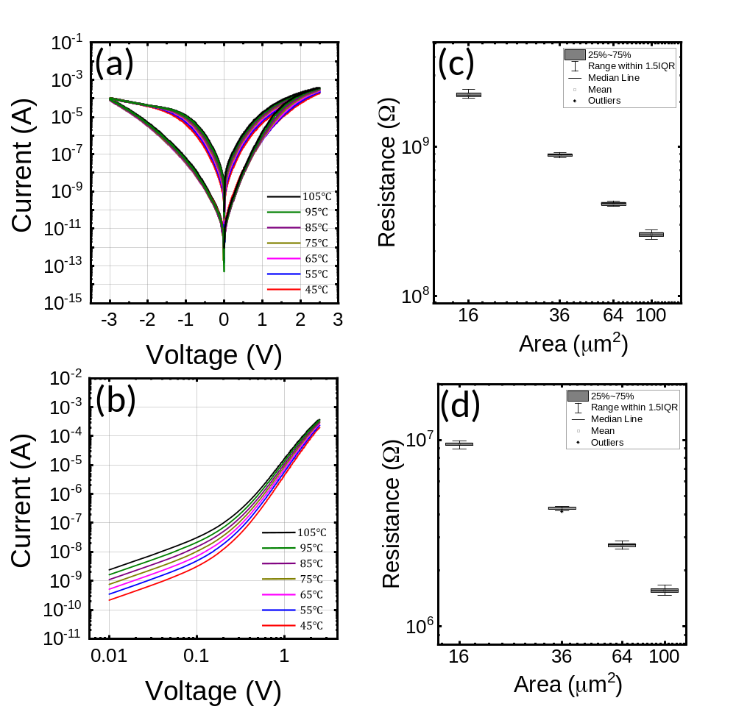

Supplementary Figure S2: The effects of the temperature and the cell area on the electrical properties of the device. a) The I-V curve at various temperatures (45~105 °C). b) The I-V graph of the LRS at various temperatures (45~105 °C). c, d) The cell area dependence of the resistance measured in 10 devices in HRS (c) and LRS (d).
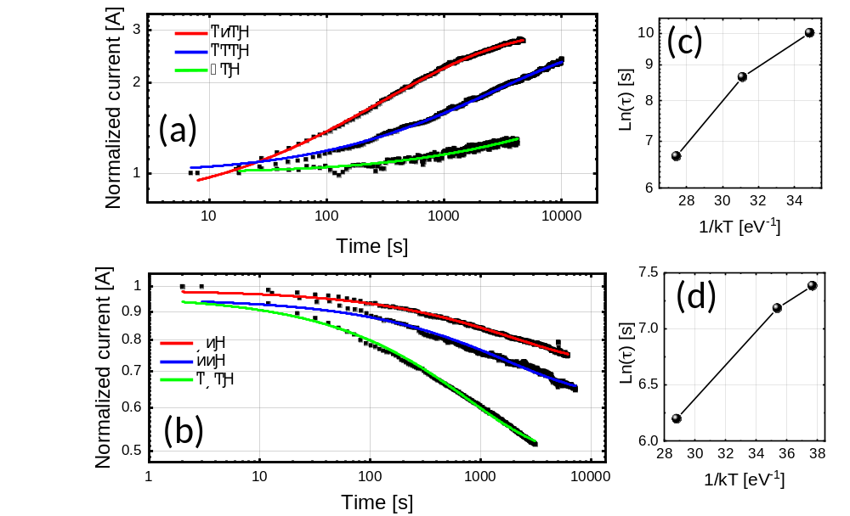
Supplementary Figure S3: The trap depth of the WHT memristor calculated from the time-dependent current-relaxation characteristics of the on and off states at various temperatures. For this test, the current was measured at the 0.5 V read voltage, and the temperature was varied from 35 °C to 150 °C. a, b) The relaxation curves at various temperatures of the HRS (a) and LRS (b). Here, the read current was normalized to the initial current at t = 0. The data show that the read current rose (a) and decayed (b) over time as the trapped electrons were being trapped (a) and detrapped (b). These relaxation curves were fitted into the stretched exponential function [$f_{β}\left(t\right)=Ae^{-{\left(\frac{t}{τ}\right)}^{β}}+B$] to attain the time constant ($τ$) at each temperature. c, d) The Arrhenius plots of ln ($τ$) versus 1/kT of the HRS and LRS cases. The analysis showed 0.45 V and 0.13 eV activation energy, which correspond to the trap depth for the HRS and LRS, respectively, of the system.

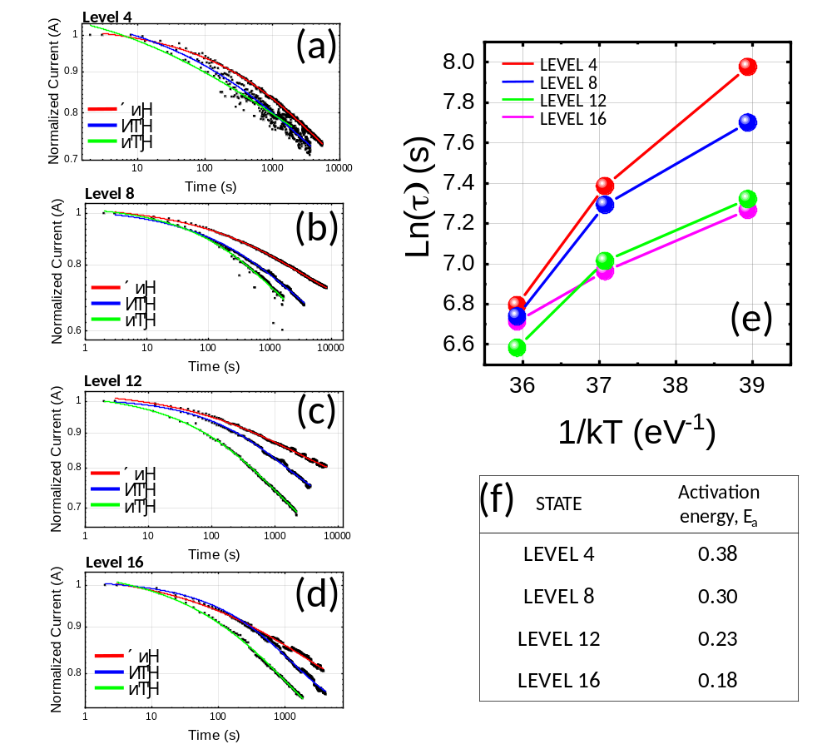
Supplementary Figure S4: The conductance levels between the HRS and the LRS divided into 20 levels. The decay of the read current was measured at four levels. a-d) The relaxation curves at various temperatures of levels 4, 8, 12, and 16. e) The Arrhenius plot of ln($τ$) versus 1/kT of each level. f) The activation energy, calculated at each level. The calculation in e shows a 0.18~0.38 eV activation energy, which corresponds to the trap depth at each level.

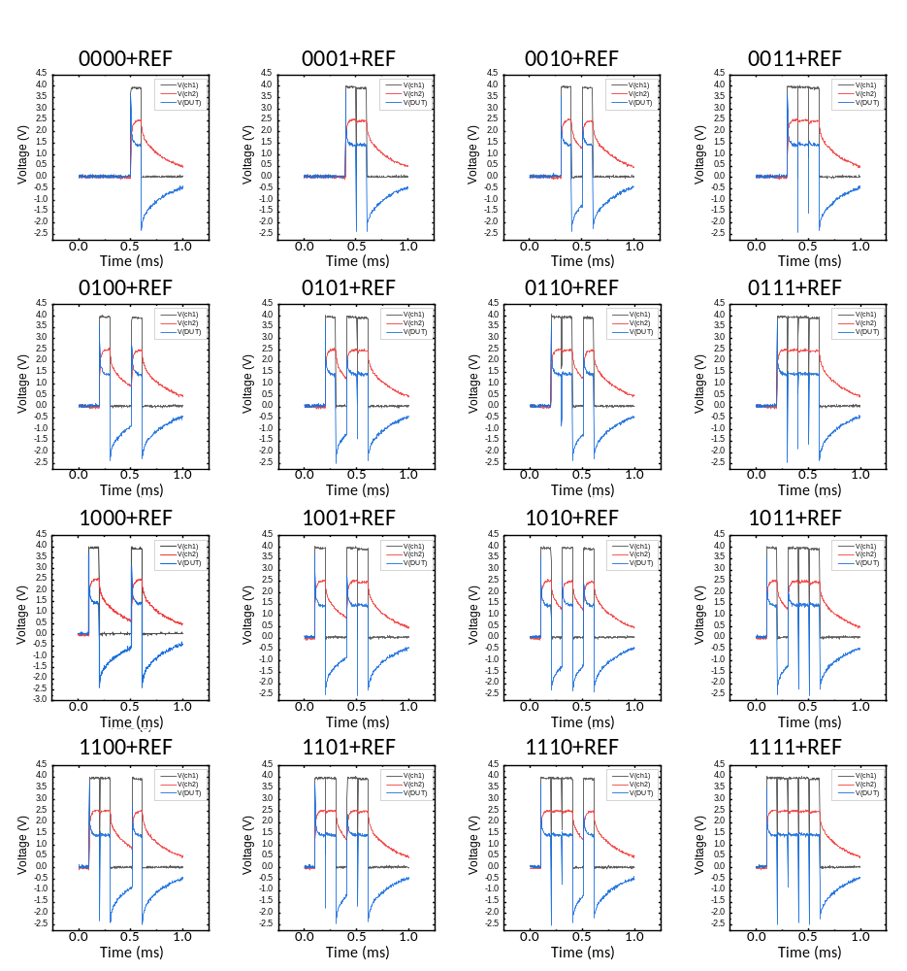
Supplementary Figure S5: The V-t graphs for the '0000'~'1111' inputs under the conditions of a 1 MΩ of R_{L} with a 4 V of signal pulse height and a 100 µs width, and a 4 V REF pulse height and a 100 µs REF pulse width.
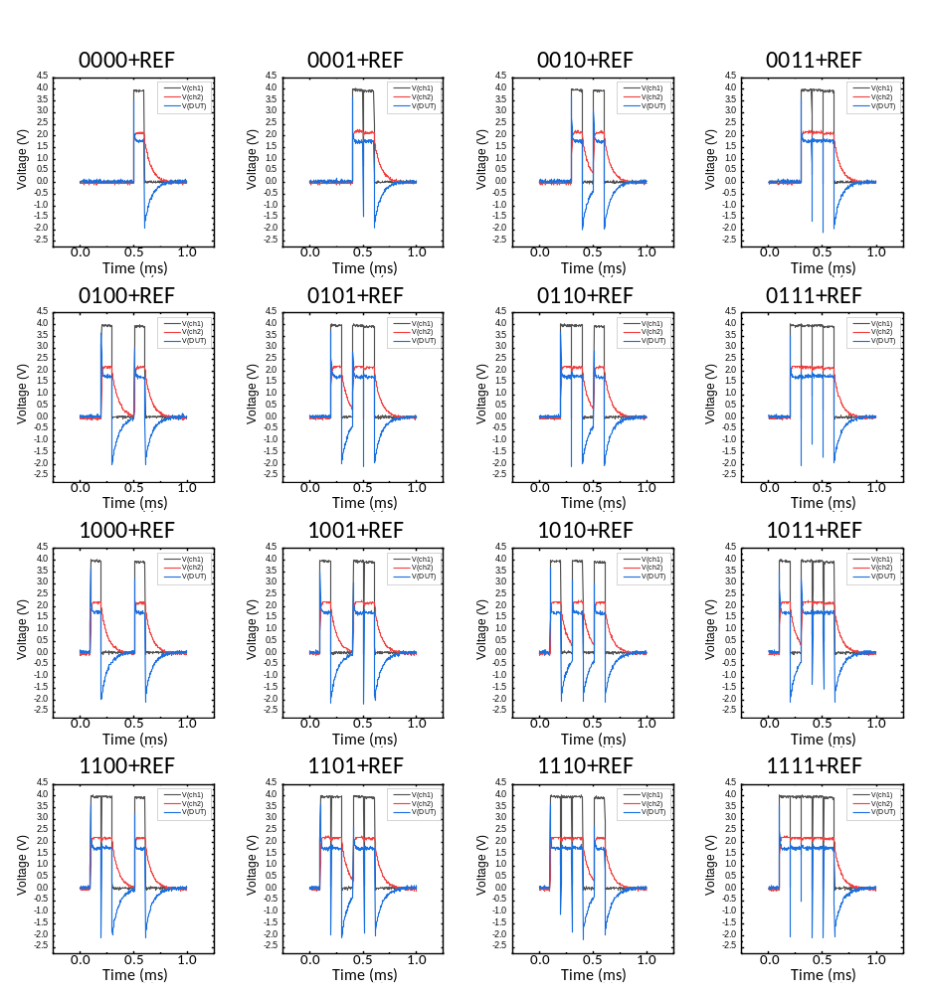
Supplementary Figure S6: The V-t graphs for the '0000'~'1111' inputs under the conditions of a 120 kΩ of R_{L} with a 4 V of signal pulse height and a 100 µs width, and a 4 V REF pulse height with a 100 µs width.

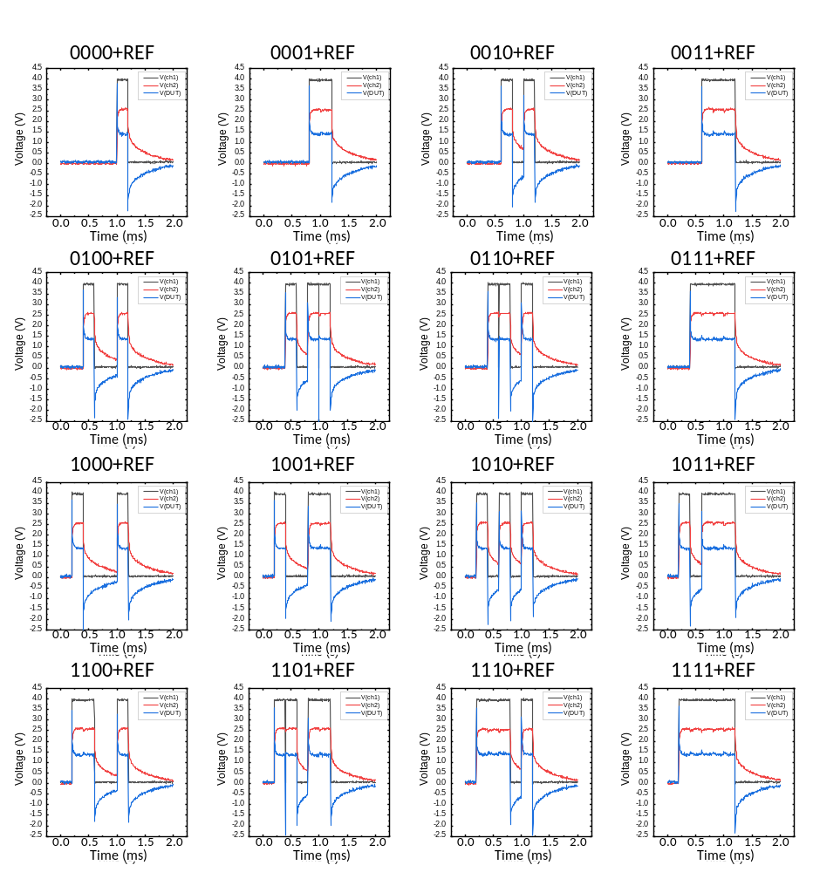
Supplementary Figure S7: The V-t graphs for the '0000'~'1111' inputs under the conditions of 1 MΩ of R_{L} with a 4 V of signal pulse height and a 200 µs width, and a 4 V REF pulse height with a 200 µs width.

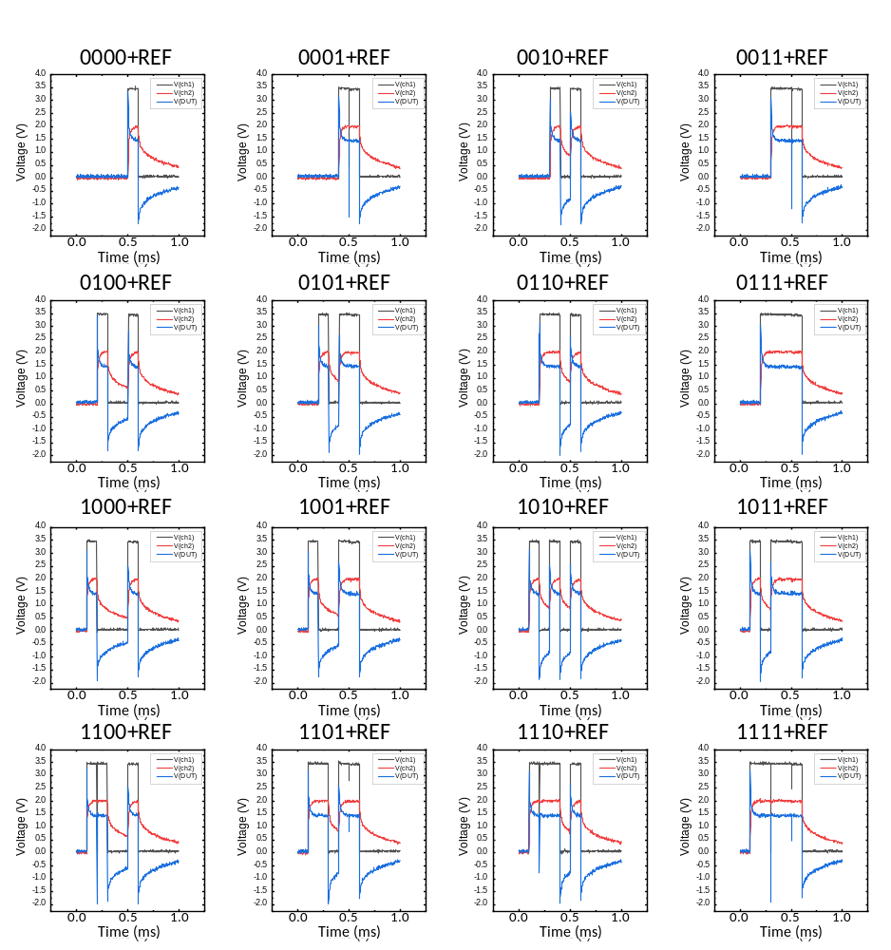
Supplementary Figure S8: The V-t graphs for the '0000'~'1111' inputs under the conditions of a 1 MΩ of R_{L} with a 3.5 V of signal pulse height and a 100 µs width, and a 3.5 V REF pulse height and a 100 µs width.

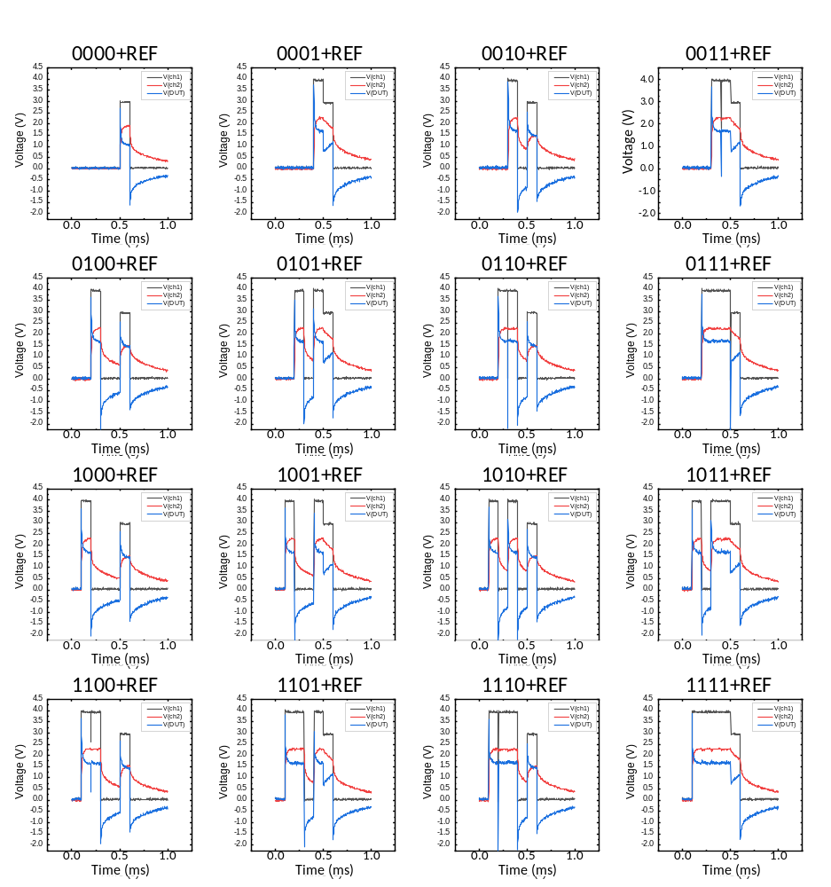
Supplementary Figure S9: The V-t graphs for the '0000'~'1111' inputs under the conditions of a 1 MΩ of R_{L} with a 4 V of signal pulse height and a 100 µs width, and a 3 V REF pulse height and a 100 µs width.

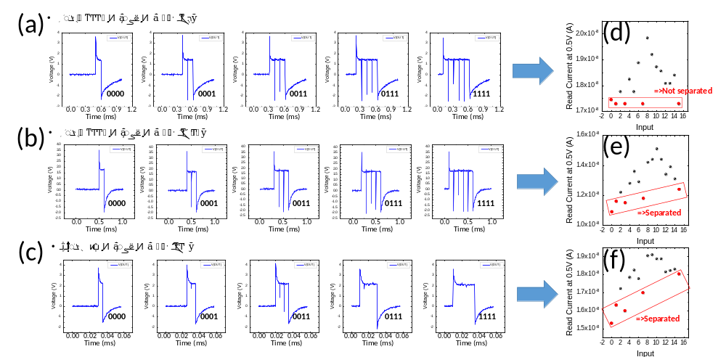
Supplementary Figure S10: Analysis of the separation of inputs that generated net 1 spikes ('0000', '0001', '0011', '0111', and '1111'). From the conditions of a 4 V signal pulse height and a 100 µs width, and a 4 V REF pulse height and a 100 µs width, R_{L} varies from 1 MΩ to 10 kΩ. a-c) The V-t graphs for the inputs that generated net 1 spikes when 1 MΩ, 120 kΩ, and 10 kΩ R_{L}, were used. d-f) The read current of the memristor for the '0000~1111' inputs under the conditions in a-c. When the 1 MΩ R_{L} was used, since the voltage distributed to the memristor was small, SET switching did not occur after the first spike (a). Therefore, the responses to the inputs that generated one net spike (0, 1, 3, 7, and 15) were not separated (d). As R_{L} decreased, the voltage distributed to the memristor increased (b-c), and thus, the responses to the corresponding inputs were separated (e and f).

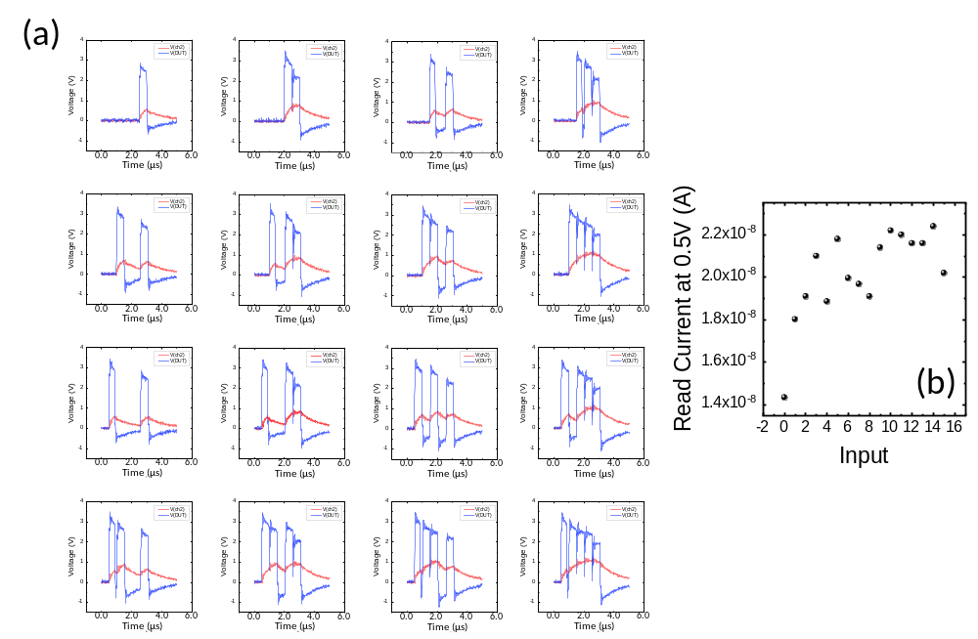
Supplementary Figure S11: a) The V-t graphs for the '0000'~'1111' inputs under the conditions of 10 kΩ of R_{L} with a 3.5 V of signal pulse height and a 500 ns width, and a 3 V REF pulse height and a 500 ns width. b) The read current of the memristor for the '0000'~'1111' inputs. Insufficient charging further increased the separability for the consecutive high signals since the capacitor was not fully charged even though consecutive high signals were applied. This is suitable for situations in which consecutive signals mainly appear, such as in MNIST.

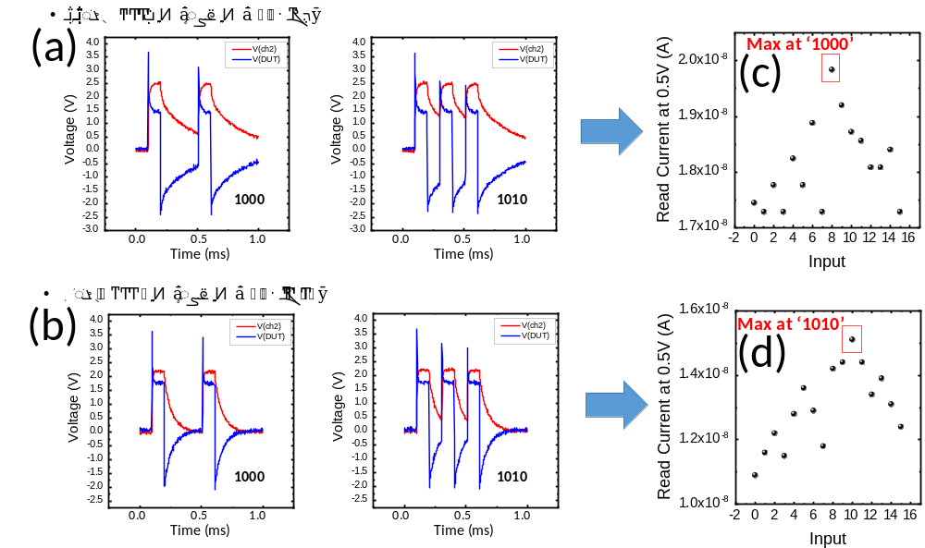
Supplementary Figure S12: Analysis of the input that caused maximum conductance. a-b) The V-t graphs for the '1000' and '1010' inputs under the conditions of a 4 V signal pulse height and a 100 µs width, and a 4 V REF pulse height and a 100 µs width 100, and a 1 MΩ R_{L} for a and 120 kΩ for b. c-d) The read current of the memristor for the '0000~1111' inputs under the conditions in a-b. Since the large R_{L} caused slow discharging, a sufficient interval after the first spike is necessary to generate a spike that can cause large SET switching. Under the conditions in a, maximum conductance occurred at the '1000' input due to the slow discharging by the 1MΩ R_{L} (c). On the other hand, under the conditions in b, second and third spikes of sufficient magnitude to cause SET switching occurred at the '1010' input due to the fast discharging by the 120 kΩ R_{L}. Therefore, maximum conductance occurred at the '1010' input (d).

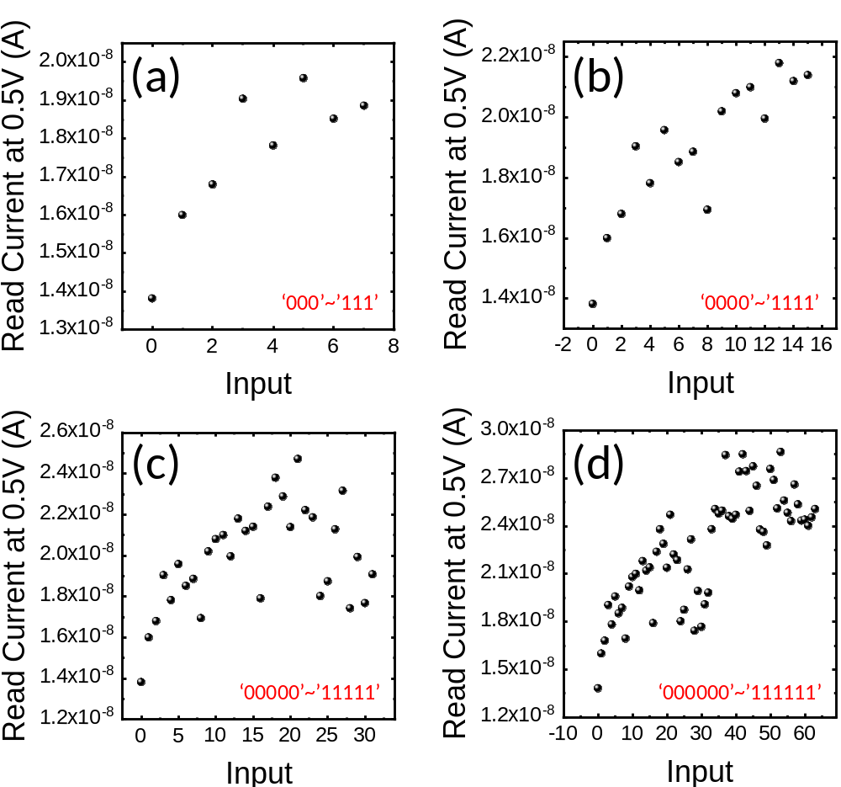
Supplementary Figure S13: The reservoir responses were measured while increasing the number of bits processed in the reservoir from 3 bits to 6 bits. a-d) The reservoir responses for the '000~111', '0000~1111', '00000~11111', and '000000~111111' inputs under the conditions of 10 kΩ of R_{L} with a 3.5 V of signal pulse height and a 200 ns width, and a 3 V REF pulse height and a 200 ns width. As the number of bits processed in the reservoir increased, the separation of the responses to each input deteriorated.

Supplementary Figure S14: The confusion matrices comparing the recognized digit and the desired digit for the MNIST test dataset (4 situations, from the top left: nBPR = 3 bits to the bottom right: nBPR = 6 bits) showing that the number of correct inferences decreased as the nBPR increased

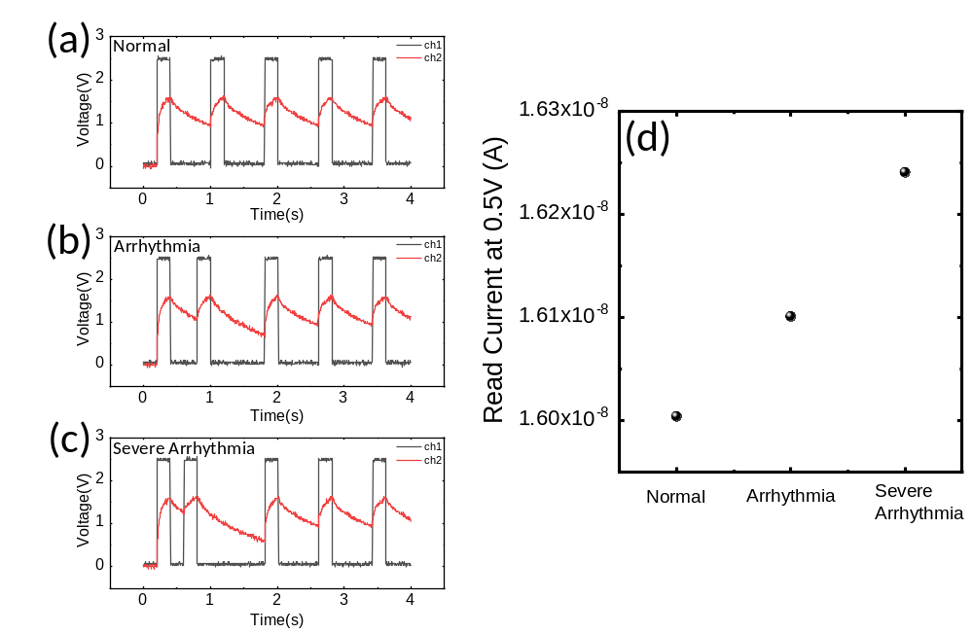
Supplementary Figure S15: The increase in the conductance of the memristor varied according to the degree of arrhythmia. When arrhythmia was severe, SET switching occurred significantly in the memristor due to long discharging. a-c) The ECG-based V-t graphs for three cases of normal, arrhythmia, and severe arrhythmia. The electrical signal of the ECG from the heartbeat was converted into a 2.5 V, 200 ms pulse and applied to the memristor. d) The read current of the memristor according to the degree of arrhythmia. The more severe the arrhythmia was, the more the memristor conductance increased.

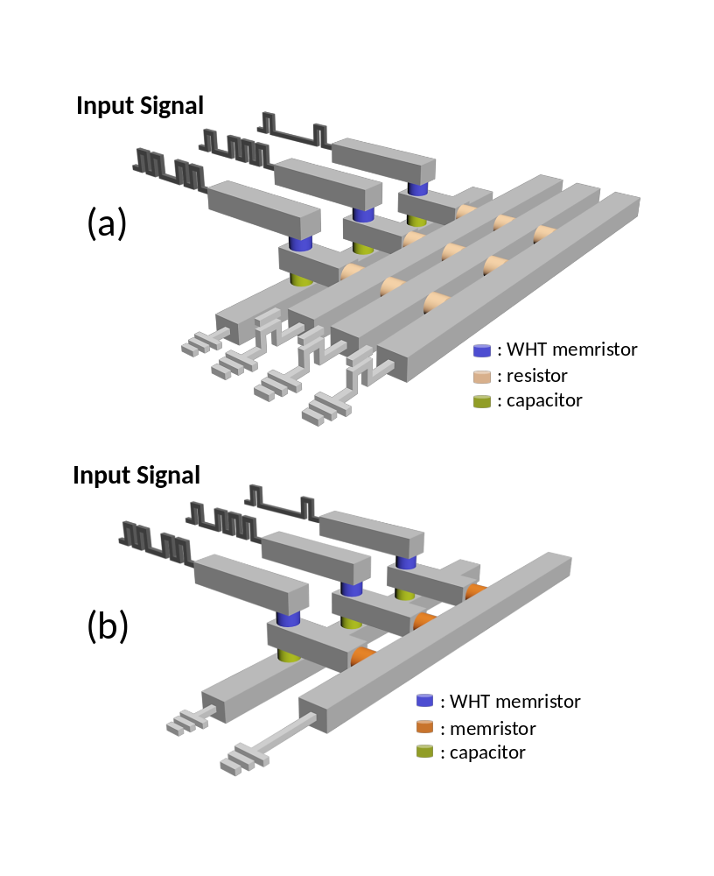
Supplementary Figure S16: The hardware structure needed to create an array of reservoirs that can adjust the reservoir configuration. a) A structure in which the resistors are sequentially connected to several metal lines. In this structure, the resistor size of the reservoir can be adjusted by selecting several metal lines connected to the resistor. b) A structure in which memristors are connected in series to the WHT memristors and parallel to the capacitors. In this structure, the resistance of the memristor can be set to the desired resistance value using a method such as the incremental step pulse program (ISPP).¹

Supplementary Tables

Supplementary Table 1: The frequency of the appearance of inputs in the preprocessed MNIST dataset, in which '0000' appeared overwhelmingly, followed by the inputs in bold font in the table (Due to the nature of the picture, the pixels were continuously blanked or filled in most cases. Therefore, inputs with consecutive high or low signals mainly appeared, and there were a few inputs with alternating high and low signals such as '1010' and '0101'.)
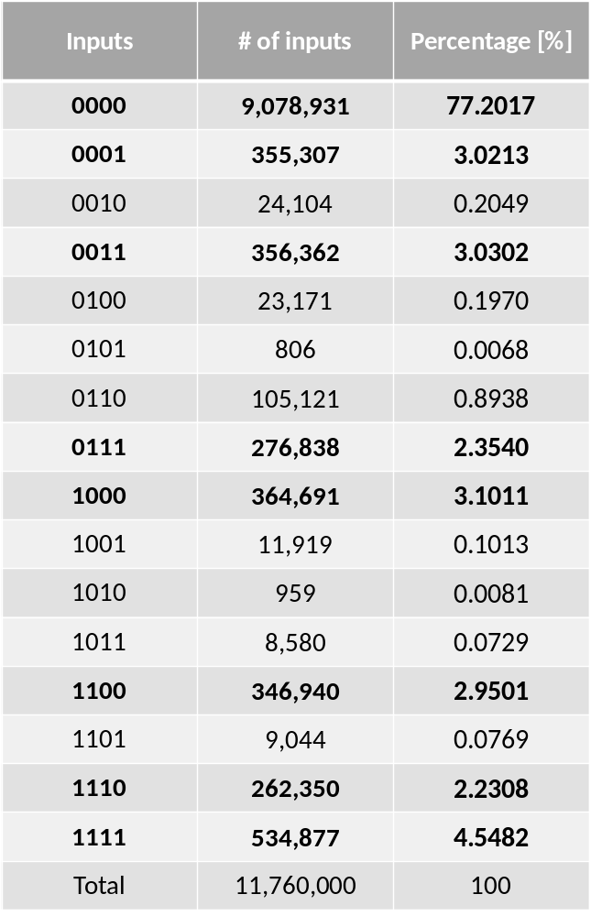

Supplementary Note 1. Area-type electronic switching memristor
The switching mechanism of the W/HfO₂/TiN device used in the experiment was analyzed based on various experiments. First, the area dependency of the device conductance, shown in Supplementary Figs. S2c,d, shows that this device is not a filamentary type. When the conducting filament is formed, the conductance is independent of the device area because the current flows locally.² Second, the temperature dependence of the current shown in Supplementary Fig. S2a,b shows that this device is not metallic in the LRS. When the filamentary type device is in the LRS, a metallic conducting filament is formed, and the current decreases as the temperature rises.³ In this device, the current increases as the temperature increases. Lastly, in Supplementary Figs. S3, 4, the activation energy in various conductance states was calculated, and reasonable values that corresponded to the trap level of the HfO₂⁴ were calculated. These support the operation of the device based on the trap-assisted switching mechanism.

Supplementary Note 2. Comparison of how the reservoir responded to the input according to various parameter changes (Fig. 3a-e)
Figure 3b shows that R_{L} had two main effects on reservoir dynamics. First, when R_{L} was changed, the distributed voltage varied. When the voltage distributed to the memristor increased, the separation of the inputs, including the consecutive ‘1’, increased. Typically, the separability for the inputs ‘0000’ (= 0), ‘0001’ (= 1), ‘0011’ (= 3), ‘0111’ (= 7), and ‘1111’ (= 15) increased. This is because when the R_{L} was small, even with the distributed voltage, considerable SET switching occurred (Supplementary Fig. S10). The second effect is the change in the discharging rate. Too fast or too slow discharging reduced the reservoir separability. For example, the effect of the interval between spikes can be neglected by too fast discharging. In Fig. 2b, the reservoir responses for the inputs ‘1000’, ‘1001’, and ‘1011’ are not identified separately. Supplementary Fig. S6 shows that the second spike was not significantly affected by the interval length due to the fast discharging. As the discharge rate increased, the input that caused the maximum conductance changed from ‘1000’ to ‘1010’ (Supplementary Fig. S11).
Figure 3c shows the RC responses when the pulse width was increased to 200 µs from the conditions in Fig. 3a. As the pulse width increased, the amount of discharging during one low signal increased, so its effect was similar to that when R_{L} decreased, but the magnitude of the voltage distributed to the memristor did not change, so the effect of the capacitor discharging appeared more clearly. Figure 3c shows that when R_{L} was large, set switching occurred according to the spike rather than according to the voltage distributed to the memristor. When ‘0000’ ~ ‘1111’ inputs were applied to this system, one to three net spikes were generated. Figure 3c shows that the RC response was separated into only three states by the number of net spikes.
Figure 3d shows the RC response when the pulse height was changed to 3.5 V. In this case, the responses to the inputs were not exactly the same because the size of the spike and the size of the divided voltage differed. However, the characteristics themselves did not significantly differ from those in Fig. 3a.
Figure 3e shows the RC responses when the signal pulse height was kept at 4 V, but the REF pulse height was lowered to 3 V. In this case, since the ‘0000’ input received only REF pulses, the SET switching was much less than in the other cases, and the RC response to the ‘0000’ input was reliably separated. Also, when the REF pulse height differed from the signal pulse height, the inputs with two spikes, such as ‘0010’ and ‘0101’, were separated from each other. In ‘0010’, the second spike was generated by the REF pulse, and in ‘0101’, the second spike was generated by the signal pulse. In the case of ‘0010’, the SET switching was much less and the two inputs were separated. Therefore, unlike in Fig. 3a, where it is difficult to distinguish the inputs, in Fig. 3d, it can be seen that the ‘0010’ and ‘0101’ inputs are well separated.
Supplementary References

1. Suh, K. D. et al. A 3.3 V 32 Mb NAND Flash Memory with Incremental Step Pulse Programming Scheme. IEEE J. Solid-State Circuits (1995) doi:10.1109/4.475701.
2. Kim, K. M., Choi, B. J., Shin, Y. C., Choi, S. & Hwang, C. S. Anode-interface localized filamentary mechanism in resistive switching of TiO₂ thin films. Appl. Phys. Lett. (2007) doi:10.1063/1.2749846.
3. Privitera, S. et al. Microscopy study of the conductive filament in HfO₂ resistive switching memory devices. Microelectron. Eng. (2013) doi:10.1016/j.mee.2013.03.145.
4. Driussi, F., Spiga, S., Lamperti, A., Congedo, G. & Gambi, A. Simulation study of the trapping properties of HfO₂-based charge-trap memory cells. IEEE Trans. Electron Devices 61, 2056–2063 (2014).

