SUPPORTING INFORMATION
Single Pt atoms on Ru nanoparticles for CO-resistant methanol oxidation reaction electrocatalysis
Agus R. Poerwoprajitno^{1,10}, Lucy Gloag^{1,10}, John Watt², Soshan Cheong³, Aaron Henson^{1,4}, Bijil Subhash⁵, Nicholas M. Bedford⁵, Benjamin K. Miller⁶, Peter B. O’Mara¹, Tania M. Benedetti¹, Dale L. Huber⁷, J. Justin Gooding^{1,8}*, Wolfgang Schuhmann⁹* and Richard D. Tilley^{1,4}*
¹ School of Chemistry, The University of New South Wales, Sydney, NSW 2052, Australia.
² Center for Integrated Nanotechnologies, Los Alamos National Laboratory, Los Alamos, NM 87545, USA.
³Mark Wainwright Analytical Centre, The University of New South Wales, Sydney, NSW 2052, Australia.
⁴Department of Materials Science and Engineering, North Carolina State University, Raleigh, NC 27695, USA.
⁵School of Chemical Engineering, University of New South Wales, Sydney 2052, Australia.
⁶Gatan Inc., Pleasanton, California, 94588, USA.
⁷Center for Integrated Nanotechnologies, Sandia National Laboratories, Albuquerque, NM 87185, USA.
⁸Australian Research Council Centre of Excellence in Convergent Bio-Nano Science and Technology, University of New South Wales, Sydney 2052, Australia.
⁹Analytical Chemistry - Center for Electrochemical Sciences (CES), Faculty of Chemistry and Biochemistry, Ruhr-Universität Bochum, Universitätsstr. 150, D-44780 Bochum, Germany.
¹⁰These authors contributed equally: Agus R. Poerwoprajitno, Lucy Gloag
Email: r.tilley@unsw.edu.au

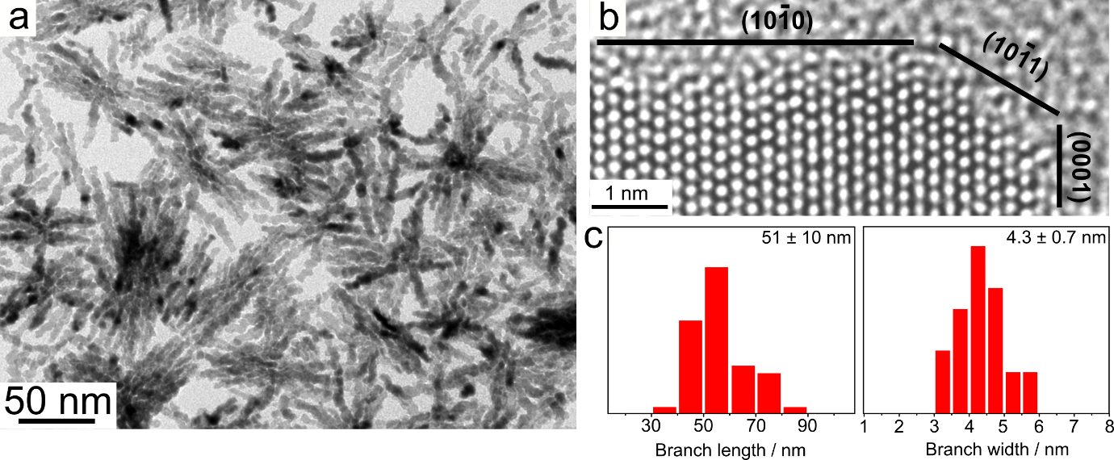
Supplementary Fig. 1 | a,b. TEM and HRTEM images of faceted Ru branched nanoparticles. Ru surface was bounded by low index {10-10}, {10-11} and {0001} facets. c. Statistical analysis of branch length and branch width of faceted branched Ru nanoparticles.

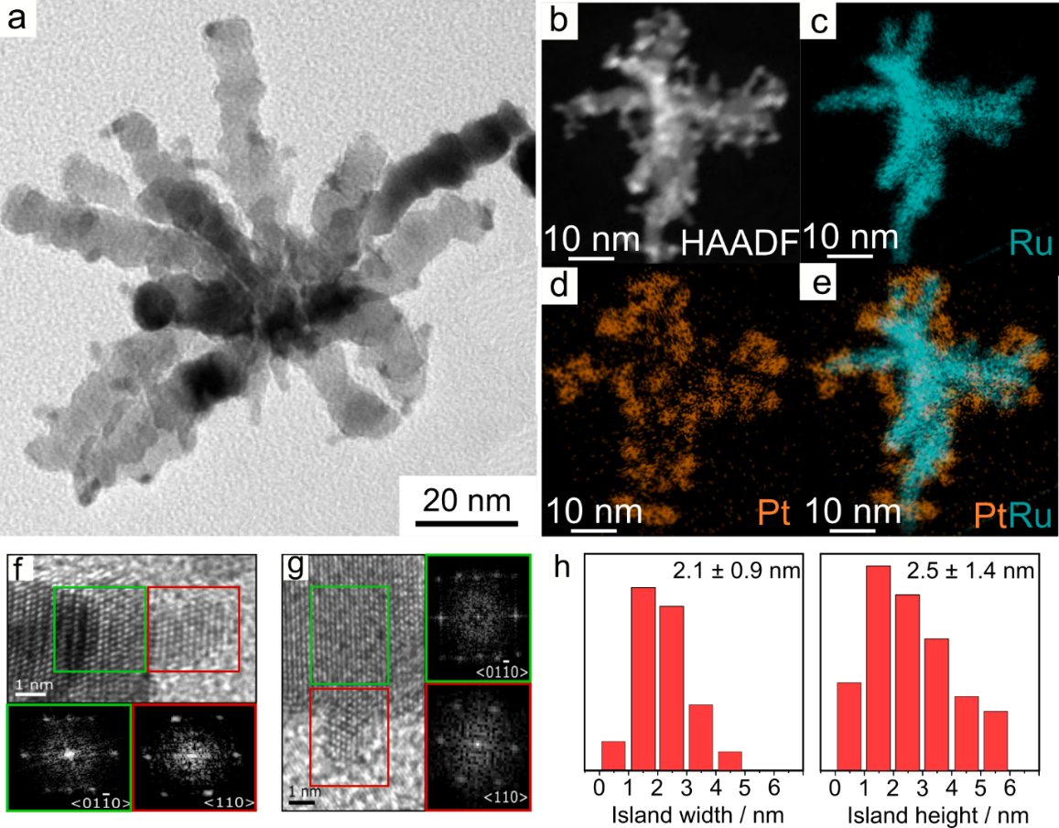
Supplementary Fig. 2 | a. TEM image of Pt island on Ru nanoparticles. b-e. HADDF and EDX mapping images of a single nanoparticles showing the Pt islands (red) and Ru branches (green). f.g HRTEM images of Pt island on the side and on the tip of Ru branch and the corresponding FFT (inset), respectively. The Pt islands are arranged in a fcc crystal structure and Ru is arranged in a hcp crystal structure as shown by FFT. h. The Pt island has an average size of 2.1±0.9 nm in width and 2.5±1.4 nm in height.
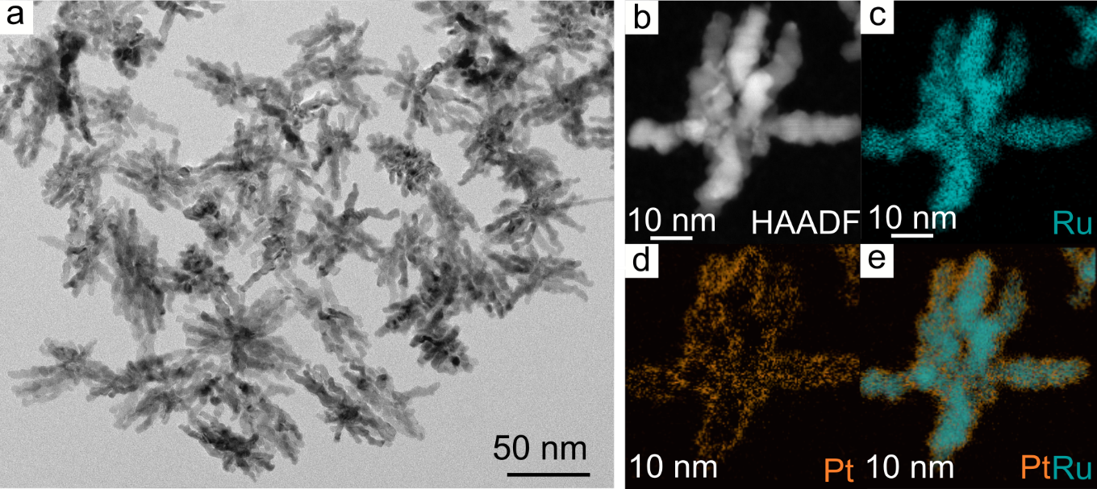
Supplementary Fig. 3 | a. TEM image of Pt atoms on Ru nanoparticles. b-e. HADDF-STEM and EDX mapping of Pt (orange), Ru (cyan) and overlay image.

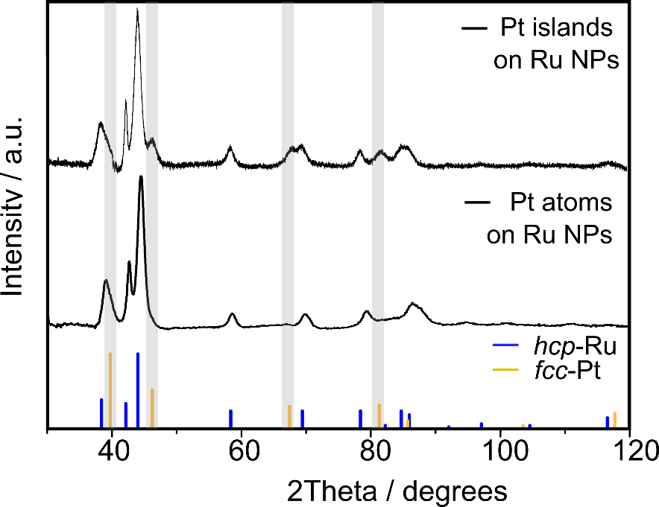
Supplementary Fig. 4 | X-ray diffraction patterns Pt islands on Ru nanoparticles and Pt atoms on Ru nanoparticles. The bulk crystallography analysis show that the fcc-Pt signals are no longer observed after annealing confirming the Pt islands are spread. The size of Pt islands is 2.9 nm as calculated using the Scherrer equation which is similar to the size analysis based on TEM images.

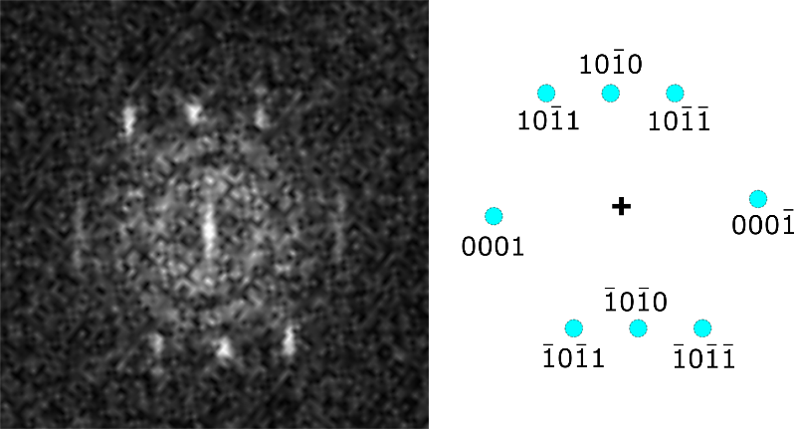
Supplementary Fig. 5| FFT of the single Pt on Ru. FFT of the image shown in Fig. 1c, 37.2 s, showing spots that match with the indexed hcp-Ru FFT pattern viewed down a <01$\overline{1}$0> zone axis (right).
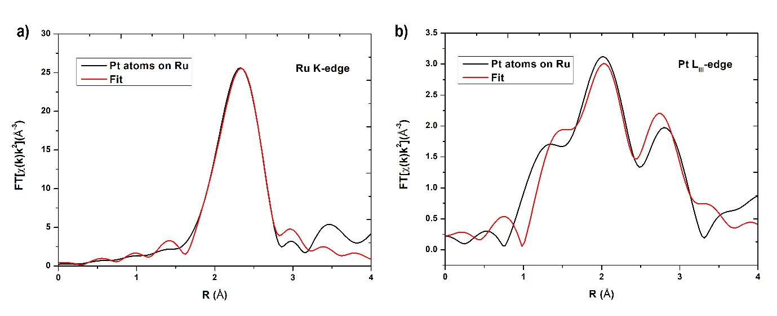
Supplementary Fig. 6| FT-EXAFS fitting for Pt atoms on Ru. a) Ru K-edge. b) Pt L_{III}-edge. The best-fit parameters are shown in Table S1.

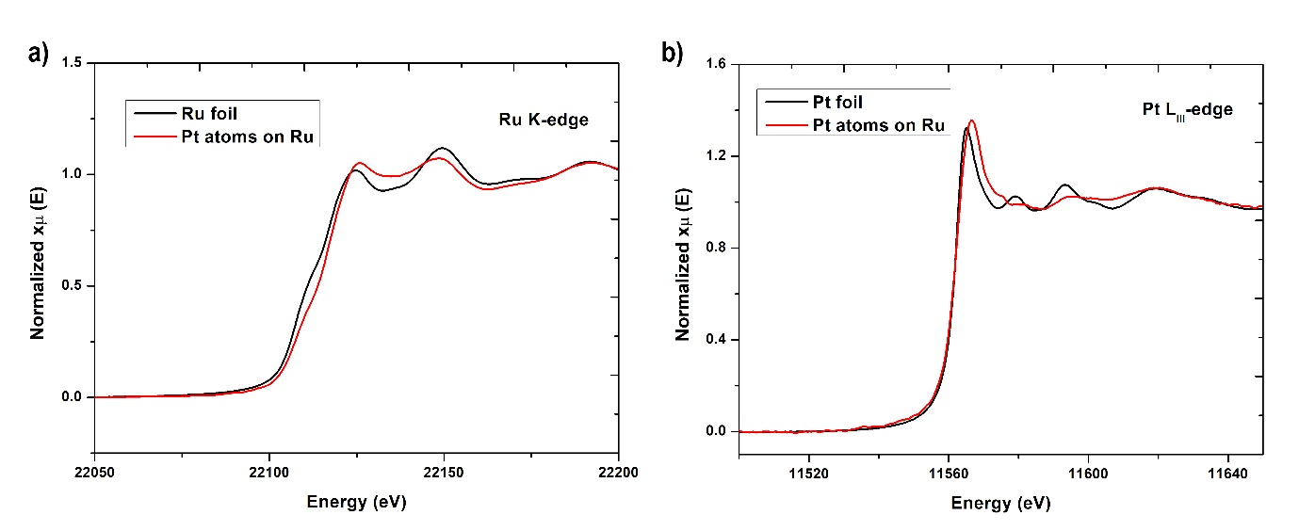Supplementary Fig. 7| XANES for Pt atoms on Ru. a) Ru K-edge. b) Pt L_{III}-edge. Reference spectra (Ru foil and Pt foil) is also shown where appropriate.

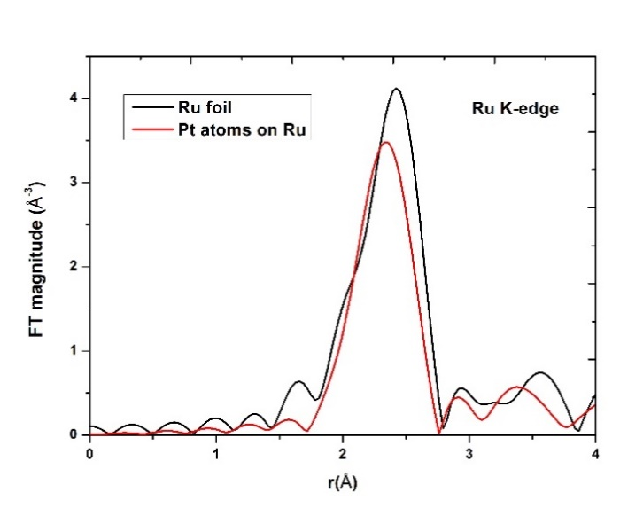
Supplementary Fig. 8| Ru K-edge FT-EXAFS spectra for Pt atoms on Ru. Reference spectrum for Ru foil is also shown
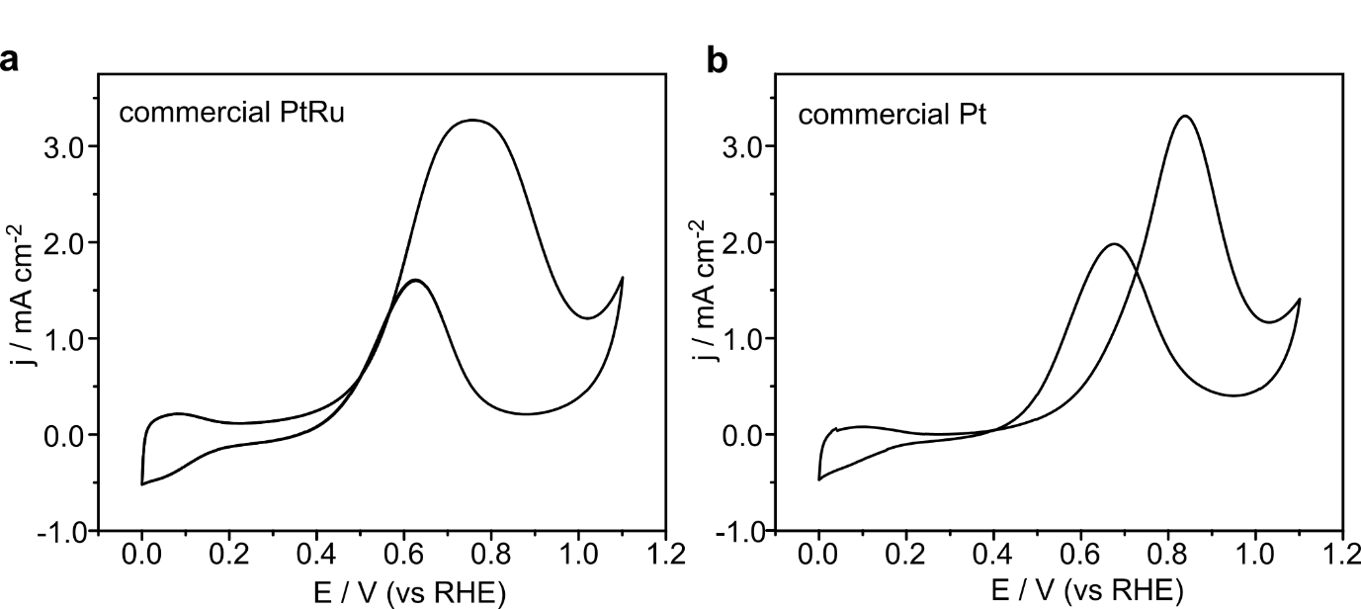

Supplementary Fig. 9 | Cyclic voltammetry of commercial PtRu alloy (a) and commercial Pt (b) nanoparticles in 0.1 M HClO₄ + 1.0 M CH₃OH with a scan rate of 25 mV s⁻¹.
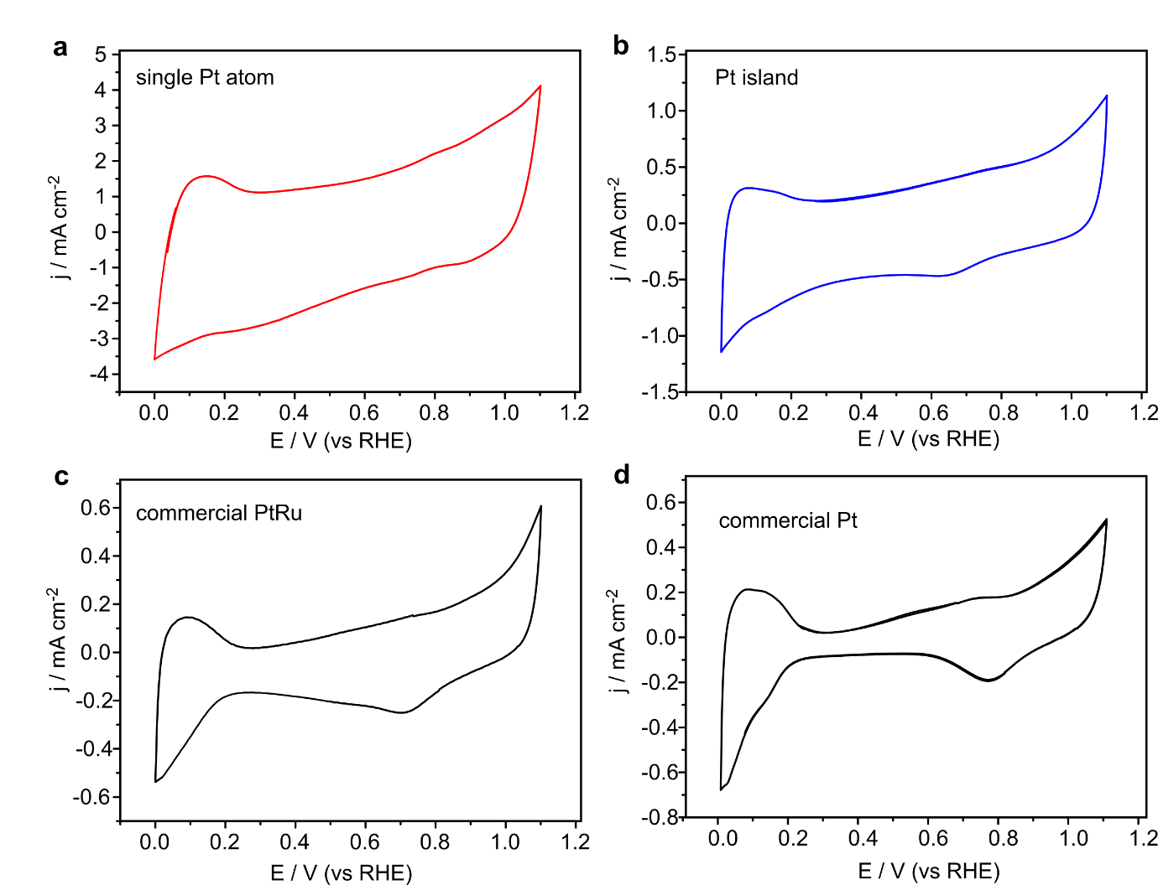

Supplementary Fig. 10 | Cyclic voltammetry of single Pt atom (a), Pt island on Ru (b), commercial PtRu alloy (c) and commercial Pt (d) nanoparticles in 0.1 M HClO₄ with a scan rate of 25 mV s⁻¹.

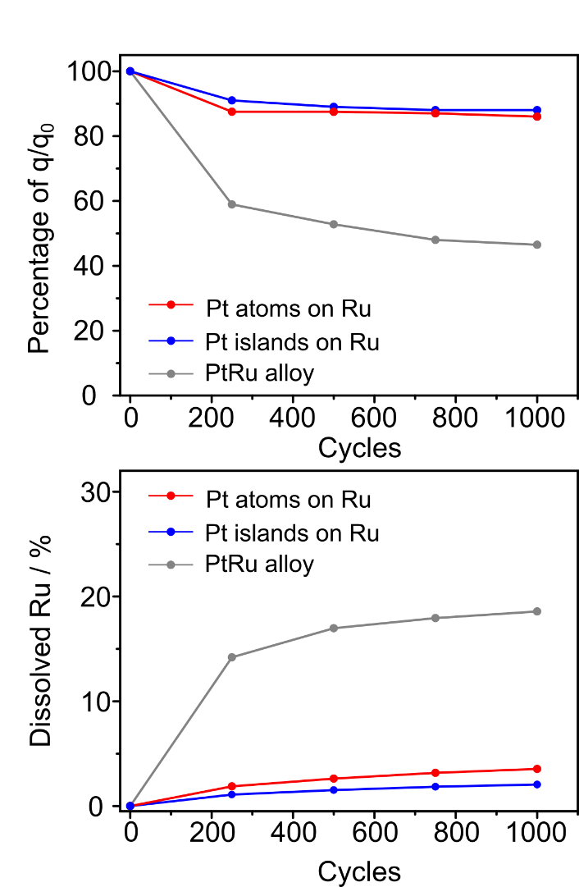
Supplementary Fig. 11 | Long-term potential cycling of Pt atoms on Ru (red), Pt islands on Ru (blue) and PtRu alloy (grey) nanoparticles in 0.1 M HClO₄ and 1.0 M CH₃OH. Both Pt atoms on Ru and Pt islands on Ru nanoparticles have higher stability than PtRu alloy nanoparticles. This high stability is due to stable Ru against dissolution.

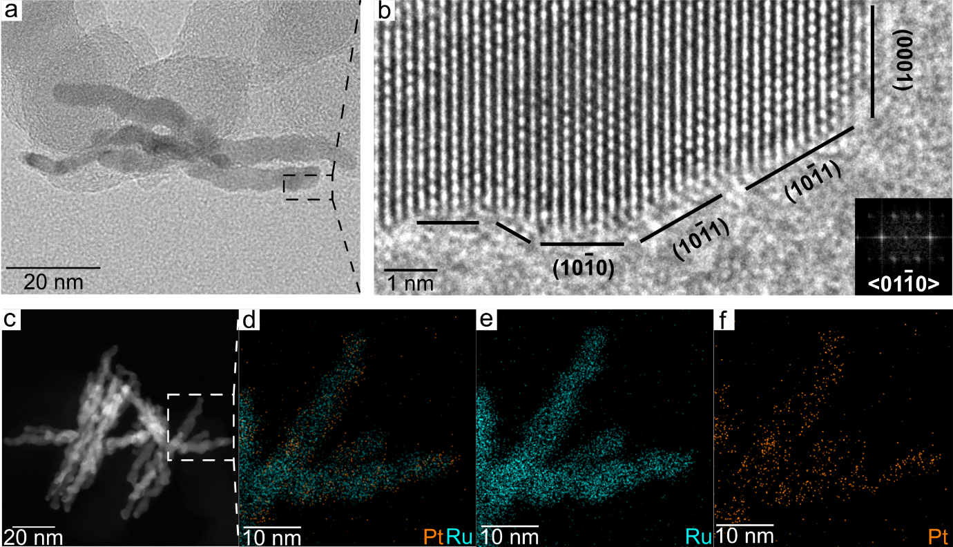
Supplementary Fig. 12 | Post-characterization TEM image of Pt atoms on Ru nanoparticles after 2 hours chronoamperometry test at 0.6 V in 0.1 M HClO₄ and 1.0 M CH₃OH.

Supplementary Table 1. EXAFS fitting parameters for Pt L_{III}-edge
 | Pt-O | Pt-Ru
CN | 2.25 ± 0.26 | 5.61 ± 1.02
NND (Å) | 2.05 ± 0.01 | 2.72 ± 0.01
σ² | 0.006 ± 0.008 | 0.002 ± 0.001
*CN – coordination number, NND – nearest neighbour distance, σ – Debye Waller factor

Supplementary Table 2. EXAFS fitting parameters for Ru K-edge
Ru-Ru
CN | 11.05 ±1.92
NND (Å) | 2.67 ± 0.01
σ² | 0.004 ± 0.001
*CN – coordination number, NND – nearest neighbour distance, σ – Debye Waller factor

Supplementary Table 3. Comparison of MOR activity to the state-of-the-art Pt and PtRu-based catalysts at 0.7 V vs RHE.
Materials | Electrolyte |  | CO-poisoning tolerance | Geometric activity  (mA cm⁻²) | Specific activity  (mA cm⁻²) | Mass Activity  (A mg⁻¹_{Pt}) | Ref
single Pt atoms on Ru | 0.1 M HClO₄ + 1.0 M CH₃OH |  | 6.3 | 14.3 | 0.75 | 1.58 | Our work
Pt islands on Ru | 0.1 M HClO₄ + 1.0 M CH₃OH |  | 2.4 | 4.6 | 0.37 | 0.69 | Our work
commercial PtRu | 0.1 M HClO₄ + 1.0 M CH₃OH |  | 1.2 | 3.0 | 0.63 | 0.24 | Our work
commercial Pt | 0.1 M HClO₄ + 1.0 M CH₃OH |  | 0.8 | 1.1 | 0.35 | 0.14 | Our work
PtRu nanowires | 0.1 M HClO₄ + 0.5 M CH₃OH |  | ~1.0 | - | 0.1 | 0.12 | 1
PtRu nanodendrites | 0.1 M HClO₄ + 1.0 M CH₃OH |  | 1.67 | 2 | 4.8 | 0.52 | 2
PtRu coreshell | 0.5 M H₂SO₄+ 1.0 M CH₃OH |  | 1.25 | 5.4 | 0.3 | 0.4 | 3
PtRuCu hexapod | 0.1 M HClO₄ + 1.0 M CH₃OH |  | 1.21 | 5.1 | 2.1 | 0.55 | 4
PtRu porous |  | 0.1 M HClO₄ + 0.5 M CH₃OH | 2.5 | - | 6.2 | 1.0 | 5

Supplementary Table 4. Comparison of MOR activity to the previous single atom-based Pt catalysts.
Materials | Electrolyte | Pt loading  (%wt) | Mass Activity  (mA mg⁻¹_{Pt}) | Ref
single Pt atoms on Ru | 0.1 M HClO₄ + 1.0 M CH₃OH | 7.8 | 1.58 | our work
single Pt atoms on Au NPs | 0.1 M H₂SO₄+ 0.5 M CH₃OH | - | 0 | 6
single Pt atoms on CNT | 0.5 M H₂SO₄+ 2.0 M CH₃OH | - | 0 | 7
single Pt atoms on TiC | 0.1 M HClO₄ + 0.5 M CH₃OH | 0.2 | 0 | 8
single Pt atoms on TiN | 0.1 M HClO₄ + 0.5 M CH₃OH | 0.35 | 0 | 9
 |  | 2.0 | 0.35 | 9
single Pt atoms on triazine framework | 0.5 M H₂SO₄+ 1.0 M CH₃OH | 1.0 | 0 | 10
single Pt atoms and sub-nanometer Pt on graphene | 0.5 M H₂SO₄+ 1.0 M CH₃OH | 1.52 | NA | 11

References:
- Huang, L. et al. Shape-Control of Pt–Ru Nanocrystals: Tuning Surface Structure for Enhanced Electrocatalytic Methanol Oxidation. J. Am. Chem. Soc. 140, 1142-1147, (2018).
- Lu, S. et al. One-pot synthesis of PtRu nanodendrites as efficient catalysts for methanol oxidation reaction. Nanoscale 9, 1033-1039, (2017).
- Xie, J. et al. Ruthenium–platinum core–shell nanocatalysts with substantially enhanced activity and durability towards methanol oxidation. Nano Energy 21, 247-257, (2016).
- Xue, S. et al. Hexapod PtRuCu Nanocrystalline Alloy for Highly Efficient and Stable Methanol Oxidation. ACS Catal. 8, 7578-7584, (2018).
- Zhao, W.-Y. et al. Highly Active and Durable Pt72Ru28 Porous Nanoalloy Assembled with Sub-4.0 nm Particles for Methanol Oxidation. Adv. Energy Mater. 7, 1601593, (2017).
- Yang, S. & Lee, H. Atomically Dispersed Platinum on Gold Nano-Octahedra with High Catalytic Activity on Formic Acid Oxidation. ACS Catal. 3, 437-443, (2013).
- Kim, Y.-T. et al. Fine Size Control of Platinum on Carbon Nanotubes: From Single Atoms to Clusters. Angew. Chem. Int. Ed. 45, 407-411, (2006).
- Shin, S. et al. Changes in the oxidation state of Pt single-atom catalysts upon removal of chloride ligands and their effect for electrochemical reactions. Chem. Commun. 55, 6389-6392, (2019).
- Yang, S., Kim, J., Tak, Y. J., Soon, A. & Lee, H. Single-Atom Catalyst of Platinum Supported on Titanium Nitride for Selective Electrochemical Reactions. Angew. Chem. Int. Ed. 55, 2058-2062, (2016).
- Kamiya, K., Kamai, R., Hashimoto, K. & Nakanishi, S. Platinum-modified covalent triazine frameworks hybridized with carbon nanoparticles as methanol-tolerant oxygen reduction electrocatalysts. Nat. Commun. 5, 5040, (2014).
- Sun, S. et al. Single-atom Catalysis Using Pt/Graphene Achieved through Atomic Layer Deposition. Sci. Rep. 3, 1775, (2013).

