Supplementary material

S1. Comparison of observed and computed waveforms at 106 ocean bottom pressure sensors shown in top-left figure (a). b) black lines are observed waveforms, red lines are computed waveforms. Station name shown in bottom-left corner. Long period waves in the first 100 mins in the observed waveforms are an effect of the bandpass filter.
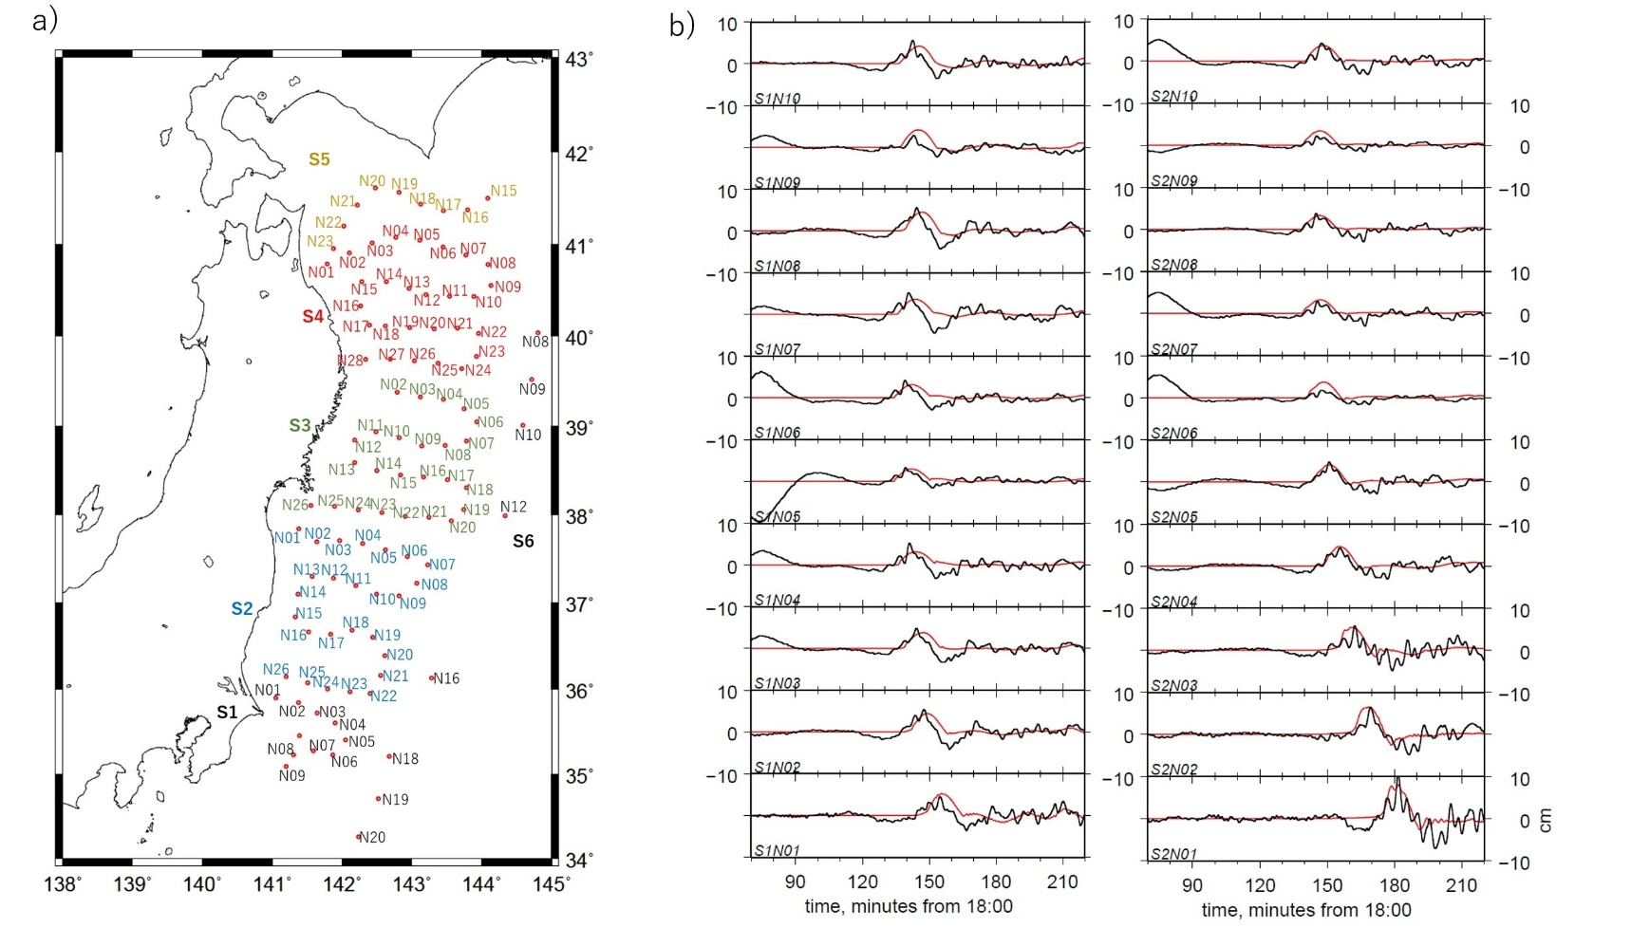
(continue)

