10-hydroxy-2E-decenoic acid (10HDA) is not a caste-differentiation factor in Melipona scutellaris stingless bees

Luiza Diniz Ferreira Borges^{1*}, Letícia Leandro Batista¹, Serena Mares Malta¹, Tamiris Sabrina Rodrigues¹, Jéssica Regina da Costa Silva¹, Gabriela Venturini², Alexandre da Costa Pereira², Pedro Henrique Gonçalves Guedes¹, Carlos Ueira-Vieira¹, Ana Maria Bonetti^{1*}

Supplementary Figure S1: Metabolites Enrichment of Melipona scutellaris L2 larvae. Enrichment for Urea Cycle (P < 0.01), Galactose Metabolism (P < 0.01), and Ammonia Recycling (P < 0.05). L2 = larva of the second stage.

Supplementary Figure S2: Metabolites Enrichment of Melipona scutellaris L3.3 larvae. Enrichment for Urea Cycle (P < 0.01), Galactose Metabolism (P < 0.01), Ammonia Recycling (P < 0.05), Glycine and Serine Metabolism (P < 0.05), Aspartate Metabolism (P < 0.05), Alanine Metabolism (P < 0.05), Methionine Metabolism (P < 0.05) and Glutamate Metabolism (P < 0.05). L3.3 = larva of the third stage in the third instar.

Supplementary Figure S3: Metabolites Enrichment of Melipona scutellaris LD larvae. Enrichment for Urea Cycle (P < 0.001), Ammonia Recycling (P < 0.001), Alanine Metabolism (P < 0.001), Warburg Effect (P < 0.01), Glucose-Alanine Cycle (P < 0.05), Glutamate Metabolism (P < 0.05), Glycine and Serine Metabolism (P < 0.05), Aspartate Metabolism (P < 0.05), Arginine and Proline Metabolism (P < 0.05), Purine Metabolism (P < 0.05). LD = defecating larva.

Supplementary Figure S4: Metabolites of Melipona scutellaris larval food. Venn diagram of shared metabolites between larval food samples.

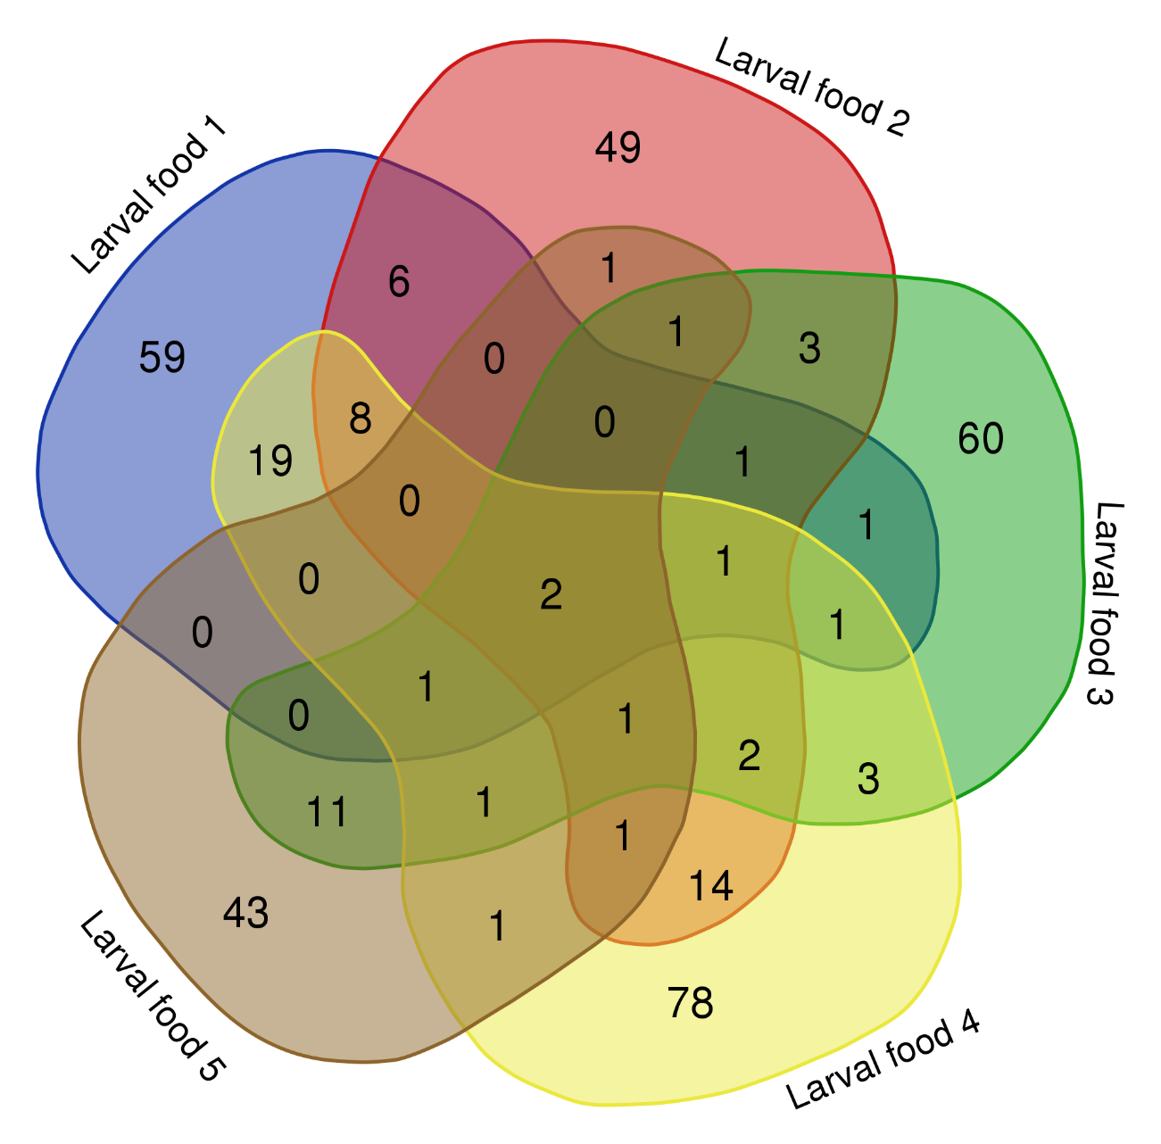

Supplementary Figure S5: Metabolites Enrichment of Melipona scutellaris larval food. Enrichment for Galactose Metabolism (P < 0.0001) and for Lactose Degradation (P < 0.05).

