Supplementary Table 1 Socioeconomic features of the MM patients
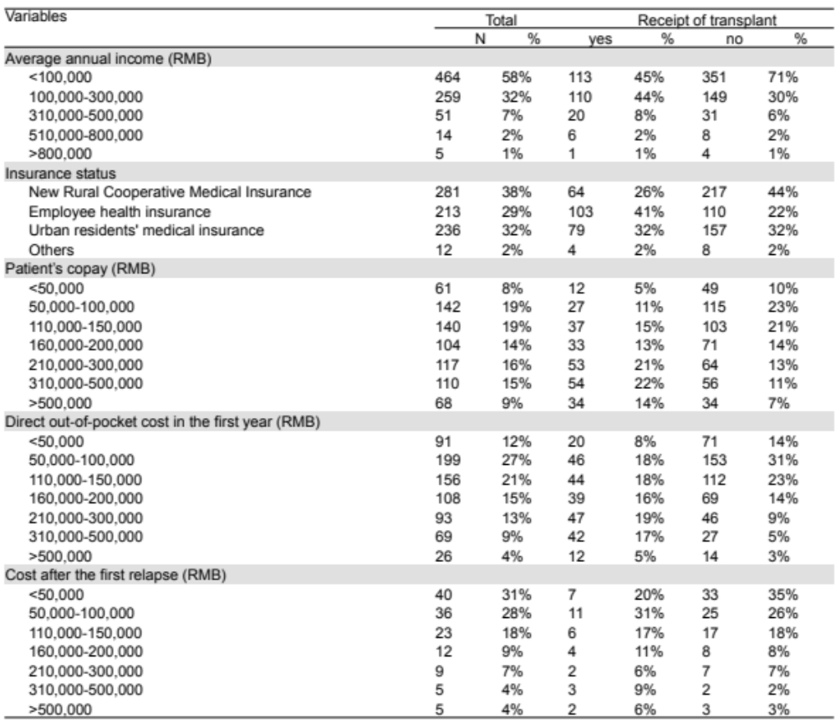

Supplementary Table 2 Main symptoms and first consultation department of the MM patients
