Electronic Supporting Information (ESI)
Synthesis of 2-aryl indoles and fused indole derivatives via Fischer indolisation and their antibacterial evaluation
Sushanta Kumar Mishraª, Prajna Parimita Mohantaª and Ajaya Kumar Behera^{a*}
ª School of Chemistry , Sambalpur University, Jyoti Vihar , Burla , Odisha , India.

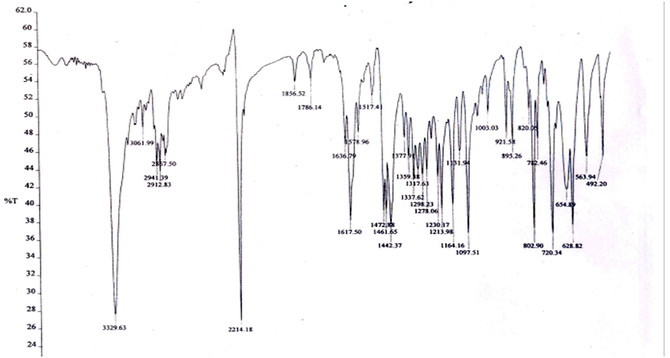
Figure 1. IR spectrum of compound 3a.
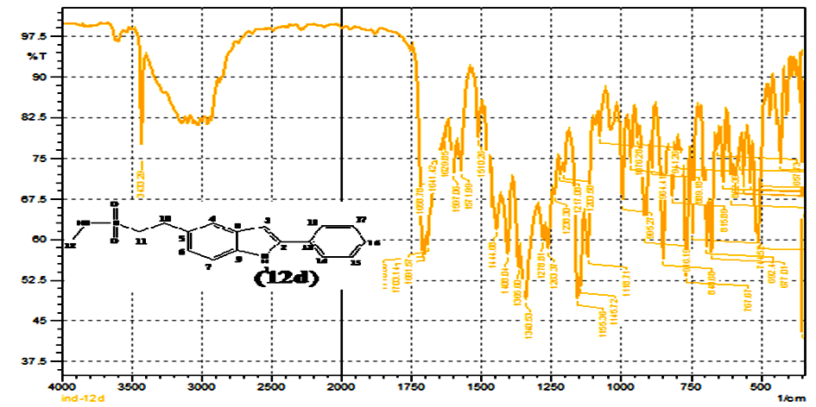
Figure 2. IR spectrum of compound 4a.
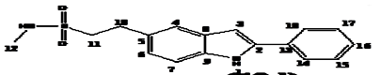
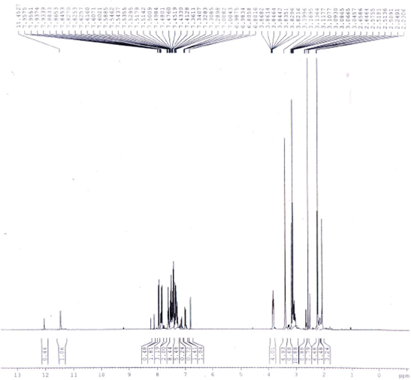
Figure 3. ¹H NMR spectrum of compound 4a.
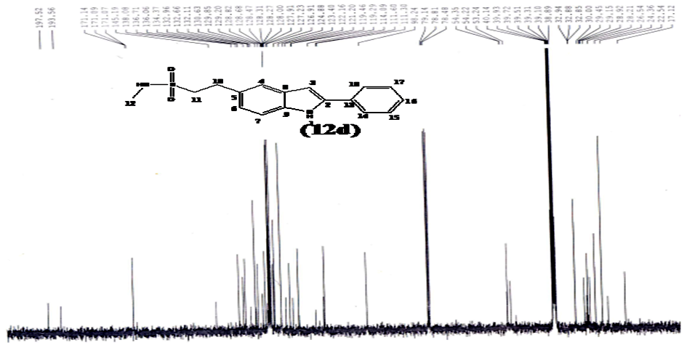
Figure 4. ¹³C NMR spectrum of compound 4a.

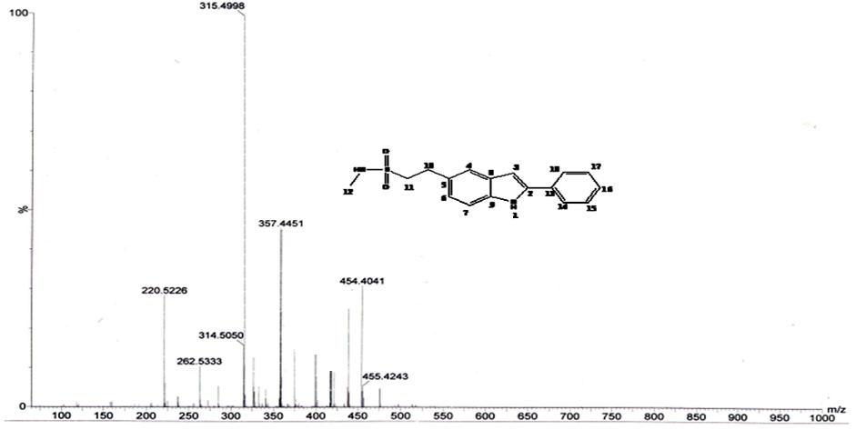
Figure 5. Mass spectrum of compound 4a.
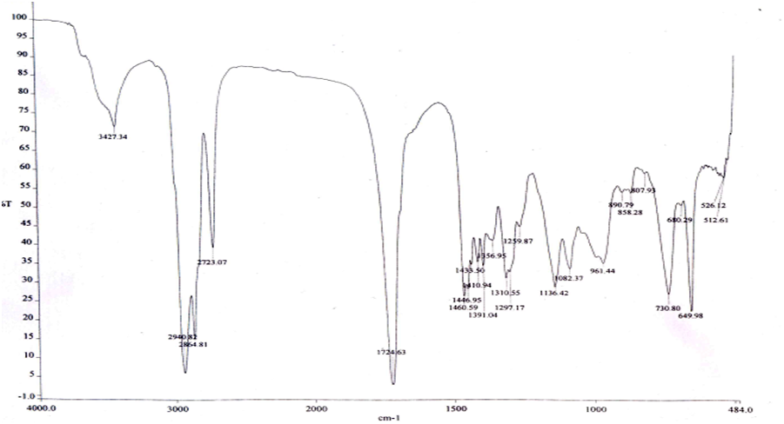
Figure 6. IR spectrum of compound 3b.

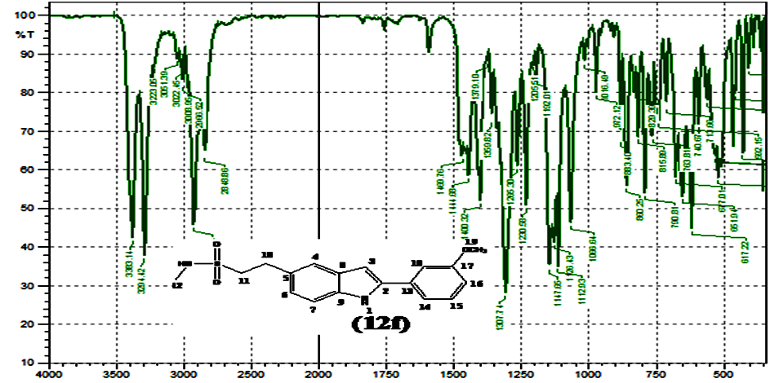
Figure 7. IR spectrum of compound 4b.

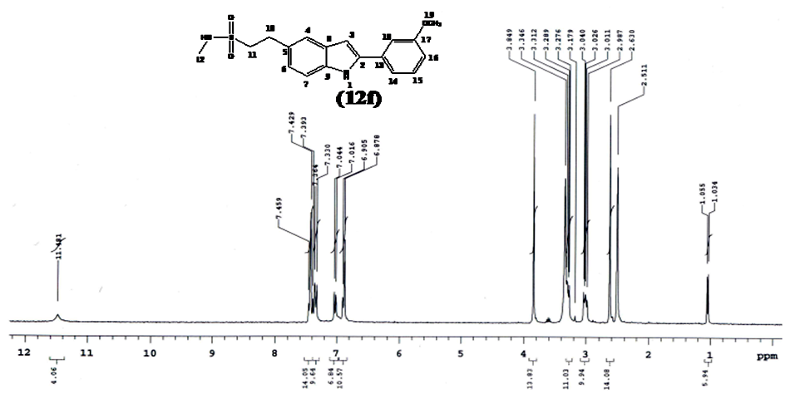
Figure 8. ¹H NMR spectrum of compound 4b.

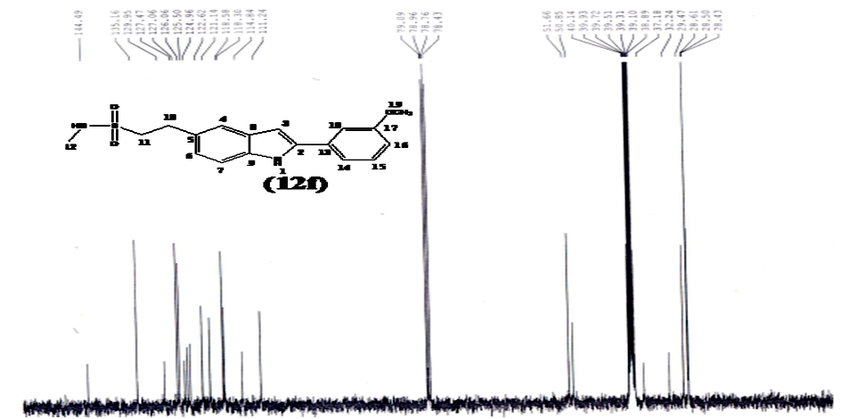
Figure 9. ¹³C NMR spectrum of compound 4b.

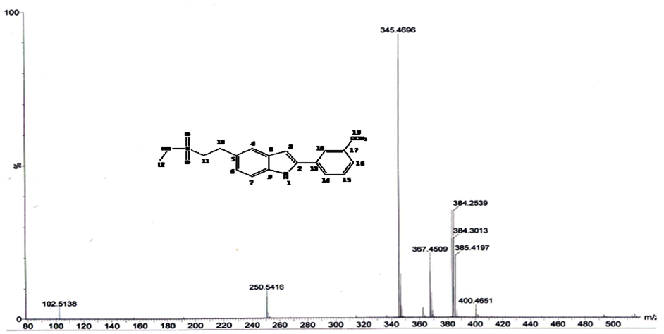
Figure 10. Mass spectrum of compound 4b.
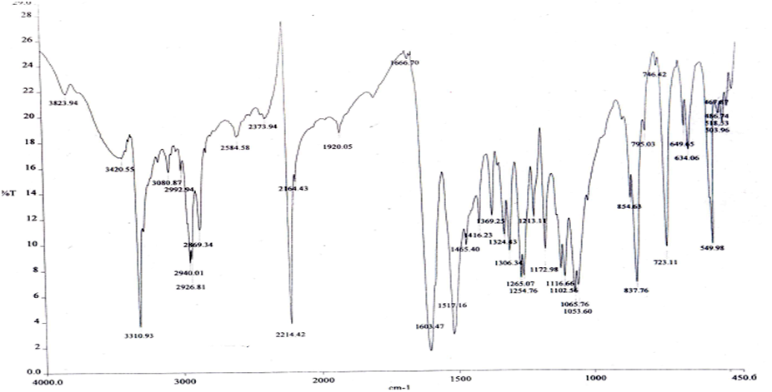
Figure 11. IR spectrum of compound 3c.
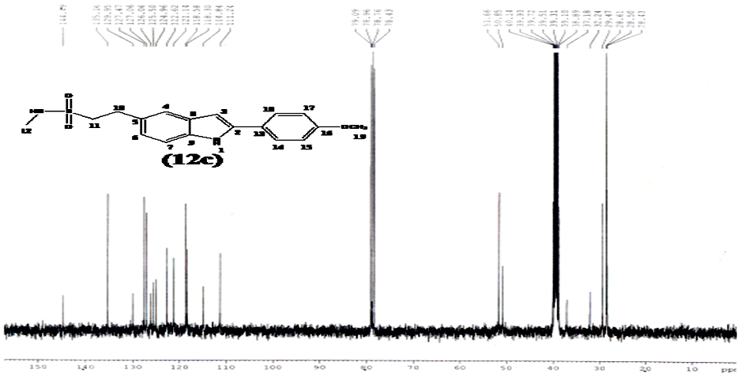
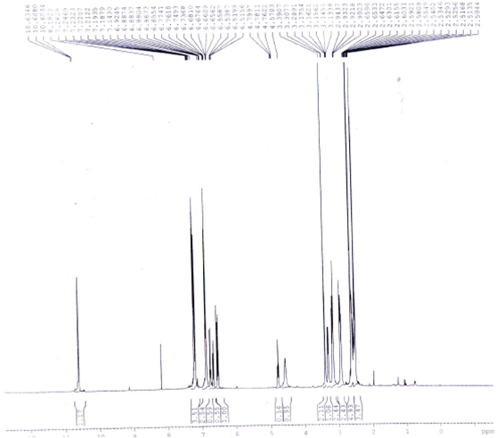
Figure 12. ¹H NMR spectrum of compound 4c.

Figure 13. ¹³C NMR spectrum of compound 4c.
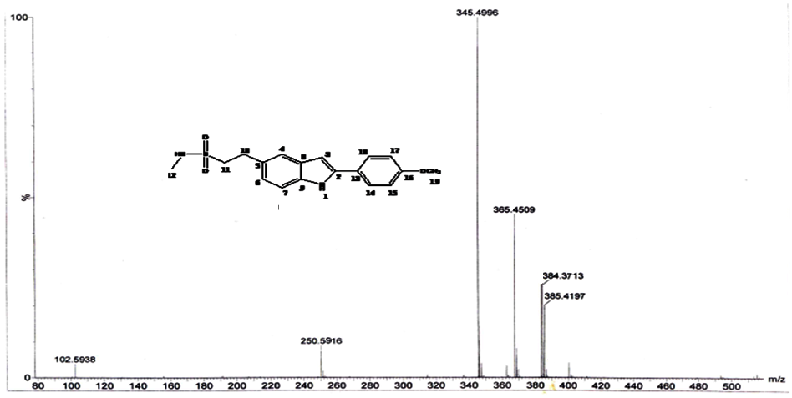
Figure 14. Mass spectrum of compound 4c.
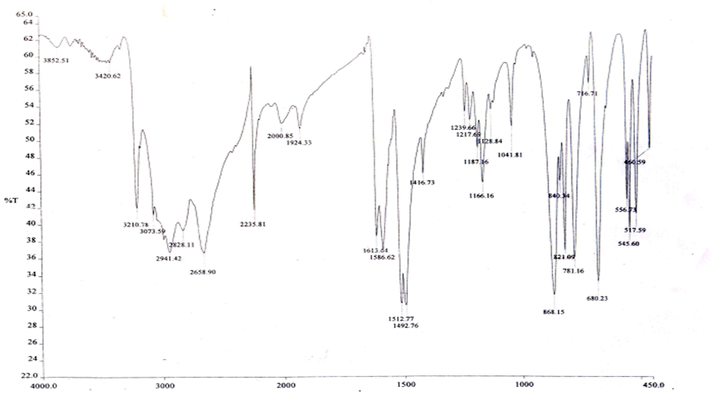
Figure 15. IR spectrum of compound 6a.

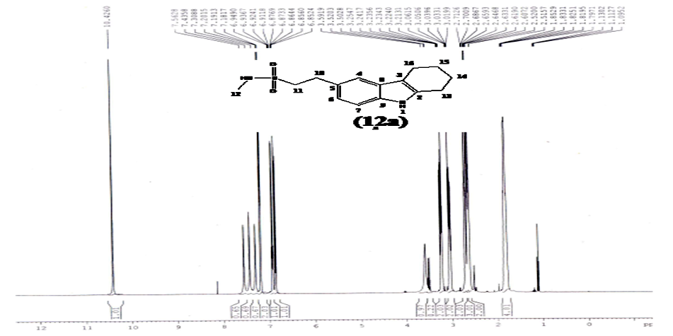
Figure 16. ¹H NMR spectrum of compound 7a.

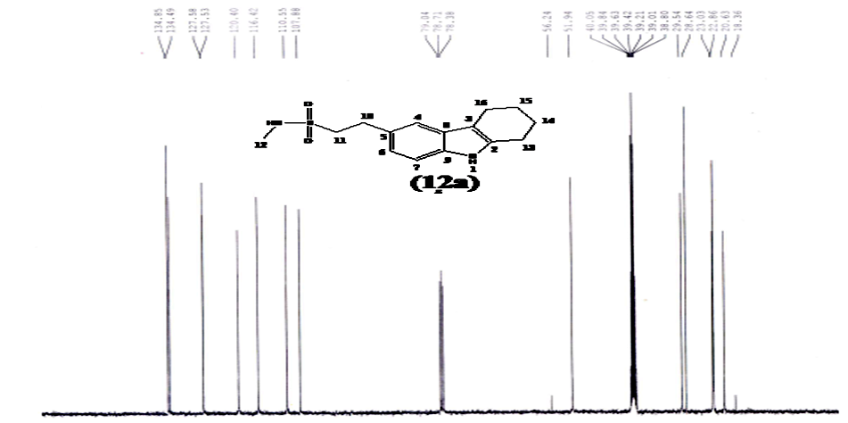
Figure 17. ¹³C NMR spectrum of compound 7a.
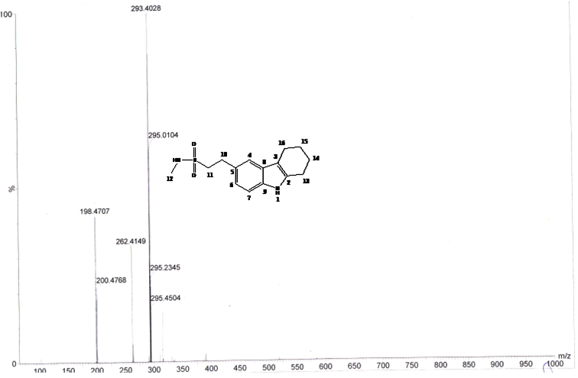
Figure 18. Mass spectrum of compound 7a.
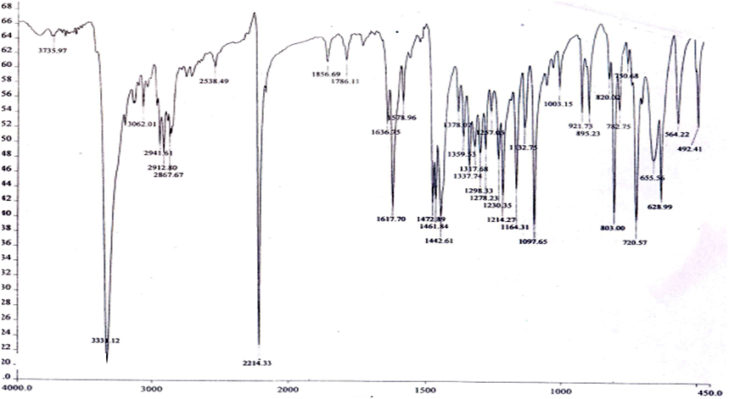
Figure 19. IR spectrum of compound 6b.

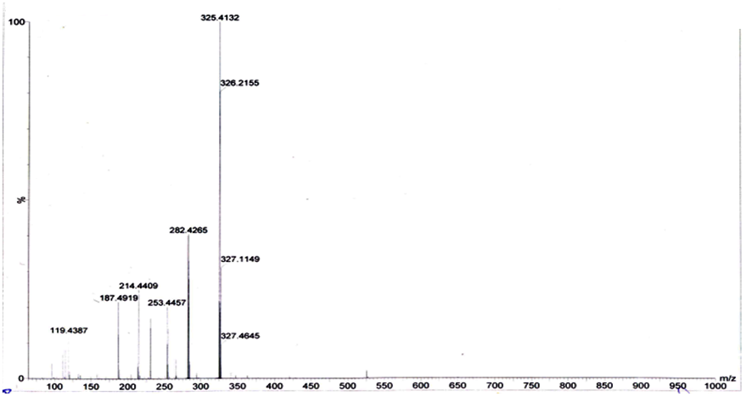
Figure 20. Mass spectrum of compound 6b.
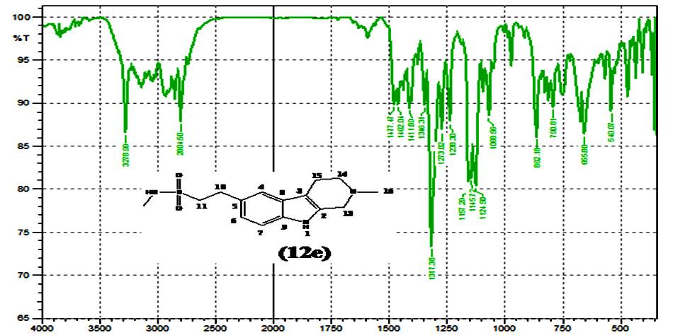
Figure 21. IR spectrum of compound 7b.

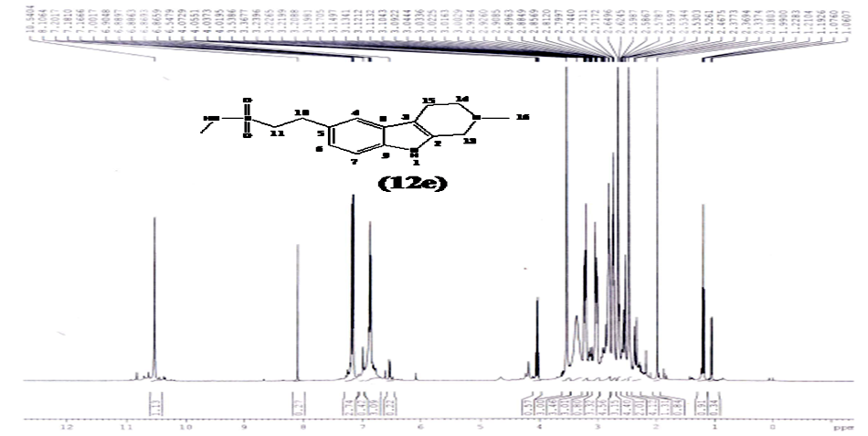
Figure 22. ¹H NMR spectrum of compound 7b.

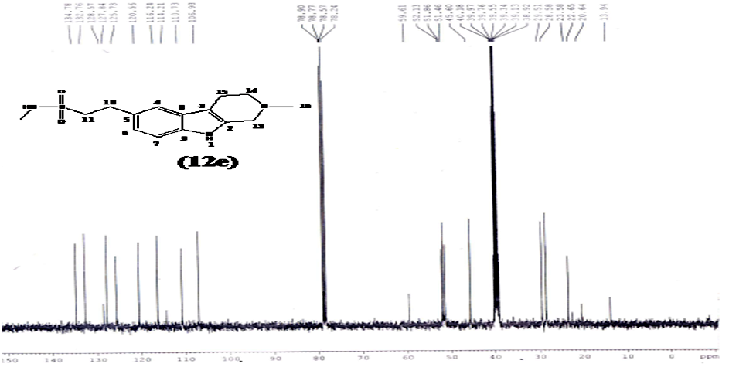
Figure 23. ¹³C NMR spectrum of compound 7b.
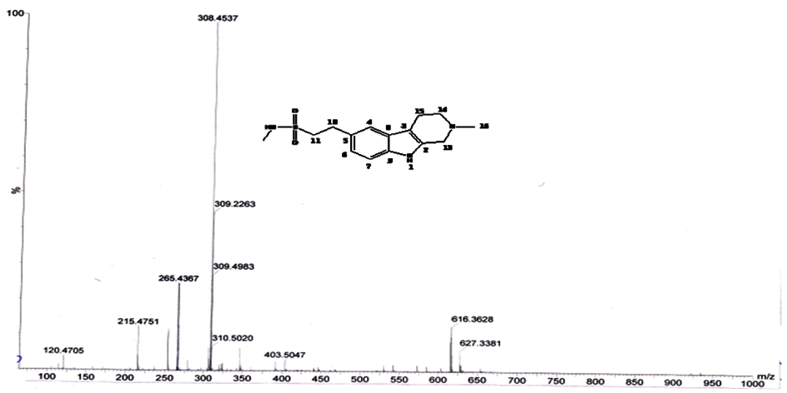
Figure 24. Mass spectrum of compound 7b.

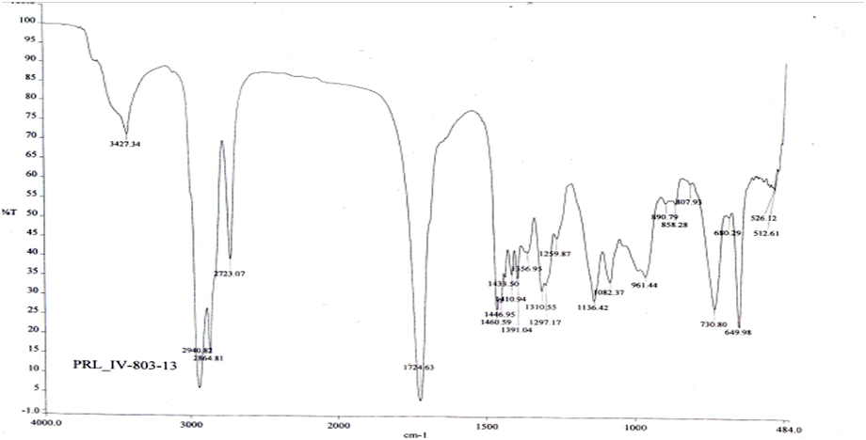
Figure 25. IR spectrum of compound 6c.

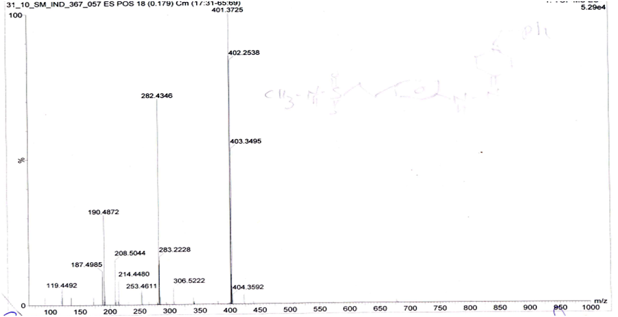
Figure 26. Mass spectrum of compound 6c.
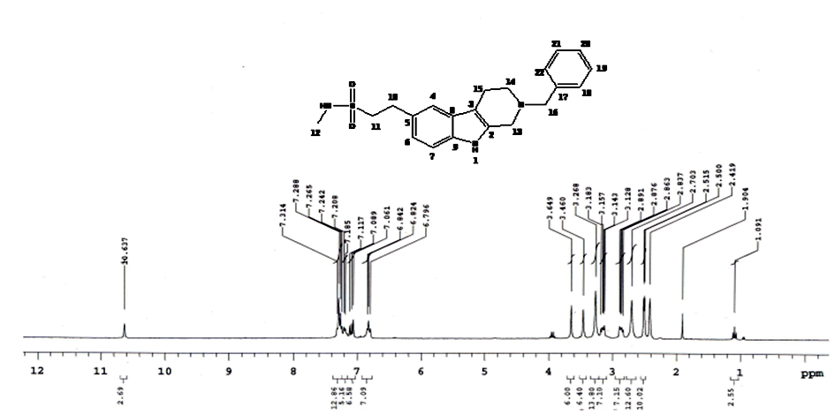
Figure 27. ¹H NMR spectrum of compound 7c.

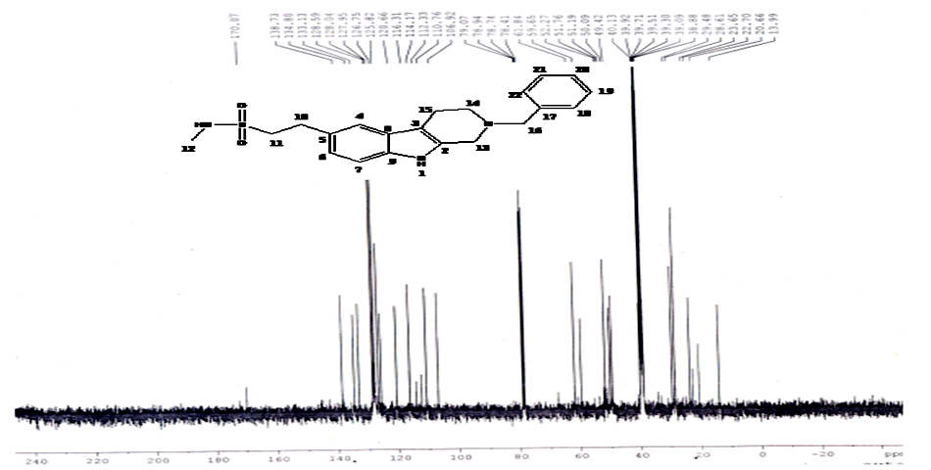
Figure 28. ¹³C NMR spectrum of compound 7c.

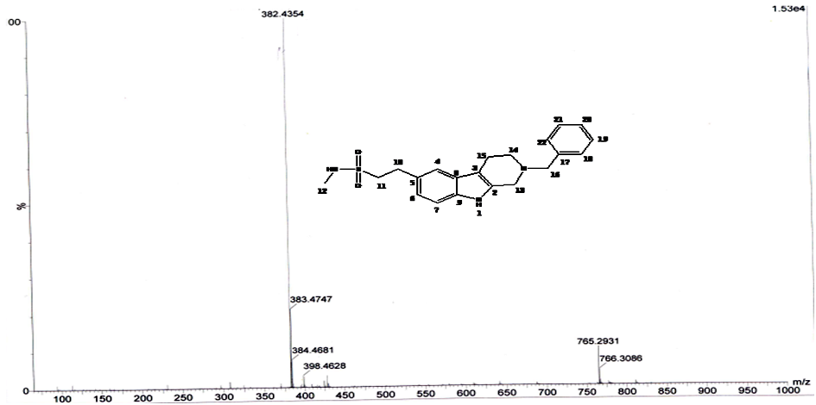
Figure 29. Mass spectrum of compound 7c.

