- Study design
To assess the IMF content, the longissimus dorsi (LD) and biceps femoris (BF) tissues were collected from 20 goats. Independent sample t-tests for fatty acids in different muscles showed that the IMF content was significantly higher in the BF (experimental group) than in the LD (control group) (P<0.01). This suggests that IMF is deposited at higher levels in the BF or metabolized to a greater degree in the LD. To better understand the molecular variations underlying intramuscular fat (IMF) anabolism and catabolism in Inner Mongolian cashmere goats, the proteomic differences between the BF and LD were investigated by a label-free strategy. Then, the identified proteins were verified as being involved in IMF anabolism and catabolism by Western blot analysis. [1].
- Sample size
 | experimental group (BF) | control group (LD)
N= | 6 | 6
External factors influencing intramuscular fat deposition include feed intake, temperature, and grazing environment. To remove the influence of these factors we chose different parts of the same goat for the experiment [2].
- Inclusion and exclusion criteria
The animals were included in the study if IMF content was significantly higher in the BF than in the LD (P<0.01). The animals were excluded if IMF content was lower in the BF than in the LD [3].
- Randomisation
6 animals (wether, carcass weight of 25-26 kg) were obtained from Aerbasi, Yiwei White Cashmere Goat Breeding Farm, Erdos, Inner Mongolia. And were randomly divided into two groups. Random numbers were generated using the standard = RAND () function in Microsoft Excel [4].
- Blinding
There are no treatment(s) animals have received, from the start of the experiment until the data have been analysed. So blinding was not considered.
- Outcome measures
There is no any variable recorded during a study.
- Statistical methods
Analysis of the content of IMF and relative protein intensity of western blot result, T-test was performed using the SPSS (IBM SPSS Statistics 22). Results are presented as mean ± standard deviation. The level of significance was set at P < 0.01 [5].
- Experimental animals
Each animal (two years old, wether, carcass weight of 25-26 kg), all of which were of Inner Mongolia cashmere goats [6].
- Experimental procedures
IMF content of meat: The IMF level for the BF and LD was determined using the Soxhlet extraction protocol following the method of Hopkins et al. [7].
Western blotting: The homogenized denatured protein was separated by SDS-PAGE and transferred in a semidry state to a PVDF membrane (Bio-Rad, USA). The PVDF membrane was blocked in blocking buffer (Li-CoR, USA) for 2 hours and incubated overnight with murine monoclonal primary antibody (Abcam, Germany). The membrane was washed 3 times for 10 minutes each time and then incubated with fluorophore-conjugated goat anti-mouse antibody (Li-CoR, USA) for 1 hour. Finally, the membrane was rinsed with water, and the immunoreactive bands were examined using a LI-COR Odyssey (CLX-0496, USA) near-infrared imager.
- Results
IMF content of the LD and BF muscles
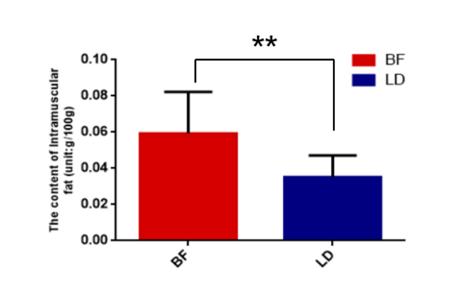
To assess the IMF content, the longissimus dorsi (LD) and biceps femoris (BF) tissues were collected from 20 goats. Independent sample t-tests for fatty acids in different muscles showed that the IMF content was significantly higher in the BF than in the LD (P<0.01) (figure 1). This suggests that IMF is deposited at higher levels in the BF or metabolized to a greater degree in the LD. To explore IMF anabolism and catabolism at the proteomic level, we selected the BF and LD from 6 goats for the next experiment.
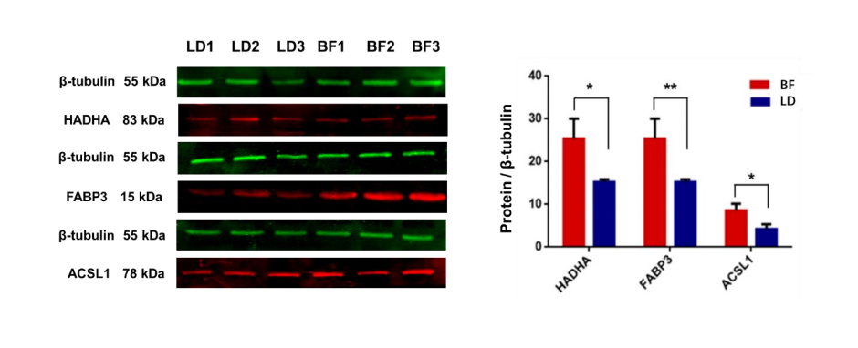
Protein determination by Western blot analysis
Western blot quantification is a critical method that provides accurate and reproducible results (figure 5). Therefore, this method was used to detect the expression levels of three DEPs (HADHA, fatty acid-binding protein (FABP3) and AMP-binding domain-containing protein (ACSL1)) from the high-IMF group and low-IMF group. All three proteins were upregulated in the high-IMF groups. The average band intensities of HADHA, FABP3 and ACSL1 (normalized to β-tubulin) had similar variation tendencies according to the results of MS analyses. The band intensities of these three proteins were significantly higher in the BF than in the LD (p<0.05).
- Abstract
Background: As a major raw-cashmere-producing province in China. Nearly 700,000 Aerbasi cashmere goats are fed per year, and the corresponding meat production is nearly 10,000 tons. However, there are no reports on the meat of this goat. To better understand the molecular variations underlying intramuscular fat (IMF) anabolism and catabolism in Inner Mongolian cashmere goats, the proteomic differences between the biceps femoris (BF) and longissimus dorsi (LD) were investigated by a label-free strategy. Then, the identified proteins were verified as being involved in IMF anabolism and catabolism by Western blot analysis.
Results: The IMF content was significantly higher in the BF than in the LD, suggesting that IMF accumulated more in the BF or was metabolized more in the LD. We performed proteomic analysis of IMF anabolism and catabolism at the proteomic level, and 1209 proteins were identified in the BF (high-IMF) and LD (low-IMF) groups. Among them, 110 were differentially expressed proteins (DEPs), 81 of which were upregulated in the high-IMF group, while 29 were upregulated in the low-IMF group. Gene ontology (GO) classification showed that the 110 DEPs were functionally classified into 100 annotation clusters. Kyoto Encyclopedia of Genes and Genomes (KEGG) analysis showed that the 110 DEPs covered 34 KEGG pathways. Three pathways were related to IMF metabolism and deposition—fatty acid metabolism, fatty acid degradation and fatty acid elongation—and included 7 proteins.
Conclusion: GO and KEGG analyses showed that differentially expressed HADHA, HADHB, ACSL1, ACADS, ACAT1 and ACAA2 in the mitochondria act via fatty acid metabolism, fatty acid degradation and fatty acid elongation to influence the metabolism and synthesis of long-, short- and medium-chain fatty acids and modulate IMF anabolism and catabolism. Protein-protein interaction (PPI) network analysis showed that IMF accumulation in different muscle tissues of Inner Mongolian cashmere goats was affected not only by 5 key enzymes and proteins involved in fatty acid synthesis and metabolism but also by five DEPs (SUCLG1, SUCLG2, CS, DLST, and ACO2) in the TCA cycle. Our results provide new insights into IMF deposition in goats and improve our understanding of the molecular mechanisms underlying IMF anabolism and catabolism.
Keywords: cashmere goat meat, IMF, anabolism and catabolism, label-free strategy, proteome
- Background
As a major raw-cashmere-producing province in China, Inner Mongolia cashmere goats harbors three types —Erlangshan, Aerbasi and Alashan [9]. The Inner Mongolian cashmere goat is a local breed that provides both cashmere and meat, and the production of cashmere in Inner Mongolia accounts for approximately 40 % of the total output of the whole country [10]. Nearly 700,000 Aerbasi cashmere goats are fed per year, and the corresponding meat production is nearly 10,000 tons. Aerbasi cashmere has been widely studied, but the meat value of this goat has not been reported. Therefore, the study of Aerbasi cashmere goat meat is of great significance.
Intramuscular fat (IMF) is mainly found in the sarcolemma, including the perimysium, epimysium and endomysium, and is mainly composed of triglycerides and phospholipids [11]. The IMF content and its fatty acid composition play an important role in meat quality, affecting the sensory properties (flavor, juiciness and tenderness) and nutritional value of meat [12]. The positive effect of IMF on the sensory quality of meat has been demonstrated in pork [5], mutton [13], and beef [14]. The IMF deposition capacity is regulated by 3 aspects: transport to fatty acids, fat anabolism and fat catabolism. Recent studies have demonstrated that FABP and CD36 play important roles in the process of fat uptake [15,16], and DGAT1 and SCD regulate the synthesis of IMF [17,18]. The HSL and LPL genes regulate fat breakdown [19,20]. However, it is not known which proteins affect the deposition and metabolism of IMF in cashmere goat meat, so research on the composition of protein in cashmere goat meat is urgently needed.
In recent years, the label-free approach to proteomics, which is known to be a reliable, versatile, and cost-effective strategy, has received much attention [21]. Furthermore, it has been successfully applied to compare proteome changes in beef color stability [15] and gain knowledge of broiler self-regulation mechanisms under heat stress [22]. However, the application of a label-free proteomics strategy to investigate proteomic changes that occur during the process of IMF regulation has not yet been reported in cashmere goats. Moreover, the proteomic abundance in cashmere goats remains unclear.
- Objectives
The objective of the present study was to identify key proteins involved in IMF anabolism and catabolism and to reveal underlying biochemical events with the help of bioinformatics analyses
- Ethical statement
Samples were collected in accordance with the Guidelines for Experimental Animals of the Ministry of Science and Technology (Beijing, China) and were approved by the experimental animal ethics committee of Inner Mongolia Agricultural University (GB 14925-2001).
- Housing and husbandry
All goats were freely grazing housed and were allowed ad libitum to feed and water until two years old.
- Animal care and monitoring
Goat are routinely protected against diseases, including injections, foot and mouth disease (FMD), triple quadruple protection, and deworming.
- Interpretation/ scientific implications
Our results provide new insights into IMF deposition in goats and improve our understanding of the molecular mechanisms associated with IMF anabolism and catabolism.
- Generalisability/ translation
Our study was to identify key proteins involved in IMF anabolism and catabolism and to reveal underlying biochemical events with the help of bioinformatics analyses. However, further functional validation is required.
- Protocol registration
Additional detailed experimental data and protocol are available at iProX database with the dataset identifier PXD022901.
- Data access
The mass spectrometry proteomics data have been deposited to the ProteomeXchange Consortium (http://proteomecentral.proteomexchange.org) via the iProX partner repository with the dataset identifier PXD022901.
- Declaration of interests
The authors have declared that no competing interests exist.

- Zhang Y, Zhang J, Gong H, et al. Genetic correlation of fatty acid composition with growth, carcass, fat deposition and meat quality traits based on GWAS data in six pig populations. Meat science, 2019, 150(APR.):47-55.
- Wang Z, Shang P, Li Q, et al. iTRAQ-based proteomic analysis reveals key proteins affecting muscle growth and lipid deposition in pigs. Rep, 2017, 7:46717.
- Qianqian, Yu, et al. Label-free proteomic strategy to compare the proteome differences between longissimus lumborum and psoas major muscles during early postmortem periods. Food Chemistry, 2018.
- Zhao S, Kang R, Deng T, Luo L, Wang J, Li E, Luo J, Liu L, Wan S and Zhao Z (2018). Comparison of two cannulation methods for assessment of intracavernosal pressure in a rat model. PLoS One.
- Fisher Box, Joan. Guinness, Gosset, Fisher, and Small Samples. Statistical Science. 1987, 2 (1): 45–52. doi: 10.2307/2245613
- Shen, Song, et al. Genome-wide discovery of lincRNAs with spatiotemporal expression patterns in the skin of goat during the cashmere growth cycle. Bmc Genomics 19.1(2018):495.
- Hopkins D L, Clayton E H, Lamb T A, et al. The impact of supplementing lambs with algae on growth, meat traits and oxidative status. Meat science 2014, 98(2):135-141.
- Wu W, Dai R, Bendixen, Emøke. Comparing SRM and SWATH Methods for Quantitation of Bovine Muscle Proteomes. Journal of Agricultural and Food Chemistry 2019 Feb 6;67(5):1608-1618.
- Su R, Fan Y, Qiao X, Li X, Zhang L, Li C, Li J. Transcriptomic analysis reveals critical genes for the hair follicle of Inner Mongolia cashmere goat from catagen to telogen. PLoS One. 2018 Oct 24;13(10).
- Su R, Gong G, Zhang L, Yan X, Wang F, Zhang L, Qiao X, Li X, Li J. Screening the key genes of hair follicle growth cycle in Inner Mongolian Cashmere goat based on RNA sequencing. Arch Anim Breed , 2020 May 26;63(1):155-164.
- GUO B, KONGSUWAN K, GREENWOOD P L, et al. A gene expression estimator of intramuscular fat percentage for use in both cattle and sheep. Journal of Animal Science and Biotechnology.4 (2014):379-390.
- Hocquette JF, Gondret F, Baéza E, Médale F, Jurie C, Pethick DW. Intramuscular fat content in meat-producing animals: development, genetic and nutritional control, and identification of putative markers. Animal. 2010 Feb;4(2):303-19.
- Gao SZ, Zhao SM. Physiology, affecting factors and strategies for control of pig meat intramuscular fat. Recent Pat Food Nutr Agric. 2009 Jan;1(1):59-74.
- Watkins PJ, Frank D, Singh TK, Young OA, Warner RD. Sheepmeat flavor and the effect of different feeding systems: a review. J Agric Food Chem. 2013 Apr 17;61(15):3561-79.
- Mateescu RG, Garrick DJ, Garmyn AJ, VanOverbeke DL, Mafi GG, Reecy JM. Genetic parameters for sensory traits in longissimus muscle and their associations with tenderness, marbling score, and intramuscular fat in Angus cattle. J Anim Sci. 2015 Jan;93(1):21-7.
- He J, Chen J, Lu L, Tian Y, Tao Z, Wang D, Li J, Li G, Shen J, Fu Y, Niu D. A novel SNP of liver-type fatty acid-binding protein gene in duck and its associations with the intramuscular fat. Mol Biol Rep. 2012 Feb;39(2):1073-7.
- YANG Y, SONG J, FU R Q, et al. AMPK subunit expression regulates intramuscular fat content and muscle fiber type in chickens. Agricultural Science ＆ Technology 2015, 16( 5) : 1006－1010.
- Anton I, K. Kovács, G. Holló, et al. Effect of leptin, DGAT1 and TG gene polymorphisms on the intramuscular fat of Angus cattle in Hungary. Livestock ence 2011, 135(2-3):300-303.
- AVILS C, HORCADA A, POLVILLO O, et al. Association study between variability in the SCD gene and the fatty acid profile in perirenal and intramuscular fat deposits from Spanish goat populations. Small Ruminant Research 136(2016):127-131.
- QIAO Y, HUANG Z G, LI Q F, et al. Developmental changes of the FAS and HSL mRNA expression and their effects on the content of intramuscular fat in Kazak and Xinjiang sheep. Journal of Genetics and Genomics 2007, 34( 10) : 909－917.
- WANG W, XUE W, ZHOU X, et al. Effects of candidate genes’polymorphisms on meat quality traits in pigs. Acta Agriculturae Scandinavica, Section A: Animal Science 2012, 62( 3) : 120－126.
- Gallego M , Mora L , Aristoy, M. Concepción, et al. Optimisation of a simple and reliable label-free methodology for the relative quantitation of raw pork meat proteins. Food Chemistry 182(2015):74-80.
- Yu Q , Wu W , Tian X , et al. Comparative proteomics to reveal muscle-specific beef color stability of Holstein cattle during post-mortem storage. Food Chemistry 2017, 229(AUG.15):769-778.
- Tang X, Meng Q, Gao J, Zhang S, Zhang H, Zhang M. Label-free Quantitative Analysis of Changes in Broiler Liver Proteins under Heat Stress using SWATH-MS Technology. Sci Rep 5(2015):15119.

