Supplementary Information
Selective electrocatalytic hydrogenation of bio-oil to oxygenated chemicals via suppression of deoxygenation
Tao Peng^{1,2†}, Taotao Zhuang^{1,3 †}, Yu Yan^{1†}, Jin Qian^{4†}, Graham R. Dick⁵, Jean Behaghel de Bueren⁵, Sung-Fu Hung¹, Ziyun Wang¹, Joshua Wicks¹, F. Pelayo Garcia de Arquer¹, Jehad Abed¹, Ning Wang¹, Armin Sedighian Rasouli¹, Geonhui Lee¹, Miao Wang², Daping He⁶, Zhe Wang⁶, Zhixiu Liang⁷, Liang Song⁷, Xue Wang¹, Bin Chen¹, Adnan Ozden⁸, Yanwei Lum¹, Wan Ru Leow¹, Mingchuan Luo¹, Debora Motta Meira^{9,10}, Alexander H. Ip¹, Jeremy S. Luterbacher^{5*}, Wei Zhao^{2*}, Edward H. Sargent^{1*}
¹Department of Electrical and Computer Engineering, University of Toronto, Toronto, Ontario, M5S 1A4, Canada.
²Institute for Advanced Study, Shenzhen University, Shenzhen 518060, China.
³Department of Chemistry, University of Science and Technology of China, Hefei, Anhui, China.
⁴Chemical Sciences Division, Lawrence Berkeley National Laboratory, Berkeley, CA 94720, United States.
⁵Laboratory of Sustainable and Catalytic Processing, Institute of Chemicals Sciences and Engineering, Ecole Polytechnique Fédérale de Lausanne (EPFL), Lausanne 1015, Switzerland
⁶Hubei Engineering Research Center of RF-Microwave Technology and Application, School of Science, Wuhan University of Technology, Wuhan 430070, China.
⁷Chemistry Division, Brookhaven National Laboratory, Upton, NY 11973, USA.
⁸Department of Mechanical and Industrial Engineering, University of Toronto, 5 King’s College Road, Toronto, Ontario, M5S 3G8, Canada.
⁹CLS@APS sector 20, Advanced Photon Source, Argonne National Laboratory, 9700 S. Cass Avenue, Argonne, IL 60439, USA
¹⁰Canadian Light Source Inc., 44 Innovation Boulevard, Saskatoon, Saskatchewan S7N 2V3, Canada
†These authors contributed equally to this work.
*Correspondence and requests for materials should be addressed to Jeremy S. Luterbacher (jeremy.luterbacher@epfl.ch) (J.S.L); Wei Zhao (weizhao@szu.edu.cn) (W.Z); Edward H. Sargent (ted.sargent@utoronto.ca) (E.H.S)

This PDF file includes:
1. Materials 3
1.1. Materials and chemicals for electrocatalytic hydrogenation 3
1.2. Materials for upgrading wood to lignin monomers 3
1.2.1. Chemicals for wood fractionation, lignin depolymerization and monomer purification 3
1.2.2. Biological materials 4
1.2.3. Gases 5
1.2.4. Reagent preparation 5
1.3. Equipment for upgrading wood to lignin monomers 5
1.3.1. Glassware, reactors, and consumables 5
1.3.2. Instruments 7
1.3.3. Instrument methods 8
2. Method 9
2.1. Computational details 9
2.2. Materials characterization 10
2.3. Electrocatalytic hydrogenation product relevant calculations 10
2.4. Experimental method for producing lignin monomers from wood by aldehyde assisted fractionation (AAF) 10
2.4.1. Purified 4-propylsyringol and 4-propylguaiacol preparation 10
2.4.2. Full fractionation of lignocellulosic biomass 12
2.4.3. Reductive catalytic fractionation 14
2.4.4. Cellulose hydration 14
2.4.5. Enzymatic hydrolysis 15
2.5. Equations 15
2.5.1. Gas chromatography yield determination 15
2.5.2. Cellulose hydration 15
2.5.3. Enzymatic hydrolysis yield determination 15
3. Supplementary text 17
3.1. Adsorption energy calculations and results 17
3.2. Electrocatalytic hydrogenation of wood-derived lignin monomer mixture to oxygenated chemicals 17
3.3. Electrocatalytic hydrogenation of wood-derived lignin monomer 4-propylguaiacol to oxygenated chemicals 17
3.4. Electrocatalytic hydrogenation of wood-derived lignin monomer 4-propylsyringol to oxygenated chemicals 17
3.5. Bond length calculations and results 17
3.6. Realistic dopant concentrations assumption basis 18
4. Supplementary figures 19
5. Supplementary tables 57
6. References 67

Materials

Materials and chemicals for electrocatalytic hydrogenation
- Nafion^{tm} 117 membrane (Fuel Cell Store))
- Titanium foam (0.6 mm thickness, MTI Corporation)
- Carbon paper (Avcarb MGL 190, Fuel Cell Store)
- Carbon felt (Avcarb G100, fuelcellstore)
- Nickel foam (1.6 mm thickness, MTI Corporation)
- Coper foam (1.6 mm thickness, MTI Corporation)
- Perchloric acid (HClO₄, 70%, Sigma-Aldrich)
- Sodium sulfate (Na₂SO₄, 99%, Sigma-Aldrich)
- Dichloromethane (CH₂Cl₂, 99.9%, Sigma-Aldrich)
- Rhodium nitrate solution (Rh(NO₃)₃, ~10 wt. % in 5wt. % HNO₃, Sigma-Aldrich)
- Chloroplatinic acid hexahydrate (H₂PtCl₆·6H₂O, ≥37.50% Pt basis, Sigma-Aldrich)
- Gold chloride trihydrate (HAuCl₄·3H₂O, 99.9%)
- Ruthenium (III) nitrosyl nitrate solution (Ru(NO)(NO₃)_{x}(OH)_{y}, x+y=3, Sigma-Aldrich)
- Palladium (II) nitrate (Pd(NO₃)₃, Sigma-Aldrich)
- Silver nitrate (AgNO₃, 99%, Sigma-Aldrich)
- Sodium hexachloroiridate(III) hydrate (Na₃IrCl₆·xh₂o, 31.5% Ir base, Alfa Aesar)
- Guaiacol (98%, Sigma-Aldrich)
- Syringol (2,6-dimethoxyphenol, 99%, Sigma-Aldrich)
- 4-Propylguaiacol (4PG, 99%, Sigma-Aldrich), 4-propylsyringol (4PS, 95%, chemspace)
- 2-Methoxycyclohexanol (2MC, 98%, Sigma-Aldrich)
- 2-Methoxycyclohexanone (97%, Sigma-Aldrich)
- Cyclohexanol (99%, Sigma-Aldrich), cyclohexanone (99%, Sigma-Aldrich)
- Cyclohexane (99.5%, Sigma-Aldrich)
- Anisole (99.7%, Sigma-Aldrich)
- Methoxycyclohexane (98%, Fisher Scientific)
- 4-Propylcyclohexanone (99%, Sigma-Aldrich)
- 4-Propylcyclohexanol (98%, Fisher Scientific)
- 2-Methoxy-4-propylcyclohexanol (2M4PC, 95%, Chemspace).

Materials for upgrading wood to lignin monomers

Chemicals for wood fractionation, lignin depolymerization and monomer purification
- 1,4-Dioxane (≥99.5% for synthesis; Carl Roth AG – 4229)
- 2-Methyltetrahydrofuran (Carl Roth – 6845.5)
- Acetonitrile (≥99.5% for analysis EMSURE®, Reagent Ph. Eur.; Merck – 100003)
- Activated carbon (puriss powder; Supelco – 31616)
- Celite® 545 (Carl Roth – 0011.2)
- Cellulases (Novozymes Cellic®CTec2; Sigma-Aldrich – SAE0020)
- Chloroform-d (≥99.8 d-atom%; Cambridge Isotope Laboratories – DLM-7-100)
- Citric acid monohydrate (≥99.0% ACS Reagent Grade; Sigma-Aldrich – C1909)
- Cycloheximide (≥94% TLC from microbial; Sigma-Aldrich – C7698
- Decane (≥99% GC; TCI Europe N.V. – D0011)
- Dichloromethane (Thommen-Furler AG – 739-VL54K)
- Diethyl ether (pure, stabilized with BHT; Carlo Erba –528275)
- Dimethylsulfoxide-d₆ (99.9 d-atom%; Cambridge Isotope Laboratories – DLM-10-10)
- Ethanol (≥99.8% analytical reagent grade, Ph. Eur.; Fisher Chemical – E/0650DF/15)
- Ethanol (5 v/v% isopropanol; Thommen-Furler – 185-VL54K)
- Ethyl acetate (Thommen-Furler AG - 142-VL54K)
- Ethylene glycol (ABCR – AB116525)
- Hexanes (fraction; Thommen-Furler AG – 272-VL54K)
- Hydrochloric acid (37 wt/wt%, analytical reagent grade; Fisher Chemical – H/1200/PB15)
- Isobutyraldehyde (ACROS Organics – AC122510025)
- Magnesium sulfate (anhydrous, powder; Sigma-Aldrich – 208094)
- Methanol (≥99%; Thommen-Furler AG – 203-VL54K)
- Milli-Q water (18.2 MΩ, 0.22-µm filtered)
- Ni/SiO₂ (64% Ni (wt/wt%) ; BASF – Ni 5249 P RS)
- Propionaldehyde (97%; Sigma-Aldrich – 538124)
- Ruthenium on carbon (5%, Strem Chemicals – 44-4050)
- Silica gel (SiliaFlash irregular silica gel, 40–63 µm, 60 Å; SiliCycle, cat. no. R12030B)
- Silica gel with indicator (orange gel, granules ~1–3 mm; Merck – 101969)
- Silicone oil (Bluestar Silicones, oil 47V350, viscosity, 350 mPa·s; Silitech – 40-131)
- Sodium bicarbonate (Carl Roth – 8551)
- Sulfuric acid (H₂SO₄; 95-97 wt/wt%; Merck –. 9265)
- Tetracycline (Sigma-Aldrich – 87128)
- Tetrahydrofuran (≥ 99.8 %, HPLC grade, unstabilized; Fisher Chemical – T/0706/PB17)
- Trisodium citrate dihydrate (Acros Organics – 22713)

Biological materials
Birch wood (7A). The birch wood was procured from Dr. Michael Studer of the Bern University of Applied Sciences. The birch tree (Betula pendula, ca. 40 years old) was harvested in May of 2018 in Solothurn, Switzerland. The tree was debarked and the stem (trunk) was converted into wood chips then air-dried at 40 °C for 24 hours. These wood chips were then collected and transported to EPFL where they were sieved and sorted to remove residual bark and leaves. The wood chips were then milled using a 6 mm screen and then machine sieved with a 0.45 mm mesh to remove fines. Our internal serial number for this feedstock is 7A.
Beech wood (5B). The beech was procured from Dr. Michael Studer of the Bern University of Applied Sciences. The beech tree (Fagus sylvatica, age unknown) was harvested in Solothurn, Switzerland. The tree was debarked and the stem (trunk) was converted into wood chips then air-dried at 40 °C for 24 hours. These wood chips were then collected and transported to EPFL where they were sieved and sorted to remove residual bark and leaves. The wood chips were then milled using a 6 mm screen and then machine sieved with a 0.45 mm mesh to remove fines. Our internal serial number for this feedstock is 5B.
Black pine (10A). The black pine was procured by Patrick Arnold of the University of Lausanne (UNIL). The black pine tree (Pinus nigra, age unknown) was harvested in Vaud, Switzerland and converted into logs before being transported to EPFL. The logs were debarked and the stem (trunk) was converted into wood sticks (around 5 cm x 15 cm x 2 cm) then air-dried at ambient conditions for 1 week. The wood sticks were then milled using a 6 mm screen and then machine sieved with a 0.45 mm mesh to remove fines. Our internal serial number for this feedstock is 10A.
Note: To the best of our knowledge, there is no reason that any other biomass source could not be used with the following exceptions. The biomass feedstock must not have been heated beyond a temperature of 65 °C prior to pre-treatment otherwise it could suffer from lignin condensation and reduced extraction yields. The biomass feedstock need not be dried prior to use. Provided that the biomass is sufficiently dry (≤10 wt/wt%), the procedures described here should provide good results. Lastly, as non-hardwood biomass sources may produce additional or different monomers after hydrogenolysis, be sure to verify the identity of your monomers by GC-MS.
We recommend that the reductive catalytic fractionation of the biomass is performed prior to extraction to determine the potential yield of monomers from the biomass source. See the methods section below for information on how to perform a reductive catalytic fractionation and how to quantify the monomers that are produced.

Gases
- Hydrogen (≥99.999%, Alphagaz™ 1 Hydrogen; Air Liquide (Carbagas) – P0231L50R2A001)
- Nitrogen (≥99.999%, Alphagaz™ 1 Nitrogen; Air Liquide (Carbagas) – P0271L50S2A001)
- Synthetic air (≥99.999%, 20% ± 2% O₂, balance N₂; Air Liquide (Carbagas) – I4520L50R2A001)

Reagent preparation
n-Decane gas chromatography standard. Mass n-decane (400 mg, 2.81 mmol) into a 10 mL volumetric flask and dilute with 1,4-dioxane to 10 mL. This solution can be stored at 23 °C for up to 6 months after which it must be tested for peroxides due to 1,4-dioxane oxidation. If no peroxides have formed, it can be stored for an additional 6 months after which it must be tested again.

Equipment for upgrading wood to lignin monomers

Glassware, reactors, and consumables
- 10 L double jacketed glass reactor
- Biotage SNAP cartridge (silica, 100g, Biotage, FSK0-1107-0100)
- Büchner filter funnel, 60 mm Ø (porosity grade 3, glass; Duran – 25 852 23)
- Büchner funnel, 156 mm Ø (porcelain; Carl Roth – XX50.1)
- Büchner funnel, 240 mm Ø (porcelain; Fisherbrand – 11707345)
- Centrifuge tubes (50 mL; Greiner Bio-One, cat. no. 227261)
- Clamping lid (plexiglass for 200 mm diameter test sieves; Fritsch – 31.2020.00)
- Dimroth reflux condenser (29/32 joint, 160-mm height, Duran; VWR – 210-1681)
- Distillation bridge (Glass Technology)
- Erlenmeyer flask, 500 mL (VWR – 214-1133)
- Filter flask, 10 L (Duran – Z232742)
- Filter flask, 2 L (Duran – 21 204 63 5)
- Filter flask, 500 mL (Duran – 21 204 44 5)
- Filter paper, 150 mm Ø (qualitative, grade 1 circles; Whatman – 1001150)
- Filter paper, 24 mm Ø (qualitative, grade 1 circles; Whatman – 1001240)
- Gas chromatography caps (Infochroma AG – G004-HP-CR-SKFK10)
- Gas chromatography vials (Infochroma AG – G004-HP-H)
- Glass filter funnel (porosity grade 3), 50 mL (Duran – 25 852 0X3)
- Graduated cylinder, 100 mL (Duran – 21 390 24 02)
- Graduated cylinder, 50 mL (Duran – 21 390 17 06)
- Membrane filtration apparatus, 250 mL (Duran – 25 710 54 51)
- Neoprene vacuum adapters (VWR – KART420)
- NMR tubes (400 MHz, 5mm x 177.8 mm, 0.43 mm wall; Wilmad – WG-1228-7)
- Nylon membrane filters (0.8 µm pore size, 47 mm diameter; Whatman – 7402-004)
- Oil bath, 1 L (Heidolph – 504-93000-00)
- Pipette Tips, 20–200 µL (Tipone – S1111-0706)
- Pipette Tips, 100–1000 µL (Tipone – S1111-2821)
- Pipette tips, 1,000–10,000 µL (Semadeni –. 4973)
PTFE coated stir-bars (oval, 50 mm length x 20 mm diameter; bar, 30 mm length x 10 mm diameter)
- Reagent bottle with GL 45 polypropylene cap, 1 L (Simax – 1632414321940)
- Reagent bottle with GL 45 polypropylene cap, 2 L (Simax – 1632414321950)
- Reagent bottle with GL 45 polypropylene cap, 250 mL (Simax – 1632414321250)
- Reagent bottle with GL 45 polypropylene cap, 5 L (Simax – 1632414321956)
- Round-bottom flask, 29/32, 1 L (Duran – 24 170 56)
- Round-bottom flask, 29/32, 100 mL (Duran – 24 170 27)
- Round-bottom flask, 29/32, 2 L (Duran – 24 170 63)
- Round-bottom flask, 29/32, 250 mL (Duran – 24 170 37)
- Round-bottom flask, 29/32, 500 mL (Duran – 24 170 46)
- Schlenk tube (25 mL, Lenz Laborglas – 3 3701 22)
- Sieve pan (stainless steel for 200 mm diameter test sieves; height: 50 mm; Fritsch – 31.1000.03)
- Spatulas
- Syringe filter (Macherey-Nagel, Chromafil Xtra H-PTFE 20/25 – 729245)
- Syringes, 1 mL (Braun – 9166106V)
- Test sieve (diameter: 200 mm; height: 32 mm; mesh size: 0.450 mm; VWR – 510-0642)
- Thin-layer chromatography development chamber (hellendahl staining jar; Biosystems, cat. no. 4200000)
- Thin-layer chromatography plates (aluminum sheets 20 × 20 cm, TLC Silica gel 60 F254; Merck, cat. no. 1.05554)
- Vacuum desiccator with socket valve (plate diameter: 235 mm; diameter: 320 mm; height: 349 mm; VWR – type; 250 – 7571-434; orange indicating silica gel desiccant)
- Variable-volume single-channel pipettes (0.1–1 mL, 1–10 mL, and 20–200 µL; VWR, cat. nos. 613-5265, 613-5267, and 613-5263)
- Volumetric flask, 10 mL (Duran – 24 671 10 54)
- Volumetric flask, 50 mL (Duran – 24 671 17 57)

Instruments
- Agilent Technologies gas chromatography system 7890B with Autosampler 7963 and a flame ionization detector (GC-FID) equipped with an Agilent Technologies HP-5 column (length: 30 m, diameter: 0.320 mm, film: 0.25 µm)
- Agilent Technologies gas chromatography system 7890B with Autosampler 7963 and mass spectrometer detector (MSD) 5977A (GC-MS) equipped with an Agilent Technologies HP-5MS UI column (length: 30 m, diameter: 0.320 mm, film: 0.25 µm)
- AGP100-XM linear pirani gauge NW 16 with active digital controller standard 1 head (Edwards cat. no. D02601000 and D39590000)
- Anti-static device (Haug Static Line Discharge Power Supply EN SL 230V/50-60 Hz – 51.7780.220W; PRX U-Electrode Anti-Static Frame – 03.8591.006)
- Automated column machine (Biotage Isolera Prime, one channel, single collection bed, 200-400 nm detector – ISO-PSV)
- Circulator (Nickel-Electro LTD – NE4-HT)
- Cutting Mill (Retsch – SM 200)
- Diaphragm vacuum pump (Edwards, cat. no. A746-02-983)
- High pressure reactor for hydrogenolysis consisting of a parr reactor (rated to 200 bar at 350 °C; 50 mL; Hastelloy C-276, moveable head with thermowell, 200 bar pressure gauge with gauge adapter and valve, rupture disk assembly, and double valve assembly with dip tube; 200 bar rupture disk, PTFE flat gasket; ASME certified; part number – 4792-50mL-T-HC-VGR-DVD-3000-ASME), hot plate stirrer (Heidolph – 505-30000-00-4), thermocouple (K-Type; Parr Instrument Company – D002E4), temperature control box (230 VAC; Omega – CN7823), and ceramic band heater (500W, 230 VAC; Equilabo – FOURMICRO2550K)
- High-pressure reactor for hydrogenolysis consisting of a Parr reactor (rated to 130 bar at 350°C; 1000 mL, Hastelloy, ref. 4533-T-HB-FMD3 (HB)-230-VS.75-GDD-600-ABH-4848-CE/PED), a manometer (0-200 bar), a rupture disk (Hastelloy C276), a magnetic stirrer (Drive FMD3), a geared direct drive motor, an aluminum block heater (P: 1000 W).
- Hot plate stirrer with temperature regulator (Heidolph – 505-30081-00-4)
- Liquid chromatography system (Agilent Technologies, model no. 1260 Infinity system) with model no. 1260 high-performance degasser (cat. no. G4225A), 1260 binary pump (cat. no. G1312B), 1260 automated liquid sampler (ALS; cat. no. G1329B), model no. 1260 thermostatted column compartment (TCC; cat. no. G1316A), model no. 1260 diode array detector (DAD; cat. no. G4212B), and model no. 1260 refractive index detector (RID; cat. no. G1362A) equipped with a Phenomenex Luna 5-µm C18(2) 100 Å LC column (150 mm × 4.6 mm; cat. no. 00F-4252-E0) and security guard cartridges for C18 guard column (4 mm × 3.00 mm; cat. no. AJ0-4287)
- Liquid chromatography system (Agilent Technologies, model no. 1260 infinity system with model no. 1260 high-performance degasser (cat. no. G4225A), model no. 1260 binary pump (cat. no. G1312B), model no. 1260 ALS (cat. no. G1329B), model no. 1260 TCC (cat. no. G1316A), model no. 1260 DAD (cat. no. G4212B), and model no. 1260 RID (cat. no. G1362A) equipped with an Aminex HPX-87H column (300 mm × 7.8 mm; Bio-Rad, cat. no. 125-0140) and micro-guard cation H+ guard column (cat. no. 125-0129))
- Mechanical stirrer (Heidolph, half-moon style, cat. no. 13-880-140)
- Microbalance (Ohaus – AX324)
- Milli-Q advantage A10 water purification system (EMD Millipore, cat. no. Z00Q0V0WW) equipped with a Millipak Express 40 Filter (EMD Millipore, cat. no. MPGP04001), Q-Gard T2 purification cartridge (EMD Millipore, cat. no. QGARDT2X1), and Quantum TEX polishing cartridge (EMD Millipore, cat. no. QTUM0TEX1)
- Nuclear magnetic resonance (Bruker Avance III 400 MHz spectrometer with BBFO-plus probe)
- Rotary evaporator (Heidolph Hei-VAP Advantage Rotary Evaporator – 562-01310-00-1; Buchi V-300 vacuum pump with I-300 interface – 11V300220)
- Rotary vane RV12 vacuum pump (Edwards – A65501903)
- Rotary vane RV5 vacuum pump (Edwards – A65301906)
- Rotator (Janke & Kunkel, IKA-WERK)
- Schlenk line (5 valves, cold trap, PTFE valve, custom design; Glass Technology)
- Shaking incubator (New Brunswick Scientific – Innova 26, 2.5 cm (1 in) orbit diameter)
- Sonicator (VWR – USC 300 TH – 142-0084)
- Vacuum oven (Vacutherm VT 6025; Thermo Scientific, cat. no. 51014550; with Buchi vacuum pump, model no. V-700; and Buchi vacuum controller, model no. I-100)
- Vibratory sieve shaker (Fritsch Analysette)

Instrument methods

Gas chromatography
Injection volume | 1 µL
Septum purge flow | 3 mL·min⁻¹
Split ratio | 50:1
Split flow rate | 161.18 mL·min⁻¹
Injection temperature | 300 °C
Column temperature | 40 °C for 3 min, ramp at 30 °C·min⁻¹ to 100 °C (2 minutes), ramp at 40 °C·min⁻¹ to 300 °C (5 minutes), hold at 300 °C (5 min)
Carrier gas | He at 3.2236 mL·min-1 and 13.302 PSI
FID detection temperature | 300 °C
FID gases | H₂ at 30 mL·min⁻¹, synthesis air at 400 mL·min⁻¹, and N₂ at 25 mL·min⁻¹

C18 reverse phase HPLC
Flow Rate | 0.7 mL·min⁻¹
Injection Volume | 1 µL
Column Temperature | 25 °C
Solvent A | pH 7 Water (MilliQ)
Solvent B | Acetonitrile
Column Conditions | - 90 v/v% Water: 10 v/v% Acetonitrile for 5 min  - Ramp from 90 v/v% Water:10 v/v% Acetonitrile to 10 v/v% Water:90 v/v% Acetonitrile over 15 min  - 10 v/v% Water: 90 v/v% Acetonitrile for 5 min  - 90 v/v% Water: 10 v/v% Acetonitrile for 10 min

pH 2 aqueous phase HPLC
Flow rate | 0.6 mL·min⁻¹
Injection volume | 20 µL
Column temperature | 60 °C
Solvent | pH 2 water (5 mL of 1 M H₂SO₄ diluted to 1 L with MilliQ water)
Column Conditions | 100 v/v% pH 2 Water for 30 min

Method

Computational details
All calculations were carried out using the Vienna ab-initio simulation program^{1,2}. The exchange and correlation energies were incorporated using the Perdew–Burke–Ernzerhof functional with the latest dispersion correction, PBE-D3^{3,4}. The projector-augmented wave method ^{5,6} was utilized to describe the electron-ion interactions, and the cut-off energy for the plane-wave basis set was 500 eV. Brillouin zone integration was accomplished using a 3 × 3 × 1 Monkhorst-Pack k-point mesh⁷. The most abundant (111) surface for face-center-cubic metals, Pt, Au, Rh, Pd, Ni, Cu, Ag, and Ir, and (0001) surface for hexagonal-close-packed metal, Ru, were chosen for preliminary study. The unit cell size was 4 × 4 × 4, with the top two layers relaxed and the bottom two layers fixed.
Descriptor based screening has been proven to be a good strategy for catalyst design^{8,9}. Unlike well-studied reactions such as CO₂ reduction reaction¹⁰, hydrogen evolution reaction¹¹, oxygen evolution reaction¹², and oxygen reduction reaction¹³, where the descriptors were previously identified, the first challenge of ECH of guaiacol was to find suitable descriptors. Therefore, we took a combined approach that correlated the experimentally measured partial current density to the theoretically calculated adsorption energy of guaiacol (E_{ad-G}, the first descriptor) on transition metals. We investigated 8 configurations for guaiacol adsorption onto Pt (111) surface¹⁴, and found that the most stable configuration was identified to be bridge 30° site (Fig. S2A)¹⁴. Results for the adsorption energy are presented in the Adsorption energy calculations and results section. We revealed a linear correlation between the natural logarithm of partial current density toward 2-methoxycyclohexanol (2MC) and the adsorption energy of guaiacol. This correlation makes physical sense if the Boltzmann Distribution of the adsorbent is assumed, and a linear relationship between E_{ad-G} and adsorbed guaiacol concentration on catalyst surface is expected. Naturally, a higher concentration on the surface would result in higher catalytic activity/partial current density towards 2MC.
The second descriptor was the bond length of C-OCH₃ that was more vulnerable than the C-OH bond. C-O bond length has been reported as a reliable indicator of the bond dissociation energy on NiFe and NiPt alloys ¹⁵, and was used as the descriptors in demethoxylation and dihydroxylation. The results of the C-OCH₃ bond length on various catalysts are shown in the Bond length calculations and results section.
Theoretical calculations for realistic atomic ratios of binary and ternary Pt-based catalysts has been hindered by the complexity of the configurational space and associated computational cost. We screened the most thermodynamically stable site combinations as the basis for a surface reaction network study since the catalytic performance was measured at its stable state of 50 cycles. The explanation of the dopant site selection is provided in the Realistic dopant concentration assumption basis section.
The descriptor-based approach provided a good starting point. We then carried out a detailed mechanistic study of all possible surface intermediates to understand the complex surface reaction network. Details of the mechanistic study are presented in the Surface reaction network calculations and results section.

Materials characterization
The morphology of the electrodes was characterized using scanning electron microscopy (SEM, Hitachi SU-5000) equipped with an energy dispersive X-ray spectroscopy (EDX) detector. Inductively coupled plasma atomic emission spectroscopy (ICP-AES) was performed using the Optima 7300 DV ICP-AES (PerkinElmer) to determine the chemical composition of catalysts. A Thermo Scientific K-Alpha system equipped with a monochromated Al K⍺ X-ray source was used for X-ray photoelectron spectroscopy (XPS). Nicolet IS50 spectrometer equipped with a mercuric cadmium telluride (MCT) detector was performed to obtain in-situ infrared reflection-absorption spectroscopy (IRRAS). Gas-phase product, hydrogen, was quantified by a gas chromatography (GC) (PerkinElmer 580).

Electrocatalytic hydrogenation product relevant calculations
(1) Yield = (moles of product)/(initial moles of reactants) × 100%
(2) Selectivity = (moles of product)/(moles of total organic cyclohexane-based products × 100%)
(3) Conversion = (moles of reactants consumed)/(initial moles of reactants) × 100%
(4) Energy efficiency (EE) was calculated based on the cathodic electrocatalytic hydrogenation (ECH) coupled with anodic water oxidation reaction using the following equation:
$EE=\frac{E_{{ox}^{o}}-E_{{red}^{o}}}{E_{ox}-E_{red}}×{FE}_{2MC}$ (1)
Where E_{ox}º and E_{red}º are the thermodynamic potentials for water oxidation and ECH guaiacol to 2-methoxycyclohexanol (2MC) (-0.06 V), respectively, where we observed an evident guaiacol ECH using in-situ Raman spectra. The E_{ox} and E_{red} are the applied anode and cathode potentials, respectively. The half-cell cathodic EE was calculated by assuming an anodic overpotential of 0V and E_{ox} value of 1.23 V.

Experimental method for producing lignin monomers from wood by aldehyde assisted fractionation (AAF)
Brief descriptions of the methods used to produce aldehyde-stabilized lignins are reported here. They were largely inspired by a previously reported protocol. Please refer to it for a detailed procedure for the preparation of isolate aldehyde-stabilized lignin ¹⁶.

Purified 4-propylsyringol and 4-propylguaiacol preparation
The purified 4-propylsyringol sample was produced from beech wood and the purified 4-propylguaiacol sample was produced form black pine.

Isobutyraldehyde fractionation
Beech wood fractionation. 1 kg of beech wood was introduced into a 10 L double jacketed glass reactor followed sequentially by 2-methyltetrahydrofuran (2-MeTHF, 4.5 L), Isobutyraldehyde (900 mL, 9.9 mol, 3.0 equiv.) and H₂SO₄ (95-97 wt/wt%, 180 mL, 3.3 mol, 1.0 equiv.). The reactor was sealed and equipped with a condenser. The mixture was stirred with a PTFE mechanical stirrer and heated to 80 ℃ by circulating a mixture of water and ethylene glycol (1:1 (v/v)) through the reactor jacket. The reactor reached 80°C after 1h and this temperature was held for 3 h after which it was cooled to room temperature. The solution was then neutralized by adding sodium bicarbonate (250 g, 3.0 mol, 0.91 equiv.) while stirring. The slurry was then filtered through Büchner funnel with a qualitative filter into a 10 L filter flask. The filter cake (recovered cellulose) was washed with 2-MeTHF (3 x 500 mL) until the filtrate was clear. The filtrate was then concentrated in vacuo on a rotavap (45 ℃, 20 mbar final pressure). Hexanes (4 L) was added to a 5 L reagent bottle along with a bar-type PTFE coated stir bar. With stirring, the concentrated filtrate was then added dropwise into the hexane solution, precipitating the lignin. A filtration apparatus was assembled consisting of a 2 L filter flask and a membrane filtration apparatus with a nylon membrane filter (0.8 µm). The hexanes solution was then filtered to recover the lignin, which was then washed with hexanes (3 x 100 mL). The resulting Isobutyraldehyde stabilized lignin was dried in a vacuum oven (45 ℃, 10 mbar final pressure) to afford a powder.
Black pine wood fractionation. The fractionation of black pine was performed identically to the above procedure, but with one modification. The black pine wood chips had a substantially lower density than the beech wood, so only 750 g of it were introduced in the reactor to ensure good distribution of the biomass in the reactor.

Lignin depolymerization
Into a 1 L high pressure reactor was added sequentially isobutyraldehyde stabilized lignin (40 g), ethanol (5% v/v% isopropanol, 700 mL), and Ni/SiO₂ (20 g). The reactor was sealed and then purged with N₂ (2 times, 2 bar) and H₂ (3 times, 20 bar) before being pressurized with H₂ (20 bar). The reactor was then heated to 200 °C for 15 h. The reactor was then cooled to room temperature and depressurized.

Monomer purification
A filtration apparatus was assembled consisting of a 2 L filter flask, a membrane filtration apparatus, and a nylon membrane filter (0.8 µm). The depolymerization mixture was filtered through this apparatus to remove the catalyst from the solution. A quantitative transfer was facilitated using ethanol (5 v/v% isopropanol, 3 x 100 mL). The resulting filtrate was concentrated in vacuo on a rotavap (45°C, 50 mbar final pressure) to obtain a concentrated lignin oil. This oil was then extract by refluxing it with hexanes in a 500 mL round-bottom flask equipped with a Dimroth condenser (3 x 300 mL). The resulting, pooled, monomer-rich hexanes solution was concentrated in vacuo on a rotavap (45°C, 50 mbar final pressure).
4-Propylsyringol purification. The monomer concentrates of five isobutyraldehyde-stabilized beech lignin hydrogenolyses (200 g lignin) were pooled together in a 100 mL round bottom flask and connected to a vacuum distillation apparatus consisting of a hot plate stirrer, an oil bath, a distillation bridge, a Schlenk tube, a cold trap, and a rotary vane vacuum pump. Trace solvent was removed overnight in vacuo (0.05 mbar, 60 ℃). The temperature was then gradually raised in 20 ℃ increments and at each new temperature, a fraction was collected. Purity of the fractions was assessed by GC-FID using decane as an internal standard.
4-Propyguaiacol purification. Approximately 5 g of monomer concentrate of derived from the hydrogenolysis of isobutyraldehyde-stabilized black pine lignin was diluted with DCM (5 mL) and loaded onto a Biotage SNAP KP_SI cartridge (silica gel, 40–63 µm, 60 Å, 100 g). The monomers were then chromatographed with an automated column machine using the following column conditions: 1 Column volume (CV) of 2 v/v% ethyl acetate in hexanes, 10 CV of a linear ramp from 2 v/v % to 20 v/v % ethyl acetate in hexanes, and then 2 CV of 20 v/v% ethyl acetate in hexanes. All fractions were analyzed by TLC (ethyl acetate 10 v/v% in hexanes). Fractions corresponding to 4-propylguaicol were collected in a 500-mL round bottom flask and concentrated in vacuo on a rotavap (45 °C, 10 mbar final pressure).

Full fractionation of lignocellulosic biomass

Propionaldehyde fractionation
Birch wood (25.0000 g) was massed into four, 250 mL, reagent bottles (100.2285 g total). To the reagent bottle was then added propionaldehyde (24 mL, 330 mmol, 6.6 equiv.), 1,4-dioxane (125 mL), hydrochloric acid (37 wt/wt%, 4.2 mL, 50 mmol, 1.0 equiv.), and an oval-type, PTFE-coated stir-bar. The reagent bottles were then sealed with a GL 45 cap and heated with stirring to 85 °C for 3 hours. The reactions were then cooled to room temperature. A filtration apparatus was setup consisting of a 2 L filter flask, Büchner Funnel (156 mm Ø), and qualitative filter paper. The PTFE coated stir-bars were removed from the reagent bottles and the reaction solutions were filtered through the filtration apparatus. Quantitative transfers were performed using 1,4 dioxane and the filter cake (cellulose) was washed with 1,4-dioxane (3 x 50 mL) until the filtrate ran clear. The filtrate was then transferred into a tared 2 L round bottom flask. The flask was then re-tared. An aliquot was removed using a 1-mL syringe, filtered through a syringe filter (PTFE, 0.22 µm) then injected on the C18 reverse phase HPLC using the method described under Instrument methods: C18 reverse phase HPLC to quantify the furfural and hydroxymethylfurfural in the solution. The flask containing the filtrate was then concentrated in vacuo on a rotavap (45 ℃, 20 mbar final pressure).

Cellulose collection
While the filtrate concentrated, the cellulose was then neutralized with saturated sodium bicarbonate solution (100 mL) then washed sequentially with deionized water (250 mL), methanol (250 mL), and acetone (250 mL). The resulting grey fibrous material was transferred into a tared 1 L round bottom flask and dried in vacuo on a rotavap (45 ℃, 20 mbar final pressure) and then left overnight in a vacuum desiccator to afford the cellulose as a grey fibrous material (39.0 g, 38.9 wt/wt%)

Lignin precipitation
Hexanes (4 L) was added to a 5 L reagent bottle containing a bar-type, PTFE-coated stir-bar. The concentrated filtrate from previously was diluted with 1,4-dioxane until the concentrated filtrate was readily pipetable (~100 mL). The resulting solution was then added drop-wise to the hexanes solution as it was being vigorously stirred, precipitating the propionaldehyde-stabilized lignin. A filtration apparatus was assembled consisting of a 2 L filter flask and a membrane filtration apparatus with a nylon membrane filter (0.8 µm). The hexanes solution was then filtered to recover the lignin, which was then washed with more hexanes (3 x 100 mL). The lignin was transferred into a tared 500 mL round bottom flask and dried in vacuo (45 ℃, 0.02 mbar final pressure). The flask was re-tared to afford the crude propionaldehyde stabilized lignin as a purple powder (31.3997 g, 31.3 wt/wt%). To the flask was then added diethyl ether (250 mL and an oval-type, PTFE-coated stir-bar. The flask was sealed with septum and stirred vigorously overnight at room temperature. The next day a filtration apparatus was assembled consisting of a 2 L filter flask and a membrane filtration apparatus with a nylon membrane filter (0.8 µm). The lignin solution was filtered through the filtration apparatus with a quantitative transfer performed by using diethyl ether. The filter cake was then washed with diethyl ether (3 x 100 mL), transferred back into the tared 500 mL round bottom flask, and dried in vacuo (45 ℃, 0.02 mbar final pressure) to afford the purified lignin as a purple powder (23.0507 g, 23.0 wt/wt%).

Dipropyl xylose isolation
The hexanes and diethyl ether filtrates from the lignin precipitation were combined and concentrated in vacuo on a rotavap (45 ℃, 20 mbar final pressure) in a 2 L round bottom flask to afford a dark oil. This oil was suspended in minimum of diethyl ether (~50 mL) and then added dropwise to a solution of hexanes (1 L) being stirred in a 2 L reagent bottle causing the precipitation of insoluble material. A quantitative transfer was performed using diethyl ether. Activated carbon (1 g) was then added to the flask and the solution was stirred for 30 minutes at room temperature. A filtration apparatus was assembled consisting of a 2 L filter flask, a neoprene adapter, and a ground- glass-frit Büchner funnel (porosity grade 3). A 1 cm pad of vacuum and hand-compressed Celite® was created in the ground-glass frit Büchner funnel. The hexanes solution was then filtered through the filtration apparatus with a quantitative transfer performed by using hexanes. The filter cake was further washed with hexanes (3 x 50 mL) and the filtrate was transferred into a 2 L round bottom flask and then concentrated in vacuo on a rotavap (45 ℃, 20 mbar final pressure). The resulting oil was transferred into a 100 mL round bottom flask. An oval-type, PTFE-coated stir-bar was added and the flask was equipped with a distillation train; a tared, two-neck, round-bottom flask; and a gas adapter. The oil was then heated to 100 ℃ under high vacuum (0.02 mbar). The dipropyl xylose was distilled and collected in the two-neck round-bottom flask as a yellow oil (22.6510 g)

Lignin hydrogenolysis
Analytical lignin hydrogenolysis. Propionaldehyde-stabilized lignin (0.2126 g), and ruthenium on carbon (5 wt/wt%, ~100 mg), were added to a 50-mL Parr reactor (see Equipment section) followed by a bar-type PTFE coated stir-bar and THF (20 mL). The reactor was sealed and then back filled once with nitrogen gas (25 bar) and then thrice with hydrogen gas (40 bar). The reactor was then filled with hydrogen gas (40 bar) and heated to 250 °C for 3 h with stirring. The reactor was then cooled to room temperature (~23-30 °C) and depressurized. To the reaction solution was then added the n-decane standard (200 µL) using an autopipette. The solution was stirred using a spatula and then 1 mL was removed using a 1-mL syringe, filtered into a gas chromatography vial using a syringe filter, and injected onto the GC using the method described under Instrument methods: Gas chromatography. The appropriate peaks were integrated to determine the yield of the reaction as described in the Equations section.
Bulk lignin hydrogenolysis. Propionaldehyde-stabilized lignin (1.5 g), and ruthenium on carbon (5 wt/wt%, 0.75 g), were added to a 50-mL Parr reactor (see Equipment section) followed by a bar-type PTFE coated stir-bar and THF (25 mL, unstabilized). The reactor was sealed and then back filled once with nitrogen gas (25 bar) and then thrice with hydrogen gas (40 bar). The reactor was then filled with hydrogen gas (40 bar) and heated to 250 °C for 3 h with stirring. The reactor was then cooled to room temperature (~23-30 °C) and depressurized. The solution was removed from reactor and poured into a 1 L reagent bottle. A quantitative transfer was facilitated using THF (3 x 5 mL). This procedure was repeated twelve times and the solutions were pooled in the 1 L reagent bottle (18.2140 g of propionaldehyde-stabilized lignin was hydrogenolyzed).

Lignin monomer purification
A filtration apparatus was assembled consisting of a 2 L filter flask, a membrane filtration apparatus, and a nylon membrane filter (0.8 µm). The bulk lignin hydrogenolysis solution was filtered through this apparatus to remove the catalyst from the solution. The resulting filtrate was transferred to a 1 L round-bottom flask and concentrated in vacuo on a rotavap (45 ℃, 20 mbar final pressure). The resulting oil was diluted with 500 mL of deionized water and PTFE coated stir-bar was added to the mixture. The flask was then fitted with a distillation apparatus and, while stirring, heated with an oil bath (180 ℃). The resulting distillate was collected in a 2 L reagent bottle. Once 250 mL of distillate was collected, the apparatus was cooled and 250 mL of deionized water was added to distillation flask. The apparatus was then reassembled and allowed to distill. This procedure was repeated until 1.5 L of distillate was collected as a cloudy aqueous solution. A portion (500 mL) of the distillate was then transferred to a 1 L separatory funnel and diluted with 250 mL of dichloromethane. The separatory funnel was then shaken and the layers were separated. This was repeated until all of the distillate had been extracted with dichloromethane. The organic phases were pooled in a 1 L reagent bottle, dried with anhydrous magnesium sulfate (~ 1 g), filtered through a glass frit Büchner funnel (porosity grade 3), and concentrated in vacuo on a rotavap (45°C, 20 mbar final pressure) to afford a pink/purple oil (5.4273 g, 100.6% of the estimated yield based on the analytical lignin hydrogenolysis)

Reductive catalytic fractionation
Into a 50 mL Parr reactor with bar-type, PTFE-coated stir-bar (20 mm length x 10 mm diameter), the raw biomass (1 g), ruthenium on carbon (5 wt/wt%, 200 mg), and methanol (20 mL) were added. The reactor was sealed and then back filled once with nitrogen gas (25 bar) and then thrice with hydrogen gas (40 bar). The reactor was then filled with hydrogen gas (40 bar) and heated to 250 °C for 15 h with stirring. The Parr reactor was then cooled to room temperature (~25-30 °C) and the residual hydrogen gas was exhausted. The Parr reactor was then opened and 200 µL of the n-decane stock solution was added. The solution was stirred with a spatula. Using a 1 mL syringe, an aliquot of the reaction solution was withdrawn from the Parr reactor. The reaction solution was filtered through a syringe filter into a gas chromatography vial. The vial was capped and then injected on the GC-FID using the method described under Instrument methods: Gas chromatography. The appropriate peaks were integrated and the yield of the reaction was calculated using the effective carbon numbers listed in Table S10 and Equations 2-5 described under Equations: Gas chromatography yield determination.

Cellulose hydration
Cellulose (300 mg) was massed into three tared, 50-mL, self-standing centrifuge tubes. These centrifuge tubes were lightly caped and placed in a vacuum oven at 60 ℃ and dried for 16 h (10 mbar final pressure). The centrifuge tubes were then removed from the vacuum oven and cooled in a vacuum desiccator (~20 mbar) at room temperature for an hour. The centrifuge tubes were re-massed and the mass-loss was used to calculate the hydration of the cellulose (see Equations: Cellulose hydration).

Enzymatic hydrolysis
A citrate buffer solution (0.1 M, pH 5) was prepared by diluting trisodium citrate dihydrate (956 mg, 3.25 mmol) and citric acid monohydrate (368 mg, 1.75 mmol) to 50 mL with Milli-Q water in a 50-mL volumetric flask. A tetracycline stock solution was prepared by dissolving the tetracycline (20 mg, 0.045 mmol) in 1.4 mL of absolute ethanol, and then diluting the resulting solution with 0.6 mL of Milli-Q water in a 5-mL vial with screw cap. A cycloheximide stock solution by combining cycloheximide (20 mg, 0.071 mmol) with 2 mL of Milli-Q water in a 5-mL vial with screw cap. Cellulose (300 mg) was added into three 25-mL glass vials containing PTFE-coated stir bars. Into each vial was then added via pipette, 11.3 mL of citrate buffer, 0.4 mL of tetracycline solution, and 0.3 mL of cycloheximide solution. The vials were capped and placed in a shaking incubator at 250 r.p.m. and 50 °C for 1 h. The vials were then removed and 10 filter paper units (FPU) of cellulases were added into each vial. The vials were recapped, shaken to dissolve the cellulases, and returned to the at 250 r.p.m. and 50 °C. The vials were then continuously heated and shaken for 72 h. The vials were then cooled to room temperature. The PTFE coated stir-bars were removed and the solutions were transferred to 50-mL volumetric flasks. A quantitative transfer was performed using Milli-Q water. The solutions were then diluted to 50 mL. The volumetric flasks were then capped and shaken. A 1 mL aliquot was removed by syringe from each volumetric flask and passed through a PTFE membrane syringe filter (0.22 µm) into a GC vial, which was then capped. These solutions were then injected onto a pH 2 aqueous-phase HPLC column to determine the glucose concentration (see Instrument methods: pH 2 aqueous phase HPLC). This value was used to determine the yield of glucose and xylose in the cellulose after accounting for the hydration of the cellulose (see Cellulose hydration).

Equations

Gas chromatography yield determination
Equations 2-5 were used to calculate the yield of each monomer based on its integrated area and effective carbon number (ECN). The ECNs of the monomers and decane can be found in Table S10. The molecular weights provided in Table S10 are the reconstituted molecular weights of the lignin monomers as they would appear in the lignin polymer. Abbreviations: mass (m), moles (n), molecular weight (MW), area of peak (A)
$$n_{decane}=\frac{m_{decane in sample}}{{MW}_{decane}}$$ | (2)
$$n_{monomer}=\frac{A_{monomer in sample}}{A_{decane in sample} }×n_{decane} × \frac{{ECN}_{decane}}{{ECN}_{monomer} }$$ | (3)
$$m_{monomer}=n_{monomer}×{MW}_{monomer}$$ | (4)
$${Yield}_{monomer}=\frac{m_{monomer}}{ m_{biomass} }×100\%$$ | (5)

Cellulose hydration
Equation 6 was used to calculate the hydration of the cellulose rich solids that was produced as part of the fractionation protocol. Abbreviations: mass (m), centrifuge tube (CFT)
$$Cellulose Hydration \left(wt/wt\%)\right)=\left(1- \frac{m_{CFT \& Dry Cellulose}- m_{CFT}}{m_{CFT \& Cellulose}- m_{CFT}}\right)×100\%$$ | (6)

Enzymatic hydrolysis yield determination
Equation 7 was used to calculate the quantity of sugar polymer that was enzymatically hydrolyzed in the cellulose rich solids that were produced as part of the fractionation protocol. Abbreviations: mass (m), molecular weight (MW)
$$Sugar Polymer \left(wt/wt\%\right)=\left(\frac{\left[HPLC response \left(g∙L^{-1}\right)\right]×\left(0.05 L\right)×\left(\frac{{MW}_{sugar}-{MW}_{water}}{{MW}_{sugar}}\right)}{m_{Cellulose}}\right) ×100\%$$ | (7)

Supplementary text

Adsorption energy calculations and results
The most abundant (111) surface face-center-cubic metals, Pt, Au, Rh, Pd, Ni, Cu, Ag, and Ir, were chosen for screening. For guaiacol adsorption, there are 8 configurations on the Pt (111) surface ¹⁴, whereas the most stable configuration is bridge 30° site ¹⁴ (Fig. S2 A and B). The adsorption energy for guaiacol on a Pt (111) surface was reported to be 2.20 eV ^{14,17}, slightly larger than our obtained value of 2.13 eV. The most abundant (0001) surface for hexagonal close packed metal Ru was chosen for screening (Fig. S2 C and D). The adsorption energy for guaiacol on Ru (0001) surface was reported to be 2.41 eV ¹⁸, which is similar to our obtained value of 2.40 eV.

Electrocatalytic hydrogenation of wood-derived lignin monomer mixture to oxygenated chemicals
The lignin monomer mixture consists of 3 mol% 4-ethylguaiacol, 12 mol% 4PG, 19 mol% 4-ethylsyringol, 66 mol% 4PS (Fig. S29). This lignin monomer is then upgraded to the oxygenated chemical 2-methoxy-4-propylcyclohexanol using the ternary PtRhAu catalyst. PtRuAh shows 68% selectivity toward target product 2-methoxy-4-propylcyclohexanol from wood-derived lignin mixture after 3-hour reaction (Fig. S30). Byproducts include 4-propylcyclohexanol (28% selectivity), 4-propylclohexanone (3%), and 2-methoxy-4-propylcyclohexanone (1%) (Fig. S30 and Fig. S31).

Electrocatalytic hydrogenation of wood-derived lignin monomer 4-propylguaiacol to oxygenated chemicals
The wood-derived 4PG has purity of 99 mol% with 1 mol% 4-ethylguaiacol as concomitant (Fig. S32). The PtRuAh achieves 70% selectivity to target product 2-methoxy-4-propylcyclohexanol from wood-derived 4PG at a 98% conversion rate during a 3-hour continuous reaction (Fig. S33). Small quantity of byproducts include 4-propylcyclohexanol (26% selectivity), 4-propylclohexanone (3%), and 2-methoxy-4-propylcyclohexanone (1%) (Fig. S33). The FE toward target 2-methoxy-4-propylcyclohexanol from 4PG reaches 22% at first-hour reaction using PtRhAu under applied current density of 20 mA·cm⁻² (Fig. S33).

Electrocatalytic hydrogenation of wood-derived lignin monomer 4-propylsyringol to oxygenated chemicals
The wood-derived 4PS has purity of 92 mol% with 8 mol% 4-ethylsyrinol as concomitant (Fig. S34). The PtRuAh achieves 72% selectivity toward target product 2-methoxy-4-propylcyclohexanol from wood-derived 4PS at a 97% conversion rate during a 3-hour continuous reaction (Fig. S35). Byproducts include 4-propylcyclohexanol (26% selectivity), 4-propylclohexanone (1%), and 2-methoxy-4-propylcyclohexanone (1%) (Fig. S35B). The FE toward target 2-methoxy-4-propylcyclohexanol (3) from 4PS (1) reaches 27% at first-hour reaction using PtRhAu under applied current density of 20 mA·cm⁻² (Fig. S35A).

Bond length calculations and results
Geometric optimization until a maximum threshold force of 0.05 eV Å⁻¹ is achieved, and the bond length for C-OCH₃ and C-OH of guaiacol adsorption on Pt, Au, Rh, Pd, Ni, Cu, Ag, Ir, Ru are summarized in Table S1.

Realistic dopant concentrations assumption basis
We first screened all possible single dopant sites with guaiacol adsorbed for Rh and Au respectively (Table S2). We ranked the dopant sites according to their thermodynamic stability. We used the numbering system in Table S2 to identify the most stable dopant sites as illustrated in Fig. S3. We then implemented these sites to a 4×4 computational cell that best mimics the real atomic ratios of the catalyst materials, such as a Pt₈Au₈ unit cell (to mimic the experimental Pt₁Au₁ binary catalyst), a Pt₁₃Rh₃ unit cell (to mimic the experimental Pt₄Rh₁ binary catalyst), and a Pt₇Au₇Rh₂ unit cell (to mimic the experimental Pt₁₂Au₁₁Rh₂ ternary catalyst) for further studies. The final computational model for the best binary PtRh and ternary PtRhAu catalysts is depicted in Fig. S3.

Supplementary figures

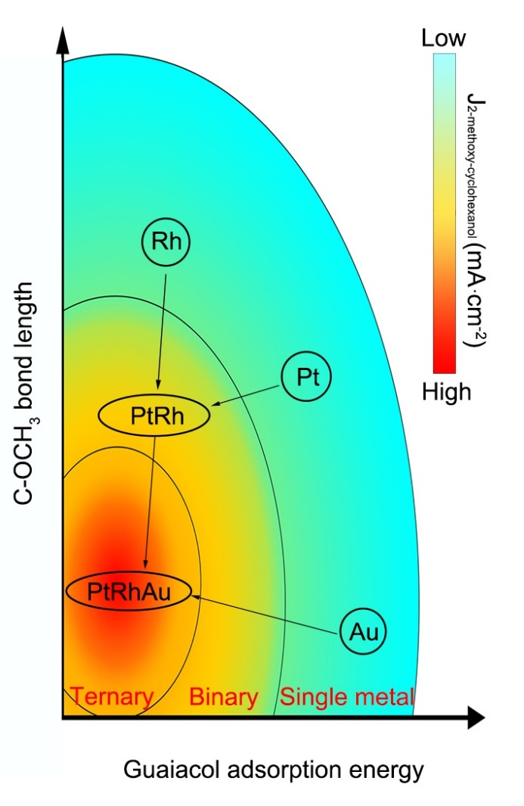
Fig. S1 | Design strategy for single metal, binary, and ternary catalysts with increasing partial current density toward 2-methoxycyclohexanol. Enhancing Pt with Rh increases the coverage of guaiacol on the catalyst surface by increasing the adsorption energy of guaiacol, thereby facilitating the ECH of guaiacol. A further enhancement of PtRh with Au stabilizes the oxygen-functionalized groups of intermediates by shortening C-OCH₃ bond length of adsorbed guaiacol, thereby suppressing the deoxygenation reactions, respectively.

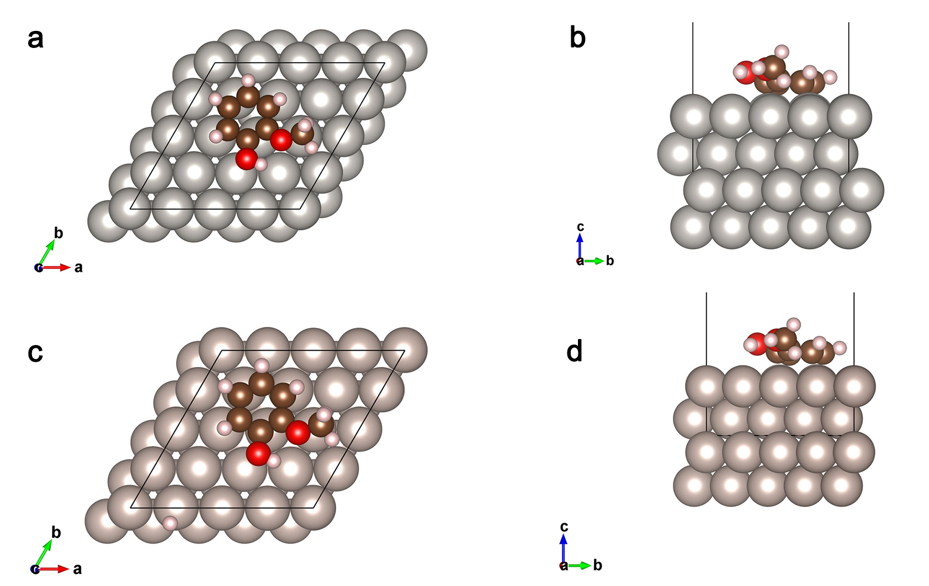

Fig. S2 | The most stable configurations of guaiacol adsorption onto Pt (111) surface and Rh (0001) surface. a, Top view of the most stable bridge 30° guaiacol adsorption site on Pt (111) as a representative for fcc metals. b, Side view of the most stable bridge 30° guaiacol adsorption site on Pt (111) as a representative for fcc metals. c, Top view of the most stable adsorption site on Ru (0001). d, Side view of the most stable adsorption site on Ru (0001). The complete results for adsorption energy as well as adsorption geometry are presented in Table S1.

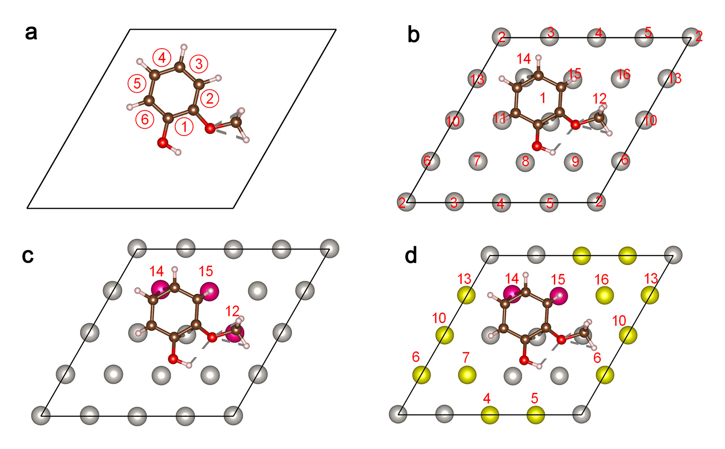
Fig. S3 | Computational models for various catalysts. a, Numbering and illustration of guaiacol C-OCH₃, C-OH, and C=C bonds. b, Numbering and illustration of surface dopant sites, consistent with the numbering in Table S2. c, Computational model for the best binary PtRh catalyst. d, Computational model for the best ternary PtRhAu catalyst.

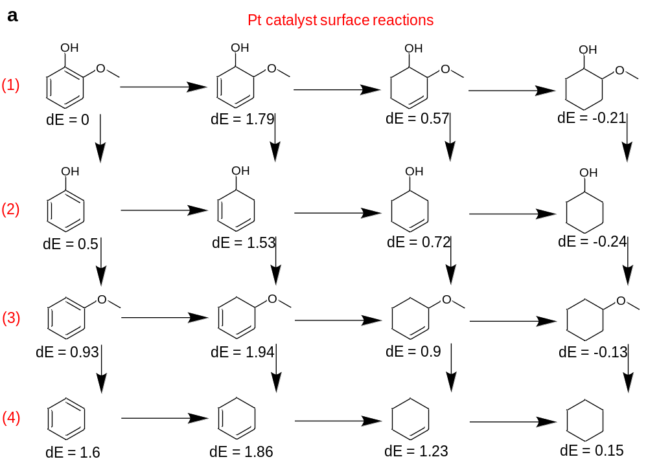

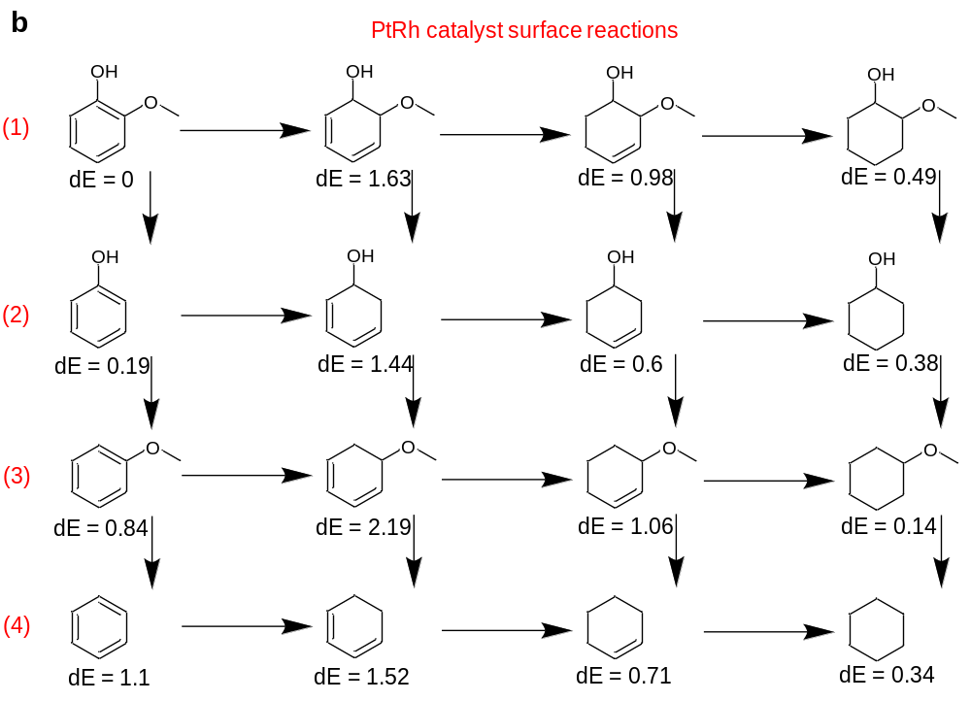

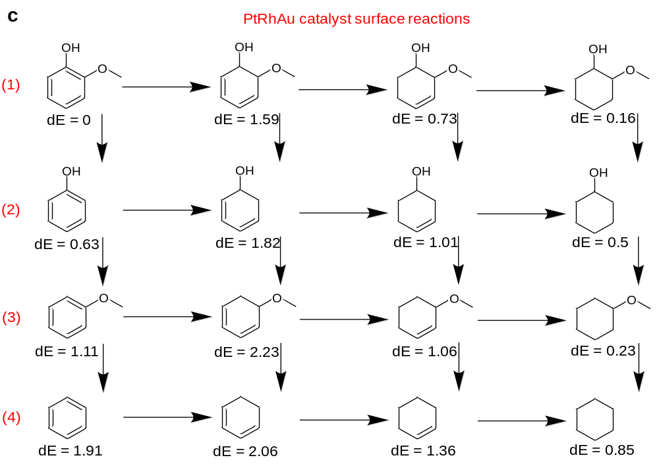
Fig. S4 | Surface reaction pathway network calculations and results of (a) Pt, (b) PtRh, and (c) PtRhAu. The surface reaction pathways can be characterized into four types: (1) Hydrogenation, (2) Demethoxylation, (3) Dihydroxylation, (4) Both demethoxylation and dehydroxylation. These four pathways overlap and connect, forming a complicated reaction network. The loss or addition of hydrogen for the surface reaction network is referenced to H₂ gas with entropic and ZPE corrections. All species are surface species.

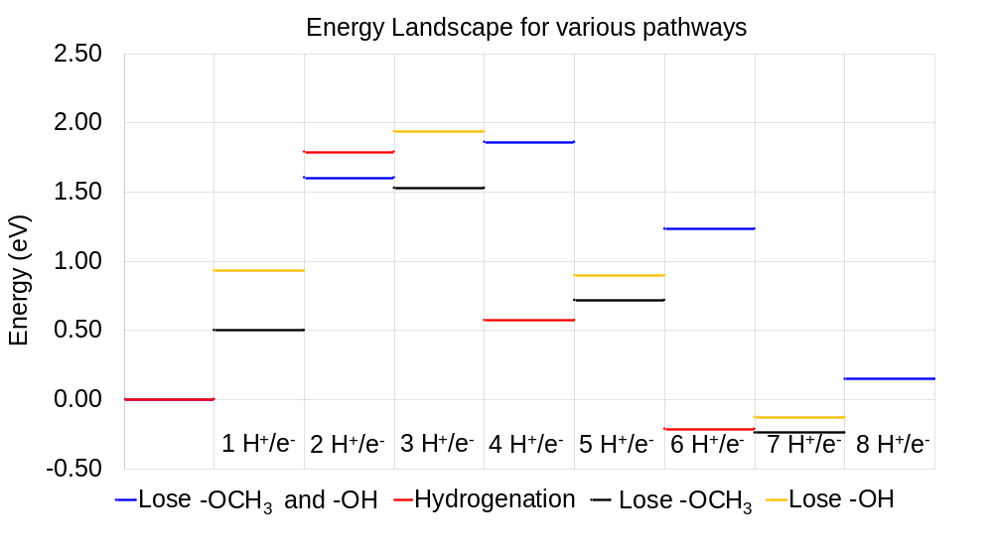
Fig. S5 | Energetics of surface reactions of the configurations in Fig. S4 plotted on the same energy landscape graph, indicating how many hydrogen electron pair is needed for each intermediate state. The reference state is guaiacol adsorbed on the Pt(111) surface.

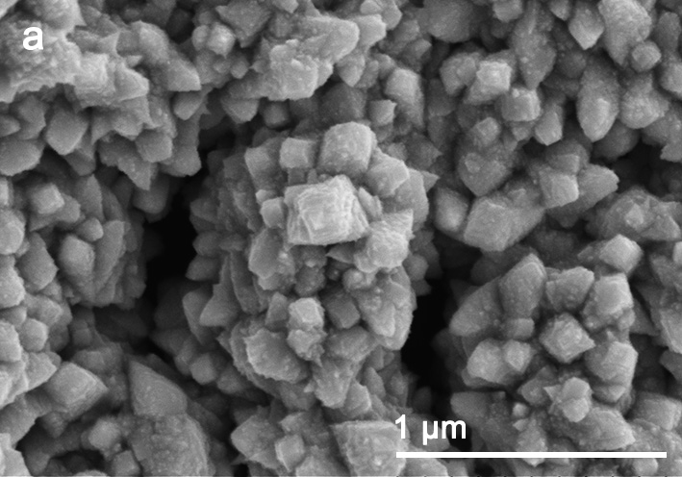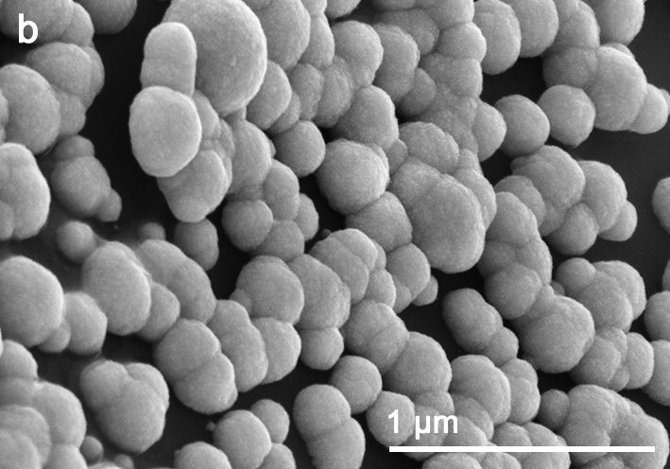
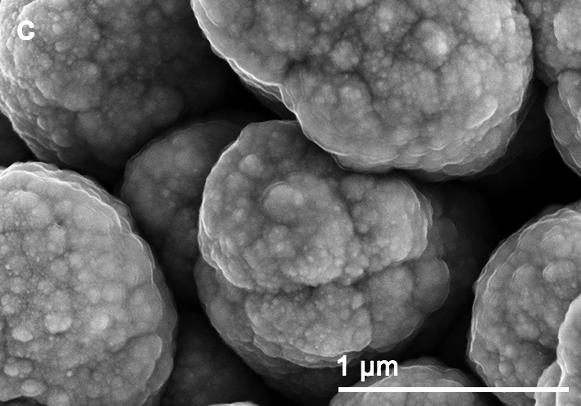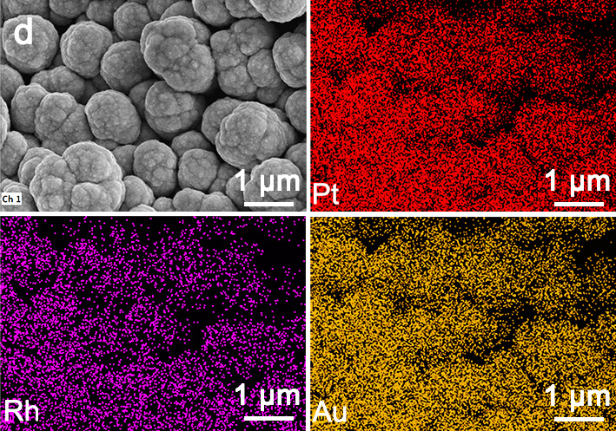
Fig. S6 | Scanning electron microscopy (SEM) of (a) Pt, (b) PtRh, (c) PtRhAu, and (d) energy-dispersive X-ray (EDX) mapping images of PtRhAu.

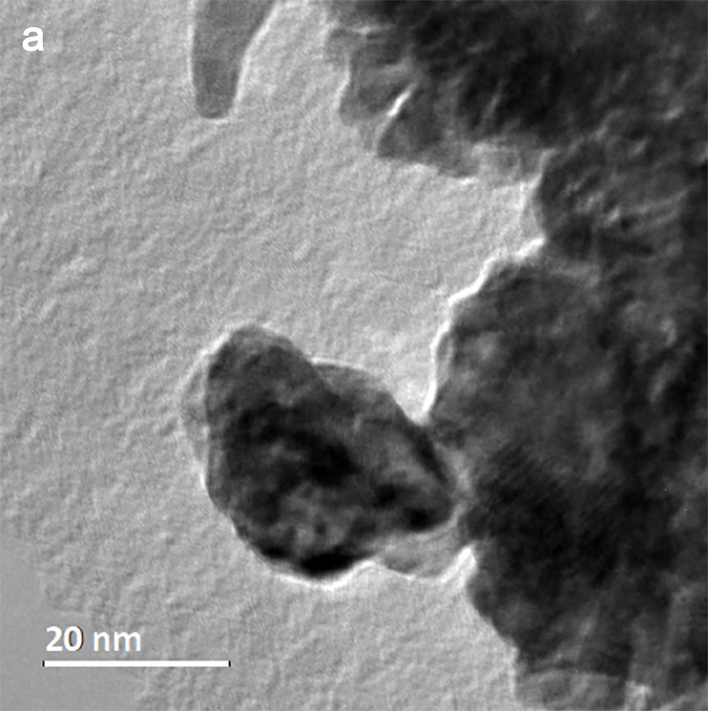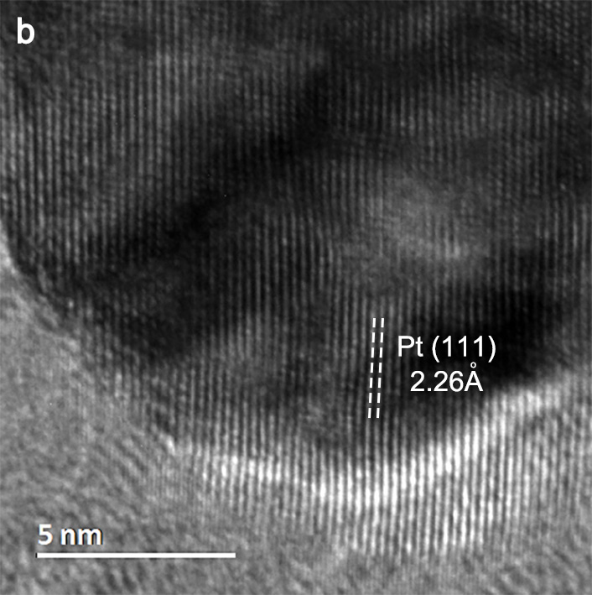
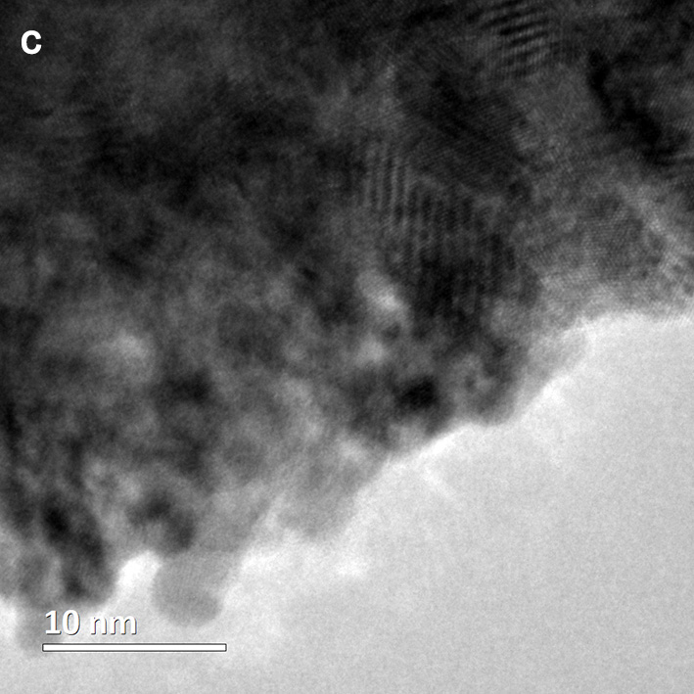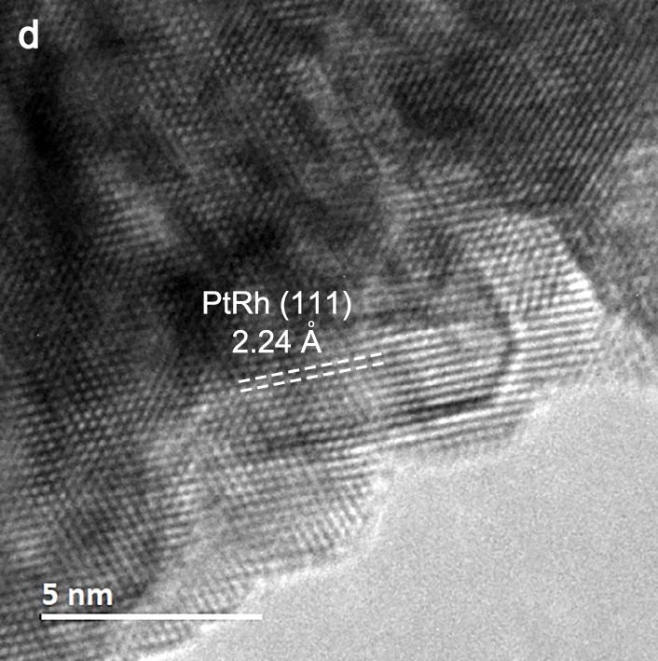
Fig. S7 | TEM images for (a and b) Pt and (c and d) PtRh samples. Relative to Pt lattice spacing, the decrease in that of PtRh is caused by replacing 20 % of Pt atoms with smaller Rh atoms.

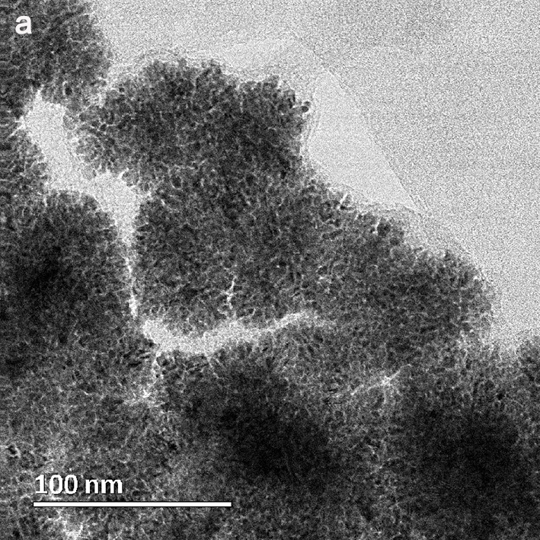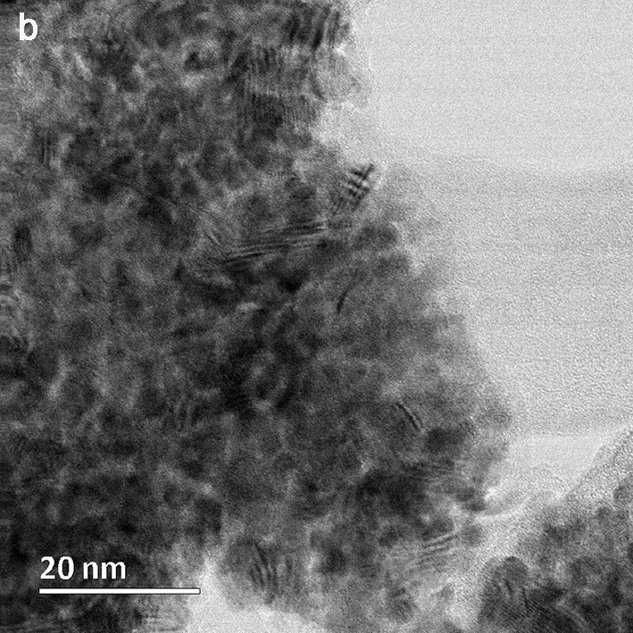
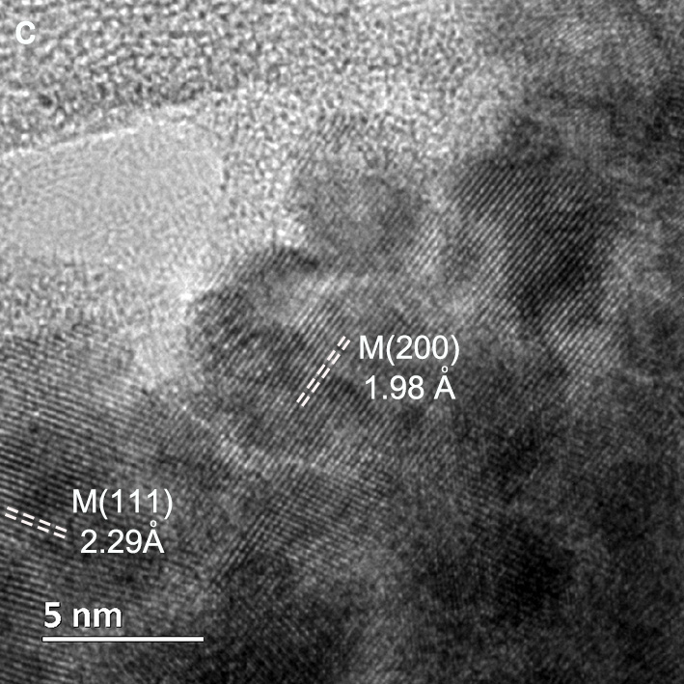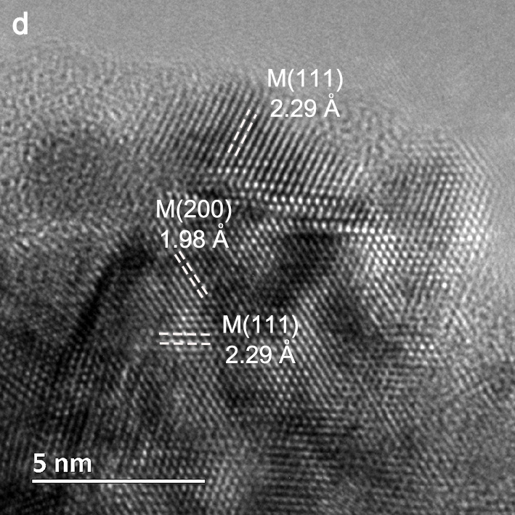
Fig. S8 | PtRhAu alloy TEM images. PtRhAu presents a lattice expansion (2.29 Å) as compared to that of Pt (2.25 Å), which is mainly caused by partially replacing Pt with the larger Au atoms.
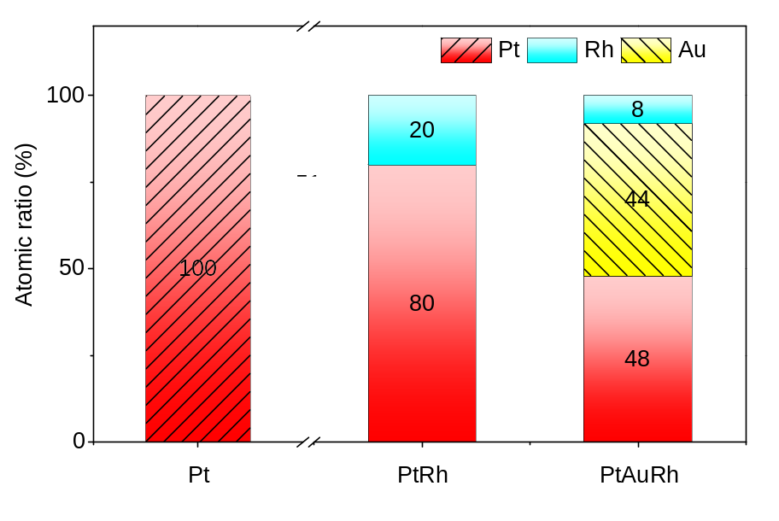
Fig. S9 | Atomic ratios as determined by inductively coupled plasma atomic emission spectroscopy (ICP-AES). Pt was synthesized using 10 mM of H₂PtCl₆; PtRh using 7mM H₂PtCl₆ and 4 mM Rh(NO₃)₃; PtRhAu using 7mM H₂PtCl₆, 4 mM Rh(NO₃)₃, and 3 mM Au HAuCl₄.

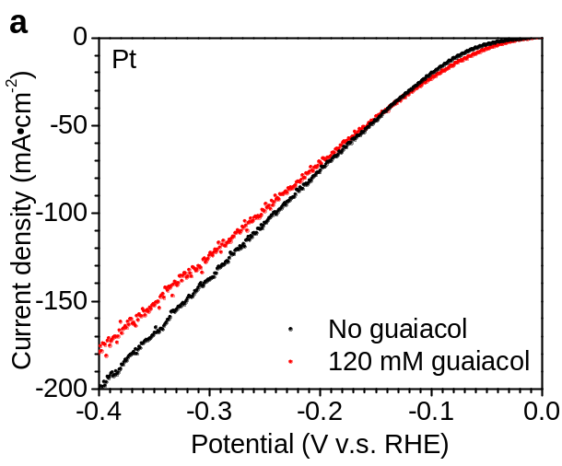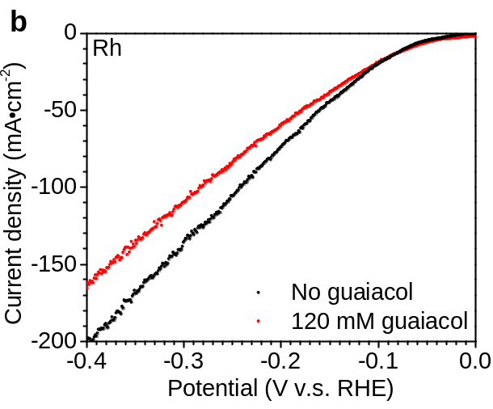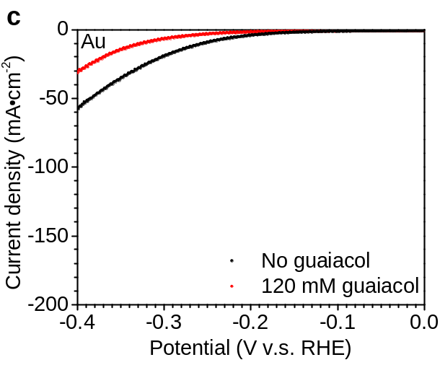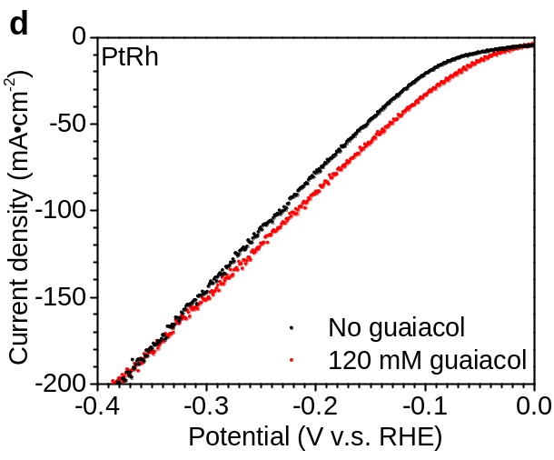
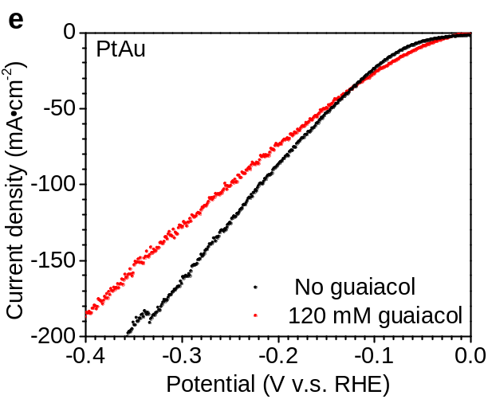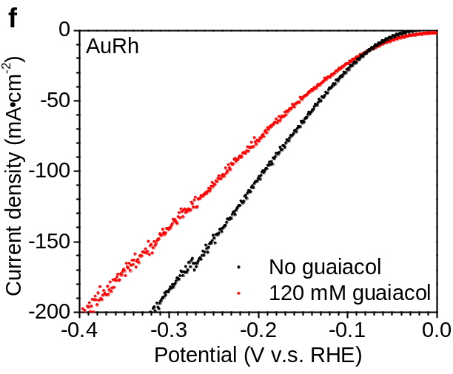
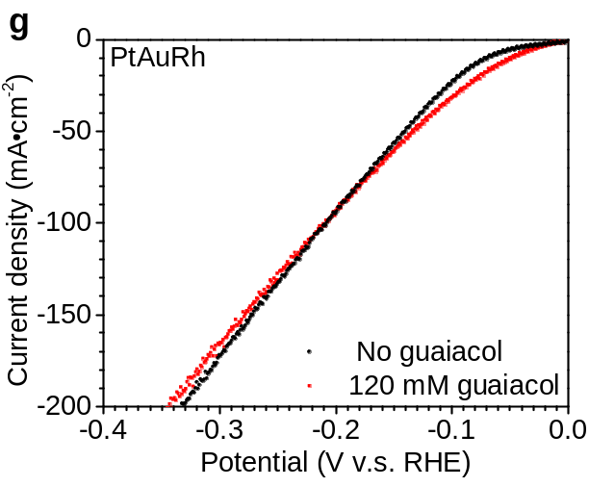
Fig. S10 | Linear sweep voltammetry (LSV) curves with and without guaiacol for (a) Pt, (b) Rh, (c) Au, (d) PtRh, (e) PtAu, (f) AuRh, and (g) PtRhAu. PtRhAu presents a superior ECH performance in the range of potential between -0.05 and -0.2 V, whereas hydrogen evolution reaction predominated at a potential lower than -0.2 V.

Optimization of electrocatalytic hydrogenation conditions and catalyst composition
An initial optimization of the ECH reaction conditions using PtRhAu suggests that the optimum reaction conditions are the current density of 60 mA·cm⁻² and the temperature of 20 ºC in 0.2 M HClO₄ electrolyte containing 120 mM guaiacol (Fig. S11). We then optimized PtRhAu composition by tuning the metal precursor ratio among Pt, Rh, and Au during the electrodeposition (Fig. S12). We synthesized the optimum PtAuRh using a Pt:Rh:Au precursor atomic ratio of 7:4:3 that links to atomic Pt:Rh:Au ratio of 48:8:44 (Fig. S9).
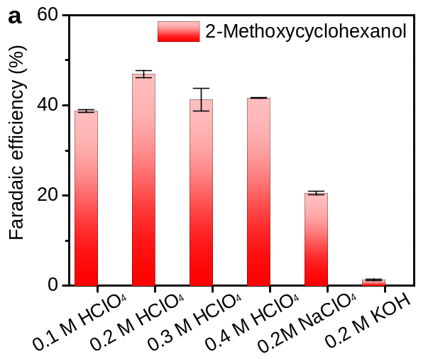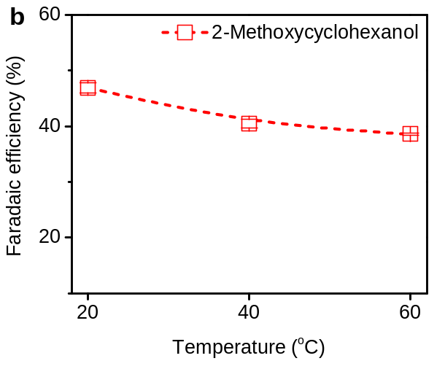
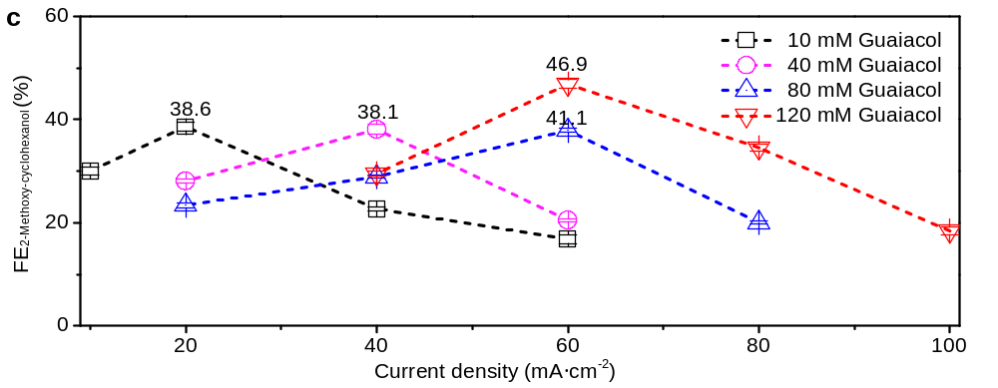
Fig. S11 | PtRhAu catalyst performance at different reaction conditions. a, Effect of electrolyte solution on the faradaic efficiency toward 2-methoxycyclohexanol. The reaction temperature, guaiacol concentration, and current density are fixed at 20 ºC, 120 mM and 60 mA·cm⁻², respectively. b, Effect of ECH temperature on FE toward 2MC. The current density is fixed at 60 mA·cm⁻² in a 0.2 M HClO₄ solution containing 120 mM guaiacol. c, Effect of guaiacol concentration on FE toward 2MC. The reaction temperature and current density are fixed at 20 ºC and 60 mA·cm⁻², respectively.

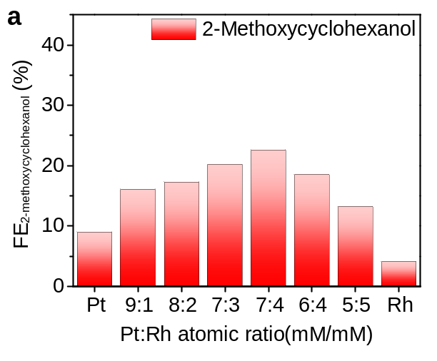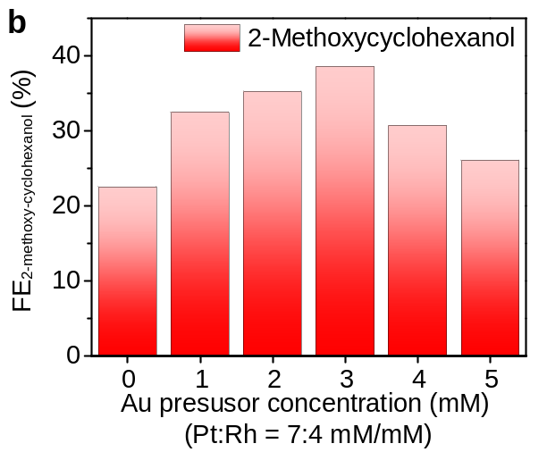
Fig. S12 | PtRhAu composition optimization by varying Pt, Rh and Au precursor molar ratios. a, Optimization of Rh concentration in PtRh alloy with increasing faradaic efficiency toward 2-methoxycyclohexanol by adjusting the Pt:Rh precursor ratio, showing the best Pt:Rh precursor molar ratio is 7:4, corresponding to a Pt:Rh atomic ratio of 8:2. b, Optimization of Au concentration in PtRhAu alloy by adjusting the Au precursor (HAuCl₄) concentration with increasing faradaic efficiency toward 2-methoxycyclohexanol when Pt precursor (H₂PtCl₆) and Rh precursor (Rh(NO₃)₃) concentrations are fixed at 7 mM and 4 mM, respectively, indicating the best Au precursor concentration is 3 mM. The optimized Pt, Rh and Au precursors concentration is 7 mM, 4 mM, and 3 mM, respectively, corresponding to a Pt:Rh:Au atomic ratio of 48:8:44. The electrocatalytic hydrogenation experiments were conducted at 20 mA·cm⁻¹ and at 20 ºC in 0.2 M HClO₄ electrolyte containing 10 mM guaiacol.

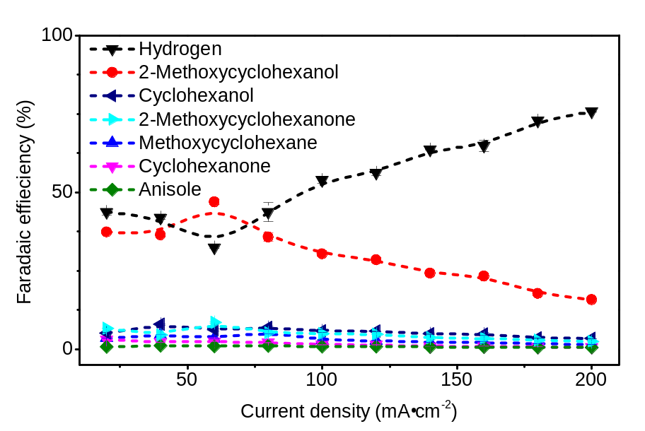
Fig. S13 | Comparison of 2-methoxycyclohexanol and the main competing reaction hydrogen production versus current density using PtRhAu catalyst. At the optimum current density of 60 mA·cm⁻², PtRhAu represents a cathodic energy efficiency (EE) of 44 ± 1% that is 1.3x and 4.6x higher than PtRh (33 ± 1 %) and Pt (9 ± 0.1 %), respectively. The maximum partial current density toward 2-methoxycyclohexanol increases to 37 ± 1 mA·cm⁻² at -0.29 V.

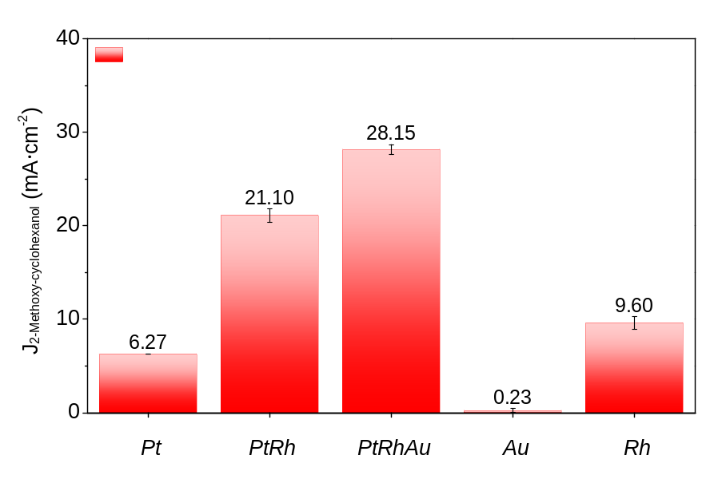
Fig. S14 | Partial current density toward 2-methoxycyclohexanol for various catalysts. The electrocatalytic hydrogenation of guaiacol experiments are applied current density of 60 mA·cm⁻².

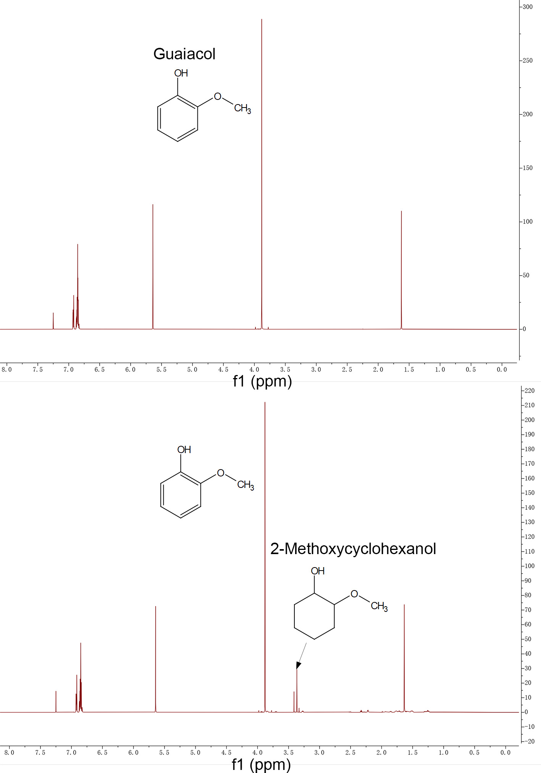
Fig. S15 | ¹H NMR spectroscopies for 120 mM of guaiacol (A) before and (B) after electrocatalytic hydrogenation at 60 mA for 1 hour with 1cm² PtRhAu catalyst.

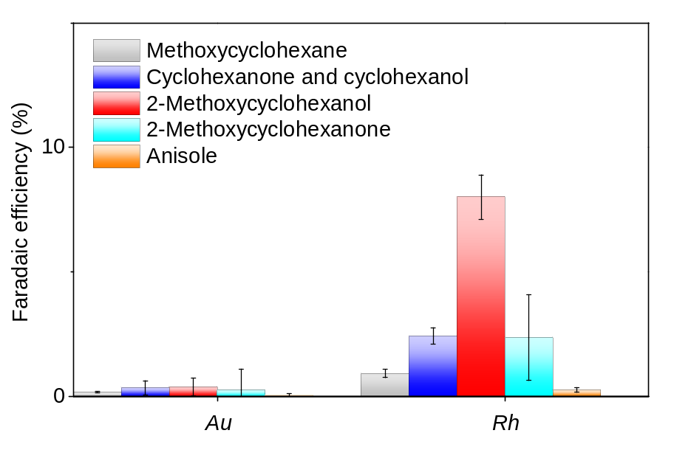
Fig. S16 | Product distribution over Au and Rh at a current density of 60 mA·cm⁻².

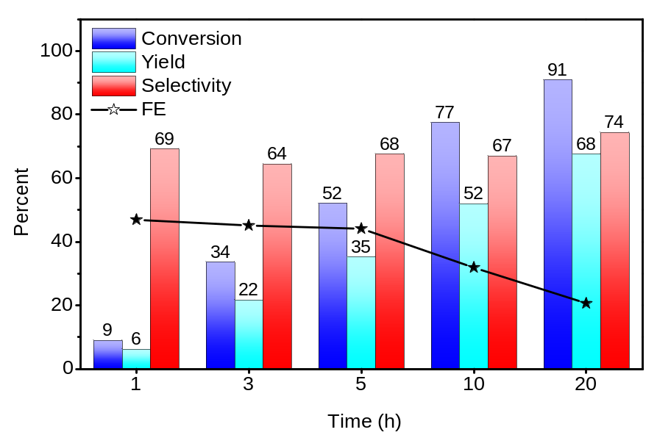
Fig. S17 | Conversion (%), yield (%), selectivity (%), and faradaic efficiency (FE) (%) toward 2-methoxycyclohexanol from guaiacol for up to 20 hours. PtRhAu catalyst is used in an H-cell containing 20 mL of 120 mM guaiacol and 0.2 M HClO₄ at 20 ºC, showing an increasing conversion, yield, and selectivity toward 2MC that reached 90.90%, 67.58%, and 74.35% at 20 h, respectively.

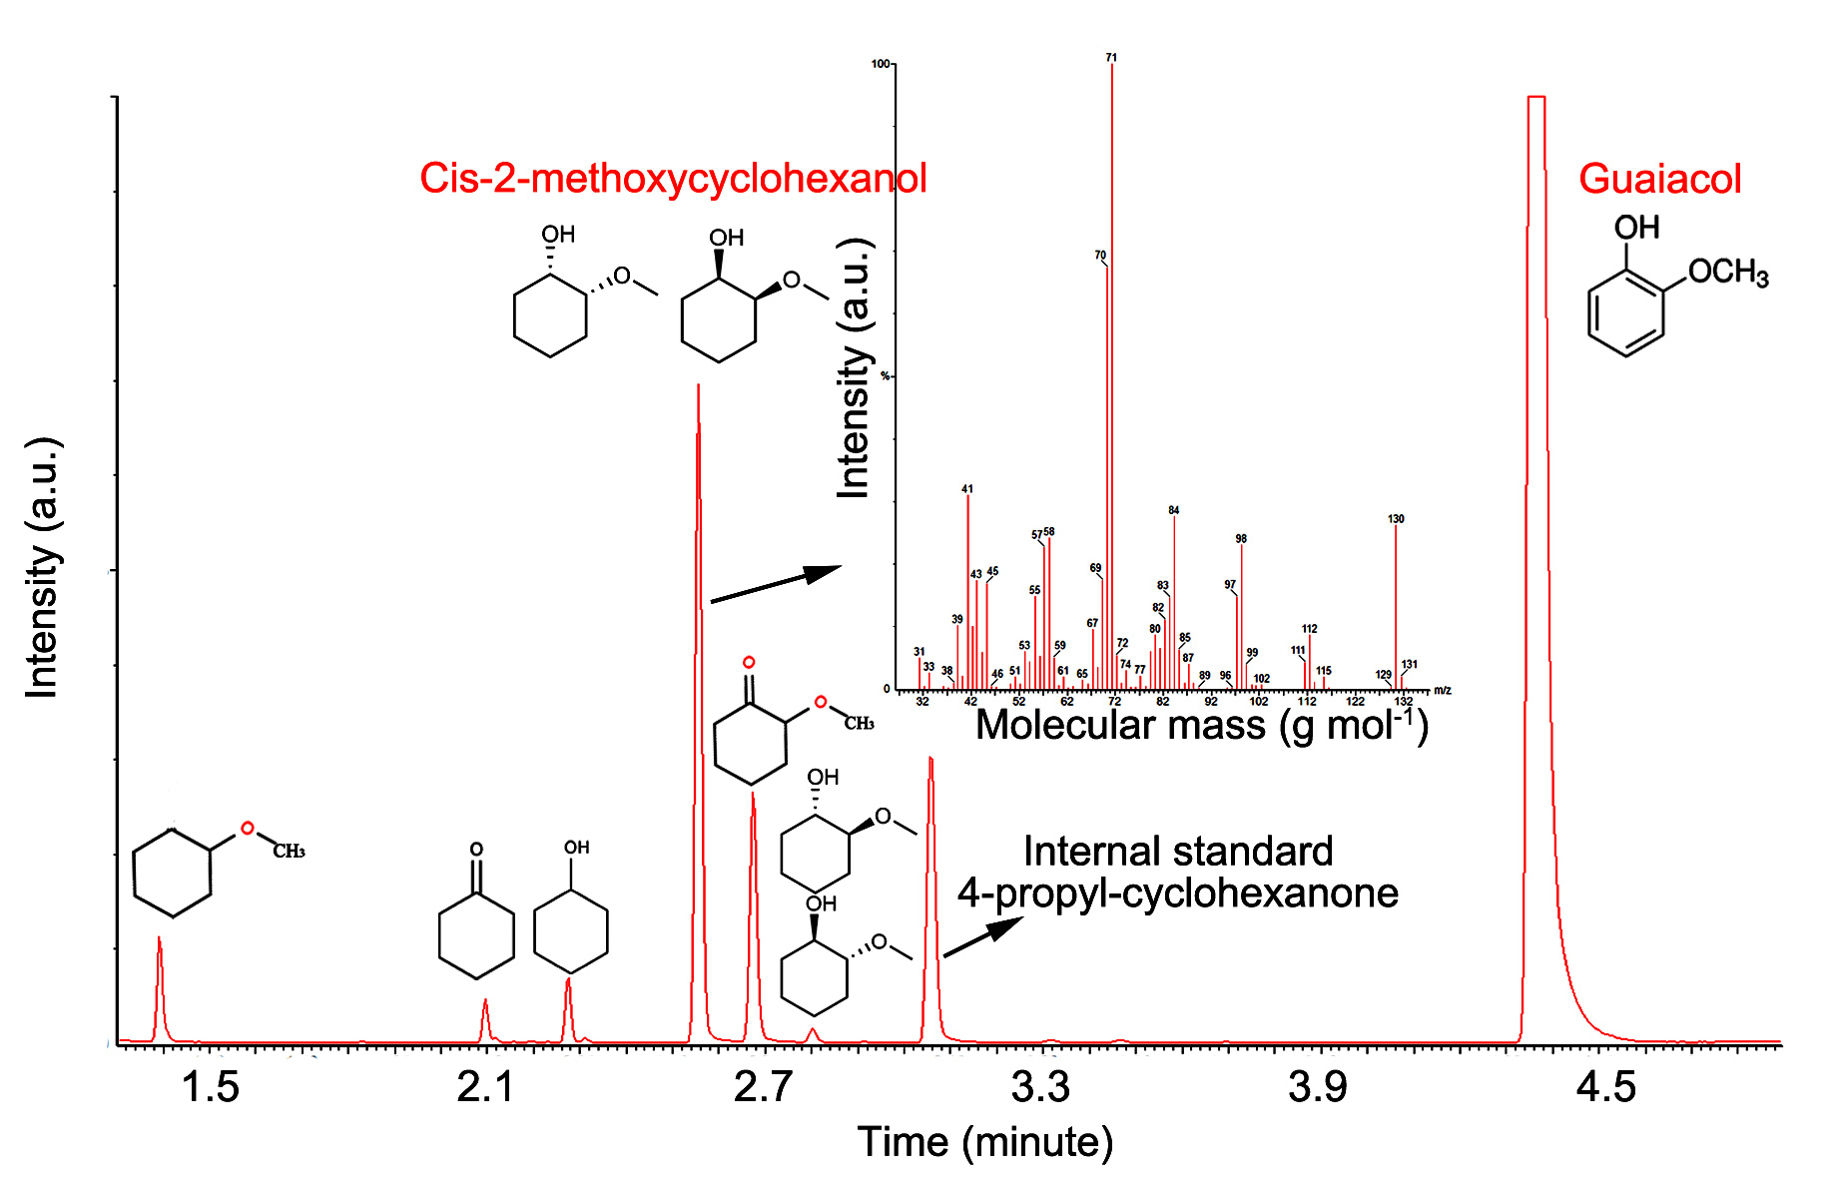
Fig. S18 | Gas chromatography-mass spectrometry (GC-MS) analysis of 2-methoxycyclohexanol produced by upgrading 120 mM guaiacol using PtRhAu electrocatalyst at 60 mA·cm⁻² for 1 hour.

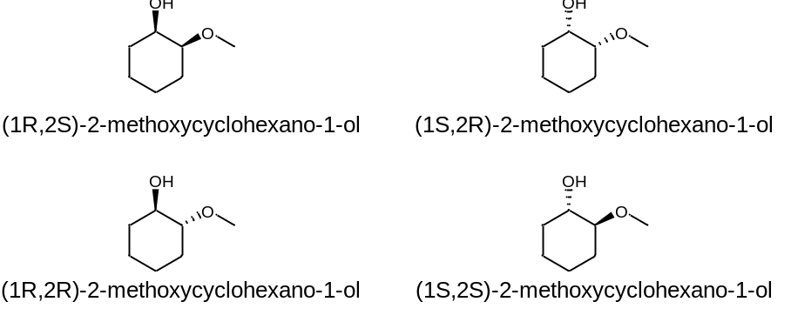
Fig. S19 | Molecular structure of 2-methoxycyclohexanol enantiomers. Cis-2-methoxycyclohexanol (top) and trans-2-methoxycyclohexanol (below).

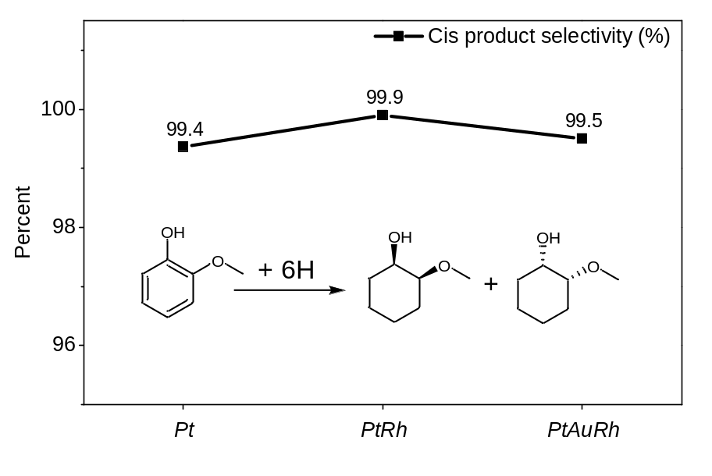
Fig. S20 | Catalyst-dependent enantioselectivity of cis-2-methoxycyclohexanol products. The enantiomeric excess (e.e.) is the excess of one enantiomer over the other enantiomer and represents the purity of a chiral chemical.

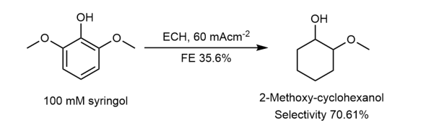
Fig. S21 | Electrocatalytic hydrogenation experiments using PtRhAu catalyst to produce oxygenated chemicals from syringol (2,6-dimethoxyphenol).

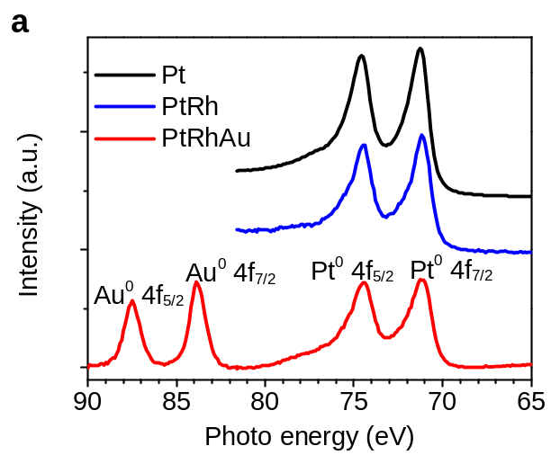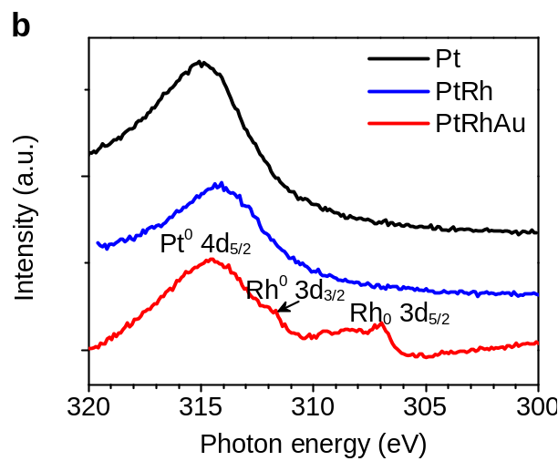
Fig. S22 | X-ray photoelectron spectroscopy (XPS) of (a) Au 4f and Pt 4f peaks and (b) Rh 3d peaks for Pt, PtRh, and PtRhAu catalysts. The zero-valence state in XPS indicates the metallic Pt, Au, and Rh phase in all samples.
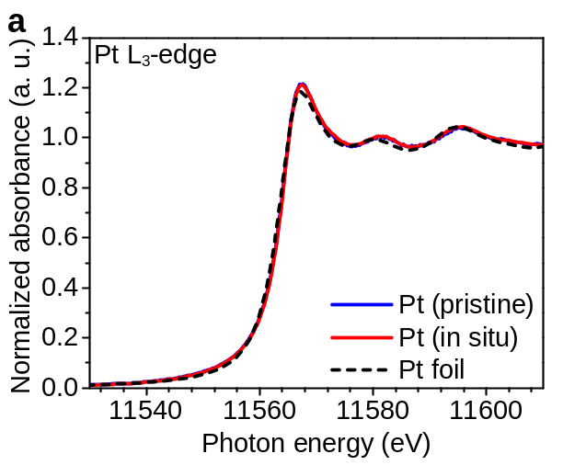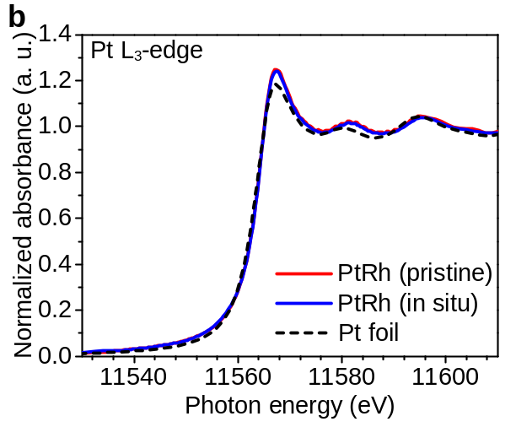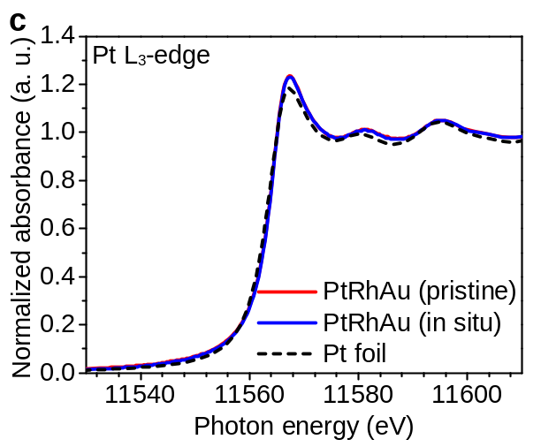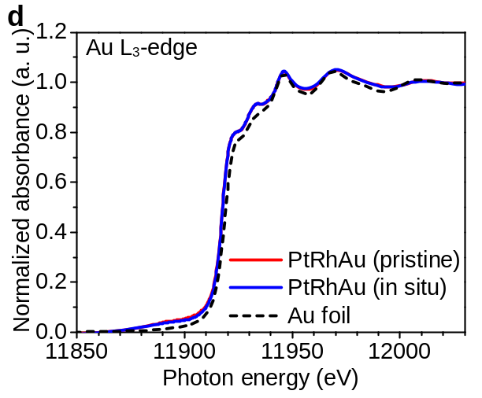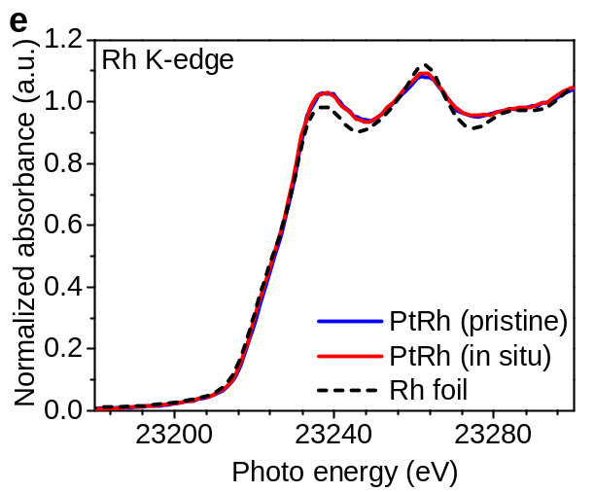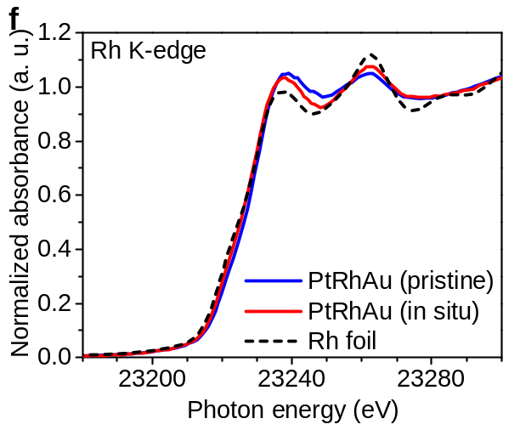
Fig. S23 | In-situ XAS of the catalysts during electrocatalytic hydrogenation (ECH) of guaiacol. a-c, Pt L₃-edge for (a) Pt, (b) PtRh, (c) PtRhAu catalysts at 60 mA·cm⁻². d, Au L₃-edge for PtRhAu. e and f, Rh K-edge for (e) PtRh and (f) PtRhAu.
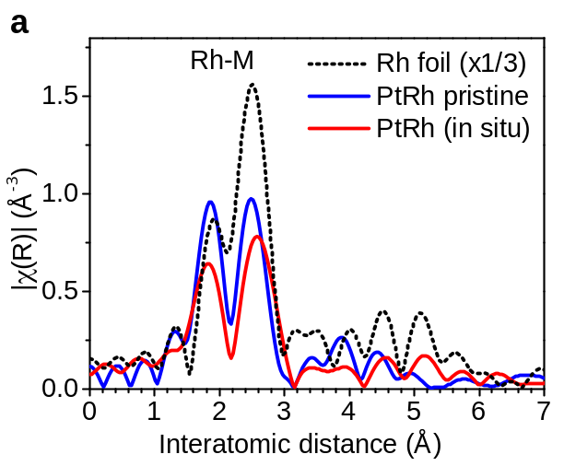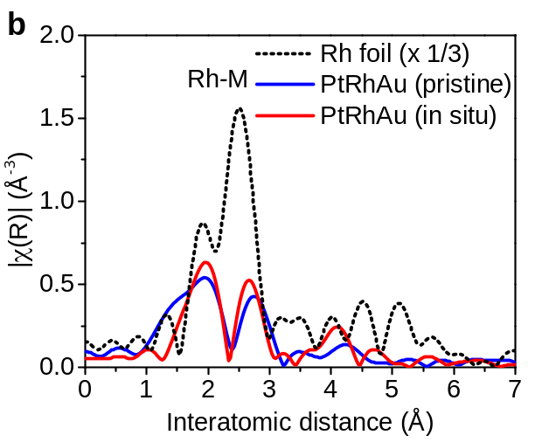
Fig. S24 | EXAFS showing the local atomic structure around Rh atoms for (a) PtRh and (b) PtRhAu catalysts.

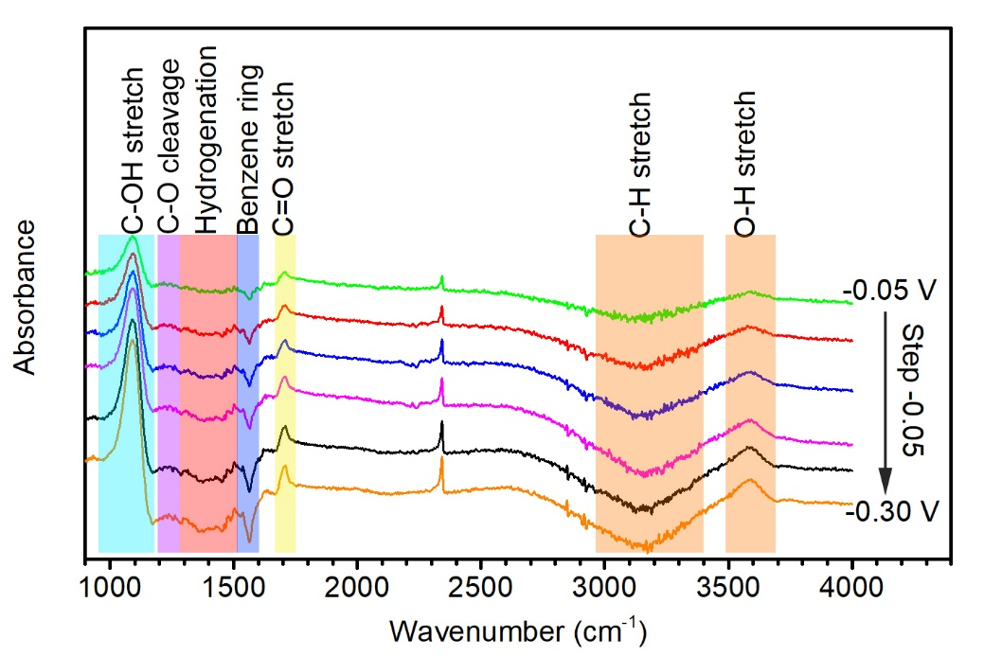
Fig. S25 | In-situ infrared reflection-absorption spectroscopy (IRRAS) of the guaiacol ECH on PtRAu catalyst in 0.2 M HClO₄ and 120 mM guaiacol electrolyte. The bands centered at 3600 cm⁻¹ (O-H stretch) and 3150 cm⁻¹ (C-H stretch) ¹⁹ indicate the adsorption of guaiacol and products. The peak at 1703 cm⁻¹ (C=O) stretching implies ketone products (cyclohexanone and 2-methoxycyclohexanone) ²⁰. The absorbance peak located at 1560 cm⁻¹ (benzene ring) suggests the adsorption of guaiacol ²⁰. The band at 1300-1500 cm⁻¹ is attributed to the disappearance of the C=C double bond in the aromatic ring caused by the electrocatalytic hydrogenation (ECH) of guaiacol ²¹. The strong peak located at 1090 cm⁻¹ (C-OH stretch on the ring) is mainly caused by the production of 2MC. PtRhAu shows a negligible peak located at 1240 cm⁻¹ (C-O bond cleavage) ²¹, indicating the suppression of deoxygenation. By contrast, PtNiB catalyst was reported to present an evident peak located at 1240 cm⁻¹ during ECH of guaiacol, indicating evident deoxygenation ²¹.

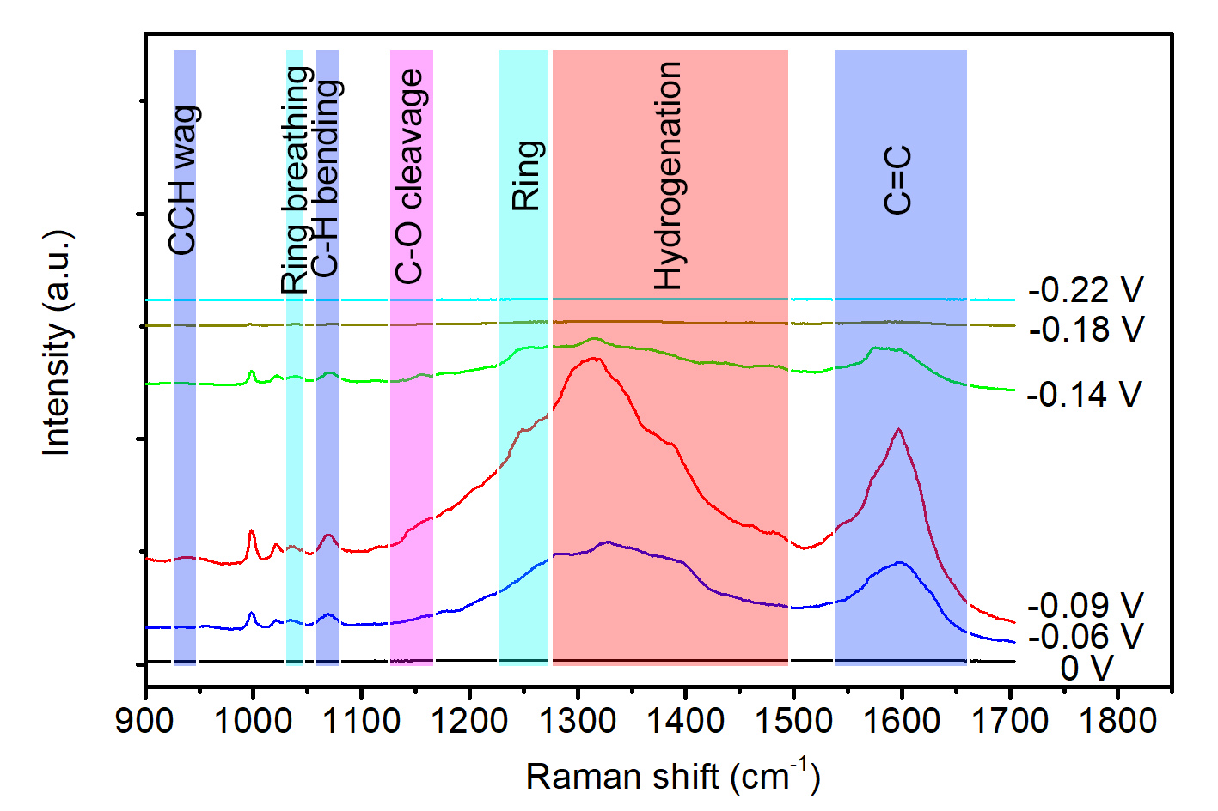
Fig. S26 | In-situ Raman spectra of guaiacol electrocatalytic hydrogenation (ECH) on Pt catalyst in 0.2 M HClO₄ electrolyte containing 120 mM of guaiacol. Pt shows an evident peak located at 1161 cm⁻¹ (C-OCH₃ cleavage) in the range of potential between -0.06 and -0.14 V, indicating the increased deoxygenation and the formation of by-products (cyclohexanol and cyclohexanone). The peaks located at 930 cm⁻¹ (attributed to CCH wag) ²², 1069 cm⁻¹ (in-plane C-H bending) ²³, and 1597 cm⁻¹ (C=C of the aromatic ring) ²² represent the adsorption of guaiacol onto catalyst surface. The band at 1300-1500 cm⁻¹ (CH₂ bending and hydrogenation) ²⁴, 1033 cm⁻¹ (ring breathing) ^{22,24}, and 1269 cm⁻¹ (ring) ²⁴ indicate the hydrogenation of guaiacol to cyclohexane derivatives. Peaks located at 1120 cm⁻¹ (C-O stretch) ²³ and 1161 cm⁻¹ (C-OCH₃ stretch) ²³ indicate C-O cleavage associated with the production of by-products (cyclohexanol, cyclohexanone, anisole, and methoxy-cyclohexane)

Fig. S27 | ¹H NMR in CDCl₃ of the distilled, isolated dipropylxylose.

Fig. S28 | HSQC in DMSO-d₆ of the propionaldehyde stabilized lignin extracted from the birch wood.

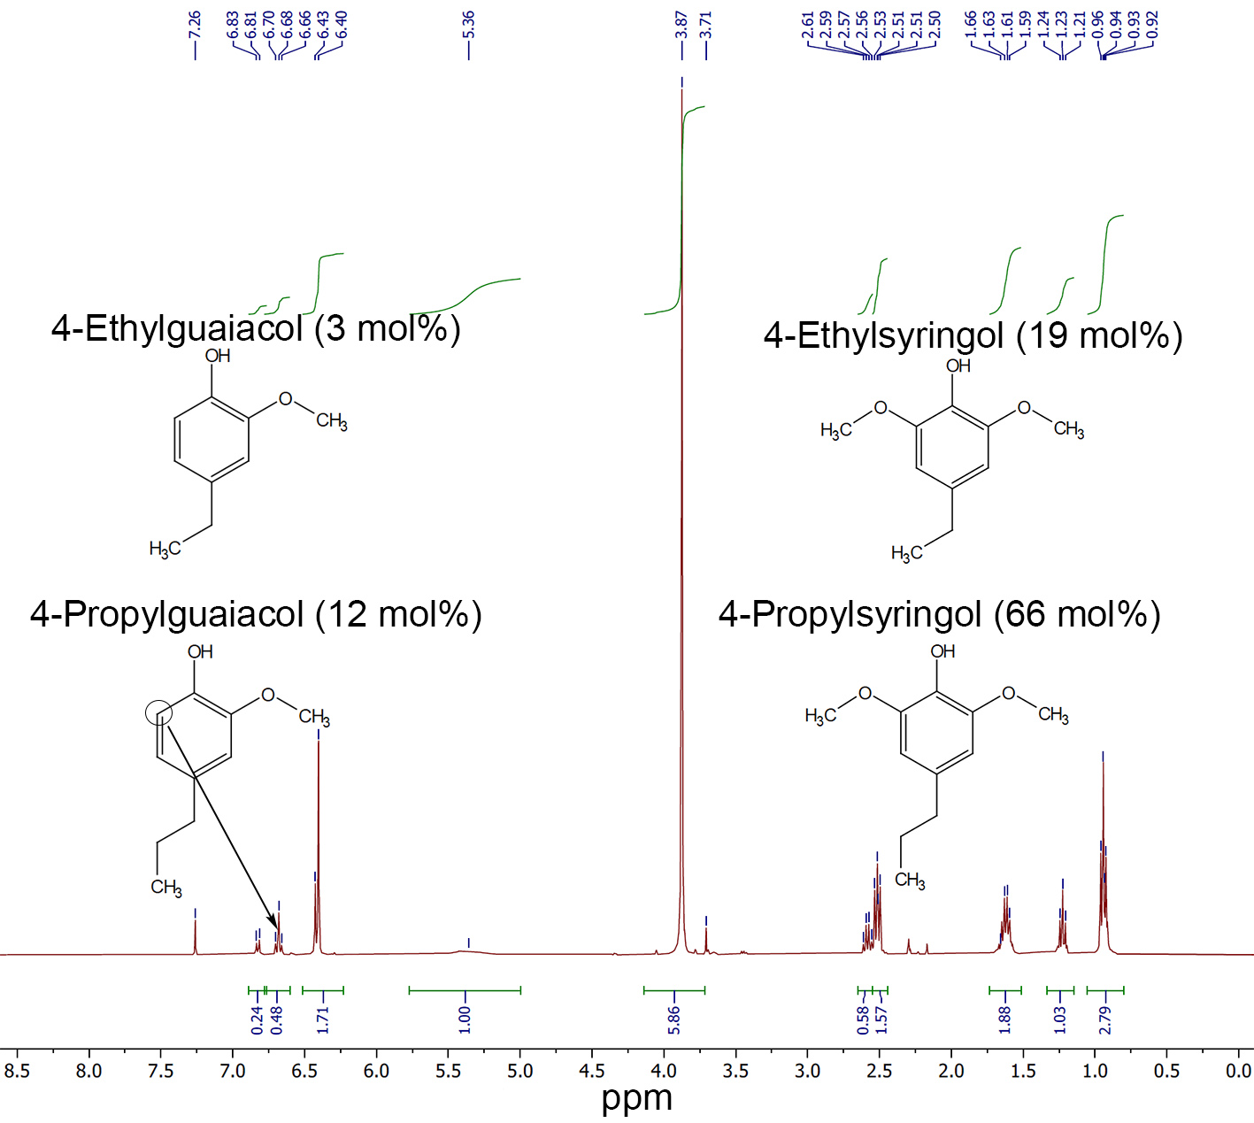
Fig. S29 | ¹H NMR spectroscopies in CDCl₃ of wood-derived lignin monomer mixture produced from the propionaldehyde stabilized lignin and purified by water distillation.

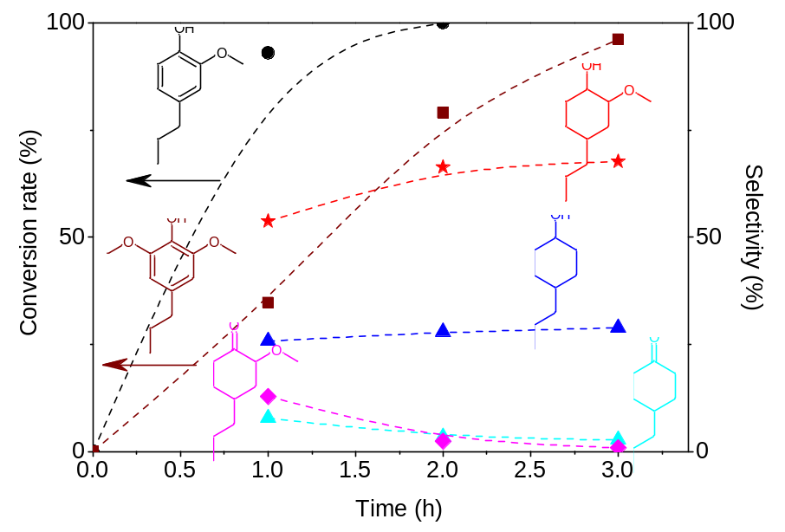
Fig. S30 | | Evolution of conversion rate and product selectivity on PtRhAu catalyst for electrocatalytically hydrogenating a wood-derived lignin monomer mixture containing 4-propylsyringol during 3 hours.

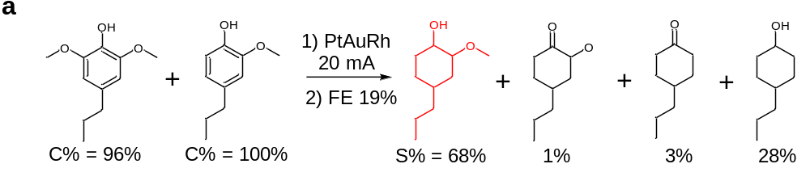
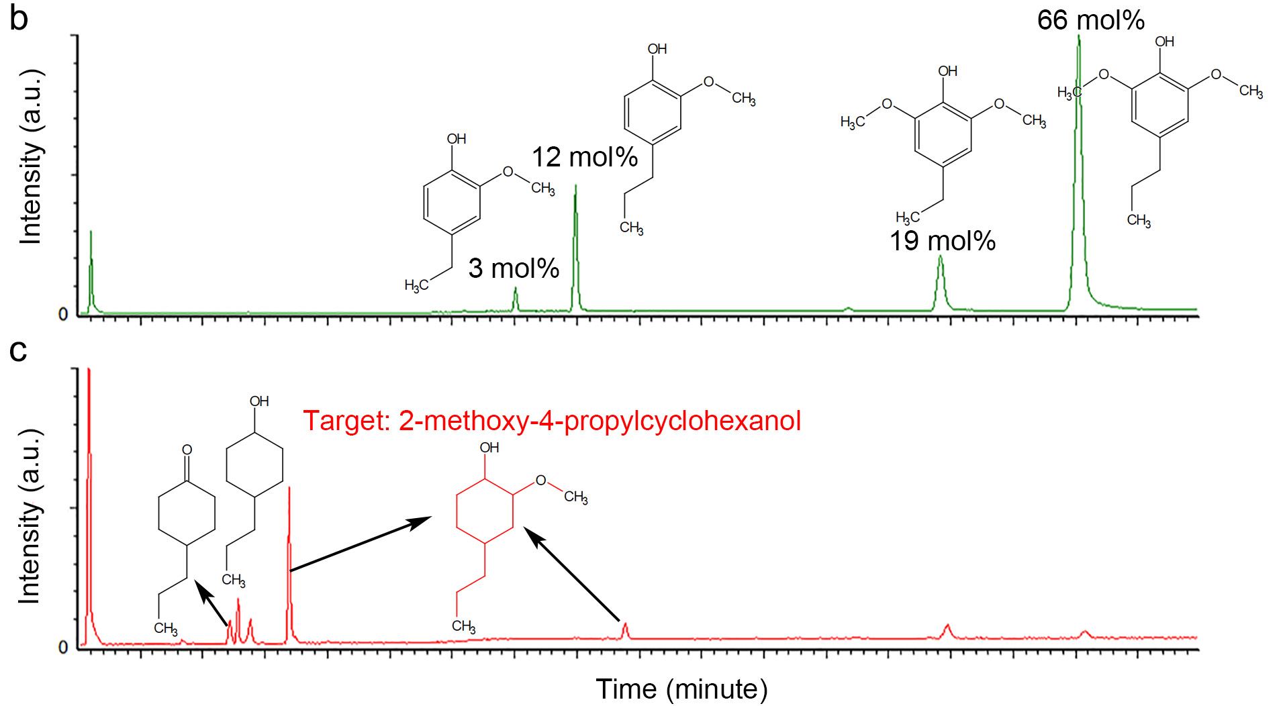
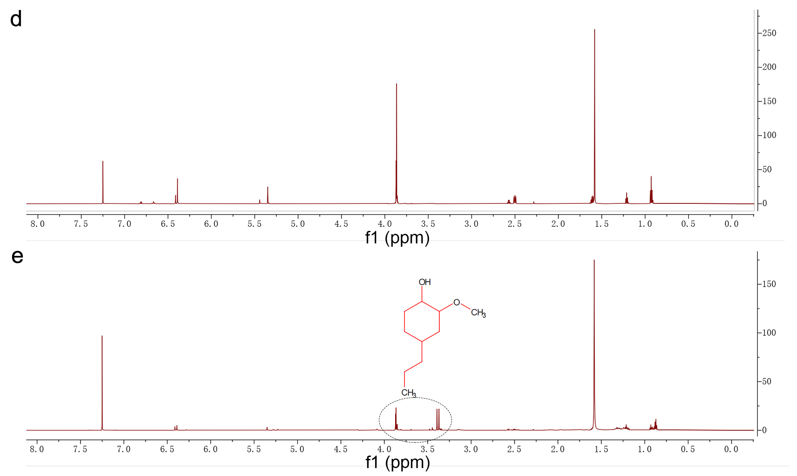
Fig. S31 | Electrocatalytic hydrogenation of a wood-derived mixture containing 12 mol% 4-propylguaiacol (4PG), 66 mol% 4-propylsyringol (4PS) and 22 mol% concomitants. a, Electrocatalytic hydrogenation of 4PS and 4PG in wood-derived lignin monomer mixture to the target product 2-methoxy-4-propylcyclohexanol (red) and other by-products. b and c, Gas chromatography-mass spectrometry (GC-MS) analysis of a wood-derived lignin monomers mixture (b) before and (c) after electrocatalytic hydrogenation at 20 mA for 3 hours with 1 cm² PtRhAu catalyst. d and e, ¹H NMR spectroscopies for a wood-derived lignin monomer mixture in 0.2 M HClO₄ electrolyte (d) before and (e) after electrocatalytic hydrogenation at 20 mA for 3 hours with 1 cm² of PtRhAu catalyst. The electrolyte is extracted with chloroform-D.

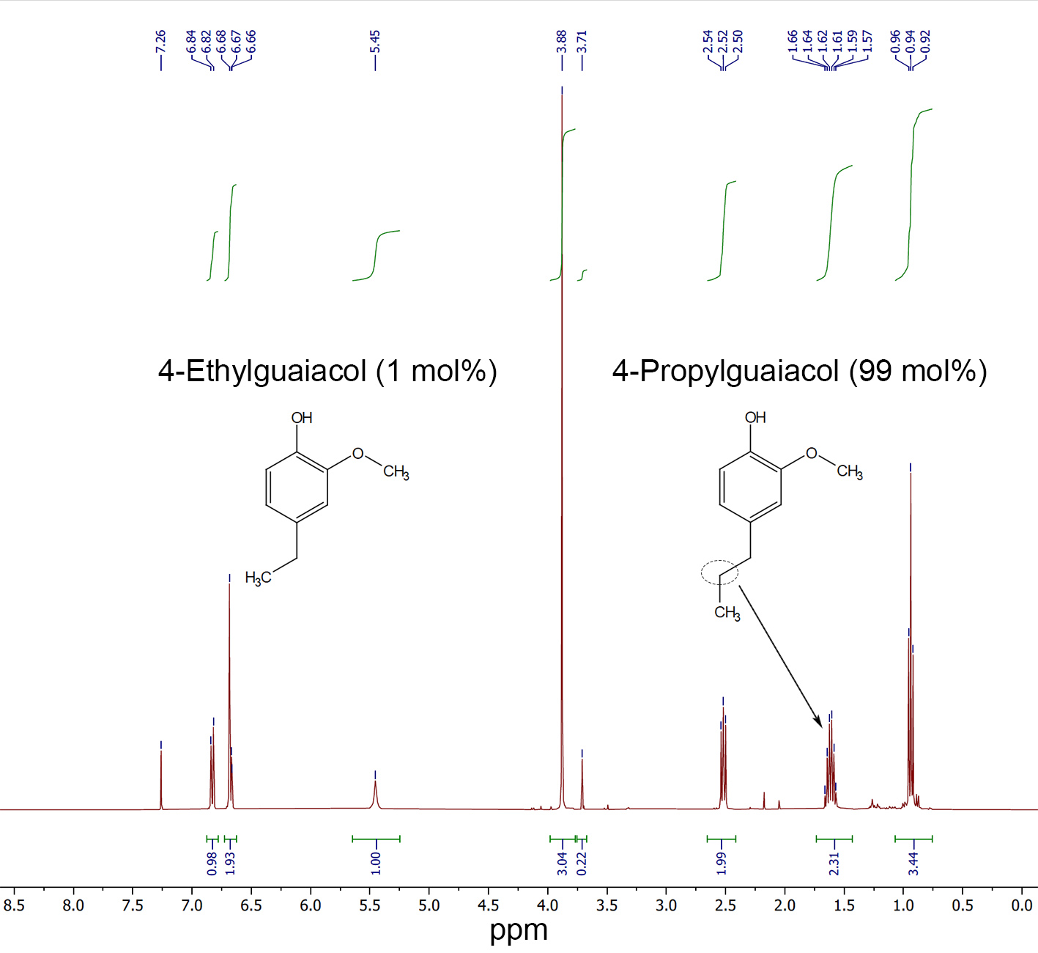
Fig. S32 | ¹H-NMR in CDCl₃ of the 4-propylguaiacol sample produced from the isobutyraldehyde stabilized lignin and purified by distillation.

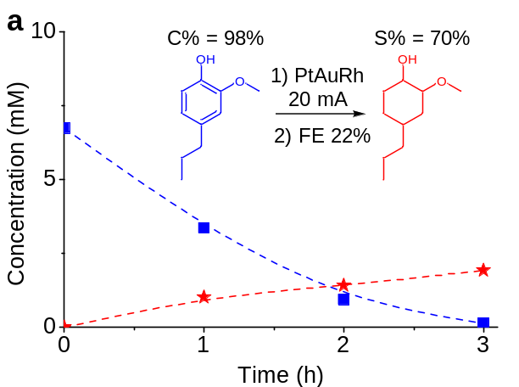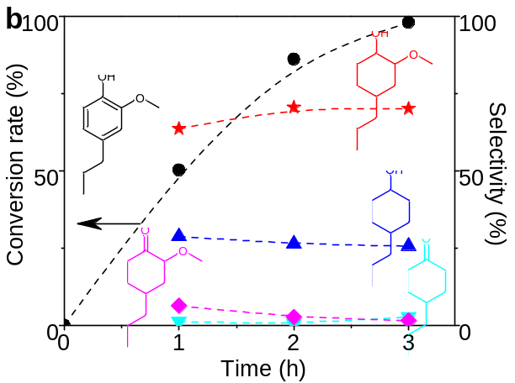

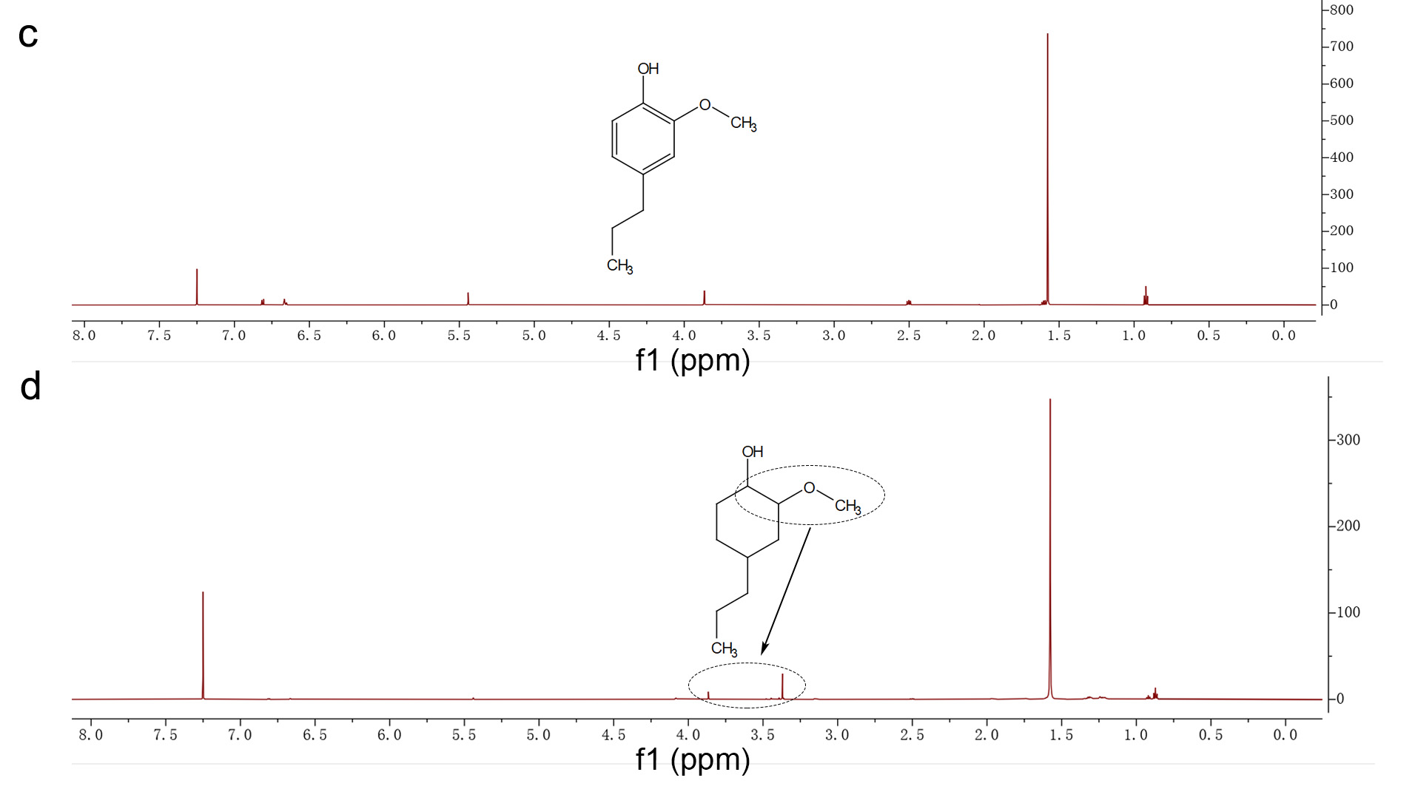
Fig. S33 | Electrocatalytic hydrogenation of a wood-derived 4-propylguaiacol (4PG, purity: 99 mol%). a and b, Evolution of (a) concentration and (b) conversion rate and product selectivity on PtRhAu catalyst for electrocatalytically hydrogenating a wood-derived 4-propylguaiacol (4PG) in 3 hours. c and d, ¹H NMR spectroscopies for a wood-derived 4PG in 0.2 M HClO₄ electrolyte (c) before and (d) after electrocatalytic hydrogenation at 20 mA for 3 hours with 1 cm² of PtRhAu catalyst. The electrolyte is extracted with chloroform-D.

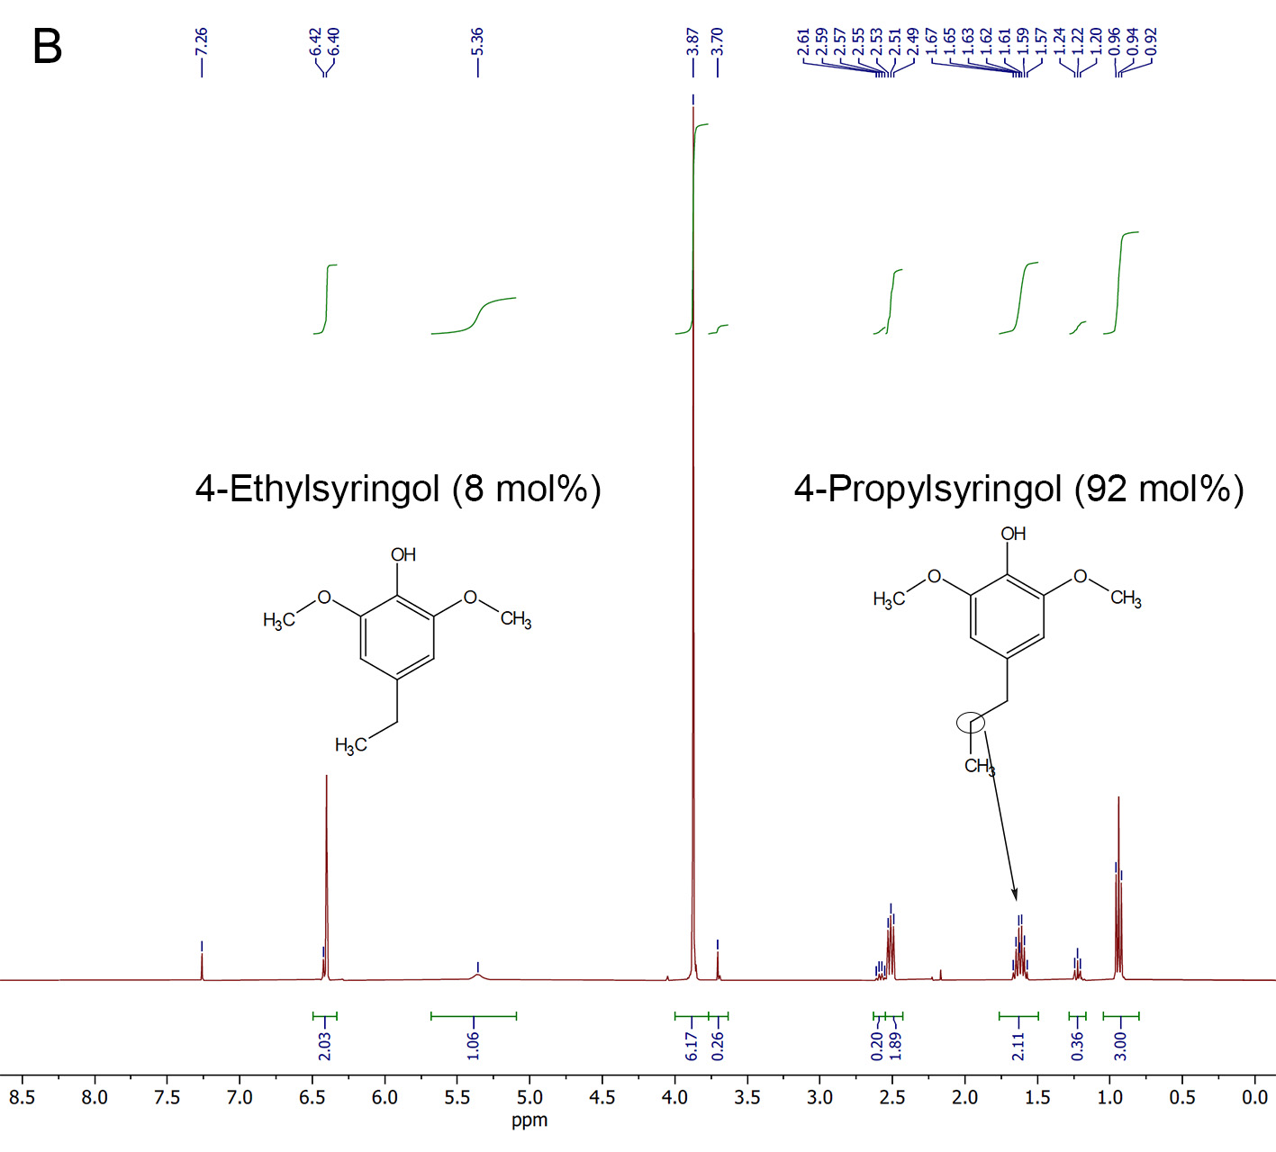
Fig. S34 | ¹H-NMR in CDCl₃ of the 4-propylsyringol sample produced from the isobutyraldehyde stabilized lignin and purified by distillation.

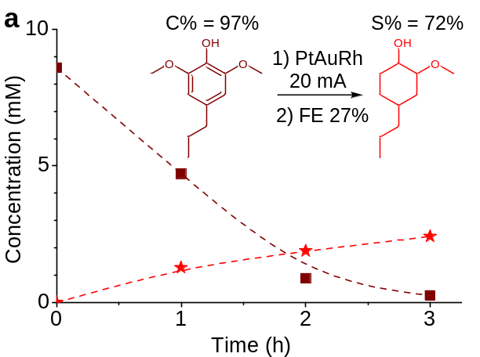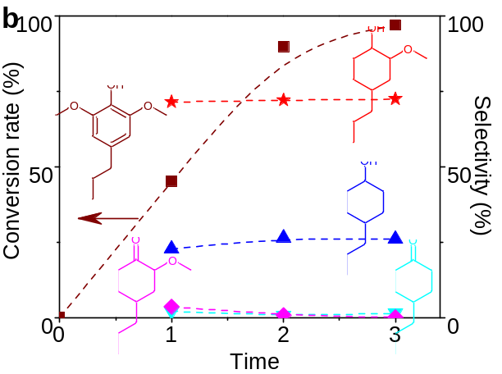
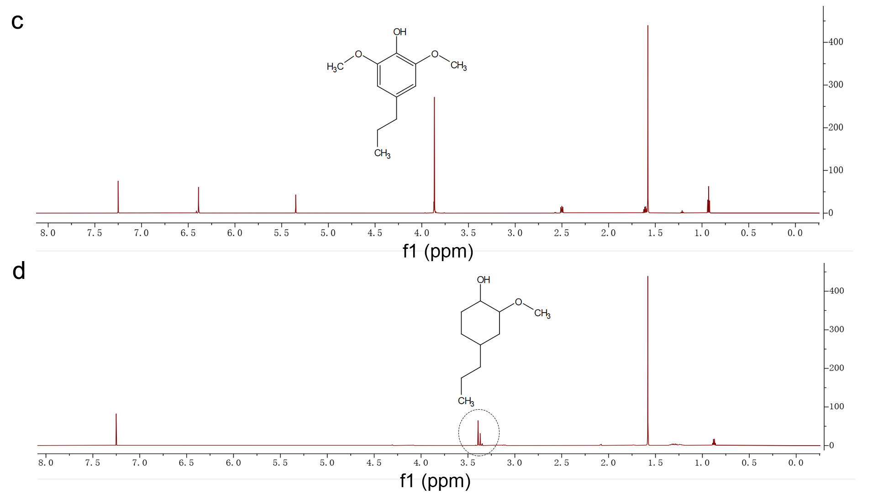
Fig. S35 | Electrocatalytic hydrogenation of a wood-derived 4-propylsyringol (4PS, purity: 92 mol%). a and b, Evolution of (a) concentration, (b) conversion rate and product selectivity on PtRhAu catalyst for electrocatalytically hydrogenating a wood-derived 4-propylsyringol (4PS) in 3 hours. c and d, ¹H NMR spectroscopies for a wood-derived 4PS in 0.2 M HClO₄ electrolyte (c) before and (d) after electrocatalytic hydrogenation at 20 mA for 3 hours with 1 cm² PtRhAu catalyst. The electrolyte is extracted with chloroform-D.

Supplementary tables

Catalyst | J_{2MC}ª (mA·cm⁻²) | ln(J_{2MC} (A·cm⁻²)) | E_{ad-G} (eV) | C-OCH₃ (Å) | C-OH (Å) | C=C (1) (Å) | C=C (2) (Å) | C=C (3) (Å) | C=C (4) (Å) | C=C (5) (Å) | C=C (6) (Å)
Ag | 0.0081 | -11.72 | -1.02 | 1.3631 | 1.3684 | 1.4184 | 1.3976 | 1.4053 | 1.3973 | 1.4040 | 1.3958
Au | 0.016 | -11.04 | -1.12 | 1.3602 | 1.3662 | 1.4199 | 1.3970 | 1.4050 | 1.3982 | 1.4034 | 1.3962
Cu | 0.11 | -9.11 | -1.20 | 1.3629 | 1.3622 | 1.4202 | 1.4035 | 1.4089 | 1.4026 | 1.4068 | 1.3992
Pd | 0.288 | -8.15 | -2.29 | 1.3706 | 1.3572 | 1.4501 | 1.4536 | 1.4569 | 1.4289 | 1.4532 | 1.4575
Ni | 0.465 | -7.67 | -1.79 | 1.3797 | 1.3581 | 1.4538 | 1.4239 | 1.4539 | 1.4466 | 1.4438 | 1.4483
Ru | 1.42 | -6.55 | -2.41 | 1.3874 | 1.3596 | 1.4337 | 1.4562 | 1.4648 | 1.4296 | 1.4535 | 1.4541
Ir | 1.501 | -6.50 | -2.18 | 1.3798 | 1.3565 | 1.4467 | 1.4772 | 1.4840 | 1.4327 | 1.4791 | 1.4850
Pt | 6.3 | -5.06 | -2.12 | 1.3646 | 1.3536 | 1.4530 | 1.4755 | 1.4793 | 1.4320 | 1.4734 | 1.4767
PtAu | 7.8 | -4.85 | -1.88 | 1.3611 | 1.3617 | 1.4530 | 1.4792 | 1.4703 | 1.4302 | 1.4748 | 1.4682
Rh | 9.6 | -4.65 | -2.67 | 1.3779 | 1.3705 | 1.4452 | 1.4604 | 1.4683 | 1.4333 | 1.4648 | 1.4666
PtRh | 21.12 | -3.86 | -2.83 | 1.3654 | 1.3555 | 1.4570 | 1.4679 | 1.4744 | 1.4305 | 1.4723 | 1.4772
PtRhAu | 28.14 | -3.57 | -2.46 | 1.3625 | 1.3595 | 1.4535 | 1.4712 | 1.4659 | 1.4286 | 1.4744 | 1.4699
Table S1 | Bond Length of C-OCH₃, C-OH, and C=C of guaiacol adsorbed on Pt, Au, Rh, Pd, Ni, Cu, Ag, Ir, and Ru. C=C bond ordering is illustrated in Fig. S3. ª. The turnover frequency, which is reflected in the current density J_{2MC}, where 2MC represents 2-methoxycyclohexanol, is linearly proportional to exp(-ΔG/kT), where G is the free energy from quantum mechanics calculation, k is the Boltzmann constant, and T is the temperature. Therefore, ln(J_{2MC}) would be linearly related to G, given that kT is fixed.

PtAu Screening | Energy Difference (eV) | Stability Ranking | RhPt Screening | Energy Difference (eV) | Stability Ranking
01PtAu111_guaiacol | 0.000 | 15 | 01RhPt111_guaiacol | 0.000 | 6
02AuPt111_guaiacol | -0.135 | 12 | 02RhPt111_guaiacol | 0.064 | 9
03AuPt111_guaiacol | -0.570 | 9 | 03RhPt111_guaiacol | 0.041 | 7
04AuPt111_guaiacol | -0.633 | 1 | 04RhPt111_guaiacol | 0.101 | 13
05AuPt111_guaiacol | -0.598 | 5 | 05RhPt111_guaiacol | 0.107 | 15
06AuPt111_guaiacol | -0.613 | 2 | 06RhPt111_guaiacol | 0.111 | 16
07AuPt111_guaiacol | -0.609 | 3 | 07RhPt111_guaiacol | 0.088 | 11
08AuPt111_guaiacol | -0.538 | 10 | 08RhPt111_guaiacol | 0.000 | 5
09AuPt111_guaiacol | -0.571 | 8 | 09RhPt111_guaiacol | 0.070 | 10
10AuPt111_guaiacol | -0.599 | 4 | 10RhPt111_guaiacol | 0.105 | 14
11AuPt111_guaiacol | -0.072 | 14 | 11RhPt111_guaiacol | -0.018 | 4
12AuPt111_guaiacol | -0.503 | 11 | 12RhPt111_guaiacol | -0.019 | 3
13AuPt111_guaiacol | -0.580 | 7 | 13RhPt111_guaiacol | 0.052 | 8
14AuPt111_guaiacol | 0.196 | 16 | 14RhPt111_guaiacol | -0.304 | 1
15AuPt111_guaiacol | -0.110 | 13 | 15RhPt111_guaiacol | -0.065 | 2
16AuPt111_guaiacol | -0.592 | 6 | 16RhPt111_guaiacol | 0.093 | 12
Table S2 | Screening results of the single dopant sites. We further ranked the dopant sites from the most stable to the least stable, and we chose dopant 8 as the most stable Au dopant site for the modeling of Pt8Au8; Dopant 3 as the most stable Rh sites for the modeling of Pt₁₃Rh₃; Dopant 7 as the most stable Au dopant site and dopant 2 as the most stable Rh site for the modeling of Pt₇Au₇Rh₂. The bold typography denotes the most stable dopant sites, which is used in the mechanistic study of the binary and ternary catalysts with realistic elemental ratios.

Metal | E_{ad-G} (eV) | C-OCH₃ (Å) | C-OH (Å) | J_{2MC} (mA·cm⁻²) |  | ln(J_{2MC} (A·cm⁻²))
Ag | -1.01984 | 1.363109 | 1.368422 | 0.00813 | -11.7206
Au | -1.11793 | 1.360174 | 1.366199 | 0.016 | -11.0429
Cu | -1.19572 | 1.362903 | 1.362233 | 0.11 | -9.11321
Pd | -2.29034 | 1.370607 | 1.357166 | 0.288 | -8.15429
Ni | -1.79303 | 1.379693 | 1.358101 | 0.465 | -7.67347
Ru | -2.40986 | 1.387363 | 1.359614 | 1.42 | -6.5571
Ir | -2.18208 | 1.379848 | 1.356467 | 1.501 | -6.50156
Pt | -2.124 | 1.36461 | 1.35359 | 6.3 | -5.06721
PtAu | -1.8841 | 1.36108 | 1.361713 | 7.8 | -4.85363
Rh | -2.66774 | 1.377882 | 1.370485 | 9.6 | -4.64599
PtRh | -2.83 | 1.365358 | 1.355527 | 21.12 | -3.85753
PtRhAu | -2.46172 | 1.362505 | 1.359505 | 28.14 | -3.57056
Table S3 | Guaiacol adsorption energy, C-OCH₃, C-OH bond length, and performance.

Catalyst | Method | T (ºC) | P (MPa) | Proton source | Precursor | Product | J (mA·cm⁻²) | FE (%) | C (%) | S (%) | Reference
PtRhAu | ECH | 25 | 0 | H₂O | Guaiacol | 2-Methoxycyclohexanol | 28 | 47 | 91 | 74 | This work
Li | ECH | 25 | 0 | Dimethylurea | Phenyl ethanol | 1,4-Cyclohexadiene-1-ethanol | - | 30.5 | 68 | 70 | Science 363, 838-845 (2019)²⁵
Li | ECH | 25 | 0 | Dimethylurea | C₇H₇(OTBS) | C₇H₉(OTBS) | 1.4 | 10.8 | <80 | 70 | Science 363, 838-845 (2019)²⁵
Pd/C | TCH | 130 | 2 | H₂ | Guaiacol | Ketones with OCH₃ | - | - | 100 | 10 | Nat. Commun. 8, 14190 (2017)²⁶
Pd/C | TCH | 100 | 1 | H₂ | Cyclohexanone | Cyclohexanol | - | - | 53.7 | 100 | Science 326, 1250-1252 (2009)²⁷
Pt/Al₂O₃ | TCH | 220 | 3 | CH₃OH | Guaiacol | 2-Methoxycyclohexanol | - | - | 80 | 20 | Renew. Energy 105, 140-148 (2017)²⁸
PtNiB | ECH | 60 | 0 | H₂O | Guaiacol | 2-Methox-cyclohexanol | 1.4 | 7 | 96 | 7 | Adv. Funct. Mater. 29, 1807651 (2019)²¹
Raney Ni | ECH | 75 | 0 | H₂O | Mequinol | 4-Methoxycyclohexanol | 1.2 | 15.2 | 19 | 48 | Green Chem. 17, 601-609 (2015)²⁹
Ru | ECH | 50 | 0 | H₂O | Guaiacol | 2-Methoxycyclohexanol | 7.9 | 31 | 60 | 62 | Green Chem. 14, 2540-2549 (2012)³⁰
Ru | ECH | 80 | 0 | H₂O | Guaiacol | 2-Methoxycyclohexanol | 4.6 | 19.4 | 80 | 48 | ACS Sustain. Chem. Eng. 7, 8375-8386 (2019)³¹
Table S4 | Comparison of catalysts that aim at retaining oxygenated functional groups (-OH and/or -OCH₃) during partial electrocatalytic hydrogenation (ECH) or thermocatalytic hydrogenation (TCH). J is partial current density, FE faradaic efficiency, S selectivity, C conversion, OTBS O-(tert-butyldimethylsilyl)hydroxylamine.

Ashª | Hydrationª | Extractivesª | Klason Ligninª | Acid Soluble Ligninª | Glucanª | Xylanª | Galactanª | Arabinanª | Mannanª | Acetylª | Totalª
0.15% | 6.09% | 3.27% | 17.94% | 2.81% | 32.16% | 17.81% | 2.01% | 0.56% | 0.26% | 5.89% | 88.95%
Table S5 | Composition of the birch wood used for the full fractionation of lignocellulosic biomass procedure. ª Fractions are presented as wt/wt% of the raw biomass. The compositional analysis was determined according to the procedure outlined in Talebi Amiri et al. ¹⁶. The data shown here is reproduced from that publication.

Biomass | M1 | M3 | M5 | M7 | M15 | M9 | Total
Birch 7A | 0.09% | 1.74% | 0.49% | 8.04% | 0.00% | 0.30% | 10.66%
Beech 5B | 0.16% | 2.47% | 0.50% | 6.15% | 0.00% | 0.82% | 10.11%
Black pine 10A | 0.46% | 4.47% | 0.00% | 0.00% | 0.00% | 0.00% | 4.93%
Table S6 | Yield of lignin monomers from the direct hydrogenolysis of the feedstocks on a dry basis. ªYields are presented as a wt/wt% of the total raw biomass on a dry basis and is corrected for any mass lost with respect to the monomers’ initial structures in the native lignin polymer.

 | Products of the propionaldehyde fractionation |  |  |  |  |  | Cellulose enzymatic hydrolysis
Biomass | Cellulose Rich Solidsª | Stabilized Lignin^{b} | Dipropyl Xylose^{c} | 5-HMF^{c} | 2-Furfural^{c} |  | Glucan | Xylan
Birch 7A | 39.0 g  (37.7%) | 23.0507 g  (21.48%) | 22.6510 g  (12.97%) | 0.350 g  (0.449%) | 1.56 g  (2.14%) |  | 34.2 g  (34.1%) | 3.16 g  (3.16%)
Table S7 | Masses and Yields of Isolated Fractions from the Propionaldehyde Fractionation and the Results of the Enzymatic Hydrolysis of the Cellulose Rich Solids. All percentages are wt/wt% of the total raw biomass. ªPercentage corrected for hydration. ^{b}Percentage corrected for the propionaldehyde stabilization. ^{c}Percentage determined based on corresponding quantity of xylan or glucan. Abbreviations: 5-hydroxymethylfurfural (HMF)

Lignin Source | M1ª | M3ª | M5ª | M7ª | M9ª | Totalª
Propionaldehyde Stabilized Lignin from Birch 7A | 0.32% | 0.55% | 2.98% | 3.75% | 0.94% | 8.54%
Table S8 | Yield of lignin monomers from the hydrogenolysis of the isolated propionaldehyde stabilized lignin powder. ªYield is presented as a wt/wt% of the total raw biomass on a dry basis and is corrected for any mass lost with respect to the monomers’ initial structures in the native lignin polymer due to the hydrogenolysis.

Monomer Source | M1 | M3 | M5 | M7
Bulk Lignin Hydrogenolysis of Propionaldehyde Stabilized Lignin | 2.98 mol% | 12.32 mol% | 18.90 mol% | 65.80 mol%
4-propyguaiacol Sample Isolated from the Hydrogenolysis of Isobutyraldehyde Stabilized Lignin | 0.93 mol% | 99.07 mol% | 0.00 mol% | 0.00 mol%
4-propysyringol Sample Isolated from the Hydrogenolysis of Isobutyraldehyde Stabilized Lignin | 0.00 mol% | 0.00 mol% | 8.20 mol% | 91.80 mol%
Table S9 | Distribution of Lignin Monomers in the Isolated Lignin Monomer Oils as Determined by Gas Chromatography Analysis.

Monomer Number | Monomer Structure | Molecular Weight (g·mol⁻¹) | Unreduced Molecular Weight (g·mol⁻¹) | Solvent | Effective Carbon Number (ECN) | Elution Time (min)
Decane | 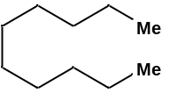 | 142.29 | 142.29 | Tetrahydrofuran | 10 | 5.440
 |  |  |  | Methanol | 10 | 5.464
M1 | 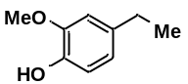 | 152.19 | 196.20 | Tetrahydrofuran | 7.65 | 6.854
 |  |  |  | Methanol | 8.19 | 6.878
M3 | 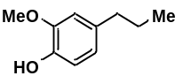 | 166.22 | 196.20 | Tetrahydrofuran | 8.76 | 7.178
 |  |  |  | Methanol | 9.02 | 7.184
M5 | 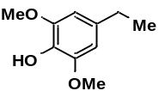 | 182.22 | 226.23 | Tetrahydrofuran | 6.90 | 7.714
 |  |  |  | Methanol | 7.06 | 7.735
M7 | 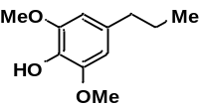 | 196.25 | 226.23 | Tetrahydrofuran | 7.49 | 7.948
 |  |  |  | Methanol | 7.78 | 7.950
M15 | 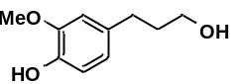 | 182.22 | 196.20 | Tetrahydrofuran | 6.65 | 8.125
 |  |  |  | Methanol | 6.95 | 8.135
M9 | 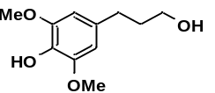 | 212.24 | 226.23 | Tetrahydrofuran | 6.40 | 8.701
 |  |  |  | Methanol | 6.65 | 8.701
Table S10 | Effective carbon numbers for the gas chromatography method.

References
1 Kresse, G. & Furthmüller, J. Efficient iterative schemes for ab initio total-energy calculations using a plane-wave basis set. Phys. Rev. B 54, 11169-11186 (1996).
2 Kresse, G. & Furthmüller, J. Efficiency of ab-initio total energy calculations for metals and semiconductors using a plane-wave basis set. Comput. Mater. Sci. 6, 15-50 (1996).
3 Perdew, J. P., Burke, K. & Ernzerhof, M. Generalized gradient approximation made simple. Phys. Rev. Lett. 77, 3865-3868 (1996).
4 Grimme, S., Antony, J., Ehrlich, S. & Krieg, H. A consistent and accurate ab initio parametrization of density functional dispersion correction (DFT-D) for the 94 elements H-Pu. J. Chem. Phys. 132, 154104 (2010).
5 Blöchl, P. E. Projector augmented-wave method. Phys. Rev. B 50, 17953-17979 (1994).
6 Kresse, G. & Joubert, D. From ultrasoft pseudopotentials to the projector augmented-wave method. Phys. Rev. B 59, 1758-1775 (1999).
7 Monkhorst, H. J. & Pack, J. D. Special points for Brillouin-zone integrations. Phys. Rev. B 13, 5188-5192 (1976).
8 Janet, J. P., Gani, T. Z. H., Steeves, A. H., Ioannidis, E. I. & Kulik, H. J. Leveraging cheminformatics strategies for inorganic discovery: application to redox potential design. Ind. Eng. Chem. Res. 56, 4898-4910 (2017).
9 Durand, D. J. & Fey, N. Computational ligand descriptors for catalyst design. Chem. Rev. 119, 6561-6594 (2019).
10 Tran, K. & Ulissi, Z. W. Active learning across intermetallics to guide discovery of electrocatalysts for CO₂ reduction and H₂ evolution. Nat. Catal. 1, 696-703 (2018).
11 Seh, Z. W. et al. Combining theory and experiment in electrocatalysis: Insights into materials design. Science 355, eaad4998 (2017).
12 Zhang, B. et al. Homogeneously dispersed multimetal oxygen-evolving catalysts. Science 352, 333 (2016).
13 Li, M. et al. Ultrafine jagged platinum nanowires enable ultrahigh mass activity for the oxygen reduction reaction. Science 354, 1414 (2016).
14 Lu, J., Behtash, S., Mamun, O. & Heyden, A. Theoretical investigation of the reaction mechanism of the guaiacol hydrogenation over a Pt(111) catalyst. ACS Catal. 5, 2423-2435 (2015).
15 Liu, X., An, W., Wang, Y., Turner, C. H. & Resasco, D. E. Hydrodeoxygenation of guaiacol over bimetallic Fe-alloyed (Ni, Pt) surfaces: Reaction mechanism, transition-state scaling relations and descriptor for predicting C–O bond scission reactivity. Catal. Sci. Technol. 8, 2146-2158 (2018).
16 Talebi Amiri, M., Dick, G. R., Questell-Santiago, Y. M. & Luterbacher, J. S. Fractionation of lignocellulosic biomass to produce uncondensed aldehyde-stabilized lignin. Nat Protoc 14, 921-954, doi:10.1038/s41596-018-0121-7 (2019).
17 Lee, K., Gu, G. H., Mullen, C. A., Boateng, A. A. & Vlachos, D. G. Guaiacol hydrodeoxygenation mechanism on Pt(111): Insights from density functional theory and linear free energy relations. ChemSusChem. 8, 315-322 (2015).
18 Lu, J. & Heyden, A. Theoretical investigation of the reaction mechanism of the hydrodeoxygenation of guaiacol over a Ru(0001) model surface. J. Catal. 321, 39-50 (2015).
19 Scoullos, E. V. et al. Guaiacol adsorption and decomposition on platinum. J. Phys. Chem. C 122, 29180-29189 (2018).
20 Jia, S., Cox, B. J., Guo, X., Zhang, Z. C. & Ekerdt, J. G. Hydrolytic cleavage of β-O-4 ether bonds of lignin model compounds in an ionic liquid with metal chlorides. Ind. Eng. Chem. Res. 50, 849-855 (2011).
21 Zhou, Y. et al. Electrocatalytic upgrading of lignin-derived bio-oil based on surface-engineered PtNiB nanostructure. Adv. Funct. Mater. 29 (2019).
22 Agarwal, U. P., McSweeny, J. D. & Ralph, S. A. FT–Raman investigation of milled-wood lignins: Softwood, hardwood, and chemically modified black spruce lignins. J. Wood Chem. Technol. 31, 324-344 (2011).
23 Verma, V. N., Nair, K. P. R. & Rai, D. K. Vibrational spectra and thermodynamic functions of the three isomeric methoxyphenols. Isr. J. Chem. 8, 777-789 (1970).
24 Neelakantan, P. The Raman spectrum of cyclohexanol. Proc. Ind. Acad. Sci., A 57, 94-102 (1963).
25 Peters, B. K. et al. Scalable and safe synthetic organic electroreduction inspired by Li-ion battery chemistry. Science 363, 838-845 (2019).
26 Meng, Q., Hou, M., Liu, H., Song, J. & Han, B. Synthesis of ketones from biomass-derived feedstock. Nat. Commun. 8, 14190 (2017).
27 Liu, H., Jiang, T., Han, B., Liang, S. & Zhou, Y. Selective phenol hydrogenation to cyclohexanone over a dual supported Pd-Lewis acid catalyst. Science 326, 1250-1252 (2009).
28 Feng, J. et al. In situ catalytic hydrogenation of model compounds and biomass-derived phenolic compounds for bio-oil upgrading. Renew. Energ. 105, 140-148 (2017).
29 Lam, C. H. et al. Electrocatalytic upgrading of model lignin monomers with earth abundant metal electrodes. Green Chem. 17, 601-609 (2015).
30 Li, Z. et al. Mild electrocatalytic hydrogenation and hydrodeoxygenation of bio-oil derived phenolic compounds using ruthenium supported on activated carbon cloth. Green Chem. 14, 2540-2549 (2012).
31 Garedew, M., Young-Farhat, D., Jackson, J. E. & Saffron, C. M. Electrocatalytic upgrading of phenolic compounds observed after lignin pyrolysis. ACS Sustain. Chem. Eng. 7, 8375-8386 (2019).

