Graphical abstract
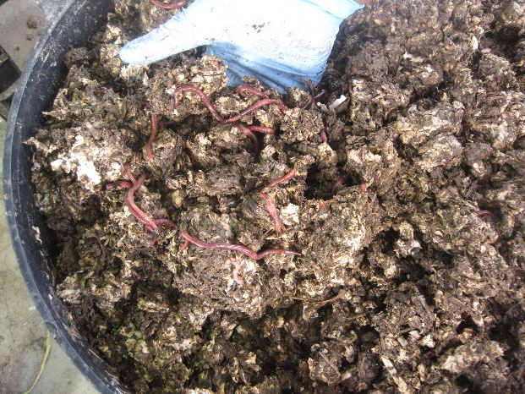
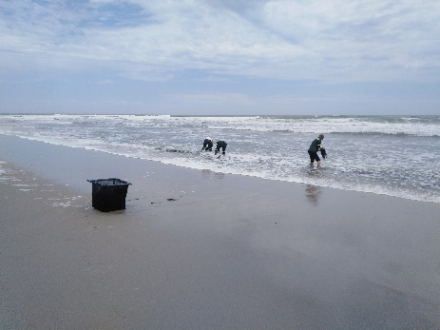
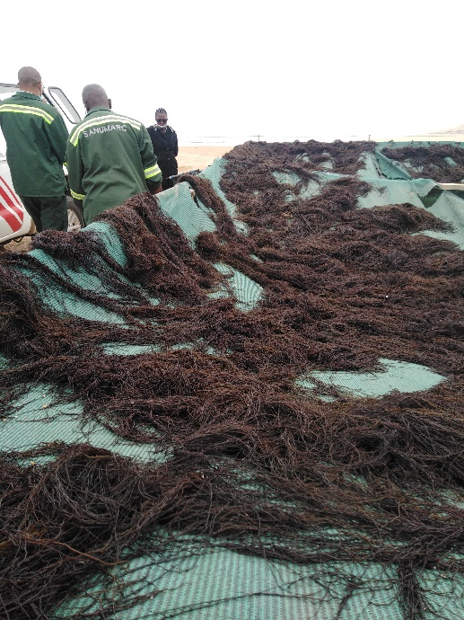
Pyrolysis to biochar
Increased Olsen P, N. Mg, Ca.
Optimum biochar inclusion level 6-8%.
No difference in biodegradation.
High EC at 8% biochar level.

2 to 8 % inclusion

