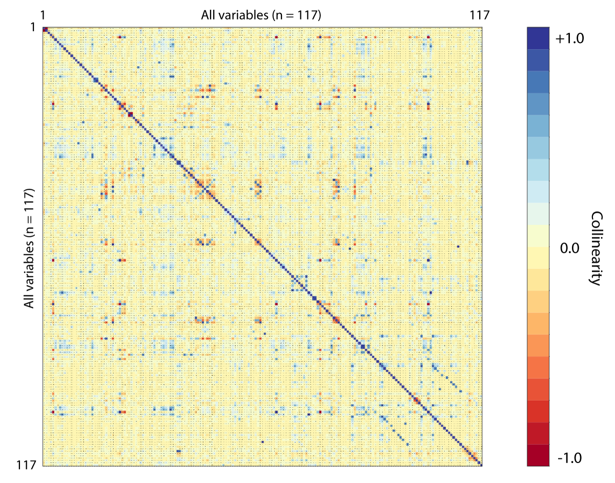
Supplementary Figure 1: Heatmap of all variables (117 x 117) depicting collinearity of all variables with isolated predictors which were excluded from further analysis.

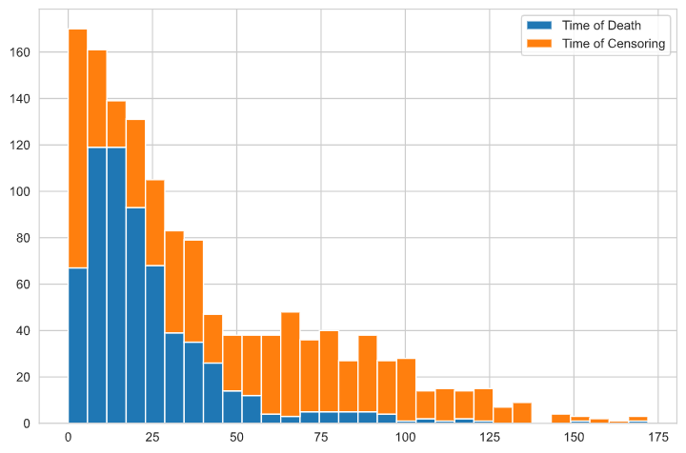
Supplementary Figure 2: Bar graph of censored versus documented data from systemic follow-up.

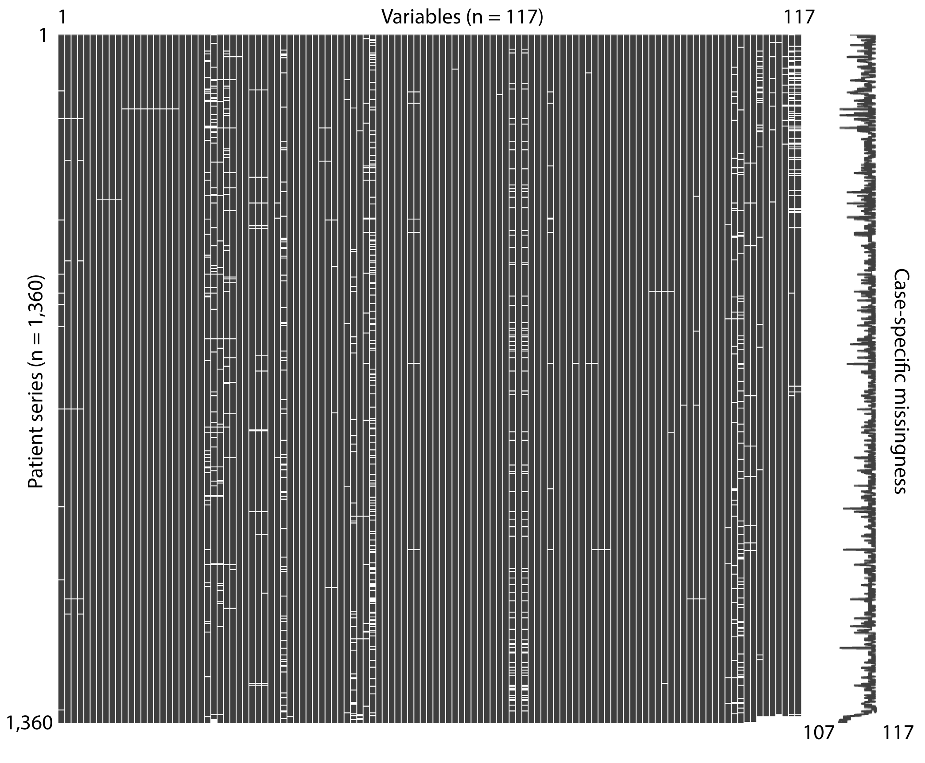
Supplementary Figure 3: Missingness matrix of all 117 variables (plotted on the x-axis) and a total of 1,360 cases (plotted on the y-axis) demonstrating a total missingness of 1.3%. The right-hand diagram shows the individual missingness with a maximum missingness in 10 variables for one patient resulting in a data availability in 107 variables.

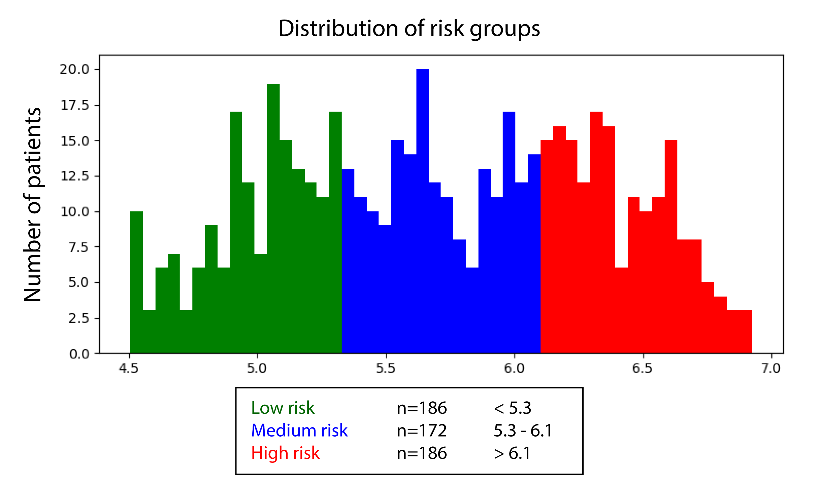

Supplementary Figure 4: Risk score distribution of the compact RSF model based on the 20 most important variables.

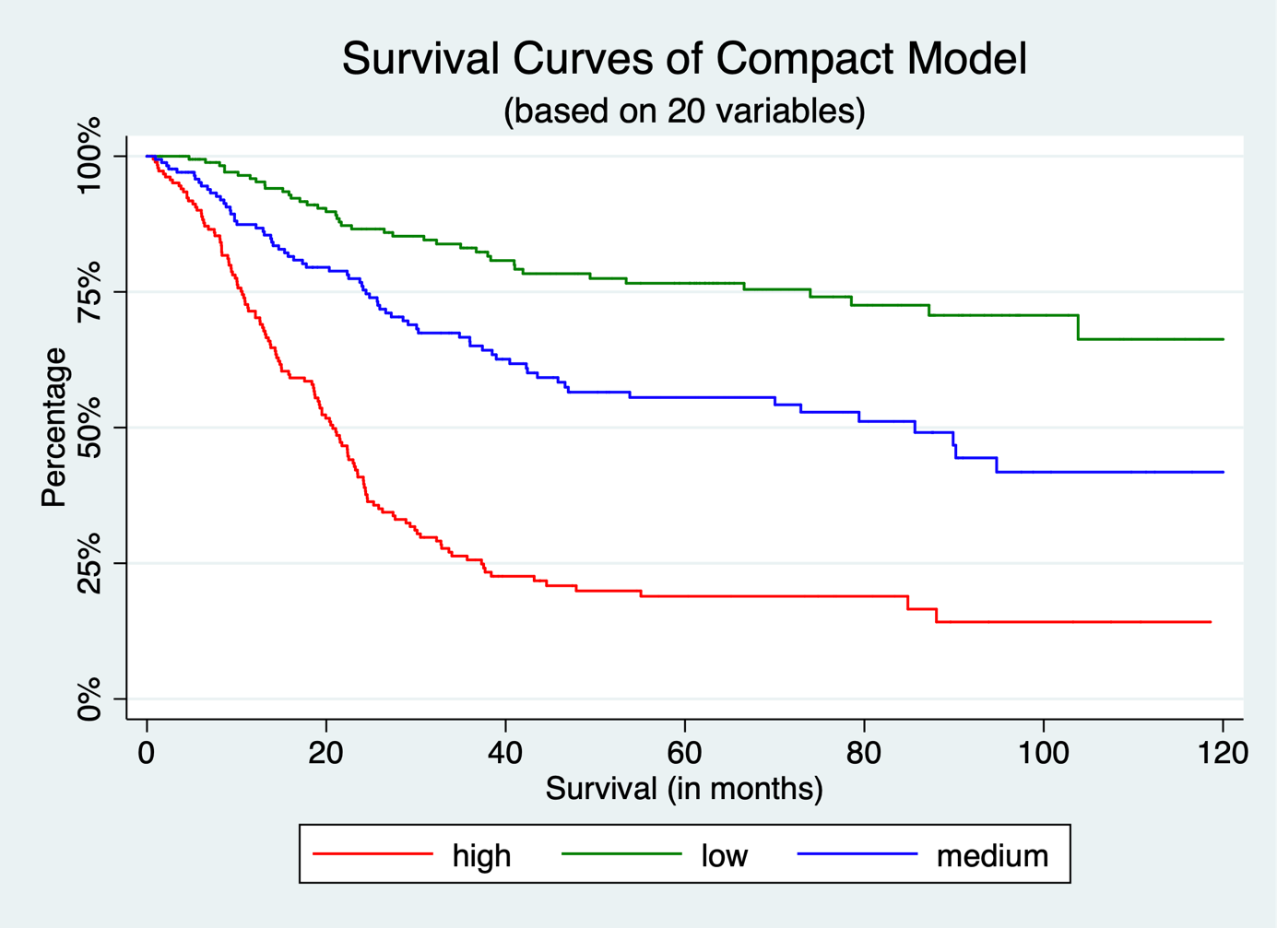

Supplementary Figure 5: Kaplan Meier plot of the compact RSF model and its three different risk groups.

