Extended data figures

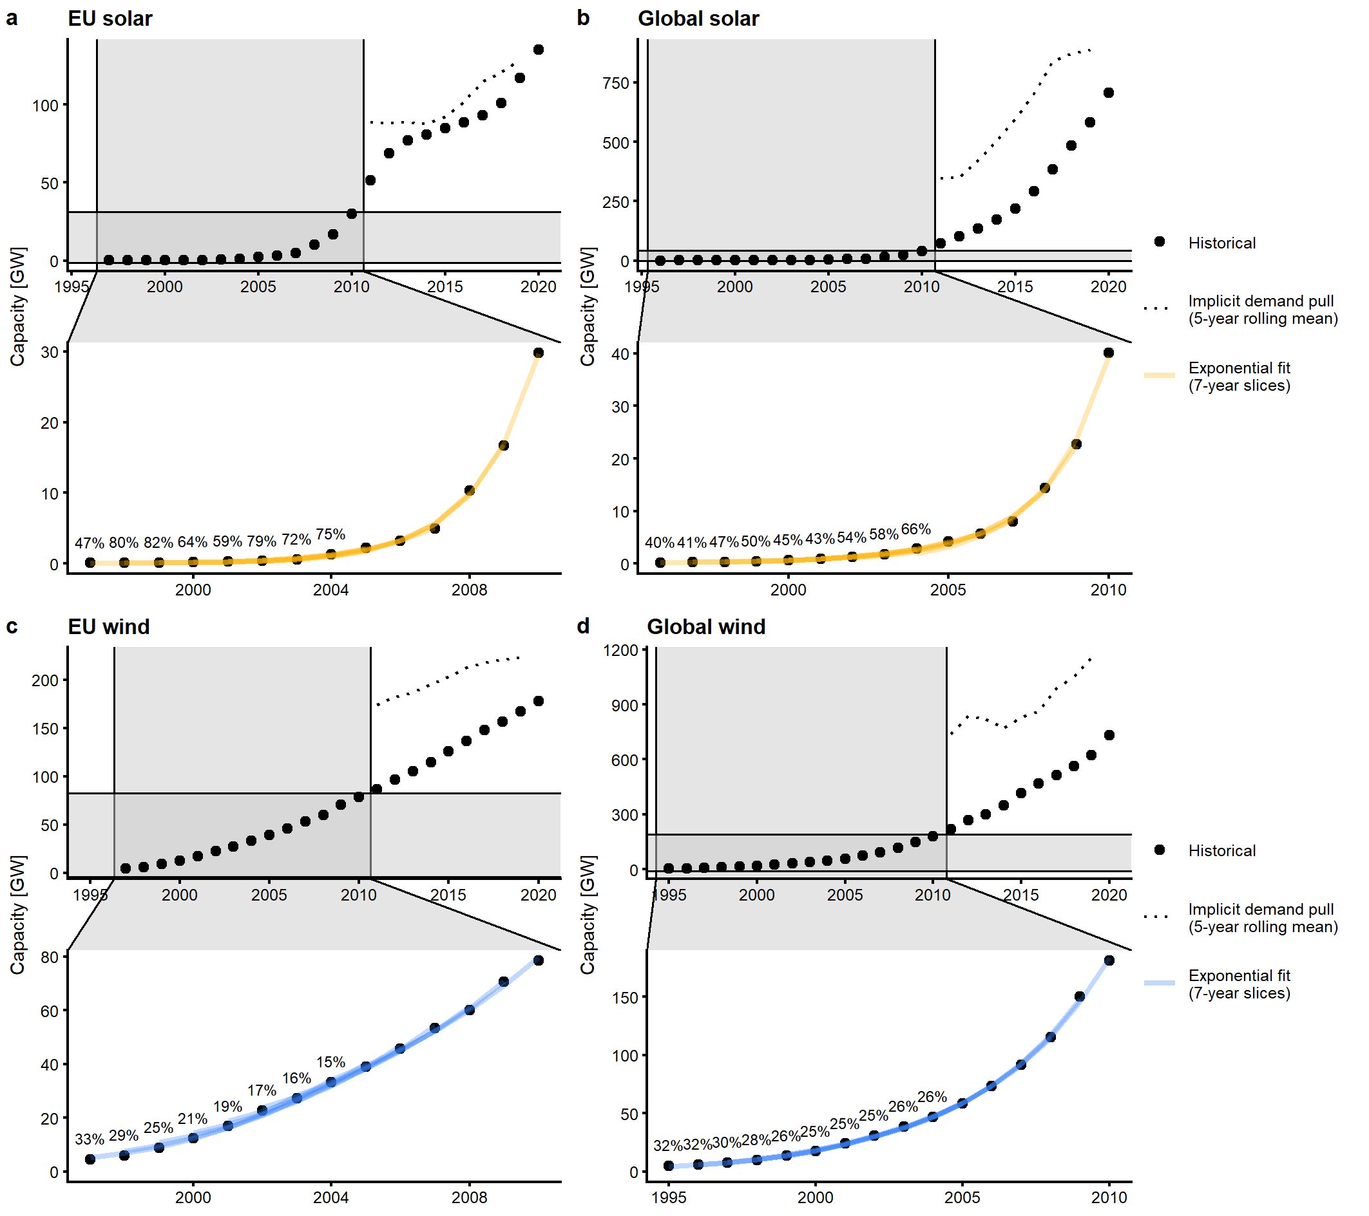
Extended Data Figure 1: Historical capacities and exponential growth rates of solar and wind power. a, Solar power in the EU, b, Solar power globally, c, Wind power in the EU, d, Wind power globally. The zoom panel displays the period of fastest growth until 2010, from which we estimate exponential growth rates in 7-year slices. The percentage values indicate the corresponding growth rate for the subsequent 7-year period. These growth rates define the emergence growth rate distributions in Figure 3c-d. To illustrate the idea of our adapted logistic technology diffusion model, we also calculate the implicit demand pull from 2011-2020 (dotted line, 5-year rolling mean) that replicates the historically observed capacities based on the average emergence growth rate taken from the 1995-2010 interval (see Equation 5). The approximately linear shape of the implicit demand pull demonstrates that this is a well-founded assumption, which we therefore also apply to the analysis of electrolysis capacity upscaling.
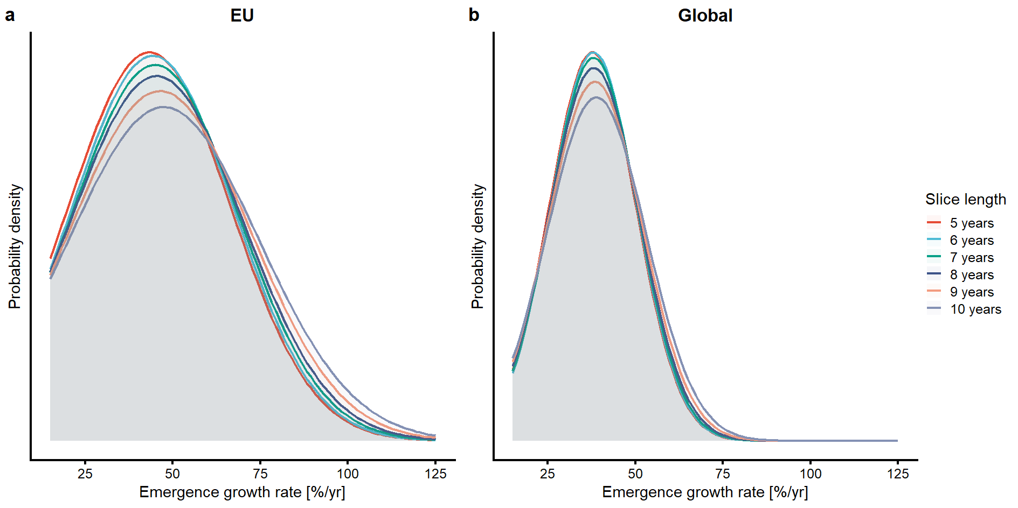
Extended Data Figure 2: Emergence growth rate distributions in the conventional growth case under varying slice lengths of the underlying solar and wind power fit. a, in the EU, b, globally. The distributions are relatively robust to the length of the time slice that underlies the estimate of the exponential growth rate. We therefore use the intermediate 7-year slice length, which also corresponds to the 2023-2030 time window that is of particular concern for 2030 policy targets as the model starts in 2023.
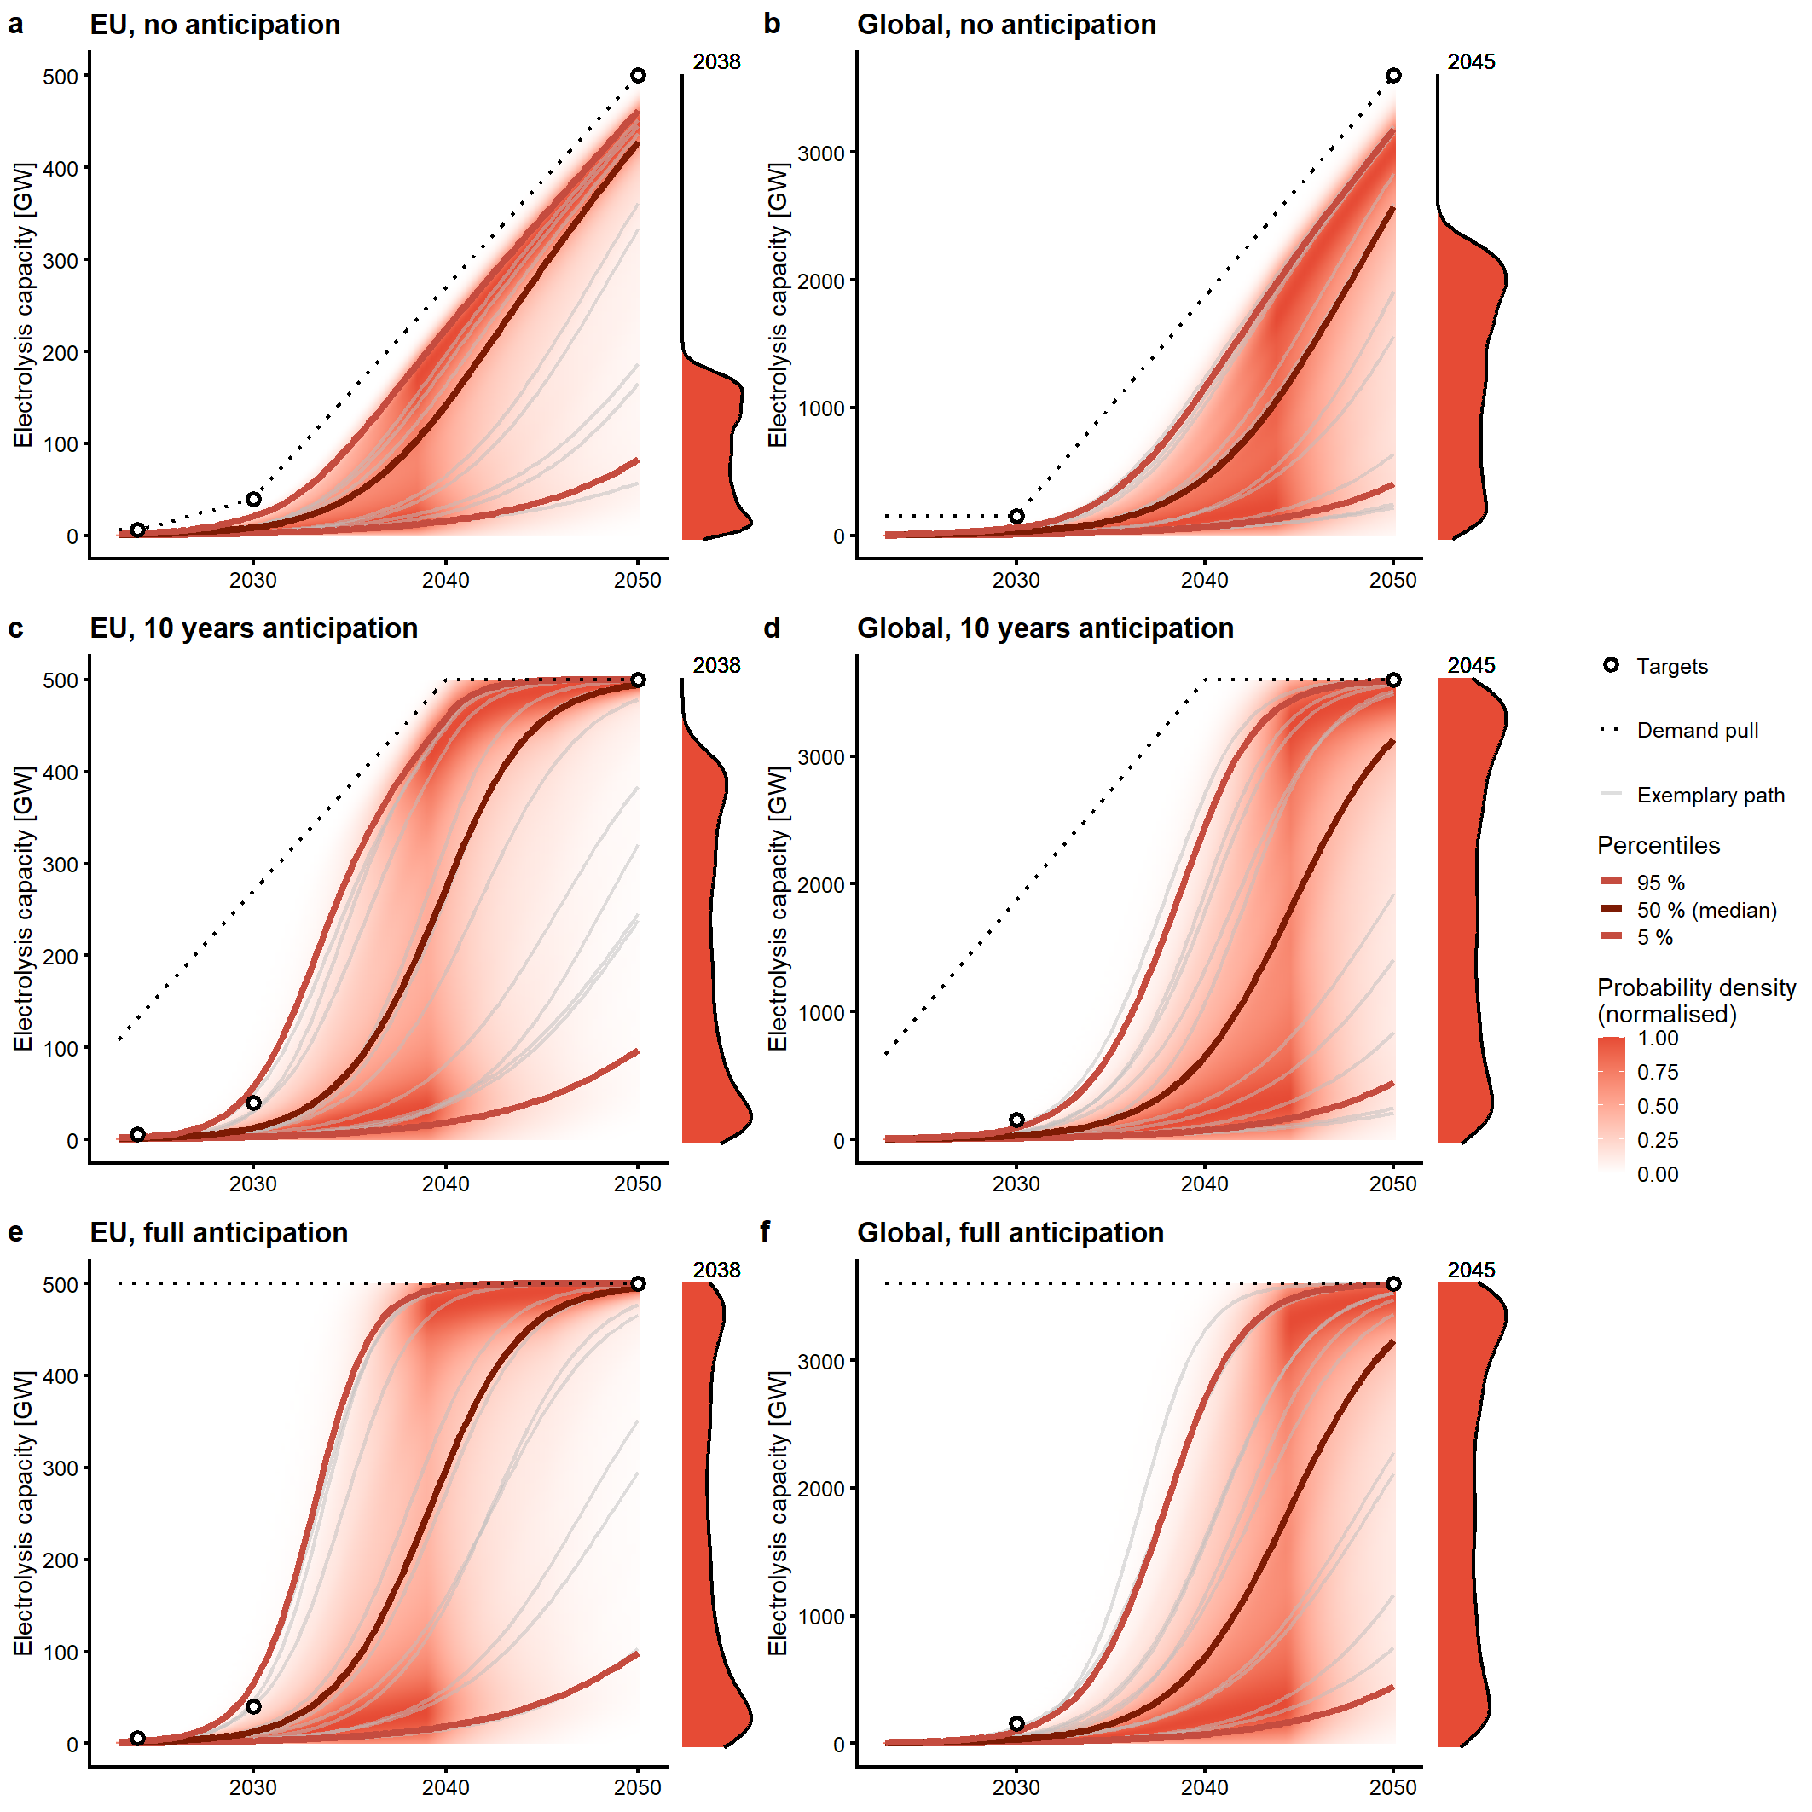Extended Data Figure 3: Sensitivity analysis of probabilistic feasibility spaces for the conventional growth case under varying demand pull anticipation levels. a,c,e, EU with no anticipation, 10 years anticipation, and a hypothetical case of full anticipation of the long-term market size, respectively. b,d,f, globally. Both short-term scarcity and long-term uncertainty are robust to the level of demand pull anticipation. However, in the long-term capacity deployment is higher under full anticipation of the demand pull (i.e. the default logistic function), especially in the EU, which has higher growth rates than globally.

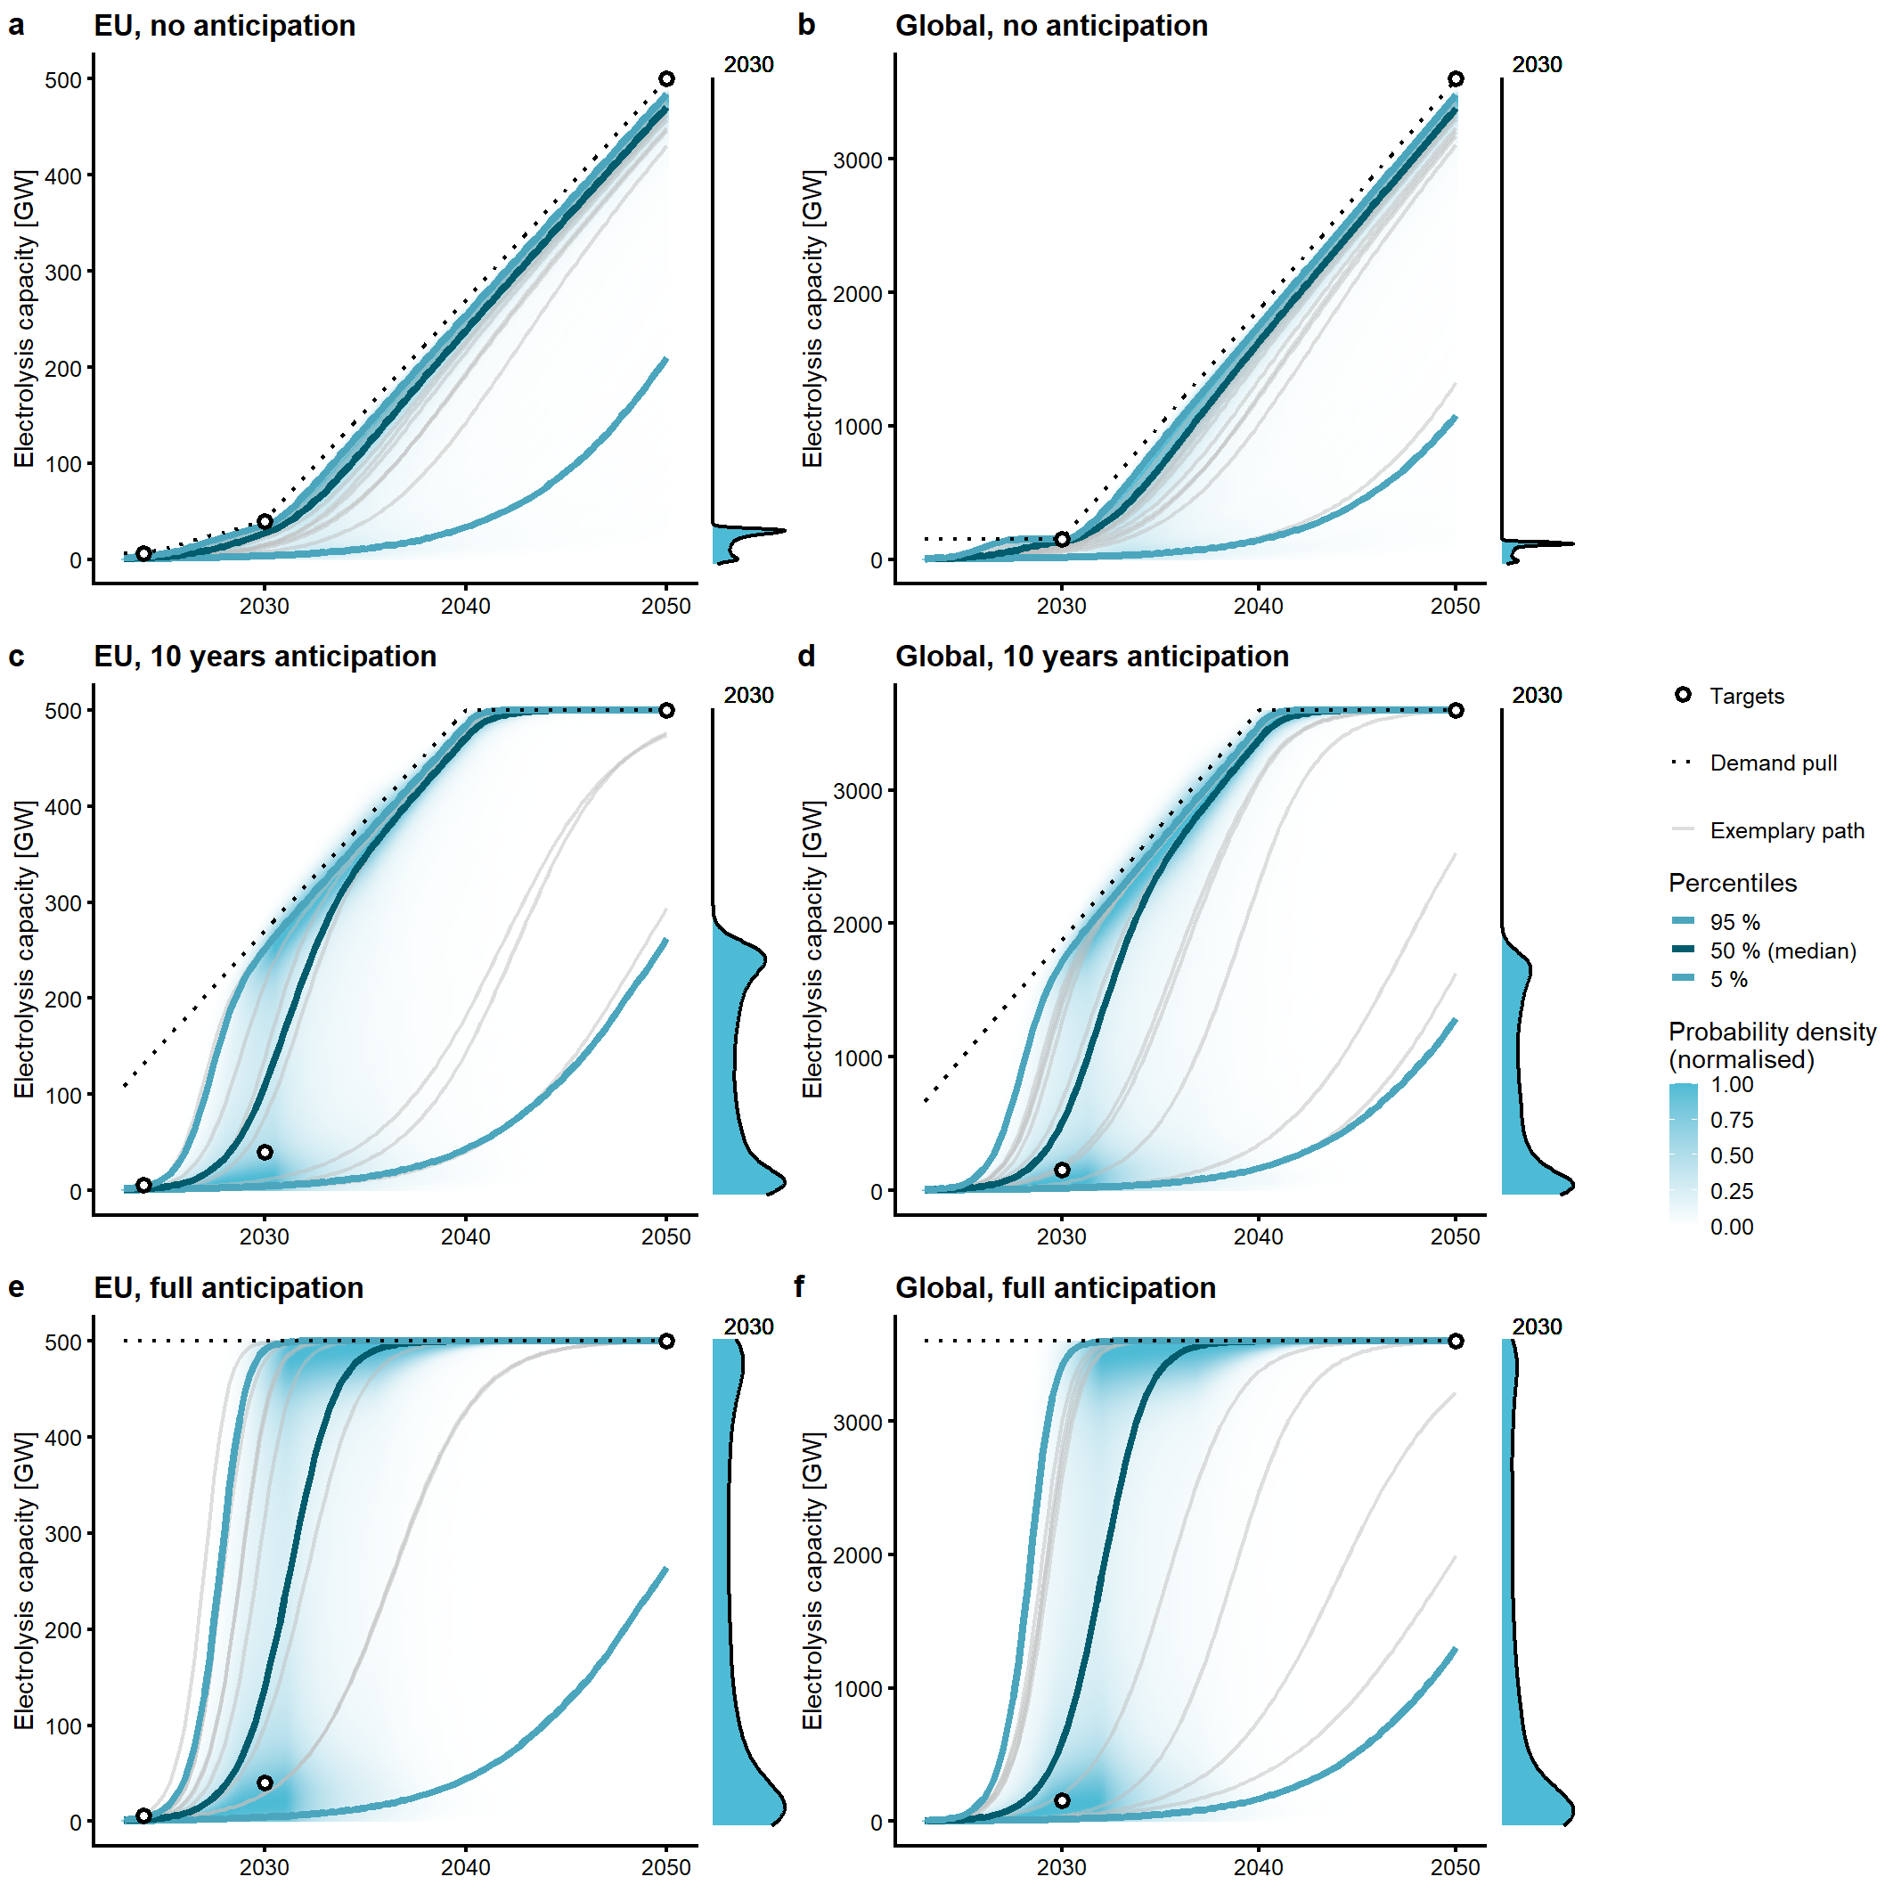
Extended Data Figure 4: Sensitivity analysis of probabilistic feasibility spaces for the unconventional growth case under varying demand pull anticipation levels. a,c,e, EU with no anticipation, 10 years anticipation, and a hypothetical case of full anticipation of the long-term market size, respectively. b,d,f, globally. In both regions, short-term scarcity can be overcome to an even greater extent under full anticipation of the demand pull. Notably, under unconventional growth rates and full demand pull anticipation, short-term uncertainty results as indicated by the marginal distributions in 2030. As the probabilistic feasibility space is primarily determined by the demand pull level after 2030 in both regions, under full demand pull anticipation the saturation market volume is reached already around 2035 with a high probability in both regions.
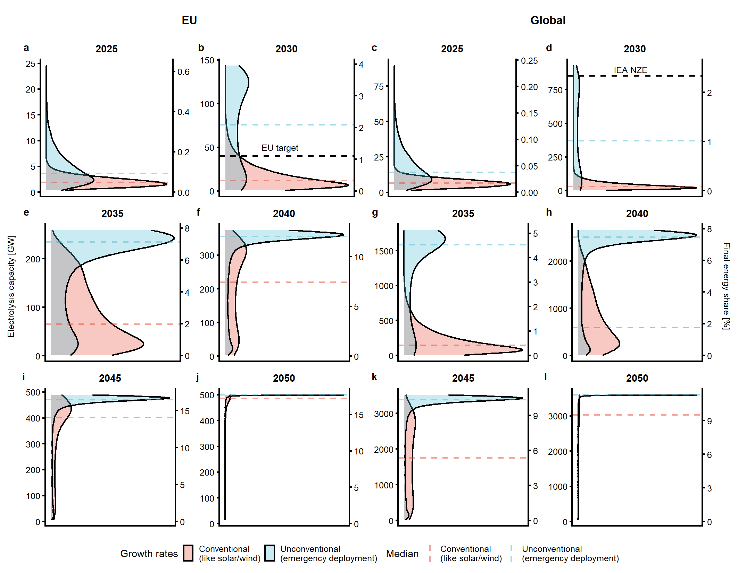
Extended Data Figure 5: Probability distribution of electrolysis capacity in 5 year time steps between 2025-2050. a,b,e,f,i,j, in the EU, c,d,g,h,k,l, globally. This diagram is an extension of Figure 6c-d with additional years (2025, 2035, 2045, 2050). The left axis shows electrolysis capacity in GW, the right axis the corresponding final energy share that can be supplied with this capacity. In 2025, green hydrogen supply is minimal in terms of the final energy share in both regions and largely irrespective of the growth rate. In 2035, unconventional growth rates enable a final energy share that is almost 4 times larger than under conventional growth rates in the EU, and more than 10 times larger globally. In 2045, and even more so in 2050, the demand pull acts as the main constraint such that the differences between conventional and unconventional growth rates become smaller again.

