Figure S1. ¹H NMR spectrum of compound 2 dissolved in acetone-d₆ containing TMS (400 MHz).
Figure S2. ¹³C NMR spectrum of compound 2 dissolved in acetone-d₆ containing TMS (400 MHz).
Figure S3. ¹H NMR spectrum of compound 4 dissolved in D₂O (400 MHz).
Figure S4. ¹³C NMR spectrum of compound 4 dissolved in D₂O (400 MHz).
Figure S5. ¹H NMR spectrum of compound 9 dissolved in DMSO-d₆ (400 MHz).

Figure S6. ¹³C NMR spectrum of compound 9 dissolved in DMSO-d₆ (400 MHz).
Figure S7. ¹H NMR spectrum of N-(3,4-dimethoxybenzyl)-N-propylpropan-1-amine dissolved in CDCl₃ (400 MHz).
Figure S8. ¹³C NMR spectrum of N-(3,4-dimethoxybenzyl)-N-propylpropan-1-amine dissolved in CDCl₃ (400 MHz).

Figure S9. ¹H NMR spectrum of compound 10 dissolved in DMSO-d₆ (400 MHz).
Figure S10. ¹³C NMR spectrum of compound 10 dissolved in DMSO-d₆ (400 MHz)

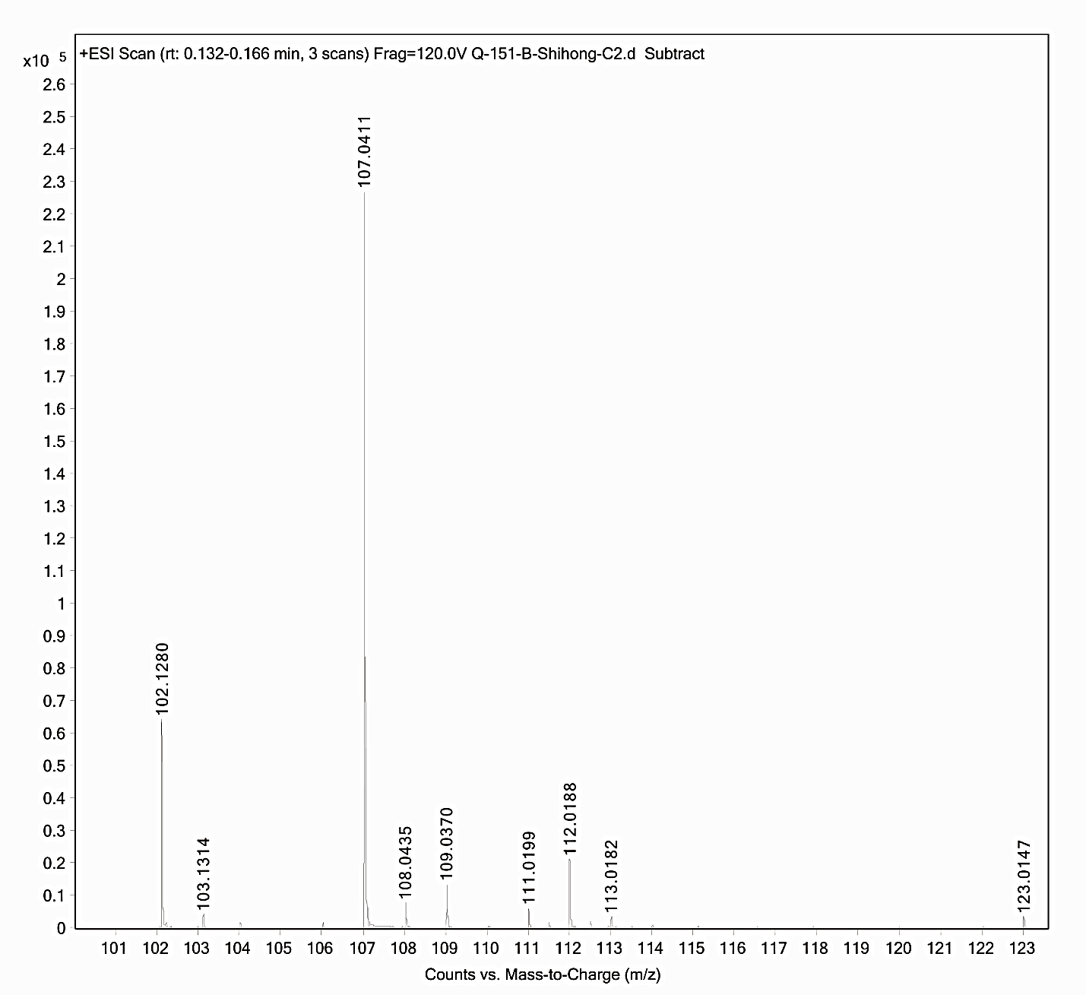

Figure S11. Low molecular weight regions of ESI-MS spectra for compound 9 in positive ion mode showing the absence of residual Ag⁺ ion.

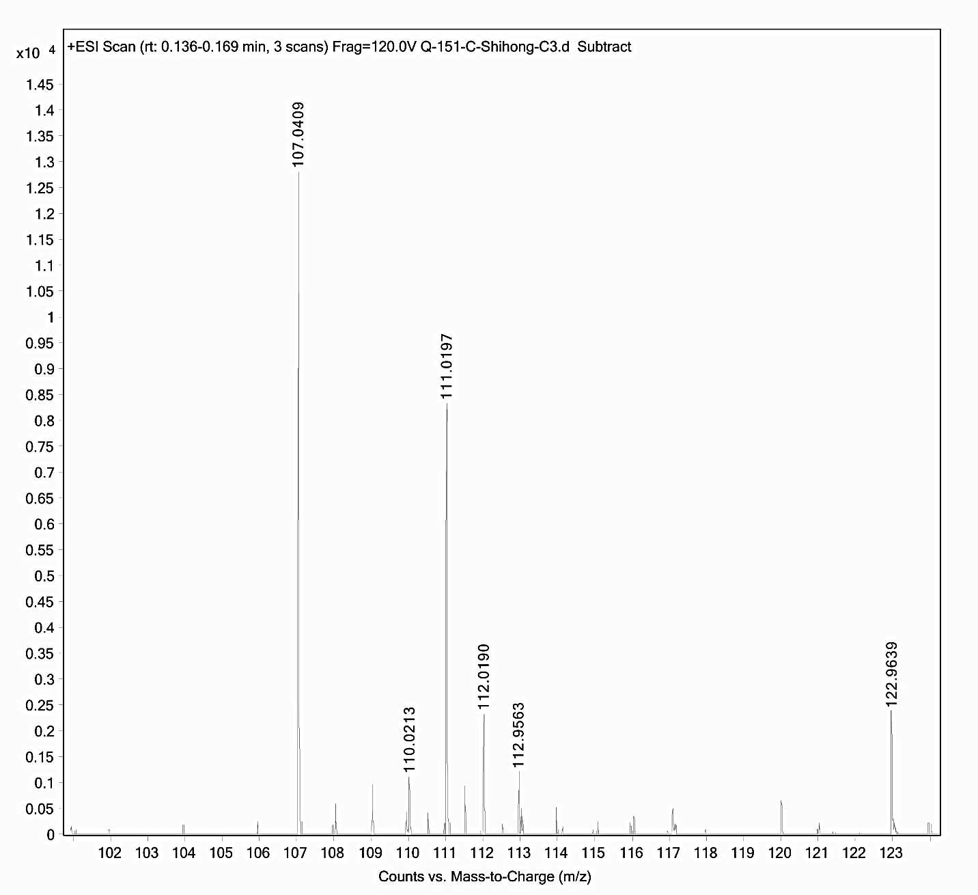
Figure S12. Low molecular weight regions of ESI-MS spectra for compound 10 in positive ion mode showing the absence of residual Ag⁺ ion.
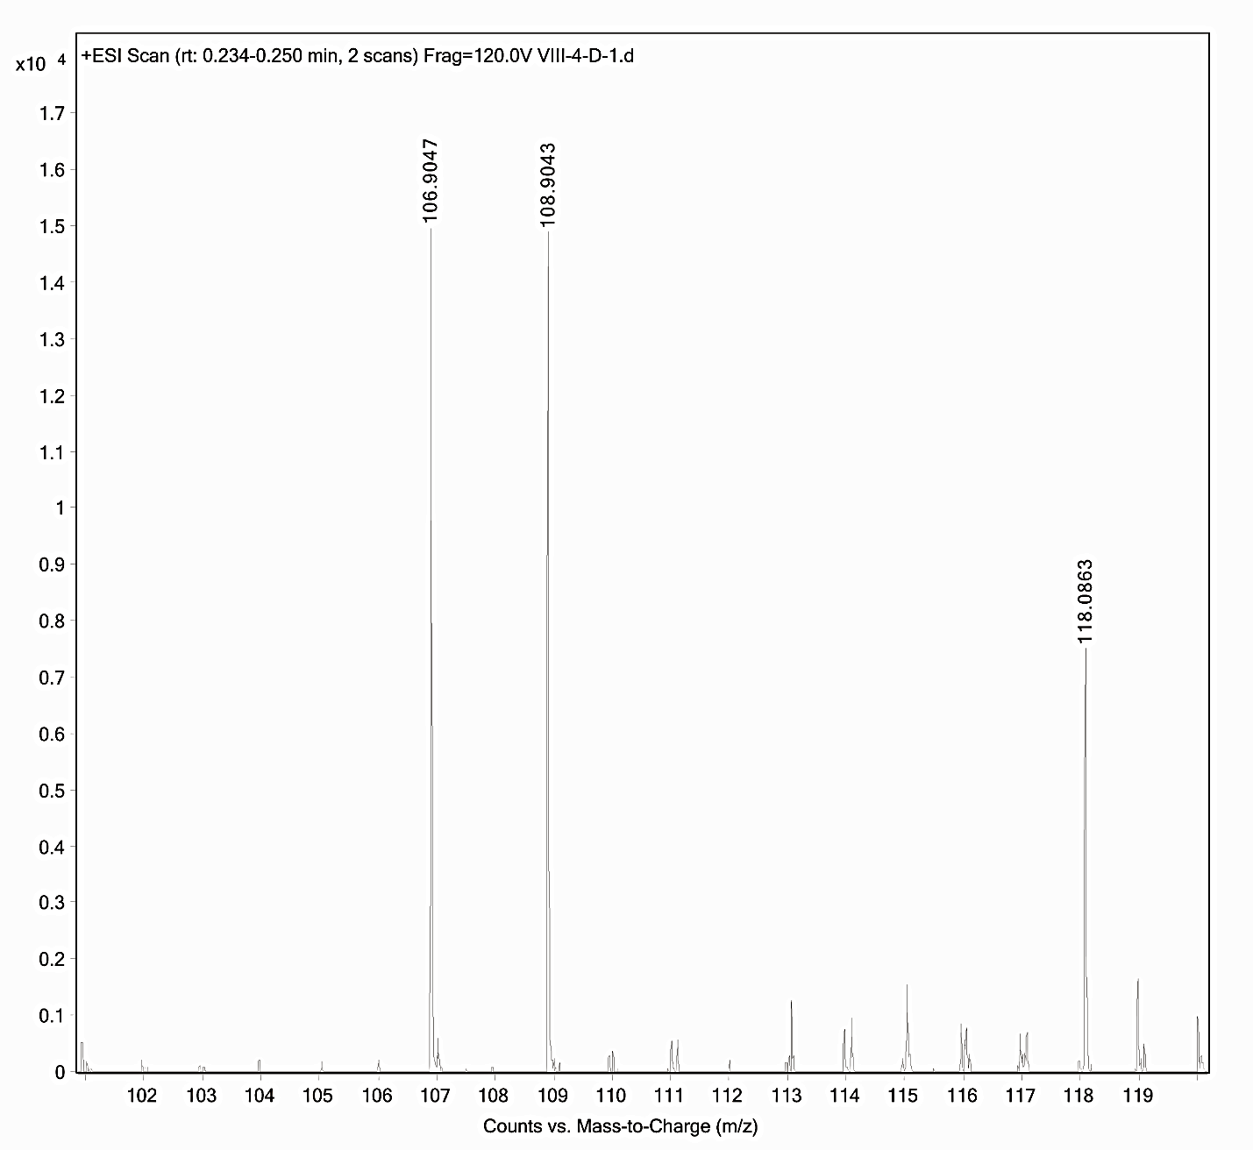
Figure S13. ESI-MS spectrum of control spectrum showing Ag⁺ signals at 106.9047 (100%) and 108.9043 (92.9%).

