Supplementary Information
Extended Data Figure 1
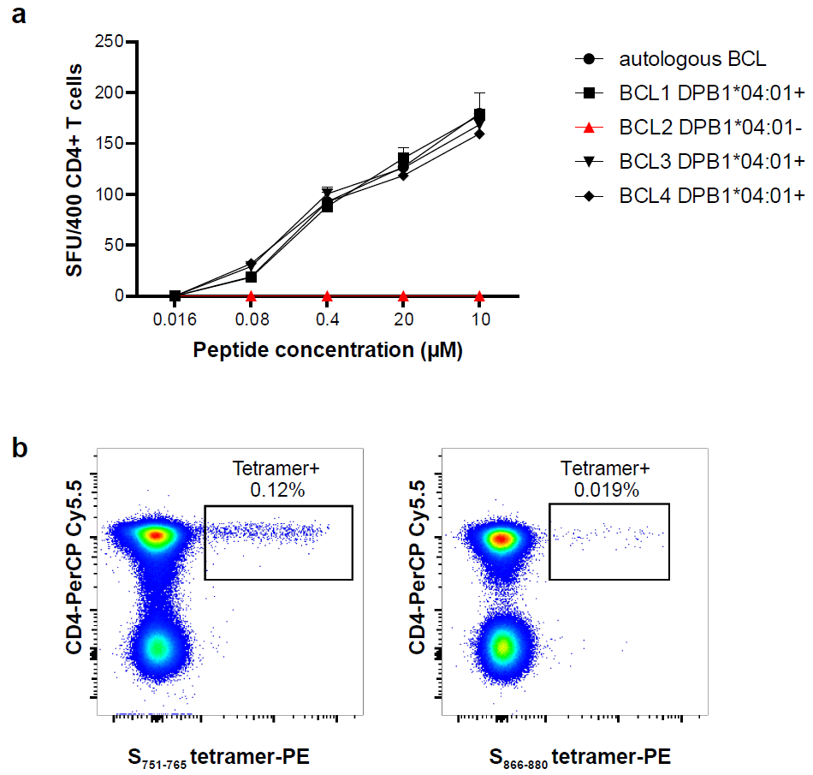
Extended Data Figure 1. HLA-restriction of the three dominant spike epitopes. (a) IFN-γ ELISPOT assay to identify HLA-restriction of S₁₆₆₋₁₈₀. (b) Tetramer-PE staining to confirm S₇₅₁₋₇₆₅ and S₈₆₆₋₈₈₀ HLA-restriction.

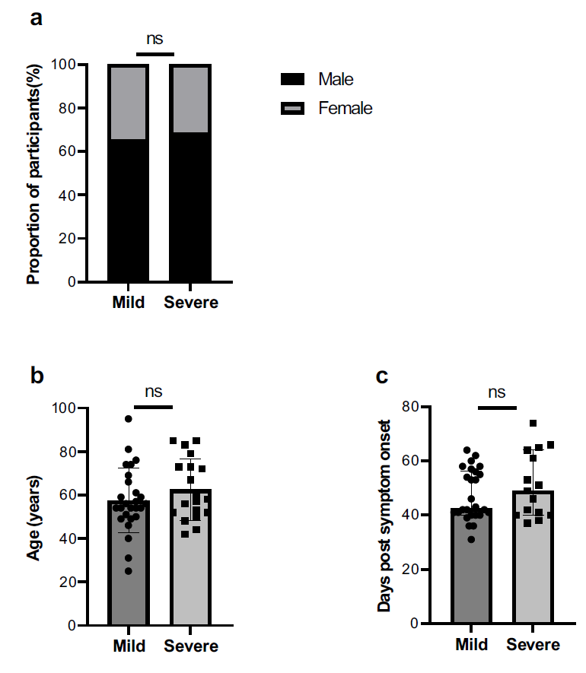
Extended Data Figure 2. Participant characteristics. (a) Proportion of male and female participants. (b) Comparison of age and (c) days post symptom onset when sampling between patient groups with mild and severe symptoms. Chi-square test (a), Independent-sample t test (b) and Mann-Whitney U test (c) was used for analysis. ns, not significant.

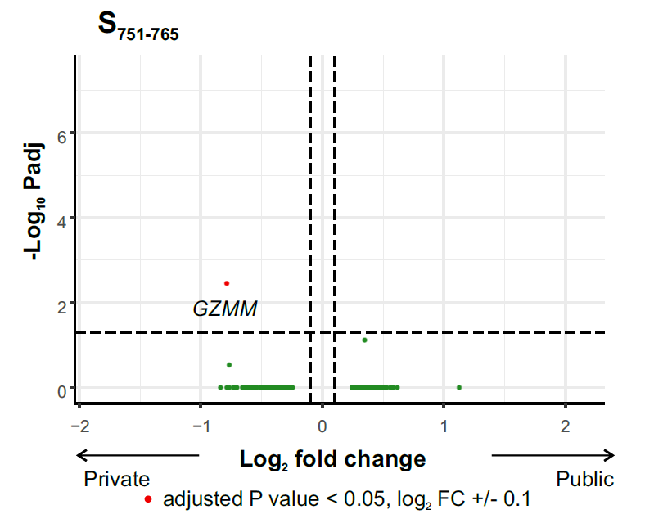
Extended Data Figure 3. Differentially expressed genes between tetramer-sorted S₇₅₁₋₇₆₅-specific T cells with private or public TCR clonotypes (n = 5 patients, 159 public cells, 767 private cells). MAST statistical test was used with sequencing batch as latent variable.

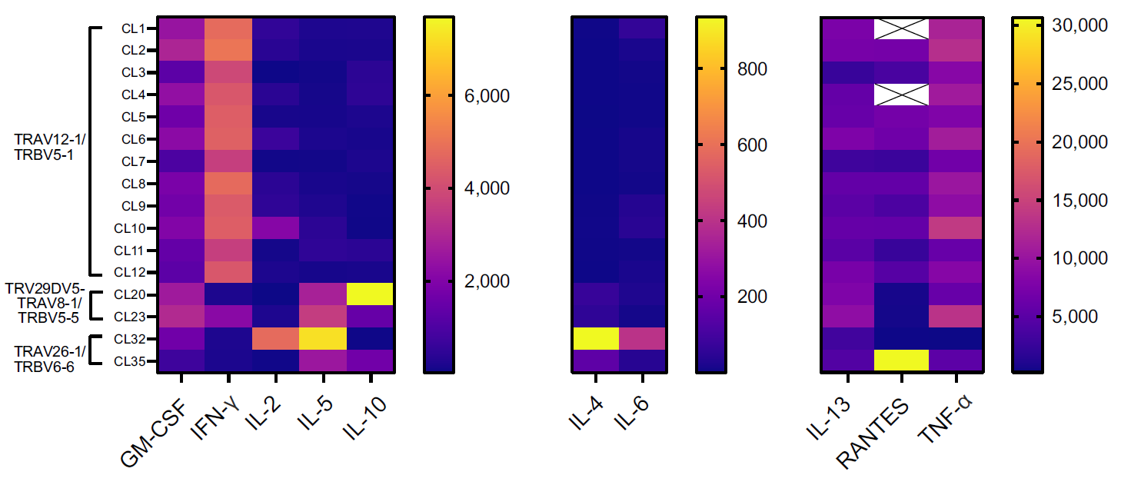
Extended Data Figure 4. Luminex assay. Cytokine expression from groups of T cell clones with identical TCRs.

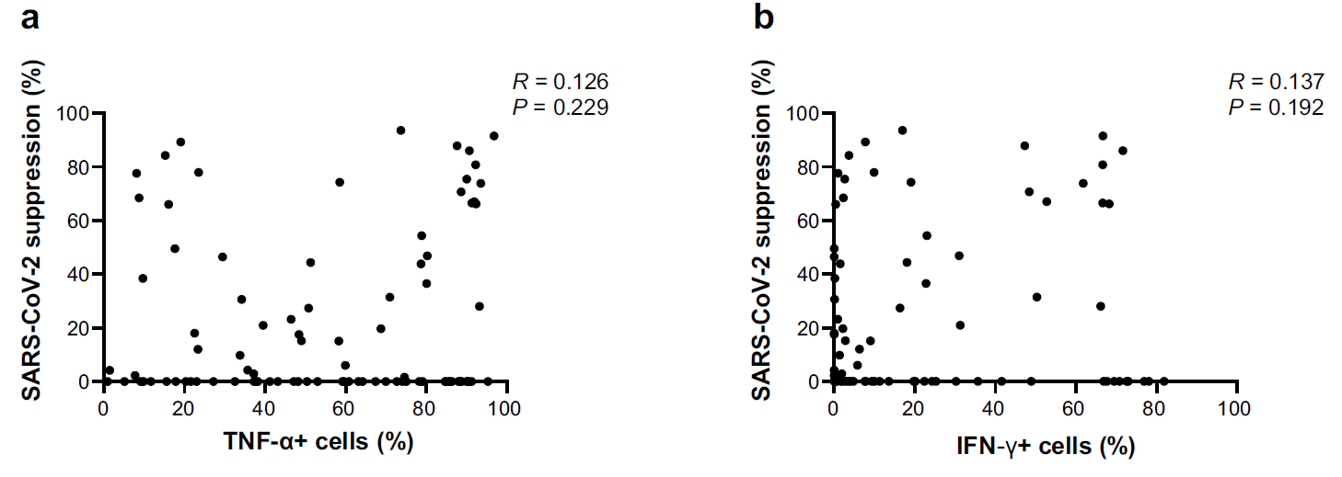
Extended Data Figure 5. Viral suppression and correlation with (a) TNF-α+ cells and (b) IFN-γ+ cells. Correlation analysis was performed using Spearman’s rank correlation coefficient.

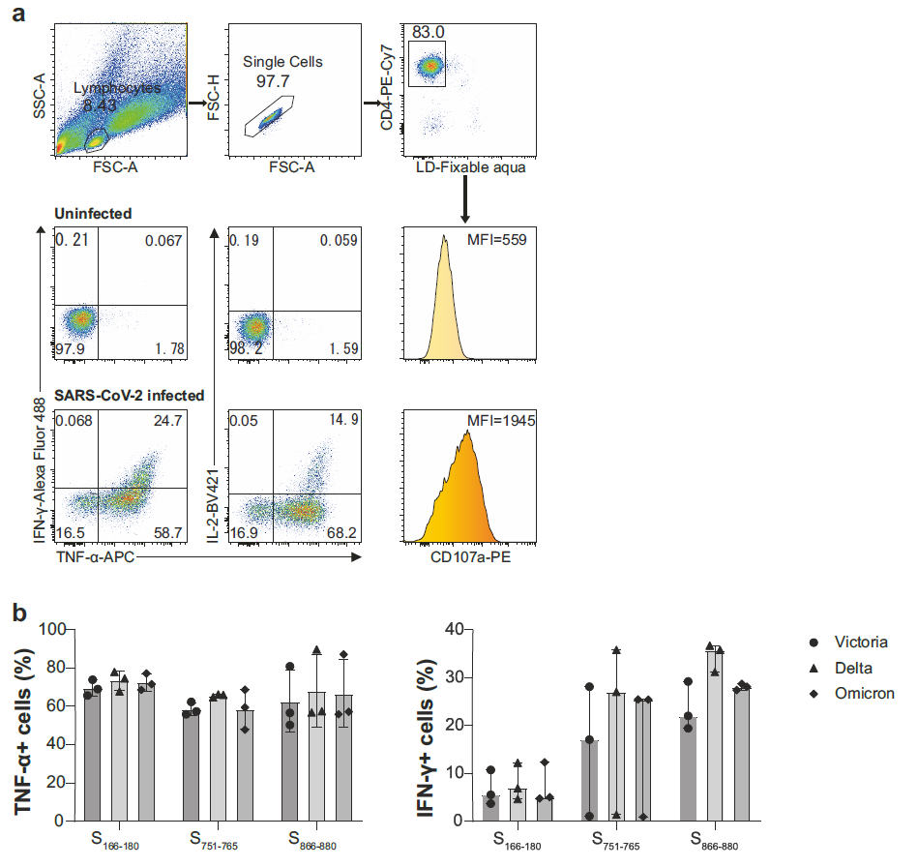
Extended Data Figure 6. Responses of spike-specific T cell bulk lines after incubation with SARS-CoV-2 infected BCLs. (a) The gating strategy of identifying TNF-α, IFN-γ and IL-2 producing cells, and expression intensity of CD107a as well. (b) TNF-α+ and IFN-γ + cell frequency in S₁₆₆₋₁₈₀, S₇₅₁₋₇₆₅ and S₈₆₆₋₈₈₀- specific CD4⁺ T cell bulk lines at 6 - 9 months when cocultured with BCLs infected with SARS-CoV-2 Victoria, Delta or Omicron variants.

Supplementary Table 1. Clinical characteristics of cohort. Oxygen denotes measured oxygen saturation at point of maximal level of oxygen support. For mild patients recruited at home, 94% on air (FiO₂ 21%) was used as an estimate; all other patients were measured.
Supplementary Table 2. T cell receptors for spike-specific T cell clones
Supplementary Table 3. Public clonotypes for each epitope.
Supplementary Table 4. Perforin gene module.

Supplementary Table 3. Public clonotypes for each epitope. α and β clonotypes defined as CDR3 amino acid sequence + V gene; αβ clonotypes defined as CDR3α amino acid sequence + TRAV + CDR3β amino acid sequence + TRBV.
Epitope | CDR3 | V gene | chain | No. of patients
S₁₆₆₋₁₈₀ | CAALNYGGSQGNLIF | TRAV35 | TRA | 4
S₁₆₆₋₁₈₀ | CAAMNYGGSQGNLIF | TRAV35 | TRA | 3
S₁₆₆₋₁₈₀ | CAAQNYGGSQGNLIF | TRAV35 | TRA | 4
S₁₆₆₋₁₈₀ | CAAVNYGGSQGNLIF | TRAV35 | TRA | 2
S₁₆₆₋₁₈₀ | CAGFNYGGSQGNLIF | TRAV35 | TRA | 2
S₁₆₆₋₁₈₀ | CAGKNYGGSQGNLIF | TRAV35 | TRA | 3
S₁₆₆₋₁₈₀ | CAGLLYGGSQGNLIF | TRAV35 | TRA | 2
S₁₆₆₋₁₈₀ | CAGLNYGGSQGNLIF | TRAV35 | TRA | 5
S₁₆₆₋₁₈₀ | CAGMNYGGSQGNLIF | TRAV35 | TRA | 5
S₁₆₆₋₁₈₀ | CAGQLFGGSQGNLIF | TRAV35 | TRA | 3
S₁₆₆₋₁₈₀ | CAGQLYGGSQGNLIF | TRAV35 | TRA | 5
S₁₆₆₋₁₈₀ | CAGQNYGGSQGNLIF | TRAV35 | TRA | 5
S₁₆₆₋₁₈₀ | CAGRNYGGSQGNLIF | TRAV35 | TRA | 4
S₁₆₆₋₁₈₀ | CAGSNYGGSQGNLIF | TRAV35 | TRA | 3
S₁₆₆₋₁₈₀ | CAGVNYGGSQGNLIF | TRAV35 | TRA | 2
S₁₆₆₋₁₈₀ | CAGYNYGGSQGNLIF | TRAV35 | TRA | 2
S₁₆₆₋₁₈₀ | CAPLNYGGSQGNLIF | TRAV35 | TRA | 2
S₁₆₆₋₁₈₀ | CASMNYGGSQGNLIF | TRAV35 | TRA | 3
S₁₆₆₋₁₈₀ | CAVLNYGGSQGNLIF | TRAV35 | TRA | 2
S₁₆₆₋₁₈₀ | CAVMNYGGSQGNLIF | TRAV35 | TRA | 4
S₁₆₆₋₁₈₀ | CAGLLFKAAGNKLTF | TRAV35 | TRA | 2
S₁₆₆₋₁₈₀ | CAGQLFKAAGNKLTF | TRAV35 | TRA | 5
S₁₆₆₋₁₈₀ | CAGQLHKAAGNKLTF | TRAV35 | TRA | 2
S₁₆₆₋₁₈₀ | CAGQLSKAAGNKLTF | TRAV35 | TRA | 2
S₁₆₆₋₁₈₀ | CAGQLYKAAGNKLTF | TRAV35 | TRA | 4
S₁₆₆₋₁₈₀ | CAGQLYRAAGNKLTF | TRAV35 | TRA | 2
S₁₆₆₋₁₈₀ | CAGLNSGGSNYKLTF | TRAV35 | TRA | 3
S₁₆₆₋₁₈₀ | CAGQLSGGSNYKLTF | TRAV35 | TRA | 2
S₁₆₆₋₁₈₀ | CAASGARGAQKLVF | TRAV29/DV5 | TRA | 2
S₁₆₆₋₁₈₀ | CASSFRGDGYTF | TRBV5-1 | TRB | 2
S₁₆₆₋₁₈₀ | CASSPRDRVNTGELFF | TRBV9 | TRB | 2
S₁₆₆₋₁₈₀ | CASSQGVGYTF | TRBV4-1 | TRB | 2
S₁₆₆₋₁₈₀ | CASSYRGAYGYTF | TRBV6-2 | TRB | 2
S₁₆₆₋₁₈₀ | CASSYSGGQPQHF | TRBV6-5 | TRB | 2
S₁₆₆₋₁₈₀ | CAWRGGIGYTF | TRBV30 | TRB | 2
S₇₅₁₋₇₆₅ | CAASIAGSARQLTF | TRAV13-1 | TRA | 2
S₇₅₁₋₇₆₅ | CAASIGGSARQLTF | TRAV13-1 | TRA | 3
S₇₅₁₋₇₆₅ | CAASITGSARQLTF | TRAV13-1 | TRA | 2
S₇₅₁₋₇₆₅ | CAASISGGYNKLIF | TRAV13-1 | TRA | 2
S₇₅₁₋₇₆₅ | CATGGSNYKLTF | TRAV17 | TRA | 3
S₇₅₁₋₇₆₅ | CAVGRYGGSQGNLIF | TRAV2 | TRA | 3
S₇₅₁₋₇₆₅ | CVVNARSSNTGKLIF | TRAV12-1 | TRA | 3
S₇₅₁₋₇₆₅ | CVVNGRSSNTGKLIF | TRAV12-1 | TRA | 5
S₇₅₁₋₇₆₅ | CVVNGVSSNTGKLIF | TRAV12-1 | TRA | 2
S₇₅₁₋₇₆₅ | CVVNKRSSNTGKLIF | TRAV12-1 | TRA | 2
S₇₅₁₋₇₆₅ | CVVNMRSSNTGKLIF | TRAV12-1 | TRA | 3
S₇₅₁₋₇₆₅ | CVVNMYSSNTGKLIF | TRAV12-1 | TRA | 2
S₇₅₁₋₇₆₅ | CVVNIGSSASKIIF | TRAV12-1 | TRA | 2
S₇₅₁₋₇₆₅ | CVVNKGSSASKIIF | TRAV12-1 | TRA | 5
S₇₅₁₋₇₆₅ | CVVNMGSSASKIIF | TRAV12-1 | TRA | 2
S₇₅₁₋₇₆₅ | CVVNKRSSSASKIIF | TRAV12-1 | TRA | 2
S₇₅₁₋₇₆₅ | CVVN RGSSASKIIF | TRAV12-1 | TRA | 3
S₇₅₁₋₇₆₅ | CVVNRGGYQKVTF | TRAV12-1 | TRA | 2
S₇₅₁₋₇₆₅ | CVVNSGGYQKVTF | TRAV12-1 | TRA | 2
S₇₅₁₋₇₆₅ | CVVNTGGYQKVTF | TRAV12-1 | TRA | 2
S₇₅₁₋₇₆₅ | CVVNKGSNYKLTF | TRAV12-1 | TRA | 2
S₇₅₁₋₇₆₅ | CVVNKYSSNTGKLIF | TRAV12-1 | TRA | 2
S₇₅₁₋₇₆₅ | CVVNPKTSYDKVIF | TRAV12-1 | TRA | 2
S₇₅₁₋₇₆₅ | CVVNRGYSTLTF | TRAV12-1 | TRA | 2
S₇₅₁₋₇₆₅ | CVVPTGGGNKLTF | TRAV12-1 | TRA | 2
S₇₅₁₋₇₆₅ | CASSEGAGSQPQHF | TRBV6-1 | TRB | 2
S₇₅₁₋₇₆₅ | CASSEGASNQPQHF | TRBV6-1 | TRB | 4
S₇₅₁₋₇₆₅ | CASSEGPSAQPQHF | TRBV6-1 | TRB | 2
S₇₅₁₋₇₆₅ | CASSSSGGGSYEQYF | TRBV6-5 | TRB | 2
S₇₅₁₋₇₆₅ | CASSTPNRGNNQPQHF | TRBV19 | TRB | 2
S₇₅₁₋₇₆₅ | CASTEGASNQPQHF | TRBV6-1 | TRB | 2
S₈₆₆₋₈₈₀ | CAFMKPVTQGAQKLVF | TRAV38-1 | TRA | 2
S₈₆₆₋₈₈₀ | CAGAGNNRKLIW | TRAV25 | TRA | 4
S₈₆₆₋₈₈₀ | CAGSGNNRKLIW | TRAV25 | TRA | 2
S₈₆₆₋₈₈₀ | CAGTGNNRKLIW | TRAV25 | TRA | 6
S₈₆₆₋₈₈₀ | CAMNGGANSKLTF | TRAV12-3 | TRA | 2
S₈₆₆₋₈₈₀ | CAVAGNNRKLIW | TRAV25 | TRA | 3
S₈₆₆₋₈₈₀ | CGGAGNNRKLIW | TRAV25 | TRA | 2
S₈₆₆₋₈₈₀ | CILRAPLSFGNEKLTF | TRAV26-2 | TRA | 2
S₈₆₆₋₈₈₀ | CIVRAANQAGTALIF | TRAV26-1 | TRA | 3
S₈₆₆₋₈₈₀ | CIVRGANQAGTALIF | TRAV26-1 | TRA | 3
S₈₆₆₋₈₈₀ | CIVRPANQAGTALIF | TRAV26-1 | TRA | 2
S₈₆₆₋₈₈₀ | CIVRGLNAGNMLTF | TRAV26-1 | TRA | 2
S₈₆₆₋₈₈₀ | CIVRVGGSWGKLQF | TRAV26-1 | TRA | 2
S₈₆₆₋₈₈₀ | CIVRVEYNFNKFYF | TRAV26-1 | TRA | 4
S₈₆₆₋₈₈₀ | CIVRVGYNFNKFYF | TRAV26-1 | TRA | 2
S₈₆₆₋₈₈₀ | CIVRVPYNFNKFYF | TRAV26-1 | TRA | 3
S₈₆₆₋₈₈₀ | CIVRVSYNFNKFYF | TRAV26-1 | TRA | 2
S₈₆₆₋₈₈₀ | CIVRVLFGNEKLTF | TRAV26-1 | TRA | 2
S₈₆₆₋₈₈₀ | CIVRVLGGGYNKLIF | TRAV26-1 | TRA | 2
S₈₆₆₋₈₈₀ | CVASGGSNYKLTF | TRAV12-1 | TRA | 2
S₈₆₆₋₈₈₀ | CVVAGGSNYKLTF | TRAV12-1 | TRA | 2
S₈₆₆₋₈₈₀ | CVVNPNARLMF | TRAV12-1 | TRA | 4
S₈₆₆₋₈₈₀ | CVVNRGSNYQLIW | TRAV12-1 | TRA | 2
S₈₆₆₋₈₈₀ | CVVNRGSSYKLIF | TRAV12-1 | TRA | 3
S₈₆₆₋₈₈₀ | CVVSGGSNYKLTF | TRAV12-1 | TRA | 3
S₈₆₆₋₈₈₀ | CASSFGAYGYTF | TRBV12-4 | TRB | 2
S₈₆₆₋₈₈₀ | CASSFGGNYGYTF | TRBV12-4 | TRB | 2
S₈₆₆₋₈₈₀ | CASSFGGNYGYTF | TRBV12-3 | TRB | 3
S₈₆₆₋₈₈₀ | CASSFGGSYGYTF | TRBV12-3 | TRB | 2
S₈₆₆₋₈₈₀ | CASSFGGVYGYTF | TRBV12-3 | TRB | 2
S₈₆₆₋₈₈₀ | CASSLGPNSGNTIYF | TRBV5-1 | TRB | 2
S₈₆₆₋₈₈₀ | CASSLLTGSTDTQYF | TRBV5-1 | TRB | 2
S₈₆₆₋₈₈₀ | CASSLSGLDGYTF | TRBV5-1 | TRB | 2
S₈₆₆₋₈₈₀ | CASSLVSEKLFF | TRBV11-2 | TRB | 2
S₈₆₆₋₈₈₀ | CASSPLANEQFF | TRBV11-2 | TRB | 2
S₈₆₆₋₈₈₀ | CASSPLSNEQFF | TRBV11-2 | TRB | 2
S₈₆₆₋₈₈₀ | CASSPTYEQYF | TRBV11-2 | TRB | 2
S₈₆₆₋₈₈₀ | CASSQTYEQYF | TRBV11-2 | TRB | 2
S₈₆₆₋₈₈₀ | CASSRAYEQYF | TRBV11-2 | TRB | 3
S₈₆₆₋₈₈₀ | CASSRLYEQYF | TRBV11-2 | TRB | 2
S₈₆₆₋₈₈₀ | CASSRSYEQYF | TRBV11-2 | TRB | 2
S₈₆₆₋₈₈₀ | CASSRTYEQYF | TRBV11-2 | TRB | 3
S₈₆₆₋₈₈₀ | CASSSTYEQYF | TRBV11-2 | TRB | 3
S₈₆₆₋₈₈₀ | CASSQVAAEQFF | TRBV3-1 | TRB | 2
S₈₆₆₋₈₈₀ | CASSQVAGEQYF | TRBV3-1 | TRB | 3

Epitope | CDR3α | TRAV | CDR3β | TRBV | No of patients
S₁₆₆₋₁₈₀ | CAGMNYGGSQGNLIF | TRAV35 | CASSQGVGYTF | TRBV4-1 | 2
S₁₆₆₋₁₈₀ | CAGMNYGGSQGNLIF | TRAV35 | CASSYRGAYGYTF | TRBV6-2 | 2
S₁₆₆₋₁₈₀ | CAGMNYGGSQGNLIF | TRAV35 | CAWRGGIGYTF | TRBV30 | 2
S₁₆₆₋₁₈₀ | CAGQLYGGSQGNLIF | TRAV35 | CASSFRGDGYTF | TRBV5-1 | 2
S₁₆₆₋₁₈₀ | CAGQLYGGSQGNLIF | TRAV35 | CASSYSGGQPQHF | TRBV6-5 | 2
S₇₅₁₋₇₆₅ | CVVNKGSSASKIIF | TRAV12-1 | CASSEGASNQPQHF | TRBV6-1 | 4
S₈₆₆₋₈₈₀ | CAGTGNNRKLIW | TRAV25 | CASSFGAYGYTF | TRBV12-4 | 2
S₈₆₆₋₈₈₀ | CAGTGNNRKLIW | TRAV25 | CASSFGGNYGYTF | TRBV12-3 | 2
S₈₆₆₋₈₈₀ | CAMNGGANSKLTF | TRAV12-3 | CASSLGPNSGNTIYF | TRBV5-1 | 2
S₈₆₆₋₈₈₀ | CAVAGNNRKLIW | TRAV25 | CASSQVGAGTDTQYF | TRBV4-3 | 2
S₈₆₆₋₈₈₀ | CIVRAANQAGTALIF | TRAV26-1 | CASSQVAGEQYF | TRBV3-1 | 3
S₈₆₆₋₈₈₀ | CIVRGANQAGTALIF | TRAV26-1 | CASSQVAAEQFF | TRBV3-1 | 2
S₈₆₆₋₈₈₀ | CIVRVEYNFNKFYF | TRAV26-1 | CASSPLANEQFF | TRBV11-2 | 2
S₈₆₆₋₈₈₀ | CIVRVEYNFNKFYF | TRAV26-1 | CASSPLSNEQFF | TRBV11-2 | 2
S₈₆₆₋₈₈₀ | CIVRVSYNFNKFYF | TRAV26-1 | CASSLVSEKLFF | TRBV11-2 | 2
S₈₆₆₋₈₈₀ | CVVNRGSSYKLIF | TRAV12-1 | CASSQTYEQYF | TRBV11-2 | 2
S₈₆₆₋₈₈₀ | CVVNRGSSYKLIF | TRAV12-1 | CASSRAYEQYF | TRBV11-2 | 2
S₈₆₆₋₈₈₀ | CVVSGGSNYKLTF | TRAV12-1 | CASSRLYEQYF | TRBV11-2 | 2

Supplementary Table 4. Perforin gene module. Perforin and interacting genes taken from STRING (https://string-db.org/)
Gene symbol | Gene name
PRF1 | Perforin
SRGN | Serglycin
GZMB | Granzyme B
NKG7 | Natural killer cell granule protein 7
GZMH | Granzyme H
GNLY | Granulysin
GZMA | Granzyme A
CD8A | CD8
FASLG | Fas ligand
CD4 | CD4
KLRK1 | NKG2D

