Supplementary Information for

Sustainable oxygen evolution electrocatalysis in aqueous 1 M H₂SO₄
with earth abundant, nanostructured Co₃O₄
Jiahao Yu,^{1,2} Felipe A. Garcés-Pineda,¹ Jesús González-Cobos,^{1,9} Marina Peña-Díaz,³ Celia Rogero,³ Sixto Giménez,⁴ Maria Chiara Spadaro,⁵ Jordi Arbiol,^{5,6} Sara Barja,^{7,8*} and José Ramón Galán-Mascarós^{1,6*}
¹Institute of Chemical Research of Catalonia (ICIQ), The Barcelona Institute of Science and Technology (BIST), Av. Països Catalans 16, 43007 Tarragona, Spain.

²Departament de Química Física i Inorgànica, Universitat Rovira i Virgili, Marcel. lí Domingo 1, 43007 Tarragona, Spain.

³Centro de Física de Materiales, CFM/MPC(UPV/EHU-CSIC), 20018 San Sebastián, Spain.

⁴Institute of Advanced Materials (INAM), Universitat Jaume I, 12006 Castelló,

⁵Catalan Institute of Nanoscience and Nanotechnology (ICN2), CSIC and BIST, Campus UAB, Bellaterra, 08193 Barcelona, Catalonia, Spain

⁶ICREA, Passeig Lluis Companys, 23, 08010 Barcelona, Spain.

⁷Departamento de Polímeros y Materiales Avanzados: Física, Química y Tecnología, Centro de Física de Materiales, University of the Basque Country UPV/EHU, 20018 San Sebastián, Spain

⁸Donostia International Physics Center, 20018 San Sebastián, Spain.

⁹Present affiliation: Institut de Recherches sur la Catalyse et l’Environnement de Lyon, UMR 5256, CNRS, Université Claude Bernard Lyon 1, 2 Avenue A. Einstein, 69626 Villeurbanne, France

*Correspondence to: sara.barja@ehu.eus; jrgalan@iciq.es

Figure S1. PXRD patterns of as-synthesized ZIF-9 (red) and the one by Yaghi’s group¹ (black).

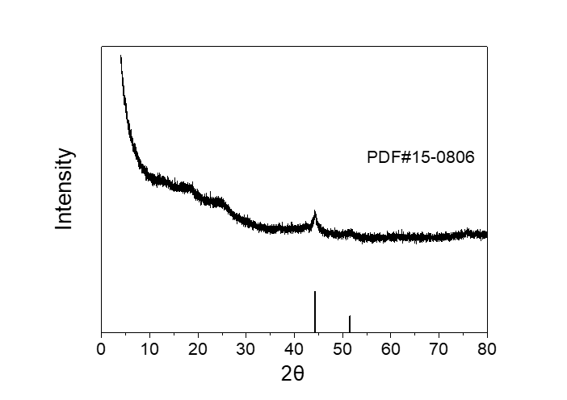
Figure S2. PXRD pattern for Co@C.

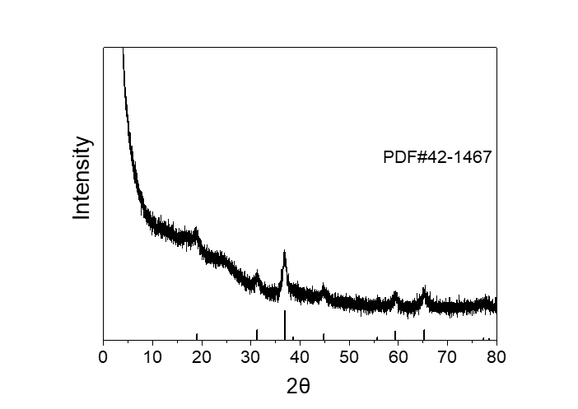
Figure S3. PXRD pattern for Co₃O₄@C.

Figure S4. Raman spectrum for Co₃O₄@C.

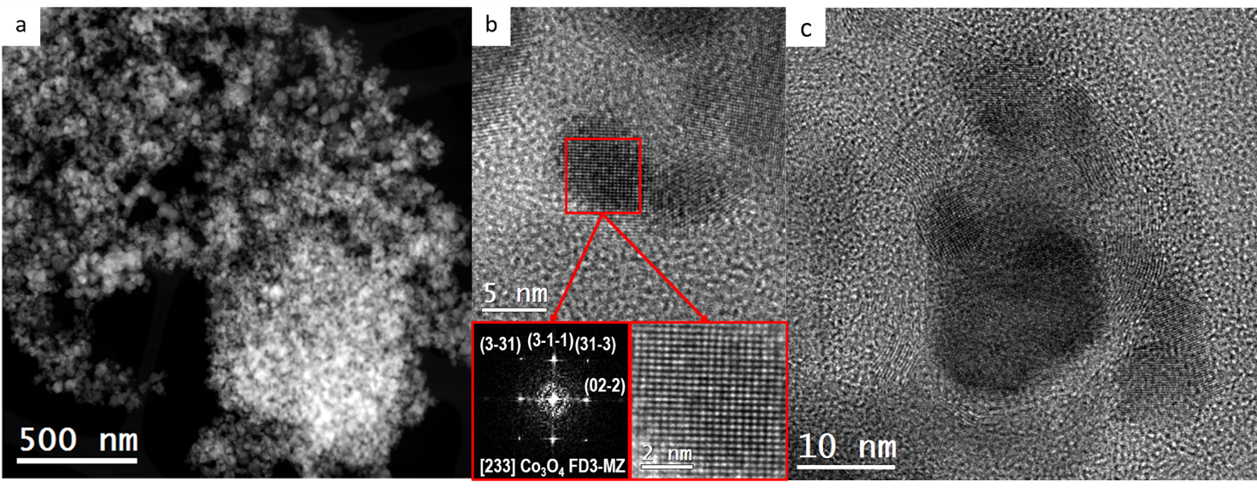
Figure S5. Low mag HAADF STEM and HRTEM images for as-prepared Co₃O₄@C together with the power spectrum analysis.
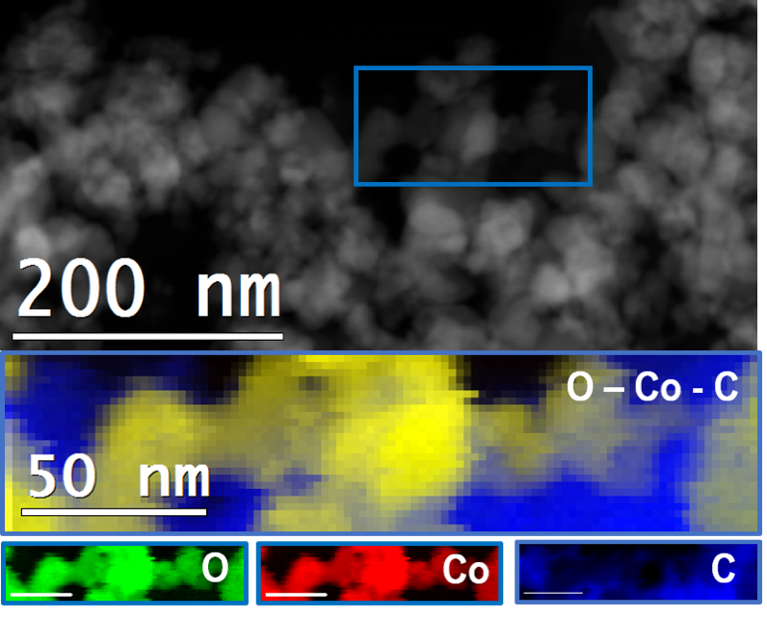
Figure S6. STEM-EELS elemental mapping for the as-prepared Co₃O₄@C.

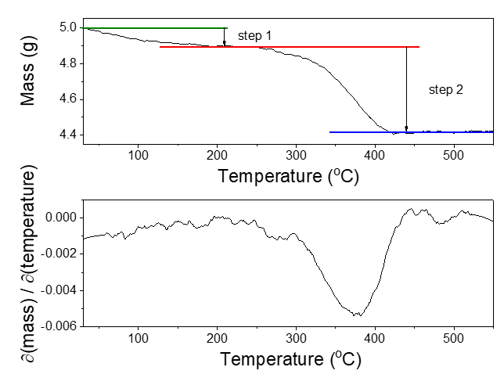
Figure S7. TGA curves of Co₃O₄@C with the heating rate of 10 °C min⁻¹ in air. The step 1 shows the loss of water whose amount is 1.9 wt% while step 2 indicates the loss of carbon, nitrogen or other unstable species and further oxidation of Co₃O₄ to Co₂O₃ at the same time.

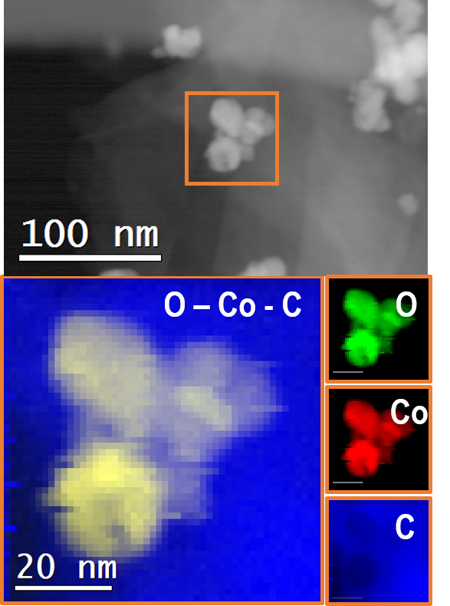
Figure S8. STEM-EELS elemental mapping for Co₃O₄@C/GPO.

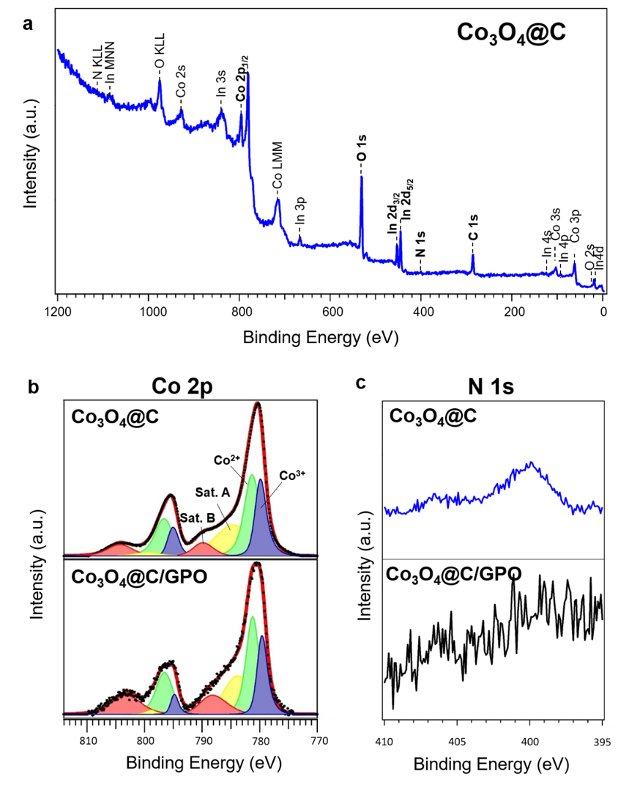
Figure S9. Chemical XPS characterization. (a) Overview spectrum of Co₃O₄@C catalyst with all the relevant core-levels attributed to the electrode composition (Co, O, N and C). No additional elements are identified, supporting the absence of cross-contamination of the catalyst. Indium (In) presence is justified since the samples were deposited onto and In tape for XPS measurement. (b) Co 2p XPS peak of the Co₃O₄@C (upper) and Co₃O₄@C/GPO (bottom) samples. No compositional changes are observed due to composite preparation. (c) N 1s XPS spectra of Co₃O₄@C (upper) and Co₃O₄@C/GPO (bottom) samples. Nitrogen detection in the system is below our resolution limit when the electrode composite is prepared.
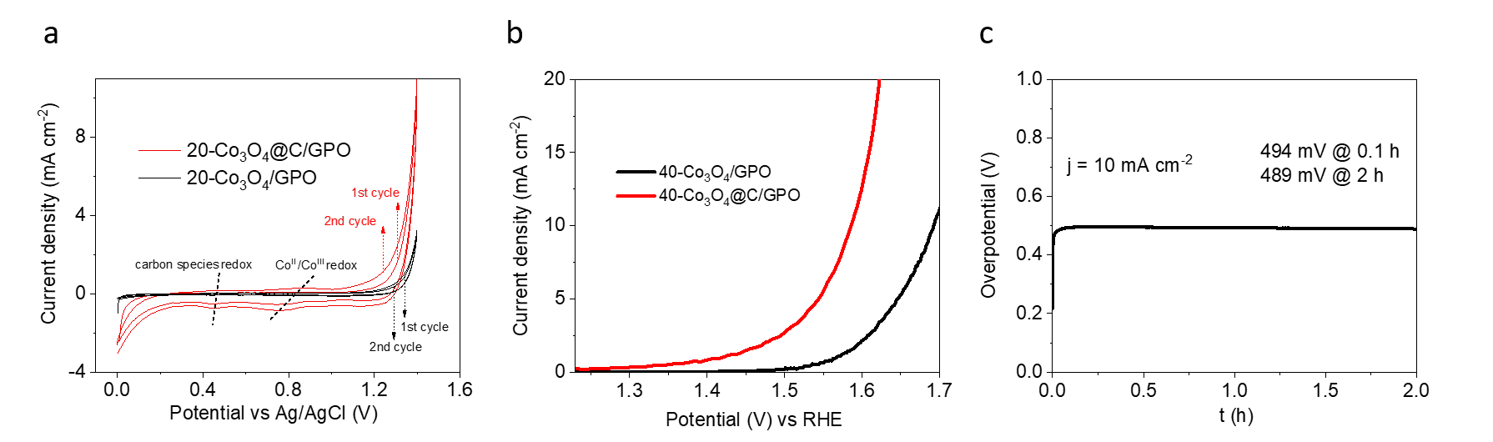
Figure S10. (a) CV curves of 20-Co₃O₄@C/GPO and 20-Co₃O₄/GPO, respectively. (b) LSV curves of 40-Co₃O₄@C/GPO and 40-Co₃O₄/GPO in 1 M H₂SO₄ electrolyte and (c) stability in chronopotentiometry measurements at 10 mA cm⁻² of 40-Co₃O₄/GPO.

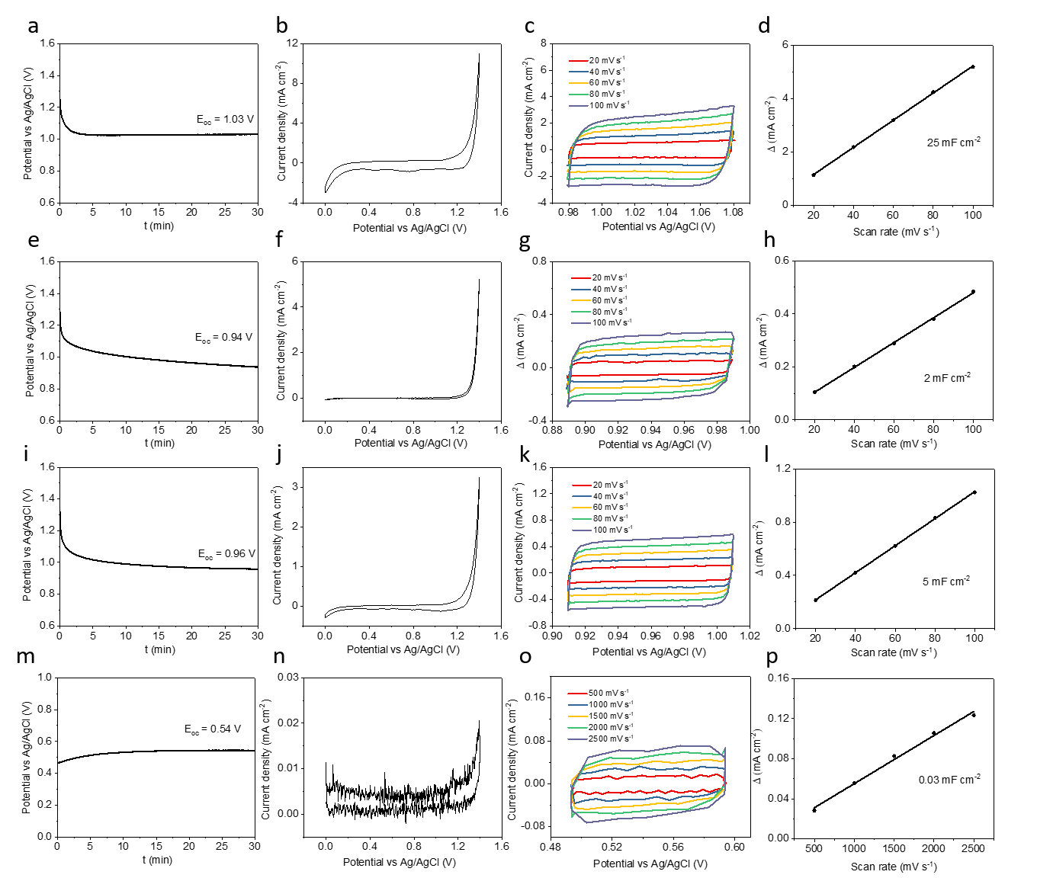

Figure S11. Electrochemical double-layer capacitance (EDLC) measurements: OCP (vs Ag/AgCl) values recording within 30 mins of (a) 20-Co₃O₄@C/GPO, (e) 20-IrO₂/GPO, (i) 20-Co₃O₄/GPO and (m) GPO; CV curves under 10 mV s⁻¹ scan rate of (b) 20-Co₃O₄@C/GPO, (f) 20-IrO₂/GPO, (j) 20-Co₃O₄/GPO and (n) GPO; CV curves under different scan rates of (c) 20-Co₃O₄@C/GPO, (g) 20-IrO₂/GPO, (k) 20-Co₃O₄/GPO and (o) GPO; The scan rate dependences of the current density differences Δ of (d) 20-Co₃O₄@C/GPO, (h) 20-IrO₂/GPO, (l) 20-Co₃O₄/GPO and (p) GPO. Note: the current density for GPO electrode under 100 mV s^{–1} was very low and hardly detected so higher scan rates (from 500 to 2500 mV mV s^{–1}) were used to obtain clear value for EDLC determination.
Figure S12. Time evolution of oxygen production rate in the cell headspace during a chronopotentiometry at 1.4 mA for 2 hours, using 3.3 mL min^{–1} of Ar stream as sweep gas at 20 ºC and 1 atm. Once the chronopotentiometry starts, the O2 signal rapidly increases, reaching a 3.6 nmol s⁻¹ production of O₂ in steady state conditions (reached after 1 hour of operation). This corresponds to a 99% Faradaic efficiency. After the chronopotentiometry, the oxygen signal rapidly decreases, as the chamber is purged with Ar. Integration of all the O₂ detected over time, yields a total of 24.9 µmol of O₂ that corresponds to ≥ 96% of Faradaic efficiency.

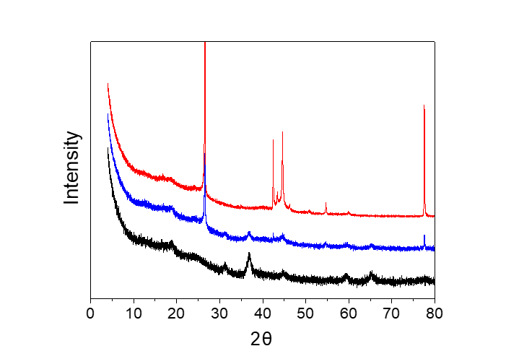
Figure S13. PXRD patterns of Co₃O₄@C (black), Co₃O₄@C after 2h catalysis, washed with acetone to remove paraffin oil (blue) and commercial graphite (red).

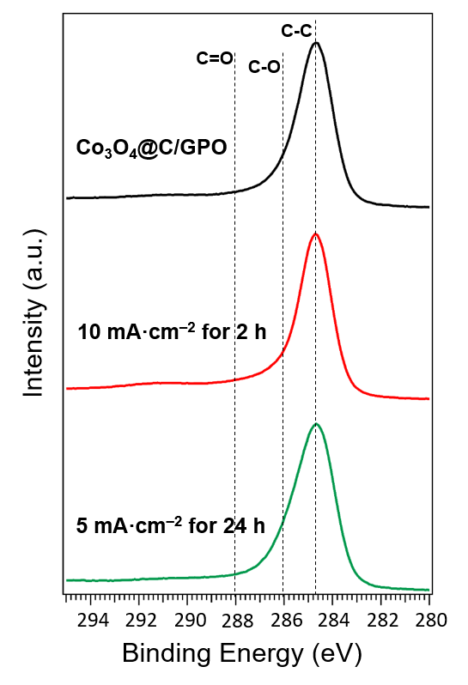
Figure S14. C1s XPS spectrum of Co₃O₄@C/GPO (black), Co₃O₄@C/GPO after 2h of electrolysis at 10 mA·cm⁻² (red) and Co₃O₄@C/GPO after 24h of electrolysis at 5mA·cm⁻² (green).
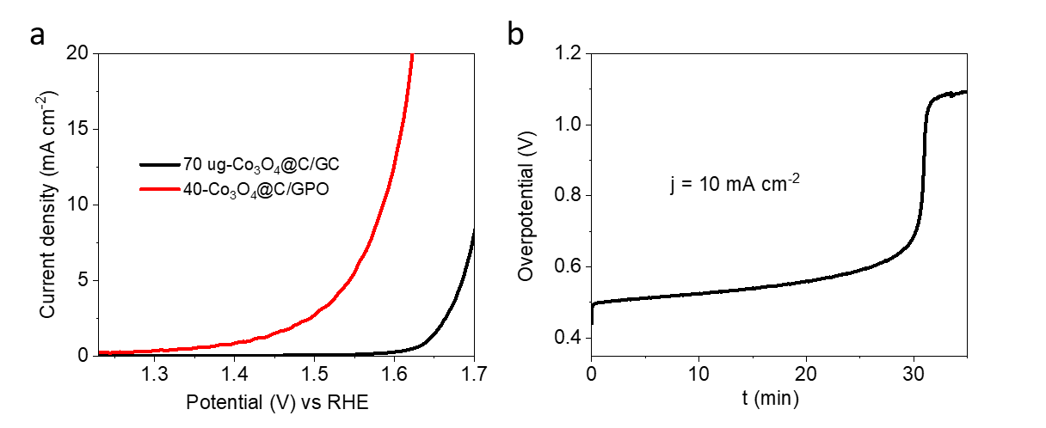
Figure S15. (a) LSV curves of 40-Co₃O₄@C/GPO and 70 ug-Co₃O₄@C/GC in 1 M H₂SO₄ electrolyte. (b) Chronopotentiometry measurement of 70 ug-Co₃O₄@C/GC at 10 mA cm⁻².
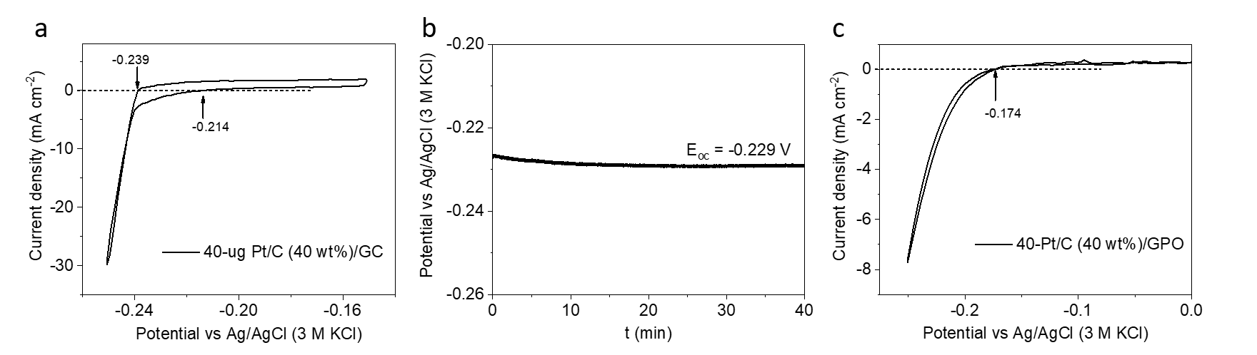
Figure S16. (a) Calibration of the actual value of the potential of the Ag/AgCl (3 M KCl) vs. the reversible hydrogen electrode (RHE) by using a hydrogen electrode reaction with 40 ug-Pt/C (40 wt%)/GC, the Ag/AgCl electrode as the reference electrode, and carbon rod as the counter electrode in a hydrogen-saturated 1 M H₂SO₄ electrolyte. (b) OCP value recording. (c) CV curve of 40-Pt/C (40 wt%)/GPO with 10 mV s^{–1} scan rate.

Figure S17. Adsorption and desorption isotherms of Co₃O₄@C and Co₃O₄.
Figure S18. Nyquist plots from EIS data for Co₃O₄@C/GPO, Co₃O₄/GPO and IrO₂/GPO electrodes at different applied potentials (a) 1.53 V vs RHE, (b) 1.58 V vs RHE and (c) 1.63 V vs RHE. The equivalent circuit model employed to fit the data is also showed as an inset in the right panel (c).

Figure S19. Fitted parameters from the EIS analysis: (a) Series resistance, R_{s}, (b) Charge transfer resistance, R_{ct} and (c) Surface capacitance, C_{S}.

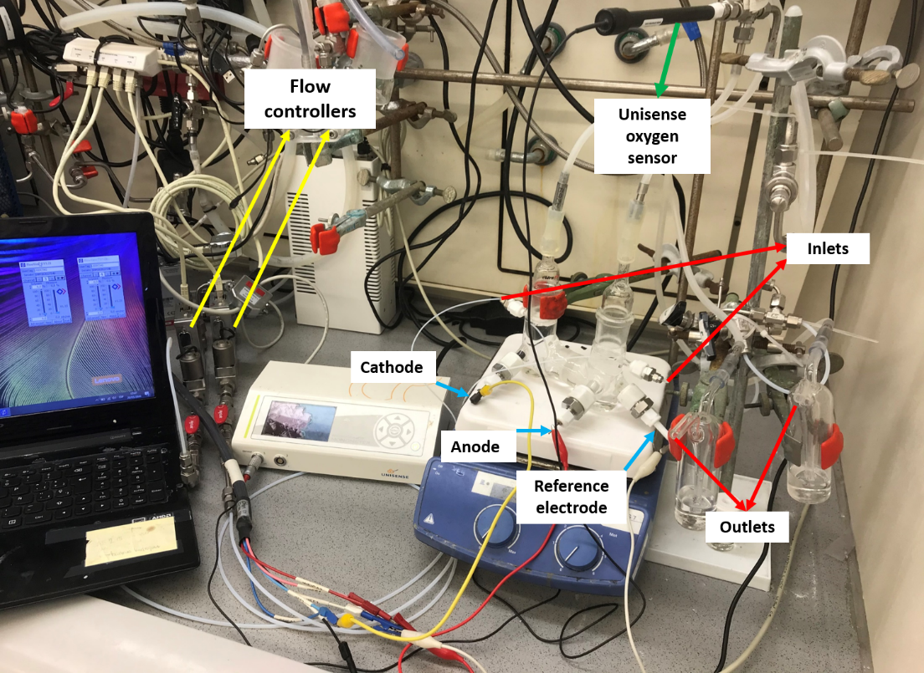
Figure S20. Setup for oxygen evolution measurement. It includes an H-type cell containing the Co₃O₄@C/GPO anode, carbon cathode and Ag/AgCl (3 M KCl) reference electrode connected to the potentiostat, the Unisense oxygen sensor connected to the anodic side headspace and the gas flow controlling system employed to feed Ar carrier gas to the cell.

Table S1. The actual ratios of carbon, nitrogen, hydrogen and cobalt determined by elemental analysis.
 | Carbon (wt%) | Nitrogen (wt%) | Hydrogen (wt%) | Cobalt (wt%)
Co₃O₄@C | 8.28 | 0.26 | 0.47 | 62

Table S2. OER activity for working electrodes from LSV curves in 1 M H₂SO₄ (pH 0.3).
 | η (mV)  @ 1 mA cm^{–2} | η (mV)  @ 5 mA cm^{–2} | η (mV)  @ 10 mA cm^{–2} | η (mV)  @ 20 mA cm^{–2}
40-Co₃O₄@C/GPO | 190 | 313 | 356 | 393
40-IrO₂/GPO | 291 | 344 | 368 | 396

Table S3. Elemental analysis (ICP-MS) of cobalt before and after 2 h electrocatalytic water oxidation at a constant current density of 10 mA cm⁻² in 1 M H₂SO₄ of 40 mL.
 | Cobalt amount (μg/L)
1 M H₂SO₄ before | –
1 M H₂SO₄ after | 756

Table S4. Performance parameters for different electrocatalysts for OER in strong acidic electrolytes.
Catalyst | Electrolyte  [H₂SO₄] | Scan rate  (mV s⁻¹) | η (mV) @  10 mA cm^{–2} | Tafel slope (mV dec⁻¹) | Stability | loading  (mg cm^{–2}) | ref.
Co₃O₄@C/GPO | 1 M | 1 | 356 |  | 43 h  @ 10 mA cm^{–2} | 20 | this work
[Co-POM]/CP | 1 M | 1 | 361 | 97 | 24 h  @ η = 250 mV | 20 | 2
IrO₂ | 1 M | 1 | 458 | 66 | 24 h  @ η = 250 mV | 26 | 2
ATO/CoHFe | 0.1 M | 50 | 770 | ~ | ~ | 0.61 | 3
IrO₂/SrIrO₃ | 0.5 M | 10 | 280 | ~ | 30 h  @ 10 mA cm^{–2} | ~ | 4
CoFePbO_{x} | 1 M | ~ | 620 | ~ | 12 h  @ 2.03 V | ~ | 5
MnO₂ | 0.1 M | 1 | 428 | 80 | 8000 h  @ 10 mA cm^{–2} | 36 | 6
Ni_{0.5}Mn_{0.5}Sb_{1.7}O_{x} | 1 M | 10 | 672 | 60 | 168 h  @ 10 mA cm^{–2} | ~0.18 | 7
Co_{0.05}Fe_{0.95}O_{y} | 0.5 M | 10 | 650 | 110 | 50 h  @ 10 mA cm⁻² | 1 | 8
Mn_{x}Sb_{1-x}O_{z} | 1 M | 20 | 508 | 75 | 2 h  @ 10 mA cm^{–2} | ~ | 9
Co₃O₄/FTO | 0.5 M | 2 | 490 | 80 | 12 h  @ 10 mA cm^{–2} | ~ | 10
W_{0.57}Ir_{0.43}O_{3-δ} | 1 M | 20 | 370 | 125 | 2000 s  @ 10 mA cm^{–2} | ~ | 11
Ti-MnO₂ | 0.05 M | 5 | ~540ª | 170 | 2 h  @ 1.9 V | ~ | 12
Ni₄₀Fe₄₀P₂₀ | 0.05 M | 5 | 540 | - | 30 h  @ 10 mA cm^{–2} | ~ | 13
c-Fe₂O₃ | 0.5 M | 10 | 650 | 56 | 24 h  @ 10 mA cm^{–2} | 1 | 14
P-NSC/  Ni₄Fe₅S₈-1000 | 0.5 M | 2 | ~560 | 72 | 10000 cycles  @ 1 mA cm^{–2} | 0.4 | 15
Y_{1.85}Zn_{0.15}Ru₂O_{7-δ} | 0.5 M | 10 | 291 | 37 | 2000 cycles  @ 1.55 V | 3 | 16
1T-MoS₂ | 0.5 M | 5 | 420 | 322 | 2 h  @ 10 mA cm^{–2} | 1 | 17
ª@ 2 mA cm⁻²

Table S5. Ohmic drop values determined by the automatic current interrupt (CI) software and actual mass of catalysts in working electrodes.
 | 40-Co₃O₄@C/GPO | 30-Co₃O₄@C/GPO | 20-Co₃O₄@C/GPO | 40-IrO₂/GPO | 30-IrO₂/GPO | 20-IrO₂/GPO
Ohmic drop (Ω) | 19 | 37 | 27 | 25 | 28 | 25
Total electrode mass (mg)* | 39.9 | 39.1 | 40.7 | 47.7 | 45.2 | 43.8
Total mass of Co₃O₄@C in the electrode (mg)* | 11 | 9 | 7 | 14 | 10 | 7
*total mass of the composite: Co₃O₄@C + graphite + paraffin oil; 1/8 of total mass is used for activity comparison as suggested by Ref.2.

References
- K. S. Park, Z. Ni, A. P. Côté, J. Y. Choi, R. Huang, F. J. Uribe-Romo, H. K. Chae, M. O’Keeffe and O. M. Yaghi, Proc. Natl. Acad. Sci. U. S. A. 2006, 103, 10186–10191.
- M. Blasco-Ahicart, J. Soriano-Lopez, J. J. Carbo, J. M. Poblet and J. R. Galan-Mascaros, Nat. Chem., 2018, 10, 24–30.
- B. Rodríguez-García, Á. Reyes-Carmona, I. Jiménez-Morales, M. Blasco-Ahicart, S. Cavaliere, M. Dupont, D. Jones, J. Rozière, J. R. Galán-Mascarós and F. Jaouen, Sustain. Energy Fuels, 2018, 2, 589–597.
- L. C. Seitz, C. F. Dickens, K. Nishio, Y. Hikita, J. Montoya, A. Doyle, C. Kirk, A. Vojvodic, H. Y. Hwang, J. K. Norskov and T. F. Jaramillo, Science, 2016, 353, 1011–1014.
- M. Chatti, J. L. Gardiner, M. Fournier, B. Johannessen, T. Williams, T. R. Gengenbach, N. Pai, C. Nguyen, D. R. MacFarlane, R. K. Hocking and A. N. Simonov, Nat. Catal., 2019, 2, 457–465.
- A. Li, H. Ooka, N. Bonnet, T. Hayashi, Y. Sun, Q. Jiang, C. Li, H. Han and R. Nakamura, Angew. Chemie - Int. Ed., 2019, 58, 5054–5058.
- I. A. Moreno-Hernandez, C. A. Macfarland, C. G. Read, K. M. Papadantonakis, B. S. Brunschwig and N. S. Lewis, Energy Environ. Sci., 2017, 10, 2103–2108.
- W. L. Kwong, C. C. Lee, A. Shchukarev and J. Messinger, Chem. Commun., 2019, 55, 5017–5020.
- L. Zhou, A. Shinde, J. H. Montoya, A. Singh, S. Gul, J. Yano, Y. Ye, E. J. Crumlin, M. H. Richter, J. K. Cooper, H. S. Stein, J. A. Haber, K. A. Persson and J. M. Gregoire, ACS Catal., 2018, 8, 10938–10948.
- J. S. Mondschein, J. F. Callejas, C. G. Read, J. Y. C. Chen, C. F. Holder, C. K. Badding and R. E. Schaak, Chem. Mater., 2017, 29, 950–957.
- S. Kumari, B. P. Ajayi, B. Kumar, J. B. Jasinski, M. K. Sunkara and J. M. Spurgeon, Energy Environ. Sci., 2017, 10, 2432–2440.
- R. Frydendal, E. A. Paoli, I. Chorkendorff, J. Rossmeisl and I. E. L. Stephens, Adv. Energy Mater., 2015, 5, 1500991.
- F. Hu, S. Zhu, S. Chen, Y. Li, L. Ma, T. Wu, Y. Zhang, C. Wang, C. Liu, X. Yang, L. Song, X. Yang and Y. Xiong, Adv. Mater., 2019, 29, 1606570.
- W. L. Kwong, C. C. Lee, A. Shchukarev, E. Bjorn, J. Messinger, J. Catal., 2018, 365, 29-35.
- Q. Hu, G. Li, X. Liu, B. Zhu, G. Li, L. Fan, X. Chai, Q. Zhang, J. Liu, C. He, J. Mater. Chem. A, 2019, 7, 461–468.
- Q. Feng, Q. Wang, Z. Zhang, Y. Xiong, H. Li, Y. Yao, X.-Z. Yuan, M. C. Willams, M. Gu, H. Chen, H. Li, H. Wang, Appl. Catal. B, 2019, 224, 494-501.
- J. Wu, M. Liu, K. Chatterjee, K. P. Hackenberg, J. Shen, X. Zou, Y. Yan, J. Gu, Y. Yang, J. Lou, P. M. Ajayan, Adv. Mater. Interfaces, 2016, 3, 1500669.

