Table S1 Physicochemical characteristics of the soil used in the present pot experiment
Soil texture | Sand | Silt | Clay | OM* | N |  | Cu-DTPA** |  | Mn-DTPA |  | Zn-DTPA |  | K |  | P-Olsen |  | Fe | EC |  |  | pH
Clay- loam | % |  |  |  |  |  | mg/kg |  |  |  |  |  |  |  |  |  |  | dS/m |  |  | -
Clay- loam | 29 | 32 | 39 | 0.91 | 0.14 |  |  | 0.938 |  | 4.338 |  | 0.236 |  | 53 |  | 8 | 4.62 | 1.39 |  |  | 7.94
*OM stands for organic matter
**diethylenetriaminepentaacetic acid

Table S2 Root area and diameter variation under drought stress, Si application and mycorrhiza inoculation interactions in examined Licorice plants
Treatment | Root area (cm²) |  |  |  | Root diameter (mm)
Treatment | Si0 |  | Si1 |  | Si0 |  | Si1
Treatment | F0 | F1 | F0 | F1 | F0 | F1 | F0 | F1
W100 | 75.09^{ab}±2.61 | 88.12ª±1.26 | 71.24^{d}±1.11 | 150.64ª±1.31 | 16.33^{abc}±0.71 | 15.95^{ab}±0.85 | 18.08^{ab}±0.86 | 18.97ª±1.63
W80 | 63.75^{b}±2.43 | 68.65^{ab}±5.17 | 87.92^{b}±2.24 | 98.45^{b}±1.81 | 18.46^{ab}±1.17 | 19.45ª±1.73 | 18.77ª±1.21 | 16.66^{ab}±1.13
W60 | 85.19ª±8.62 | 90.01ª±6.57 | 79.52^{c}±1.02 | 80.14^{c}±6.39 | 18.91ª±0.78 | 15.52^{ab}±1.52 | 15.77^{ab}±1.67 | 19.98ª±1.28
W40 | 67.73^{ab}±2.67 | 56.14^{bc}±6.41 | 113.36ª±1.35 | 55.39^{d}±4.34 | 14.69^{bc}±0.97 | 12.44^{b}±0.48 | 13.39^{ab}±0.97 | 16.13^{ab}±1.66
W20 | 61.15^{b}±0.84 | 54.05^{c}±2.84 | 46.75e±0.63 | 47.75^{d}±1.31 | 13.07^{c}±0.61 | 11.39^{b}±0.54 | 12.68^{b}±1.42 | 12.54^{b}±0.65
According to the analysis of variance that triple effects of fungi, drought levels, and Si showed a significant difference, the slice method was used for mean comparisons. Mean values with the same letters within a column are not significantly different (p<0.05), Tukey test.

Abbreviations: W stands for water deficit treatment (5 levels including 100% (W₁₀₀), 80% (W₈₀), 60% (W₆₀), 40% (W₄₀), and 20% (W₂₀) of field capacity), Si stands for silicon application (two levels including Si₀ (no Si application) and Si₁ (Si application)) and F stands for mycorrhiza inoculation (two levels including F₀ (no inoculation) and F₁ (inoculated)).

Table S3 Total phenol and IC-50 variation among drought stress, Si application, and mycorrhiza inoculation interactions in examined Licorice plants
Treatment | Total Phenol (mg/g _{DW}) |  |  |  | IC-50 (mg/ml)
Treatment | Si0 |  | Si1 |  | Si0 |  | Si1
Treatment | F0 | F1 | F0 | F1 | F0 | F1 | F0 | F1
W100 | 1.71ª±0.03 | 1.65ª±0.06 | 1.73ª±0.04 | 1.65^{b}±0.02 | 1.53^{c}±0.07 | 1.61^{c}±0.06 | 1.41^{b}±0.06 | 2.32ª±0.06
W80 | 1.62^{b}±0.04 | 1.62ª±0.02 | 1.69ª±0.02 | 1.61^{b}±0.01 | 0.73^{d}±0.06 | 2.32^{b}±0.06 | 0.95^{c}±0.09 | 1.71^{bc}±0.06
W60 | 1.61^{b}±0.01 | 1.64ª±0.02 | 1.72ª±0.04 | 1.64^{b}±0.01 | 2.33ª±0.06 | 1.72^{c}±0.06 | 1.51^{b}±0.06 | 1.95^{b}±0.09
W40 | 1.71ª±0.04 | 1.61ª±0.03 | 1.66ª±0.04 | 1.74ª±0.02 | 1.53^{c}±0.07 | 3.01ª±0.06 | 2.62ª±0.06 | 1.63^{c}±0.07
W20 | 1.68^{ab}±0.02 | 1.61ª±0.01 | 1.76ª±0.06 | 1.65^{b}±0.01 | 1.94^{b}±0.09 | 1.032^{d}±0.07 | 1.63^{b}±0.06 | 2.52ª±0.06
According to the analysis of variance that triple effects of fungi, drought levels, and Si showed a significant difference, the slice method was used for mean comparisons. Mean values with the same letters within a column are not significantly different (p<0.05), Tukey test.

Abbreviations: W stands for water deficit treatment (5 levels including 100% (W₁₀₀), 80% (W₈₀), 60% (W₆₀), 40% (W₄₀), and 20% (W₂₀) of field capacity), Si stands for silicon application (two levels including Si₀ (no Si application) and Si₁ (Si application)) and F stands for mycorrhiza inoculation (two levels including F₀ (no inoculation) and F₁ (inoculated)).

Table S4 Polyphenols profile variation among drought stress, Si application, and mycorrhiza inoculation interactions in examined Licorice plants
Treatment | Sinapic acid (mg/g _{DW}) |  |  |  | Quercetin (mg/g _{DW}) |  |  |  | Vanilin (mg/g _{DW}) |  |  |  | Trans-ferulic acid (mg/g _{DW})
Treatment | Si0 |  | Si1 |  | Si0 |  | Si1 |  | Si0 |  | Si1 |  | Si0 |  | Si1
Treatment | F0 | F1 | F0 | F1 | F0 | F1 | F0 | F1 | F0 | F1 | F0 | F1 | F0 | F1 | F0 | F1
W100 | 1.38^{d}±0.58 | 10.11^{d}±0.56 | 1.88ª±0.59 | 1.13^{c}±0.61 | 0.72^{c}±0.59 | 0.91ª±0.64 | 1.45ª±0.62 | 0.71^{b}±0.59 | 0.09ª±0.58 | - | - | - | 0.55^{c}±0.61 | 0.68^{c}±0.59 | 1.11ª±0.58 | 0.76^{c}±0.59
W80 | 1.18e±0.58 | 1.77ª±0.59 | 1.26^{d}±0.62 | 1.87^{b}±0.59 | 1.37^{b}±0.59 | 0.91ª±0.61 | 0.56^{d}±0.59 | 0.87ª±0.59 | - | - | - | - | 0.91ª±0.63 | 0.85^{b}±0.66 | 0.66^{d}±0.58 | 0.97ª±0.58
W60 | 1.68^{c}±0.61 | 1.61^{b}±0.57 | 1.51^{c}±0.57 | 0.96^{d}±0.62 | 1.59ª±0.47 | 0.73^{b}±0.58 | 0.67^{c}±0.61 | 0.54^{c}±0.61 | - | - | - | - | 0.91ª±0.63 | 0.95ª±0.59 | 0.72^{c}±0.61 | 0.59^{d}±0.62
W40 | 1.81^{b}±0.63 | 1.51^{c}±0.65 | 0.98e±0.61 | 16.46ª±0.59 | - | 0.66^{c}±0.65 | 0.45e±0.64 | - | - | - | - | - | 0.91ª±0.61 | 0.86^{b}±0.62 | 0.55e±0.62 | 0.81^{b}±0.57
W20 | 1.85ª±0.59 | 1.59^{b}±0.61 | 1.63^{b}±0.61 | 1.11^{c}±0.57 | 0.72^{c}±0.61 | - | 0.81^{b}±0.59 | 0.54^{c}±0.58 | - | - | - | - | 0.74^{b}±0.61 | 0.61^{d}±0.55 | 0.81^{b}±0.64 | 0.61^{d}±0.61
According to the analysis of variance that triple effects of fungi, drought levels, and Si showed a significant difference, the slice method was used for mean comparisons. Mean values with the same letters within a column are not significantly different (p<0.05), Tukey test.

Abbreviations: W stands for water deficit treatment (5 levels including 100% (W₁₀₀), 80% (W₈₀), 60% (W₆₀), 40% (W₄₀), and 20% (W₂₀) of field capacity), Si stands for silicon application (two levels including Si₀ (no Si application) and Si₁ (Si application)) and F stands for mycorrhiza inoculation (two levels including F₀ (no inoculation) and F₁ (inoculated)).

Table S5. Nutrient concentrations variation among drought stress, Si application, and mycorrhiza inoculation interactions in examined Licorice plants
Treatment | Nutrients N (%) |  |  |  | P (%) |  |  |  | K (%) |  |  |  | Si (%)
Treatment | Si0 |  | Si1 |  | Si0 |  | Si1 |  | Si0 |  | Si1 |  | Si0 |  | Si1
Treatment | F0 | F1 | F0 | F1 | F0 | F1 | F0 | F1 | F0 | F1 | F0 | F1 | F0 | F1 | F0 | F1
W100 | 37.18^{b}±1.26 | 44.43^{ab}±0.11 | 44.82ª±4.12 | 40.06^{bc}±3.81 | 41.78^{b}±5.21 | 46.76^{b}±0.85 | 49.16ª±2.35 | 37.51^{b}±1.71 | 48.88ª±3.25 | 22.21^{b}±0.42 | 44.75ª±2.32 | 40.45^{ab}±4.99 | 45.71ª±0.47 | 51.13^{ab}±0.13 | 53.51ª±0.58 | 52.37^{abc}±1.67
W80 | 38.19^{b}±0.61 | 44.53^{ab}±0.89 | 37.51^{ab}±2.55 | 39.64^{bc}±1.03 | 43.87^{b}±4.57 | 49.19^{b}±2.81 | 33.33^{b}±1.71 | 64.61ª±0.15 | 25.44^{c}±0.86 | 39.85ª±0.05 | 38.54ª±2.13 | 30.52^{b}±2.04 | 45.54ª±0.19 | 51.25^{ab}±0.07 | 46.87^{b}±1.28 | 58.28ª±1.06
W60 | 38.37^{b}±0.59 | 48.28ª±2.23 | 41.27^{ab}±0.99 | 49.01^{ab}±2.81 | 55.74^{b}±3.64 | 59.29ª±0.26 | 37.51^{b}±1.43 | 40.89^{b}±6.24 | 36.05^{b}±0.58 | 36.67^{ab}±0.99 | 34.39^{ab}±0.82 | 35.69^{b}±0.24 | 45.81ª±0.16 | 50.01^{ab}±1.48 | 55.03ª±1.32 | 57.18^{ab}±0.41
W40 | 49.93ª±2.35 | 43.35^{b}±0.95 | 39.44^{ab}±0.26 | 37.82^{c}±0.66 | 56.91^{b}±4.24 | 37.91^{c}±1.27 | 46.98ª±2.82 | 30.01^{b}±1.17 | 41.81^{b}±0.93 | 44.91ª±6.79 | 42.56ª±3.31 | 32.31^{b}±0.66 | 45.75ª±0.03 | 51.87ª±1.91 | 49.03^{ab}±0.66 | 52.79^{abc}±1.96
W20 | 34.65^{b}±4.59 | 44.22^{ab}±0.05 | 31.38^{b}±3.46 | 53.51ª±0.62 | 77.18ª±2.21 | 36.41^{c}±2.19 | 30.02^{b}±0.51 | 74.07ª±7.78 | 36.43^{b}±0.11 | 37.21^{ab}±3.82 | 23.83^{b}±2.93 | 50.26ª±1.95 | 43.05^{b}±0.82 | 49.45^{b}±0.51 | 49.91^{ab}±2.69 | 51.33^{bc}±1.51
According to the analysis of variance that triple effects of fungi, drought levels and Si showed significant difference, slice method used for mean comparisons. Mean values with the same letters within a column are not significantly different (p<0.05), Tukey test.

Abbreviations: W stands for water deficit treatment (5 levels including 100% (W₁₀₀), 80% (W₈₀), 60% (W₆₀), 40% (W₄₀), and 20% (W₂₀) of field capacity), Si stands for silicon application (two levels including Si₀ (no Si application) and Si₁ (Si application)) and F stands for mycorrhiza inoculation (two levels including F₀ (no inoculation) and F₁ (inoculated)).

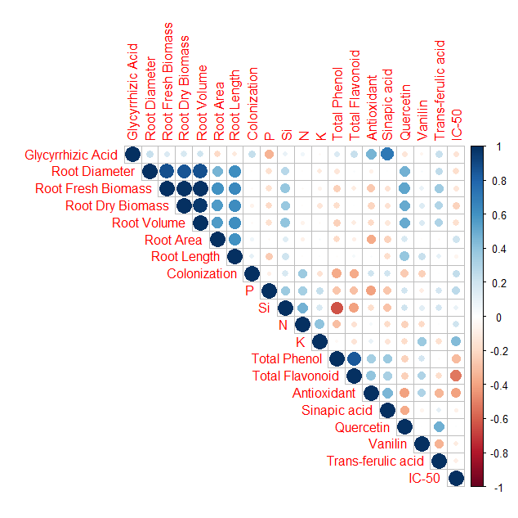
A

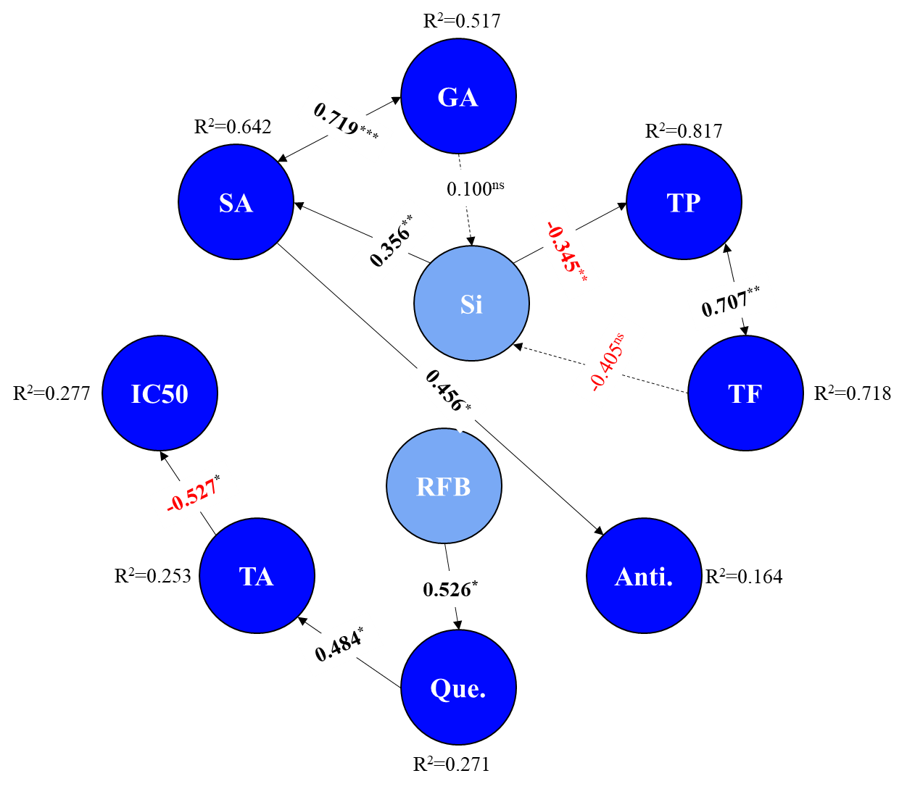
B
Fig. S1 (A) Corrplot between various measured parameters of licorice. (B) Path diagram showing of measured variables of licorice and their effects on each other. Numerical values indicate β path coefficients between traits (Red shows negative beta value; Black shows positive beta value). Asterisks indicate the significance of the coefficient (***, ** and * are significant at 0.001, 0.01, and 0.05 levels of probability, respectively). Solid arrow shows direct effect; Dashed arrow shows indirect effect. Abbreviations: GA: Glycyrrhizic acid; TP: Total phenol; TF: Total flavonoid; TA: Trans ferulic acid; SA: Sinapic acid; RFB: Root fresh biomass; Que: Quercetin; Anti: Antioxidant.

