Supplementary Material

Table S1. Saturated zone properties for various aquifer types present within the study catchments obtained from the literature. Properties in bold are those input directly into MIKE-SHE.
Property | Value & units | Location | Literature Source
Porosity  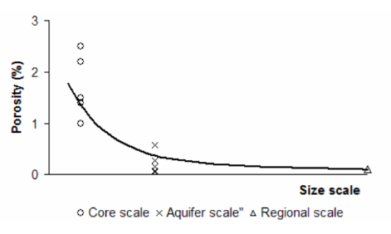 | Strongly scale dependent (graph):  Upper limit: 1.0% ~3.6%  Mid range: 0.05% ~0.6%  Lower limit: 1.2e-8% | TMG Aquifer | (Lin, 2007)
 | 16.4% for fractured sandstone | Rietfontein deep hole | (Lin, 2007)
 | 0.005 - 0.163 (0.5% to 16.3%) | Peninsula & Skurweberg Aquifer | (DWAF, 2008)
 | 1.9-2.3 (1.5)  0.6-1.7 (1.4)  0.9-5.4 (3.1)  1.2-3.0 (2.2)  1.0-3.6 (2.5)  0.01-0.35 (0.06)  0.11-0.22 (0.15)  0.1—0.01 (0.05)  0.21-1.2 (0.57) | TMG Aquifer  Koo Valley  Kammanassie  Boschkloof  Gevonden | (Jia, 2007)
Matrix density | 2.75 g/cm³ | Sandstone | (Lin, 2007)
Specific yield | Low: 1x10⁻⁴  Medium: 5 x10⁻⁴  High: 5 x10⁻³ | Unconfined TMG Aquifer (Peninsula) | (Jia, 2007) in (Lin, 2007)
Specific storage | 3x10⁻⁶ to 7x10⁻⁶ /m | Peninsula & Skurweberg Aquifer | (DWAF, 2008)
Storativity | 10⁻² to 10⁻⁵ | TMG Aquifer | (Lin, 2007)
Storativity | 3.28 x 10⁻³  1.12 x 10⁻³ | Peninsula Aquifer at Berg Gauging Weir | (Lasher, 2011)
Storativity | 1.68 x 10⁻² | Peninsula Aquifer at Gevonden (Rawsonville) | (Lasher, 2011)
Storativity | Low: 1x10⁻⁴  Medium: 5x10⁻⁴  High: 5x10⁻³ | TMG Aquifers | (Jia, 2007)
Hydraulic conductivity (K) | <70 mS/m | The Berg area | (Lasher 2011; Ractliffe 2007) , in (Madlala et al., 2018)
Hydraulic conductivity (K) | 10⁻²~10⁻³ m/d (00.1-0.01) | TMG Aquifer | (Lin, 2007)
Hydraulic conductivity (K) | 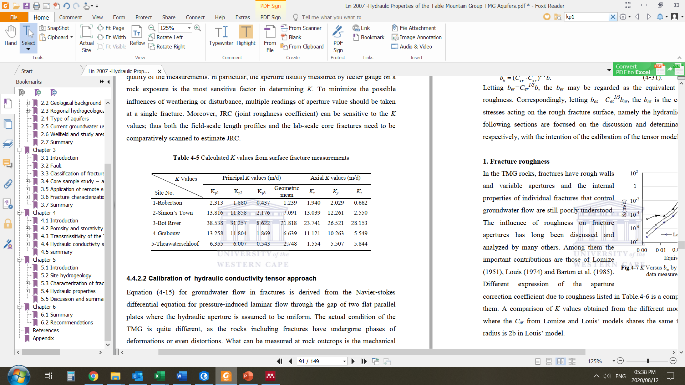 | TMG Aquifer | (Lin, 2007)
Hydraulic conductivity (K) | i=1: 2.528x10⁻³ m/d  i=2: 2.503x10⁻³ m/d  i=3: 2.567x10⁻⁵ m/d  Mean: 5.457x10⁻⁴ m/d (0.00054) | Rawsonville TMG Aquifer | (Lin, 2007)
Hydraulic conductivity (K) | 2.4% of fractures involved: 10⁻⁸ m/s | Rawsonville case study | (Lin, 2007)
Hydraulic conductivity (K) | 1.99m/d-1.99x10⁻³ m/d  0.3m/d  0.05m/d  0.17-0.86 (mean 0.26) m/d  0.04-0.52 (mean 0.17) m/d | -Baths spring  -Nardouw subgroup (Villiersdorp)  -Nardouw subgroup (Agter-Witzenberg)  -Peninsula  -Peninsula | -Umvoto 2000  -Rosewarne 1991  -Weaver 1999  In: (Pietersen & Parsons, 2002)
Hydraulic conductivity (vertical) | In an anisotropic medium, K is not a scalar any more compared with isotropic one. | - | (Lin, 2007)
Hydraulic conductivity (horizontal) | -
Transmissivity | 9 to 400 m²/d | Peninsula Aquifer | (Lin, 2007)
Transmissivity | 31.67 m²/d  23.8 m²/d  (Cooper Jacob method) | Peninsula Aquifer at Berg Gauging Weir | (Lasher, 2011)
Transmissivity | 10.7 m²/d | Peninsula Aquifer at Gevonden (Rawsonville) | (Lasher, 2011)
Hydraulic resistance | -
Initial potential head | BH1: water strikes at 42, 48 and 123 m (162m)  BH2: water strikes at 38, 49 and 57 m (60m)  In both cases at max 10m above river.  20-35m above dam toe-mid | Peninsula Aquifer at Berg Gauging Weir | (Lasher, 2011)
Initial potential head | Aquifer top  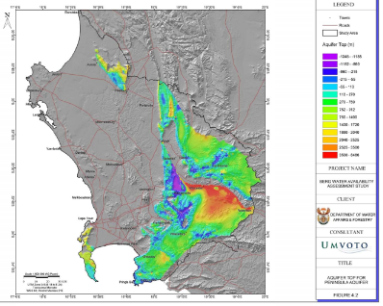 | Peninsula Aquifer | (DWAF, 2008)
Aquifer bottom | Granites of the Cape Granite Suite between 137 – 160 m | Peninsula Aquifer at Berg Gauging Weir | (Lasher, 2011)
Aquifer bottom | Aquifer thickness  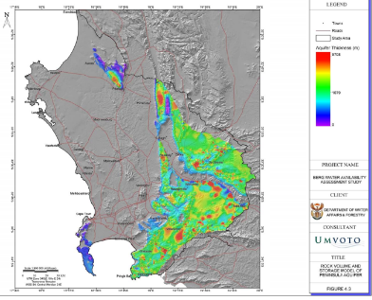 | Peninsula Aquifer | (DWAF, 2008)
Groundwater Potential Yield | 28.3 Mm³/a | Berg River Catchment | Parsons 2003, in (Madlala et al., 2018)
% riverflow derived from GW | 8% | Upper Berg | (Madlala et al., 2018)
Thickness | 500m – 4000m | TMG Aquifer | (Lin, 2007)
Thickness | 138 m | Peninsula Aquifer at Berg Gauging Weir | (Lasher, 2011)
Groundwater recharge | 5-15% | TMG Aquifer | Meyer 2001, Wu 2005 in (Lasher, 2011)
Groundwater recharge | 404M m³/a | Peninsula Aquifer | (DWAF, 2008)
Groundwater flow direction | Local groundwater flow is in a north easterly direction, similar to that of the surface water flow | Peninsula Aquifer at Berg Gauging Weir | (Lasher, 2011)

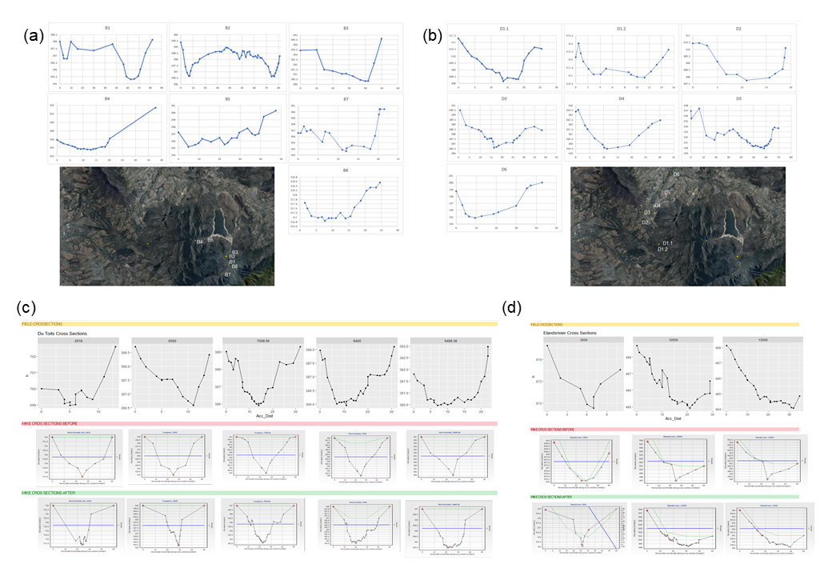
Figure S1. Cross section inputs for each of the four catchments, the (a) Upper Berg, (b) Dwars, (c) Du Toits, and (d) Elands catchments, Western Cape, South Africa.
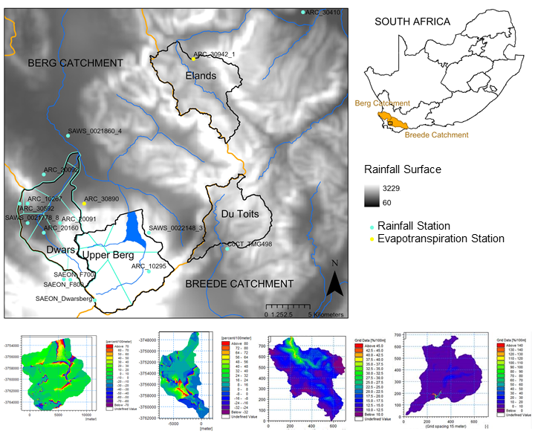
Figure S2. Rainfall and evapotranspiration stations overlain on a rainfall surface (DWAF, 2007), Thiessen polygons and lapse rate layers for the four study catchments, South Africa. Also see Table S2 for the list of rainfall station and associated details.

Table S2. List of the rainfall stations used for each catchment, as well as location, percentage of missing data for the modelling period (2004-2018) and overall, the length of the time-series (years) and the mean correlation with other stations used to patch each timeseries.
Catchment | Station ID | Station Name | Lat | Lon | % Missing (2004-2018) | % Missing (full period) | Years | Mean Correlation
Dwars | ARC_10267 | Lemoenkloof | -33.90 | 18.93 | 100.0 | 87.3 | 87.0 | 0.89
Upper Berg | ARC_10295 | Robertsvlei - Bos | -33.97 | 19.08 | 98.3 | 27.0 | 58.0 | 0.89
Upper Berg/Dwars | ARC_20091 | Bethlehem | -33.92 | 18.97 | 100.0 | 62.6 | 41.6 | 0.85
Dwars | ARC_20092 | Mountain Vineyards | -33.87 | 18.95 | 19.2 | 3.3 | 41.6 | 0.85
Dwars | ARC_20160 | Dwarsriviershoek | -33.93 | 18.95 | 31.3 | 59.8 | 108.1 | 0.86
Dwars | ARC_30592 | Thelema 1: Aws | -33.90 | 18.92 | 51.0 | 44.9 | 13.3 | 0.86
Upper Berg/Dwars | ARC_30890 | Franschoek: Lormarins 1 | -33.90 | 19.00 | 36.0 | 27.6 | 19.2 | 0.87
Dwars | SAEON_F700 | Langrivier 700 Fog Station | -33.98 | 18.97 | 70.2 | 3.8 | 4.7 | 0.93
Upper Berg/Dwars | SAEON_F800 | Langrivier 800 Fog Station | -33.98 | 18.98 | 69.4 | 0.6 | 4.6 | 0.94
Dwars | SAWS_0021778_8 | Driefontein -Bos | -33.92 | 18.93 | 55.9 | 16.6 | 59.0 | 0.81
Dwars | SAWS_0021860_4 | Bien Donne -Agr | -33.83 | 18.98 | 0.8 | 15.2 | 58.8 | 0.84
Upper Berg | SAWS_0022148_3 | Franschhoek Robertsvlei | -33.93 | 19.08 | 0.8 | 1.1 | 58.0 | 0.85
Upper Berg | SAEON_Dwarsberg | Dwarsberg Weather Station | -34.00 | 19.01 | 61.9 | 1.5 | 5.8 | 0.92
Elands | ARC30410 | Du Toitskloof Kelder | -33.70 | 19.27 | 24.3 | 29.8 | 19.3 | 0.86
Du Toits | CoCT_TMG498 | Purgatory | -33.95 | 19.18 | 68.5 | 10.3 | 6.8 | 0.75

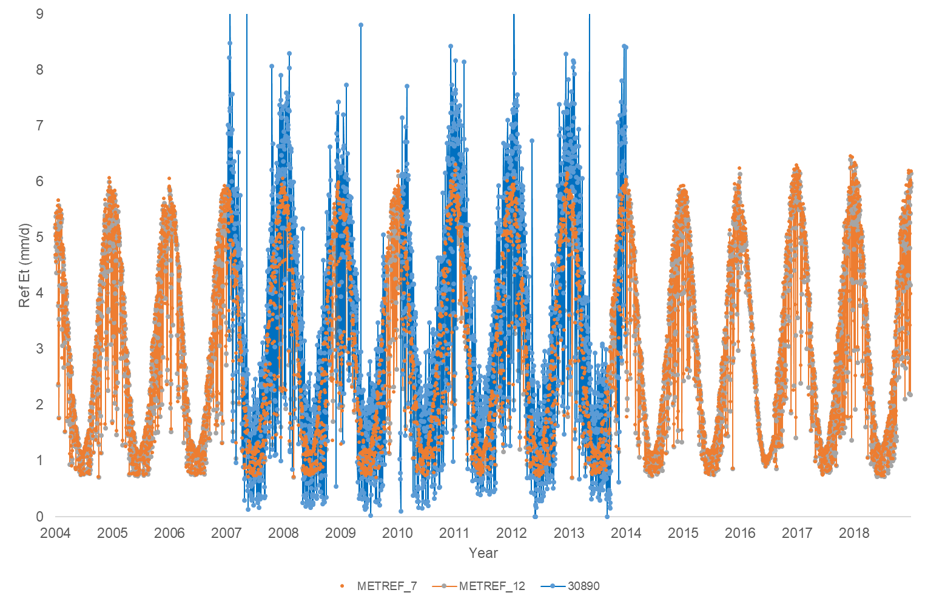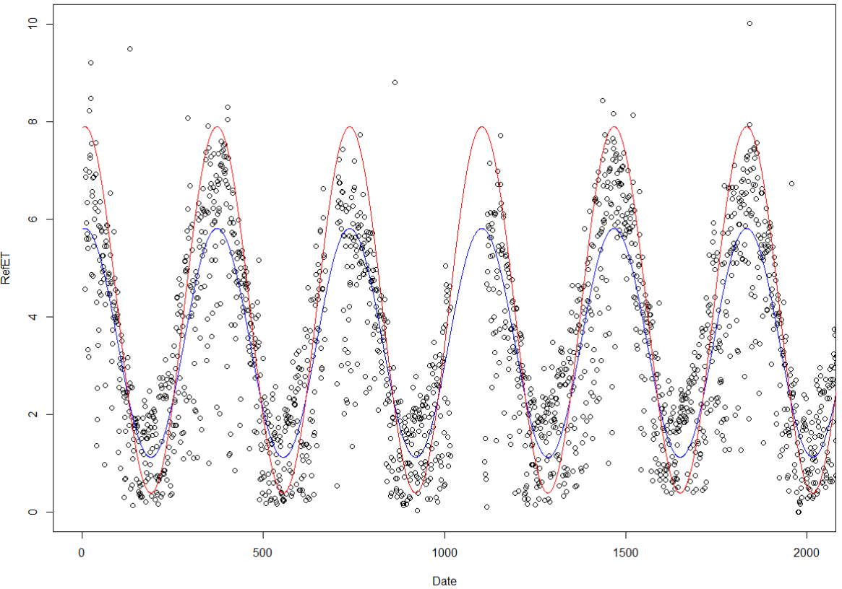
Figure S3. (top) Daily reference evapotranspiration from an ARC weather station (Station 30890) calculated using the Penman-Monteith FAO-56 Method, compared with METREF satellite-derived reference evapotranspiration (EUMETSAT, 2016) for two grid cells covering the Berg Catchment, and overlapping the ARC weather station location, Western Cape, South Africa; (bottom) Two fitted sine curves (blue and red) to predict daily reference evapotranspiration from ARC weather station (Station 30890). The blue line is the predicted curve, and the red line is adjusted using the following formula: predicted*1.6-1.4, which was the dataset used as final input for station 30890.

Appendix 1. R Code for fitting the sine curve

setwd("")
Data <- read.csv("RefETData_station.csv")
Date <- Data$DATE_int
RefET <- Data$X30890

xc<-cos(2*pi*Date/365.25)
xs<-sin(2*pi*Date/365.25)
fit.lm <- lm(RefET~xc+xs)
fit.lm

# access the fitted series (for plotting)
fit <- fitted(fit.lm)

# find predictions for original time series
pred <- predict(fit.lm, newdata=data.frame(Time=Date))

plot(RefET ~ Date, data= Data2, xlim=c(0, 2000), ylim=c(0, 10))
lines(fit, col="red")
lines(Date, pred, col="blue")

#manually adjusted (to lift curve, +, to drop curve -, to stretch multiply)
lines(fit*1.4, col="orange")
lines(fit*1.6-1.4, col="green")
lines(pred*1.6-1.4, col="brown")

# Export new sine timeseries
write.csv(pred*1.6-1.4, "predicted.csv")

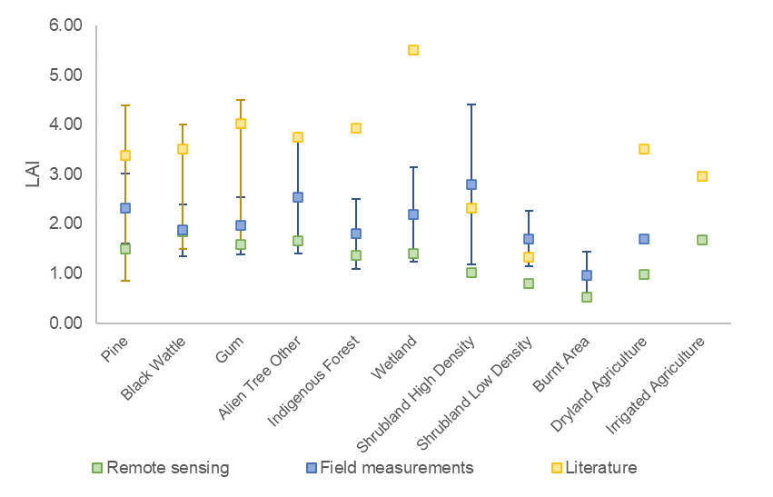
Figure S4. Means and standard deviations of Leaf Area Index (LAI) measurements from remote sensing, field measurement and literature for various land-use/land-cover classes used in the modelling for which reliable data were not readily available. Remote sensing and field measurements were from the Berg and Breede Catchments, South Africa.

Table S3. Area (km²) for each of the land-use/land-cover classes for each of the five scenarios of the four case studies, Western Cape, South Africa.
 | Upper Berg |  |  |  |  | Dwars |  |  |  |  | Du Toits |  |  |  |  | Elands
Scenario | 1 | 2 | 3 | 4 | 5 | 1 | 2 | 3 | 4 | 5 | 1 | 2 | 3 | 4 | 5 | 1 | 2 | 3 | 4 | 5
Agriculture: Dryland |  |  |  |  |  | 4.4 | 4.4 | 4.4 | 4.4 | 4.4 |  |  |  |  |  | 0.1 | 0.1 | 0.1 | 0.1 | 0.1
Agriculture: Orchards |  |  |  |  |  | 3.6 | 3.6 | 3.6 | 3.6 | 3.6
Agriculture: Vineyards |  |  |  |  |  | 3.9 | 3.9 | 3.9 | 3.9 | 3.9
Bare Ground | 0.6 | 0.6 | 0.6 | 0.6 | 0.6 | 2.5 | 2.5 | 2.5 | 2.5 | 2.5 | 0.1 | 0.1 | 0.1 | 0.1 | 0.1 | 0.2 | 0.2 | 0.2 | 0.2 | 0.2
Burnt Area | 0.0 | 0.0 |  | 0.0 |  |  |  |  |  |  | 0.1 | 0.1
Indigenous Forest | 0.5 | 0.5 | 0.3 | 0.2 |  | 0.4 | 0.4 | 0.1 | 0.2 |  | 0.3 | 0.3 | 0.1 | 0.2 |  | 1.4 | 1.4 | 0.5 | 0.9
Rock | 2.2 | 2.2 | 2.2 | 2.2 | 2.2 | 3.5 | 3.5 | 3.5 | 3.5 | 3.5 | 0.6 | 0.6 | 0.6 | 0.6 | 0.6 | 2.6 | 2.6 | 2.6 | 2.6 | 2.6
Shrubland High Density | 35.2 | 28.3 | 3.8 | 31.4 |  | 20.8 | 13.7 | 1.7 | 19.0 |  | 28.9 | 10.6 | 3.5 | 25.4 |  | 12.6 | 11.4 | 1.9 | 10.7
Shrubland Low Density | 33.8 | 33.8 | 2.1 | 31.7 |  | 22.5 | 22.5 | 0.4 | 22.1 |  | 16.0 | 16.0 | 0.5 | 15.5 |  | 42.8 | 42.8 | 1.6 | 41.1
Urban | 0.0 | 0.0 | 0.0 | 0.0 | 0.0 | 1.3 | 1.3 | 1.3 | 1.3 | 1.3 | 0.2 | 0.2 | 0.2 | 0.2 | 0.2 | 0.0 | 0.0 | 0.0 | 0.0 | 0.0
Water | 5.1 | 5.1 | 5.1 | 5.1 | 5.1 | 0.4 | 0.4 | 0.4 | 0.4 | 0.4
Wetland | 0.9 | 0.9 | 0.2 | 0.6 |  | 0.5 | 0.5 | 0.1 | 0.5 |  | 0.1 | 0.1 |  | 0.1 |  | 0.1 | 0.1 | 0.0 | 0.0
Alien Trees: Black Wattle 0-2 years |  |  |  |  |  |  | 0.0 |  |  |  |  |  |  |  |  |  | 0.0
Alien Trees: Black Wattle 2-3 years |  | 0.0 |  |  |  |  | 0.2
Alien Trees: Black Wattle 3-6 years |  | 0.0 |  |  |  |  | 0.0
Alien Trees: Black Wattle > 6 years |  | 0.0 |  | 6.5 | 6.5 |  | 0.3 |  | 2.4 | 2.4 |  | 0.0 |  | 4.2 | 4.2 |  | 0.1 |  | 4.0 | 4.0
Alien Trees: Gum 1-2 years |  |  |  |  |  |  | 0.0
Alien Trees: Gum 2-6 years |  |  |  |  |  |  | 0.6
Alien Trees: Gum > 6 years |  |  |  |  |  |  | 0.4
Alien Trees: Other 0-2 years |  |  |  |  |  |  | 0.2
Alien Trees: Other 2-4 years |  | 0.0 |  |  |  |  | 0.9
Alien Trees: Other 4-6 years |  | 0.1 |  |  |  |  | 0.0
Alien Trees: Other > 6 years |  | 0.0 |  |  |  |  | 3.8 |  |  |  |  | 0.0 |  |  |  |  | 0
Alien Trees: Pine 0-2 years |  |  |  |  |  |  | 0.0 |  |  |  |  |  |  |  |  |  | 0.0
Alien Trees: Pine 2-4 years |  | 0.0 |  |  |  |  | 0.2 |  |  |  |  | 0.2
Alien Trees: Pine 4-6 years |  | 0.0
Alien Trees: Pine 7-15 years |  | 6.6 | 63.9 |  | 63.9 |  | 0.1 | 41.9 |  | 41.9 |  | 18.1 | 41.3 |  | 41.2 |  | 1.0 | 52.7 |  | 52.7
Alien Trees: Pine > 15 years |  | 0.1 |  |  |  |  | 0.3 |  |  |  |  | 0.0
Total | 78.4 | 78.4 | 78.4 | 78.4 | 78.4 | 63.9 | 63.9 | 63.9 | 63.9 | 63.9 | 46.3 | 46.3 | 46.3 | 46.3 | 46.3 | 59.7 | 59.7 | 59.7 | 59.7 | 59.7
Alien trees (km2) | 0.0 | 6.9 | 63.9 | 6.5 | 70.4 | 0.0 | 7.1 | 41.9 | 2.4 | 44.2 | 0.0 | 18.4 | 41.3 | 4.2 | 45.4 | 0.0 | 1.1 | 52.7 | 4.0 | 56.8
Alien trees (%) | 0.0 | 8.8 | 81.5 | 8.3 | 89.7 | 0.0 | 11.2 | 65.5 | 3.7 | 69.2 | 0.0 | 39.7 | 89.2 | 9.2 | 98.1 | 0.0 | 1.9 | 88.4 | 6.8 | 95.1
Table S4. Vegetation input parameters for each of the land-use/land-cover classes modelled, as well as database and reference information in this study of four catchments, Western Cape, South Africa.
LULC | Root Depth (m) | Leaf Area Index | Canopy Interception (mm/2hr) | Crop Factor (Kc) | ACRU Category | Reference | FAO56 Category
Agriculture: Dryland | 0.70 | 1.69 | 0.06 | 0.77 | [3021001] Pastures, perennial crop | Schulze 1995 | Combined all forage values from initial to end
Agriculture: Orchards | 1.21 | 2.96 | 0.05 | 0.63 | [3021102] Citrus E Cape W Cape; [7770107] Apples | Smithers & Schulze 1995; Taylor & Gush 2014 | Citrus: 70% canopy; Apples: no ground cover, no frosts
Agriculture: Vineyards | 1.21 | 2.00 | 0.04 | 0.38 | [3021302] Wine Grapes | Schulze 1995 | Wine grapes
Alien Trees: Black Wattle 0-2 years | 2.40 | 1.50 | 0.07 | 0.48 | [6030102] Young; intermediate site prep | Schulze 1995
Alien Trees: Black Wattle 2-3 years | 3.60 | 2.50 | 0.04 | 0.48 | [6030102] Young; intermediate site prep | Schulze 1995
Alien Trees: Black Wattle 3-6 years | 4.80 | 3.50 | 0.04 | 1.08 | [6030202] Intermediate; intermediate site prep | Schulze 1995
Alien Trees: Black Wattle > 6 years | 6.33 | 4.00 | 0.05 | 1.08 | [6030302] Mature; intermediate site prep | Schulze 1995
Alien Trees: Gum 0-1 years | 3.75 | 1.25 | 0.15 | 0.48 | [6010102] Young; intermediate site prep | Schulze 1995
Alien Trees: Gum 1-2 years | 9.75 | 2.00 | 0.09 | 0.48 | [6010102] Young; intermediate site prep | Schulze 1995
Alien Trees: Gum 2-6 years | 14.00 | 4.00 | 0.05 | 1.2 | [6010202] Intermediate; intermediate site prep | Schulze 1995
Alien Trees: Gum > 6 years | 20.07 | 4.50 | 0.07 | 1.2 | [6010302] Mature; intermediate site prep | Schulze 1995
Alien Trees: Other 0-2 years | 1.40 | 1.40 | 0.11 | 0.48 | average of all other alien tree species of this age class
Alien Trees: Other 2-4 years | 2.88 | 2.88 | 0.07 | 0.86 | average of all other alien tree species of this age class
Alien Trees: Other 4-6 years | 3.33 | 3.33 | 0.06 | 1.01 | average of all other alien tree species of this age class
Alien Trees: Other > 6 years | 4.30 | 4.30 | 0.05 | 1.01 | average of all other alien tree species of this age class
Alien Trees: Pine 0-2 years | 0.18 | 0.85 | 0.21 | 0.48 | [6020102] Young; intermediate site prep | Schulze 1995
Alien Trees: Pine 2-4 years | 0.20 | 1.50 | 0.19 | 1.01 | [6020202] Intermediate; intermediate site prep | Schulze 1995 | Connifers
Alien Trees: Pine 4-6 years | 0.65 | 2.50 | 0.12 | 1.01 | [6020202] Intermediate; intermediate site prep | Schulze 1995 | Connifers
Alien Trees: Pine 7-15 years | 2.74 | 4.50 | 0.06 | 1.01 | [6020302] Mature; intermediate site prep | Schulze 1995 | Connifers
Alien Trees: Pine > 15 years | 3.47 | 5.00 | 0.05 | 1.01 | [6020302] Mature; intermediate site prep | Schulze 1995 | Connifers
Bareground | - | - | - | -
Burnt Area | 0.10 | 0.97 | 0.05 | 0.41 | [2020103] Degraded | Schulze 1995
Indigenous Forest | 0.92 | 3.93 | 0.07 | 1.02 | [2080301] Knysna Forest | Schulze 1995
Rock | - | - | - | -
Shrubland High Density | 3.50 | 2.79 | 0.04 | 0.72 | [2020102] Macchia: April to September | Schulze 1995
Shrubland Low Density | 1.40 | 1.97 | 0.04 | 0.58 | [2020102] Macchia: October to March | Schulze 1995
Urban | - | - | - | -
Water | - | - | - | -
Wetland | 3.50 | 2.18 | 0.02 | 0.93 | [9010202] Reed Wetland; Mvoti; [9010203] Grass Wetland; Mvoti; [5100102] Wetland general | Schulze 1995; Rebelo et al. 2020 | Wetland, no frost (mean of short veg, reed swamp, cattails)

Table S5. Literature review of leaf area index for the target land-use/land-cover categories for the four study catchments, South Africa.
Reference | Species/Veg Type | LULC | Location | Age | Month | LAI (m²/m²)
Ntshidi et al. 2018 -Characterising the water use and hydraulic properties of riparian tree invasions | Populus canescens | Alien Tree Other | Upper Berg River | Varying | August | 0
 | Populus canescens | Alien Tree Other | Upper Berg River | Varying | October | 1.8
 | Populus canescens | Alien Tree Other | Upper Berg River | Varying | November | 2.3
 | Populus canescens | Alien Tree Other | Upper Berg River | Varying | May | Leaf fall begins
van Deventer 2020 -National Wetland Map 5 An improved spatial extent and representation of inland | Arid wetland | Wetland | National | - | - | 0-1
 | Palustrine wetlands: dense grass to tree cover | Wetland | National | - | - | 1-8
Glenday 2015 -Modelling the Hydrologic Impacts of Vegetation and Channel Network Change for a Semi-arid, Mountainous, Meso-scale Catchment | Forest | Indigenous Forest | Baviaanskloof | - | - | 3-5
 | Fynbos | Shrubland High/Low Density | Baviaanskloof | - | - | 1-3
Everson et al. 2016 -Rehabilitation of alien invaded riparian zones and catchments using indigenous trees | Eucalyptus Sp. | Gum | Buffeljagsrivier | - | - | 5
 | Pinus Sp. | Pine | Buffeljagsrivier | - | - | 5
 | Mixed Riparian Forest | Indigenous Forest | Buffeljagsrivier | - | - | 4
 | Indigenous patch | Indigenous Forest | Western Cape Afrotemperate Forest | - | - | 3.4
 | Acacia mearnsi | Black Wattle | Western Cape Afrotemperate Forest | - | - | 3.1
 | Indigenous trees | Indigenous Forest | Western Cape Afrotemperate Forest (upper reach) | - | - | 3.6
Le Maitre 2002 -Crop Factors for Tall Shrubs: A Discussion Document. Draft Discussion Document. | Tall shrubs | Shrubland High Density | Berg River Catchment, Western Cape | - | - | 3.5
Dzikiti et al. 2016 -Quantifying potential water savings from clearing invasive alien Eucalypt | Eucalyptus (Trees) | Gum | Berg River Catchment, Western Cape | - | - | 2.2 ± 0.4
 | Eucalyptus (Stand) | Gum | Berg River Catchment, Western Cape | - | - | 1.8 ± 0.5
 | Indigenous (Trees: cleared of alien trees) | Indigenous Forest | Berg River Catchment, Western Cape | - | - | 1.5 ± 2.0
 | Indigenous (Stand: cleared of alien trees) | Indigenous Forest | Berg River Catchment, Western Cape | - | - | 0.7 ± 1.2
Dzikiti et al. 2014 -Measurement and modelling of evapotranspiration 3 fynbos veg types | Sand Fynbos | Shrubland Low Density | Riverlands Nature Reserve | - | Oct | 1.12-1.54
 | Sandstone Fynbos | Shrubland High Density | Kogelberg NR | - | April to June | 0.15-0.43
 | Sandstone Fynbos | Shrubland High Density | Kogelberg NR | - | Sept to Oct | 0.54-3.32
 | Alluvium Fynbos | Shrubland High Density | Elandsberg NR | - | Oct 2011 to Jan 2013 | 0.21-1.33
Doko 2017 -Quantifying the water use of apple tree orchards | Golden delicious apples | Irrigated Agriculture | Koue Bokkeveld | - | - | 3.43
Doko 2017 -Quantifying the water use of apple tree orchards | Crispy pink apples | Irrigated Agriculture | Koue Bokkeveld | - | - | 2.82
SWAT BLAI (Note BLAI is max potential LAI) | DRYLAND CROPLAND AND PASTURE | Dryland Agriculture | North America | - | Annual ave | 3.5
SWAT BLAI (Note BLAI is max potential LAI) | IRRIGATED CROPLAND AND PASTURE | Irrigated Agriculture | North America | - | Annual ave | 3.5
SWAT BLAI (Note BLAI is max potential LAI) | DECIDUOUS BROADLEAF FOREST | Indigenous Forest | North America | - | Annual ave | 5
SWAT BLAI (Note BLAI is max potential LAI) | DECIDUOUS NEEDLELEAF FOREST | Indigenous Forest | North America | - | Annual ave | 5
SWAT BLAI (Note BLAI is max potential LAI) | EVERGREEN BROADLEAF FOREST | Indigenous Forest | North America | - | Annual ave | 5
SWAT BLAI (Note BLAI is max potential LAI) | EVERGREEN NEEDLELEAF FOREST | Indigenous Forest | North America | - | Annual ave | 5
SWAT BLAI (Note BLAI is max potential LAI) | MIXED FOREST | Indigenous Forest | North America | - | Annual ave | 5
SWAT BLAI (Note BLAI is max potential LAI) | HERBACEOUS WETLAND | Wetland | North America | - | Annual ave | 6
SWAT BLAI (Note BLAI is max potential LAI) | WOODED WETLAND | Wetland | North America | - | Annual ave | 5
SWAT BLAI (Note BLAI is max potential LAI) | Apple | Irrigated Agriculture | North America | - | Annual ave | 4
SWAT BLAI (Note BLAI is max potential LAI) | Oak | Alien Tree Other | North America | - | Annual ave | 5
SWAT BLAI (Note BLAI is max potential LAI) | Poplar | Alien Tree Other | North America | - | Annual ave | 5
SWAT BLAI (Note BLAI is max potential LAI) | Vineyard | Irrigated Agriculture | North America | - | Annual ave | 2
SWAT BLAI (Note BLAI is max potential LAI) | Orange | Irrigated Agriculture | North America | - | Annual ave | 2

Table S6. Soil dataset for the four study catchments in the Berg and Breede Catchments, South Africa. Long = longitude, Lat = latitude, BD = bulk density.
 | Long | Lat | Depth (cm) | Moisture (%) | BD (g/cm3) | Texture Class | Mean Saturated Hydraulic Conductivity (m/s) | Saturated moisture content (θs) (Porosity) | Residual Moisture Content (θr) | Empirical Constant (α) | Empirical Constant (n) | Empirical Constant (m) | Wilting Point | Field Capacity
Upper Berg | 19.07 | -33.96 | 32.00 | 2.54 | 1.20 | Loamy Sand | 3.70E-05 | 0.62 | 0.05 | 0.02 | 3.50 | 0.71 | 0.05 | 0.23
Upper Berg | 19.07 | -33.96 | 17.33 | 14.07 | 1.02 | Sand | 3.97E-05 | 0.51 | 0.06 | 0.02 | 3.50 | 0.71 | 0.06 | 0.15
Upper Berg | 19.07 | -33.96 | 11.33 | 2.05 | 0.98 | Loamy Sand | 2.78E-05 | 0.55 | 0.07 | 0.02 | 3.00 | 0.67 | 0.07 | 0.25
Upper Berg | 19.12 | -33.91 | 8.17 | 0.18 | 1.20 | Sand | 4.29E-05 | 0.51 | 0.02 | 0.02 | 2.00 | 0.50 | 0.03 | 0.29
Upper Berg | 19.07 | -33.96 | 8.83 | 0.52 | 1.14 | Sand | 4.19E-05 | 0.50 | 0.02 | 0.03 | 2.50 | 0.60 | 0.02 | 0.13
Upper Berg | 19.03 | -33.94 | 26.00 | 3.32 | 1.17 | Sand | 4.34E-05 | 0.50 | 0.06 | 0.02 | 2.70 | 0.63 | 0.06 | 0.20
Upper Berg | 19.04 | -33.94 | 6.83 | 5.09 | 0.87 | Sand | 4.28E-05 | 0.61 | 0.07 | 0.02 | 2.80 | 0.64 | 0.07 | 0.27
Upper Berg | 19.10 | -33.91 | 29.13 | 7.73 | 0.99 | Sand Loam | 1.12E-05 | 0.63 | 0.14 | 0.01 | 3.50 | 0.71 | 0.14 | 0.40
Upper Berg | 19.10 | -33.91 | N/A |  |  | Sandy Loam | NA | NA | NA | NA | NA | NA | NA | NA
Upper Berg | 19.10 | -33.91 | 60.17 | 5.82 | 1.35 | Sandy Loam | 1.08E-05 | 0.50 | 0.11 | 0.02 | 3.50 | 0.71 | 0.11 | 0.19
Upper Berg | 19.10 | -33.91 | 25.00 |  |  | Sandy Clay Loam | NA | NA | NA | NA | NA | NA | NA | NA
Upper Berg | 19.10 | -33.91 | 9.75 | 6.42 | 0.84 | Loamy Sand | 2.93E-05 | 0.60 | 0.05 | 0.02 | 2.50 | 0.60 | 0.05 | 0.30
Upper Berg | 19.10 | -33.91 | 14.00 | 4.17 | 1.28 | Sand | 8.20E-05 | 0.46 | 0.02 | 0.02 | 3.50 | 0.71 | 0.02 | 0.10
Upper Berg | 19.06 | -33.98 | 21.33 | 10.48 | 0.99 | Loamy Sand | 3.41E-05 | 0.65 | 0.07 | 0.02 | 3.50 | 0.71 | 0.07 | 0.16
Upper Berg | 19.07 | -33.97 | 35.30 | 6.55 | 1.18 | Sand | 3.24E-05 | 0.56 | 0.12 | 0.02 | 3.50 | 0.71 | 0.12 | 0.18
Upper Berg | 19.08 | -33.97 | >200 | 17.87 | 0.75 | Sandy Loam | 1.06E-05 | 0.69 | 0.16 | 0.01 | 3.10 | 0.68 | 0.16 | 0.43
Upper Berg | 19.08 | -33.97 | N/A |  |  | Sandy Clay Loam | NA | NA | NA | NA | NA | NA | NA | NA
Upper Berg | 19.09 | -33.93 | 23.00 | 6.90 | 1.01 | Loamy Sand | 2.60E-05 | 0.55 | 0.09 | 0.02 | 3.00 | 0.67 | 0.09 | 0.20
Upper Berg | 19.09 | -33.92 | 12.33 | 2.48 | 1.27 | Sand | 5.33E-05 | 0.53 | 0.07 | 0.02 | 3.20 | 0.69 | 0.07 | 0.16
Dwarsrivier | 18.96 | -33.90 | >100 | 6.78 | 1.00 | Sand | 8.15E-05 | 0.54 | 0.05 | 0.06 | 2.16 | 0.54 | 0.05 | 0.11
Dwarsrivier | 18.97 | -33.95 | N/A | 27.71 | 1.44 | Sand | 4.68E-05 | 0.48 | 0.01 | 0.02 | 2.50 | 0.60 | 0.01 | 0.22
Dwarsrivier | 18.97 | -33.95 | 14.00 | 7.68 | 1.07 | Loamy sand | 4.27E-05 | 0.53 | 0.08 | 0.03 | 3.50 | 0.71 | 0.08 | 0.13
Dwarsrivier | 18.97 | -33.95 | 12.33 | 9.47 | 1.04 | Sand | 3.82E-05 | 0.53 | 0.05 | 0.01 | 2.70 | 0.63 | 0.05 | 0.36
Dwarsrivier | 18.94 | -33.93 | 16.83 | 18.52 | 0.72 | Sandy Loam | 4.10E-05 | 0.61 | 0.12 | 0.02 | 3.00 | 0.67 | 0.12 | 0.23
Dwarsrivier | 18.94 | -33.91 | 207.00 | 15.25 | 0.71 | Sand | 2.42E-05 | 0.53 | 0.05 | 0.01 | 2.70 | 0.63 | 0.05 | 0.36
Dwarsrivier | 18.94 | -33.91 | 192.00 |  |  | Sand | NA | NA | NA | NA | NA | NA | NA | NA
Dwarsrivier | 18.94 | -33.91 | N/A |  |  | Sand | NA | NA | NA | NA | NA | NA | NA | NA
Dwarsrivier | 18.94 | -33.91 | 87.00 | 2.91 | 1.15 | Loamy Sand | 5.26E-05 | 0.54 | 0.05 | 0.02 | 3.50 | 0.71 | 0.05 | 0.20
Dwarsrivier | 18.96 | -33.90 | 16.00 | 16.32 | 0.98 | Sandy Loam | 2.80E-05 | 0.64 | 0.08 | 0.01 | 2.70 | 0.63 | 0.08 | 0.38
Dwarsrivier | 18.96 | -33.90 | 42.00 |  |  | Loamy Sand | NA | NA | NA | NA | NA | NA | NA | NA
Dwarsrivier | 18.97 | -33.89 | 258.00 | 8.22 | 0.72 | Sandy Loam | 3.20E-05 | 0.57 | 0.07 | 0.02 | 3.50 | 0.71 | 0.07 | 0.23
Dwarsrivier | 18.97 | -33.89 | N/A |  |  | Sandy Loam | NA | NA | NA | NA | NA | NA | NA | NA
Dwarsrivier | 18.98 | -33.87 | 70.67 | 8.67 | 1.13 | Sand | 2.32E-05 | 0.57 | 0.06 | 0.02 | 3.50 | 0.71 | 0.06 | 0.14
Dwarsrivier | 18.96 | -33.89 | 101.50 | 7.48 | 1.06 | Sandy Loam | 5.56E-05 | 0.51 | 0.04 | 0.06 | 1.88 | 0.47 | 0.04 | 0.14
Dwarsrivier | 18.94 | -33.91 | 95.00 | 7.94 | 0.99 | Sand | 5.75E-06 | 0.51 | 0.07 | 0.13 | 1.46 | 0.32 | 0.08 | 0.20
Dwarsrivier | 18.97 | -33.84 | >100 | 1.93 | 1.08 | Sand | 7.06E-05 | 0.51 | 0.04 | 0.05 | 2.04 | 0.51 | 0.04 | 0.12
Dwarsrivier | 18.97 | -33.84 | N/A |  |  | Sand | NA | NA | NA | NA | NA | NA | NA | NA
Holsloot | 19.32 | -33.70 | >300 | 4.47 | 1.28 | Loamy Sand | 3.11E-05 | 0.45 | 0.05 | 0.04 | 2.09 | 0.52 | 0.05 | 0.13
Holsloot | 19.32 | -33.70 | 235.00 |  |  | Sand | NA | NA | NA | NA | NA | NA | NA | NA
Holsloot | 19.32 | -33.70 | 300.00 |  |  | Sand | NA | NA | NA | NA | NA | NA | NA | NA
Holsloot | 19.32 | -33.70 | 12.50 | 3.95 | 1.88 | Sand | 6.51E-05 | 0.48 | 0.05 | 0.03 | 2.44 | 0.59 | 0.05 | 0.13
Holsloot | 19.33 | -33.74 | 17.83 | 1.39 | 1.00 | Sand | 4.07E-05 | 0.53 | 0.04 | 0.06 | 1.77 | 0.44 | 0.05 | 0.17
Holsloot | 19.33 | -33.79 | 28.46 | 44.73 | 1.00 | Sandy Loam | 5.14E-05 | 0.53 | 0.04 | 0.58 | 1.69 | 0.41 | 0.05 | 0.07
Holsloot | 19.31 | -33.80 | 27.33 | 0.95 | 1.59 | Sand | 7.68E-05 | 0.35 | 0.05 | 0.04 | 3.47 | 0.71 | 0.05 | 0.06
Holsloot | 19.27 | -33.83 | 8.33 | 1.31 | 1.43 | Loamy Sand | 3.08E-05 | 0.38 | 0.03 | 0.04 | 1.58 | 0.37 | 0.04 | 0.18
Holsloot | 19.27 | -33.83 | 9.17 | 2.82 | 1.36 | Sandy Loam | 8.59E-05 | 0.43 | 0.05 | 0.04 | 3.71 | 0.73 | 0.05 | 0.06
Holsloot | 19.27 | -33.83 | 46.10 | 0.62 | 1.17 | Sand | 3.89E-05 | 0.48 | 0.04 | 0.05 | 1.92 | 0.48 | 0.04 | 0.14
Holsloot | 19.31 | -33.80 | 8.67 | 1.58 | 1.36 | Sandy Loam | 1.21E-05 | 0.42 | 0.04 | 0.03 | 1.47 | 0.32 | 0.07 | 0.26
Elandsrivier | 19.15 | -33.77 | N/A | 2.19 | 1.31 | Sand | 5.54E-05 | 0.44 | 0.05 | 0.04 | 3.62 | 0.72 | 0.05 | 0.07
Elandsrivier | 19.15 | -33.77 | 8.67 | 14.68 | 0.82 | Loamy Sand | 3.53E-05 | 0.57 | 0.04 | 0.05 | 1.43 | 0.30 | 0.07 | 0.30
Elandsrivier | 19.15 | -33.77 | 13.33 | 17.96 | 0.73 | Sand | 2.10E-05 | 0.60 | 0.05 | 0.03 | 1.35 | 0.26 | 0.11 | 0.41
Elandsrivier | 19.17 | -33.79 | 9.83 | 18.48 | 1.31 | Sand | 5.23E-05 | 0.44 | 0.05 | 0.04 | 2.93 | 0.66 | 0.05 | 0.08
Elandsrivier | 19.12 | -33.74 | 18.33 | 5.75 | 1.02 | Loamy Sand | 2.70E-05 | 0.45 | 0.06 | 0.12 | 2.28 | 0.56 | 0.06 | 0.07
Elandsrivier | 19.12 | -33.73 | 8.33 | 6.98 | 0.89 | Sand | 3.11E-05 | 0.57 | 0.05 | 0.05 | 1.55 | 0.36 | 0.06 | 0.25
Elandsrivier | 19.17 | -33.79 | 22.25 | 15.64 | 0.84 | Loamy Sand | 3.05E-05 | 0.54 | 0.04 | 0.03 | 1.38 | 0.27 | 0.09 | 0.35
Molenaars | 19.17 | -33.79 | 40.00 |  |  | Loamy Sand | NA | NA | NA | NA | NA | NA | NA | NA
Molenaars | 19.15 | -33.73 | 78.00 | 8.44 | 1.03 | Loamy Sand | 2.00E-05 | 0.50 | 0.04 | 0.03 | 1.41 | 0.29 | 0.08 | 0.31
Molenaars | 19.15 | -33.72 | 7.83 | 2.76 | 1.07 | Loamy Sand | 2.05E-05 | 0.49 | 0.04 | 0.03 | 1.44 | 0.30 | 0.07 | 0.29
Molenaars | 19.15 | -33.72 | 10.50 | 19.08 | 1.43 | Sand | 4.44E-05 | 0.41 | 0.05 | 0.03 | 3.43 | 0.71 | 0.05 | 0.07
Molenaars | 19.12 | -33.73 | 56.50 | 14.79 | 0.76 | Sand | 5.28E-05 | 0.62 | 0.05 | 0.07 | 1.72 | 0.42 | 0.05 | 0.18
Molenaars | 19.12 | -33.73 | 52.33 | 2.71 | 0.89 | Sand | 3.84E-05 | 0.56 | 0.04 | 0.06 | 1.54 | 0.35 | 0.06 | 0.24
Molenaars | 19.28 | -33.71 | 36.00 | 2.02 | 0.89 | Sand | 7.96E-05 | 0.57 | 0.05 | 0.07 | 1.90 | 0.48 | 0.05 | 0.14
Molenaars | 19.28 | -33.71 | 35.00 | 4.46 | 1.26 | Loamy Sand | 3.71E-05 | 0.45 | 0.04 | 0.05 | 1.82 | 0.45 | 0.04 | 0.15
Molenaars | 19.11 | -33.74 | 49.27 | 3.07 | 1.40 | Sand | 8.32E-05 | 0.41 | 0.05 | 0.04 | 3.67 | 0.73 | 0.05 | 0.06
Molenaars | 19.12 | -33.74 | 7.67 | 4.79 | 0.90 | Loamy Sand | 2.70E-05 | 0.55 | 0.04 | 0.04 | 1.41 | 0.29 | 0.08 | 0.31
Molenaars | 19.12 | -33.74 | 7.67 | 0.27 | 1.30 | Sand | 4.48E-05 | 0.45 | 0.05 | 0.04 | 3.17 | 0.68 | 0.05 | 0.08
Du Toits | 19.17 | -33.94 | 111.50 | 7.39 | 0.72 | Loamy Sand | 2.66E-05 | 0.61 | 0.04 | 0.40 | 1.37 | 0.27 | 0.07 | 0.19
Du Toits | 19.18 | -33.97 | 14.67 | 8.37 | 1.00 | Sandy Loam | 9.09E-06 | 0.50 | 0.06 | 0.01 | 1.46 | 0.32 | 0.09 | 0.39
Du Toits | 19.17 | -33.94 | N/A |  |  | Loamy Sand | NA | NA | NA | NA | NA | NA | NA | NA
Du Toits | 19.17 | -33.94 | 13.33 | 31.30 | 0.70 | Sand | 2.80E-05 | 0.60 | 0.04 | 0.04 | 1.36 | 0.26 | 0.10 | 0.38
Du Toits | 19.17 | -33.94 | 95.75 | 11.75 | 0.90 | Sand | 8.13E-05 | 0.57 | 0.05 | 0.07 | 1.96 | 0.49 | 0.05 | 0.13
Du Toits | 19.16 | -33.90 | 10.33 | 8.78 | 0.79 | Sand | 5.26E-05 | 0.61 | 0.05 | 0.07 | 1.75 | 0.43 | 0.05 | 0.17
Du Toits | 19.16 | -33.90 | 7.00 | 6.31 | 0.80 | Sand | 5.16E-05 | 0.61 | 0.05 | 0.07 | 1.72 | 0.42 | 0.05 | 0.18
Du Toits | 19.16 | -33.90 | 27.67 | 24.79 | 0.39 | Sand | 5.25E-05 | 0.71 | 0.05 | 0.09 | 1.56 | 0.36 | 0.06 | 0.24
Du Toits | 19.16 | -33.92 | 17.67 | 4.78 | 1.00 | Sand | 3.35E-05 | 0.55 | 0.05 | 0.05 | 1.80 | 0.45 | 0.05 | 0.18
Du Toits | 19.16 | -33.92 | 13.43 | 7.09 | 0.97 | Sandy Loam | 4.10E-05 | 0.54 | 0.04 | 0.06 | 1.75 | 0.43 | 0.05 | 0.18

Table S7. Literature review for root depth for the land-use/land-cover categories used in this study, Western Cape, South Africa. A full reference list follows the table.
Category/ Genus | Species/ Type | Age | <> | Root Depth (m) | Upper range limit (where specified) | Location/country | Source | Original source (where applicable)
Pinus | radiata | 8 |  | 1.81 |  | New Zealand | Watson and O'Loughlin 1989
Pinus | radiata | 16.00 |  | 2.36 |  | New Zealand | Watson and O'Loughlin 1990
Pinus | radiata | 25.00 |  | 2.93 |  | New Zealand | Watson and O'Loughlin 1991
Pinus | pinaster | 2 |  | 0.18 | 0.20 | Spain | Andivia et al 2019
Pinus | pinaster | 5 |  | 0.65 | 0.80 | France | Danjon et al 1999
Pinus | pinaster | 15-50 |  | 2.74 | 3.47 | France | Cucchi et al nd
Pinus | rigida | <1 |  | 0.13 |  | New Jersey | Mcquilkin et al 1935
Pinus | rigida | 1 |  | 0.20 |  | New Jersey | Mcquilkin et al 1936
Pinus | rigida | 4 |  | 0.50 |  | New Jersey | Mcquilkin et al 1937
Pinus | rigida | 8 |  | 0.60 |  | New Jersey | Mcquilkin et al 1938
Pinus | nigra | 54 |  | 3.50 |  | Netherlands | Musters et al 1999
Pinus | palustris | 13 |  | 0.10 | 0.15 |  | Pessin 1939
Pinus | radiata | adult |  | 2.00 |  | S Australia | Canadell et al 1996
Pinus | pinaster | adult |  | 7.00 |  | Australia | Canadell et al 1996 | Butcher and Havel 1976
Pinus | halepensis | adult |  | 7.30 |  | Israel | Canadell et al 2000 | Shachori et al. 1967
Pinus | halepensis | adult |  | 7.50 |  | NE Spain | Canadell et al 2001 | J. Canadell, unpublished work
Pinus | abies | adult |  | 1.62 |  | Finland | Kalliokoski 2011
Pinus | rigida | adult |  | 2.70 |  | New Jersey | Canadell et al 2008 | McQuilkin 19
Pinus | rigida | adult |  | 3.40 |  | Japan | Canadell et al 2009 | Karizumi 1979
Pinus | banksiana | adult |  | 2.00 |  | S Canada | Canadell et al 1996 | Strong and La Roi 1983
Pinus | contorta | adult |  | 3.30 |  | S Canada | Canadell et al 1996 | Horton 1958
Pinus | tremuloides | adult |  | 2.00 |  | S Canada | Canadell et al 1996 | Strong and La Roi 1983
Pinus | densiflora | adult |  | 3.40 |  | Japan | Canadell et al 1997 | Karizumi 1979
Pinus | echinata | adult |  | 3.30 |  | Japan | Canadell et al 1998 | Karizumi 1979
Pinus | elliotii | adult |  | 3.30 |  | New Jersey | Canadell et al 1999 | Lull and Axley 1958
Pinus | luchuensis | adult |  | 3.50 |  | Japan | Canadell et al 2002 | Karizumi 1979
Pinus | palustris | adult |  | 4.80 |  | Florida | Canadell et al 2003 | Hey ward 19
Pinus | pinea | adult |  | 5.00 |  | NE Spain | Canadell et al 2004 | J. Canadell, unpublished work
Pinus | ponderosa | adult |  | 3.50 |  | Oregon | Canadell et al 2005 | Zwieniecki and Newton 1994
Pinus | resinosa | adult |  | 2.70 |  | New York | Canadell et al 2006 | White and Wood 1958
Pinus | resinosa | adult |  | 5.00 |  | New York | Canadell et al 2007 | Leaf et al. 1955
Pinus | strobus | adult |  | 2.80 |  | Japan | Canadell et al 2010 | Karizumi 1979
Pinus | sylvestris | adult |  | 2.70 |  | UK | Canadell et al 2011 | Roberts 1976
Pinus | sylvestris | adult |  | 2.91 |  | Finland | Kalliokoski 2011
Pinus | taeda | adult |  | 2.00 |  | USA | Canadell et al 2012 | Harris et al. 1977
Pinus | taeda | adult |  | 4.00 |  | USA | Canadell et al 2013 | Richter and Markewitz 1995
Eucalyptus | grandis | 0.5 |  | 2.50 |  | Brazil | Laclau et al 2013
Eucalyptus | grandis | 1 |  | 5.00 |  | Brazil | Laclau et al 2014
Eucalyptus | grandis | 1.5 |  | 7.50 |  | Brazil | Laclau et al 2015
Eucalyptus | grandis | 2 |  | 12.00 |  | Brazil | Laclau et al 2016
Eucalyptus | grandis | 2.5 |  | 14.00 |  | Brazil | Laclau et al 2017
Eucalyptus | marginata | adult |  | 30.00 | 40 | S Australia | Lintern et al 2013
Eucalyptus | camaldulensis | adult |  | 10.00 | 30 | South Africa | Hirsh et al 2019
Eucalyptus | marginata | adult |  | 15.00 |  | SW Australia | Canadell et al 1996 | Kimber 1974
Eucalyptus | marginata | adult |  | 20.00 |  | SW Australia | Canadell et al 1996 | Carbon et al 1980
Eucalyptus | marginata | adult |  | 40.00 |  | SW Australia | Canadell et al 1996 | Dell et al 1983
Eucalyptus | regnans | adult |  | 2.70 |  | SW Australia | Canadell et al 1996 | Incoll 1969
Eucalyptus | signata | adult |  | 3.00 |  | NE Australia | Canadell et al 1996 | Westman and Rogers 1977
Eucalyptus | sp | adult |  | 10.00 |  | NE Australia | Canadell et al 1996 | Westman and Rogers 1977
Acacia | mearnsii | 1 |  | 2.40 |  | Pietermaritzburg, South Africa | Clulow et al 2011
Acacia | mearnsii | 3 | > | 4.80 |  | Pietermaritzburg, South Africa | Clulow et al 2012
Acacia | sp | adult |  | 6.33 |  | South Africa | Morris et al 2011
Alien Tree Other | Populus tremuloides |  |  | 2.00 |  | S Canada | Canadell et al 1996 | Strong and La Roi 1983
Alien Tree Other | Populus tremuloides |  |  | 2.30 |  | USA | Canadell et al 2000 | Day 1944
Alien Tree Other | Populul tremuloides |  |  | 2.90 |  | USA | Canadell et al 2001 | Gifford 1966
Alien Tree Other | Populus nigra |  |  | 1.90 |  | Japan | Canadell et al 1997 | Karizumi 1979
Alien Tree Other | Populus sargentii |  |  | 2.60 |  | USA | Canadell et al 1998 | Biswell 1935
Alien Tree Other | Populus tremula |  |  | 2.00 |  | Sweden | Canadell et al 1999 | Persson 1975
Alien Tree Other | Leptospermum myrsinoides |  |  | 2.30 |  | SE Australia | Canadell et al 1996 | Specht and Rayson 1957
Alien Tree Other | Quercus calliprinos |  |  | 4.60 |  | Israel | Canadell et al 1996 | Shachori et al. 1967
Alien Tree Other | Quercus dumosa |  |  | 8.50 |  | California | Canadell et al 1996 | Hellmers et al. 1955
Alien Tree Other | Quercus turbinella |  |  | 6.40 |  | Arizona | Canadell et al 1996 | Davis and Pase 1977
Alien Tree Other | Quercus turbinella |  |  | 9.10 |  | Arizona | Canadell et al 1996 | Saunier and Wagle 1967
Alien Tree Other | Quercus agrifolia |  |  | 10.70 |  | California | Canadell et al 1997 | Cannon 1914
Alien Tree Other | Quercus chrysolepis |  |  | 7.30 |  | California | Canadell et al 1998 | Hellmers et al. 1955
Alien Tree Other | Quercus douglasii |  |  | 3.70 |  | California | Canadell et al 1999 | Cannon 1914
Alien Tree Other | Quercus ilex |  |  | 3.70 |  | NE Spain | Canadell et al 2000 | J. Canadell, unpublished
Alien Tree Other | Quercus wislizenii |  |  | 22.90 |  | California | Canadell et al 2001 | Lewis and Burgy 1964
Alien Tree Other | Quercus dentata |  |  | 4.30 |  | Japan | Canadell et al 2002 | Karizumi 1979
Alien Tree Other | Quercus macrocarpa |  |  | 4.30 |  | USA | Canadell et al 2003 | Weaver and Kramer 1932
Alien Tree Other | Quercus macrocarpa |  |  | 4.40 |  | USA | Canadell et al 2004 | Biswell 1935
Alien Tree Other | Quercus Carya |  |  | 4.00 |  | USA | Canadell et al 2005 | Kochenderfer 1973
Alien Tree Other | Quercus velutina |  |  | 3.00 |  | Japan | Canadell et al 2006 | Karizumi 1979
Alien Tree Other | Salix babylonica |  |  | 2.20 |  | Japan | Canadell et al 2007 | Karizumi 1980
Indigenous Forest | Apodytes dimidiata |  |  | 1.40 |  | George, South Africa | Kotze and Geldenhuys 1992
Indigenous Forest | Curtisia dentata |  |  | 0.60 |  | George, South Africa | Kotze and Geldenhuys 1992
Indigenous Forest | Ocotea bullata |  |  | 0.60 |  | George, South Africa | Kotze and Geldenhuys 1992
Indigenous Forest | Olea capensis subsp macrocarpa |  |  | 0.90 |  | George, South Africa | Kotze and Geldenhuys 1992
Indigenous Forest | Podocarpus falcatus |  |  | 1.10 |  | George, South Africa | Kotze and Geldenhuys 1992
Wetland | Prionium serratum |  |  | 5.00 |  | South Africa | Tanner et al 2019
Wetland | Psoralea tenuiflora |  |  | 1.80 |  | USA | Canadell et al 2006 | Weaver 1919
Wetland | Psoralea tenuiflora |  |  | 3.70 |  | USA | Canadell et al 2007 | Weaver 1919
Shrubland High Density | Deep rooted shrubs |  | > | 3.50 |  | Fynbos, South Africa | Higgins et al 1987
Shrubland Low Density | Herbaceous sp (Restionaceae and Cyperraceae) |  |  | 0.10 |  | Fynbos, South Africa | Higgins et al 1988
Shrubland Low Density | Protea neriifolia |  | > | 3.00 |  | Fynbos, South Africa | Higgins et al 1989
Shrubland Low Density | Protea repens |  | > | 3.00 |  | Fynbos, South Africa | Higgins et al 1990
Shrubland Low Density | Leucadendron salignum |  | > | 3.50 |  | Fynbos, South Africa | Higgins et al 1991
Shrubland Low Density | Cliffortia ruscifolia |  |  | 1.50 |  | Fynbos, South Africa | Higgins et al 1992
Shrubland Low Density | Erica plukenetii |  |  | 0.40 |  | Fynbos, South Africa | Higgins et al 1993
Shrubland Low Density | Otholobium fruticans |  |  | 1.50 |  | Fynbos, South Africa | Higgins et al 1994
Shrubland Low Density | Aristea major Andr. |  |  | 0.95 |  | Fynbos, South Africa | Higgins et al 1995
Shrubland Low Density | Watsonia pyramidata |  |  | 0.40 |  | Fynbos, South Africa | Higgins et al 1996
Shrubland Low Density | Tetraria bromoides |  |  | 0.25 |  | Fynbos, South Africa | Higgins et al 1997
Shrubland Low Density | Ischyrolepis gaudichaudiana |  |  | 0.80 |  | Fynbos, South Africa | Higgins et al 1998
Dryland Agriculture | Lucerne |  |  | 1.00 | 2 | South Africa | Smithers 1995 (Table 6.21.1)
Dryland Agriculture | Pasture grasses |  |  | 0.40 |  | South Africa | Smithers 1995 (Table 6.21.1)
Irrigated Agriculture | Citrus |  |  | 1.00 | 1.5 | South Africa | Smithers 1995 (Table 6.21.1)
Irrigated Agriculture | Grape |  | > | 3.00 |  | South Africa | Smithers 1995 (Table 6.21.1)
Irrigated Agriculture | Orchards |  |  | 0.90 | 1.5 | South Africa | Smithers 1995 (Table 6.21.1)
Irrigated Agriculture | Apple orchard |  |  | 0.60 |  | Western Cape | Gush and Taylor 2014
Irrigated Agriculture | Navel orchard |  |  | 0.60 |  | Western Cape | Gush and Taylor 2014
Irrigated Agriculture | Nectarine orchard |  |  | 0.80 | 1 | Western Cape | Gush and Taylor 2014

References
Andivia, E., P. Zuccarini, B. Grau, F. de Herralde, P. Villar-Salvador, and R. Savé. 2018. Rooting big and deep rapidly: the ecological roots of pine species distribution in southern Europe. Trees 33:293-303.
Canadell, J., R. B. Jackson, J. B. Ehleringer, H. A. Mooney, O. E. Sala, and E. D. Schulze. 1996. Maximum rooting depth of vegetation types at the global scale. Oecologia 108:583-595.
Clulow, A. D., C. S. Everson, and M. B. Gush. 2011. The long-term impact of Acacia mearnsii trees on evaporation, streamflow and ground water resources. Water Research Commission, Pretoria, South Africa.
Cucchi, V., A. Stokes, C. Meredieu, S. Berthier, M. Najar, and D. Bert. 2003. Root anchorage of Maritime pine (Pinus pinaster Ait.) growing in different soil conditions. Pages 307-314 in Wind Effects on Trees., University of Karlsruhe, Germany.
Danjon, F., D. Bert, C. Godin, and P. Trichet. 1999. Structural root architecture of 5-year-old Pinus pinaster measured by 3D digitising and analysed with AMAPmod. Plant and Soil 217:49-63.
Gush, M., and N. Taylor. 2014. The water use of selected fruit tree orchards (Volume 2): Technical report on measurements and modelling. Water Research Commission, Pretoria, South Africa.
Higgins, K., A. Lamb, and B. Van Wilgen. 1987. Root systems of selected plant species in mesic mountain fynbos in the Jonkershoek Valley, south-western Cape Province. South African Journal of Botany 53:249-257.
Hirsch, H., M. H. Allsopp, S. Canavan, M. Cheek, S. Geerts, C. J. Geldenhuys, G. Harding, B. P. Hurley, W. Jones, J.-H. Keet, H. Klein, S. Ruwanza, B. W. van Wilgen, M. J. Wingfield, and D. M. Richardson. 2019. Eucalyptus camaldulensis in South Africa – past, present, future. Transactions of the Royal Society of South Africa:1-22.
Kalliokoski, T. 2011. Root system traits of Norway spruce, Scots pine, and silver birch in mixed boreal forests: an analysis of root architecture, morphology, and anatomy. University of Helsinki, Faculty of Agriculture and Forestry of the University of Helsinki.
Kotze, H., and C. J. Geldenhuys. 1992. Root systems of some Southern Cape indigenous forest trees. South African Forestry Journal 163:21-25.
Laclau, J.-P., E. A. Da Silva, G. Rodrigues Lambais, M. Bernoux, G. Le Maire, J. L. Stape, J.-P. Bouillet, J. L. D. M. Gonçalves, C. Jourdan, and Y. Nouvellon. 2013. Dynamics of soil exploration by fine roots down to a depth of 10 m throughout the entire rotation in Eucalyptus grandis plantations. Frontiers in Plant Science 4.
Lintern, M., R. Anand, C. Ryan, and D. Paterson. 2013. Natural gold particles in Eucalyptus leaves and their relevance to exploration for buried gold deposits. 4.
Mcquilen, W. 1936. Root development of Pitch Pine, with some comparative observations on shortleaf Pine. Journal of Agricultural Research 51:983-1017.
Morris, T. L., K. J. Esler, N. N. Barger, S. M. Jacobs, and M. D. Cramer. 2011. Ecophysiological traits associated with the competitive ability of invasive Australian acacias. Diversity and Distributions 17:898-910.
Musters, P. A. D., and W. Bouten. 1999. Assessing rooting depths of an austrian pine stand by inverse modeling soil water content maps. 35:3041-3048.
Pessin, L. J. 1939. Root habits of Longleaf Pine and associated species. Ecology 20:47-57.
Smithers, J. 1995. ACRU agrohydrological modelling system: user manual version 3.00. Water Research Commission, Pretoria, South Africa.
Tanner, J., C. Smith, W. Ellery, and P. Schlegel. 2019. Palmiet wetland sustainability: A hydrological and geomorphological perspective on system functioning. Water Research Commission, Institute for Water Research, Rhodes University.
Watson, A. J., and C. L. O’Loughlin. 1990. Structural root morphology and biomass of three age classes of Pinus radiata. New Zealand Journal Forest Science 20:97-110.
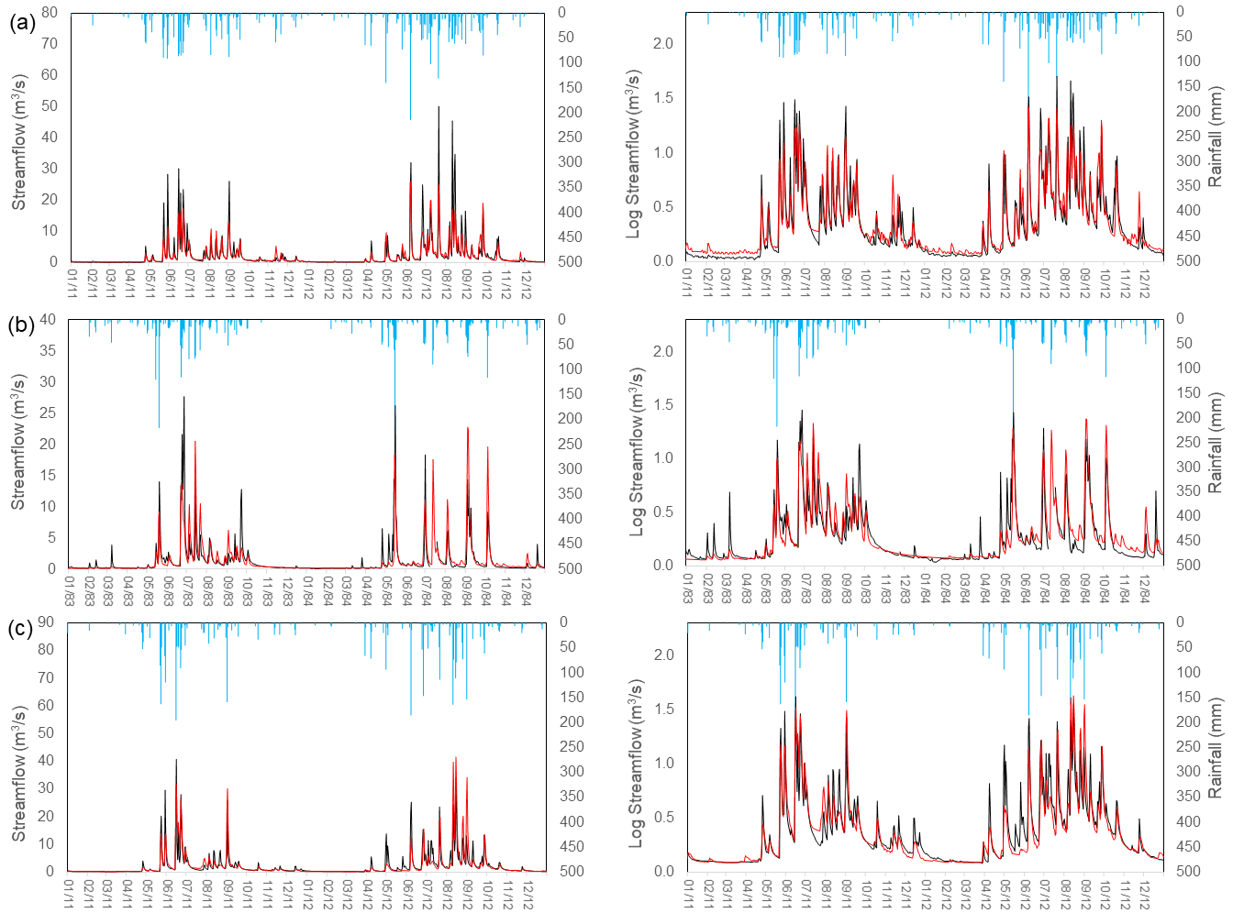
Figure S5. A two-year demonstration period of daily (left) and logged daily (right) simulated (red) and observed (black) streamflow (m³/s) for the baseline scenario (scenario 2) for three of the four case studies, the (a) Upper Berg, (b) Du Toits, and (c) Elands catchments, Western Cape, South Africa. Mean daily rainfall (blue) is shown on a secondary axis. For the Dwars River comparison to two catchment gauges, please see Figure S7.
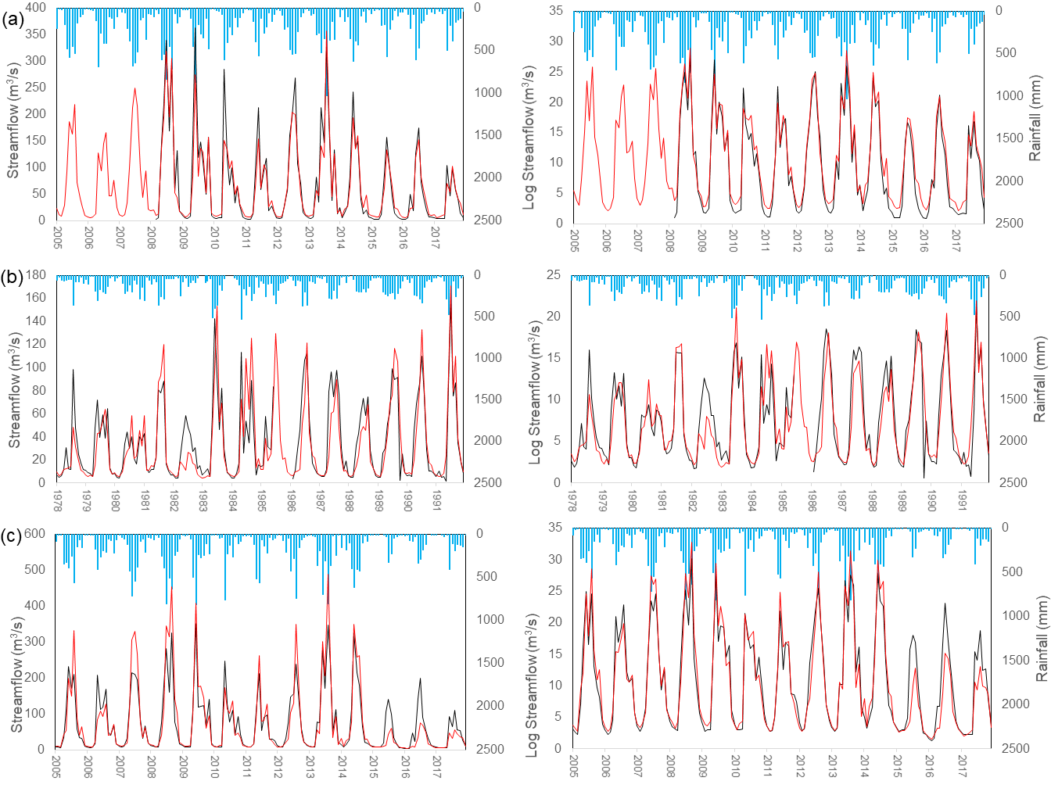
Figure S6. Monthly summed (left) and logged summed (right) simulated (red) and observed (black) streamflow (m³/s) for the baseline scenario (scenario 2) for three of the four case studies, the (a) Upper Berg, (b) Du Toits, and (c) Elands catchments, Western Cape, South Africa. Annual rainfall (blue) is displayed on a secondary axis.

Table S8. Daily streamflow statistics (m³/s) for the simulated compared to the observed for the baseline scenario (scenario 2) of the four case studies, Western Cape, South Africa. Greyed out numbers are those that do not represent a true ‘validation’ case.
Statistic | Upper Berg |  | Dwars |  | Dwars |  | Du Toits |  | Elands
Statistic | Observed | Simulated | Observed | Simulated | Observed | Simulated | Observed | Simulated | Observed | Simulated
Gauge | G1H076 |  | G1H019 |  | G1H078 |  | H6H007 |  | H1H033
Dates | 2009-2017 |  | 2005-2017 |  | 2014-2017 |  | 1971-1991 |  | 2005-2017
Years | 8 |  | 12 |  | 3 |  | 20 |  | 12
Mean | 2.02 | 1.95 | 0.38 | 1.17 | 0.65 | 1.40 | 1.18 | 1.08 | 2.38 | 2.42
difference |  | -0.07 |  | 0.79 |  | 0.75 |  | -0.10 |  | 0.04
% difference |  | -3.41 |  | 206.24 |  | 116.84 |  | -8.47 |  | 1.68
Std. dev | 4.87 | 3.46 | 0.75 | 2.21 | 1.20 | 3.56 | 2.10 | 2.04 | 4.93 | 5.57
CV | 2.41 | 1.77 | 1.95 | 1.89 | 1.86 | 2.54 | 1.77 | 1.86 | 2.07 | 2.30
Min | 0.04 | 0.16 | 0.00 | 0.07 | 0.01 | 0.00 | 0.09 | 0.14 | 0.08 | 0.12
Max | 67.35 | 45.54 | 8.54 | 21.66 | 13.40 | 36.07 | 35.90 | 24.40 | 67.03 | 78.98
r |  | 0.77 |  | - |  | - |  | 0.78 |  | 0.79
r2 |  | 0.60 |  | - |  | - |  | 0.61 |  | 0.63
PBIAS% |  | -4.40 |  | - |  | - |  | -10.1 |  | 2
RMSE |  | 3.19 |  | - |  | - |  | 1.36 |  | 3.34
MAE |  | 1.04 |  | - |  | - |  | 0.52 |  | 1.14
NSE |  | 0.59 |  | - |  | - |  | 0.58 |  | 0.52
NSE(log) |  | 0.81 |  | - |  | - |  | 0.74 |  | 0.79

Table S9. Water balance components extracted for this study, and their MIKE-SHE type and item names.
Water Balance | Category | MIKE-SHE Water Balance Type Name | Item Name
Precipitation | Precipitation | Total waterbalance | 1:Precip [millimeter]
Total Evapotranspiration | Evapotranspiration | Total waterbalance | 3:Evapotrans [millimeter]
Canopy Interception | Evapotranspiration | Canopy interception component | Evaporation
Soil Evaporation | Evapotranspiration | Unsaturated Zone | 2:Evaporation [millimeter]
Transpiration | Evapotranspiration | Unsaturated Zone | 3:Transpiration [millimeter]
Groundwater Evapotranspiration | Evapotranspiration | Saturated Zone -detailed - layer(s) | qetsz layer 1
Open Water Evaporation | Evapotranspiration | Overland flow | Evaporation
Overland Flow | Overland Flow | Total waterbalance | 9:OL->River/MOUSE [millimeter]
Interflow | Baseflow | Saturated Zone -detailed - layer(s) | qszrivpos layer 1
Deep Groundwater Flow | Baseflow | Saturated Zone -detailed - layer(s) | qszrivpos layer 2
Boundary Outflow | Outflow | Total waterbalance | 7:OL Bou.Outflow [millimeter] + 17:SubSurf.Bou.Outflow [millimeter]
Net Storage Change | Storage | Total waterbalance | 15:SubSurf.Stor.Change [millimeter]

Table S10. Percentage change in exceedance probabilities for each scenario of each of the four catchments in the Western Cape, South Africa, relative to scenario 1 (baseline) for six percentiles. The mean across all catchments and all scenarios is also given.
 | Upper Berg |  |  |  | Dwars |  |  |  | Du Toits |  |  |  | Elands |  |  |  | Mean
Scenario | 2 | 3 | 4 | 5 | 2 | 3 | 4 | 5 | 2 | 3 | 4 | 5 | 2 | 3 | 4 | 5 | Mean
5th percentile | 3.5 | 27.3 | 27.0 | 50.8 | 4.7 | 15.6 | 12.5 | 27.5 | 12.9 | 20.2 | 22.1 | 38.0 | 2.3 | 48.2 | 24.3 | 67.4 | 25.3
10th percentile | 4.4 | 28.2 | 25.1 | 50.0 | 5.6 | 16.9 | 12.0 | 27.5 | 12.4 | 20.3 | 21.5 | 38.4 | 1.6 | 40.8 | 21.2 | 56.7 | 23.9
25th percentile | 3.9 | 28.5 | 19.4 | 46.7 | 7.8 | 21.2 | 11.4 | 30.6 | 15.2 | 24.2 | 20.2 | 41.3 | 2.2 | 35.4 | 17.4 | 50.0 | 23.5
50th percentile | 3.3 | 24.8 | 7.8 | 32.0 | 18.8 | 40.1 | 6.3 | 46.2 | 14.7 | 30.5 | 12.8 | 42.6 | 1.2 | 39.6 | 8.6 | 47.9 | 23.6
75th percentile | 0.9 | 14.0 | 2.3 | 16.1 | 8.7 | 20.0 | 0.8 | 21.5 | 10.9 | 30.0 | 5.3 | 35.5 | 0.0 | 25.9 | 2.6 | 29.0 | 14.0
95th percentile | 1.8 | 11.9 | 1.8 | 13.5 | 6.7 | 14.2 | 0.7 | 15.2 | 9.0 | 28.7 | 3.0 | 31.3 | 0.0 | 23.4 | 1.0 | 24.6 | 11.7

Table S11. Correlation statistics for the annual relationship between wet and dry years for each of the four catchments in the Western Cape, South Africa.
 | Upper Berg |  |  |  | Dwars |  |  |  | Du Toits |  |  |  | Elands
 | 2 | 3 | 4 | 5 | 2 | 3 | 4 | 5 | 2 | 3 | 4 | 5 | 2 | 3 | 4 | 5
r | -0.93 | -0.94 | -0.94 | -0.95 | -0.94 | -0.95 | -0.90 | -0.95 | -0.84 | -0.84 | -0.93 | -0.88 | -0.91 | -0.89 | -0.91 | -0.91
t Statistic | -8.90 | -9.46 | -9.64 | -10.19 | -9.77 | -11.04 | -6.97 | -10.96 | -5.33 | -5.45 | -8.69 | -6.42 | -7.47 | -6.83 | -7.56 | -7.43
p Value | 1E-06 | 6E-07 | 5E-07 | 3E-07 | 5E-07 | 1E-07 | 1E-05 | 1E-07 | 2E-04 | 1E-04 | 2E-06 | 3E-05 | 8E-06 | 2E-05 | 7E-06 | 8E-06
Significance | * | * | * | * | * | * | * | * | * | * | * | * | * | * | * | *

Table S12. Area (km² and %) of riparian and terrestrial invasions for each of the five scenarios of the four case studies, Western Cape, South Africa
 | Upper Berg |  |  |  |  | Dwars |  |  |  |  | Du Toits |  |  |  |  | Elands
Scenario | 1 | 2 | 3 | 4 | 5 | 1 | 2 | 3 | 4 | 5 | 1 | 2 | 3 | 4 | 5 | 1 | 2 | 3 | 4 | 5
Riparian invasion (km²) | 0 | - | 0.0 | 6.5 | 6.5 | 0 | - | 0.0 | 2.4 | 2.4 | 0 | - | 0.0 | 4.2 | 4.2 | 0 | - | 0.0 | 4.0 | 4.0
Terrestrial invasion (km²) | 0 | - | 63.9 | 0.0 | 63.9 | 0 | - | 41.9 | 0.0 | 41.9 | 0 | - | 41.3 | 0.0 | 41.2 | 0 | - | 52.7 | 0.0 | 52.7
Total invasion (km²) | 0.0 | 6.9 | 63.9 | 6.5 | 70.4 | 0.0 | 7.1 | 41.9 | 2.4 | 44.2 | 0.0 | 18.3 | 41.3 | 4.2 | 45.4 | 0.0 | 1.1 | 52.7 | 4.0 | 56.8
Riparian invasion (%) | 0 | - | 0.0 | 8.3 | 8.3 | 0 | - | 0.0 | 3.7 | 3.7 | 0 | - | 0.0 | 9.2 | 9.2 | 0 | - | 0.0 | 6.8 | 6.8
Terrestrial invasion (%) | 0 | - | 81.5 | 0.0 | 81.5 | 0 | - | 65.5 | 0.0 | 65.5 | 0 | - | 89.2 | 0.0 | 88.9 | 0 | - | 88.4 | 0.0 | 88.4
Total invasion (%) | 0.0 | 8.8 | 81.5 | 8.3 | 89.7 | 0.0 | 11.2 | 65.5 | 3.7 | 69.2 | 0.0 | 39.6 | 89.2 | 9.2 | 98.1 | 0.0 | 1.9 | 88.4 | 6.8 | 95.1

Table S13. Area-weighted impacts on water resources of terrestrial compared to riparian invasions for each of the four case studies, Western Cape, South Africa. Terrestrial results are from scenario 3, and riparian results are from scenario 4. The overall mean ratio of the impacts of Riparian/Terrestrial invasion on water resources was 1.704.
 | Upper Berg |  | Dwars |  | Du Toits |  | Elands
Scenario | Terrestrial | Riparian | Terrestrial | Riparian | Terrestrial | Riparian | Terrestrial | Riparian
Change in mean streamflow (m³.s⁻¹.km⁻²) | 0.008 | 0.016 | 0.009 | 0.014 | 0.007 | 0.013 | 0.010 | 0.015
Change in mean annual volume (Mm³.km⁻²) | 0.265 | 0.518 | 0.277 | 0.442 | 0.228 | 0.419 | 0.321 | 0.458
Change in mean annual runoff (mm.km⁻²) | 3.064 | 5.996 | 3.204 | 5.121 | 2.645 | 4.850 | 3.720 | 5.304
% Change | 0.20 | 0.39 | 0.390 | 0.623 | 0.612 | 1.122 | 0.426 | 0.608
Ratio (Riparian/Terrestrial) |  | 1.957 |  | 1.598 |  | 1.834 |  | 1.426

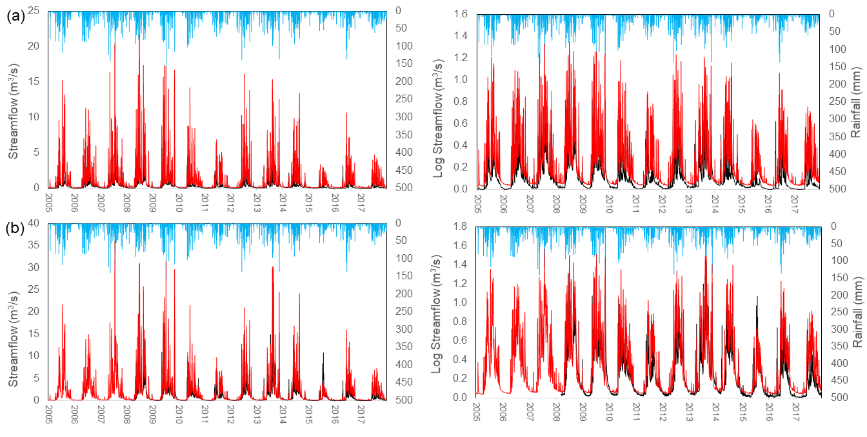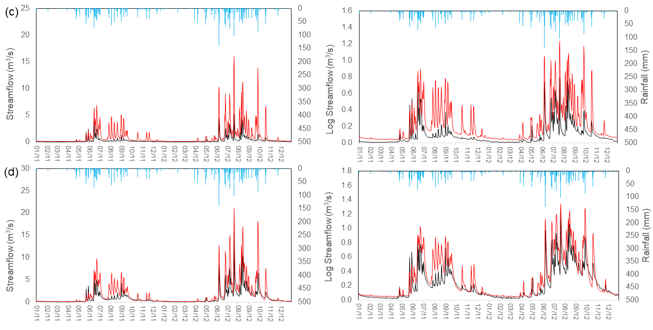
Figure S7. Rainfall (blue) as well as streamflow (left) and logged streamflow (right) (m³/s) for simulated (red) compared to observed (black) for the baseline scenario (scenario 2) for the Dwars catchment, Western Cape, South Africa. (a) mean daily values at gauge G1H019, (b) mean daily values at gauge G1H078, (c) a two-year demonstration period of mean daily values at gauge G1H019, and (d) a two-year demonstration period of mean daily values at gauge G1H078.
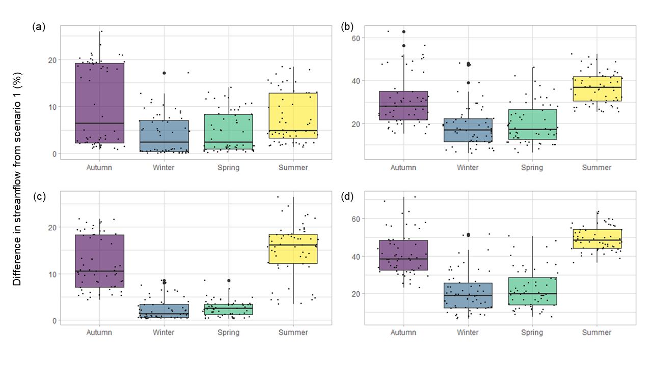
Figure S8. Box-and-whisker plots for seasonal differences in the percentage difference in streamflow (%) for 14 years (2005-2018) between ecological infrastructure scenarios 2-5 and the baseline (scenario 1) for winter and summer for the four case studies, the Upper Berg, Dwars, Du Toits, and Elands catchments, Western Cape, South Africa. Data are subset by scenarios: (a) Scenario 2, (b) Scenario 3, (c) Scenario 4, and (d) Scenario 5. Data are shows as points, and outliers as dots.

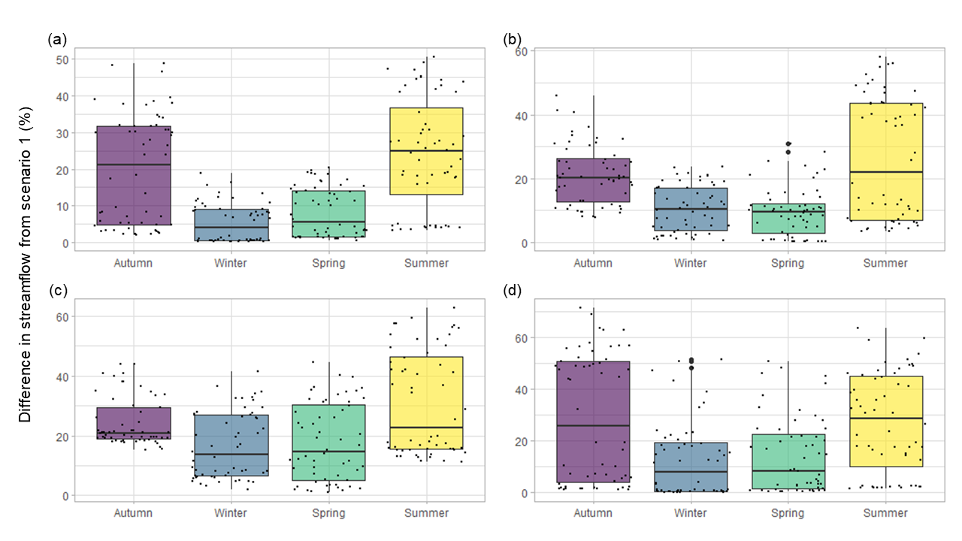
Figure S9. Box-and-whisker plots for seasonal differences in the percentage difference in streamflow (%) for 14 years (2005-2018) between ecological infrastructure scenarios 2-5 and the baseline (scenario 1) for winter and summer for the four case studies, Western Cape, South Africa. Data are subset by catchment: (a) the Upper Berg, (b) Dwars, (c) Du Toitsand (d) Elands. Data are shows as points, and outliers as dots.

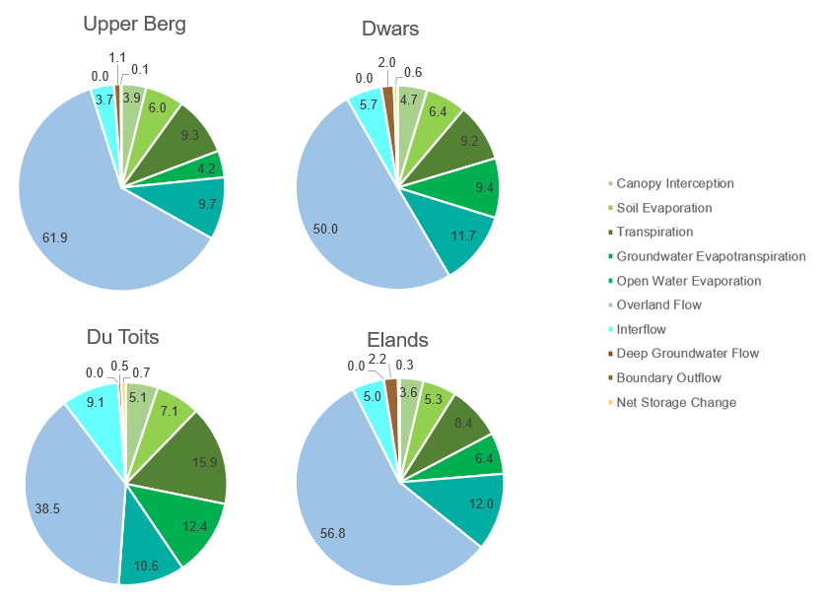
Figure S10. Detailed water balances (expressed as % of rainfall) for the period 2005 to 2018 for scenario 1 (no invasive alien trees) for each of the four case studies in the Western Cape, South Africa.

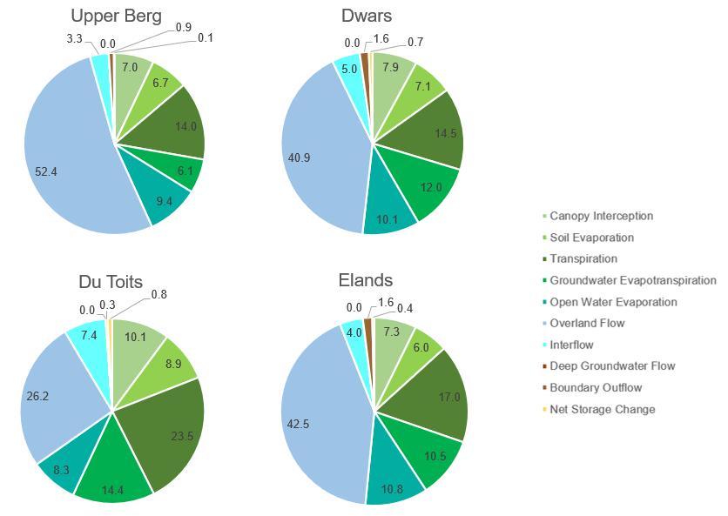
Figure S11. Detailed water balances (expressed as % of rainfall) for the period 2005 to 2018 for scenario 5 (fully invaded with invasive alien trees) for each of the four case studies, Western Cape, South Africa.
Table S14. Water balances (in mm per annum and % of rainfall) for the period 2005 to 2018 for scenarios 1 and 5 the four case studies, Western Cape, South Africa
 |  | Upper Berg |  | Dwars |  | Du Toits |  | Elands
 | Water Balance | mm | % | mm | % | mm | % | mm | %
Scenario 1 | Precipitation | 2594.5 | 100.0 | 1998.7 | 100.0 | 1695.1 | 100.0 | 2044.8 | 100.0
Scenario 1 | Total ET | 860.0 | 33.1 | 828.5 | 41.5 | 866.4 | 51.1 | 730.5 | 35.7
Scenario 1 | Canopy Interception | 100.7 | 3.9 | 93.3 | 4.7 | 87.3 | 5.1 | 74.5 | 3.6
Scenario 1 | Soil Evaporation | 156.7 | 6.0 | 128.6 | 6.4 | 120.4 | 7.1 | 107.6 | 5.3
Scenario 1 | Transpiration | 241.1 | 9.3 | 183.6 | 9.2 | 270.2 | 15.9 | 171.0 | 8.4
Scenario 1 | Groundwater Evapotranspiration | 108.5 | 4.2 | 188.1 | 9.4 | 209.4 | 12.4 | 131.3 | 6.4
Scenario 1 | Open Water Evaporation | 252.9 | 9.7 | 234.8 | 11.7 | 179.1 | 10.6 | 246.1 | 12.0
Scenario 1 | Overland Flow | 1607.2 | 61.9 | 1000.1 | 50.0 | 653.3 | 38.5 | 1162.0 | 56.8
Scenario 1 | Interflow | 96.2 | 3.7 | 112.9 | 5.7 | 154.8 | 9.1 | 102.0 | 5.0
Scenario 1 | Deep Groundwater Flow | 0.0 | 0.0 | 0.0 | 0.0 | 0.0 | 0.0 | 0.0 | 0.0
Scenario 1 | Boundary Outflow | 27.3 | 1.1 | 39.2 | 2.0 | 9.0 | 0.5 | 44.2 | 2.2
Scenario 1 | Net Storage Change | 2.6 | 0.1 | 12.4 | 0.6 | 11.5 | 0.7 | 6.0 | 0.3
Scenario 5 | Precipitation | 2594.5 | 100.0 | 1998.7 | 100.0 | 1695.1 | 100.0 | 2044.8 | 100.0
Scenario 5 | Total ET | 1120.9 | 43.2 | 1030.8 | 51.6 | 1105.9 | 65.2 | 1053.7 | 51.5
Scenario 5 | Canopy Interception | 182.8 | 7.0 | 158.1 | 7.9 | 171.7 | 10.1 | 148.4 | 7.3
Scenario 5 | Soil Evaporation | 174.8 | 6.7 | 142.5 | 7.1 | 151.2 | 8.9 | 123.2 | 6.0
Scenario 5 | Transpiration | 362.6 | 14.0 | 289.9 | 14.5 | 398.9 | 23.5 | 347.5 | 17.0
Scenario 5 | Groundwater Evapotranspiration | 158.1 | 6.1 | 238.9 | 12.0 | 243.8 | 14.4 | 214.0 | 10.5
Scenario 5 | Open Water Evaporation | 242.6 | 9.4 | 201.5 | 10.1 | 140.4 | 8.3 | 220.6 | 10.8
Scenario 5 | Overland Flow | 1359.5 | 52.4 | 816.7 | 40.9 | 444.2 | 26.2 | 868.6 | 42.5
Scenario 5 | Interflow | 86.6 | 3.3 | 99.2 | 5.0 | 125.5 | 7.4 | 81.8 | 4.0
Scenario 5 | Deep Groundwater Flow | 0.0 | 0.0 | 0.0 | 0.0 | 0.0 | 0.0 | 0.0 | 0.0
Scenario 5 | Boundary Outflow | 23.5 | 0.9 | 31.6 | 1.6 | 5.7 | 0.3 | 32.6 | 1.6
Scenario 5 | Net Storage Change | 2.6 | 0.1 | 13.0 | 0.7 | 13.7 | 0.8 | 7.5 | 0.4

