Supporting Material

Catch the next designer drug: bioactivity data derived pharmacological affinity fingerprints and performance in similarity searching and unsupervised clustering

Kedan He*

*Eastern Connecticut State University, Physical Sciences, 83 Windham St, Willimantic, CT, USA.
*Corresponding author: hek@easternct.edu

GitHub repository

For datasets and python codes used in this study, please go to the following GitHub repository:
https://github.com/nina23bom/NPS-Pharmacological-profile-fingerprint-prediction-using-ML

Clustering analysis and validation indices

Silhouette analysis measures the optimal depth of a specified clustering method. It assesses how well each sample $x^{(i)}$ belongs to its assigned cluster $C_{p}$. Each individual Silhouette number is evaluated as:
$$s^{(i)}=\frac{{\overline{x}}_{C_{q}}^{(i)}-{\overline{x}}_{C_{p}}^{(i)}}{max⁡({\overline{x}}_{C_{q}}^{\left(i\right)},{\overline{x}}_{C_{p}}^{(i)})} (1)$$
Where $C_{q}$ represents the closest cluster to each $C_{p}$. At each depth on the dendrogram, the average silhouette number is evaluated across all samples and calculated as $\overline{s}=\frac{1}{N}\sum_{i=1}^{N}{s^{(i)}}$.

External indices measure the similarity between the output of the clustering algorithm and the correct partitioning of the dataset. Different clustering trees were compared with each other using the adjusted Rand-Index (ARI). Let $U=\left\{u_{1},u_{2},…{,u}_{R}\right\}$ and $V=\left\{v_{1},v_{2},…,v_{C}\right\}$ represent the external cluster label and that determined by the cluster algorithm, $n_{ij}$ is the number of objects belonging to both subset ${,u}_{R}$ and $v_{j}$, the ARI is calculated:
$$ARI= \frac{\sum_{i,j}{\left(\begin{matrix}n_{ij} \\ 2\end{matrix}\right)-\frac{\left[\sum_{i}{\left(\begin{matrix}n_{i.} \\ 2\end{matrix}\right)}\sum_{j}{\left(\begin{matrix}n_{.j} \\ 2\end{matrix}\right)}\right]}{\begin{matrix}n \\ 2\end{matrix}}}}{1/2\left[\sum_{i}{\left(\begin{matrix}n_{i.} \\ 2\end{matrix}\right)}+\sum_{j}{\left(\begin{matrix}n_{.j} \\ 2\end{matrix}\right)}\right]-\frac{\left[\sum_{i}{\left(\begin{matrix}n_{i.} \\ 2\end{matrix}\right)}\sum_{j}{\left(\begin{matrix}n_{.j} \\ 2\end{matrix}\right)}\right]}{\begin{matrix}n \\ 2\end{matrix}}} (2)$$
When two sets of cluster labels have a perfect one-to-one correspondence, the ARI equal to unity. The normalized mutual information (NMI) quantifies the mutual dependence between two random variables based on concepts of information theory:
$$NMI\left(C_{i},C_{j}\right)=\frac{I\left(C_{i},C_{j}\right)}{\sqrt{\left[H\left(C_{i}\right),H\left(C_{j}\right)\right]}} (3)$$
where $C_{i}$ and $C_{j}$ are cluster assignments of the points generated from feature subsets of feature selector $i$ and $j$, respectively. Mutual information $I(C_{i},C_{j})$ is given as $H\left(C_{i}\right)-H\left(C_{i} | C_{j}\right)$. $H(C)$ is the Shannon entropy of C, and $H\left(C_{i} | C_{j}\right)$ is the conditional entropy of $C_{i}$ given $C_{j}$. NMI = 0 mean two partitions contain no information about one another, whereases NMI = 1 indicates two partitions contain perfect information about one another.

Maximum Common Substructure (MCS) based external class label

The MCS Tanimoto similarity coefficient ($T_{MCS}$) is calculated only on the matched heavy atoms as described:
$$T_{MCS}=\frac{N_{C}}{N_{A}+N_{B}-N_{C}} \left(4\right)$$
where $N_{C}$ is the number of matched heavy atoms in MCS of molecule A and B, $N_{A}$ and $N_{B}$ are the number of heavy atoms in molecule A and B, respectively.
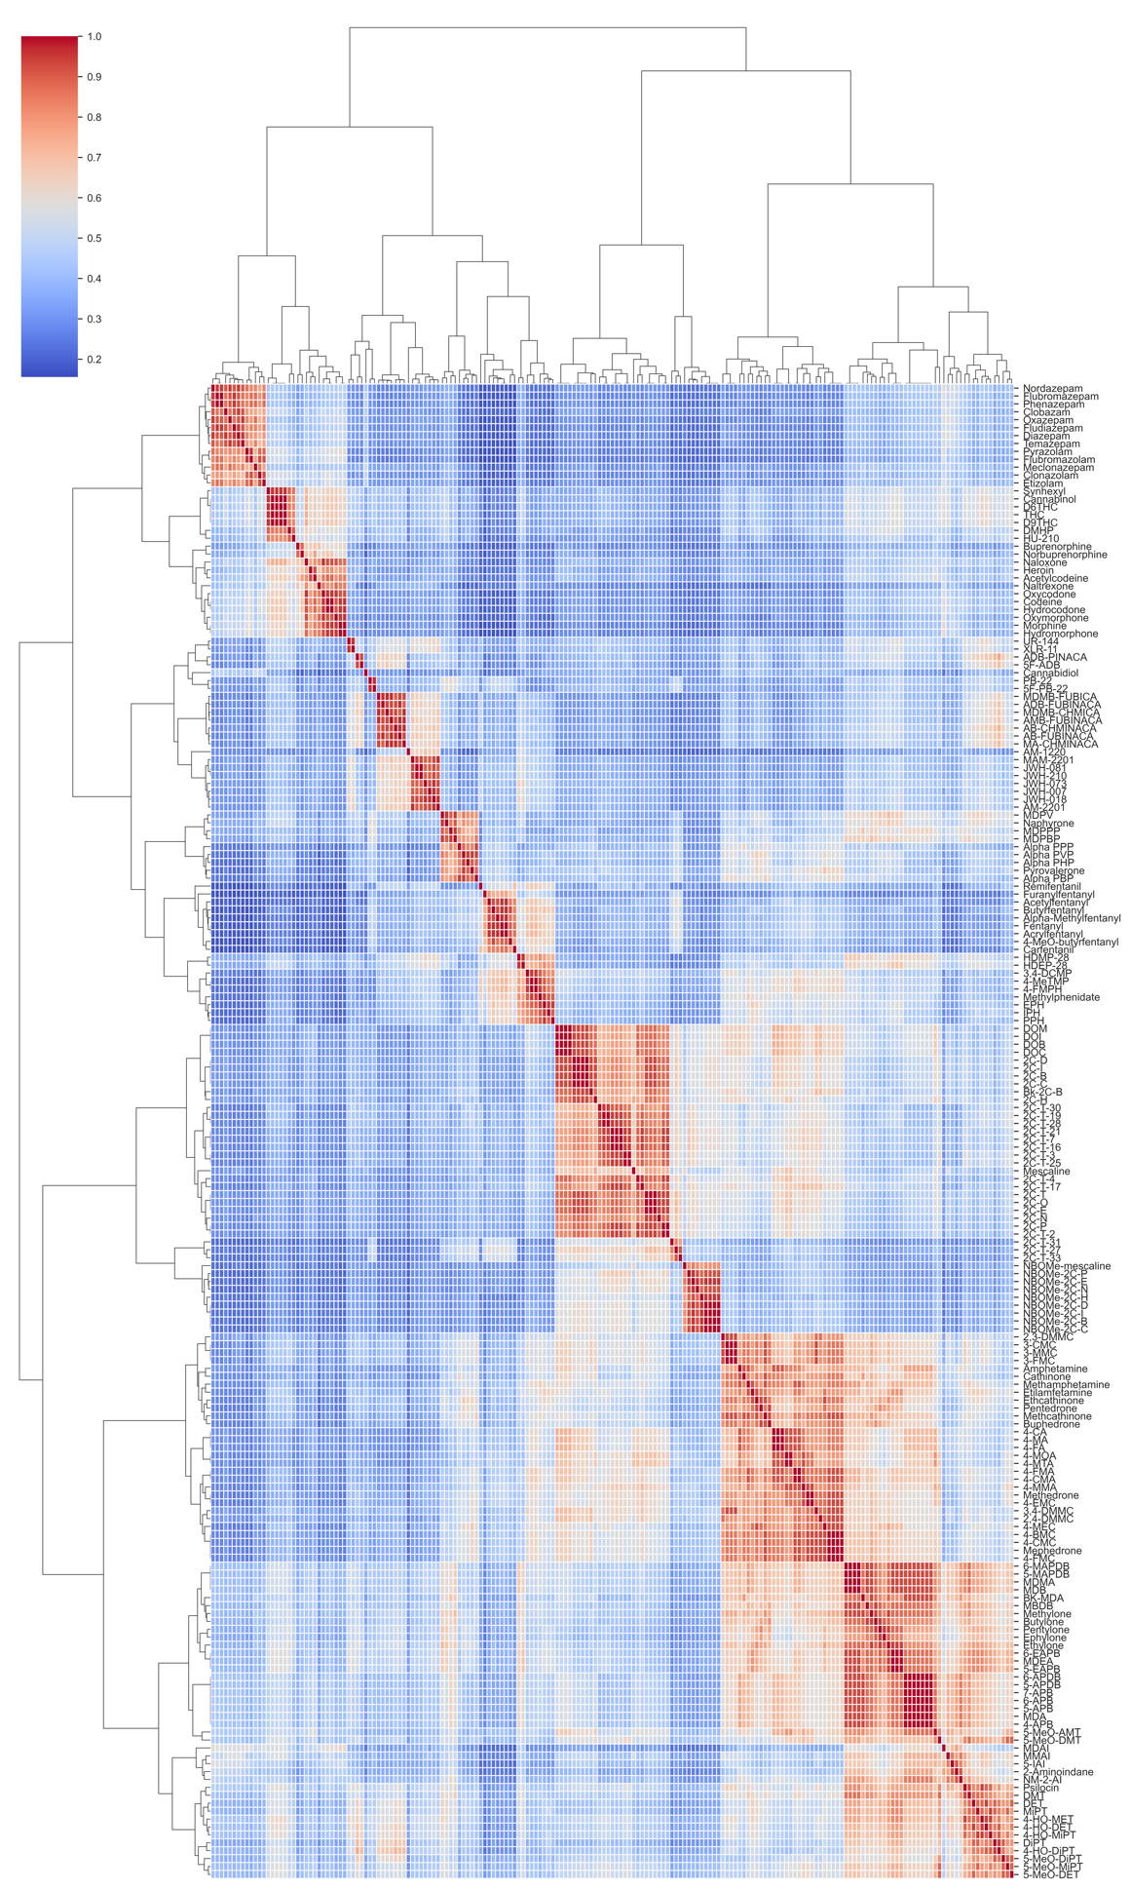
Fig. S1 Heatmap of the MCS clustering of NPS set compounds

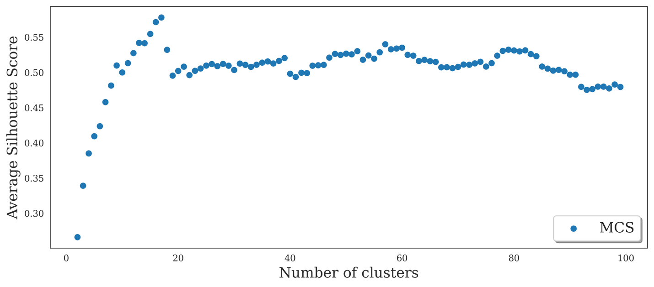
Fig. S2 Silhouette analysis for determining optimal clusters K of the MCS clustering of NPS set compounds

