Supplemental information for

Uridine, a sustainable insulin secretagogue, inhibits UDP-glucose and cereblon dependent proinsulin degradation

This pdf file includes:
Abbreviations
Supplementary Figure S1 to 6

Abbreviations
CRBN, cereblon
CRL4, cullin ring ubiquitin ligase 4
CUL4, cullin 4
DDB1, damage-specific DNA binding protein 1
ER, endoplasmic reticulum
ERAD, ER-associated protein degradation
ERRS, ER-retention signal
GCK, glucokinase
GLUT, glucose transporter
HOMAβ, homeostatic model assessment of β cells
HRD1, HMG-CoA reductase degradation 1
IC₅₀, half maximal (50%) inhibitory concentration
IP, immunoprecipitation
MODY, maturity-onset diabetes of the young
TCA cycle, tricarboxylic acid cycle
UGGT, UDP-glucose:glycoprotein glucosyltransferase
UPR, unfolded protein response
WB, Western blot
WT, wild type

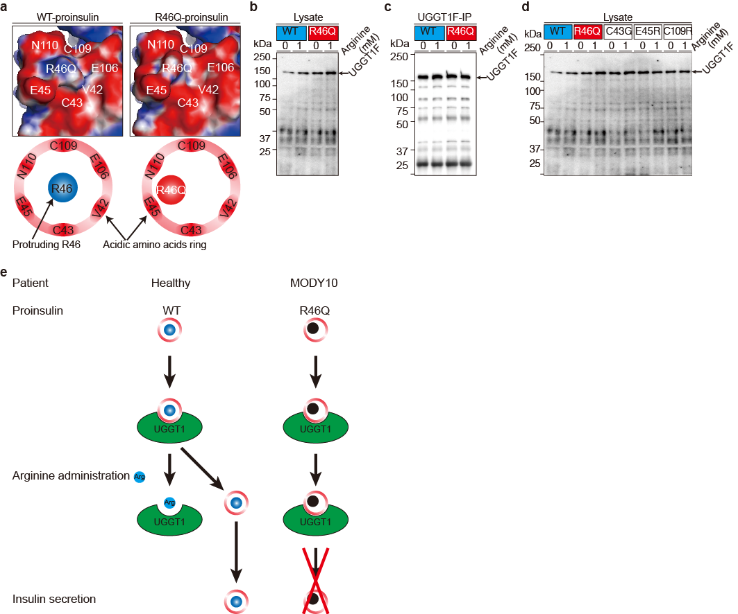
Supplementary Figure S1. R46 residue of proinsulin is involved in arginine-induced insulin secretion (Supplementary data for Fig. 1).
(S1a) The predicted structure of R46 (WT) and R46Q proinsulin.
(S1b and c) Intracellular proinsulin and UGGT1 were analyzed by WB (c and Fig. S1b). Proinsulin bound to UGGT1 was assessed by IP of UGGT1 followed by IP-WB (Fig. 1d and Fig. S1c).
(S1d) Proinsulin was immunoprecipitated and blotted for UGGT1 (c, d, Fig. S1b, S1c and S1d).
(S1e) Possible model of arginine-induced R46Q secretion.
WT-insulin binds to UGGT1, and is retained in the ER. Arginine administration releases proinsulin from UGGT1 in a competitive manner.
On the other hands, R46Q proinsulin binds to UGGT1 like WT-proinsulin in the absence of arginine. Arginine administration has no effect on the R46Q and UGGT1 interaction, leading to less induced R46Q secretion by arginine.

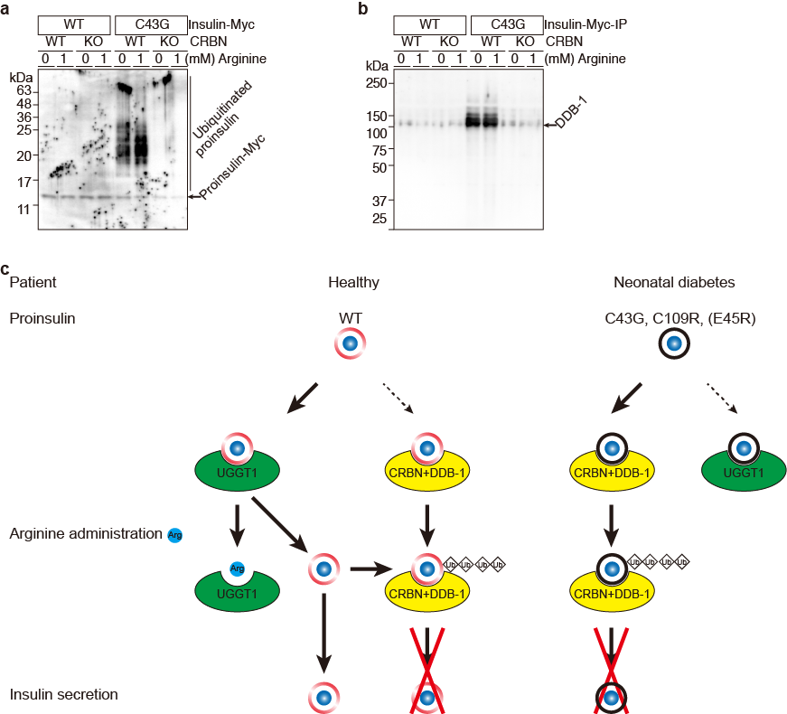
Supplementary Figure 2. Impaired UGGT1-interaction in C43G-neonatal diabetes variant (Supplementary data for Figure 2).
(S2a and S2b) Ubiquitination of Insulin^{C43G} protein and association with DDB1 was observed only in CRBN^{WT} cells (Fig. 2d, e, Fig. S2a and S2b).
(f) Summary of interaction of insulin (R46Q and C43G variants) with UGGT1 and CRBN in the presence and absence of arginine.

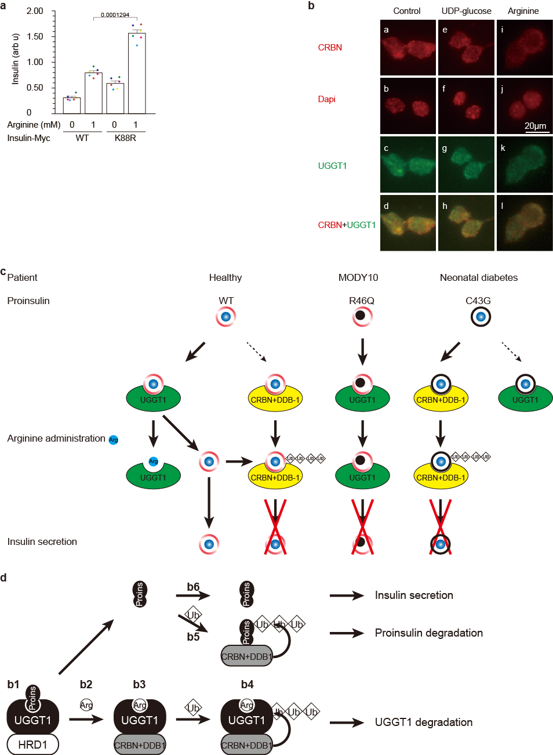
Supplementary Figure S3. Arginine switches proinsulin associated E3 ubiquitin ligases from HRD1 to CRBN. (Supplementary data for Fig. 3).
(S3a) CRBN co-locates with UGGT1 in the ER. The NIT1 cells treated with control, UDP- (S3b) CRBN co-locates with UGGT1 in the ER. The NIT1 cells treated with control, UDP-glucose, and arginine were visualized with anti-CRBN (red color), Dapi (red color), UGGT1 (green color). Co-localized CRBN and UGGT1 merged into orange color.
(S3b) Possible model of arginine-induced WT, R46Q and C43G-insulin secretion.
(Healthy) WT-proinsulin; in the absence or low concentration of arginine, WT-proinsulin binds to UGGT1 mainly. Arginine administration releases proinsulin from UGGT1. Free proinsulin partially binds to CRBN and DDB1 for ubiquitination, and the rest free proinsulin will be secreted.
(MODY10) R46Q-proinsulin; in the absence of arginine R46Q binds to UGGT1, although arginine administration has no effect on the R46Q-UGGT1 interaction, leading less arginine-induced R46Q secretion.
(Neonatal diabetes) C43G-proinsulin; in the absence and presence of arginine C43G binds mainly to CRBN and DDB1 and is ubiquitinated.
(S3c) Possible model of arginine-induced insulin secretion with inhibition of proinsulin ubiquitination and degradation.
(b1) In the absence or low concentration of arginine, proinsulin binds to UGGT1 and HRD1.
(b2) Arginine administration triggers proinsulin releasing from UGGT1 and HRD1 complex.
(b3) Proinsulin-free UGGT1 is also release from HRD1 and binds to arginine, CRBN and DDB1.
(b4) This arginine-UGGT1-CRBN-DDB1 complex leads to UGGT1 ubiquitination.
(b5) A half of free proinsulin binds to CRBN and DDB1 with unknown endogenonus ligand X, and is ubiquitinated and degraded.
(b6) The rest half proinsulin is secreted.

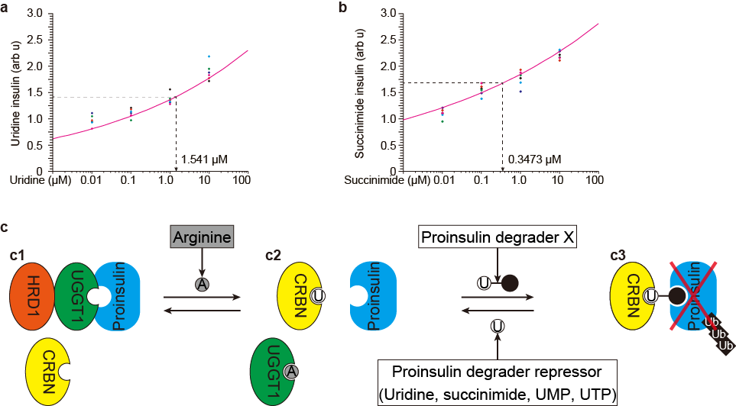
Supplementary Figure S4. Uridine and succinimide protect proinsulin degradation from CRBN and stimulate insulin secretion from 3h to 24h. (Supplementary data for Fig. 4).
(S4a) Uridine stimulates insulin secretion. IC₅₀ = 1.541 uM
(S4b) Succinimide stimulates insulin secretion. IC₅₀ = 0.3473 uM
(S4c) Possible model insulin secretion.
(c1) In the absence or low concentration of arginine, proinsulin binds to UGGT1 and HRD1.
(c2) Arginine binds to UGGT1, and proinsulin releases from UGGT1. Uridine binds to CRBN to mask the interaction with proinsulin
(c3) Proinsulin degrader X interacts with CRBN and proinsulin, and proinsulin was ubiquitinated and degraded.

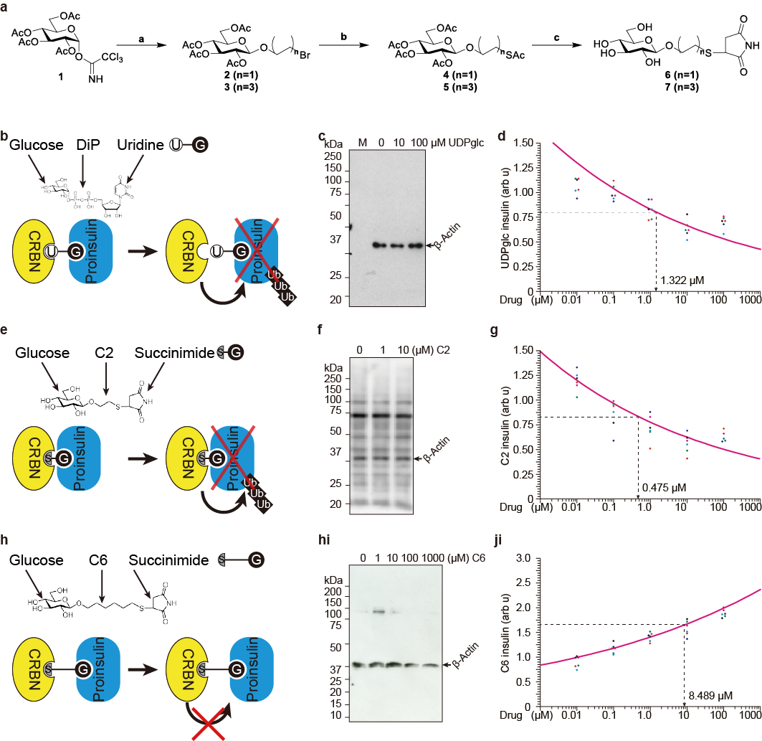
Supplementary Figure S5. UDP-glucose is endogenous proinsulin protein degrader through CRBN (Supplementary data for Fig. 5).
(S5a) Synthesis of glucose conjugated maleimide by thiol–ene click reaction
Synthesis of glucose conjugated maleimide. aReagents and conditions: (a) 2-bromoethanol, BF3-Et2O, CH2Cl2, −40 °C, 30 min, 66% (for 2); 6-bromohexanol, BF3-Et2O, CH2Cl2, −40 °C, −30 min, −20 °C, 30 min, and then 0 °C, 30 min, 66% (for 3); (b) AcSH, K2CO3, DMF, r.t., 12 h, 99% (for 4); AcSH, K2CO3, DMF, r.t., 17.5 h, 83% (for 5); (c) (i) NaOMe−MeOH, r.t., 1 h, (ii) Maleimide, Et3N, MeOH, r.t., 1 h, 81 % (for 6); (i) NaOMe−MeOH, r.t., 2.5 h, (ii) Maleimide, Et3N, MeOH, r.t., 1 h, 72 % (for 7).
(S5b-d) UDP-glucose degrades proinsulin at IC₅₀ = 1.322 uM
(S5e-g) Suciinimide-C2-glucose degrades proinsulin at IC₅₀ = 0.475 uM
(S5h-j) Suciinimide-C6-glucose protects proinsulin degradation at IC₅₀ = 8.489 uM

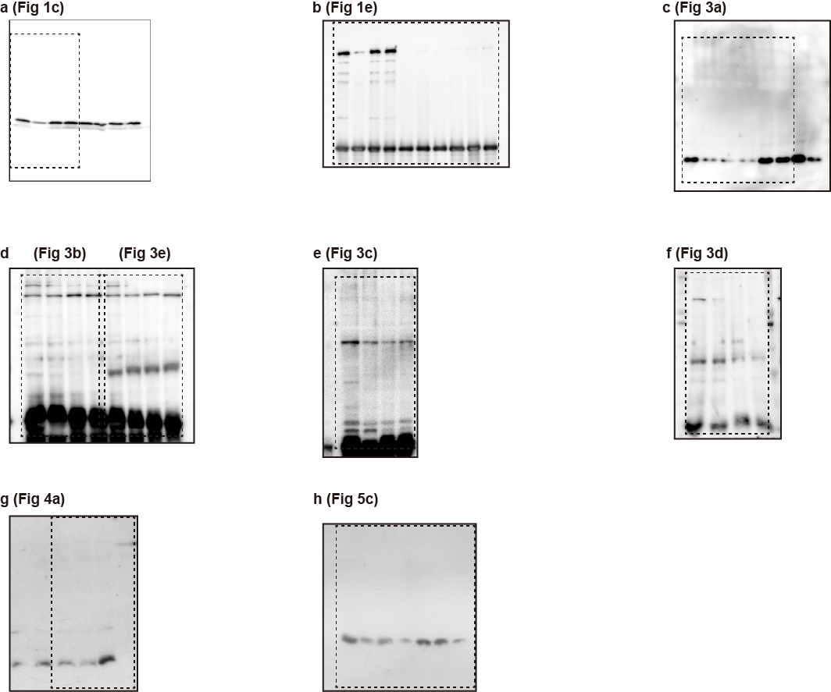
Figure S6 Source data

