Supplementary Material
Supplementary Table 1. Participant characteristics.
ID | Age | Sex | Handedness | Seizure Focus | BMI | Sweet-fat Solution Rating | Preferred Sweet-fat over Neutral? | Number of Contacts
 |  |  |  |  |  |  |  | dlHPC | Non-dlHPC
S1 | 59 | M | R | Bitemporal | 26 | 5/10 | Yes | 2(L) 2(R) | 3(L) 2(R)
S2 | 34 | F | R | L. Lateral Temporal | 32 | 3/10 | Yes | 2(L) | 1(L) 2(R)
S3 | 24 | M | R | R. Mesial Temporal | 51 | 3/10 | Yes | 4(R) | 0
S4 | 49 | M | R | L. Frontal and L. Mes. Temporal | 31 | 8/10 | Yes | 1(L) | 2(L)
S5 | 51 | M | R | L. Mesial Temporal | 27 | 10/10 | Yes | 2(L) 6(R) | 1 (L) 2 (R)
S6 | 20 | M | R | R. Parietal/Occipital | 19 | 5/10 | Yes | 2(L) | 0
S7 | 27 | M | R | R. Parietal | 24 | 8/10 | Yes | 1(L) | 1(L)
S8 | 36 | M | R | Bitemporal | 23 | 7/10 | Yes | 2(L) 4(R) | 4(L)
S9 | 29 | F | R | R Frontal Dysplasia | 41 | 3/10 | Yes | 5(L) 4(R) | 1(L) 1(R)

Supplementary Table 2. Summary of MRI acquisition parameters.
 | HCP Dataset | Binge-eating Cohort
Data Type | Diffusion | Diffusion | Structural (T1w) | Resting-state
Magnetic Field | 7T | 3T | 3T | 3T
Sequence | Spin-Echo EPI | Spin-Echo EPI | BRAVO | SPIRAL
TE / TR (ms) | 71.2 / 7000 | 97.5 / 12800 | 1.87 / 5.8 | 30 / 2000
Flip Angle (°) | 90 | 90 | 11 | 80
Field-of-View (mm²) | 210 | 220 | 230 | 220
Matrix Size | 200 (acquisition) x 200 (recon) | 128 (acquisition) x 256 (recon) | 192 (acquisition) x 256 (recon) | 128 (acquisition) x 64 (recon)
In-plane Res. (mm²) | 1.05x1.05 | 0.8594x0.8594 | 0.9375x0.9375 | 3.4x3.4
Slice Thickness (mm) | 1.05 | 2.3 | 1.2 | 3.5
Number of Slices | 132 Axial | 74 Axial | 146 Axial | 31 Axial
Runs | 4 | 1 | 1 | 1
Acquisition Time (min) | 9:50 (39:20 total) | 15:23 | 8:40 | 8:00
Diffusion Encoding (s/mm²) | 6 × b=0  65 dir. × b=1000,  65 dir. × b=2000 | 1 × b=0  37 dir. × b=1000 | N/A | N/A

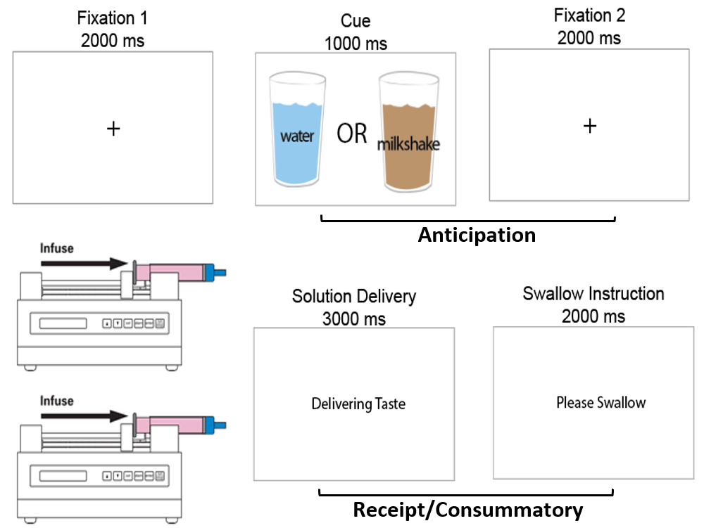
Supplementary Figure 1. Sweet-fat incentive paradigm design and intracranial recordings. Each trial in this paradigm began with a 2-sec presentation of fixation cross (pre-stimulus period). This was followed by a 1-sec presentation of a drawing of a glass representative of either a taste-neutral or a sweet-fat solution, which served as a cue for the solution to be subsequently delivered. A 2-sec presentation of a fixation cross then preceded delivery of the solution. Following the anticipatory period is a 5-sec receipt/consummatory period, consisting of a 3-sec solution delivery period followed by a 2-sec consumption of solution period.
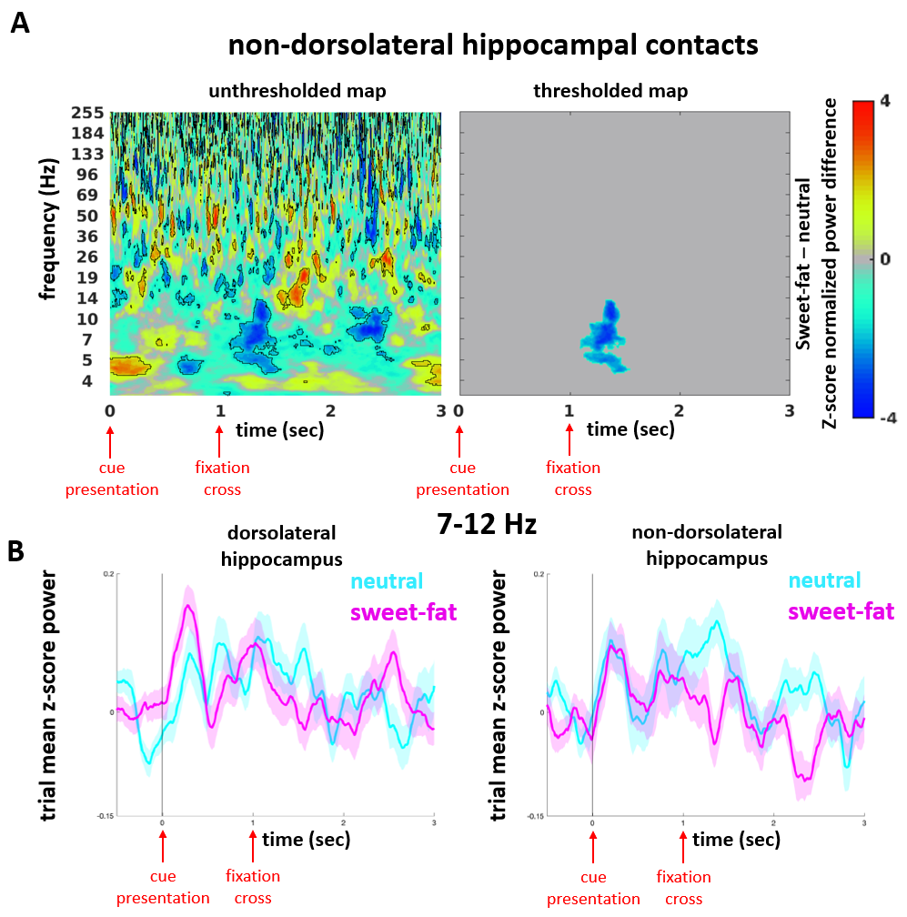
Supplementary Figure 2. Non-dorsolateral hippocampal spectral content during food anticipation. (A) Z-score normalized difference spectrograms (sweet-fat - neutral item) in the non-dorsolateral hippocampus (non-dlHPC) before (left spectrogram) and after (right spectrogram) correction for multiple comparisons. Color bar indicates mean z-score power difference (using pooled channels as observations) between the two conditions compared to a null distribution. Outlined clusters (left spectrogram) reflect significant contiguous time-frequency voxels (p < 0.05, cluster-based permutation testing, 1000 permutations) before correction for multiple comparisons. Thresholded map displays significant time-frequency cluster (~ 7-12 Hz) after correction for multiple comparisons. Note the absence of a ~4-6 Hz cluster in the thresholded map. (B) 7-12 Hz Hz mean z-score power time traces in the dlHPC (left traces) and non-dlHPC (right traces) hippocampal sites, respectively. 0-time indicates cue presentation. Note that while 7-12 Hz power is recruited in both subregions, condition specificity to water at this frequency range is only observed in non-dlHPC.
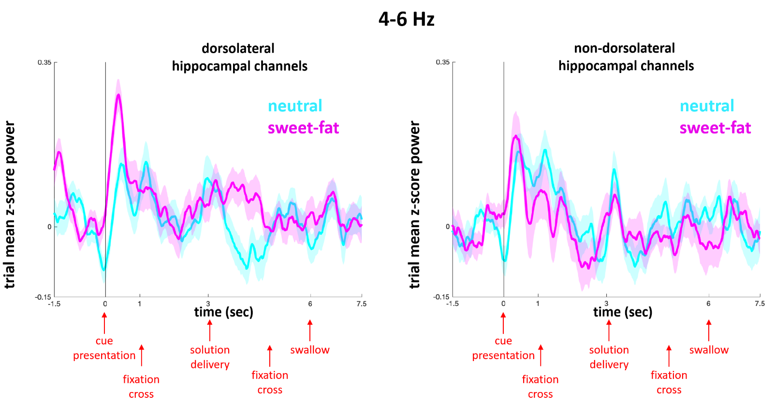Supplementary Figure 3. 4-6 Hz power time course throughout the entirety of the trial. 4-6 Hz mean z-score power time traces in the dlHPC (left traces) and non-dlHPC (right traces) hippocampal sites, respectively. The time interval displayed includes the pre-cue period (-1.5 to 0 sec), cue presentation (0-1 sec), fixation cross (1-3 sec), solution delivery (3-5 sec), fixation cross (5-6 sec), and a portion of solution receipt (6-7.5 sec). Note increased 4-6 Hz power for sweet-fat solution is specific to the dorsolateral contacts during both cue presentation and solution delivery (indicated by star).

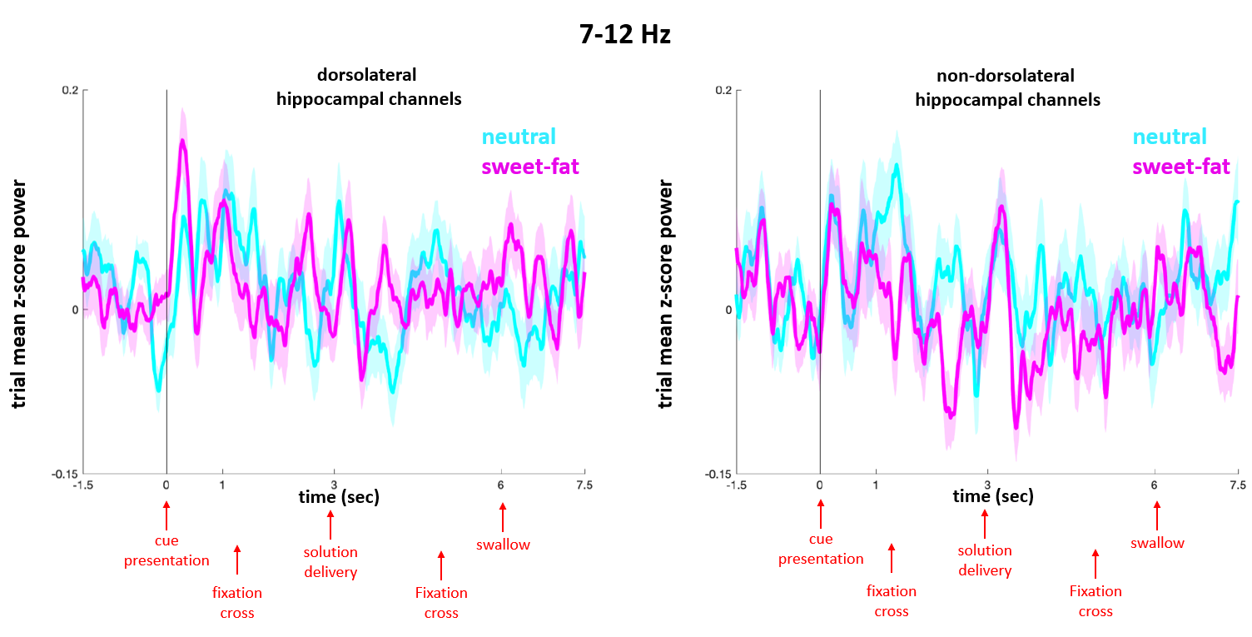Supplementary Figure 4. 7-12 Hz power time course throughout the entirety of the trial.7-12 Hz mean z-score power time traces in the dlHPC (left traces) and non-dlHPC (right traces) hippocampal sites, respectively. The time interval displayed includes the pre-cue period (-1.5 to 0 sec), cue presentation (0-1 sec), fixation cross (1-3 sec), solution delivery (3-5 sec), fixation cross (5-6 sec), and a portion of solution receipt (6-7.5 sec). Note that increased 7-12 Hz power for water solution is specific to non-dorsolateral contacts during the post-cue fixation period (indicated by star).

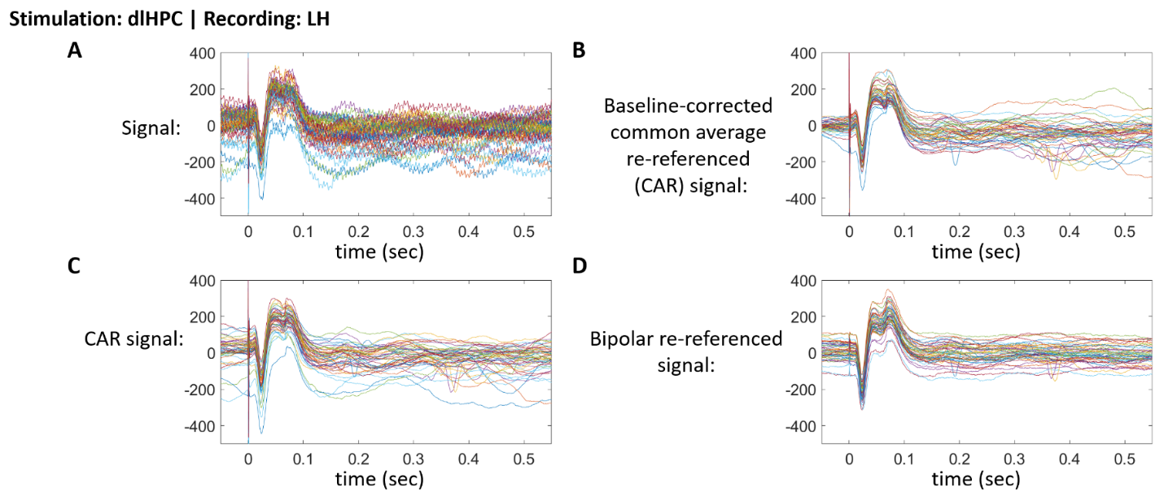
Supplementary Figure 5. Time series from single trials of dlHPC-LH evoked potentials recorded in the LH in response to single-pulse stimulation of a pair of sweet-fat-responsive, dlHPC electrodes. Each color lines represent signal traces for a single stimulation trial (n=49) visualized after different steps of pre-processing: (A) after applying high-pass filter, (B) common average re-referencing (CAR) with baseline-correction, (C) CAR without baseline correction, and (D) bipolar re-referencing without baseline correction.
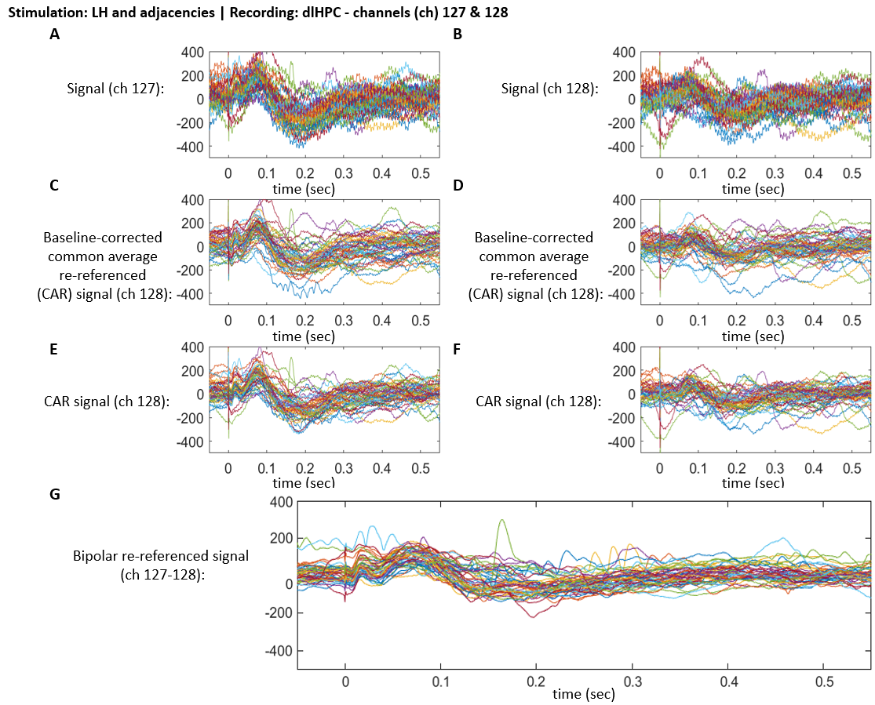Supplementary Figure 6. Time series from single trials of LH-dlHPC evoked potentials recorded in two sweet-fat-responsive, dlHPC channels (ch), identified as ch 127 and ch 128, in response to single-pulse stimulation of a pair of ipsilateral electrodes in LH area. Each color lines represent signal traces for a single stimulation trial (n=49) visualized after different steps of pre-processing: (A, B) after applying high-pass filter, (C, D) common average re-referencing (CAR) with baseline-correction, (E, F) CAR without baseline correction, and (G) bipolar re-referencing without baseline correction.
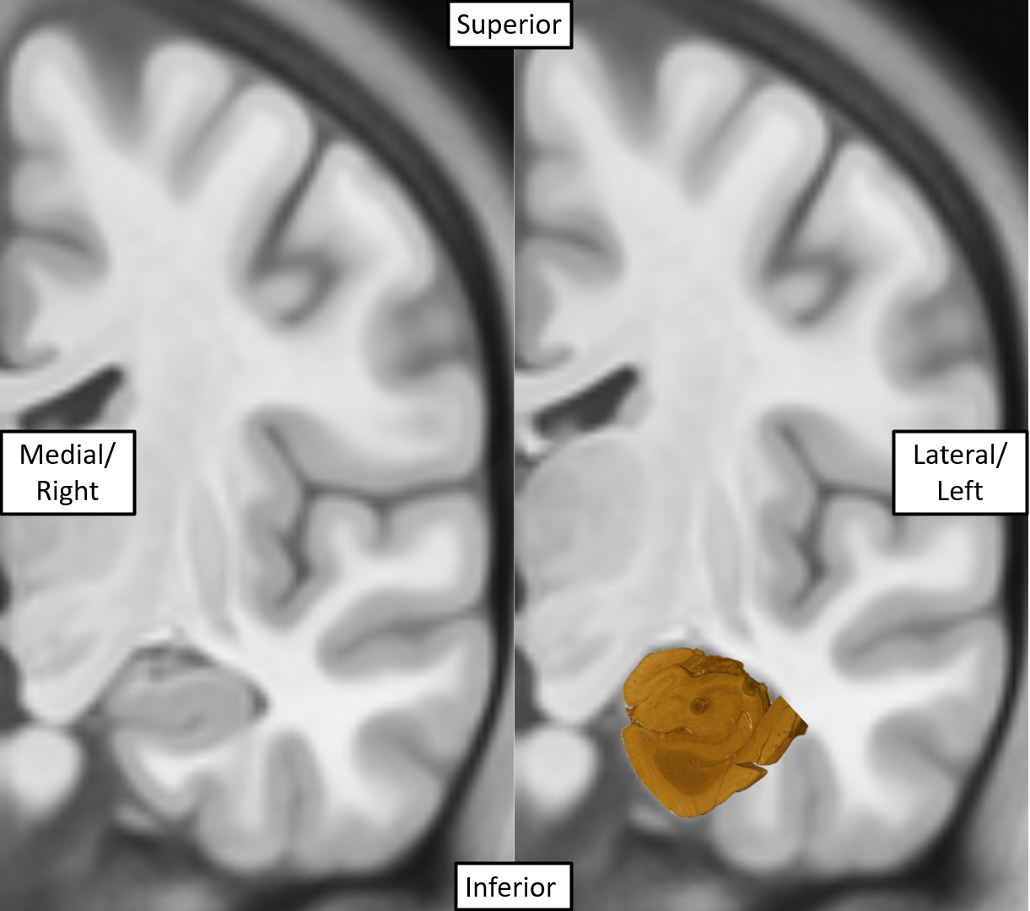
Supplementary Figure 7. Manual localization of the post-mortem hippocampal sample in a coronal slice of the MNI 09c brain template.

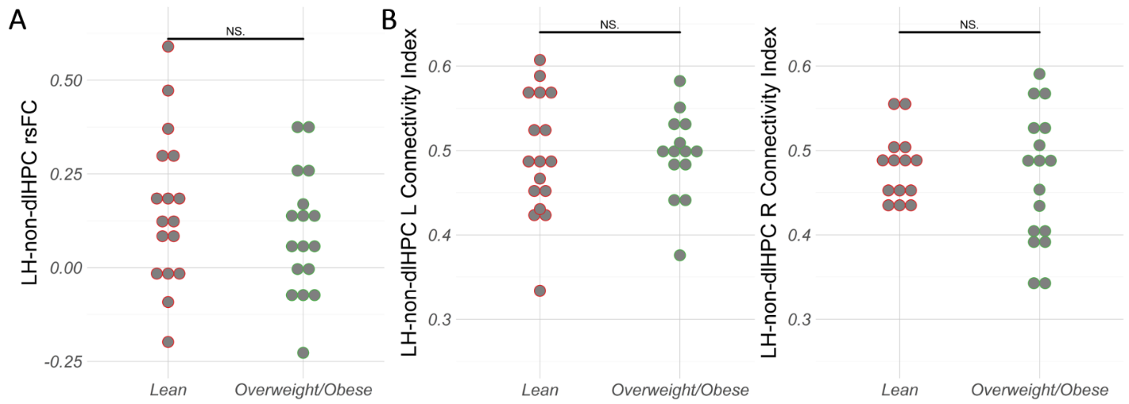Supplementary Figure 8. No significant differences in (A) LH-non-dlHPC rsFC or (B) structural CI were found in overweight/obese compared to lean group. NS. = non-significant.

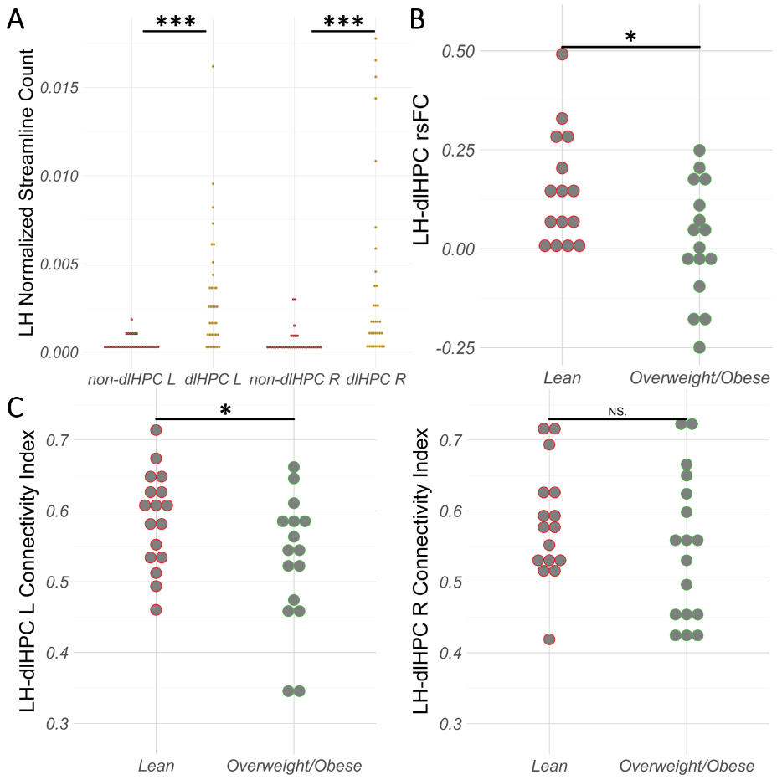Supplementary Figure 9. Individual subject data points assessing the LH-dlHPC appetitive processing circuit with regards to the obese state in the context of dysregulated eating. A) Significantly higher normalized streamline counts observed between the LH and the left (t = -4.585; p < .001) and right (t = -3.609; p < .001) dlHPC compared to the non-dlHPC in the overall binge-eating cohort. (B) rsFC between the dlHPC and LH was decreased in overweight/obese compared to the lean group (t = 2.51; p = .018). (C) Structural CI between the left dlHPC and LH was significantly decreased (t = 2.13; p = .042) in overweight/obese compared to lean group. No significant differences (t = 1.07; p = .295) in structural CI between the right dlHPC and LH were found. NS. = non-significant. * = p < .05. ** = p < .01. *** = p < .001.

