Appendix A
Select Photos From the Photovoice Study
Figure A1
Photo 1: Bicycle in the Parking Lot of the evolv1 Building (Illustrative of Q1-T1: Individual Interest and Commitment to Sustainability)
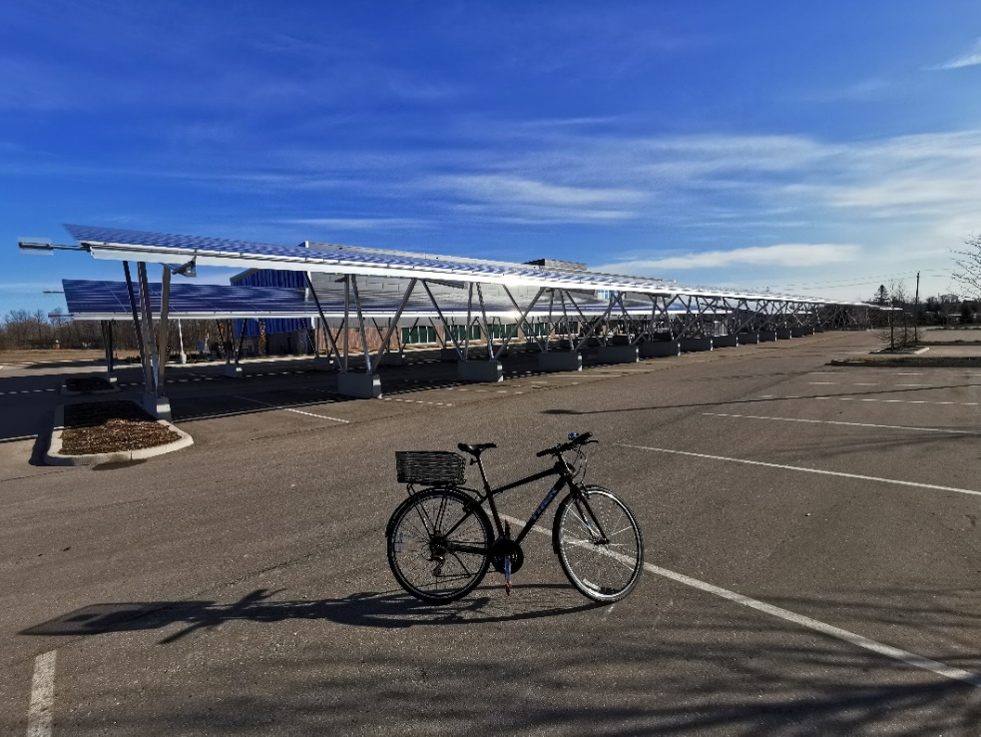
Figure A2
Photo 2: Large Parking Lot at evolv1 (Illustrative of Q2-T2: Sustainability is Not Always ‘Pure’)
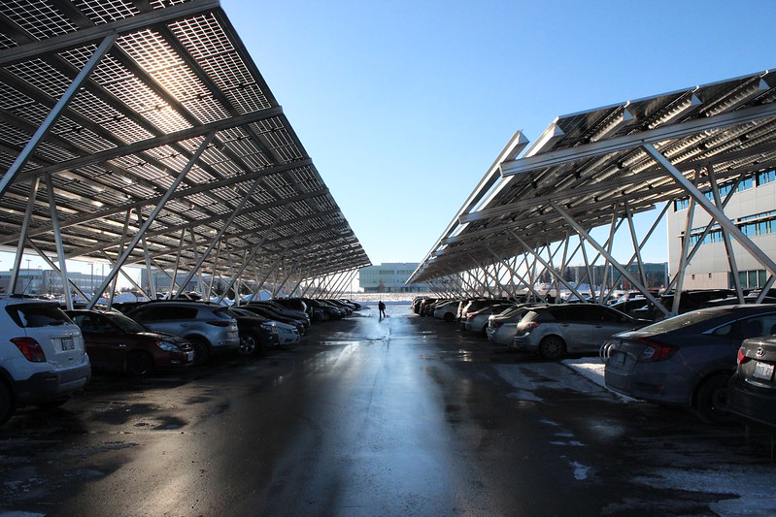
Figure A3
Photo 3: Living Wall in the evolv1 Atrium (Illustrative of Q3-T1: Certain Building Features Clearly Function as Symbolic ‘Green Features’)
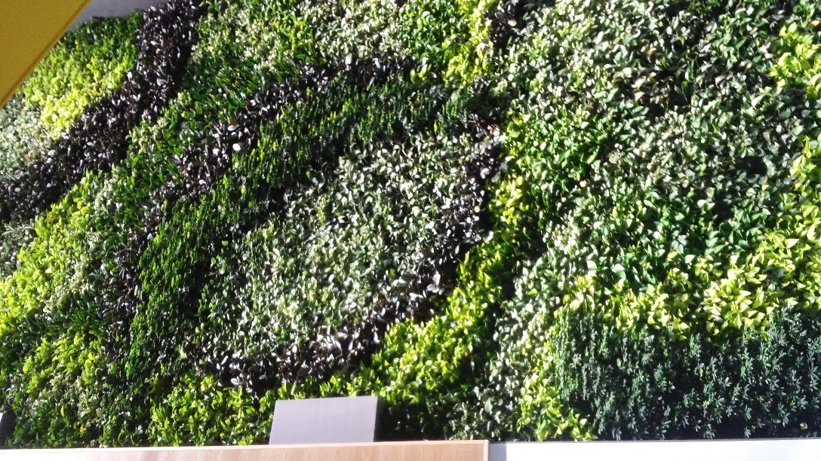

Figure A4
Photo 4: Solar Panels Covering the evolv1 Parking Lot (Illustrative of Q3-T2: Symbolic Communication Often Requires ‘Standing Out’)
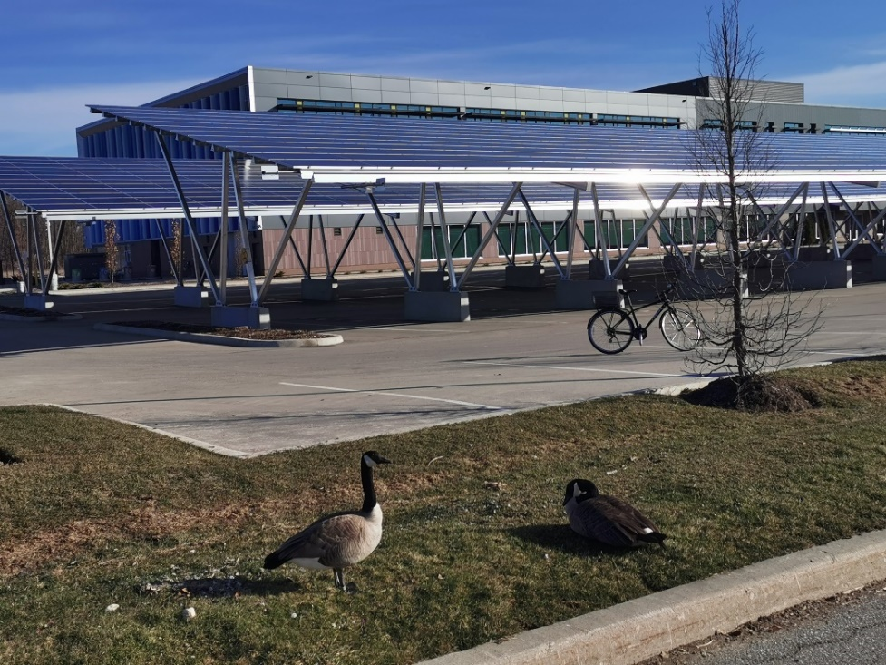
Figure A5
Photo 5: The ‘Make Change’ Classroom in evolv1 (Illustrative of Q3-T4: Sustainability Communication and Education are Distinct From but Connected to Sustainability Symbolism)
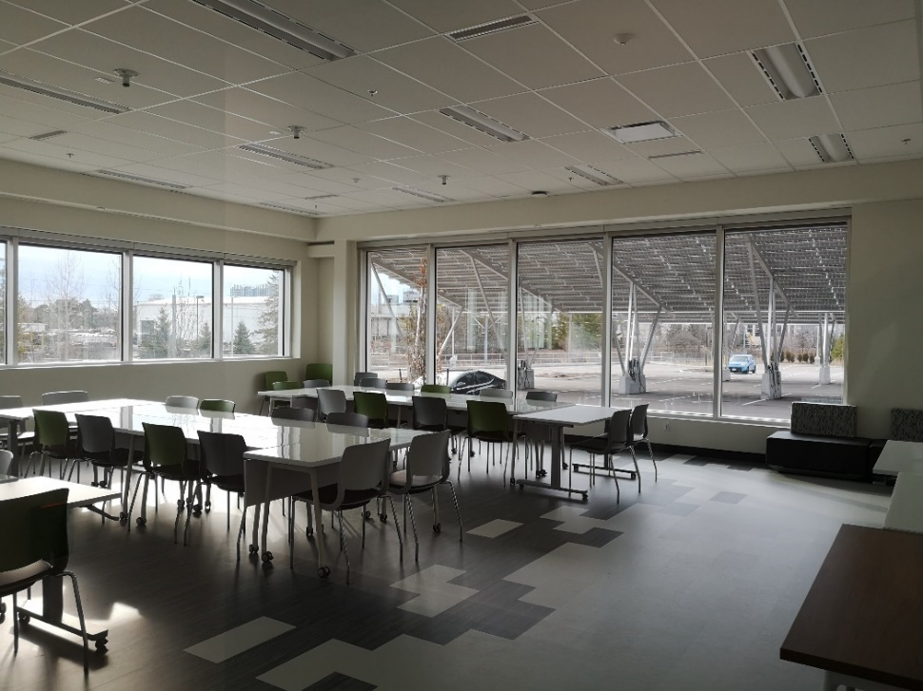
Figure A6
Photo 6: Bare Garden at evolv1 (Illustrative of Q3-T3: What is Missing or Invisible in an Environment can Unintentionally Create a ‘Negative Symbol’ for Sustainability)
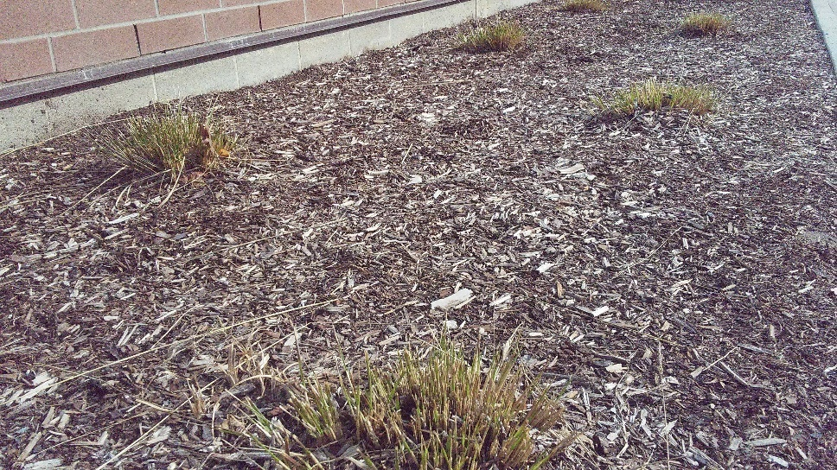
Figure A7
Photo 7: Seating Area in the Hub at evolv1 (Illustrative of Q4-T1: Reconsider the Function of Spaces Within and Around evolv1 to Center Sustainability and Community-Building)
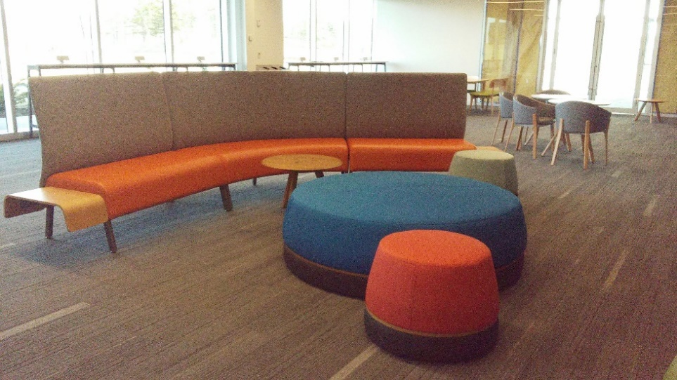

Figure A8
Photo 8: Cycling and Walking Trail That Connects to evolv1 (Illustrative of Q4-T3: Encourage More Sustainable Behaviours and Discourage Less Sustainable)
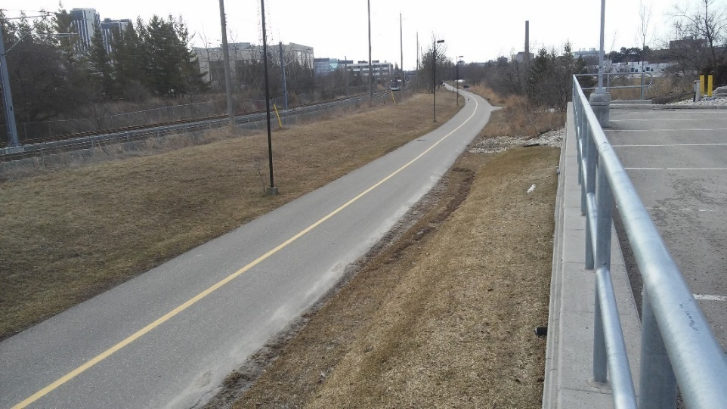
Figure A9
Photo 9: Leaf Floating on Water (Illustrative of Q4-T4: Increase Opportunities for Social Connection, Nature Connection, Community-Building and Sustainability Leadership)


Appendix B
Concise Descriptions of Themes

Q1: What does a culture of sustainability mean for citizens of the building, and what can influence its development?
Q1, Theme 1: Individual interest and commitment to sustainability
Description: Some level of interest and commitment to sustainability is needed by individuals to build a culture of sustainability.
Q1, Theme 2: Community-building for collective action with shared purpose(s)
Description: A culture of sustainability does require attention to community-building for taking collective action with shared purpose(s), enabling advancing sustainability in particular areas.
Q1, Theme 3: An empowering, healthy and enabling environmental context
Description: A culture of sustainability both requires, benefits from, and helps create a broader environmental context that is empowering, healthy and enables participants to pursue sustainability actions.
Q2: What, if any, building features positively or negatively influence the sustainable values and practices of citizens and their organizations?
Q2, Theme 1: Many evolv1 features already promote sustainable values, norms and practices
Description: There are many features both in the evolv1 building itself and the surrounding evolv1 property that already promote sustainable values, norms and practices.
Q2, Theme 2: Sustainability is not always ‘pure’
Description: Building features do not necessarily purely promote sustainability – some building features may both promote and hinder sustainable values, norms and practices.
Q2, Theme 3: Some evolv1 features are actively discouraging more sustainable values, norms and practices
Description: There are some features both in the evolv1 building itself and the surrounding evolv1 property that actively discourage more sustainable values, norms and practices.
Q2, Theme 4: evolv1 still embodies several ‘missed opportunities’
Description: There are some building features that could better promote sustainability, but don’t, and hence can be seen as ‘missed opportunities’ (e.g., lack of sustainability signage).
Q3: How does the building symbolically communicate to people and how do symbols in the building environment translate into citizens’ own sustainability-related values and practices?
Q3, Theme 1: Certain building features clearly function as symbolic ‘green features’
Description: There are certain building features that clearly take on a role or function as a symbolic ‘green feature’ (e.g., the solar PV, and living wall).
Q3, Theme 2: Symbolic communication often requires ‘standing out’
Description: For a feature to symbolically communicate, it often needs to be easily noticed or seen, and hence to ‘stand out’ (e.g., the solar PV, staircase, and living wall).
Q3, Theme 3: What is missing or invisible in an environment can unintentionally create a ‘negative symbol’ for sustainability
Description: What is not present or cannot be seen in an environment can unintentionally operate as a ‘negative symbol’ for sustainability (e.g., lack of clear visitor bike parking; lack of greenery around evolv1)
Q3, Theme 4: Sustainability communication and education are distinct from but connected to sustainability symbolism
Description: While sustainability communication and education are not the same as sustainability symbolism, they are connected and can often strengthen each other (e.g., including educational signage alongside a symbol of sustainability)
Q3, Theme 5: Concern over symbolic representation of sustainability, versus actual sustainability
Description: While some features may clearly symbolize sustainability, that does not guarantee that they are actually fully sustainable – raising concerns over representation of sustainability versus actual sustainability.
Q4: What could be done to further promote sustainable values and practices at evolv1? *Note. For Q4, the theme titles are also seen to provide sufficient descriptions; hence, separate descriptions are not included.
Q4, Theme 1: Reconsider the function of spaces within and around evolv1 to center sustainability and community-building
Q4, Theme 2: Combine existing symbolic communication with direct sustainability education and engagement
Q4, Theme 3: Encourage more sustainable behaviours and discourage less sustainable
Q4, Theme 4: Increase opportunities for social connection, nature connection, community-building and sustainability leadership

