Appendix S
Urban vultures preferentially roost at sites surrounded by more developed land cover and lower deer carcass density.
Hannah C. Partridge¹† and Sara A. Gagné¹
¹Department of Geography and Earth Sciences, University of North Carolina at Charlotte, Charlotte, North Carolina, USA
†hpartrid@uncc.edu

Table S1 Correlation matrix for all variables. Developed land cover, open water, deer carcass density, and edge density were landscape variables measured within 0.4km of all roosting sites. Edge density describes the amount of Developed-Forest edge within the landscape.
 | Site ID | Date | Count | Air temperature | Wind speed | Cloud cover | Developed land cover | Open water | Deer carcass density | Edge density | Corridor width | Roost structure height | Surrounding vegetation height
Site ID | 1
Date | 0.44 | 1
Count | -0.08 | -0.03 | 1
Air temperature | -0.14 | -0.18 | 0.01 | 1
Wind speed | 0.23 | 0.17 | 0.03 | -0.01 | 1
Cloud cover | -0.03 | -0.06 | 0.07 | 0.30 | 0.08 | 1
Developed land cover | -0.46 | -0.19 | -0.09 | 0.04 | -0.26 | -0.02 | 1
Open water | 0.40 | 0.17 | 0.00 | -0.09 | 0.02 | -0.05 | -0.32 | 1
Deer carcass density | -0.27 | -0.07 | -0.16 | 0.02 | -0.10 | -0.04 | 0.34 | -0.11 | 1
Edge density | -0.11 | 0.02 | 0.13 | 0.11 | -0.04 | 0.05 | -0.39 | 0.13 | -0.20 | 1
Corridor width | -0.02 | -0.06 | -0.07 | 0.02 | 0.01 | 0.01 | -0.13 | 0.13 | 0.12 | -0.29 | 1
Roost structure height | 0.53 | 0.36 | 0.10 | -0.18 | 0.29 | -0.02 | -0.53 | 0.26 | -0.11 | 0.01 | -0.12 | 1
Surrounding vegetation height | -0.24 | -0.14 | -0.25 | -0.05 | -0.14 | -0.02 | 0.44 | -0.30 | 0.42 | -0.39 | -0.03 | -0.22 | 1
Table S2 Correlation matrix for all variables. Developed land cover, open water, deer carcass density, and edge density were landscape variables measured within 0.5km of all roosting sites. Edge density describes the amount of Developed-Forest edge within the landscape.
 | Site ID | Date | Count | Air temperature | Wind speed | Cloud cover | Developed land cover | Open water | Deer carcass density | Edge density | Corridor width | Roost structure height | Surrounding vegetation height
Site ID | 1
Date | 0.44 | 1
Count | -0.08 | -0.03 | 1
Air temperature | -0.14 | -0.18 | 0.01 | 1
Wind speed | 0.23 | 0.17 | 0.03 | -0.01 | 1
Cloud cover | -0.03 | -0.06 | 0.07 | 0.30 | 0.08 | 1
Developed land cover | -0.43 | -0.19 | -0.10 | 0.03 | -0.26 | -0.03 | 1
Open water | 0.42 | 0.22 | -0.03 | -0.10 | 0.06 | -0.07 | -0.30 | 1
Deer carcass density | -0.38 | -0.10 | -0.18 | 0.03 | -0.14 | -0.05 | 0.48 | -0.17 | 1
Edge density | -0.08 | 0.02 | 0.11 | 0.09 | -0.02 | 0.05 | -0.43 | 0.13 | -0.32 | 1
Corridor width | -0.02 | -0.06 | -0.07 | 0.02 | 0.01 | 0.01 | -0.09 | 0.13 | 0.18 | -0.30 | 1
Roost structure height | 0.53 | 0.36 | 0.10 | -0.18 | 0.29 | -0.02 | -0.54 | 0.36 | -0.24 | 0.04 | -0.12 | 1
Surrounding vegetation height | -0.24 | -0.14 | -0.25 | -0.05 | -0.14 | -0.02 | 0.43 | -0.29 | 0.47 | -0.40 | -0.03 | -0.22 | 1
Table S3 Correlation matrix for all variables. Developed land cover, open water, deer carcass density, and edge density were landscape variables measured within 1km of all roosting sites. Edge density describes the amount of Developed-Forest edge within the landscape.
 | Site ID | Date | Count | Air temperature | Wind speed | Cloud cover | Developed land cover | Open water | Deer carcass density | Edge density | Corridor width | Roost structure height | Surrounding vegetation height
Site ID | 1
Date | 0.44 | 1
Count | -0.08 | -0.03 | 1
Air temperature | -0.14 | -0.18 | 0.01 | 1
Wind speed | 0.23 | 0.17 | 0.03 | -0.01 | 1
Cloud cover | -0.03 | -0.06 | 0.07 | 0.30 | 0.08 | 1
Developed land cover | -0.33 | -0.16 | -0.14 | 0.00 | -0.28 | -0.05 | 1
Open water | 0.06 | 0.17 | 0.19 | -0.05 | 0.08 | -0.03 | -0.43 | 1
Deer carcass density | -0.36 | -0.13 | -0.24 | -0.01 | -0.16 | -0.06 | 0.61 | -0.51 | 1
Edge density | -0.13 | 0.00 | 0.02 | 0.16 | -0.04 | 0.04 | -0.21 | 0.37 | -0.38 | 1
Corridor width | -0.02 | -0.06 | -0.07 | 0.02 | 0.01 | 0.01 | 0.00 | 0.06 | 0.17 | -0.33 | 1
Roost structure height | 0.53 | 0.36 | 0.10 | -0.18 | 0.29 | -0.02 | -0.57 | 0.50 | -0.42 | -0.03 | -0.12 | 1
Surrounding vegetation height | -0.24 | -0.14 | -0.25 | -0.05 | -0.14 | -0.02 | 0.45 | -0.43 | 0.53 | -0.26 | -0.03 | -0.22 | 1
Table S4 Correlation matrix for all variables. Developed land cover, open water, deer carcass density, and edge density were landscape variables measured within 2km of all roosting sites. Edge density describes the amount of Developed-Forest edge within the landscape.
 | Site ID | Date | Count | Air temperature | Wind speed | Cloud cover | Developed land cover | Open water | Deer carcass density | Edge density | Corridor width | Roost structure height | Surrounding vegetation height
Site ID | 1
Date | 0.44 | 1
Count | -0.08 | -0.03 | 1
Air temperature | -0.14 | -0.18 | 0.01 | 1
Wind speed | 0.23 | 0.17 | 0.03 | -0.01 | 1
Cloud cover | -0.03 | -0.06 | 0.07 | 0.30 | 0.08 | 1
Developed land cover | -0.25 | -0.15 | -0.15 | -0.01 | -0.32 | -0.06 | 1
Open water | -0.07 | 0.05 | -0.10 | -0.04 | -0.10 | -0.07 | -0.02 | 1
Deer carcass density | 0.25 | 0.17 | -0.08 | -0.18 | 0.32 | -0.02 | 0.02 | 0.06 | 1
Edge density | -0.25 | -0.03 | -0.10 | 0.13 | -0.25 | -0.04 | 0.19 | 0.08 | -0.39 | 1
Corridor width | -0.02 | -0.06 | -0.07 | 0.02 | 0.01 | 0.01 | 0.04 | 0.14 | 0.00 | -0.36 | 1
Roost structure height | 0.53 | 0.36 | 0.10 | -0.18 | 0.29 | -0.02 | -0.54 | 0.20 | 0.39 | -0.17 | -0.12 | 1
Surrounding vegetation height | -0.24 | -0.14 | -0.25 | -0.05 | -0.14 | -0.02 | 0.41 | -0.15 | 0.14 | -0.11 | -0.03 | -0.22 | 1
Table S5 Correlation matrix for all variables. Developed land cover, open water, deer carcass density, and edge density were landscape variables measured within 3km of all roosting sites. Edge density describes the amount of Developed-Forest edge within the landscape.
 | Site ID | Date | Count | Air temperature | Wind speed | Cloud cover | Developed land cover | Open water | Deer carcass density | Edge density | Corridor width | Roost structure height | Surrounding vegetation height
Site ID | 1
Date | 0.44 | 1
Count | -0.08 | -0.03 | 1
Air temperature | -0.14 | -0.18 | 0.01 | 1
Wind speed | 0.23 | 0.17 | 0.03 | -0.01 | 1
Cloud cover | -0.03 | -0.06 | 0.07 | 0.30 | 0.08 | 1
Developed land cover | -0.21 | -0.16 | -0.19 | 0.00 | -0.34 | -0.08 | 1
Open water | -0.08 | -0.04 | -0.07 | -0.12 | -0.08 | -0.02 | 0.28 | 1
Deer carcass density | 0.34 | 0.21 | 0.02 | -0.18 | 0.45 | -0.01 | -0.45 | -0.14 | 1
Edge density | -0.45 | -0.16 | -0.16 | 0.17 | -0.34 | -0.05 | 0.39 | -0.31 | -0.42 | 1
Corridor width | -0.02 | -0.06 | -0.07 | 0.02 | 0.01 | 0.01 | 0.07 | 0.11 | -0.08 | -0.18 | 1
Roost structure height | 0.53 | 0.36 | 0.10 | -0.18 | 0.29 | -0.02 | -0.51 | -0.16 | 0.63 | -0.36 | -0.12 | 1
Surrounding vegetation height | -0.24 | -0.14 | -0.25 | -0.05 | -0.14 | -0.02 | 0.40 | 0.30 | -0.12 | 0.22 | -0.03 | -0.22 | 1
Table S6 Correlation matrix for all variables. Developed land cover, open water, deer carcass density, and edge density were landscape variables measured within 4km of all roosting sites. Edge density describes the amount of Developed-Forest edge within the landscape.
 | Site ID | Date | Count | Air temperature | Wind speed | Cloud cover | Developed land cover | Open water | Deer carcass density | Edge density | Corridor width | Roost structure height | Surrounding vegetation height
Site ID | 1
Date | 0.44 | 1
Count | -0.08 | -0.03 | 1
Air temperature | -0.14 | -0.18 | 0.01 | 1
Wind speed | 0.23 | 0.17 | 0.03 | -0.01 | 1
Cloud cover | -0.03 | -0.06 | 0.07 | 0.30 | 0.08 | 1
Developed land cover | -0.19 | -0.17 | -0.21 | 0.01 | -0.35 | -0.08 | 1
Open water | -0.09 | -0.06 | -0.07 | -0.12 | -0.08 | -0.01 | 0.20 | 1
Deer carcass density | 0.26 | 0.15 | 0.01 | -0.15 | 0.42 | 0.00 | -0.52 | -0.24 | 1
Edge density | -0.42 | -0.18 | -0.22 | 0.17 | -0.33 | -0.07 | 0.52 | -0.25 | -0.38 | 1
Corridor width | -0.02 | -0.06 | -0.07 | 0.02 | 0.01 | 0.01 | 0.10 | 0.10 | -0.09 | -0.02 | 1
Roost structure height | 0.53 | 0.36 | 0.10 | -0.18 | 0.29 | -0.02 | -0.50 | -0.20 | 0.60 | -0.45 | -0.12 | 1
Surrounding vegetation height | -0.24 | -0.14 | -0.25 | -0.05 | -0.14 | -0.02 | 0.38 | 0.36 | -0.15 | 0.24 | -0.03 | -0.22 | 1
Table S7 Correlation matrix for all variables. Developed land cover, open water, deer carcass density, and edge density were landscape variables measured within 5km of all roosting sites. Edge density describes the amount of Developed-Forest edge within the landscape.
 | Site ID | Date | Count | Air temperature | Wind speed | Cloud cover | Developed land cover | Open water | Deer carcass density | Edge density | Corridor width | Roost structure height | Surrounding vegetation height
Site ID | 1
Date | 0.44 | 1
Count | -0.08 | -0.03 | 1
Air temperature | -0.14 | -0.18 | 0.01 | 1
Wind speed | 0.23 | 0.17 | 0.03 | -0.01 | 1
Cloud cover | -0.03 | -0.06 | 0.07 | 0.30 | 0.08 | 1
Developed land cover | -0.17 | -0.16 | -0.21 | 0.02 | -0.35 | -0.09 | 1
Open water | -0.12 | -0.09 | -0.07 | -0.11 | -0.09 | -0.01 | 0.17 | 1
Deer carcass density | 0.19 | 0.14 | 0.00 | -0.16 | 0.36 | -0.01 | -0.63 | -0.21 | 1
Edge density | -0.42 | -0.17 | -0.24 | 0.16 | -0.33 | -0.06 | 0.59 | -0.21 | -0.40 | 1
Corridor width | -0.02 | -0.06 | -0.07 | 0.02 | 0.01 | 0.01 | 0.09 | 0.13 | -0.15 | 0.02 | 1
Roost structure height | 0.53 | 0.36 | 0.10 | -0.18 | 0.29 | -0.02 | -0.50 | -0.19 | 0.53 | -0.50 | -0.12 | 1
Surrounding vegetation height | -0.24 | -0.14 | -0.25 | -0.05 | -0.14 | -0.02 | 0.38 | 0.40 | -0.20 | 0.24 | -0.03 | -0.22 | 1
Table S8 Correlation matrix for all variables. Developed land cover, open water, deer carcass density, and edge density were landscape variables measured within 10km of all roosting sites. Edge density describes the amount of Developed-Forest edge within the landscape.
 | Site ID | Date | Count | Air temperature | Wind speed | Cloud cover | Developed land cover | Open water | Deer carcass density | Edge density | Corridor width | Roost structure height | Surrounding vegetation height
Site ID | 1
Date | 0.44 | 1
Count | -0.08 | -0.03 | 1
Air temperature | -0.14 | -0.18 | 0.01 | 1
Wind speed | 0.23 | 0.17 | 0.03 | -0.01 | 1
Cloud cover | -0.03 | -0.06 | 0.07 | 0.30 | 0.08 | 1
Developed land cover | -0.07 | -0.04 | -0.18 | 0.05 | -0.31 | -0.10 | 1
Open water | -0.22 | -0.24 | -0.01 | 0.00 | -0.08 | 0.08 | -0.29 | 1
Deer carcass density | 0.15 | 0.03 | 0.02 | -0.03 | 0.24 | 0.02 | -0.49 | -0.37 | 1
Edge density | -0.25 | -0.11 | -0.27 | 0.15 | -0.25 | -0.06 | 0.79 | -0.38 | -0.22 | 1
Corridor width | -0.02 | -0.06 | -0.07 | 0.02 | 0.01 | 0.01 | 0.01 | 0.16 | -0.15 | 0.13 | 1
Roost structure height | 0.53 | 0.36 | 0.10 | -0.18 | 0.29 | -0.02 | -0.29 | -0.34 | 0.38 | -0.41 | -0.12 | 1
Surrounding vegetation height | -0.24 | -0.14 | -0.25 | -0.05 | -0.14 | -0.02 | 0.19 | 0.47 | -0.48 | 0.09 | -0.03 | -0.22 | 1
Table S9 Correlation matrix for all variables. Developed land cover, open water, deer carcass density, and edge density were landscape variables measured within 15km of all roosting sites. Edge density describes the amount of Developed-Forest edge within the landscape.
 | Site ID | Date | Count | Air temperature | Wind speed | Cloud cover | Developed land cover | Open water | Deer carcass density | Edge density | Corridor width | Roost structure height | Surrounding vegetation height
Site ID | 1
Date | 0.44 | 1
Count | -0.08 | -0.03 | 1
Air temperature | -0.14 | -0.18 | 0.01 | 1
Wind speed | 0.23 | 0.17 | 0.03 | -0.01 | 1
Cloud cover | -0.03 | -0.06 | 0.07 | 0.30 | 0.08 | 1
Developed land cover | -0.08 | -0.06 | -0.19 | 0.09 | -0.29 | -0.08 | 1
Open water | -0.22 | -0.24 | 0.06 | 0.05 | -0.08 | 0.11 | -0.34 | 1
Deer carcass density | 0.13 | 0.07 | 0.01 | -0.06 | 0.18 | -0.01 | -0.39 | -0.51 | 1
Edge density | -0.06 | -0.14 | -0.32 | 0.12 | -0.23 | -0.04 | 0.77 | -0.16 | -0.18 | 1
Corridor width | -0.02 | -0.06 | -0.07 | 0.02 | 0.01 | 0.01 | -0.02 | 0.17 | -0.15 | 0.07 | 1
Roost structure height | 0.53 | 0.36 | 0.10 | -0.18 | 0.29 | -0.02 | -0.32 | -0.32 | 0.35 | -0.41 | -0.12 | 1
Surrounding vegetation height | -0.24 | -0.14 | -0.25 | -0.05 | -0.14 | -0.02 | 0.12 | 0.42 | -0.53 | 0.03 | -0.03 | -0.22 | 1
Table S10 Correlation matrix for all variables. Developed land cover, open water, deer carcass density, and edge density were landscape variables measured within 20km of all roosting sites. Edge density describes the amount of Developed-Forest edge within the landscape.
 | Site ID | Date | Count | Air temperature | Wind speed | Cloud cover | Developed land cover | Open water | Deer carcass density | Edge density | Corridor width | Roost structure height | Surrounding vegetation height
Site ID | 1
Date | 0.44 | 1
Count | -0.08 | -0.03 | 1
Air temperature | -0.14 | -0.18 | 0.01 | 1
Wind speed | 0.23 | 0.17 | 0.03 | -0.01 | 1
Cloud cover | -0.03 | -0.06 | 0.07 | 0.30 | 0.08 | 1
Developed land cover | -0.10 | -0.07 | -0.19 | 0.13 | -0.28 | -0.06 | 1
Open water | -0.22 | -0.24 | 0.11 | 0.06 | -0.13 | 0.11 | -0.26 | 1
Deer carcass density | -0.07 | -0.13 | -0.29 | 0.07 | -0.22 | -0.07 | 0.47 | -0.41 | 1
Edge density | -0.05 | -0.20 | -0.24 | 0.11 | -0.28 | 0.00 | 0.72 | 0.26 | 0.43 | 1
Corridor width | -0.02 | -0.06 | -0.07 | 0.02 | 0.01 | 0.01 | -0.05 | 0.09 | 0.09 | 0.06 | 1
Roost structure height | 0.53 | 0.36 | 0.10 | -0.18 | 0.29 | -0.02 | -0.36 | -0.32 | -0.32 | -0.44 | -0.12 | 1
Surrounding vegetation height | -0.24 | -0.14 | -0.25 | -0.05 | -0.14 | -0.02 | 0.08 | 0.35 | -0.13 | 0.16 | -0.03 | -0.22 | 1
Table S11 Variance inflation factors for all variables at each landscape scale. Edge density describes the amount of Developed-Forest edge within the landscape.
Landscape scale | Date | Air temperature | Wind speed | Cloud cover | Developed land cover | Open water | Deer carcass density | Edge density | Corridor width | Roost structure height | Surrounding vegetation height
0.4 km | 1.06 | 1.12 | 1.05 | 1.09 | 2.40 | 1.25 | 1.32 | 1.80 | 1.51 | 2.13 | 1.44
0.5 km | 1.06 | 1.11 | 1.05 | 1.09 | 2.68 | 1.37 | 1.57 | 1.90 | 1.59 | 2.34 | 1.41
1 km | 1.06 | 1.12 | 1.05 | 1.09 | 2.13 | 2.12 | 2.14 | 1.90 | 1.43 | 2.64 | 1.40
2 km | 1.06 | 1.12 | 1.09 | 1.09 | 1.72 | 1.21 | 1.78 | 1.84 | 1.38 | 2.01 | 1.20
3 km | 1.06 | 1.12 | 1.09 | 1.09 | 1.70 | 1.41 | 2.19 | 2.01 | 1.10 | 1.88 | 1.24
4 km | 1.07 | 1.13 | 1.09 | 1.10 | 1.87 | 1.50 | 2.07 | 2.05 | 1.03 | 1.81 | 1.32
5 km | 1.07 | 1.13 | 1.08 | 1.10 | 2.28 | 1.49 | 2.05 | 2.17 | 1.05 | 1.70 | 1.36
10 km | 1.10 | 1.13 | 1.08 | 1.10 | 4.31 | 2.81 | 2.41 | 4.46 | 1.16 | 2.15 | 1.70
15 km | 1.12 | 1.13 | 1.09 | 1.10 | 6.69 | 3.58 | 3.71 | 3.77 | 1.07 | 1.54 | 1.52
20 km | 1.10 | 1.13 | 1.10 | 1.10 | 5.35 | 4.98 | 2.80 | 6.72 | 1.06 | 2.00 | 1.25

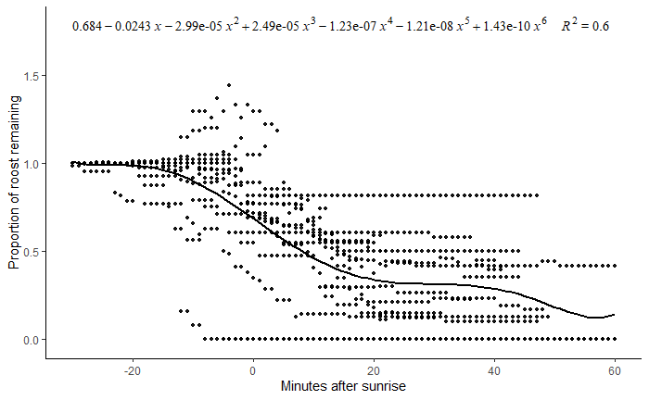
Figure S1 The proportion of black vulture (Coragyps atratus) and turkey vulture (Cathartes aura) roosts remaining with respect to the time elapsed from 60 minutes before sunrise when all individuals were roosting. A 6th order polynomial regression (solid line; F_{6,1042} = 262.30, p < 0.001, adjusted R² = 0.60) was used to correct roost count data collected in the Charlotte Metropolitan Area, USA in 2019-2020 and 2020-2021 for any vultures that left the roosting structure before the roost survey was conducted.

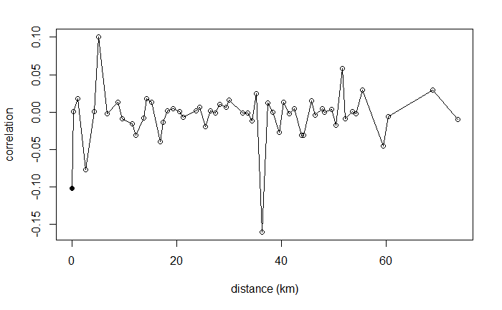
Figure S2 Correlogram of residuals from model of roost attendance with respect to surrounding vegetation height and deer carcass density within landscapes of 20 km surrounding roosting sites. Moran I statistic = -0.009, Bonferroni corrected p-value = 0.08.

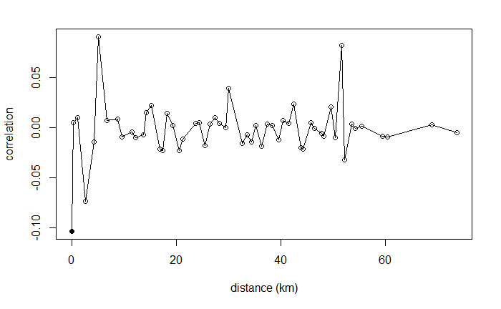
Figure S3 Correlogram of residuals from model of roost attendance with respect to surrounding vegetation height and Developed-Forest edge density within landscapes of 15 km surrounding roosting sites. Moran I statistic = -0.001, Bonferroni corrected p-value = 0.04.

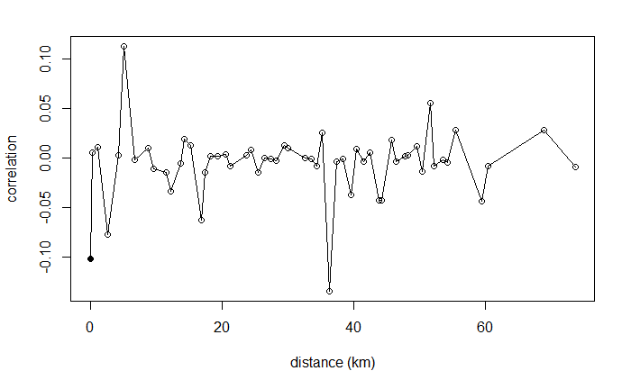
Figure S4 Correlogram of residuals from model of roost attendance with respect to surrounding vegetation height, deer carcass density within landscapes of 20 km surrounding roosting sites, and the survey date. Moran I statistic = -0.008, Bonferroni corrected p-value = 0.08.

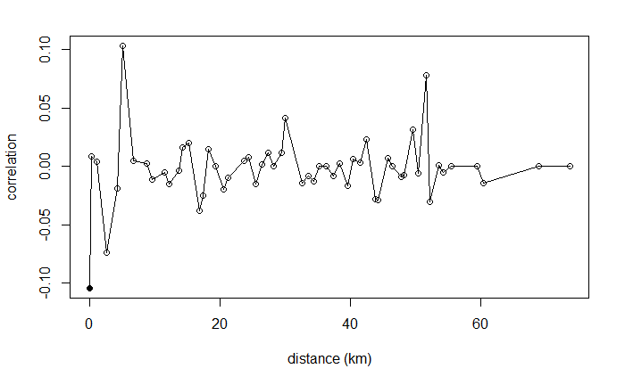
Figure S5 Correlogram of residuals from model of roost attendance with respect to surrounding vegetation height, Developed-Forest edge density within landscapes of 15 km surrounding roosting sites, and the survey date. Moran I statistic = -0.002, Bonferroni corrected p-value = 0.04.

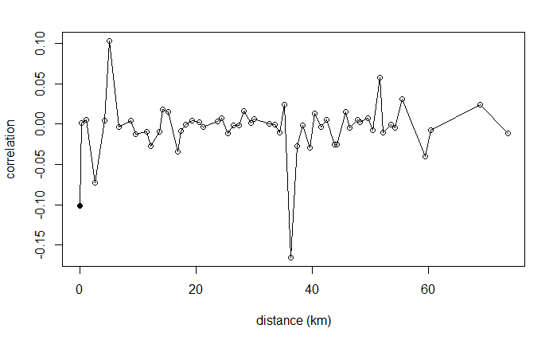
Figure S6 Correlogram of residuals from model of roost attendance with respect to wind speed, surrounding vegetation height, and deer carcass density within landscapes of 20 km surrounding roosting sites. Moran I statistic = -0.009, Bonferroni corrected p-value = 0.08.

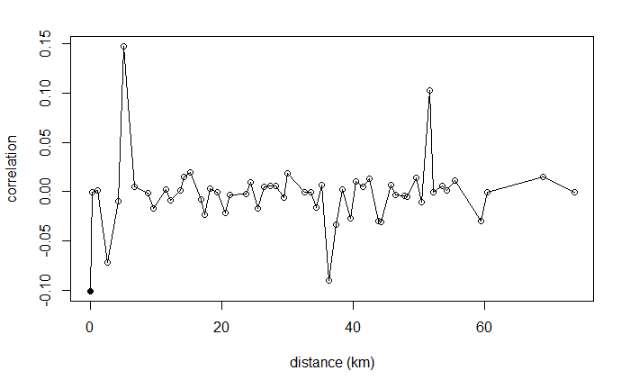
Figure S7 Correlogram of residuals from model of roost attendance with respect to surrounding vegetation height, Developed-Forest edge density within landscapes of 15 km surrounding roosting sites, and deer carcass density within landscapes of 20 km surrounding roosting sites. Moran I statistic = -0.002, Bonferroni corrected p-value = 0.04.

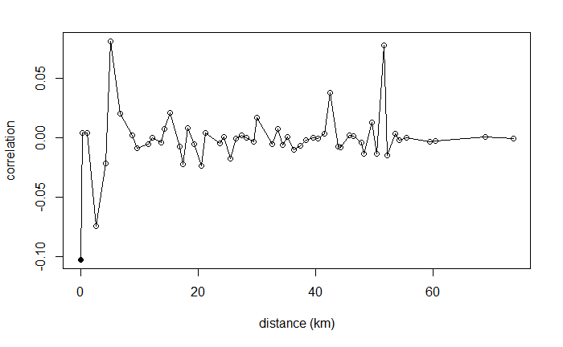
Figure S8 Correlogram of residuals from model of roost attendance with respect to surrounding vegetation height, Developed land cover within landscapes of 15 km surrounding roosting sites, and deer carcass density within landscapes of 20 km surrounding roosting sites. Moran I statistic = -0.001, Bonferroni corrected p-value = 0.04.

