Research feasibility and ethics in Scottish new-born blood spot archive.
Supplementary information Methods
Citizens Jury
SI Table 1 summarises the Jurors consensus views on terms of access to the Guthrie card archive. This information was shared at the Stakeholders event and will inform the Public Consultation planned by Scottish Government Chief Scientist’s Office.
Guthrie card box contents
SI Figure 1 illustrates how the Scottish Guthrie card archive has been stored (boxes, sub-boxes and card bundles contents).
SI Figure 2 illustrates representative cards (with personal details masked) to show a card that was not useable under the restrictions placed by the Caldicott Guardians on only approving samples be taken that would leave at least one blood spot intact (SI Figure 2A) and another card where punches could be taken for testing (SI Figure 2B).
DNA methylation analysis
To analyse whether all samples matched their reported sex, multiple dimensional scaling was performed on X chromosome probes, reducing DNAm data from 15316 CpGs to two coordinates for each sample. After plotting, there were two clusters corresponding to sex. Annotating each data point by reported sex revealed no mismatches (SI Figure 3). Using “rs” probes on the EPIC array, estimated genotypes were checked against those generated at baseline using a SNP array. At these probes it is possible to observe a unimodal, bi-modal or tri-modal distribution depending on genotype (AA/AB/BB). DNAm levels at these probes were plotted against hard-called genotypes (i.e. SNP array). Tight clustering of DNAm levels was observed according to genotype (SI Figure 4). Average methylation levels by genotype are summarised in SI Table 2.

Supplementary information Tables
SI Table 1: Citizens Jury terms of access
Q1: Who should have access to the Guthrie Cards for research purposes?
Opinion: Access should be granted for the sole use, by a public or private sector organisation, who’s clear rationale meets the stringent guidelines of the ethics committee.
Q2: For what purposes should research access be granted?
The primary purpose should be to advance medical research for the good of public health, through analysis of historical, current and future data.
Q3: What form of regulation and oversight would be required?
Opinion: An independent body, based on the Danish model (which includes a bio-centre management group, ethics committee and a data privacy committee), that is independent of government and data users, and able to issue sanctions for misuse.
Q4: Should any form of consent be sought and, if so, how would this work?
Opinion: There should be a universal [automatic] opt-in system, with the option to opt-out within one year or from the age of 16 The dead are automatically opted-in, with no consent necessary. Parents should be made aware of these conditions before their baby is born.
Q5: Whether and how the public might be involved in the process?
Opinion: Here there was consensus that once consent for research had been obtained there was no further need for public involvement, that parents should be well informed and that a website could communicate about research and outcomes.

SI Table 2: Mean (SD) DNA methylation levels at “rs” probes for each genotype group derived from SNP profiling.

SNP | Mean (SD) DNAm AA | Mean (SD) DNAm AB | Mean (SD) DNAm BB
rs877309 | 0.0251 (0.0129) | 0.46 (0.0561) | 0.863 (0.0296)
rs11249206 | 0.0311 (0.014) | 0.407 (0.044) | 0.86 (0.0198)
rs654498 | 0.448 (0.124) | 0.474 (0.119) | 0.516 (0.116)
rs715359 | 0.953 (0.0224) | 0.459 (0.144) | 0.0511 (0.00765)
rs6426327 | 0.065 (0.0219) | 0.47 (0.0706) | -
rs6546473 | 0.0474 (0.0189) | 0.443 (0.0682) | 0.819 (0.0111)
rs264581 | 0.058 (0.0626) | 0.386 (0.0513) | 0.73 (0.123)
rs2125573 | 0.103 (0.0582) | 0.49 (0.0872) | 0.782 (0.0748)
rs9292570 | 0.426 (0.113) | 0.494 (0.079) | 0.668 (0.0689)
rs348937 | 0.611 (0.131) | 0.333 (0.0509) | 0.12 (0.0382)
rs9363764 | 0.799 (0.0446) | 0.415 (0.121) | 0.0611 (0.019)
rs10457834 | 0.741 (0.0703) | 0.487 (0.0785) | 0.109 (0.019)
rs6982811 | 0.103 (0.0691) | 0.413 (0.0547) | 0.785 (0.0553)
rs6471533 | 0.772 (0.282) | 0.521 (0.207) | 0.0524 (0.009)
rs472920 | 0.799 (0.0435) | 0.468 (0.0898) | 0.0985 (0.0211)
rs2385226 | 0.853 (0.18) | 0.376 (0.0837) | 0.0807 (0.0483)
rs4742386 | 0.835 (0.0587) | 0.419 (0.117) | 0.156 (0.181)
rs10796216 | 0.588 (0.146) | 0.462 (0.0967) | 0.413 (0.0837)
rs11034952 | 0.0963 (0.0349) | 0.49 (0.123) | 0.953 (0.00998)
rs2468330 | 0.0391 (0.0166) | 0.43 (0.0719) | 0.85 (0.046)
rs951295 | 0.0619 (0.00981) | 0.571 (0.0576) | 0.948 (0.0188)
rs2959823 | 0.749 (0.0864) | 0.448 (0.0527) | 0.195 (0.12)
rs1941955 | 0.83 (0.0448) | 0.339 (0.0681) | 0.0783 (0.0607)
rs2235751 | 0.0427 (0.0163) | 0.385 (0.0558) | 0.83 (0.0183)
rs1467387 | 0.0767 (0.0289) | 0.412 (0.0847) | 0.705 (-)
rs739259 | 0.0484 (0.0266) | 0.405 (0.0618) | 0.814 (0.0223)
rs2208123 | 0.543 (0.103) | 0.468 (0.091) | 0.428 (0.0577)

Supplementary Information Figures
SI Figure 1 Guthrie card archive
SI Figure 1A Guthrie card archive: main box, bar coded
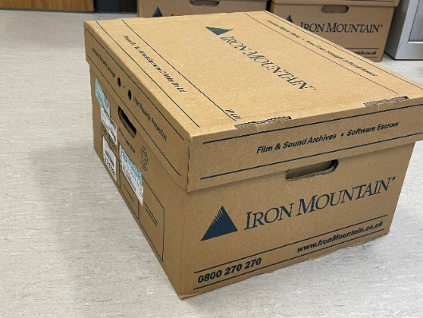
SI Figure 1B Guthrie card archive: sub-box, labelled
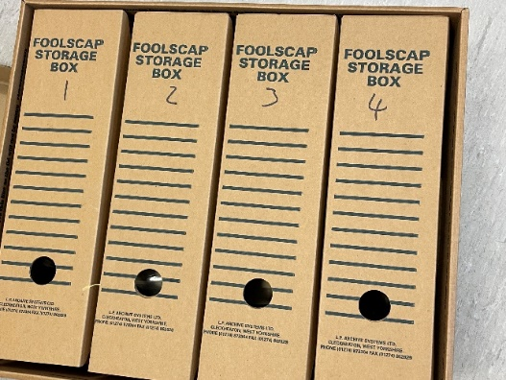
SI Figure 1C Guthrie card archive: sub-box, date labelled bundles
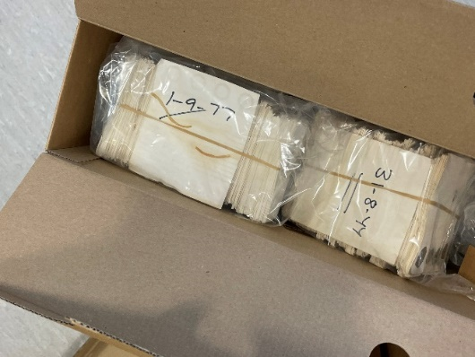
SI Figure 1D Bundle Guthrie card archive: main box, unmarked bundles
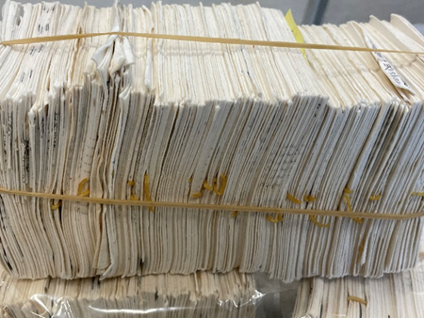

SI Figure 2 Guthrie card blood spot sampling
SI Figure 2A Guthrie card blood spot not useable for feasibility study
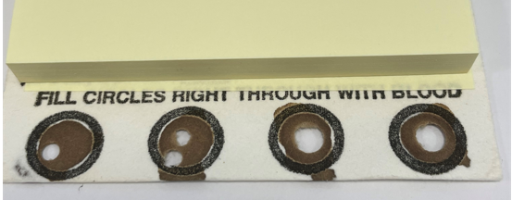
Legend: All four spots had been sampled previously, excluding use in this feasibility study on account of the requirement set by the Caldicott Guardians that one spot remained untouched.

SI Figure 2 Guthrie card blood spot useable for feasibility study and punches taken
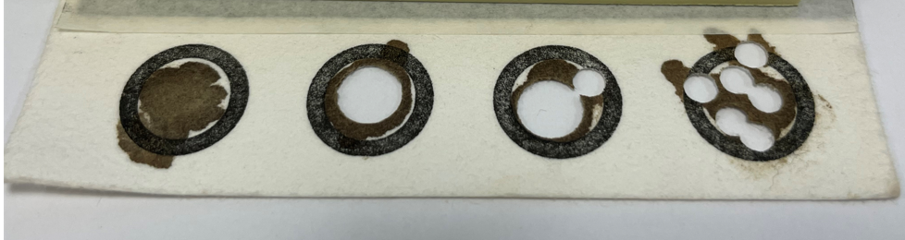
Legend: The left hand spot had not been sampled, allowing seven 3mm punches to be taken for the feasibility study.

SI Figure 3: Multidimensional scaling plot of X-chromosome probes coded by sample sex

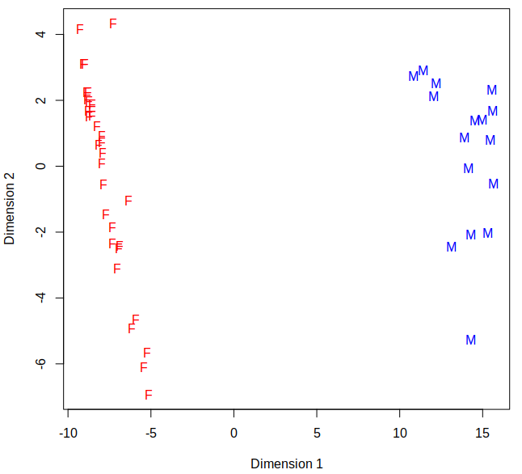

SI Figure 4: DNAm Levels at “rs” probes with tight-clustering (y-axis) plotted against hard-called genotypes (x-axis)

