Supplementary Figures
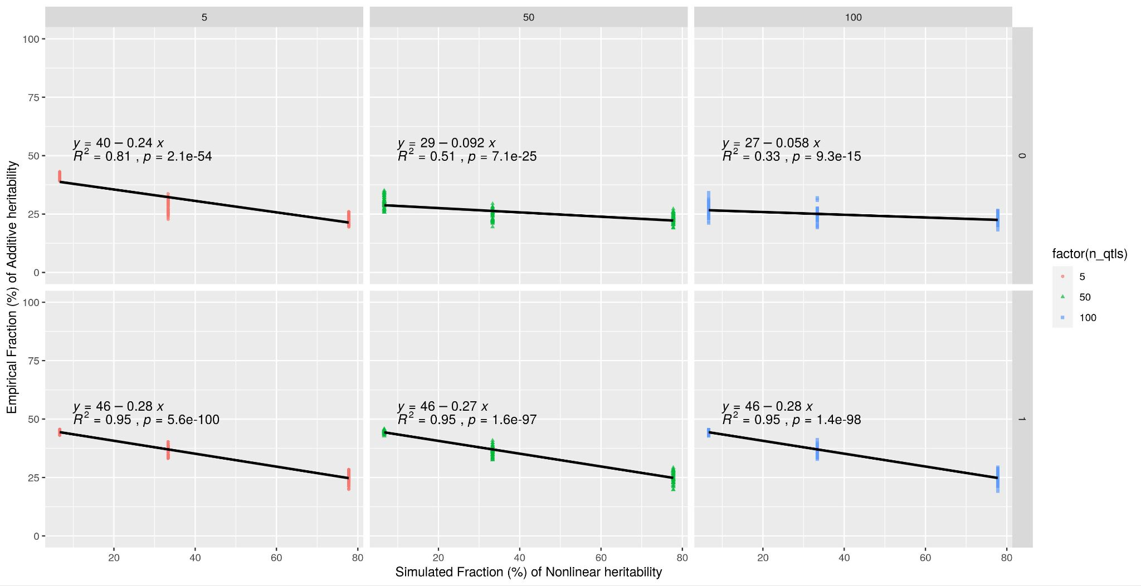
Figure S1. Assessment of phenotypic class (linear or nonlinear). The fraction of additive to residual genetic variance was used to assess relative linearity of phenotypes. With an increase in simulated fraction of nonlinear heritability, the measure (σ²_{a} / σ²_{r}) (equation (9)) decreases, implying that additive variance decreases.

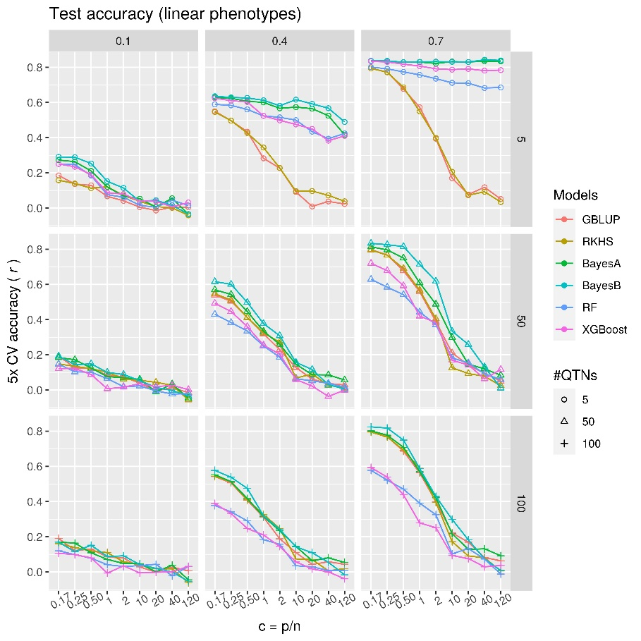 | 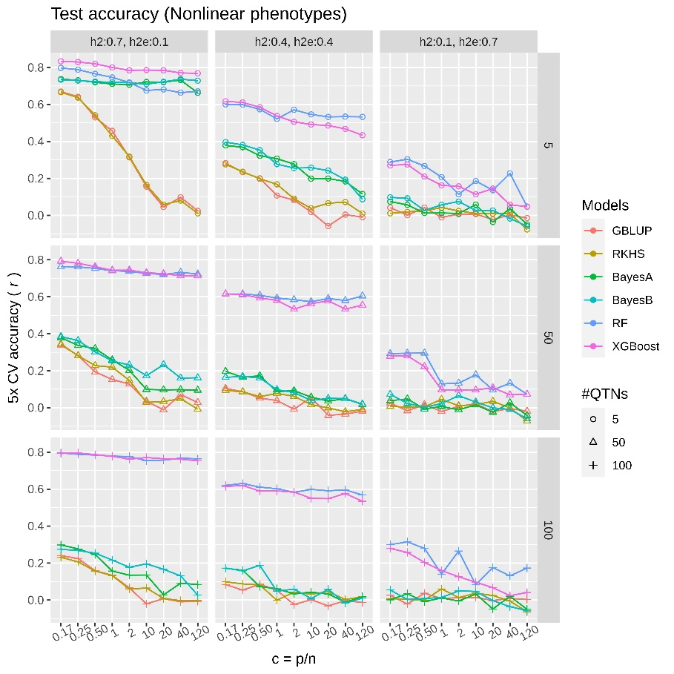
A | B
Figure S2. Comparison of test data prediction performance using simulated phenotypes without a large effect QTN. Average performance (Pearson correlation coefficient between true and predicted values) of parametric (GBLUP), semi-parametric (RKHS), parametric Bayesian (BayesA, BayesB) and ML (RF and XGBoost) methods are compared on test data using 5-fold cross-validation. Each subplot is based on a particular heritability and #QTNs, where the ratio of number of markers to number of samples (p/n) increases from left to right for each subplot. The genetic complexity of the phenotypes increases from top row to bottom row such that a trait with five QTNs is simpler than one with 100 QTNs. (A) linear polygenic phenotypes with only additive effects without a large effect QTN (equal effects), simulated using equation (1); (B) nonlinear phenotypes with both additive and epistatic effects, simulated using equation (2). Here broad-sense heritability was set to 0.8 (H² = h² + h²_{e} = 0.8), such that the plots from left to right show an increase in nonlinearity in phenotypes.

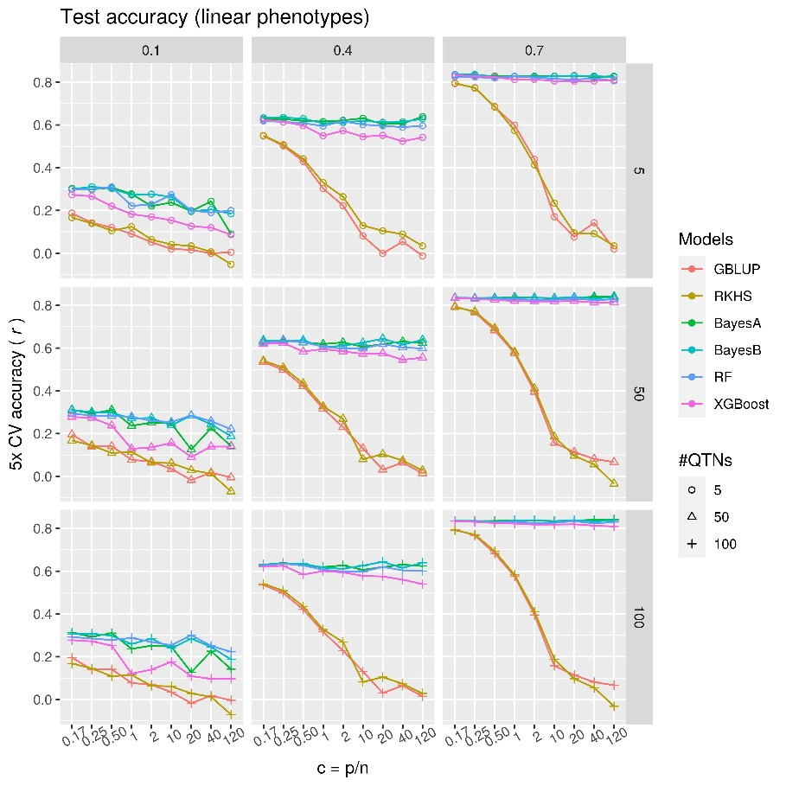 | 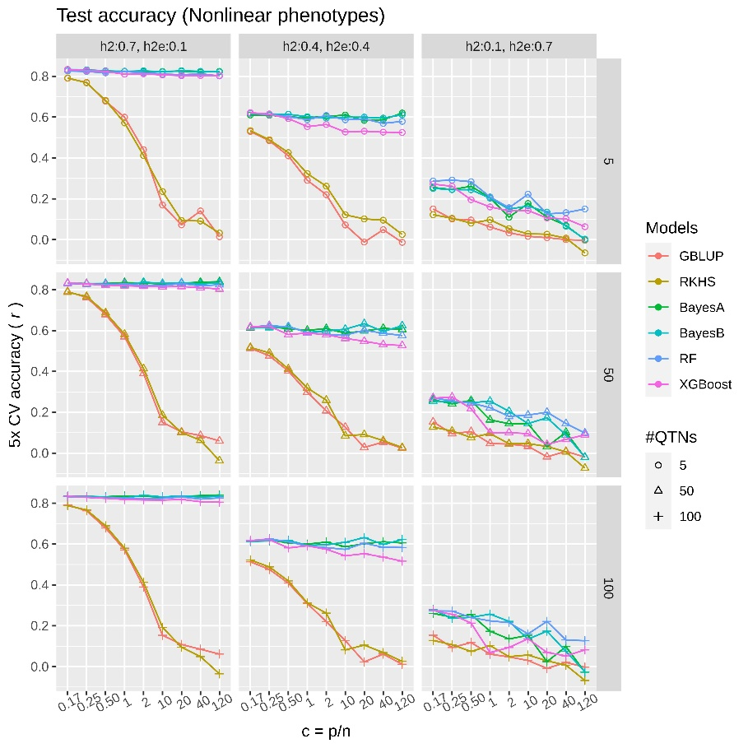
A | B
Figure S3. Comparison of test data prediction performance using simulated phenotypes with one large effect QTN. Average performance (Pearson correlation coefficient between true and predicted values) of parametric (GBLUP), semi-parametric (RKHS), parametric Bayesian (BayesA, BayesB) and ML (RF and XGBoost) methods are compared on test data using 5-fold cross-validation. Each subplot is based on a particular heritability and #QTNs, where the ratio of number of markers to number of samples (p/n) increases from left to right for each subplot. The genetic complexity of the phenotypes is increasing from top row to bottom row such that a trait with five QTNs is relatively simpler than the one with 100 QTNs. (A) linear polygenic phenotypes with only additive effects, simulated using equation (1) but one QTN is given a larger effect than others (see methods); (B) nonlinear phenotypes with both additive and epistatic effects, simulated using equation (2). Here broad-sense heritability was set to 0.8 (H² = h² + h²_{e} = 0.8), such that the plots from left to right show an increase in nonlinearity in phenotypes.

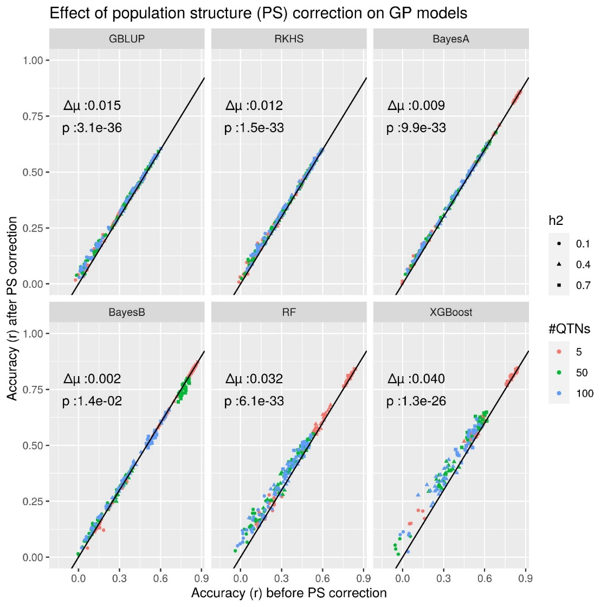
Figure S4. Effect of population structure correction on GP model accuracies. Prediction accuracies using simulated phenotypes on real structured genotype dataset (STRUCT-simdata) for different models are shown as scatter plots before and after correcting for population structure (PS). Here each subplot is based on Pearson’s correlation coefficients (r) of 5-fold cross-validation on test set. For parametric methods (GBLUP, RKHS, BayesA, BayesB), population structure was corrected by adding first two principal components (PCs) as fixed effects to the linear mixed model equation; for ensemble methods (RF, XGBoost) the first two PCs were added as additional features (see methods). The difference in average accuracy between corrected versus uncorrected accuracies is shown as ∆µ, and p values are based on nonparametric Wilcoxon’s paired rank sum test.
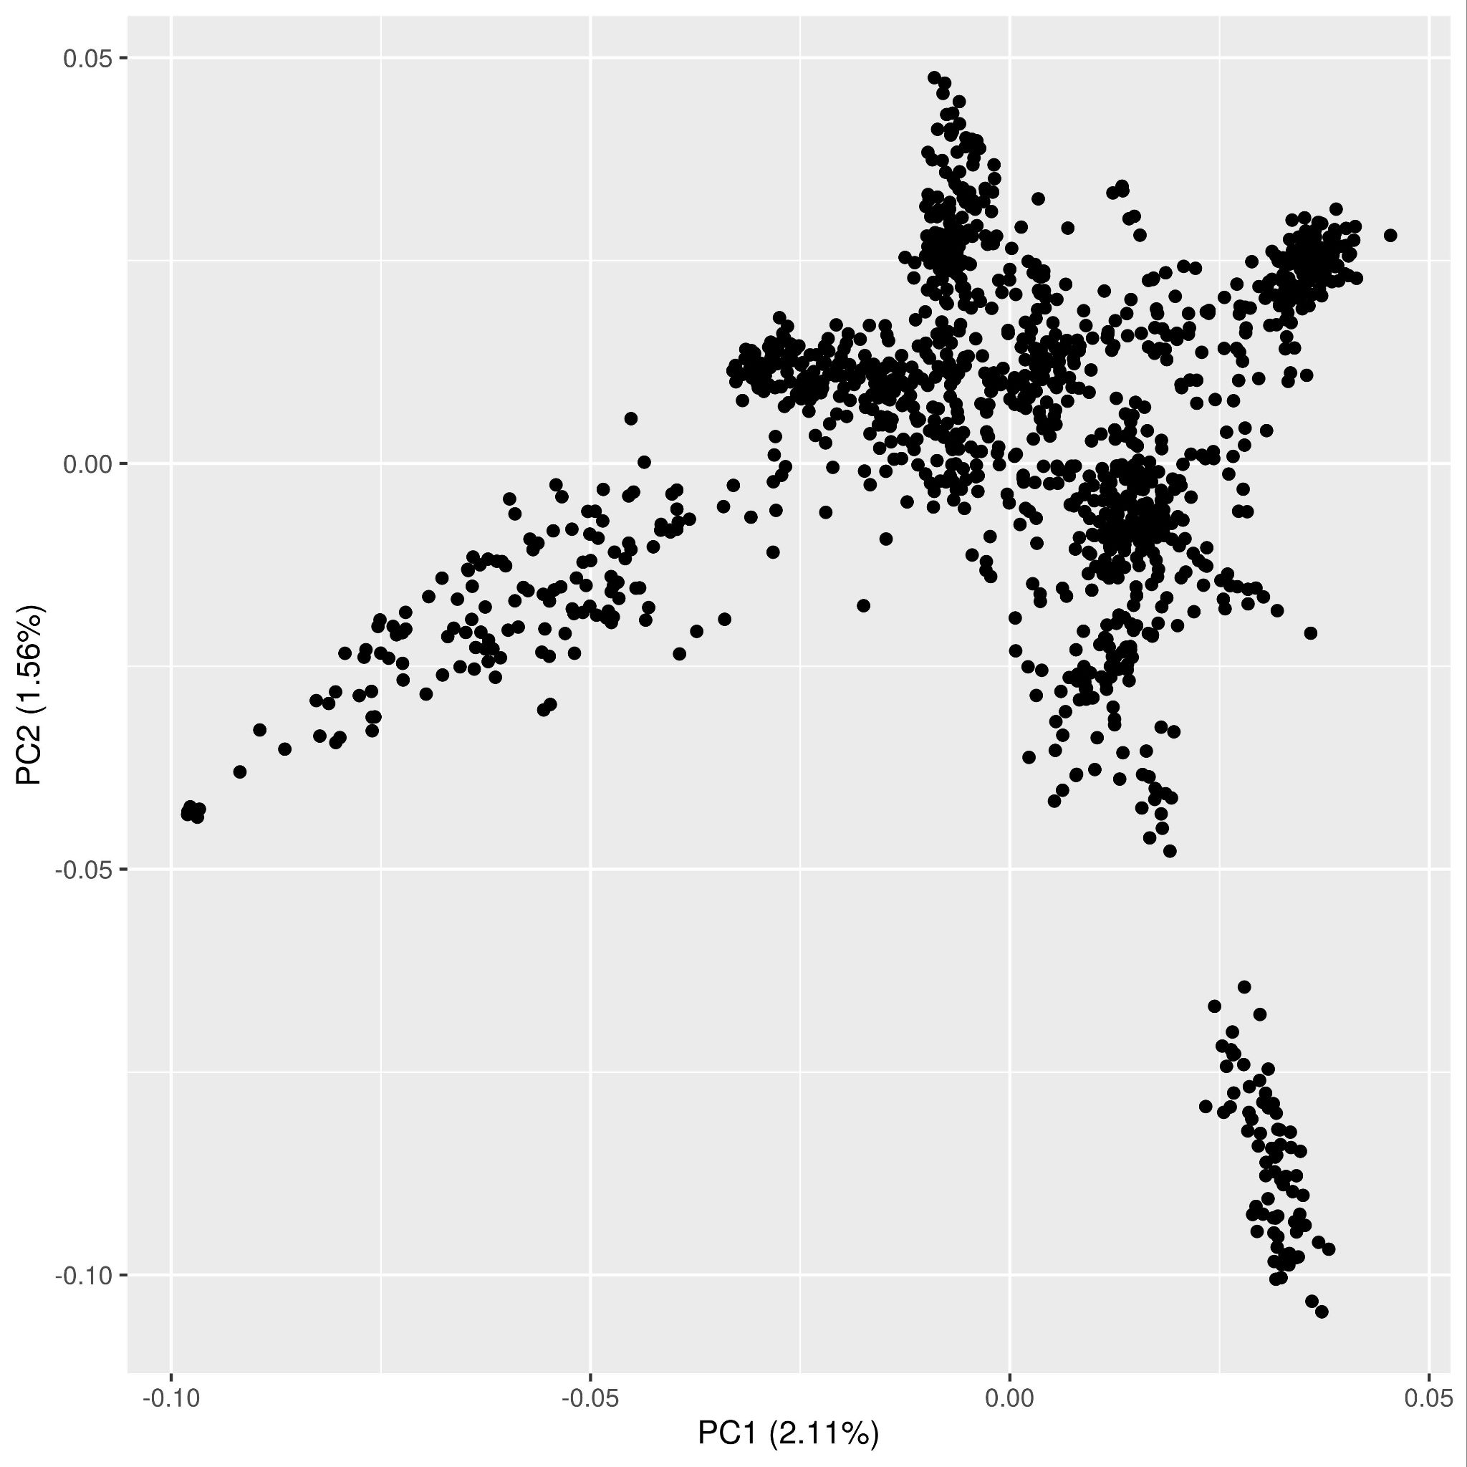
Figure S5. Principal Component Analysis (PCA) of Arabidopsis thaliana RegMap 1,307 accessions using uncorrelated set of markers. Population structure was assessed using PCA based on a smaller subset of markers than the original paper. Here only uncorrelated sets of markers (r² < 0.1) were considered; so a total of 15,662 markers were left out of ~214k SNPs from the Arabidopsis 250k Affymetrix SNP chip.
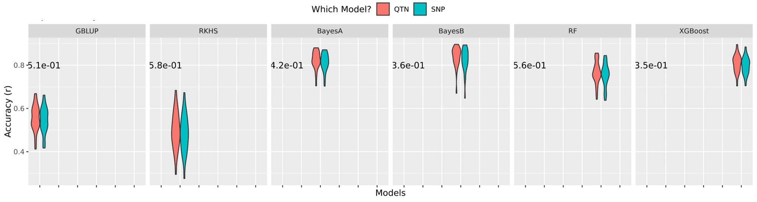
Figure S6. Effect of high SNP-QTN LD (r²>0.9) on prediction accuracy. Prediction accuracy for QTN versus SNP models for each GP method is shown as a violin plot. The QTN model contains the actual QTN used to simulate phenotypes and the SNP model uses SNPs in high LD instead of QTN. The p-values are based on the nonparametric Wilcoxon ranksum test between corresponding QTN versus SNP models.

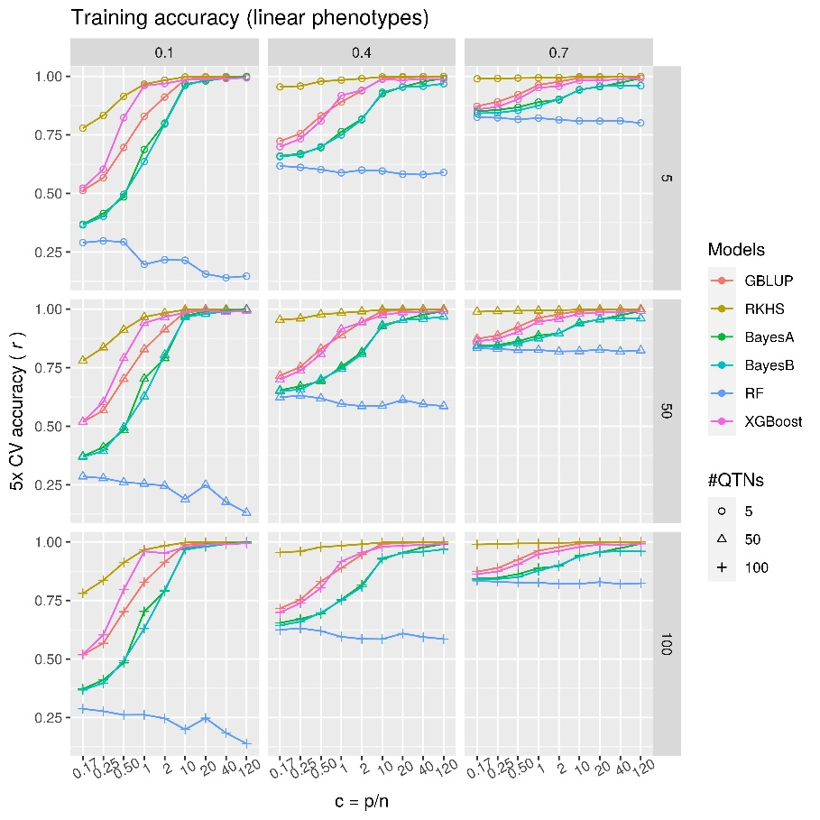 | 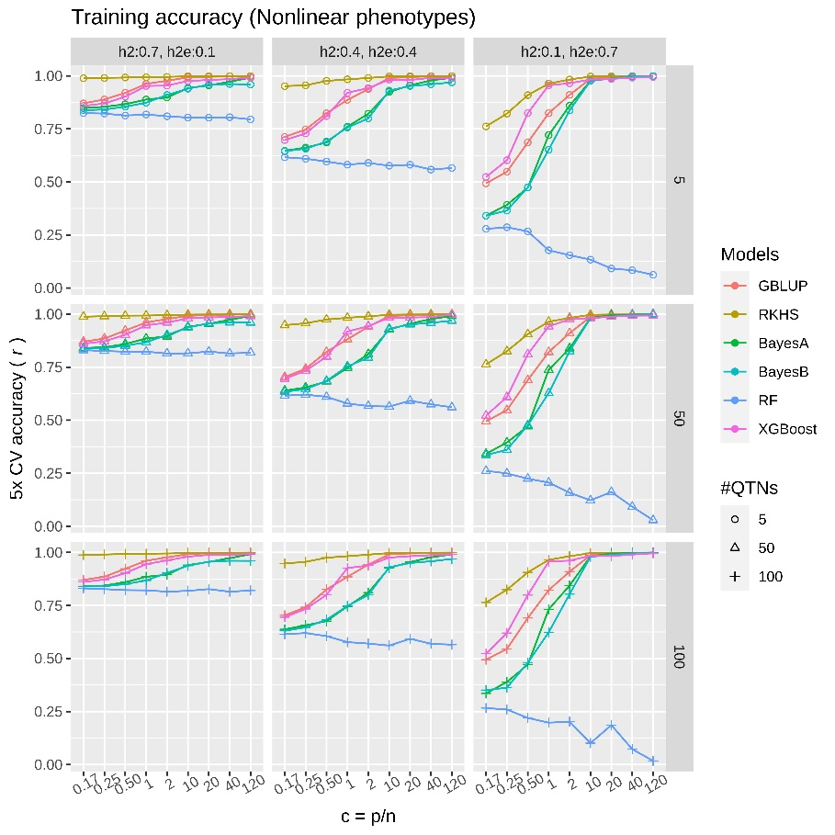
A | B
Figure S7. Comparison of training data prediction performances using simulated phenotypes with one large effect QTN. Average performance (Pearson correlation coefficient between true and predicted values) of parametric (GBLUP), semi-parametric (RKHS), parametric Bayesian (BayesA, BayesB) and ML (RF and XGBoost) methods are compared on test data using 5-fold cross-validation. Each subplot is based on a particular heritability and #QTNs, where the ratio of number of markers to number of samples (p/n) increases from left to right for each subplot. The genetic complexity of the phenotypes is increasing from top row to bottom row such that a trait with five QTNs is relatively simpler than the one with 100 QTNs. (A) linear polygenic phenotypes with only additive effects, simulated using equation (1) but one QTN is given a larger effect than others (see methods); (B) nonlinear phenotypes with both additive and epistatic effects, simulated using equation (2). Here broad-sense heritability was set to 0.8 (H² = h² + h²_{e} = 0.8), such that the plots from left to right show an increase in nonlinearity in phenotypes.

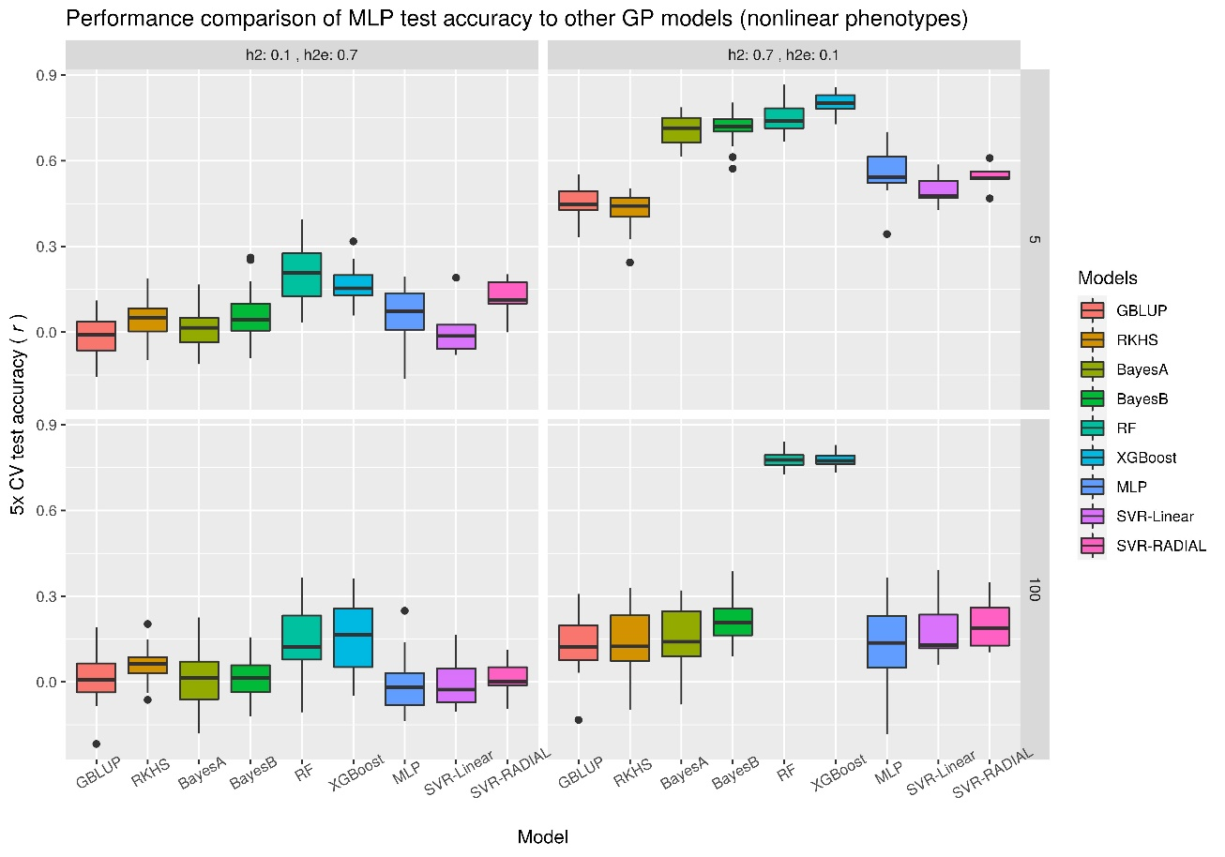
Figure S8. Comparison of prediction performances of parametric, semi-parametric and ML methods using simulated phenotypes without a large effect QTN for nonlinear phenotypes. The figure compares performances of parametric (GBLUP), semi-parametric (RKHS, Support Vector Regressions (SVR) ), parametric Bayesian (BayesA, BayesB) and nonparametric ML (RF and XGBoost, MLP) methods on test data using 5-fold cross-validation. Each subplot is based on a particular heritability and #QTNs. The genetic complexity of the phenotypes is increasing from top row to bottom row such that a trait with 5 QTNs is relatively simpler than the one with 100 QTNs. The plots from left to right show a decrease in nonlinearity in phenotypes and on top of each subplot, h² and h²_{e} are mentioned, such that H² = h² + h²_{e} = 0.8 holds true. Here number of samples and number of SNPs are fixed at 500 (p/n = 1). MLP architecture from Sandhu, Karansher S., et al. 2021 was used with no. of epochs and batch size equal to 2000 and 100, respectively. For SVR, linear and radial kernels (SVR-Linear & SVR-RADIAL) were used and hyperparameters e.g. ‘cost’ and ‘epsilon’ were tuned using cross-validated grid search in {1, 50} and {0, 1} respectively.

