Supporting Information

Ultrafast Transient Infrared for Probing Trapping States in Hybrid Perovskite Films
Ahmed M. El-Zohry^{a,d*}, Bekir Türedir^{b}, Abdullah Alsalloum^{b}, Partha Maityª, Osman M. Bakr^{b}, Boon S. Ooi^{c}, and Omar F. Mohammed^{a*}
ª King Abdullah University of Science and Technology (KAUST), Division of Physical Sciences and Engineering, Thuwal 23955-6900, KSA.
^{b} KAUST Catalysis Center, King Abdullah University of Science and Technology (KAUST), Thuwal 23955-6900, Saudi Arabia..
^{c} Photonics Laboratory, King Abdullah University of Science and Technology (KAUST), Thuwal 23955-6900, KSA.
^{d} Department of Physics, AlbaNova Center, Stockholm University, 10691 Stockholm, Sweden.
*Corresponding author: ahmed.elzohry@fysik.su.se , omar.abdelsaboor@kaust.edu.sa

Methods
Preparing the perovskite films: the CaF₂ substrates were cleaned with DI water, acetone, and IPA, followed by a 10 minute UV ozone treatment. FAPbBr₃ and FAPbI₃ thin films were prepared using a modified antisolvent dripping technique as described elsewhere.¹ 1.1 M of FAX and PbX₂ were dissolved in DMF:DMSO (9:1 ratio), and 100µl of the solution was spin-coated for 15 seconds at 4000 rpms. 300µl of toluene was drop-casted during the sixth second, and the films were annealed immediately after the spin-coating process for 10 minutes at 170° for FAPbI₃ and 100° for FAPbBr₃.

Femtosecond transient absorption setup
More details about the setup specifications have been reported previously.²⁻⁶ Briefly, an excitation wavelength of 410 to 520 nm was utilized, while probe light was also changing from 4000 nm to 6000 nm. The power used for the excitation wavelength depends on the utilized wavelength but was changing from ca. 100 to 300 μW.

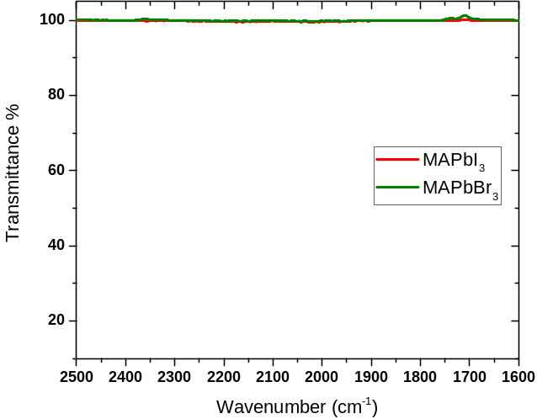
Figure S 1: FTIR for perovskite films in the region of fs-IR measurements.

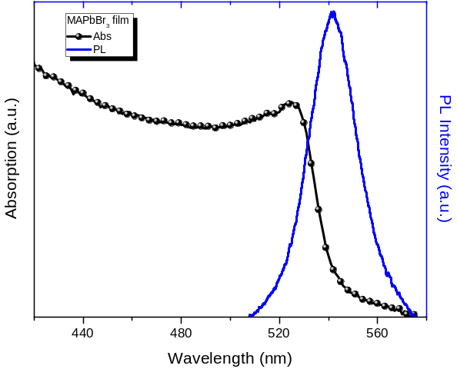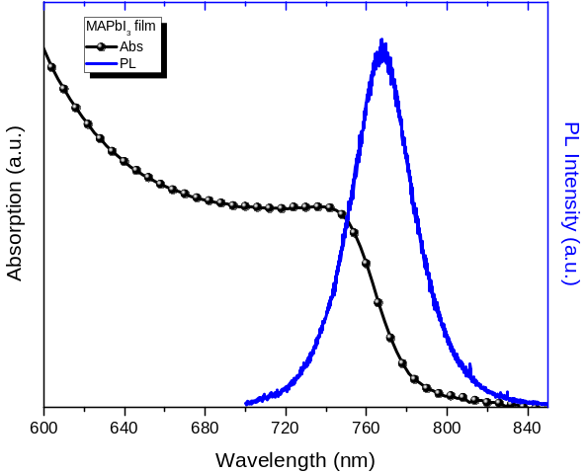
Figure S 2: Steady state normalized absorption and emission data for MAPbBr₃ and MAPbI₃ films on CaF₂ plates.

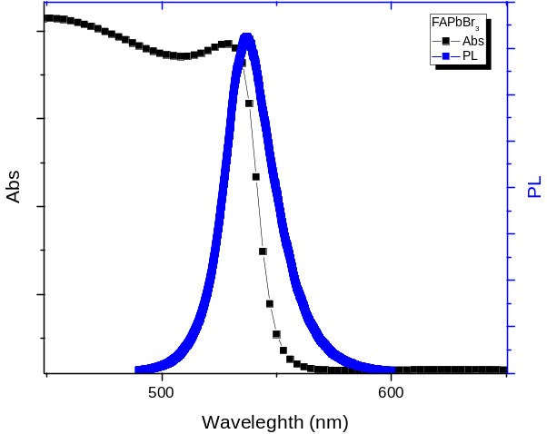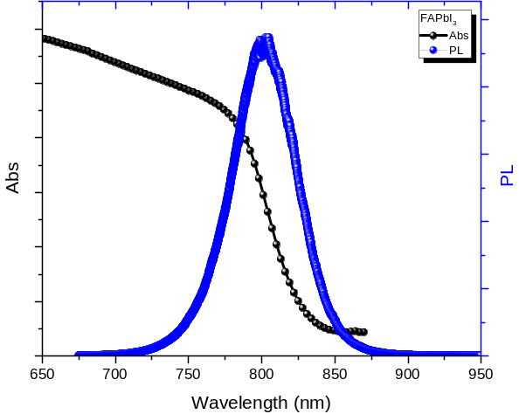
Figure S 3: Steady state normalized absorption and emission data for FAPbBr₃ and FAPbI₃ films on CaF₂ plates.
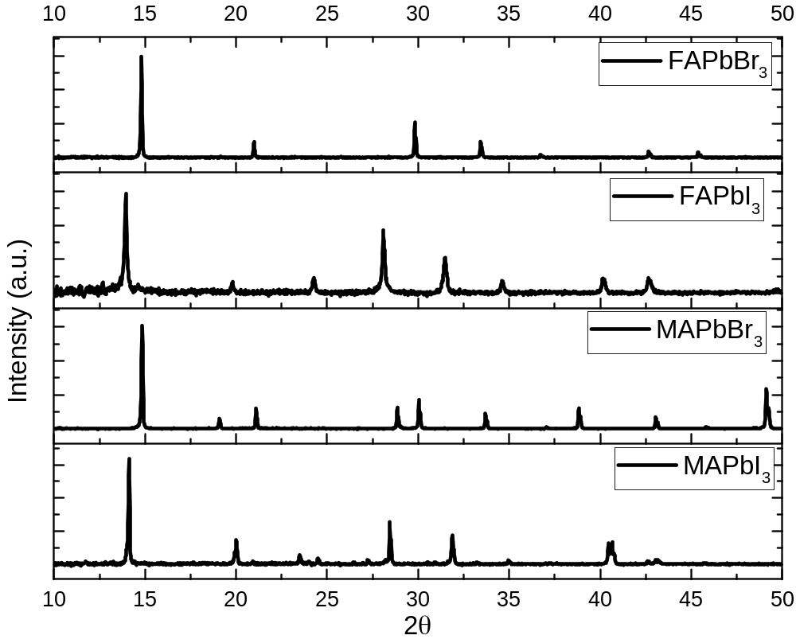
Figure S 4: XRD measurements for thin films of hybrid perovskite films used in the current study.

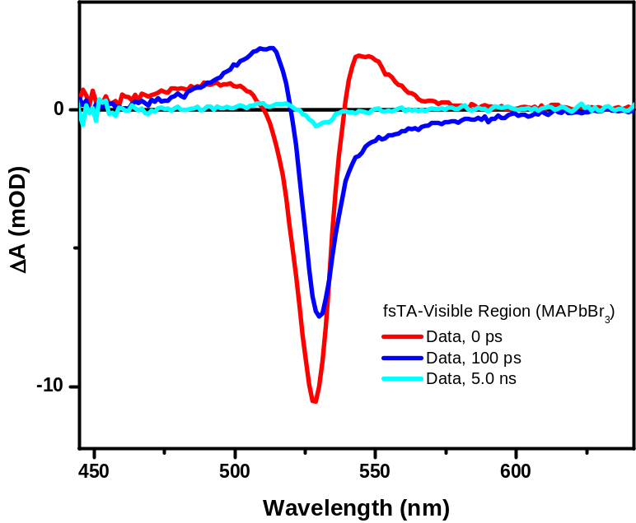
Figure S 5: fs-TA data for MAPbBr₃ in the visible region upon exciting with 520 nm.

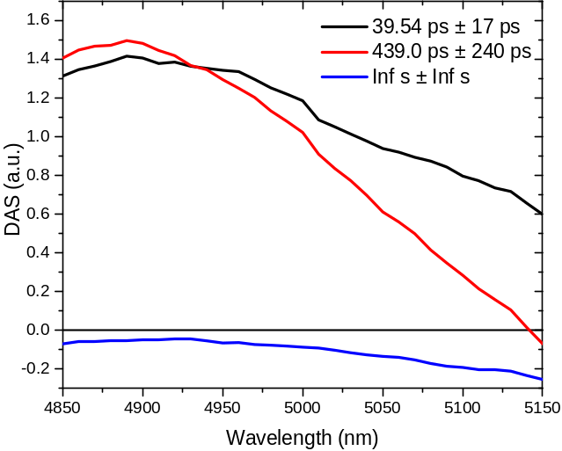
Figure S 6: Decay associated spectra for charge dynamics of MAPbBr₃ film
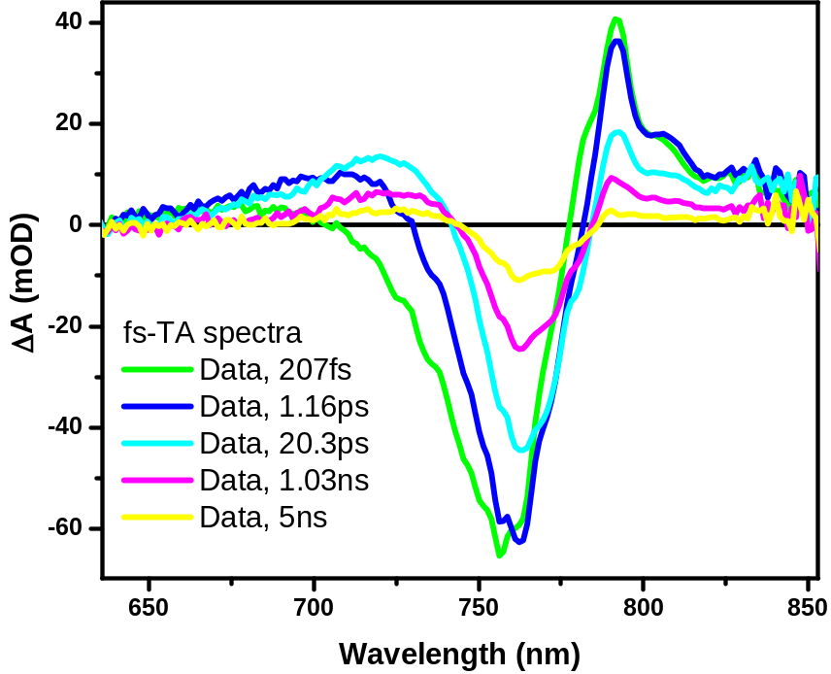
Figure S 7: fs-TA for MAPbI₃ in the visible range.
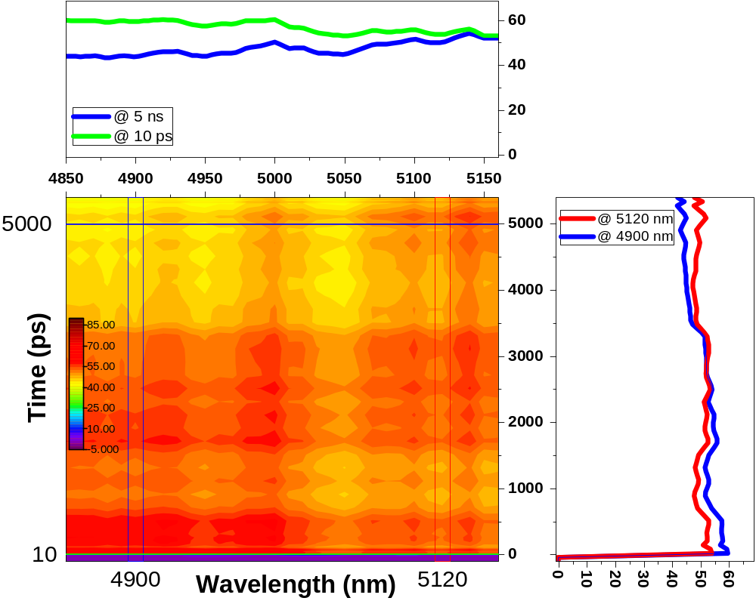
Figure S 8: 2D-false plot of fs-TA for silicon substrate using excitation wavelength of 520 nm and probing the mid-IR window between 4850-5150 nm. Extracted kinetics and spectra are shown at different locations, see the legends.

References
1 . Jeon, N. J.; Noh, J. H.; Kim, Y. C.; Yang, W. S.; Ryu, S.; Seok, S. I., Solvent Engineering for High-Performance Inorganic–Organic Hybrid Perovskite Solar Cells. Nature Materials 2014, 13, 897.
2 . Hussain, M.; El-Zohry, A. M.; Hou, Y.; Toffoletti, A.; Zhao, J.; Barbon, A.; Mohammed, O. F., Spin–Orbit Charge-Transfer Intersystem Crossing of Compact Naphthalenediimide-Carbazole Electron-Donor–Acceptor Triads. J. Phys. Chem. B 2021, 125, 10813-10831.
3 . Imran, M.; El-Zohry, A. M.; Matt, C.; Taddei, M.; Doria, S.; Bussotti, L.; Foggi, P.; Zhao, J.; Di Donato, M.; Mohammed, O. F.; Weber, S., Intersystem Crossing Via Charge Recombination in a Perylene-Naphthalimide Compact Electron Donor/Acceptor Dyad. Journal of Materials Chemistry C 2020, 8, 8305-8319.
4 . El-Zohry, A. M.; Zietz, B., Electron Dynamics in Dye-Sensitized Solar Cells Influenced by Dye-Electrolyte Complexation. J. Phys. Chem. C 2020, 124, 16300-16307.
5 . El-Zohry, A. M., Excited-State Dynamics of Organic Dyes in Solar Cells. In Solar Cells, IntechOpen: 2020.
6 . Abdellah, M.; El-Zohry, A. M.; Antila, L. J.; Windle, C. D.; Reisner, E.; Hammarström, L., Time-Resolved Ir Spectroscopy Reveals a Mechanism with Tio2 as a Reversible Electron Acceptor in a Tio2–Re Catalyst System for Co2 Photoreduction. J. Am. Chem. Soc. 2017, 139, 1226-1232.

