Supplemental Table. Clinical characteristics of each SNP genotype (UCP1-3826 A/G and ß3ADR Trp64Arg)
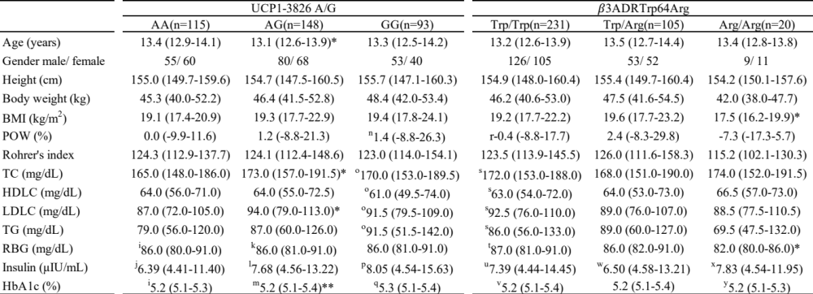
Data are presented as means (P25-P75) and n. BMI, body mass index; POW, percentage of overweight; TC, total cholesterol; HDLC, high-density lipoprotein cholesterol; LDLC, low-density lipoprotein cholesterol; TG, triglyceride; RBG, random blood glucose; HbA1c, hemoglobin A1c. * P < 0.05 vs. wild type of the corresponding gene, ** P < 0.01 vs. wild type of the corresponding gene. ª n = 172, ^{b} n = 162, ^{c} n = 173, ^{d} n = 151, ^{e} n = 130, ^{f} n = 149, ^{g} n = 29, ^{h} n = 28

